
Name : Catalina Mihaela Iovu
Student ID :2112981
Course name : Academic and Employability Skills(BMSW4001)
Lecture Name :Md. Nazmul Hasan
TASK 2
Reflective Report

I'm Catalina and I'm studying Skill's for Workplace at UWTSD, I did the same as Donna I left everything for the last few days. Saturday I started to start the report ,meanwhile my parents and my friend said to go out in the city that it was nice and warm outside , Sunday morning I woke up late when I wanted to start the report to finish I called my girlfriends to go shopping ,when I got home it was already too late to get to work . Monday I came from work with the enthusiasm to finish the project for the course , once I got home I got the job , I started to cook and forget that I have something to do , around 18 I started the first Task , I completed around 22 o'clock . it was already too late to do the next task. Tuesday I got home after a hard day of work , I took around 2-3 hours to find my inspiration and words to start the next task . scared that I will not finish it on time Wednesday until 3 p.m. I stayed until late at night knowing that the next day I will be very tired at work . I finally managed to finish it knowing that it is not my best work, but knowing in the future not to leave everything on the last hundred meters and give the best of myself . I knew it was not going to be my best project, because I did not have time to complete it to write everything in detail and give me the interest that is needed. because I have a very busy schedule . I work to make my own purpose in life and to be on my own. and on the weekend I go to college , I started college to have more doors open for my future and to prove to me that I can and that I am capable .

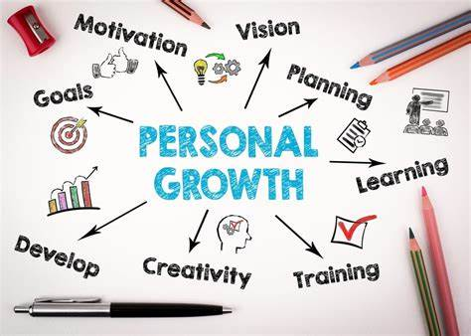
(Anon., 2022)


Description  (What happened?) | after the presentation colleagues and the teacher gave me a pretty good feedback , I was told that I had a lot of information put in one page had to share them in several slides , content was good images had the same significance about the theme of the project . The title was a bit meaningless because I did not add the name of the teacher, the people who are part of the group, module and a title name
Feelings  (What were you thinking and feeling at the time?) | I felt uncomfortable because I was afraid of saying something wrong or transmitting something wrong
Evaluation  (What was good and bad about the experience?) | the good part was that I managed to complete the presentation and that people were happy with my project the bad part was that I did not have eye contact with the people in the class I was focused on the screen
Analysis  (What sense can you make out of the situation?) | in the future I will focus more on eye contact and less on the presentation on the screen
Conclusion  (What else could you have done? Or what could you have improved?) | to add more slides with less information , not to put all the information in one page , I had to add the main ideas and with more images with significance
Action Plan  (If you did another presentation, what would you do differently? What skills do you need to develop?) | I would change the content of the presentation, I would make everything more detailed and be understandable to each person, because each person conceives ideas differently for some people is easier to understand ideas when you do not have a presentation loaded to have only the main ideas and important ideas. and other people perceive more easily when there is more information put on a single page

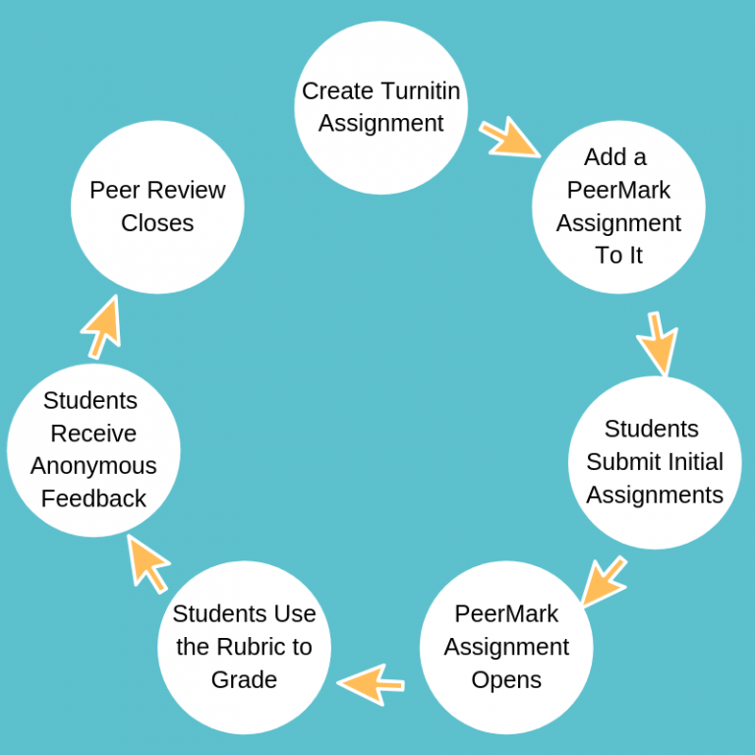

(Anon., 2022)

The group experience was a pleasant one with many obstacles, I tried to contact my colleagues from the group I was in (group number 5) but it took a little longer until we mobilised. I saw that another week passed and time was running out I sent them another email . finally we managed to get in touch with all , we created a group on WhatsApp where we communicated with all , we chose each one an question that I thought we represent and who I thought we would succeed with it , on the last day when we had to present it , the leader of the group said that he does not think he finishes making the presentation so I decided to take over the position of leader of the group to complete everything on time .
On the day of the presentation I had many emotions because I am an emotive person and I am ashamed to speak in front of people because I am afraid not to say something wrong or with another subtitles and to offend or upset the present people. I started to present as if the words and my mind were running away, physically I was present in front of the class but my mind was not present We presented each what they worked on, the colleagues were somewhat excited about our presentation but the feedback followed. there were both good parts and bad parts
From colleagues the feedback was a pleasant one but also an unpleasant one told us that the content was well arranged in the page, with images on that topic. Just that the less good part was that I did not have eye contact with people in the class we were too focused on what is written on the screen and not at them . through this I could not transmit any emotion to the people in the room
From the teacher's side the feedback was good, he was delighted with the content and our placement in the page the images were well chosen, and his advice was that in the future to try to have eye contact with the world even if they think that we look them in the eyes but we do not do, to imagine that in the room there are not many people and that you are you with your reflection explaining something in front mirrors
I enjoyed working with people in my group, there are some people paying attention to details who give their interest in the work to be done, we supported each other. My experience with teamwork has been enjoyable and in the future I want to improve those things that my teacher and colleagues were not so surprised .

Definitions of Student Engagement
The definition of student involvement as the time and effort that students devote to the school activities in which they are involved is very high. Arriving from school late, he first deals with homework and what he has to prepare for the next day, then I have dinner and if they have a little free time I go for a walk outside. A very important first aspect is the involvement and devotion of the teacher, as the teacher has a simpler teaching technique but also clear the faster and easier the student learns. This simple technique includes as many representative images as possible on that topic, tables, graphs and less content, the easier the human brain learns. There are two types of people:
a) those who through faster when the teacher speaks
b) those who perceive the information in writing faster. Although this definition is useful in most cases for improving student learning, it also offers a one-dimensional perspective on student involvement. According to Gibb's, student involvement is used to refer to so many things. Gibb's is a simple method often used by students but also by other people or companies, it is easy to use but just as easy to understand, it is a simplistic scheme that contains only the basis of long definitions.

Engagement
Doing
Feeling
Thinking
With other student
Teaching
Learning
With the community
Research
With faculty and staff

(Created by student )

Analyses
We used the two-stage approach (Cheung & Chan, 2005) to fit the hypothesised model to the data. In the first stage, correlation matrices are combined to form a pooled correlation matrix. In the second stage, a structural model is fitted to this pooled correlation matrix. In Stage 1, the random effects approach is used as implemented in the R-package meta SEM (Cheung, 2014, 2015), which utilises the Open Mx package (Boker et al., 2011) to pool the correlation coefficients. Random effects models account for heterogeneity across studies by assuming that studies have their own study-specific population correlation matrices.
CURRENT SKILLS | OBSERVING | QUESTIONING | IMPOSING CONDITION | CREATING NEW VARIABLE
SKILLS TO WORK ON | PREPARING | CONSIDERING OPPOSITION’S OBJECTIVE | LISTENING MORE AND TALKING LESS | TEAMWORK
MY GOALS | ANALYSE MORE INFORMATION I HAVE | BE REACTIVE ON OBJECTIVES TO FIND NEW STRATEGIES | NO AGGRESSIVE BEHAVIOURS  TAKE TIME | TRY NOT TO BE ALWAYS THE LEADER
MY RESOURCES | APPLY NEW TECHNIQUES | PRACTICE DURING SOCIAL ACTIVITIES | PRACTICE A SPORT OF RELATION AND SELF CONTROL | INCREASE NUMBER OF TEAMWORK AT SCHOOL
ACTION PLAN | I COULD DO IT NEXT TIME I NEGOTIATE | IT IS A DAILY WORK ( 1 MONTH) | I NEED TO CHANGE MY PERSONALITY (6 MONTHS) | FIND THE WEAKEST OF THE TEAM AND BE COOPERATIVE WITH THEM ( 8 MONTHS)

(Create by student )

Conclusion
In conclusion, involvement has been a central point of his efforts to understand and improve what he has to do and to learn higher education for over 70-80 years.
The involvement of students in school activities has increased from year to year, offering them a lot of activities so that they can figure out which activity and which profile suits them, you can sign up for as many courses and activities as you can your true passion and what you would like to study further in the next years of college



References
Anon., 2022. [Online]
Available at: https://www.bing.com/images/search?view=detailV2&ccid=2A94x3iZ&id=1A0B16AD2F093A92E4D5638DBE028D20C98DA43B&thid=OIP.2A94x3iZhUfI365V-zlu2AHaFS&mediaurl=https%3a%2f%2fanivda.com%2fwp-content%2fuploads%2f2019%2f06%2fWhat-is-Personal-Development.jpg&cdnurl=h
[Accessed 05 04 2022].
Anon., 2022. GOOGLE. [Online]
Available at: https://www.bing.com/images/search?view=detailV2&ccid=2A94x3iZ&id=1A0B16AD2F093A92E4D5638DBE028D20C98DA43B&thid=OIP.2A94x3iZhUfI365V-zlu2AHaFS&mediaurl=https%3a%2f%2fanivda.com%2fwp-content%2fuploads%2f2019%2f06%2fWhat-is-Personal-Development.jpg&cdnurl=h
[Accessed 05 04 2022].
Groccia, j. E., 2018. What Is Student Engagement?. What Is Student Engagement?, 01 07, p. 5.
Roorda Debora L, J. ,. S., 2017. Affective Teacher-Student Relationships and Students' Engagement and Achievement: A Meta-Analytic Update and Test of the Mediating Role of Engagement.. 10 09, p. 23.

