Research Proposal

Submission date: 7th November 2025
Submission ID: 2407116

THE IMPACT OF STRATEGIC HUMAN RESOURCE MANAGEMENT PRACTICES ON EMPLOYEE RETENTION IN THE UK RETAIL INDUSTRY

Table of Contents
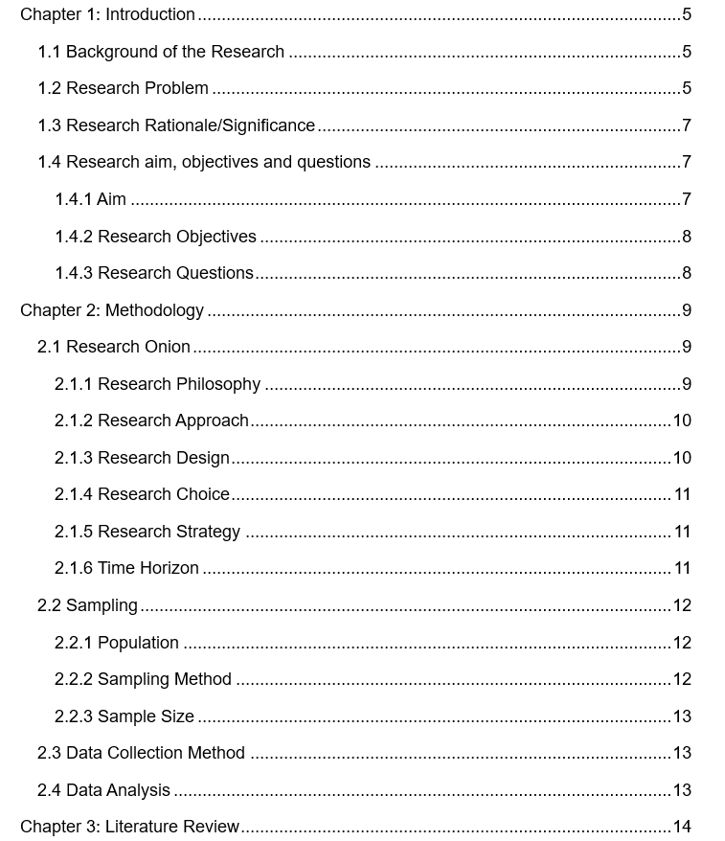

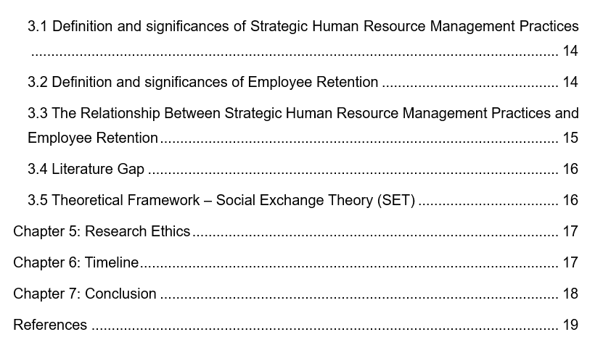

Chapter 1: Introduction

1.1 Background of the Research
The retail sector in the United Kingdom plays a crucial role in the country's economy, with over three million people employed in this industry and contributing to the gross domestic product. However, the problem of retaining employees is one of the main and persistent challenges of the sector. Higher levels of employee turnover led to operational disruptions, increased recruitment and training costs, as well as poor quality of service and customer satisfaction (Shrestha et al., 2024). Strategic Human Resource Management (SHRM), practices have become a crucial strategy in reducing the organisational challenges by long term alignment of human capital strategies with corporate goals. In the retail industry, SHRM focuses on the involvement of workers and performance management, training programs, and compensation systems all of which are interconnected and serve in increasing motivation and better retention.
The ever-changing nature of workforce dynamics, along with digital transformation and shifting employee expectations, have made it increasingly necessary to take a more proactive approach in human resources management (Tripathi et al., 2025). Furthermore, wider contextual factors such as economic uncertainty, the realignment of the workforce in the post-pandemic landscape and a rise in the cost of living have heightened the urgency to implement retention strategies that incorporate elements of flexibility, employee well-being and career development. Accordingly, we need to have a thorough understanding of the influence of strategic human resource management (SHRM) practises on employee retention in the UK retail sector for creating organisational sustainability and competitiveness in the post-pandemic labour market (Jebbouri, 2025).

1.2 Research Problem
An essential issue in the UK retail market is employee retention because this field has an annual turnover rate of more than 50 per cent, which is significantly higher than the overall national value (Mehmood et al., 2025). The increased attrition rate leads to increased recruitment spending, loss of organizational knowledge, and low productivity which adversely affects the profitability and brand reputation of retail firms. A large percentage of workers leave the company due to their dissatisfaction caused by low pay, a lack of career promotion, and poor working conditions, which is further increased by more macroeconomic factors, such as inflationary forces and unpredictable working hours (Jebbouri, 2025).
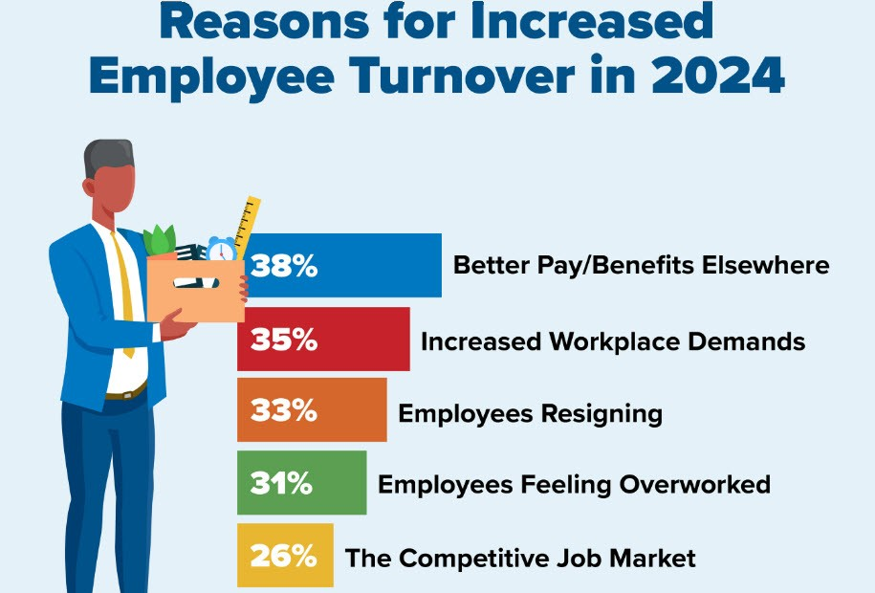
Figure 1:Reasons for Increased Employee Turnover in 2024
(Source: Adapted from HR Digest Report on Workforce Trends (2024))
Additionally, there's a growing sense of job insecurity and mental health anxiety provoked by the pandemic, making employees desire to pursue other career paths in sectors that are more stable. Although an impressive amount of existing literature emphasized the importance of human resource practices, including training, remuneration, and employee engagement, empirical literature on the extent to which the integration of strategic HRM is important with regard to long-term employee retention is still a very limited domain of study within the retail industry in the United Kingdom (Shrestha et al., 2024). The research problem currently is thus concerned about understanding the extent to which strategic human resource management practices, including talent development, performance management, and reward systems can counter the problem of turnover and foster a stable and committed retail workforce in the face of changing, evolving market challenges (Tripathi et al., 2025).

1.3 Research Rationale/Significance
Employee retention is a major concern in the UK retail industry because the turnover is already above 50% per annum, which is much higher in comparison with the national average (Mehmood et al., 2025). This trend can be largely attributed to low remuneration, unfavourable working conditions and limited opportunity for career development, all of which combined contribute to a decline in job satisfaction. Many retails employees' well-being is marginally reduced due to customer-hostility, precarity, and work overload. There is also a lack of quality career development, systematic training initiatives, which dictate leaving the staff to seek other mediums of employment, which offer them with better prospects of professional growth (Shrestha et al., 2024).
Moreover, external factors (exacerbated by the COVID-19 pandemic and general economic uncertainty) have intensified retention challenges by driving up operating costs and downgrading workforce morale. UK retailers are, therefore, forced to adopt strategic human resource management practises which are aimed at reducing such issues such as competitive pay, structured career development, infusing a strong organisational culture and flexible work practises to improve employee commitment and thereby organisational performance (Tripathi et al., 2025).

1.4 Research aim, objectives and questions

1.4.1 Aim
The aim of this research is to examine the impact of Strategic Human Resource Management (SHRM) practices on employee retention in the UK retail industry.

1.4.2 Research Objectives
I. To identify the key Strategic Human Resource Management (SHRM) practices that influence employee retention in the UK retail industry.
II. To analyse the impact of Strategic Human Resource Management (SHRM) practices on employee retention in the UK retail industry.

1.4.3 Research Questions
I. What are the key Strategic Human Resource Management (SHRM) practices that influence employee retention in the UK retail industry?
II. What is the impact of Strategic Human Resource Management (SHRM) practices on employee retention in the UK retail industry?

1.5 Expected outcomes
RQ I
The study is expected to identify key SHRM practices such as training and development, reward and compensation, career development, employee engagement, and performance management as major factors influencing employee retention in the UK retail industry.

RQ II
The study is expected to find a significant positive impact of effective SHRM practices on employee retention, showing that well-aligned HR strategies reduce turnover intentions and improve employee commitment in the UK retail sector.

Chapter 2: Methodology

2.1 Research Onion

Figure 2: Research Onion
(Source: Saunders, 2019)

2.1.1 Research Philosophy
The positivist paradigm will be used in the study because reality is objective and can be determined by using empirical and statistical data. The research turns towards positivism thus attempting to draw conclusions based on quantifiable data thus reducing subjectivity in the research. Such philosophical position will likely enable the researcher to test the hypotheses empirically and outline the correlation between the adoption of Strategic Human Resource Management (SHRM) practices and employee retention based on quantitative observations. The investigation will use structured methods and standardized measures to maintain validity, reliability, and generalizability (Park et al., 2019). Therefore, positivist epistemology will guide the research to make empirically proved, evidenced-based inferences.

2.1.2 Research Approach
The deductive method will be utilized to test existing theories related to strategic human resource management (SHRM) and retention of employees. Starting with the general theoretical assumptions that are based on the existing literature, this methodology will proceed to the development of certain hypotheses that will be tested in an empirical manner by analyzing the data that is gathered. The use of a deductive methodology makes it easier to achieve rigorous logical inference and validate theoretical constructs through empirical research through the use of quantitative analytical techniques (Ghanad, 2023). The proposed methodology will determine how much strategic human resource management practices affect employee retention in the UK retail sector and thus contribute to the body of literature by either supporting or refuting existing theoretical frameworks.

2.1.3 Research Design
A quantitative research design will hereby be used to systematically explore the relationship between Strategic Human resource management (SHRM) practices and Employee retention using numerical data in the work. The design, in turn, would allow deploying measurable variables, conduct relevant statistical tests, and use standardized tools, including structured surveys, to obtain the insights of retail employees (Hyer, 2024). The quantitative nature of research design will provide objective results that could be generalized in the sector, which will reduce bias and provide greater accuracy. Using regression analysis and descriptive statistics, the research will measure the strength and statistical significance of the relationships hence allowing inferences to be drawn using data rather than having assumptions about the role played by strategic human resource management in retention of employees.

2.1.4 Research Choice
This research will use the mono-method quantitative approach, using only one technique for data collection and data analysis. Using a mono-methodology ensures uniformity, straightforwardness and dependability since focusing solely on quantitative methods, therefore, avoiding the combination of qualitative tools. The use of this methodology helps the researcher accumulate and gather standardized responses, which greatly aids in the comparison of results and performing statistical tests (Shrestha et al., 2024). The study ensures that methodological rigor has been maintained using a single, systematic approach, hence allowing a subtle interpretation of empirical data to describe the effect of strategic human resources management practices on employee retention in the retail sector in the United Kingdom.

2.1.5 Research Strategy
The survey strategy will be carried out using an online survey questionnaire for employees in the UK retail industry. Surveys represent an effective tool of collecting large scale and standardized data in geographically spread populations at a lower cost and in a period that is shorter (Mehmood et al., 2025). The questionnaire will consist of closed-ended items on five-point Likert scales which will be used systematically to determine the perceptions of participants in strategic human resource management (SHRM) practices and determinants of employee retention. Such a methodological framework will make valid statistical analysis and make responses both measurable and valid, which will make it suitable to the empirical verification of hypothesis regarding employee retention results.

2.1.6 Time Horizon
The present study will use a cross-sectional time perspective collecting data on a single point in time to look for the link between SHRM practices and employee retention. This design will help the researchers to take a picture of modern HRM practices and how they affect the choice made by employees to stay or live in the retail industry (Jebbouri, 2025). The cross-sectional method allows for both expediency in terms of time and cost and hence the ability to analyze and interpret empirical data in a timely manner. Additionally, it provides the basis for meaningful insights into current patterns of human resource management and workforce dynamics without requiring extended observation or long-term monitoring.

2.2 Sampling

2.2.1 Population
This research will target a population of employees in the retail industry of the United Kingdom, which will include people who work in supermarket chains, clothing stores, and department stores. Thus, the employees referred to indicate a scale of positions in retail organizations, from front-lines employees to intermediate management ranks. The chosen population is the one to be employed because it will be the group that has been negatively affected most by SHRM practices related to employee retention and workforce consistency (Shrestha et al., 2024). Through focusing on this demographic, the study will provide meaningful findings on those human resource management strategies that directly affect employee satisfaction and retention results.

2.2.2 Sampling Method
Purposive sampling will be applied to select the participants who have the relevant experience and knowledge related to strategic human resource management practices and employee retention in the field of the retail industry. The use of this nonprobability sampling method will allow the researcher to be selective in choosing those respondents of occupational backgrounds, professional background, and exposure to human resource policies (Mehmood et al., 2025). Purposive sampling also presupposes that the data is strong and relevant to the research purposes and, thus, it is possible to concentrate on studying the impact of HR practices on the retention outcomes in diverse retail settings.

2.2.3 Sample Size
The study aims to obtain answers from around 150-200 employees of the retail industry in the United Kingdom. The current sample size is large enough to ensure that the findings are statistically reliable and valid and is not too big to make data collection and analysis manageable (Ghanad, 2023). The sample will include participants from a multiplicity of demographic and professional strata and as such ensure that a diverse array of perspectives is represented.

2.3 Data Collection Method

Primary Data
- Primary quantitative data from retail employees in the UK
- Employees’ perceptions of key SHRM practices (training, rewards, career development, performance management, engagement)
- Employee retention factors (job satisfaction, commitment, turnover intention)
- Demographic and professional data (age, gender, job role, experience, organization size)

The data will be gathered by filling out the Google Form questionnaire that will evaluate the perception towards the SHRM practices and retention related factors among employees. The survey technique in the form of an online survey will be effective, economical, and suitable in reaching out to a wide range of respondents representing various retail companies (Tripathi et al., 2025). A Likert scale set of closed-ended items will be used in the questionnaire, so that data are quantifiable. This methodology is expected to increase the data precision and allow easy export of the responses to statistical software for further analysis.
- Use an online questionnaire created using Google Forms
- Distribute the survey via email, professional networks, and social media platforms
- Use Likert-scale, closed-ended questions to ensure quantifiable data
- Ensure voluntary participation and anonymity in line with ethical requirements

2.4 Data Analysis
Data obtained will be processed with the help of SPSS statistical package to perform both descriptive and inferential analysis with the possibility of grounded regression analysis to explain the relationships between strategic human resource management practices and retention of employees. The SPSS software will be used to create frequencies, correlations, and coefficients to validate the hypotheses proposed in the current project (Jebbouri, 2025). The regression analysis will assist in identifying the HR practices which have a significant impact on employee retention. The analytical methodology will hopefully assure the objectivity, narrow interpretive accuracy and provide evidence-based policy suggestions to improve strategic human resource management practice in the United Kingdom retail industry.

Chapter 3: Literature Review

3.1 Definition and significances of Strategic Human Resource Management Practices
The value of HRM in Practice Strategic Human Resource Management (SHRM) practices refer to the mindful CS orientation of HR strategies in relation to organisational objectives that subsequently result in sustained performance and increased employee involvement. Cahyono (2024) defines strategic human resource management (SHRM) as the planning of the workforce, talent management, compensation management, and performance appraisal to ensure that human resource is aligned with the overall business strategies. As per Georgescu et al. (2024), these practices improve adaptability and resilience of organizations (especially in competition-based industries such as retail).
In addition, Alam et al. (2024) argue that the strategic human resource management practice fosters employee dedication and involvement and increases productivity and organizational achievement. In the United Kingdom, the retail industry still experiences high employee attrition, and by utilizing strategic human resource management practices, this ensures that the organization retains a stable and skilled workforce which ensures continuity and keeps the customers satisfied (Georgescu et al., 2024).

3.2 Definition and significances of Employee Retention
Employee retention refers to the ability of an organization to maintain a balanced employee’s workforce by reducing unnecessary employee turnover. Al-Suraihi et al. (2021) operationalize retention as the organizational effort to create an ambience of work that enhances the persistence of employees in the firm for a long time. Among the challenges mentioned by Nilsson and Backman (2025) concerning the retail sector, high rates of employee turnover might be labeled as a major problem and may be explained by destructive compensation packages, the lack of career development, and the current state of job insecurity.
Backman, Nilsson, et al. (2025) further emphasize the fact that the choice of employees in terms of staying or leaving is based on human capital development and the perception of growth opportunities. In turn, the problem of turnover rates can be addressed by developing effective retention strategies, such as training, recognition, and friendly leadership, which will increase the level of employee satisfaction and loyalty, in turn. A strong focus on retaining employees advances the quality of services, customer satisfaction, and profit growth in the retail sector of the United Kingdom (Al bit Suraihi et al., 2021).

3.3 The Relationship Between Strategic Human Resource Management Practices and Employee Retention
The strategy of strategic human resource management (SHRM) practices in relation to employee retention is based on the ability to increase the degree of job satisfaction, employee involvement, and commitment to the organization. Georgescu et al. (2024) believe that strategic HRM creates a favourable culture with a high appreciation for employees as strategic resources and promotes their identification with the organization. According to Cahyono (2024), performance-based remuneration, systematic and structured training programs, and involving employees in interventions foster the sentiment of trust and motivation and thus have a direct effect on the measurement of retention.
Alam et al. (2024) found that synchronization of human resource strategies with supervisory role and employees' needs connected with high engagement level, which further led to less intention to quit jobs. Strategic human resource management (SHRM) applied to the United Kingdom retail sector helps to curb the high turnover rate of employees as this practice leads to career development and work-life balance programs, which in turn increases stability of the workforce (Nilsson et al., 2025). Therefore, strategic human resource management is a strategic tool for retaining valuable employees and maintaining a competitive advantage in dynamic retail markets.

3.4 Literature Gap
Recent literature has discussed the impact of Strategic Human Resource Management (SHRM) on employee engagement and performance, but empirical studies specifically on SHRM itself as an independent variable affecting employee retention in the retail environment in the United Kingdom are limited. Although several studies have focused on the role of strategic human resource management in organisational resilience and productivity (Cahyono, 2024; Georgescu et al., 2024), empirical research in the retail industry is surprisingly under-developed. On the same note, Nilsson et al. (25) have conducted some research on the determinants of turnover in retail environments, but the research does not provide any information on how strategic human resource practices can be used to mitigate such issues.
Moreover, there are only a few previous studies incorporating the contemporary theoretical framework such as Social Exchange Theory (SET) to explain the psychological process about employee organizational loyalty and support. This gap is attempted to be filled by the current research that will build on empirical investigation of the nexus between strategic human resource management practice and retention of employees in the retail industry of the United Kingdom thus generating fresh evidence and practical implications in designing human resource strategies.

3.5 Theoretical Framework – Social Exchange Theory (SET)
The Social Exchange Theory (SET) provides the theoretical foundation necessary for explaining the (reciprocal) nature of the employer-employee relationship. Blau (1964) argues that relationships in the workplace occur in mutual exchange of tangible and intangible rewards. Cropanzano et al. (2005) found that when employees believe that their organizations provide fairness, support, and rewards to their employees, their intrinsic outcomes such as organizational commitment and loyalty are strengthened and, as a result, their turnover intentions are reduced.
Ahmad et al. (2023) restate that cases of self-efficacy theory (SET) is critical in comprehending employee retention, since when one feels that their input is appreciated and properly compensated, they will feel more prepared to stay within an organization. Alnajim (2021) reiterates that human resource practices, including recognition, professional development, and fair compensation, contribute to building trust which in turn fosters a constructive feedback cycle. According to the contextual analysis of SHRM framework along the retail sector in the United Kingdom, SET explains how carefully implemented HR strategies improve employee satisfaction that subsequently facilitate long-term retention and establish organizational stability.

Chapter 5: Research Ethics
This research will strictly follow the guidelines set by the University's ethical guidelines, thus maintaining integrity, transparency and respect for all participants. Ethical authorization will be received before the actual data collection, and the participants will be notified completely on the purpose and the procedures of data collection, his rights to turn back without any penalty. Prior to participation informed consent will be obtained and confidentiality will be maintained by anonymization of all responses; personal or sensitive information will NOT be shared with third parties. The data will be safely kept and remain only to academic use. The research will have neither biases nor deceptions nor inflicting damage upon the participants and will fully operate under institutional ethical standards and data protection laws.

Chapter 6: Timeline
Main activities and stages
Activity / Week | 1 | 2 | 3 | 4 | 5 | 6 | 7 | 8 | 9 | 10 | 11 | 12 | 13 | 14 | 15 | 16
Discuss with supervisor | ■ | ■ | ■ | ■ | ■ | ■ | ■ | ■ | ■ | ■ | ■ | ■ | ■ | ■ | ■ | ■
Introduction | ■ | ■ | ■ | ■
Literature review (development) |  | ■ | ■ | ■ | ■ | ■ | ■ | ■ | ■ |  | ■
Develop questionnaire |  |  |  | ■ | ■ | ■ |  |  |  | ■
Ethics form preparation & approval |  |  |  |  |  |  |  |  |  | ■
Proposal submission |  |  |  |  |  |  |  |  | ■
Data collection |  |  |  |  |  |  |  |  |  |  |  | ■ | ■
Data analysis |  |  |  |  |  |  |  |  |  |  |  |  | ■ | ■
Prepare draft (Chapters 1–3) |  |  |  |  |  |  | ■ | ■ | ■ | ■
Literature review revision |  |  |  |  |  |  |  |  |  |  |  |  |  |  | ■ | ■
Prepare final draft |  |  |  |  |  |  |  |  |  |  |  |  |  | ■ | ■ | ■
Final dissertation submission |  |  |  |  |  |  |  |  |  |  |  |  |  |  |  | ■

Chapter 7: Conclusion
The current research proposal has highlighted the impact of strategic human resource management (SHRM) practice on employee retention in the United Kingdom retailing industry. The current research aims to define the key strategic human resource management (SHRM) practices that are effective in reducing employee turnover and building workforce stability. The research will provide empirical data that shows the relationship between the training, performance management and compensation practices in shaping the commitment of employees by using a positivism epistemology and a quantitative, deductive research approach. Using data collected through surveys distributed to retail personnel and analyzed with the help of Statistical Package for Social Science (SPSS), the research hopes to produce substantial findings and strategic recommendations directed towards strengthening HR structures in UK retail entities and improving lasting employee retention.

References
Ahmad, R., Nawaz, M.R., Ishaq, M.I. & Khan, M.M. (2023) ‘Social Exchange Theory: Systematic Review and Future Directions’, Frontiers in Psychology, 13, 1015921. DOI: 10.3389/fpsyg.2022.1015921.
Alam, M.J., Ullah, M.S., Islam, M. & Chowdhury, T.A. (2024) ‘Human Resource Management Practices and Employee Engagement: The Moderating Effect of Supervisory Role’, Cogent Business & Management, 11(1).
Alexandro, R. (2025) ‘Strategic human resource management in the digital economy era: an empirical study of challenges and opportunities among MSMEs and startups in Indonesia’, Cogent Business & Management, 12(1).
Alnajim, A.Y. (2021) ‘Impact and Application of Social Exchange Theory in Employee Retention’, SSRN Electronic Journal. DOI: 10.2139/ssrn.3884032.
Al-suraihi, W.A., Al-Suraihi, A.S.A. & Ibrahim, I. (2021) ‘Employee Turnover: Causes, Importance and Retention Strategies’, European Journal of Business Management and Research, 6(3), p. 10. DOI: 10.24018/ejbmr.2021.6.3.893.
Backman, M., Nilsson, H. & Öner, Ö. (2025) ‘Career Trajectories in Retail and Wholesale – Turnover, Retention, and Labor Status’, The International Review of Retail, Distribution and Consumer Research, 35(3).
Cahyono, N.D. (2024) ‘Strategic Human Resource Management Practices for Enhancing Employee Engagement and Organizational Performance’, Global International Journal of Innovative Research, 2(7), pp. 1429–1444. DOI: 10.59613/global.v2i7.229.
Cropanzano, R. & Mitchell, M. (2005) ‘Social Exchange Theory: An Interdisciplinary Review’, Journal of Management, 31(6), pp. 874–900. DOI: 10.1177/0149206305279602.
Georgescu, I., Bocean, C.G., Vărzaru, A.A., Rotea, C.C., Mangra, M.G. & Mangra, G.I. (2024) ‘Enhancing Organizational Resilience: The Transformative Influence of Strategic Human Resource Management Practices and Organizational Culture’, Sustainability, 16(10), p. 4315. https://doi.org/10.3390/su16104315.
Jebbouri, A. (2025) ‘Investigating the Impact of Strategic Human Resource Management on Employee Turnover and Retention’, Journal of Human Resource Management Studies.
Mehmood, Q., Sarwar, A. & Ullah, K. (2025) ‘The Impact of Human Resource Management (HRM) Practices on Employee Retention’, International Journal of Management Research and Emerging Sciences, 15(2). DOI: 10.56536/ijmres.v15i2.731.
Nilsson, H. & Backman, M. (2025) ‘Retail Employee Turnover and Turnover Destinations – The Role of Human Capital’, The International Review of Retail, Distribution and Consumer Research, 35(1).
Shrestha, P. & Prajapati, M. (2024) ‘Impact of Strategic Human Resource Management Practices on Employee Retention’, The Batuk, 10(1), pp. 55–71. DOI: 10.3126/batuk.v10i1.62298.
Tripathi, V., Garg, D., Di Bona, G. & Silvestri, A. (2025) ‘Leveraging the Power of Human Resource Management Practices for Workforce Empowerment in SMEs on the Shop Floor: A Study on Exploring and Resolving Issues in Operations Management’, Sustainability, 17(15), p. 6928. https://doi.org/10.3390/su17156928.

