Project Initiation and Planning Report: Click-and-Collect Service for Willow Lane Bakery
Table of Contents
1. Introduction 3
2. Aim, Objectives, Scope and Approach 3
3. Project Planning 4
3.1 Outputs and Deliverables 4
3.2 Activities and Work Breakdown Structure 5
3.3 Milestones and Schedule 6
3.4 Resources and Budget 7
3.5 Monitoring and Control 8
4. References 11

1. Introduction
Willow Lane Bakery is a fictitious independent bakery in Bristol, which now takes orders in advance most often via telephone or on the counter. This brings discontinuities during the busy times, missing order records and unnecessary collection mistakes. The mobile-friendly click-and-collect service will be introduced in the proposed project where customers will be able to choose their products, read about the allergens, select a time to collect their products and complete the purchase with the help of a hosted checkout. Digital capability has the potential to enhance work of small businesses in case technology is incorporated into the operations of a business instead of being viewed as a separate IT acquisition (Prakasa and Jumani, 2024). There are three options that are taken into consideration in the business case. Option 1 which is to maintain the telephone ordering system has virtually no implementation expense and maintains the current inefficiencies. Option 2, will be to set up a pre-established e-commerce system with a planning limit of £12,000 and will be implemented quicker, receiving supplier assistance and reduced technical difficulty. Alternative 3, which is to make a custom application, is more customised, but would require more development, testing and maintenance than the bakery requires at present. The second option is hence more preferable as it is more economical, fast and can be operated manually. This conclusion is also evidence of the fact that successful digital transformation of SMEs is determined by the alignment of technology with organisational capabilities and conditions of its implementation (Sagala and Őri, 2024).

2. Aim, Objectives, Scope and Approach
Aim: To have a safe and operational click-and-collect service within 12 weeks and an approved limit of 12,000 -12,000.
The objectives are to: (1) to approve requirements, supplier and baseline budget by week 3; (2) to configure product catalogue, allergen information, collection-slot rules and hosted payments by week 8; (3) to train all the six customer-facing employees by week 9; and (4) to complete at least 30 supervised pilot orders by week 11, 100 percent payment reconciliation, at least 95 percent correct fulfilment and no unresolved critical privacy, security or allergen defects. Launch will be authorised by the owner only in case these criteria are fulfilled.
These include one-site online order, menu details, allergen details, payment, notifications, collection process, crew training and testing, and launching and pilot testing communications. Home delivery, loyalty accounts, replacing the inventory system of the bakery, the creation of specific software and expansion to another branch are not included. A hybrid approach will be employed in the project: predictive controls will be used to fix the scope, cost, and safety gates and dependencies, and short demonstrations will be conducted to get the staff feedback in screens and operating procedures (Leong et al., 2023). The hybrid designs should be designed to be integrated but not merely a mix of techniques. The same argument is put forward by Pmi.org (2024), which states that it is the types of selection that should be used based on purpose and not an insistence on a single way of delivery.

3. Project Planning

3.1 Outputs and Deliverables
Deliverable | Importance and acceptance evidence
D1. Approved charter and baseline | Confirms sponsor, scope, £12,000 ceiling and 12-week deadline; signed by owner.
D2. Validated menu and allergen register | Ensures every active item has checked description, price and allergen information.
D3. Ordering service and hosted checkout | Enables mobile ordering, slot controls, confirmation, payment and refund testing.
D4. Collection workflow and staff guide | Standardises packing, labelled handover, exceptions and staff responsibilities.
D5. Pilot, launch and handover pack | Records test evidence, resolved defects, access details, supplier contacts and owner acceptance.
Table 1. Project Deliverables and Acceptance Criteria
(Source: Self-Created)
D2 is a safety-critical deliverable and not a normal web site content. Food Standards Agency regulations insist on accurate mandatory allergen information being readily available and identifiable and identifies written information that is backed by conversation as best practice with non-prepacked food (Gov.uk, 2025). The bakery manager will then check every listing with recipes prior to release and recheck the listing whenever there has been a change in ingredients or substitutes.

3.2 Activities and Work Breakdown Structure
There are five work packages identified in the WBS; initiation, planning, execution, monitoring and control and closure. Initiation involves current-process mapping, prediction of demand, consultation of staff and approval of charter. The requirements, customer-journey mapping, privacy and safety requirements, schedule, budget, supplier selection and the initial risk register are included in planning. Execution includes menu validation, configuration, testing the payment, training, rehearsal and pilot, launch. Closure receives ownership, receives acceptance of the owner and documents lessons.
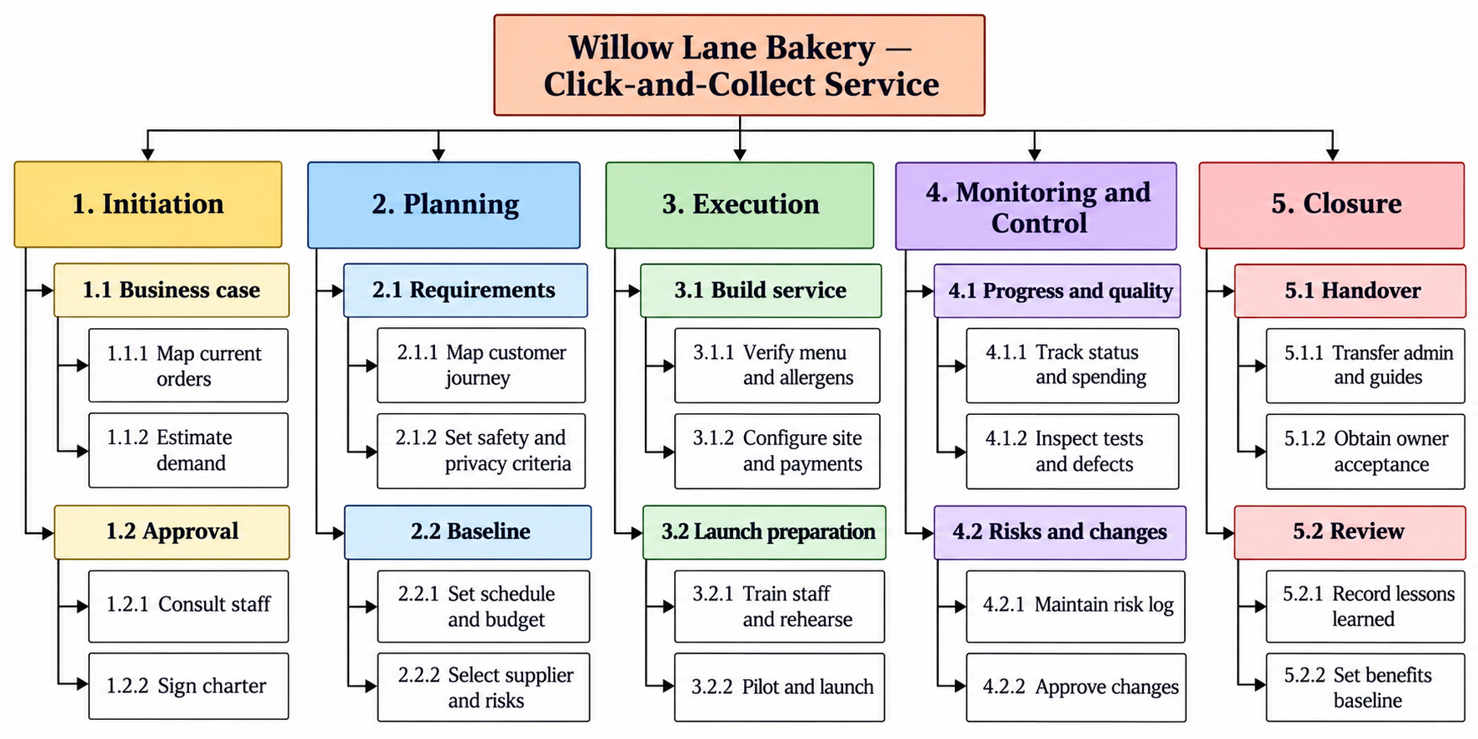
Figure 1: Hierarchical Work Breakdown Structure for Willow Lane Bakery Click-and-Collect Project
(Source: Self-Created)
The hierarchical WBS ready-made beforehand can be maintained, with the current 1.0- 5.0 numbering. Monitoring and control is presented as a work package to be accountable but will be a continuous activity between weeks 1 and 12 and not post execution. All the tasks at the lowest level will be verified against D1-D5, a milestone and a named owner. This will help avoid the phase-based WBS being detached to ownership of deliverables. The hybrid project research underlines that the proportion of traditional and adaptive practices has to be adjusted to the project-specific conditions instead of being implemented in a mechanistic way (Leong et al., 2023).

3.3 Milestones and Schedule
WBS / milestone | Main output | Duration | Owner | Dependency
1.0 / M1 | Charter and approved case | W1–2 | Project manager/owner | Start
2.0 / M2 | Specification, supplier, budget, risk baseline | W2–3 | Project manager | M1
3.1.1 / M3 | Validated menu and allergen register | W3–5 | Bakery manager | M2
3.1.2 / M4 | Configured site, checkout and notifications | W4–8 | Supplier | M2–M3
3.2.1 / M5 | Six staff trained; workflow rehearsed | W8–9 | Project manager | M4
3.2.2 / M6 | 30-order pilot and defects closed | W10–11 | Project manager/supplier | M5
5.0 / M7 | Launch, handover and owner acceptance | W12 | Owner | M6
4.0 | Monitoring, risk, quality and change control | W1–12 | Project manager | Continuous
Table 2: Baseline Schedule, Responsibility and Dependencies
(Source: Self-Created)
Critical dependency starts with the approved requirements, configuration, training, pilot and launch. Menu photography and launching communication can be done simultaneously, however, the tests of safety and payments cannot be condensed merely to recapture time. There is a one-week correction window that is maintained in the pilot stage. This intentionally puts quality ahead of schedule in which a failure may impact customers and still have an iterative level of control in the baseline (Leong et al., 2023).

3.4 Resources and Budget
Some of the personnel include the owner who is the sponsor, part-time project manager, bakery manager, six front office employees and an external supplier of a platform. Material resources consist of a tablet, label printer, test machines, good internet connection, training resources and the hosted ordering system. When there is production in the mornings, staff availability is limited and hence the workshops and tests will be done when there is less traffic. Digital transformation studies in SMEs emphasise skills, managerial ability and organisational knowledge as the key factors to the successful adoption of technologies, which justifies the use of training and support of suppliers instead of just putting the budget on software (Sagala and Őri, 2024).
Resource/activity | Cost
Platform configuration | £3,000
Tablet, printer and labels | £900
Menu content and allergen checking | £850
Staff training and backfill | £1,350
Security, payment and pilot QA | £1,100
Launch communication | £850
Project coordination | £2,350
Subscription/setup allowance | £400
Base estimate | £10,800
Contingency reserve | £1,200
Authorised ceiling | £12,000
Table 3: Provisional Resource Budget
(Source: Self-Created)
These are not quotations given by the suppliers, but are planning assumptions. In M2, the project manager will make assumptions to be substituted by verifiable quotations and document recurring subscription and transaction costs, as post-project operating expense.

3.5 Monitoring and Control
On a weekly basis, the project manager will report on a dashboard that displays the status of the milestones, planned and committed costs, defects, risks, approved changes and ownership by the next week. Planned and actual accomplishment at every milestone will also be compared on the dashboard making it easy to see that there is a slippage in the schedule even before it becomes critical. Red exception will be raised in case of failure in a critical safety test, payment test or a milestone which is not met by more than five working days or a forecast expenditure over £12,000 (Willumsen et al. 2024). The percentage of progress will not be considered as a completion; it will be necessary to have signed evidence of the tests and the pilot results. This process of review also identifies emerging contextual risks instead of controlling being seen as an administrative activity (Willumsen et al. 2024). Mobile usability, prices, allergen information, slot capacity, payments, refunds and reconciliation will be tested using quality controls. The customer data will be confined to what is needed to take the order and a clear privacy notice will be provided on how it is used, which is based on ICO guidance on small organisations (Org.uk, 2024). Strong account controls and multi-factor authentication will be used to access suppliers since Ncsc.gov.uk (2024) recognises secured accounts as a fundamental safeguard in using cloud services by small organisations.
Risk | Probability | Impact | Response/owner
Incorrect allergen information | Medium | Very high | Recipe-to-menu verification and change recheck / bakery manager
Provider outage or payment mismatch | Medium | High | Failure-path tests, manual list and reconciliation/supplier
Staff resistance at peak times | Medium | Medium | Early involvement, rehearsal and slot limits/project manager
Scope additions during build | High | Medium | Change register and sponsor approval/owner
Table 4: Risk Priorities and Responses
(Source: Self-Created)
Risk identification, assessment, treatment and monitoring will be an ongoing process in the project instead of being a onetime planning process. The reason is that certain risks might not manifest themselves until the ordering platform is set up, employees start working on the new process, or pilot customers use the service. Willumsen et al. (2024) highlight that project risks are frequently addressed using a mix of both formal and situational assessment. Thus, the weekly review of the project will not assume the formal risk register but will also include the feedback of the staff, the concerns of the suppliers, the observations of the work and the emerging issues in the course of the implementation. This strategy ought to assist the project team to address issues before they escalate to become more severe cost, schedule or service-quality failures. The clear approval process will also be a way to control change. Any change that is requested will be recorded along with the anticipated effect on cost, time, scope, benefits, quality and customer safety. The project manager may deal with minor changes, e.g. corrections in wording or minor layout changes that do not have an impact on approved scope or risk. More important changes such as adding more features or changes to the system that might result in high spending or slowing milestones will need the bakery owner to approve of them before they are implemented. In cases where a material change is accepted, the corresponding project baseline will be revised in such a way that subsequent monitoring can be accurate. The completion of the project will include the formal hand-over of the administrator access, operating procedures, supplier information and unfinished follow-up measures to the owner. Lessons learned will also be documented by the project manager and a four-week review of benefits after the launch established. This review will look at the volume of orders carried out online, fulfilment, payment methods and workload as reported by staff. This follow-up is needed since the finalization of the project outputs may not necessarily indicate that the intended operational benefits were attained.

4. References
Gov.uk, (2025). Allergen Information for Non-Prepacked Foods Best Practice. Available at: https://www.gov.uk/government/publications/allergen-information-for-non-prepacked-foods-best-practice/allergen-information-for-non-prepacked-foods-best-practice
Leong, J., Yee, K.M., Baitsegi, O., Palanisamy, L. and Ramasamy, R.K. (2023). Hybrid Project Management between Traditional Software Development Lifecycle and Agile Based Product Development for Future Sustainability. Sustainability, 15(2), 1121. Available at: https://doi.org/10.3390/su15021121
Ncsc.gov.uk, (2024). Using online services safely: Securing your users' accounts. Available at: https://www.ncsc.gov.uk/collection/using-online-services-safely/securing-your-users-accounts
Org.uk, (2024). New tool helps small businesses create privacy notices. Available at: https://ico.org.uk/about-the-ico/media-centre/news-and-blogs/2024/08/new-tool-helps-small-businesses-create-privacy-notices/
Pmi.org, (2024). The Future of Project Work: Pulse of the Profession 2024. Available at: https://www.pmi.org/learning/thought-leadership/future-of-project-work
Prakasa, Y. and Jumani, Z.A. (2024). Linking digital capability to small business performance: the mediating role of digital business transformation. Cogent Business & Management, 11(1), 2342486. Available at: https://doi.org/10.1080/23311975.2024.2342486
Sagala, G.H. and Őri, D. (2024). Toward SMEs digital transformation success: a systematic literature review. Information Systems and e-Business Management, 22, pp. 667–719. Available at: https://doi.org/10.1007/s10257-024-00682-2
Willumsen, P.L., Oehmen, J. and Selim, H.M.R. (2024). Project risk management in practice: the actuality of project risk management in organizations. International Journal of Managing Projects in Business, 17(4/5), pp. 593–617. Available at: https://doi.org/10.1108/IJMPB-09-2023-0214

