
Table of Contents
Introduction 1
Task 1. e-Commerce Website builders or software solutions 1
1.1 WooCommerce 1
1.2 Wix 1
Task 2. Mind-map of contemporary software applications 1
a. Mind mapping and explain the benefits of using mind mapping in business operations 1
b. Create a mind map of contemporary software applications 1
Task 3. Office Applications 1
a. Four office software solutions for business operations 1
MS Word 1
MS PowerPoint 1
MS Excel 1
MS Access 2
b. Practical demonstration of Two Office Features 2
Mail Merge 2
If Statement 2
Task 4. Communication and Collaboration applications 2
a. One contemporary Communication and one Online Collaboration applications/tools 2
MS Outlook 2
MS Teams 2
b. One feature of a freely available Communication (1) and one feature of a Collaboration (1) application 2
Slack 2
Google Docs 2

Introduction

APPENDIX GA36a

LEVEL 4 ASSESSMENT SPECIFICATION

Student name: |  | Student ID number:
Programme: | CertHE Computing Skills for Workplace
Module: | Software Solutions for Business
Module code: | ACCA4026 | Contribution to Overall Module Assessment (%): | 100%
Lecturer: | Fahad, Kwame, Amitave | Internal Verifier: | Sadhana Jha
Assignment Title: | Component 1- Coursework:  Portfolio | Word count (or equivalent): | 4000 Words
Submission deadline: | Monday [15-12-2025]  14:00 (2PM) | Return date of provisional marks & written feedback: | 19th January 2026
Submission method: | All written assessments, where practical and possible, must be submitted via Turnitin unless otherwise instructed by the Lecturer. (Please DO NOT put this assessment specification into Turnitin or it will match many similarities with other students’ submissions.)  Alternative submission method (if applicable):  Late submission of the assessment will result in a late penalty mark:  Work which is submitted up to 1 week late will be capped at 40% for the first attempt and will be awarded a mark of 0% for re-assessment. Late submission penalties may be lifted only if there is an approved extenuating circumstances claim.  Work submitted more than 1 week late will be considered as a non-submission and will not be marked. The work may be considered as a submission for reassessment if offered by an Examining Board or if there is an approved extenuating circumstances claim.
Academic honesty / referencing: | Academic honesty is required. In the main body of your submission you must give credit to authors on whose research and ideas your work is based. Append to your submission a reference list that indicates the books, articles, etc. that you have used, cited or quoted in order to complete this assessment.



Task 1. e-Commerce Website builders or software solutions

WooCommerce

WooCommerce Website Builders and Software Solutions
- Building a successful WooCommerce store, which runs on the powerful WordPress platform, relies heavily on user-friendly design tools and themes. These solutions allow users to customize their storefronts without needing to write code.

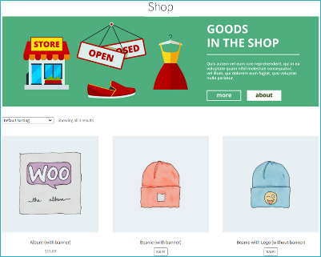
- WooCommerce, being a free and open-source plugin for WordPress, fundamentally relies on the WordPress ecosystem for its website building solutions.
- Key WooCommerce Website Solutions
- WordPress Page Builders: These are the most common tools for designing WooCommerce sites, offering drag-and-drop functionality. Popular options include:
  - Element or Pro: Highly popular for its visual design tools and dedicated WooCommerce widgets.
  - Divi: A comprehensive theme and builder combination known for its robust features and design flexibility.
  - Beaver Builder: A fast, lightweight, and easy-to-use page builder.
- WooCommerce-Specific Themes: Themes like Avada or the default Storefront are designed specifically to integrate seamlessly with WooCommerce, providing a solid foundation for your online store's layout and appearance.
- Block Editor (Gutenberg): WordPress's native block editor, coupled with WooCommerce Blocks, allows users to design product and shop pages directly within the WordPress interface using modular content blocks.
- Custom Development: For high-end, unique, or complex needs, many businesses hire WooCommerce development agencies for bespoke themes, custom plugins, and seamless integration with ERP/CRM systems.
- The choice of solution depends on your budget, technical skill, and need for customization. Page builders offer the best balance of power and ease of use for most users.
These solutions enable beginners and professionals alike to create a unique, high-performing online store on the WooCommerce platform.

References
[1] S. Trongtorsak, K. Saraubon and P. Nilsook, "Collaborative Experiential Learning Process for Enhancing Digital Entrepreneurship." Higher education studies, vol. 11, no. 1, pp.137–147, 2021.
[2] L. Nguyen, "Building e-commerce solutions with Woocommerce," 2019.
[3] R. Ravensbergen, Building E-commerce solutions with WooCommerce, Packt Publishing, 2015.
[4] V. L. Neale, et al., "An overview of the 100-car naturalistic study and findings," National Highway Traffic Safety Administration, Paper, vol. 5, pp.0400, 2005.
[5] S. A. Wood, "Creating a website," in A Therapist’s guide to private practice, Routledge, 2024, pp. 82–97.

1.2 Wix
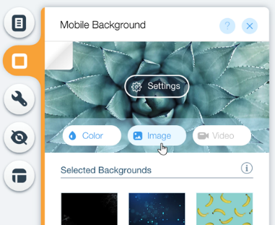

Wix Website Builders and Software Solutions

Absolutely! Wix is a market-leading website builder known for its accessibility and comprehensive feature set, making it an all-in-one solution for individuals and small to medium-sized businesses.
Key Features and Experience
- Ease of Use: Wix offers a choice between two main editors. The traditional Wix Editor is a highly flexible, drag-and-drop interface, giving you "pixel-perfect" control over design, ideal for those who want creative freedom. For faster, simpler creation, Wix ADI (Artificial Design Intelligence) generates a personalized website after asking a few questions, perfect for beginners or those short on time.
- Templates & Design: The platform boasts an enormous library of over 800 professionally designed templates across various industries. While these templates are visually stunning, a significant limitation is that you generally cannot switch templates once your site is live without starting your design from scratch.
- Scalability: The Wix App Market allows you to extend your site's functionality with hundreds of apps for everything from booking systems to forms, making it suitable for growing businesses.
- E-commerce: Wix supports online selling through its e-commerce plans (starting around the Core plan tier). It includes essential features like inventory management, payment processing, and abandoned cart recovery on higher-tier plans.
Notable Alternatives
For users whose needs might not align perfectly with Wix, popular competitors include:
- Squarespace: Best for creatives, known for its elegant, design-forward templates and excellent blogging tools.
- Shopify: The market leader for serious e-commerce, offering a more robust platform for large-scale online stores and inventory.
- WordPress: Offers the greatest flexibility and scalability via its open-source platform but has a significantly steeper learning curve.
References
[1] T. Nguyen, "Web design fundamentals: Web builder software," Australian Law Librarian, vol. 28, no. 3, pp.165–167, 2020.

Task 2. Mind-map of contemporary software applications

Mind mapping and explain the benefits of using mind mapping in business operations
Mind mapping is a powerful visual thinking tool that provides a systematic and graphic way to capture, organize, and structure ideas, concepts, and information. It is a non-linear method that mirrors the brain's natural process of associative thinking, moving away from traditional linear notetaking.
What is Mind Mapping?
A mind map begins with a central idea or topic, which is placed in the canter of a page or digital workspace. This central concept serves as the foundation from which all other related information stems.
- Central Idea: The core subject, goal, or problem is the starting point. It is often represented by an image to aid memory and creativity.
- Primary Branches: Main themes or key categories related to the central idea are drawn as thick, curvilinear branches radiating outwards. Each primary branch is labelled with a concise keyword or phrase.
- Secondary and Sub-Branches: From each primary branch, thinner sub-branches emerge, adding further detail, supporting ideas, and specific information. This hierarchical structure breaks down complex information into manageable pieces.
- Visual Elements: Mind maps utilize colours, images, and icons to group related concepts, clarify relationships, and make the information more engaging and memorable. The lines connecting the nodes represent the relationships between the ideas.
This radial and hierarchical structure allows users to see the "big picture" at a glance while simultaneously containing detailed information.

Benefits of Using Mind Mapping in Business Operations
Mind mapping offers numerous advantages that can significantly boost efficiency, innovation, and clarity across various business functions. Business users have reported an average productivity increase of around 25% by using mind mapping.
1. Enhanced Brainstorming and Ideation
Mind maps facilitate free-flowing thought generation, making them an excellent tool for individual and team brainstorming.
- Boosts Creativity: The visual, non-linear format encourages association and lateral thinking, sparking new and innovative ideas that might be missed in linear lists.
- Captures All Ideas: It allows teams to quickly add and organize thoughts during a session, ensuring all contributions are captured before being structured and refined.
2. Improved Organization and Clarity
In business, complex projects, strategies, and large volumes of data can quickly lead to information overload.
- Structures Complex Information: Mind maps break down complicated ideas or processes into a clear, hierarchical structure, simplifying them for better comprehension.
- Shows Relationships: The connecting branches visually highlight the relationships, dependencies, and connections between different tasks, concepts, or stakeholders, which is crucial for systems thinking and planning.
3. Optimized Project and Task Management
Mind maps are highly effective for planning, management, and execution of business projects.
- Project Outlining: They can be used to outline project designs, create a Work Breakdown Structure (WBS), and identify key deliverables from the initial brainstorming phase.
- Task Visibility and Tracking: Teams can use colours or icons to visualize the status of tasks (open, in progress, blocked, completed), providing a transparent, agile overview of the project's progress.
4. Better Communication and Collaboration
For cross-functional and distributed teams, mind maps serve as a clear, shared visual language.
- Clarity in Meetings: Using a mind map as a meeting agenda ensures everyone stays focused on the central goal and facilitates better notetaking by instantly capturing key decisions and action items.
- Stakeholder Alignment: By presenting plans or strategies visually, mind maps help align stakeholders by giving them a clear, accessible view of the overall objective and how all the parts connect.
5. Effective Problem-Solving and Decision-Making
Mind maps are a strategic tool for analysing issues and weighing options.
- Dissecting Problems: They allow a problem to be placed at the canter, with branches exploring root causes, potential impacts, and various solution pathways, encouraging a holistic perspective.
- Informed Decisions: By visually laying out all possible options, pros, and cons, a mind map aids critical thinking, leading to faster and more confident decision-making.
By leveraging the brain's natural affinity for visual organization and association, mind mapping helps businesses to be more productive, creative, and strategically aligned in their daily operations.
Would you like me to elaborate on a specific business use case for mind mapping, such as project planning or meeting management?

Create a mind map of contemporary software applications
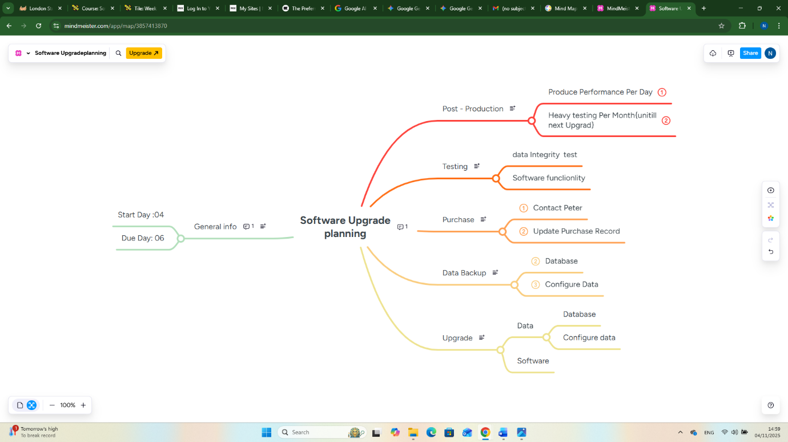

https://www.mindmeister.com/app/map/3857413870

Software upgrade planning
Software upgrade planning is a critical process to ensure stability, security, and a smooth transition to a new version.
A successful software upgrade project generally follows a phased approach, similar to a project management lifecycle, but with specific technical focus.

- purchase
In a business context, "purchase form" typically refers to documents like purchase orders (PO) or purchase requisitions
1 A. Contact Peter
To contact "Peter," more information is needed as the name is very common and refers to many different people in various contexts
1 B. Update Purchase Record
To update a purchase record, you will need to follow specific procedures within the software system where the record is stored, such as an Enterprise Resource Planning (ERP), accounting, or inventory management system.

2.Data Backup
the process of creating a secure copy of your important information or files and storing it in a separate, safe location so that it may be used to restore the original data after a loss event, such as hardware failure, human error, a cyberattack, or a natural disaster

2A.Database
A database is an organized, electronic collection of structured information, or data, that is stored in a computer system. It is designed to be easily accessed, managed, modified, updated, and organized. Databases are the backbone of most modern digital systems, powering everything from websites and mobile apps to corporate financial systems.

2B. Configure Data
Configuring data" refers to the process of defining, structuring, customizing, and managing data to ensure it is correctly organized and linked to specific parameters so it can be used efficiently by systems and applications.

3.Testing
Testing is a broad term that refers to the process of evaluating a system, component, or product to determine if it satisfies specified requirements and to identify any errors, defects, or gaps.
3A. data Integrity test
A data integrity test is the process of systematically validating the accuracy, consistency, and reliability of data across its entire lifecycle to ensure it remains uncorrupted and fit for its intended use. The goal is to detect and prevent errors, anomalies, or unauthorized modifications, which is crucial for sound business decision-making and regulatory compliance.
3B. Software functionality
the ability of a software product to perform the tasks, operations, and activities for which it was designed.
4.Upgrad
When used as a generic verb or noun (spelled "upgrade"), it refers to replacing a product, system, or software version with a newer, better, or more advanced version
4A. Data
Data refers to raw, unprocessed facts, figures, and symbols that lack context or interpretation. In the digital world, data is stored in a format that computers can process and transmit. It is the fundamental building block of information systems.
4A1.Database
A database is an organized, electronic collection of structured information, or data, that is stored in a computer system. It is designed for efficient storage, retrieval, management, and analysis of large amounts of data. Databases are essential for powering modern applications, websites, and business operations.
4A2. the process of defining, customizing, structuring, and managing how data is handled, stored, processed, and accessed within a system or application.
5 General info
basic, widely known, or fundamental knowledge about a topic or the world at large that is not specific to any particular field of specialized study or training

Task 3. Office Applications

Four office software solutions for business operations

MS Word
Word processing (letters, reports, proposals)
Word processing software is the fundamental tool used to create, edit, and format text-based documents such as letters, reports, and proposals. Applications like Microsoft Word and Google Docs offer robust features that facilitate the creation of professional and polished documents for various business and academic needs Lettes require specific formatting to be considered professional, which word processors handle easily: Structure and Templates: Users can quickly set up correct business letter formats, including date lines, recipient addresses, salutations, body text, and closing signatures.
Reports are often lengthy and data-rich, requiring advanced organization features:
Navigation and Organization: Word processors automatically generate tables of contents based on applied heading styles (Heading 1, Heading 2, etc.), making long reports easy to navigate. Data Integration: Tables, charts, and diagrams can be easily inserted and formatted. Data from spreadsheet programs can often be linked and embedded seamlessly. Citations and References: Built-in tools help manage citations, bibliographies, footnotes, and endnotes according to academic or industry standards (e.g., APA, MLA, Chicago).
Proposals
Proposals are persuasive documents aiming to secure approval or funding and must be visually compelling: Professional Branding: Templates ensure consistent branding by easily adding company logos, colour schemes, and standardized cover pages. Emphasis: Tools like bullet points, bolding, italics, and text boxes are used strategically to highlight key benefits, value propositions, and calls to action. Versioning and Collaboration: Review features, such as tracking changes and commenting, are vital for team collaboration before a proposal is finalized and sent to a client or stakeholder.
Most major office suites, including Microsoft 365 and Google Workspace, provide extensive template libraries to get started with these document types. You can find free templates for various documents directly within applications like Microsoft Word or access them via Google Docs online.
References[1] Syed Balkhi. "WPBeginner." https://simply-docs.co.uk/. Accessed: October 08 2013. [Online]. Available: https://simply-docs.co.uk/Blog/Legal-Contracts/Benefits-Of-Using-Document-Templates#:~:text=More%20Efficient%20Use%20of%20Time,lot%20of%20time%20and%20hassle.
- Formatting tools (styles, templates, tables)
Word processing formatting tools such as styles, templates, and tables are crucial for creating professional, consistent, and well-organized documents efficiently. Styles are predefined sets of formatting characteristics (e.g., font, size, colour, paragraph alignment, spacing) that can be applied to text with a single click. Consistency: Styles ensure a uniform appearance for all similar elements, such as all headings (Heading 1, Heading 2, etc.) or body text paragraphs. Efficiency: Applying a style is much faster than manually formatting each section of text. If the look needs to change, modifying the style automatically updates all text in the document using that style. Navigation & Automation: Using heading styles allows the word processor to automatically generate a table of contents and enables navigation panes for quickly moving through long documents. Accessibility: Styles create a structural hierarchy that makes documents more accessible for users with disabilities who rely on screen readers. Templates are pre-formatted document models with a predefined structure, layout, and styles, serving as a starting point for new documents. Timesaving: Instead of starting from scratch, users can select a template for a specific document type (e.g., a business letter, report, or resume) and fill in the relevant content. Branding & Professionalism: Templates help ensure all organizational documents maintain a consistent, professional appearance and adhere to company branding guidelines.
[1] Syed Balkhi. "WPBeginner." https://simply-docs.co.uk/. Accessed: October 08 2013. [Online]. Available: https://simply-docs.co.uk/Blog/Legal-Contracts/Benefits-Of-Using-Document-Templates#:~:text=More%20Efficient%20Use%20of%20Time,lot%20of%20time%20and%20hassle.

- Limited for data analysis
While word processors excel at managing and presenting text, they have significant limitations when it comes to complex data analysis. They are fundamentally designed for document creation and layout, not computational processing. The limitations can be summarized in the following ways: Lack of Analytical Functionality Word processors do not possess the core functions necessary for deep data analysis Complex Formulas: They lack the vast library of mathematical, statistical, and logical functions found in spreadsheet software like Microsoft Excel or Google Sheets. Basic arithmetic can sometimes be done in tables, but this is cumbersome and limited. Data Manipulation: Tasks such as data sorting, filtering large datasets, aggregating data, performing pivot table analysis, or running statistical regressions are not possible in a word processor. Modelling and Simulation: They cannot handle financial modelling, 'what-if' analysis, or predictive modelling. Inefficient Data Handling Word processors struggle with large volumes of numerical data: Structure: Data is unstructured or semi-structured within a document's body or limited tables, making it difficult to systematically query or transform the information. Visual Representation: While you can insert a basic chart or graph generated externally, word processors offer very limited tools for creating and manipulating dynamic data visualizations internally. Collaboration and Source Issues Data Integrity: There are no robust mechanisms to ensure data integrity during entry or to track data lineage (where the data came from or how it was transformed). Real-time Updates: Data embedded in a report often becomes static. If the source data changes, the information in the word document must be manually updated, leading to potential errors. The Right Tools for the Job For effective data analysis, users should migrate their data to purpose-built software: Spreadsheet Applications: Programs like Microsoft Excel and Google Sheets are the standard for handling structured data, calculations, and analysis. They offer powerful charting, filtering, and formula capabilities.
Business Intelligence (BI) Tools: Tools such as Tableau or Microsoft Power BI are used for advanced visualization, dashboard creation, and analysing massive datasets. A typical workflow involves performing the analysis and calculation in a spreadsheet or BI tool, and then exporting or linking the resulting insights, charts, and key figures into the word processor document for final reporting and presentation.

Formatting can shift on different devices

A key limitation of word processing software is that document formatting is not always consistent across different devices, operating systems, or even different software versions. This means a document that looks perfect on one computer might have shifted page breaks, different margins, or altered fonts when opened elsewhere. Primary Causes of Formatting Shifts Missing Fonts: The most common reason for formatting changes is when the recipient's device does not have the original fonts installed. The software substitutes an available font, which may have slightly different character widths and spacing (font metrics), causing text to reflow, potentially leading to extra pages, shifting paragraphs, or misaligned elements. Printer Drivers: Word processors use the characteristics of the currently selected printer driver to determine the page layout and display. Differences in "unprintable zones" (margins the printer physically cannot reach) or resolution settings between different printer models can cause page breaks and general layout to shift significantly. Software Version and Type: Different versions of Word or different word processing applications (e.g., Word vs. Google Docs or LibreOffice) may interpret the document's underlying code and formatting instructions differently. The online versions of applications often have fewer features than their desktop counterparts, further exacerbating this issue. Operating Systems (Mac vs. PC): There can be inherent differences in how Mac and Windows operating systems handle font rendering and display settings, which can lead to minor variations in layout and appearance. "Automatically Update Styles" Setting: If this setting is enabled in the document's template settings, opening the document on a different system can cause its styles to update based on the recipient's default template, overriding the original formatting. Solutions for Maintaining Formatting Convert to PDF: The most reliable way to ensure a document's layout remains identical across all devices is to save it as a PDF (Portable Document Format) file. PDFs are designed to display exactly the same everywhere, though they are not intended for further editing. Use Common Fonts: Stick to widely available, standard fonts (like Times New Roman, Arial, or Calibri) that are highly likely to be installed on all computers. Embed Fonts: Some word processors allow you to embed the font data within the document file itself, ensuring the font is available even if not installed on the viewing system. This increases the file size. Standardize Environments: In collaborative work settings, ensure all users are using the same version of the software and, ideally, the same printer drivers installed on their systems.
[1] B. Lockwood. B. Lockwood. The magazine of the melbourne PC user group. The magazine of the melbourne PC user group. 2004. .

MS Excel
Microsoft Excel is a powerful spreadsheet application used for organizing, analysing, calculating, and visualizing data using a grid system of rows and columns. Key features include:
Core Data Handling and Calculations
Formulas and Functions: Excel offers a vast library of built-in functions (e.g., SUM, AVERAGE, VLOOKUP, IF, MIN, MAX) that automate complex calculations, from basic arithmetic to advanced statistical and financial analysis .Data Organization: Data is stored efficiently in cells, rows, and columns, making it easy to input, manage, and retrieve information .AutoFill and Flash Fill: These features help speed up data entry by automatically completing data patterns or filling a series of numbers, dates, or text based on existing data. Data Validation: Users can set rules to restrict the type of data that can be entered into a cell (e.g., only numbers, specific dates, or items from a dropdown list), which helps ensure data accuracy and consistency.
Data Analysis and Visualization
Sorting and Filtering: Large datasets can be quickly sorted in ascending or descending order and filtered to display only specific information, aiding focused analysis. Pivot Tables and Pivot Charts: Powerful tools that summarize large amounts of data to help identify trends, patterns, and insights. Pivot charts are linked dynamically to pivot tables for visual representation of the summarized data. Conditional Formatting: This allows users to automatically apply formatting, such as colour scales, data bars, or icons, to cells based on their content. This highlights important data points or trends visually. Charts and Graphs: Excel supports various chart types (bar charts, pie charts, line graphs, etc.) to help visualize data effectively for presentations and reports. “What-If" Analysis: Excel allows for dynamic recalculation of formulas when data is modified, which is crucial for testing different scenarios in financial modelling and forecasting.
Advanced and Collaborative Features
Macros and VBA: The integrated Visual Basic for Applications (VBA) language allows users to record macros to automate repetitive tasks or write custom code to extend Excel's functionality. Collaboration: Multiple users can work on the same workbook simultaneously in real-time, with features like threaded comments and co-author visibility to facilitate teamwork. Data Integration: Excel can import data from external sources, such as the web or databases, allowing for comprehensive data consolidation and analysis. Security: Workbooks can be password-protected to prevent unauthorized access or modification of sensitive information.

References
[1] E. J. Billo, "Excel for chemists: a comprehensive guide," 2004,
Spreadsheet creation & data organization
Microsoft Excel is built around the primary function of creating spreadsheets and organizing data using a simple, yet robust, grid system of rows and columns. Workbook and Worksheets: An Excel file is a workbook, which can contain one or more individual worksheets (spreadsheets). This allows related data to be compartmentalized within a single file. Grid Structure: Data is entered into cells, which are the intersections of numbered rows (horizontal) and lettered columns (vertical). Each cell has a unique address (e.g., A1, B5) used for reference in formulas. Data Types: Cells can hold various types of data, including text, numbers, dates, and formulas. Starting a Spreadsheet: Users typically begin with a blank workbook or utilize a vast library of Microsoft Excel templates for specific needs like budgets or project trackers. These guides explain the core features of spreadsheet creation, including organizing data with rows and columns, and leveraging features like data validation and filtering:
What Is a Spreadsheet? Use Cases and Software - Microsoft
Rows. Rows run horizontally across the spreadsheet and are numbered sequentially. Each row contains multiple cells, and data is or...

Microsoft

Data Organization Features
Excel provides powerful tools to structure and manage data efficiently, particularly within formal "Excel Tables":
Tables: Converting a range of cells into an Excel Table provides specific features for managing related data independently of other data on the sheet. This includes automatic sorting/filtering buttons in the header row and the automatic extension of formulas to new rows. Sorting and Filtering: Users can quickly sort data in ascending or descending order (alphabetical, numerical, or by date). Filters allow users to display only the data that meets specific criteria, making it easier to analyse specific subsets of information. Data Validation: This feature helps maintain data integrity and consistency by restricting the type or range of values users can enter into a cell (e.g., only allowing whole numbers or selections from a dropdown list). Grouping/Outlining: Users can group related rows or columns together, allowing for the collapsing and expanding of detailed sections to focus on summary data, which improves readability for large datasets. Column Labels: Best practice involves using clear, consistent column labels in the first row to identify data, which Excel uses for features like filtering and creating reports. By following organizational guidelines, such as keeping data in a single rectangular format with no empty cells, users can leverage Excel's full analytical potential.
[1] P. Sestoft, Spreadsheet Implementation Technology: Basics and Extensions, The MIT Press, 2014.
Formulas, functions, charts, and pivot tables
In Microsoft Excel, formulas, functions, charts, and pivot tables work together to analyse large amounts of data, extract meaningful insights, and present that information clearly.

Formulas and Functions
Formulas are expressions that perform calculations, while functions are predefined formulas that automate specific tasks. Automation: They automate calculations, reducing manual effort and potential errors in tasks like budgeting or forecasting.
Data Analysis: Functions like SUMIFS or COUNTIFS are essential for data analysis, allowing users to sum or count values that meet specific criteria. Data Manipulation: Functions can clean data (e.g., TRIM, CONCATENATE) or perform logical comparisons (e.g., IF, AND, OR). Charts provide graphical representations of data, making trends and patterns instantly visible. Visualization: They transform raw numbers into intuitive visuals (bar charts, line graphs, pie charts) for quick interpretation. Communication: Charts are vital for presentations and reports, helping stakeholders easily understand complex information. Identifying Trends: Visualizing data helps in quickly spotting outliers, performance metrics, or seasonal trends that might be hidden in rows of numbers. Pivot tables are interactive tools that summarize, explore, and reorganize large datasets without changing the original source data. Summarization: They efficiently aggregate numerical data, such as calculating total sales by region or average expenses by category. Dynamic Flexibility: Users can easily "pivot" rows to columns (and vice versa), filter, and group data to view it from different perspectives and answer ad-hoc questions. Interactive Reporting: They are ideal for creating dynamic reports and dashboards that automatically update when the source data is refreshed.
How They Work Together
The typical workflow involves using formulas and functions to prepare the raw data, using pivot tables to summarize and analyse the data for key insights, and then using charts (often pivot charts) to visually represent those summaries for clear presentation. This combined approach allows users to transform large datasets into actionable intelligence efficiently.
References
[1] A. Jeffrey and H. H. Dai,Handbook of mathematical formulas and integrals, Elsevier, 2008.
Data analysis and visualization tools
Microsoft Excel includes a comprehensive suite of built-in tools for both data analysis and visualization. These features range from basic sorting to advanced business intelligence add-ins, enabling users to gain insights from raw data.
Data Analysis Tools
Excel provides several features for manipulating, summarizing, and analyzing data:
- Formulas and Functions: A vast library of functions (e.g., SUM, AVERAGE, VLOOKUP, INDEX/MATCH, SUMIFS, COUNTIFS) automates calculations and performs logical tests. Sorting and Filtering: Users can organize data quickly by sorting it in various orders and applying filters (including the AutoFilter feature) to focus on specific subsets of data. Pivot Tables: A powerful feature that allows users to summarize large datasets dynamically, group data by categories, and perform aggregate calculations to identify trends and patterns. What-If Analysis Tools: These include Scenarios, Goal Seek, and Data Tables, which help model different outcomes by changing input values. Analysis Tool Pak: An add-in for more advanced statistical analysis, such as correlation and regression analysis. Power Query: A business intelligence tool (available as an add-in or built-in feature in modern Excel versions) used to import, clean, transform, and reshape data from multiple sources. Power Pivot: This add-in allows users to create sophisticated data models, establish relationships between multiple tables, and use the Data Analysis Expressions (DAX) formula language for complex calculations with large datasets. Python in Excel: In newer versions of Excel, users can run Python code directly within cells, unlocking extensive libraries for advanced data analysis and machine learning.
Learn about Excel's built-in tools for data analysis and visualization, including formulas, charts, and business intelligence features.
What Is a Spreadsheet? Use Cases and Software | Microsoft Excel
Key takeaways * Spreadsheets are versatile tools for data organization, analysis, and management. * Key features include data inpu...
Microsoft

Data Visualization Tools
Excel offers numerous ways to visually represent data to make it easier to interpret:
- Charts and Graphs: Excel supports a wide range of chart types to visualize trends and comparisons:
  - Bar and Column Charts
  - Line Charts (ideal for time-series data)
  - Pie Charts (for showing proportions of a whole)
  - Scatter Plots and Bubble Charts (for showing relationships between variables)
  - Combo Charts (combining multiple chart types)
  - Waterfall, Histogram, Tree map, and Sunburst charts (available in modern Excel versions)
- Conditional Formatting: This tool applies visual formatting (like colour scales, data bars, or icons) to cells based on their value, highlighting key data points or trends directly within the spreadsheet grid.
- Sparklines: These are tiny charts placed within a single cell that graphically represent a row of data, offering at-a-glance insight into trends.
- Slicers and Timelines: Interactive filtering tools primarily used with Pivot Tables and Charts that allow users to dynamically filter data by categorical values or time periods.
- Dashboards: By combining various charts, pivot tables, slicers, and conditional formatting on a single sheet, users can create interactive dashboards for a high-level overview of key metrics.
For more advanced, interactive visualization and reporting capabilities, Microsoft also offers Power BI, which integrates seamlessly with Excel data. You can explore the full potential of these tools on the Microsoft Excel product page
[1] G. Divya Zion and B. K. Tripathy, "Comparative analysis of tools for big data visualization and challenges," in Data Visualization: Trends and Challenges Toward Multidisciplinary Perception, Springer, 2020, pp. 33–52.
Benefits:
Microsoft Excel is widely considered an excellent tool for budgeting, analysis, and forecasting due to its powerful computational features, flexible grid interface, and robust analytical tools.
Budgeting
Excel provides an ideal environment for creating and managing budgets, whether for personal finance, departmental expenses, or organizational forecasts.
Customization: Users can build budgets from scratch to perfectly match specific needs, defining categories, time periods (monthly, quarterly, annually), and input fields. Templates: Microsoft provides numerous free budget templates for immediate use, covering personal, family, and business budgeting needs. Calculations: Formulas and functions (like SUM, SUMIFS) automate the calculation of actual vs. budgeted amounts, variances, and remaining balances, eliminating manual entry errors. Tracking and Monitoring: Conditional formatting can visually highlight when budget limits are approached or exceeded, providing at-a-glance monitoring.
Analysis
Excel's strength lies in its data analysis capabilities, which allow users to interpret large datasets and derive meaningful insights.
Pivot Tables: A cornerstone of Excel analysis, pivot tables rapidly summarize data, identify trends, and reorganize data to answer various business questions without altering the source data. Filtering and Sorting: These basic yet essential tools quickly narrow down data views to focus on specifics or outliers. What-If Analysis: Tools like Goal Seek and Scenarios help model different business conditions and understand potential outcomes. Data Visualization: Charts and graphs transform analysed data into clear visual reports for quick decision-making.
Forecasting
Forecasting involves using historical data to predict future trends, and Excel has features that facilitate this process:
Trend Functions: Functions like FORECAST use linear regression to predict future values based on existing data points. Data Analysis Tool Pak: This add-in offers advanced statistical tools, including moving averages and exponential smoothing, which are classic forecasting methods. Trendlines in Charts: Users can add automatically generated trendlines to charts to visualize historical trends and project future movement. Python in Excel: The integration of Python provides access to sophisticated machine learning and statistical libraries for highly advanced predictive modelling and forecasting capabilities.
References
[1] A. Al Maruf, R. Paul, M. H. Imam and Z. Babar, "A Systematic Review of The Role Of SQL And Excel In Data-Driven Business Decision-Making For Aspiring Analysts," vol. 1, no. 01, pp.249–269, 2022,
Limitations:

While Microsoft Excel is a highly versatile and widely used tool, it has several notable limitations, particularly when used for large-scale operations, data management, and collaborative, error-sensitive projects.
Scalability and Performance Issues
- Data Volume Limits: Excel has hard limits on the number of rows (1,048,576) and columns (16,384) per worksheet. While this is sufficient for many tasks, it can lead to data truncation (as seen in the UK's COVID-19 data mishap) and performance issues when dealing with "big data". Performance Degradation: As files increase in size and complexity with numerous formulas and formatting, workbooks can become slow, lag, or crash, especially with 32-bit versions which are limited to about 2GB of virtual memory. System Resource Dependency: Excel performance is limited by the local computer's memory (RAM) and processor speed, making it difficult to scale across different hardware configurations.
Data Integrity and Error Proneness
Human Error Vulnerability: Spreadsheets rely heavily on manual data entry and formula creation, which are highly susceptible to human error. A simple mistake in a single cell can compromise an entire analysis or financial model. Lack of Error Control: Excel has no built-in debugging or robust error-tracking systems. Errors often go unnoticed until they skew final results, and identifying the source of an error in a complex spreadsheet can be time-consuming. Limited Data Validation: Unlike dedicated database software, Excel offers limited mechanisms to enforce data types or relationships between tables, allowing users to enter inconsistent or invalid data (e.g., entering a name in a date field).
Collaboration and Version Control
Collaboration Hurdles: While modern versions offer co-authoring, real-time collaboration can still lead to confusion, lag, and version conflicts. Version Control Nightmares: Managing multiple versions of a spreadsheet (e.g., emailing different copies) is a significant challenge and increases the likelihood of working with outdated or incorrect data. Security Risks: Excel files lack robust, enterprise-grade security features and encryption compared to dedicated data management systems. This makes sensitive data vulnerable to unauthorized access, breaches, and misuse.
Analytical and Automation Limitations
Limited Automation: While macros (VBA) can automate tasks, modifying them requires coding expertise and is less efficient than automation in specialized software or programming languages (like Python or R). Static Dashboards: Excel's dashboards and visualizations are generally static. Unlike modern business intelligence (BI) tools, they lack interactive "drill-down" functionality and do not update in real time from live data warehouses without manual refreshes or complex integrations. Unstructured Data Challenges: Excel is designed for structured, tabular data and struggles with analysing real-time, unstructured data formats like JSON.

References
[1] G. d. A. e Aquino, et al., "From RAG to Multi-Agent Systems: A Survey of Modern Approaches in LLM Development," 2025,

MS PowerPoint
Features:
Microsoft PowerPoint is a leading presentation software that provides a wide range of features to help users create, edit, and deliver professional slideshows.
Key Features of MS PowerPoint
- Templates and Themes: PowerPoint offers a variety of pre-designed templates and themes that provide a consistent design, including color schemes, fonts, and layouts, for an entire presentation. The Slide Master feature allows for centralized control over the design to ensure brand consistency.
- Multimedia Integration: Users can embed various multimedia elements to enhance engagement, including:
  - Images and icons
  - Audio files (narration or background music)
  - Videos from a device or online sources
- Animations and Transitions: These features add dynamic visual effects to a presentation.
  - Transitions control how one slide moves to the next (e.g., Fade, Morph).
  - Animations apply motion effects to individual objects on a slide (e.g., text, images, charts) to highlight key points or guide the audience's attention.
- Design Tools: Tools like SmartArt graphics help simplify complex text into professional-looking diagrams (e.g., organizational charts, process flows). The AI-powered Designer tool automatically suggests professional slide layouts and design ideas based on the content added.
- Presenter Tools: These tools aid in delivering a smooth presentation:
  - Presenter View allows the speaker to see their private notes, a timer, and a preview of upcoming slides on one screen, while the audience only sees the current slide.
  - Speaker Coach (an AI-driven feature) provides real-time feedback on pacing, pitch, and vocabulary during rehearsal.
  - Ink Annotations allow presenters to draw or write directly on the slides during a presentation for emphasis.
- Collaboration and Sharing: Multiple users can work on the same presentation simultaneously in real-time when saved to a cloud service like OneDrive or SharePoint. Users can leave comments, use @mentions to tag collaborators for feedback, and track changes easily.
- Accessibility Features: The Accessibility Assistant provides recommendations to improve the readability and accessibility of presentations for users with disabilities.
- Export Options: Presentations can be saved in various formats besides .pptx, including PDF, video files (MP4), and image formats, for easy distribution and consistent viewing across devices.

References
[1] L. Foulkes, Learn Microsoft Office 2019: A Comprehensive Guide to Getting Started with Word, PowerPoint, Excel, Access, and Outlook, Packt Publishing Ltd, 2020.
[2] G. d. A. e Aquino, et al., "From RAG to Multi-Agent Systems: A Survey of Modern Approaches in LLM Development," 2025,
[3] A. Al Maruf, R. Paul, M. H. Imam and Z. Babar, "A Systematic Review of The Role Of SQL And Excel In Data-Driven Business Decision-Making For Aspiring Analysts," vol. 1, no. 01, pp.249–269, 2022,
[4] G. Divya Zion and B. K. Tripathy, "Comparative analysis of tools for big data visualization and challenges," in Data Visualization: Trends and Challenges Toward Multidisciplinary Perception, Springer, 2020, pp. 33–52.
[5] A. Jeffrey and H. H. Dai,Handbook of mathematical formulas and integrals, Elsevier, 2008.
[6] P. Sestoft, Spreadsheet Implementation Technology: Basics and Extensions, The MIT Press, 2014.
[7] E. J. Billo, "Excel for chemists: a comprehensive guide," 2004,
[8] Syed Balkhi. "WPBeginner." https://simply-docs.co.uk/. Accessed: October 08 2013. [Online]. Available: https://simply-docs.co.uk/Blog/Legal-Contracts/Benefits-Of-Using-Document-Templates#:~:text=More%20Efficient%20Use%20of%20Time,lot%20of%20time%20and%20hassle.
[9] T. Nguyen, "Web design fundamentals: Web builder software," vol. 28, no. 3, pp.165–167, 2020,
[10] S. Trongtorsak, K. Saraubon and P. Nilsook, "Collaborative Experiential Learning Process for Enhancing Digital Entrepreneurship." vol. 11, no. 1, pp.137–147, 2021,
[11] L. Nguyen, "Building e-commerce solutions with Woocommerce," 2019,
[12] R. Ravensbergen, Building E-commerce solutions with WooCommerce, Packt Publishing, 2015.
[13] V. L. Neale, T. A. Dingus, S. G. Klauer, J. Sudweeks and M. Goodman, "An overview of the 100-car naturalistic study and findings," vol. 5, pp.0400, 2005,
[14] S. A. Wood, "Creating a website," in A Therapist’s guide to private practice, Routledge, 2024, pp. 82–97.

Benefits:

Microsoft PowerPoint offers numerous benefits that make it the industry standard for creating and delivering presentations across business, education, and personal contexts.
Effective Communication and Clarity
Structured Information Delivery: PowerPoint encourages presenters to break down complex information into digestible, visual slides, which helps the audience understand and retain information more effectively than plain text or purely verbal delivery. Enhanced Engagement: The use of multimedia elements—images, videos, audio, and animations—captures audience attention and makes presentations more dynamic and interesting. Visual Storytelling: It allows for a cohesive visual narrative, using a consistent design and flow to guide the audience through a story or argument, rather than just delivering a stream of facts.
Professionalism and Polish
Professional Appearance: With features like themes, the Design Ideas panel, and SmartArt, users can quickly create polished, professional-looking presentations that enhance credibility and branding. Consistency: Slide masters and templates ensure a uniform look across all slides, preventing disjointed or amateurish designs. Versatility: PowerPoint is used for a wide variety of communication needs, including sales pitches, training sessions, academic lectures, status reports, and even digital signage displays.
Efficiency and Ease of Use
User-Friendly Interface: The interface is intuitive for most users who are familiar with other Microsoft Office products, making it easy to pick up the basics of creating a slide deck. Time-Saving Templates: Starting with a template saves significant time that would otherwise be spent on initial design and layout decisions. Collaboration: Cloud-based sharing allows multiple users to work on the same file in real-time, streamlining teamwork and reducing version control issues.
Presentation Delivery Aids
Presenter View: This tool is invaluable for speakers, as it displays notes and upcoming slides privately while the audience sees the main slide, helping the presenter stay on track and maintain eye contact. Portability: Presentations can be easily shared electronically, saved to USB drives, or stored in the cloud, allowing them to be presented almost anywhere in the world. Audience Accessibility: The final presentation can be exported into universally readable formats, such as PDF or video files, ensuring content reaches the intended audience regardless of whether they have the PowerPoint software installed.
References
[1] S. H. Webb, "Using Office Mix in Online Business Communication Courses: Revisiting the Power of Microsoft PowerPoint," vol. 58, no. 1, pp.39–50, 2017,
Limitations:
While Microsoft PowerPoint is a powerful presentation tool, it has several limitations and drawbacks:
Risk of Information Overload: The ease of adding information to slides often leads to text-heavy presentations. Overcrowding slides with too much data or text can overwhelm the audience, leading to poor information retention and disengagement. Encourages Passive Audience Experience: Traditional slide-based presentations can be linear and static, turning the audience into passive observers rather than active participants in the conversation or learning process. Focus Shifts from Speaker to Slides: The audience's attention may fixate on the visual aids rather than the speaker or the core message being delivered verbally. Formatting Inconsistencies: Similar to other Office products, formatting can shift between different versions of the software or different operating systems, potentially altering the intended look during a presentation if not properly prepared (e.g., embedding fonts or saving as a PDF/video). "Death by PowerPoint" Stereotype: Poorly designed or excessively long presentations have led to the common complaint of "Death by PowerPoint," where the tool itself is blamed for boring, ineffective communication rather than the content creator's method. Learning Curve for Advanced Features: While basic slide creation is easy, advanced features like complex animations, interactive elements, and robust Slide Master manipulation require specific knowledge and practice. Potential for Design Distractions: The vast array of design options (animations, sounds, excessive graphics) can sometimes distract from the substance of the presentation rather than enhance it. Limited Data Analysis: PowerPoint is purely a presentation tool and offers no robust capabilities for data analysis, complex calculations, or data management; those tasks must be completed in software like Excel first.
References
[1] A. B. Abusharib, I. H. Nourein, M. A. Huneif, A. M. Abdelrahman and M. A. Elshaikh, "Limitations and Pitfalls of PowerPoint Presentations: Najran University Medical Students' Point of View," vol. 4, no. 3, pp.43–47, 2015,

MS Access
Microsoft Access is a relational database management system (RDBMS) that combines the Microsoft Access Database Engine (ACE) with a graphical user interface and software-development tools. It is part of the Microsoft Office suite (in professional editions or sold separately) and is used primarily by individuals and small-to-medium-sized businesses to organize, manage, and analyse data efficiently without extensive programming knowledge.
Access integrates several components into a single file (.act) to create a fully functional database application:
Tables: The foundation of the database where data is stored in a structured grid of rows and columns. Users can define field types (text, number, date/time, etc.) and establish primary and foreign keys to link data across different tables and maintain data integrity. Queries: Tools used to extract, manipulate, sort, filter, and calculate data from one or more tables based on specified criteria. Queries can be built using a visual designer or SQL statements. Forms: Customizable user interfaces for viewing, entering, and editing data in a user-friendly manner, helping to minimize data entry errors and improve efficiency. Reports: Tools for formatting and presenting data in a structured, professional, and visually appealing way (e.g., summaries, charts, mailing labels) for analysis or distribution. Reports can be based on tables or queries. Macros and Modules: Macros automate repetitive tasks using a simplified visual interface, while modules allow developers to write custom functions and automate complex processes using Visual Basic for Applications (VBA) code. Relationships: The ability to define and manage connections between tables to ensure data consistency and avoid data redundancy, which is a core concept of relational databases.

Benefits
Ease of Use: The graphical user interface and ready-to-use templates allow non-developers to quickly create functional database applications. Cost-Effective: Included in some Microsoft Office suites or available as a standalone purchase, it is generally much cheaper to implement and maintain than enterprise-level database systems like Oracle or SQL Server. Integration with Microsoft Office: Seamlessly imports and exports data from applications like Excel and Word, facilitating data sharing and consolidated reporting. Rapid Application Development (RAD): It provides a comprehensive environment for quickly prototyping and deploying small-to-medium scale applications.
Limitations
Scalability Limits: A single Access database file has a maximum size limit of 2 GB, which can lead to performance degradation or data corruption with large datasets. Limited Concurrent Users: While the technical limit is 255 users, real-world practical limits are closer to 10-80 concurrent users, making it unsuitable for large, enterprise-wide applications. Security Concerns: Access provides basic security features (passwords, user-level permissions) but lacks the robust, enterprise-grade security and auditing capabilities of larger database systems. Desktop-Based Focus: It is primarily designed for desktop applications and does not inherently support modern web-based applications without complex workarounds involving SharePoint or Azure.
References
[1] J. Eckstein and B. R. Schultz,Introductory relational database design for business, with Microsoft Access, John Wiley & Sons, 2018.

Practical demonstration of Two Office Features

Mail Merge

Mail merge is a software feature that combines a standard document template with a data source containing variable information to create multiple personalized documents, emails, envelopes, or labels efficiently. It allows for mass communication that feels individual and personalized to each recipient
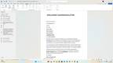 Mailings - EMPLOYMENT CONFIRMATION LETTER

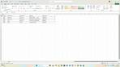 Create employer list in Excel
 Strat mail Merge next Step by Step Mail Merge

 Next Select document type
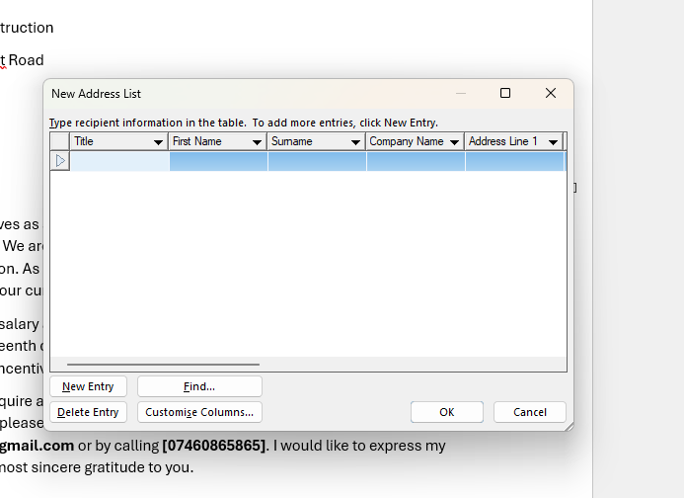 type the list of Names
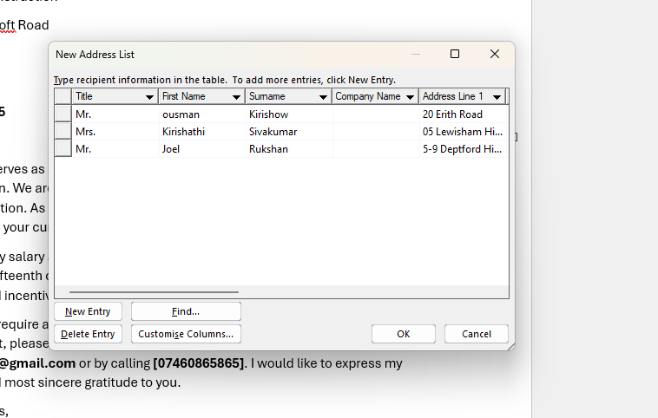 Name Information
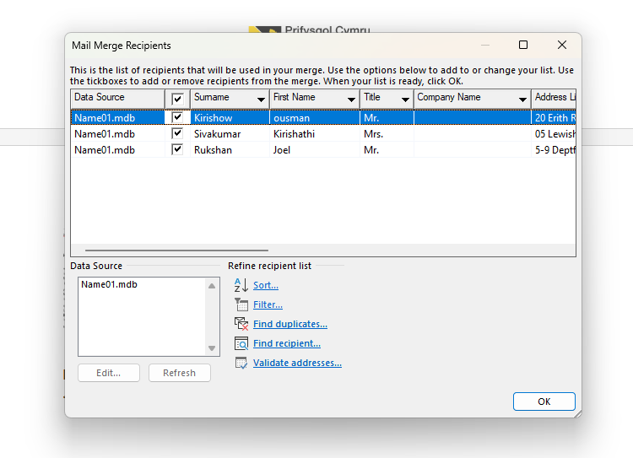 mail merge Recipients
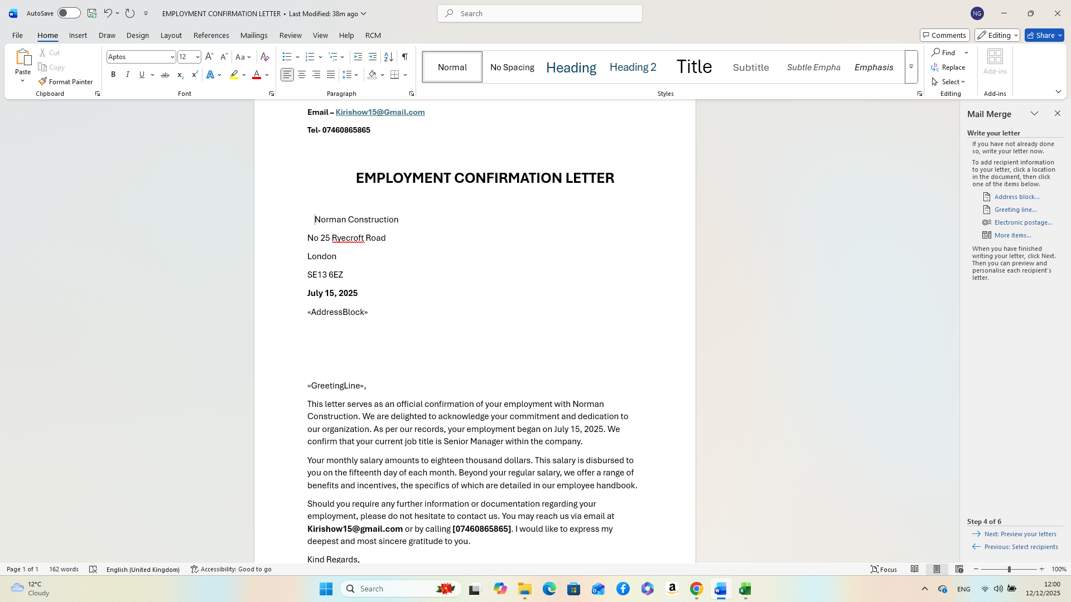 now Create «Address Block» & «Greeting Line»,
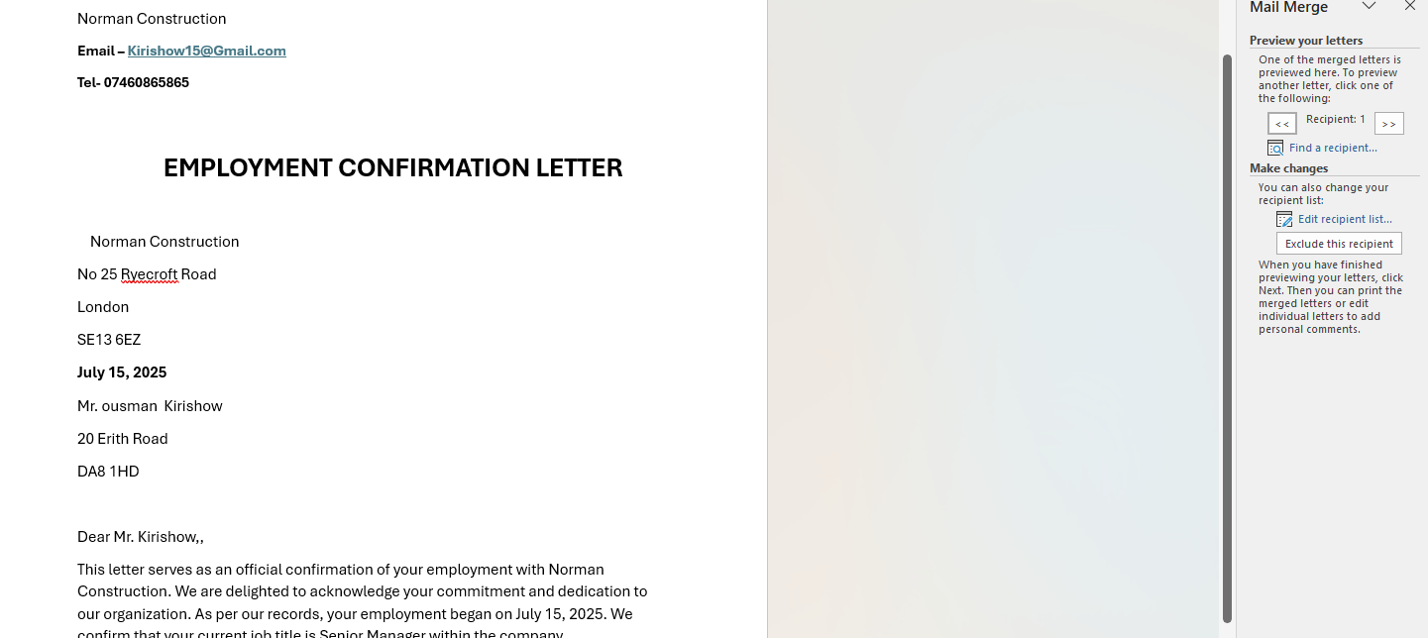 Complete merge
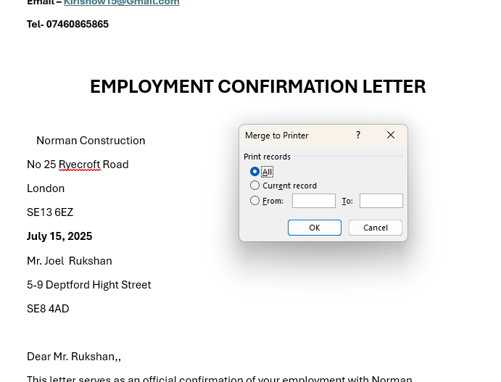 Merge to Print

Pivot table
A pivot table is a powerful data processing tool used to quickly summarize, analyze, explore, and present large amounts of data from a database or spreadsheet program like Microsoft Excel or Google Sheets.
It allows users to dynamically reorganize (or "pivot") data, aggregate information by specific categories, and present the results in a concise, structured report without altering the original source data.

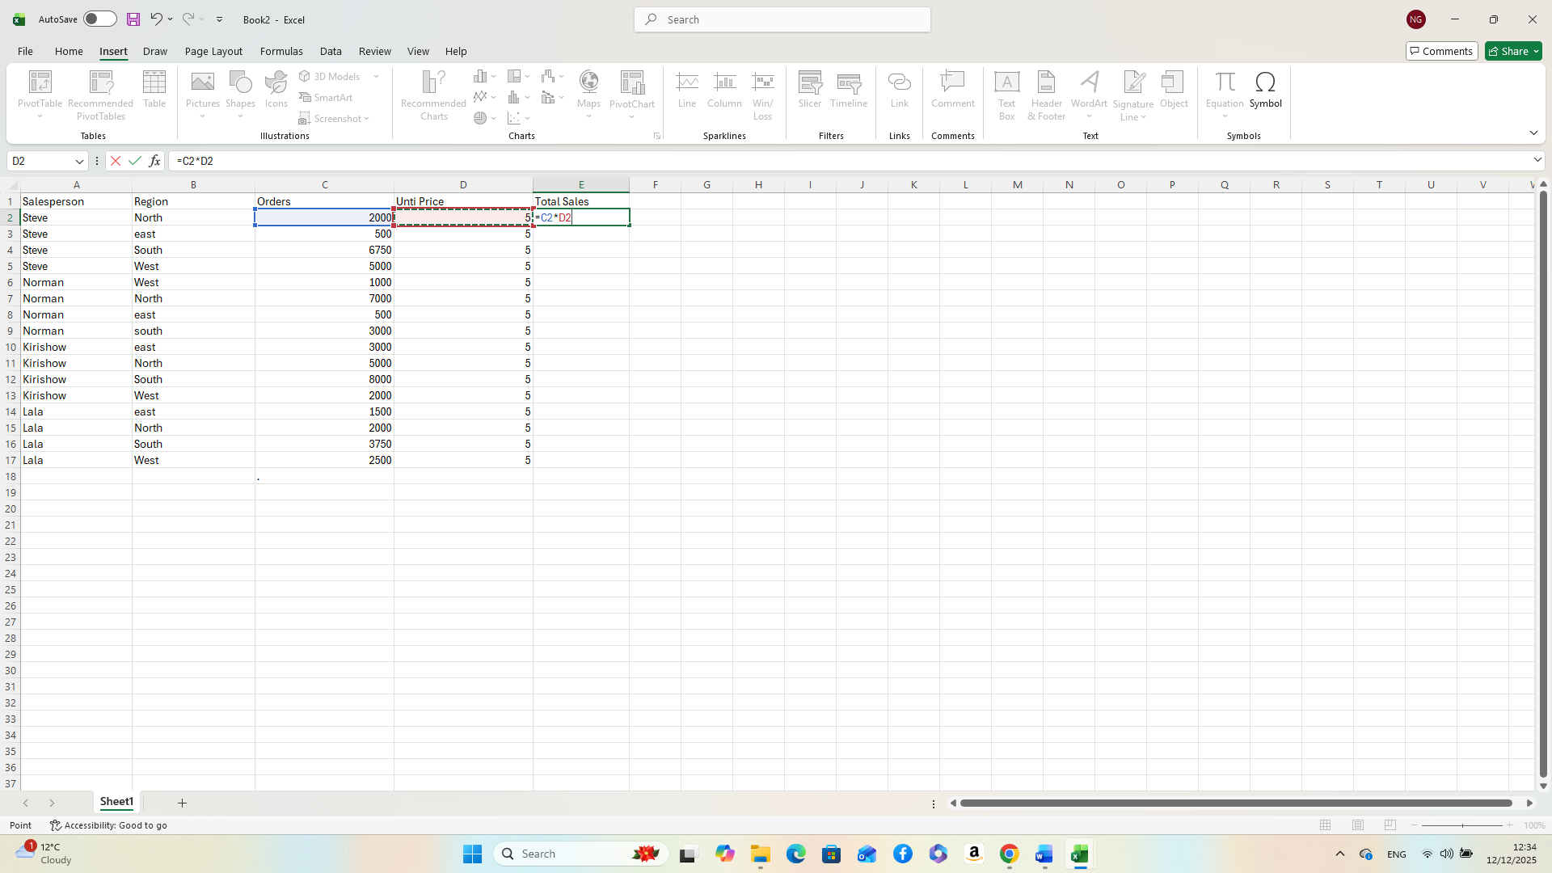 Total Sales - (=column c*Column D)
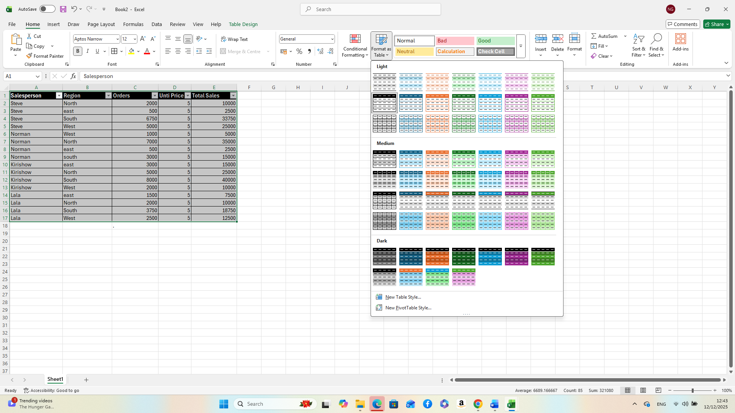 Format as table
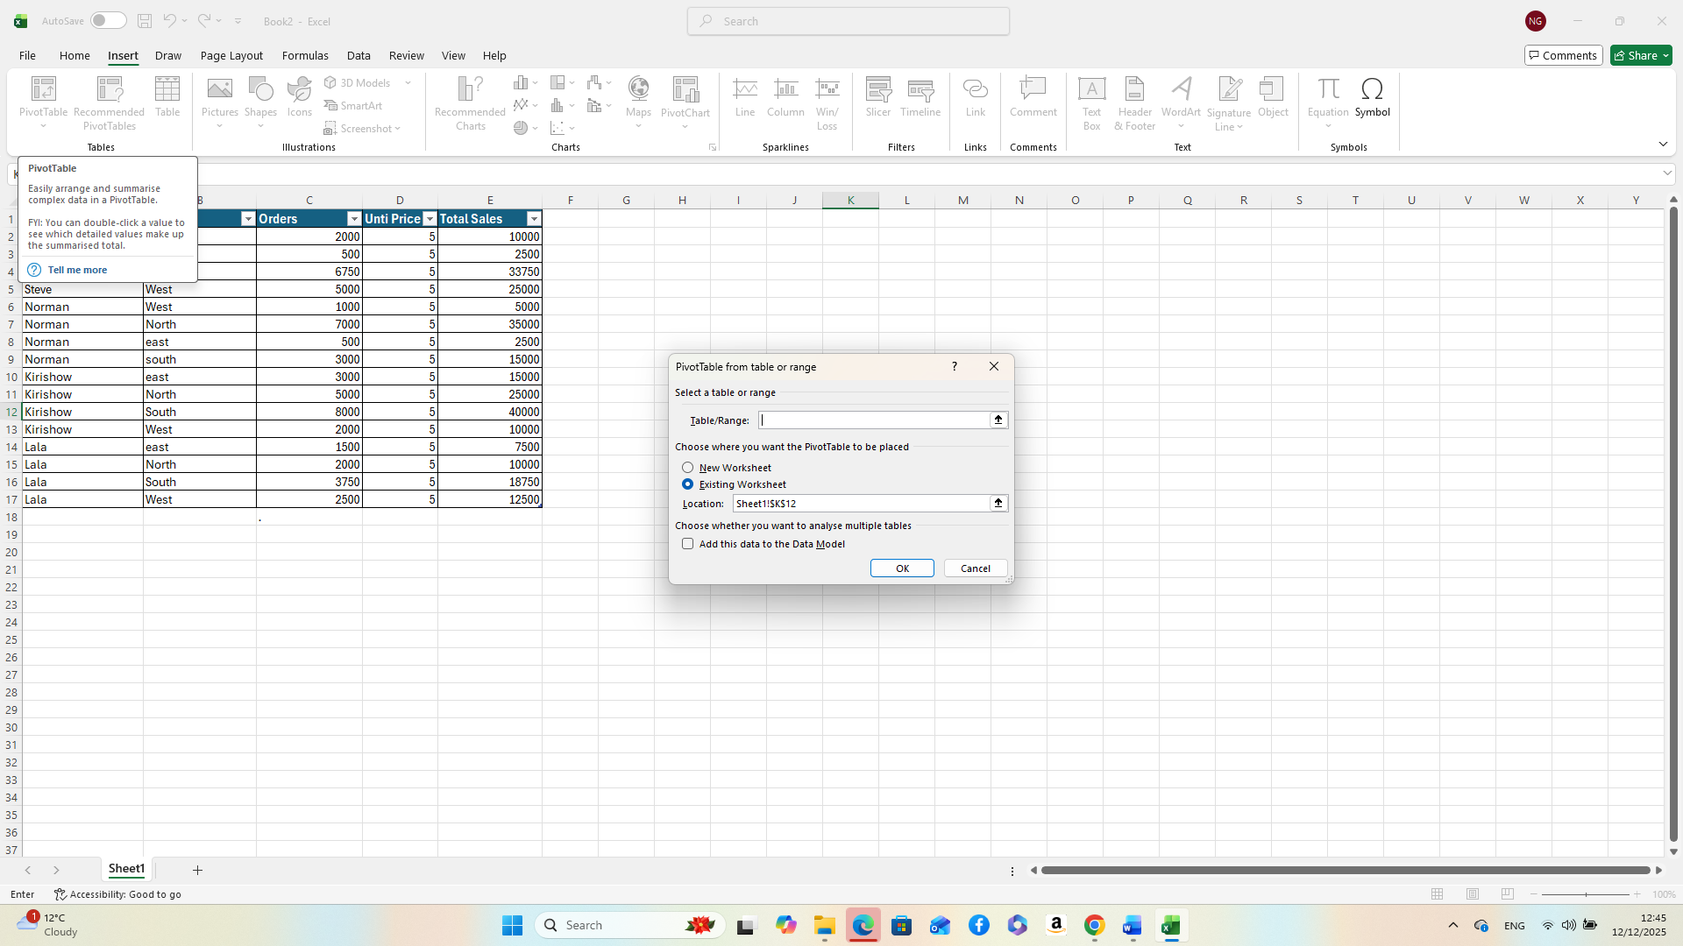 Pivot Table
we can find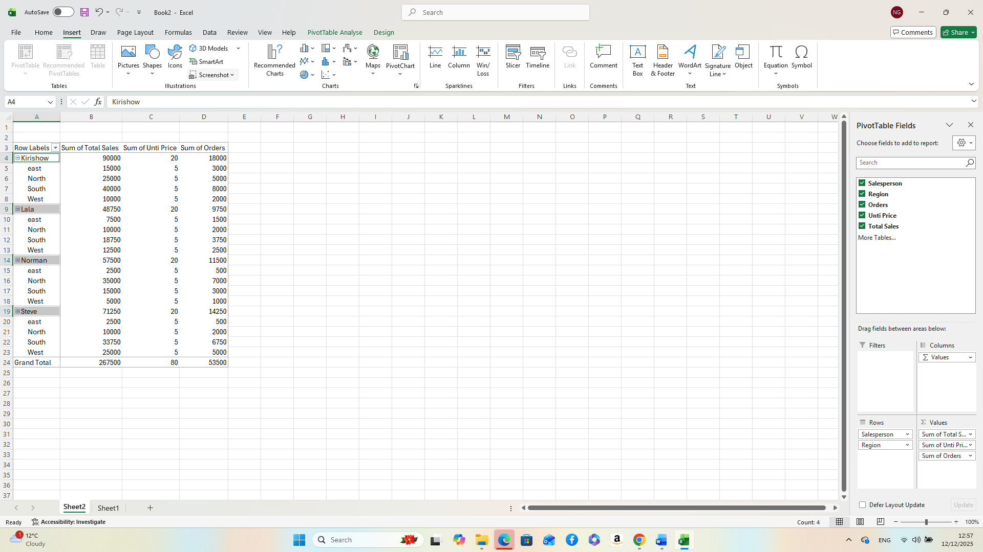 out you need detail from here – Pivot table fields

Task 4. Communication and Collaboration applications

One contemporary Communication and one Online Collaboration applications/tools

MS Outlook



Microsoft Outlook are a comprehensive personal information manager (PIM) and a leading email client developed by Microsoft, available as a key part of the Microsoft 365 software suite. It has evolved far beyond a simple inbox tool into a central hub for professional and personal organization, combining email with calendaring, task management, contact storage, and note-taking functions within a unified interface.
Primarily used in business environments and trusted by many large organizations, Outlook serves as the backbone of communication and scheduling for millions of users worldwide. It offers robust features for managing multiple email accounts (including Outlook.com, Gmail, and Exchange) from one application, allowing users to streamline their digital communication and workflow.
Core Features of Microsoft Outlook
The strength of Outlook lies in its integrated suite of organizational tools:
Email Management: Outlook provides a sophisticated email experience with features designed for efficiency. The Focused Inbox automatically prioritizes important messages, separating them from clutter. Users can apply smart filters, use rules to automate actions (e.g., categorizing and moving emails to specific folders), flag messages for follow-up, and utilize powerful search functionality to retrieve information quickly. It also includes essential security measures like anti-phishing protection, spam filtering, and data encryption. Calendar and Scheduling: The integrated calendar is a powerful tool for time management. Users can schedule appointments, create meetings with reminders, invite attendees, track RSVPs, and manage multiple calendars simultaneously. A key business feature is the ability to share calendars with colleagues, allowing teams to coordinate schedules and book conference rooms seamlessly, often integrating with Microsoft Teams for online meetings. Contact Management ("People"): The "People" hub acts as a digital address book, allowing users to store detailed contact information including names, job titles, company details, phone numbers, and addresses. Contacts can be organized into lists or groups for mass communication, ensuring all relevant details are easily accessible for professional networking. Task Management and To-Do Lists: Outlook helps users manage productivity via integration with Microsoft to Do. Users can create, assign, and track tasks, set deadlines, add subtasks, and attach files. Emails can be quickly converted into tasks or calendar appointments, ensuring nothing falls through the cracks and helping users stay on top of deadlines and priorities. Notes and Journaling: Users can also jot down quick ideas or important details using the Notes feature, providing a centralized place to capture information that might not fit into an email or calendar entry.

Platform Integration and Security
Outlook is engineered to work across various platforms (Windows, macOS, web, iOS, and Android), with data syncing seamlessly via a Microsoft account or Microsoft 365 subscription. Its deep integration with the broader Microsoft 365 ecosystem—including OneDrive, Word, Excel, PowerPoint, and Teams—enhances collaboration significantly. For example, users can share attachments directly from the cloud, ensuring everyone has access to the latest version of a document.
For business users, Outlook offers enterprise-grade security, password policies, and multi-factor authentication controls to protect confidential information and defend against cyber threats. This comprehensive approach to information management and communication makes Microsoft Outlook a robust, all-in-one productivity solution, vital for managing a complex digital life. References
[1] J. Boyce, Microsoft Outlook 2010 Inside Out, Microsoft Press, 2010.

MS Teams
Microsoft Teams is a unified communication and collaboration platform developed by Microsoft as a core component of the Microsoft 365 (formerly Office 365) suite. It is designed to function as a central digital hub for modern workplaces, bringing together chat, meetings, calling, and file sharing in a single application to streamline communication and enhance productivity, especially in hybrid and remote work environments.
Core Functionality
The main purpose of Teams is to improve collaboration by moving conversations and work processes out of fragmented email chains and into an organized, shared workspace. Its key features include Teams and Channels: The platform is structured around "Teams," which are groups of people brought together for specific projects or departments. Within each team, "channels" are created as dedicated sections to organize conversations and content around specific topics (e.g., "Marketing Project A," "General Discussion"). These channels can be standard (visible to everyone in the team) or private (for a select audience). Persistent Chat: Teams provides instant messaging capabilities for one-on-one, group, and channel conversations. Chats are persistent and threaded, allowing users to keep track of discussions over time. Features like @mentions, emojis, and GIFs help facilitate engagement and draw specific individuals' attention to messages. Video Conferencing and Meetings: Users can schedule and host high-definition audio and video meetings. Key meeting features include screen sharing, virtual backgrounds, meeting recording and transcription, live captions, breakout rooms for smaller group discussions, and the AI-powered "Intelligent Recap" for summarizing missed meetings. File Sharing and Collaboration: Teams is tightly integrated with Microsoft 365 apps like Word, Excel, and PowerPoint, as well as cloud storage solutions like OneDrive and SharePoint. Users can share and co-author documents in real-time directly within the platform, eliminating the need to constantly email file attachments. App Integration: The platform can be customized and extended with a vast marketplace of Microsoft and third-party apps and services (such as Asana, Trello, or Salesforce). This allows organizations to build a centralized, all-in-one workspace tailored to their specific needs. Teams Phone: For businesses seeking a unified communications solution, Teams can replace traditional phone systems by offering enterprise-grade voice calling features, including cloud-based VoIP, voicemail, auto attendants, and call queues.
Benefits and Platform
Microsoft Teams operates on Windows, macOS, iOS, and Android devices, ensuring users remain connected whether in the office or on the go. It emphasizes robust, enterprise-grade security and compliance standards, including data encryption and multi-factor authentication, to protect sensitive business information. By consolidating communication channels and integrating essential work tools, MS Teams boosts productivity, simplifies workflows, and fosters transparency across an organization.
References
[1] L. Martin and D. Tapp, "Teaching with Teams: An introduction to teaching an undergraduate law module using Microsoft Teams," vol. 3, no. 3, pp.58–66, 2019,

One feature of a freely available Communication (1) and one feature of a Collaboration (1) application

Slack
Part 1: Communication Application Test

1.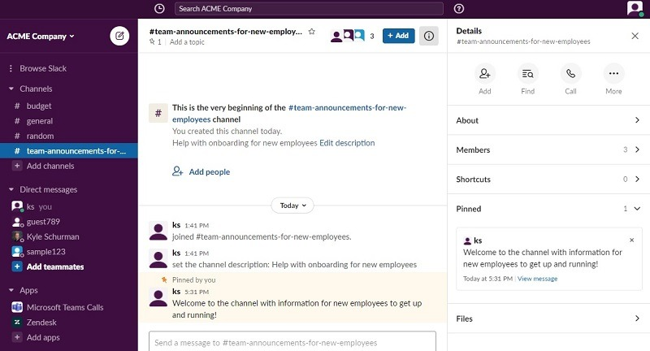
Initial Setup: A busy Slack channel (e.g., #project-status) showing several unrelated messages. A user posts an initial question that needs focused discussion

2.


Action: The user (or a second user) hovers over the initial question and clicks the 'Start a thread' icon. This shows the separate thread view opening up next to the main channel.
3.
Evidence of Use: The secondary user posts a reply within the thread (e.g., "The draft is 50% complete, due end of day."). This shows the conversation continuing in the dedicated side panel, keeping the main channel clear.
4.
Result: The main channel view is shown again, now displaying the initial question with a small indicator underneath that says "X replies" (e.g., "1 reply"). This confirms the conversation is contained and easy to follow later.

Google Docs

Part 2: Collaboration Application Test

1.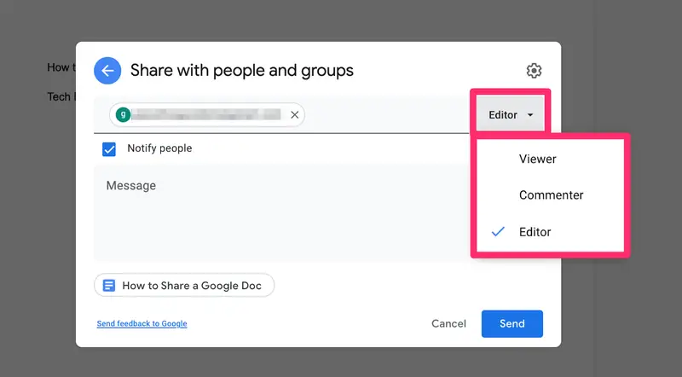
Initial Setup: The owner of the document clicks the 'Share' button and enters the email of a collaborator, setting their permission to 'Editor'. This ensures the teammate has the necessary access.
2.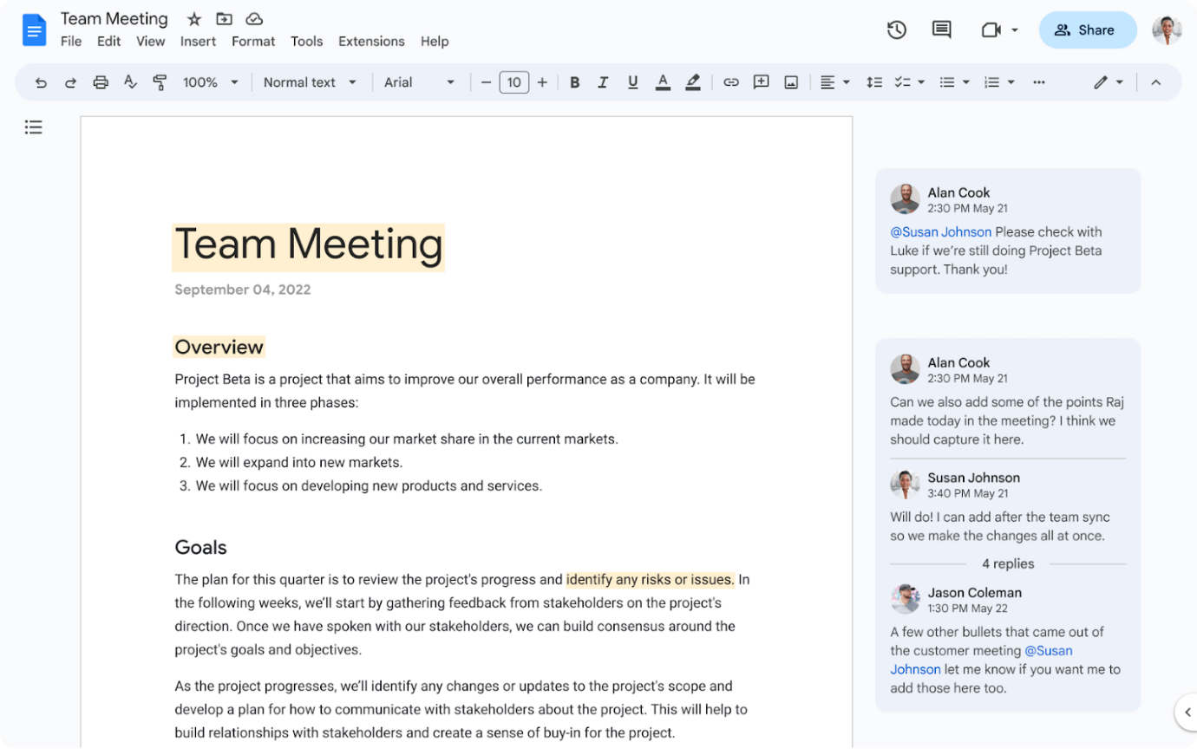
Action (Simultaneous Editing): Both users are in the document at the same time. The first user types a sentence. The second user's coloured cursor (and/or icon at the top right) is visible, demonstrating simultaneous, real-time presence and editing.

3.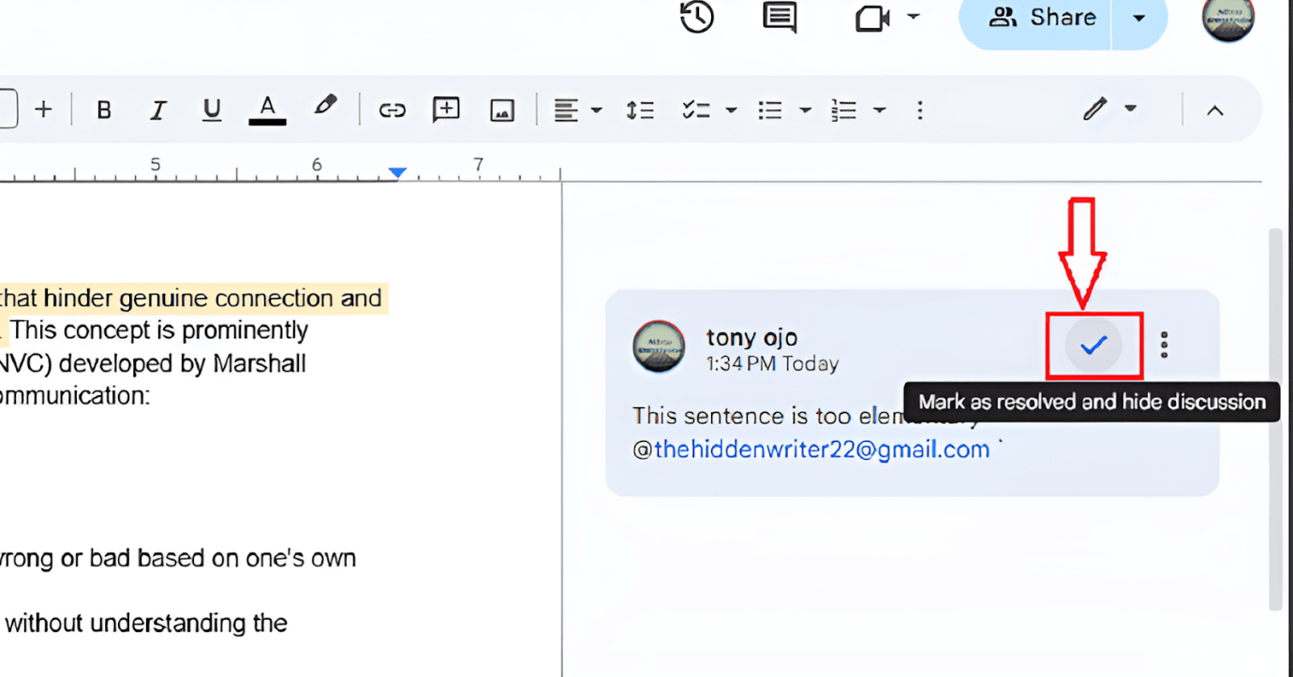
Action (Commenting): The second user highlights a specific paragraph of the first user's text and clicks the 'Add comment' icon. They type a specific note (e.g., "I suggest rewording this for a stronger opening.").

4.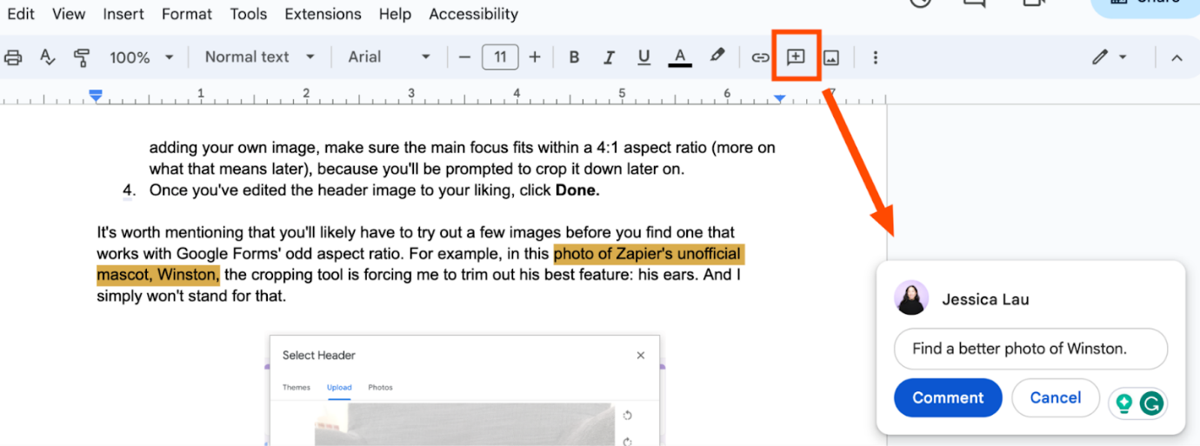
Result: The first user clicks on the new comment, makes the requested change, and then clicks 'Resolve' on the comment box. This demonstrates the closed-loop feedback process central to collaborative work.

