

University of Wales Trinity Saint David
School of Engineering
Quality Tools & Root Cause Analysis
Written by Joshua Hadden
Student Number: 2206081
Engineering Management
Date Written:
L4 – Quality & Business Improvements ACMA4004

Contents
Introduction 3
Collecting the Data 5
Root Cause Analysis 7
Improvements 10
Conclusion 11
Bibliography 12

Figures
Figure 1 – A Process Flow of the Valve Housing Manufacturing Process (For Illustration Purposes Only – Original Document Submitted by Email) 4
Figure 2 - An Area Chart Summarising Weekly Defects of Valve Housing Manufacturing (For Illustration Purposes Only) 6
Figure 3 - A Pareto Analysis of the Defects Total at the End of the Week (For Illustration Purposes Only) 7
Figure 4 - A Bar Chart Showing the Correlation of Defects to Operators (For Illustration Purposes Only) 8
Figure 5 - Ishikawa Diagram and 5 Why’s for Variables Associated with Burring on the Lathe (For Illustration Purposes Only - Original Document Submitted by Email) 8
Figure 6 - Pareto of Weighted Defect Results Multiplying Quantity with Cost Impact Score 10

Tables
Table 1 - A Key Chart for the Colour Assignments Throughout the Report 5
Table 2 - Weekly Reporting of Valve Housing Defects by Operators (For Illustration Purposes Only) 6
Table 3 - Table of Weighted Defect Results Multiplying Quantity with Cost Impact Score 10

Introduction
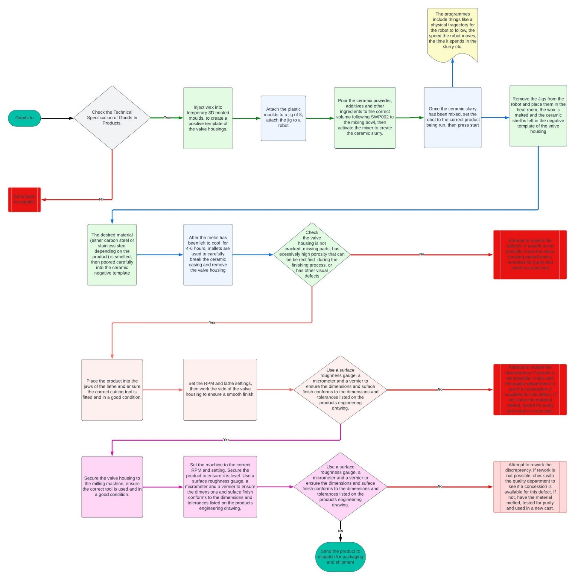
To begin understanding how things go wrong, we must first understand the ideal approach for when they go right. The best way to achieve this is to visualise a process via a process flow, such as figure A which was generated using a free online resource called ‘Lucid Charts’.
Figure 1 – A Process Flow of the Valve Housing Manufacturing Process (For Illustration Purposes Only – Original Document Submitted by Email)

  - Figure A – A Process Flow of the Valve Housing Manufacturing Process (For Illustration Purposes Only – Original Document Submitted by Email)
Figure 1 creates the ideal state of the manufacturing process, identifying the operators by colour coding the process step. A key chart can be observed in table 1 to aid with correlating the different operators with the process steps, and in graphs further down this report.
Operator
A | Shared with operator A, the casting process
B | Shared with operator B, the casting process
C | Lathe operator – surface finish and final inspection
D | Miller operator - surface finish and final inspection
Neutral | Unidentified operator / compilation of data
Table 1 - A Key Chart for the Colour Assignments Throughout the Report
Using table 1, it can be observed that operators A and B share their duties, whereas operators C and D complete similar duties using a different machine and with different tooling.
The manufacturing process for creating the valve housings involves the lost wax process, also known as ‘investment casting’. To begin the process, an exact model of the valve housing is made using wax, the wax model is then dipped into a ceramic slurry to make an exact negative template of the cast, the ceramic slurry is then left to solidify. Due to the low melting point of the wax, the cast is heated to a temperature that melts the wax, leaving the negative ceramic casting intact. The desired material of the valve housing is then poured into the negative casting in liquid form and left to solidify for around 4-6 hours. Finally, the ceramic housing is broken away leaving the final product, which is taken to a milling and turning process to create a high-quality surface finish. A detailed description of this can be found in figure 1, including quality inspections.
(PI Casting, 2017)

Collecting the Data
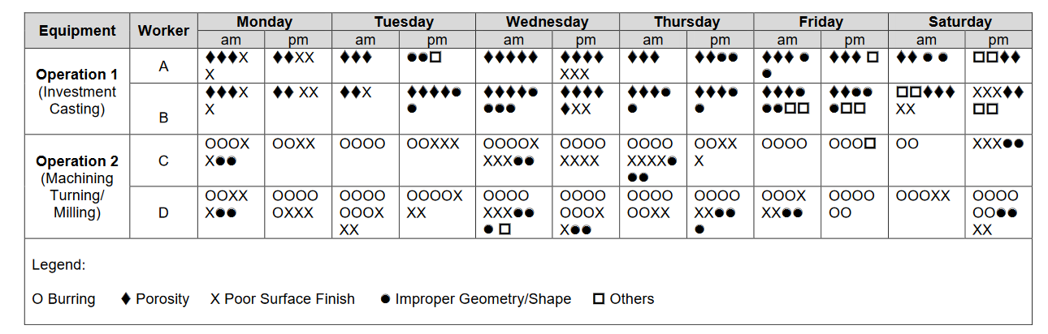
The data being analysed was generated by the operators in the form of tally, this is recorded at the finding of faults and provided at the weeks end. The data analysed in this report can be observed in table 2.
Table 2 - Weekly Reporting of Valve Housing Defects by Operators (For Illustration Purposes Only)

The above data categorises four main defects:
- Burring – Rough edges, usually created during drilling, turning and milling processes.
- High Porosity – Small gaps / holes through the surface area of a casted material, resulting in an inconsistent surface finish (Haworth Castings, 2019).
- Poor Surface Finish – A rough finish, or obvious markings / impurities on the surface of the material.
- Improper Geometry / Shape – Any inconsistencies in the final product that deviates from the engineering drawings, such as missing components from casting, or dimensions being smaller than desired etc.
- Other – Any defects that do not fit into the above categories, this includes but is not limited to; the wrong material used, flashing (the material solidifying after it has dripped to the bottom of the products) etc.

Figure 2 - An Area Chart Summarising Weekly Defects of Valve Housing Manufacturing (For Illustration Purposes Only)
Figure 2 starts by plotting the data from table 2 into a simple area chart (a line chart colour coded to show the total defects per day, and the individual defects impact.
Figure 2 indicates Wednesday produced the highest number of defects total; and burring, porosity and surface finish appear to be the worse defects on a consistent basis.

Figure 3 - A Pareto Analysis of the Defects Total at the End of the Week (For Illustration Purposes Only)
Figure 3 shows more insight into the worse defects. Burring is the most common defect contributing towards 31.36% of all defects throughout the week. Fortunately, the rework procedure for burring is not very intrusive and has almost a 100% success rate without exhausting many resources. The rework involves simply running a memory cloth across the corners of the valve housing until a blunt edge has been received.

Root Cause Analysis

Figure 4 - A Bar Chart Showing the Correlation of Defects to Operators (For Illustration Purposes Only)

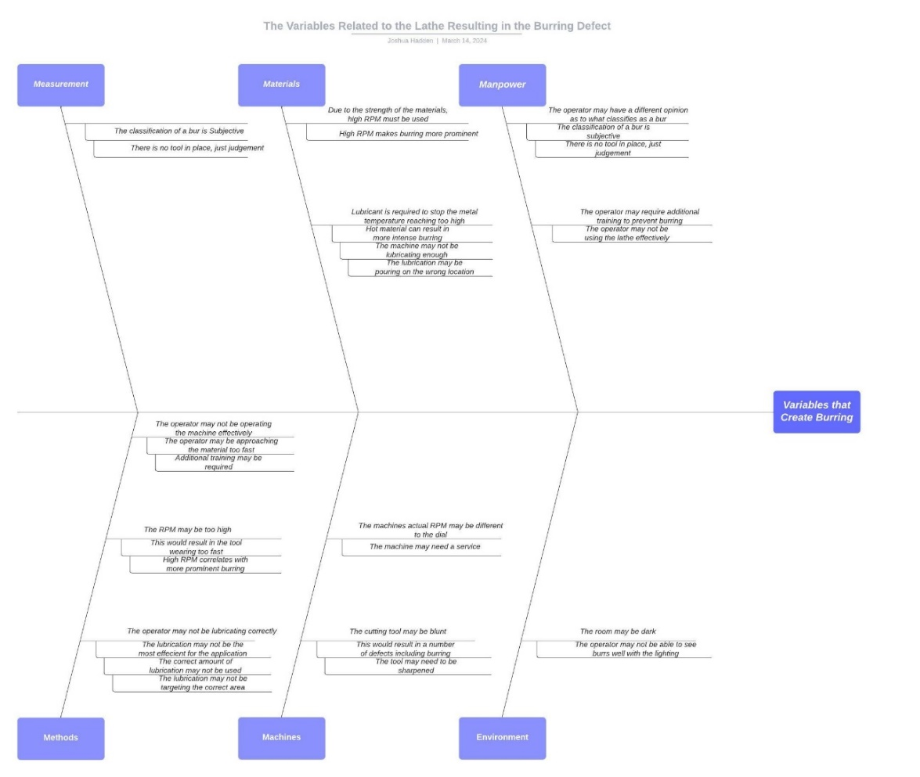
After a closer look at the data regarding the highest defect cause, only two of the operators are causing the burring. As is demonstrated on figure 1, this is due to the nature of the defect only occurring at the end of the manufacturing process, during the surface finishing. Figure 4 indicated 63.64% of the burring defects are coming from operator D.
Figure 5 - Ishikawa Diagram and 5 Why’s for Variables Associated with Burring on the Lathe (For Illustration Purposes Only - Original Document Submitted by Email)

Figure 5 shows an Ishikawa (also known as a fishbone or cause and effect diagram) demonstrating the potential impacts the turning process has on burr’s, see below for a summary of the potential root causes:
- The test is ambiguous, there is no tool to objectify what is considered a burr. Operator C may work towards a lower threshold than operator D.
- The tooling on the lathe may need to be checked, it is possible the cutting tool is blunt, or the RPM is faster than that registered on the dial.
- The operator may not be utilising the lathe in the most efficient way, poor technique could be the result of a higher yield of defects.
- The correct amount of lubrication may not be covering the material while it is being worked on.
Following the above potential root causes, an audit is required on the process to determine if the machine has been set up correctly, if the operator is following the procedures and whether any of the above theories can be observed. Depending on the above, there are several potential actions that could improve this process.
- A tool such as a radius gauge could be used to ensure the corners of the valve housings are flush, this validation would remove ambiguity from the inspection. A measurement system analysis (MSA) is a tool that could measure the variation between operator C and D, to determine if their inspection criteria is impacting the high volume of defects found by operator C.
- Preventative maintenance may need to be put in place to ensure tools are maintained correctly, and tooling is replaced at end of life.
- Training may be required for operator C to ensure they are applying good practices while operating the lathe.
- The lubrication pump may require maintenance, the lubrication material should also be checked to ensure it is capable of supporting the heat reached during the lathe process.
The second highest fault listed on the pareto in figure E is for the quality of the surface finish. Much like the burring defect, surface finish is a fault created by operators C and D during the milling and turning process; another similarity this defect shares with burring is that it can be very easily rectified.
The one disadvantage of the pareto in figure 3, is that is only accounts for the quantity of failures and not the severity. To balance this, it is possible to make a weighted pareto chart. To do this, it is first necessary to create a balanced score for each of the defects, by multiplying the quantity of the defects by the severity related to the cost of reworking. See table 3 for the calculation of these scores:

Defect | Quantity | Scrap Cost Rating | Weighted Score
Burring | 91 | 1 | 91
Poor Surface Finish | 72 | 2 | 144
Porosity | 68 | 5 | 340
Improper Geometry / Shape | 47 | 5 | 235
Other | 14 | 5 | 70
Table 3 - Table of Weighted Defect Results Multiplying Quantity with Cost Impact Score
Figure 6 - Pareto of Weighted Defect Results Multiplying Quantity with Cost Impact Score
Figure 6 demonstrates that when the cost of rework is considered, porosity has the biggest cost on rework than any of the other defects by a significant amount. Porosity is a more costly defect than burring, poor surface finish and other defects combined, using the scoring system above.
The scoring system is good to generate a quick representation of a pareto when balancing it with a different variable, however, it must be considered with caution as the data has now been subjected to a level of subjectivity. The most efficient way to generate this would be to calculate the cost of rework for each of these defects and multiply the value by the quantity, to achieve a “total scrap value” for the week; however, achieving this data was not possible in this instance.
Burring was given a score of 1 because the rework process is almost 100% effective and does not require much skill or time; is simply involves passing a memory cloth across the effected areas. Poor surface finish can be easily reworked too; but it does require re-mounting the unit to the lathe or miller and taking more material off. Rework has a slightly lower pass rate due to the possibility of removing too much material thus impacting the overall form of the product. Porosity and improper form / shape can not be reworked, they must be melted down, the purity of the material must be inspected to ensure it can be re-used, and the process starts from the beginning, this is worse case scenario. The ‘other’ category can feature a variety of defects, the worse case scenario also includes full rework.

Improvements
Based on the data above, there are several ways to potentially improve the operation. It is essential to ensure complete standardization over the machinery, the first step to this should be a detailed audit on the processes and a review over what documentation is currently in place. The machinery should have a service to ensure it is all in a good working order, and the tooling should be checked to ensure the maintenance and upkeep is being upheld.
Once this has been completed, a planned preventative maintenance (PPM) schedule should be developed and followed indefinitely. It is easy for machinery be forgotten about, but when maintenance is not upheld a message will eventually be sent via the quality of the products, and eventually, customer satisfaction. Reactive maintenance ensures this is not the case, instead the machineries underlying problems are resolved before they can impact the quality of the products (Bidwells, 2022).
One tool a lot of senior plants use is control charts. Control charts help understand the voice of the process and understand whether the variation in output is expected (common cause variation) or unique (special cause variation) (Minitab, 2023). There are four states of process variation, as listed by Dr Donald J. Wheeler; these are:
- The Ideal State – Conforming products and a predictable process
- The Threshold State – Nonconforming products and a predictable process
- The Brink of Chaos – Conforming products and an unpredictable process
- State of Chaos – Nonconforming products and unpredictable process
(Wheeler, 2009)
Using statistical process control (SPC) the processes can be analyses to determine if they are in process, and which of the above categories they fit into. This will give an indication as to whether large amounts of scrap are expected for the process (common cause variation) or if something has specially gone wrong such as a cutting tool becoming dull (special cause variation). There is only one way to improve the variation of a process that is in control, and that is to make a change to the process.
Control charts are an incredibly powerful tool for analysing different types of variation and interpreting the voice of the process, they help filter out the noise and very clearly indicate when special cause variation is present in the process (Qsutra, 2020). Control charts are a key tool in most mature manufacturing environments and remove a lot of the guess work from fault finding on problematic processes (Brown, 2020).

Conclusion
The data provided in tally form provides a rudimentary overview of the process’s quality control. The defects are recorded in tally form and only specify four different defects, categorising the rest as ‘other’. These creates blind spots in the process, some defects are process indicators of worse underlying issues, and unless they are being documented efficiently it leaves the process vulnerable.
When analysing the data, burring is the worse defect contributing towards 31.36% of all defects, followed by poor surface finish. These defects, however, require very little resources and cost to rectify and do not have a huge impact on daily operation. When the quantity of the defects is balanced with their impact on rework cost, porosity becomes the top cause for concern.
The burring defect was further analysed, and it was found most of the defects were coming from the turning process, an Ishikawa diagram was created to determine the variables of the process that could have an impact on the defects, some ideas for improvements were highlighted such as:
- Preventative maintenance
- Servicing the lathe
- Updated training for the lathe operator
- Auditing the process
It was also highlighted that the company could benefit from implementing statistical process control (SPC), a tool widely adopted by mature manufacturing operations to detect special cause variation at the earliest stages, preventing unwanted changes in a process from driving large amounts of scrap.

Bibliography

Bidwells (2022) What is PPM Maintenance?, Bidwells. Available at: https://www.bidwells.co.uk/what-we-think/what-is-ppm-maintenance/#:~:text=PPM%20stands%20for%20Planned%20preventative,property)%20on%20a%20regular%20basis. (Accessed: 16 March 2024).
Brown, P. (2020) The Benefits of SPC Solutions in Manufacturing, CompanionLink. Available at: https://www.companionlink.com/blog/2020/12/the-benefits-of-spc-solutions-in-manufacturing/ (Accessed: 16 March 2024).
Haworth Castings (2019) Casting defects and how to prevent them - part 1, Haworth Castings. Available at: https://www.haworthcastings.co.uk/news/casting-defects-and-how-to-prevent-them-part-1/ (Accessed: 16 March 2024).
Minitab (2023) Using control charts to detect common-cause variation and special-cause variation , Minitab. Available at: https://support.minitab.com/en-us/minitab/21/help-and-how-to/quality-and-process-improvement/control-charts/supporting-topics/basics/using-control-charts-to-detect-variation-in-a-process/ (Accessed: 16 March 2024).
PI Casting (2017) Investment Casting Process. YouTube. Available at: https://www.youtube.com/watch?v=TVsJlWEzZY8 (Accessed: 16 March 2024).
Qsutra (2020) Control chart, Qsutra. Available at: https://qsutra.com/explore/knowledge-base/control-chart/ (Accessed: 16 March 2024).
Wheeler, D. (2009) ‘Two Definitions of Trouble’, Quality Digest Daily [Preprint]. Available at: https://www.spcpress.com/pdf/DJW203.pdf (Accessed: 16 March 2024).

