Essay one
This essay will aim to analyse the role of independent bodies in holding the police accountable to those they serve. Police officers are expected to always succeed in their duties to keep people safe and secure (HMICFRS, 2018). For the quality of these standards to be upheld, there are independent bodies that investigate and monitor complaints to ensure that serious and sensitive incidents involving the police are dealt with correctly. It will also discuss examples of where policing standards have not been met and the implications of this on public perception and impacts of these failings. It will also contain the college of policing who works closely with HMICFRS.

The two bodies accountable for investigating complaints against the police are: the Independent Office for Police Conduct (IOPC) and the forces Professional Standards Departments (PSDs). “The Independent Office for Police Conduct (IOPC) exists to increase public confidence in the police complaints system in England and Wales” (IOPC, 2020) Additionally, Her Majesty’s Inspectorate of Constabulary and Fire & Rescue Services (HMCIFRS) independently examine efficiency and effectiveness of police forces, in the public interest (HMICFRS, 2018).

The IOPC has an executive team which is led by a director and none of the team or regional directors have ever worked for the police (IOCP, 2020). Their role is to investigate serious complaints and allegations of misconduct against the police and handles appeals (IOPC, 2020). As they work independently, it can eliminate bias and provide fairness, trust, and transparency when investigating. Furthermore, promoting improvements in the police service to ensure everyone’s safety. Many complaints about the police are dealt with by the relevant police force’s Professional Standards Departments (PSDs) however, by law specific matters must be referred to the IOPC. These can include allegations of serious assault or corruption, misconduct or if serious injury/death has occurred whilst in contact with the police (IOPC, 2020).

(IOPC,2020) states that when they receive a referral from a police force their assessment unit reviews the information they have provided.
There are three different types of investigation:
- independent – they investigate the matter using their own investigators
- directed – they direct and control the investigation using police resources
- local – the police force PSD investigates
(IOPC,2020) also states
Their investigators then gather evidence to establish all the circumstances of what’s happened. This may involve:
- taking statements
- interviewing police officers or members of police staff
- analysing footage from CCTV or cameras worn by police officers (body-worn video)
- reviewing policies that are relevant to what’s happened

(IOPC,2020) At the end of our investigation, we produce a report that sets out:
- what happened
- what and how we investigated
- what evidence our investigators found

A report is then sent back to the police force. We also decide what should happen to those involved in the incident – for instance, they may need further training, or they may face a misconduct meeting or a gross misconduct hearing.
The police force can then provide its representations about what should happen. While we will consider those views, we will make the final decision on what happens because of our investigation.
It is the police force that carries out any disciplinary action. They can hold disciplinary hearings (for gross misconduct) or meetings (for misconduct).
The possible disciplinary actions that the police force can carry out include:
- written warning
- final written warning
- reduction on rank
- dismissal without notice
However, an up-to-date article points out that the IOPC’s recommendations are not always considered, meaning that the IOPC is not always effective in fulfilling their role. (West Yorkshire Police Federation,2022) stated that “IOPC will never be trusted”. This is regarding Performance Liaison Officer Aaron Horsfall stating that West Yorkshire Police Federation is “absolutely disgusted” about comments make by the IOPC calling for greater scrutiny of Taser use. “However, seeing statements of this nature only leads me to believe that regardless of the name the IOPC will never understand, will never be truly independent and will never be trusted by my colleagues holding the front line.”

(BBC,2022) The number of complaints made against police in England and Wales has reached a record high.

There were 34,863 cases involving complaints in 2013-14, figures from the Independent Police Complaints Commission show.

The figures show a 15% increase on the previous year - and the highest since the IPCC was established in 2004.

Another organisation which seeks to hold police to account for their actions and behaviour is the College of Policing, it states in the Blackstone`s handbook (BLACKSTONE,2022 of policing that there are ten standards of behaviour and there is also the code of ethics. This is what police officers should always follow to ensure that they are adhering with. The college of policing is an independent body for holding police the police accountable for their actions. That is why police officers should always act and follow at a high standard and always following the right procedures to ensure that they are always doing the right thing.

(GOV.UK,2021), states that the police Professional Standards Departments (PSDs) have final responsibility for the value judgment on whether information relating to the misconduct of police officers should be revealed to the prosecutor. This decision must be made on a case-by-case basis and guidance may be sought from the prosecutor if required. In addition to managing and reviewing their own obligations to reveal, PSDs will provide advice to officers on their obligations to reveal. At the conclusion of misconduct proceedings, PSDs will assist in determining whether information should be revealed, for how long and the nature of proceedings in which the obligation exists…….

Her Majesty’s Inspectorate of Constabulary and Fire & Rescue Services (HMICFRS) independently assesses and reports on the effectiveness and efficiency of police forces and fire & rescue services – in the public interest.
We ask the questions that we believe the public wish to have answered, and publish our findings, conclusions, and recommendations. We use our expertise to interpret the evidence and make recommendations for improvement.
We provide authoritative information to allow the public to compare the performance of their police force and fire & rescue service against others. We also routinely monitor the performance of police forces in England and Wales.
To conclude this essay there is a wide range of independent bodies, which are effective in ensuring that police are held to account for their actions. Within the police, officers are obliged to act in accordance with organisations such as the IOPC and HMICFRS. Officers are also required to follow procedures and legislation such as PACE and the code of practice, the ten standards of professional behaviour, the code of ethics.

Essay two:

In this essay, I will be evaluating the effects of multi-culturalism on policing ethics and values. This essay will also focus on the strategies to which police officer’s police diverse their communities. Robert Longley states that in sociology, multiculturalism describes the way a given society deals with cultural diversity. Based on the underlying assumption that members of often very different cultures can coexist peacefully, multiculturalism expresses the view that society is enriched by preserving, respecting, and even encouraging cultural diversity. In the area of political philosophy, multiculturalism refers to the ways in which societies choose to formulate and implement official policies dealing with the equitable treatment of different cultures. (Robert Longley,2020).

In 1829, Sir Robert Peel established the London Metropolitan Police Force. He became known as the “Father of Modern Policing,” and his commissioners established a list of policing principles that remain as crucial and urgent today as they were two centuries ago. They contain three core ideas and nine principles. (Wikipedia,2022)

A quote from Sir Robert peel was that “The Police are the Public; the Public are the Police. The Police are paid to give full time attention to duties that are incumbent upon every citizen in the interest of community welfare and existence.” (RITE ACADAMY LLC),2015-2020)

However, on 25th May 2020 George Floyd was a 46-year-old who bought a pack of cigarettes at a convenience store in South Minneapolis on the evening of 25 May 2020.
A shop assistant believed he had used a counterfeit $20 bill and called the police after Mr Floyd refused to return the cigarettes or pay again.
Officers arrived and handcuffed him but when they tried to put him into the squad car, he resisted. A struggle ended with Mr Floyd face down on the street. Chauvin, 44, who was a police officer placed his left knee on Mr Floyd's neck and shoulder, and kept it there for more than nine minutes, according to prosecutors. Two other officers helped pin him down, while another prevented witnesses from intervening.
More than 20 times Mr Floyd said he could not breathe. The video shows him going limp and being carried away by police.
He was pronounced dead in hospital an hour later. (BBC,2022)

This caused uproar within the village and there were protests to remember Mr Floyd and take a stand against racial injustice. George Floyd's death sparked protest marches in countries around the world, including the UK. Many of the protesters marched as part of the Black Lives Matter movement - a decentralised global network that campaigns for justice, equality, and an end to racism. (BBC,2022)
Black Lives Matter was founded on 13th July 2013 they wanted to highlight racism and discrimination of how in this day in age is still as bad as it was before.

Multiculturalism can sometimes have a negative affect police code of ethics especially when police are not following the police principles with diversity being one of them. It states here Perhaps, in recognizing that there are historical differences in the treatment of those who are from minority or marginalized races and cultures and acknowledging that the disparate treatment ultimately influences people’s worldviews and perceptions of what is fair and just, one can begin to understand the lack of confidence of an equitable society. It then is reasonable to comprehend why the members of those groups are reluctant to place absolute trust in the police. The acknowledgment of these differences in treatment of various people may allow for a substantial commitment to systemic change and equitable service and justice. ( Damon J. Brown, (2020).

However, it is said that the police service is improving by policing their communities and since 2019 there has been an increase of black and ethnic minority officers who have joined the police force
As of March 2019 just 7% of UK officers, or (8,329), identified as black and minority ethnic (BAME) – and that was the highest proportion since records began. Black officers in the UK make up only 1.2% of this figure (1,492 officers) – despite black people making up 3.3% of the population.( The Conversation Trust (UK) Limited,2020).

Examine how do police officers’ diverse communities

It’s the right thing to do - Valuing people as individuals is purely the right thing to do. Everyone deserves to be treated fairly and respectfully and that means that no one should suffer any disadvantage, discrimination, or harassment because of who they are. Due to policies and legislation as a police officer you should credit in the benefits of inclusion and diversity.
Building community relationships, trust, and confidence - People expect police and those in public services to behave and act in the way the standards request those in the police and public services (policing principles and PS principles). When this is done and successfully done the perception and satisfaction of policing improves as the public are more trustworthy of the police. Effective policing is dependent on cooperative and engagement with the public and that can only be done by building relations with all communities. Getting this right will build on the trust, openness & confidence that will form so that an effective and legitimate service can be delivered.
Needs to be done through engagement, listening and partnership work so services can meet communities needs and sometimes expectations thus, empowering communities.
Enhanced workforce with different experiences - staff need to feel included in working environments. They are happier, produce more productive & effective than an environment that is harmful and intimidating. Inclusion also can bring learning of each other’s differences, looking after each other and eliminate assumptions or stereotypes.
Experiences having a diverse workforce can bring different experiences & knowledge. Seeing the world through different eyes & knowledge which can only improve services for individuals and communities.
Attracting people from different backgrounds and with different personal circumstances brings a wider range of experiences and perspectives which enables a better performance.

Essay three:

In this essay I will be talking about the impact of early intervention and partnership approaches in reducing re-offending in relation to gang-related activity. I will be talking about the early preventions that are in place to try and prevent the communities to not get involved within the gang related activities.

A group of criminals or of people, esp. young men, and women, who spend time together and cause trouble.
a group of people who are friendly with each other or are involved in the same activity (Cambridge University Press,2022)

What Is the Role of Police in Preventing Gang Membership?

To help prevent kids from joining gangs, law enforcement must move beyond the traditional role as “crime fighter” to become a strong partner in prevention strategies. Because of their knowledge of and presence in the community, law enforcement officers are well-situated to identify those youth at risk of joining gangs at an early age and to play a vital role in efforts to prevent gang-joining, including service referrals.

The Scanning, Analysis, Response and Assessment (SARA) problem-solving model frequently used in law enforcement shares complementary data-driven components with the public health prevention model and can help build initiatives and partnerships to prevent youth from joining gangs.

Law enforcement officers can build trust in communities by playing an active, visible role in front-end gang-prevention activities. Collaborations with other groups — such as schools, public health, community, and other public and private partners — to prevent gang-joining increases police legitimacy and credibility, particularly in at-risk communities and among at-risk youth. (“What Is the Role of Police in Preventing Gang Membership?",2013)

Although the police already engage in a considerable number of prevention activities,
their role in gang-membership prevention
should be enhanced. These measures include
targeting at-risk youth with the appropriate
response, avoiding suppression-only tactics, and
understanding the following:
• Gang-joining is part of the gang problem.
• How the SARA and public health prevention
models complement each other.
• The role of police in assessing nature
and magnitude of an actual or potential gang
problem.
• The role of police in identifying at-risk youth.
• The role of police in partnerships.
To understand the roles that police can play
in gang-membership prevention, it is useful to
consider the Gang Response and Involvement
Pyramid below

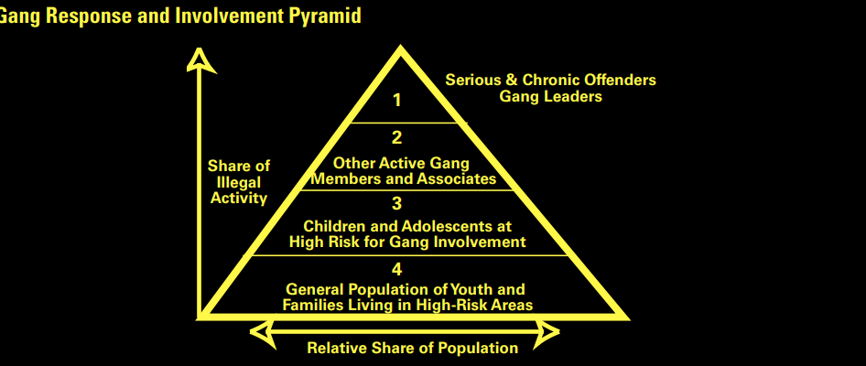

The SARA Model
In law enforcement, the primary problem-solving
model is called SARA: Scanning, Analysis, Response and Assessment. SARA grew out of
problem-oriented policing, which focuses on
preventing crime and, in fact, has been used in
response to gang activity.2
The four steps of
SARA are:
1. Scanning the environment to identify the
problem.
2. Analysing the problem, using multiple sources
of information.
3. Developing a response consistent with the
information gathered.
4. Assessing the effectiveness of the response

The following people are the who may be more likely to join a gang are the following

• Poor parental supervision.
• Early childhood aggression.
• Believing that it is acceptable to engage in
delinquency.
• Significant negative life events, such as
death of a parent.
• Peers who are gang member

What is County Lines?
County Lines is the police term for urban gangs exploiting young people into moving drugs from a hub, normally a large city, into other markets - suburban areas and market and coastal towns - using dedicated mobile phone lines or “deal lines”. Children as young as 12 years old have been exploited into carrying drugs for gangs. This can involve children being trafficked away from their home area, staying in accommodation, and selling and manufacturing drugs. This can include:
Airbnb and short term private rental properties
budget hotels
the home of a drug user, or other vulnerable person, that is taken over by a criminal gang- this may be referred to as cuckooing. (Adapted in the Children Commissioner’s Report, February 2019)

How County Lines work
County Lines operations have evolved and become more sophisticated over time in response to local policing and safeguarding practices.
This has significantly increased the risk of recruitment and exploitation for growing numbers of looked after children who are placed away from their home area or in unregistered, unregulated settings.
Perpetrators may:
- target children and young people of any background, gender or ethnicity, in a range of settings
- use social media to make initial contact with children
- control and coerce through drug debts, grooming and coercion
County Lines involve multiple activities, as shown in Figure 2.
Figure 2: Flowchart showing how County Lines operations work
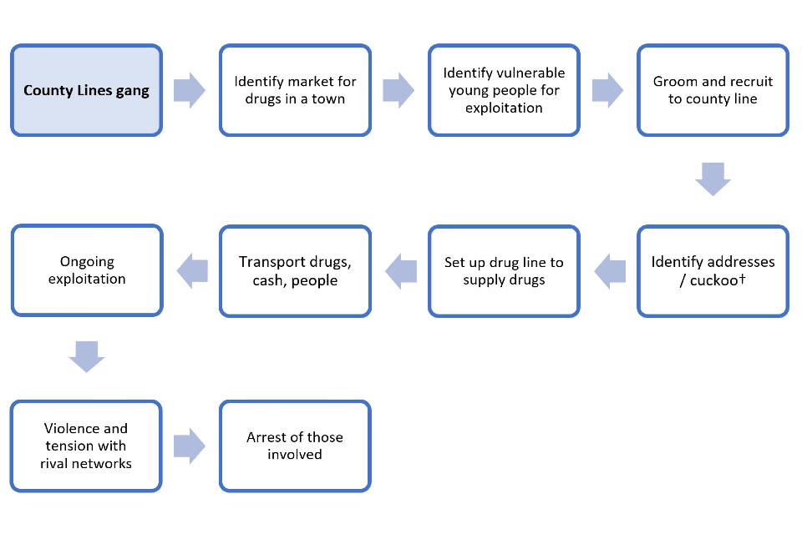
- identify the market for drugs in a town
- identify vulnerable young people for exploitation
- groom and recruit to a county line
- identify addresses/cuckoo†
- set up drug line to supply drugs
- transport drugs, cash, people
- ongoing exploitation
- violence and tension with rival networks
- arrest of those involved
† Cuckoo refers to a drug dealer taking over the home of vulnerable person to use as base to sell or manufacture drugs. (GOV.UK, FEBRUARY,2021)

What do police officers do to prevent county lines and what works regarding preventing it?

NRM
The process by which an individual is identified as a victim of modern
slavery or trafficking and ensuring they receive the appropriate support.

Safeguarding
A wider term than child protection, it involves promoting a child or
young person’s health and development and ensuring that their overall
welfare needs are met.

Youth Offending Service (YOS) /
Youth Offending Team (YOT)
Youth Offending Team is the term used in the Crime and Disorder Act
1998 to describe a multi-agency team that is required to coordinate the
provision of youth justice services in their area. YOSs are known locally
by many titles, such as youth justice service (YJS), youth offending
service (YOS), and other generic titles that may illustrate their wider
role in the local area in delivering services for children. (Ministry of Justice, October 2019)

In conclusion the early intervention programmes that are being used to try and prevent youths from getting involved in these activities are helping and preventing then getting involved, however some youths will go ahead and get involved due to up bringing of children and their parents already being involved and that is the only life that they will know. All the police service and other partner agencies can do is try their best and hopefully listen and not get involved and get themselves caught up in it all.

Essay four:

This essay I will be analysing protentional links between serious and organised crime and public protection issues and I will be evaluating the effect of current public protection practices investigating incidents. I will also be talking about why there a certain people that are targeted to join them in serious and organised crime.

Serious and organised crime is made up from gangs that try to encourage others to join. Here are some examples of serious and organised crime which include county lines, kidnapping, child sexual exploitation, illegal drugs, illegal firearms, fraud, money laundering, bribery and corruption, organised immigration crime, modern slavery and human trafficking, cybercrime.

Despite significant progress, the scale of the challenge we face is stark and we have therefore revised our approach. Our aim is to protect our citizens and our prosperity by leaving no safe space for serious and organised criminals to operate against us within the UK and overseas, online, and offline. This strategy sets out how we will mobilise the full force of the state, aligning our collective efforts to target and disrupt serious and organised criminals. We will equip the whole of government, the private sector, communities, and individual citizens to play their part in a single collective endeavour to rid our society of the harms of serious and organised crime, whether they be child sexual exploitation and abuse, the harm caused by drugs and firearms, or the day-to-day corrosive effects on communities across the country. We will pursue offenders through prosecution and disruption, bringing all our collective powers and tools to bear. We will: prevent people from engaging in serious and organised crime; protect victims, organisations, and systems from its harms; and prepare for when it occurs, mitigating the impact. We will strengthen our global reach to confront the threat before it comes to our shores. This strategy provides a framework and outlines a set of capabilities which are designed to respond to the full range of serious and organised crime threats. We have four overarching objectives to achieve our aim.

1. Relentless disruption and targeted action against the highest harm serious and organised criminals and networks We will target our capabilities on criminals exploiting vulnerable people, including the most determined and prolific child sex offenders and we will proactively target, pursue, and dismantle the highest harm networks affecting the UK. We will use new and improved powers and capabilities to identify, freeze, seize or otherwise deny criminals access to their finances, assets, and infrastructure, at home and overseas including Unexplained Wealth Orders and Serious Crime Prevention Orders. At the heart of this approach will be new data, intelligence and assessment capabilities which will allow the government, the NCA, to penetrate and better understand serious and organised criminals and their vulnerabilities more effectively and target our disruptions to greater effect.
2. Building the highest levels of defence and resilience in vulnerable people, communities, businesses, and systems We will remove vulnerabilities in our systems and organisations, giving criminals fewer opportunities to target and exploit. We will ensure our citizens better recognise the techniques of criminals and take steps to protect themselves. This includes working to build strong communities that are better prepared for and more resilient to the threat, and less tolerant of illegal activity. We will also identify
those who are harmed faster and support them to a consistently high standard.

3. Stopping the problem at source, identifying, and supporting those at risk of
engaging in criminality
We will develop and use preventative methods and education to divert more young
people from a life of serious and organised crime and reduce reoffending. We
will use the government’s full reach overseas to tackle the drivers of serious and
organised crime.
4. Establishing a single, whole-system approach
At the local, regional, national, and international levels, we will align our collective
efforts to respond as a single system. We will improve governance, tasking
and coordination to ensure our response brings all our levers and tools to bear
effectively against the highest harm criminals and networks. We will expand us
global reach and influence, increasing our overseas network of experts to ensure
the UK’s political, security, law enforcement, diplomatic, development, defence
relationships and financial levers are used in a more coordinated and intensive
manner. And we will work to integrate with the private sector, pooling our skills,
expertise and collective resources, co-designing new joint capabilities, and
designing out vulnerabilities together.
5. As a result, we will be able to measure and demonstrate that:
a) We have significantly raised the risk of operating for the highest harm criminals and
networks within the UK and overseas, online, and offline, by ensuring:
• new data and intelligence capabilities have targeted and disrupted serious
and organised criminals and networks in new ways.
• a range of partnerships and working practices are embedded in the UK that
enable us to sharpen and accelerate our response.
• overseas partners are working with us more often, more collaboratively and
more effectively to target serious and organised crime affecting the UK; and
• we are arresting and prosecuting the key serious and organised criminals,
stopping their abuse, denying, and recovering from them their money and
assets, dismantling their networks and breaking their business model.
b) Communities, individuals, and organisations are reporting they are better protected
and better able to protect themselves; and victims are better supported to recover
from their abuse or exploitation.
c) Fewer young people are engaging in criminal activity or reoffending.

We will maintain the Pursue, Prepare, Protect and Prevent delivery framework,
sometimes known as ‘4Ps’, as it provides a coherent approach for all partners involved in
countering serious and organised crime, from preventing crime in the first place to convicting
perpetrators and helping victims. The four strands, shown alongside our aim and objectives, are:
• To Pursue offenders through prosecution and disruption
• To Prepare for when serious and organised crime occurs and mitigate impact
• To Protect individuals, organisations, and systems from the effects of serious and
organised crime
• To Prevent people from engaging in serious and organised crime (Serious and Organised Crime Strategy, November 2018)

Costs of serious and organised crimes

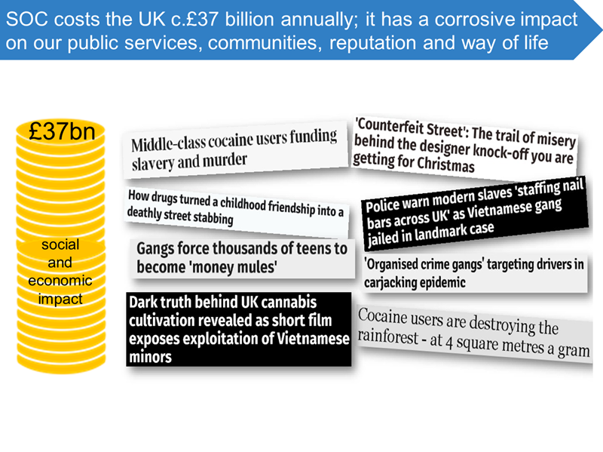

Who are the types of people who are most likely to get involved?

Gangs are known to target vulnerable children and adults; some factors that heighten a person’s vulnerability include:

having prior experience of neglect, physical and/or sexual abuse
lack of a safe/stable home environment, now or in the past (domestic violence or parental substance misuse, mental health issues or criminality
economic vulnerability
homelessness or insecure accommodation status
connections with other people involved in gangs
having a physical or learning disability

References

BBC (2022) Complaints against police reach a record high available at:www.bbc.co.uk/news/uk-31088778 (Assessed:08th august 2022).

BBC (2022) Who was George Floyd and what happened to Derek Chauvin? Available at:www.bbc.co.uk/news/world-us-canada-56270334(Assessed 10th august 2020)

Blackstone’s (2022) blackstones police available at: Blackstone's Police (blackstonespoliceservice.com) (Assessed:08th august 2022).

Cambridge dictionary(2022) Meaning of gang in English available at:https://dictionary.cambridge.org/dictionary/english/gang(assessed 11th august 2020).

Copyright © BBC (2022) The death of George Floyd and the Black Lives Matter movement available at:www.bbc.co.uk/teach/school-radio/assemblies-ks1-ks2-george-floyd-death-and-black-lives-matter-movement/zxcvn9q(Assessed 10th august 2020)

Crimestoppers(2020) keeping safe community and families available at https://crimestoppers-uk.org/keeping-safe/community-family(Assessed 12th august 2020)
Damon J. Brown (2020), “Community Policing in Multicultural Communities: Adding Key Components to Make It Successful” available at: Community Policing in Multicultural Communities - Police Chief Magazine(Assessed 10th august 2020)

Gov.uk (2020) Criminal exploitation of children and vulnerable adults: county lines available at: www.gov.uk/government/publications/criminal-exploitation-of-children-and-vulnerable-adults-county-lines/criminal-exploitation-of-children-and-vulnerable-adults-county-lines (Assessed 12th august 2022)
Gov.uk (2021) County Lines exploitation: applying All Our Health available at: www.gov.uk/government/publications/county-lines-exploitation-applying-all-our-health/county-lines-exploitation-applying-all-our-health (assessed 11th august 2020).

Gov.uk(2018) Serious and Organised Crime Strategy available at:publishing.service.gov.uk/government/uploads/system/uploads/attachment_data/file/752850/SOC-2018-web.pdf (assessed 12th august 2022)
Hallsworth S and Young T (2004) Criminal exploitation and gangs available at: www.nspcc.org.uk/what-is-child-abuse/types-of-abuse/gangs-criminal-exploitation/(assessed 11th august 2020).

HMICFRS (2018) Promotingimprovementspolicingandfire&rescue,services to make everyone safer available at:www.justiceinspectorates.gov.uk/hmicfrs/about-us/what-we-do/(Assessed:08th august 2022).

IOPC (2020) independent office for police conduct available at:policeconduct.gov.uk/(Assessed:08th august 2022).

IOPC (2020) who we are available at:www.policeconduct.gov.uk/who-we-are (Assessed:08th august 2022).

Ministry of justice(2019) County Lines Exploitation Practice guidance for YOTs and frontline practitioners Available at:assets.publishing.service.gov.uk/government/uploads/system/uploads/attachment_data/file/839253/moj-county-lines-practical-guidance-frontline-practitionerspdf.pdf (assessed 11th august 2020).
National Institute of Justice, (2013)"What Is the Role of Police in Preventing Gang Membership?," , available at:https://nij.ojp.gov/topics/articles/what-role-police-preventing-gang-membership(assessed 11th august 2020).

RITE Academy (2015-2020) The Police Are the Public; The Public Are The Police” Sir Robert Peel Quote available at:riteacademy.com/the-police-are-the-public-the-public-are-the-police-sir-robert-peel-quote/ (Assessed 10th august 2020)

The Conversation Trust (UK) Limited (2020) Police force diversity is improving in the UK – but there’s a long way to go available at: theconversation.com/police-force-diversity-is-improving-in-the-uk-but-theres-a-long-way-to-go-139997(Assessed 10th august 2020)

Thought and co (2020) What Is Multiculturalism? Definition, Theories, and Examples available at: www.thoughtco.com/what-is-multiculturalism-4689285(Assessed 10th august 2020)
WIKIPEDEA (2020) pelian principles Abailable at:en.wikipedia.org/wiki/Peelian_principles (Assessed 10th august 2020)

