ACDA 4018: FUNDAMENTALS OF ELECTRICAL AND ELECTRONIC SYSTEMS
Daani Nayyar - 2319570
QinetiQ
HNC LEVEL 4 OME, UWTSD

Table of Contents
Introduction 2
Circuit Description 3
Schematics 4
Design Calculations 5
Tables and Graphs (Proteus) 5
Bread Board 7
Tables and Graphs (Bread Board) 9
Differences 11
Conclusion 11
Table of Figures 12
References 13

Introduction
This report has been done to show what a 555 timer circuit is, its uses, how it is built on a bread board as well as any differences between a simulation of one and a physical one. This circuit consists of two LED’s / Light Emitting Diodes (one red and one green), two capacitors (100nF and 100uF), four resistors (10k, 1k, NA, NA), an oscilloscope and the 555 integrated circuit. The oscilloscope will be used to measure the On/Off times therefore giving the period and the wave frequency. The 555 timer actually has three modes: monostable, bistable and astable. This two phase experiment uses the astable mode only.

Circuit Description
In simple terms, an electric circuit is a path for transmitting electric current. An electric circuit includes a device that gives energy to the charged particles constituting the current [1]. Here an Astable 555 timer circuit is used. This circuit has a function to produce constant and uninterrupted wave pulses in a square/rectangular form [2]. The main component of this circuit is the 555 timer integrated circuit (IC) itself. It has 8 pins with each its own function: 1 is the one connecting the circuit to ground; 2 is the trigger, a low voltage applied to this pin causes the output to go higher; 3 is the output, when it’s low the voltage is close to 0V and when it’s high the voltage is 1.7V lower than the supply voltage; 4 is the reset and is used for resetting the internal flip-flop as well as controlling the output state; 5 is the control voltage; 6 is the threshold and ends the timer when 2/3 of V+ is reached; 7 is the discharge and connects to ground when output is low. 8 is the positive supply voltage terminal (V+) [3] [4].
A 555 timer circuit has many uses in real life such as police sirens or motion sensors.

Schematics
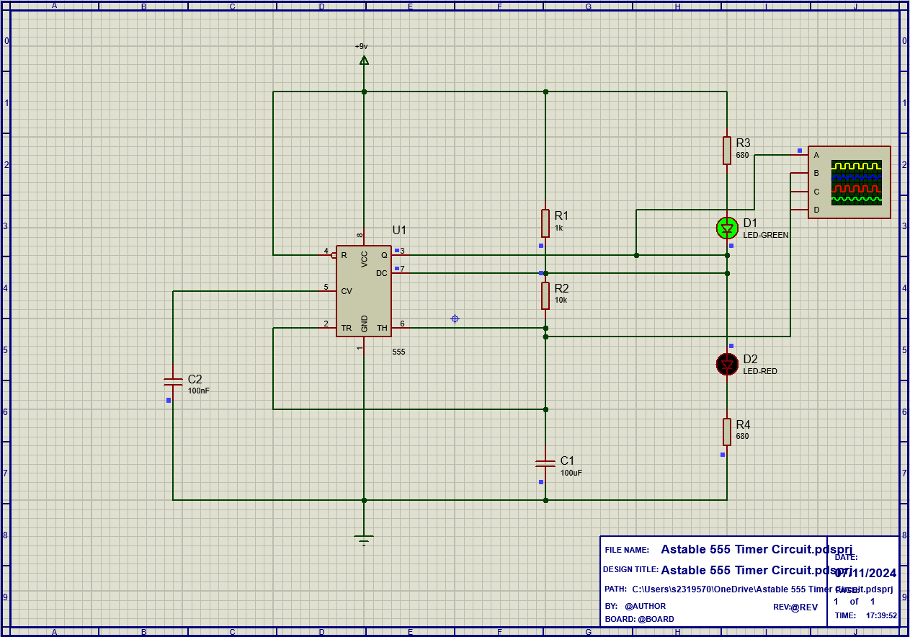
Figure 1
Figure 2
Figures 1 and 2 show the schematics of the simulation using the program software ‘Proteus.’ Two of the four resistors (10k and 1k) were given however the other two needed to be calculated. The calculations can be seen in the ‘Design Calculations’ section below.
Making the simulation in Proteus required researching each pin and their uses. After the circuit was made and tested to work, an oscilloscope was added to record the frequency and on/off time.

Design Calculations
The resistance of both R3 and R4 are both calculated by using Ohm’s Law. Resistance = Voltage / Amps (R=V/A). Both frequency and the On/Off times can be found in Figures 3 and 4 below. As the Voltage to the circuit is 9 and the voltage to the LED is 2.2. This should be divided by the 10mA to give you the resistance of 680 Ohms for both resistors as the LED’s had the same values too.

Tables and Graphs (Proteus)
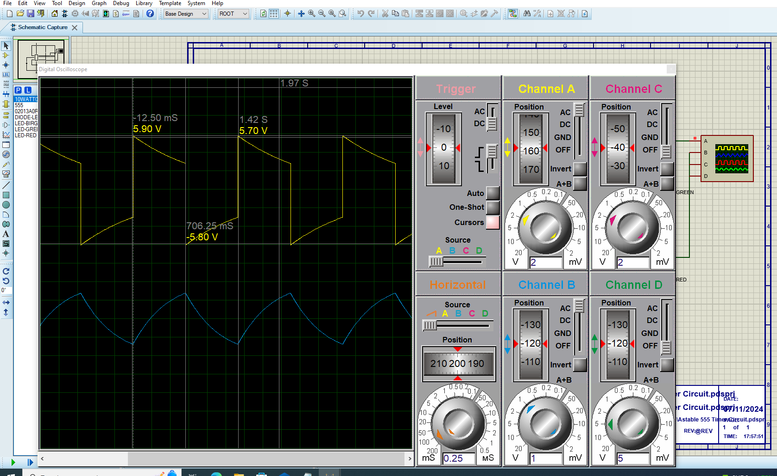
Figure 3
As simulated in Proteus, the On time can be noted down as 0.706 seconds as well as the Off time being 1.42 seconds. The period is worked out by adding both the On time and the Off time which comes to 2.1 seconds in this case. These results are only for channel 1. From this, the wave frequency can be worked out as 1/2.1 which is equal to 0.476. Therefore channel 1 has a wave frequency of 0.476 Hz / Hertz.
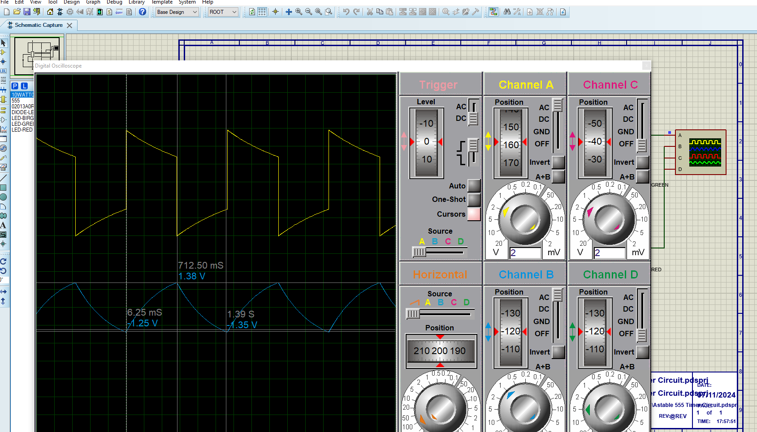
Figure 4
For channel 2, the On time can be seen as 0.712 seconds and the Off time being 1.39 seconds. Again, the frequency of the wave itself can be calculated by 1/1.39 which comes to a figure of 0.719. The period for channel 2 is worked out by 0.712 + 1.39 which comes to 2.1 seconds. The wave frequency for channel 2 is also 0.476 Hz / Hertz

Bread Board
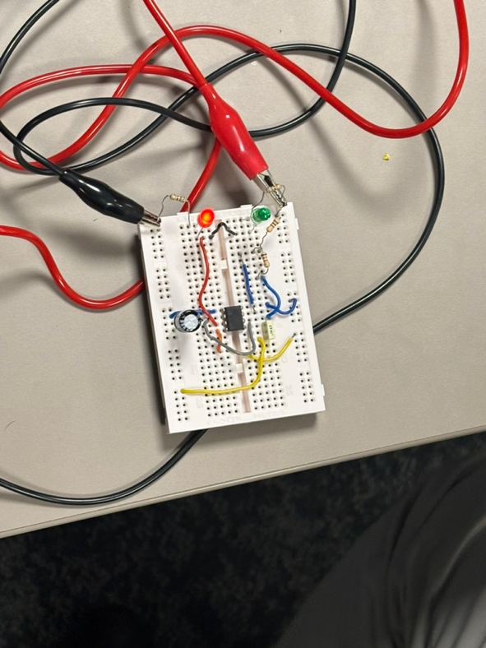
Figure 5
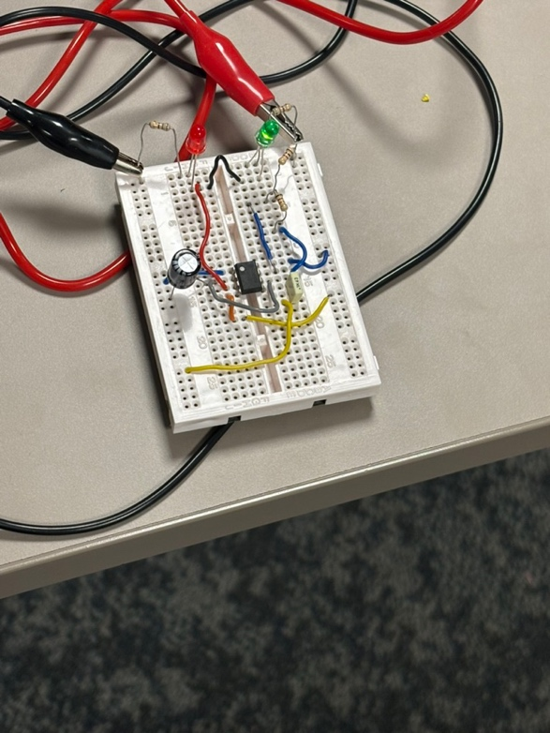
Figure 6
Once the Proteus simulation was done, the second stage could be started. This was making the circuit onto a Bread Board. A Bread Board is a temporary circuit that is both wireless and solderless therefore very useful for testing out circuits as prototypes and much easier to fix a mistake than a soldered circuit. A Bread Board has three separate sections, two of which are the same. The two outer sections (bus strips) consist of multiple rows of two that are all vertically connected using power rails these are used for ground and V+/VCC which is the supply voltage. The middle section (terminal strip) is two parts of multiple rows consisting of five that are all horizontally connected using a metal strip that cannot be seen.
By using the research of each pin and the Proteus simulation of the circuit, the Bread board was made connecting each pin of the IC to their required destination. After the two resistors were calculated, the correct ones could be placed onto the Bread Board. The completed Bread Board can be seen in Figures 5 and 6. The IC had to be placed in the middle of the terminal strip with four pins on one half and four on the other, bridging the gap and allowing full use of the limited space given. The trigger was connected to the 100uF capacitor which was then connected to the 10k resistor and fed back into the threshold. The two LEDs had to be connected to the output and the reset was connected to the other bus strip to gain power. The V+ pin was connected to the same bus strip as well as the 1k resistor. The 10k resistor was then connected to the discharge as well as the threshold like mentioned previously. The control voltage was fed into the bus strip that wasn’t being used for grounding. One of the 680 resistors is attached to one of the LEDs and the other 680 resistor is connected to the other. Once done, it needs to be connected to that same bus strip as the control voltage. To check if the Bread Board was working correctly, the LEDs should alternate between red and green.
The resistors themselves have a colour-coded strip technique to identify the resistance of each one. The ones used here are 4-band resistors, consisting of two digit bands, a multiplier band and a tolerance band. The two digit bands are the exact same when it comes to the colour code and what they mean. Black meaning 0, brown meaning 1, red meaning 2, orange meaning 3, yellow is 4, green is 5, blue is 6, violet is 7, grey is 8 and white is 9. Digit bands cannot be gold nor silver. The Multiplier band is similar as each colour progressively increases by another power. Black being x1, brown is x10, red is x10², orange is x10³, yellow is x10⁴, green is x10⁵, blue is x10⁶, violet is x10⁷, grey is x10⁸ and white is x10⁹. However, the Multiplier band can be either silver or gold with a meaning of x10⁻¹ for gold and x10⁻² for silver. Now for the Tolerance band, they cannot have a black nor white band. The figures for each band are: brown for +/- 1%, red for +/- 2%, orange for +/- 3%, yellow for +/- 4%. Here is it where it stops following the pattern for the other bands: green for +/- 0.5%, blue for +/- 0.25%, violet for +/- 0.1% and grey for +/- 0.05%. The Tolerance band can be gold or silver with a figure of +/- 5% for gold and +/- 10% for silver. [5]

Tables and Graphs (Bread Board)
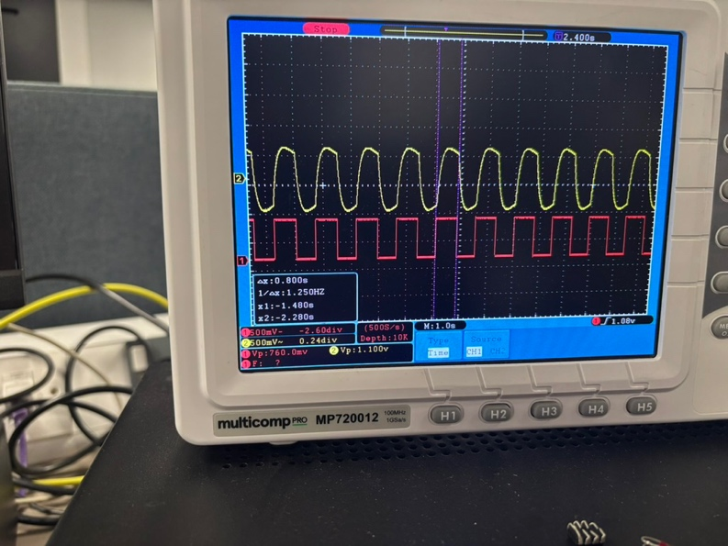
Figure 7
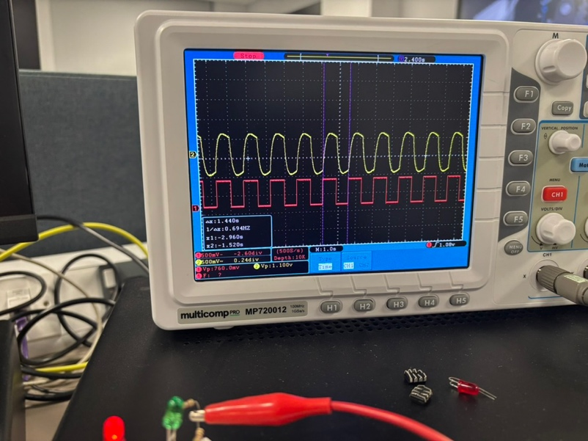
Figure 8
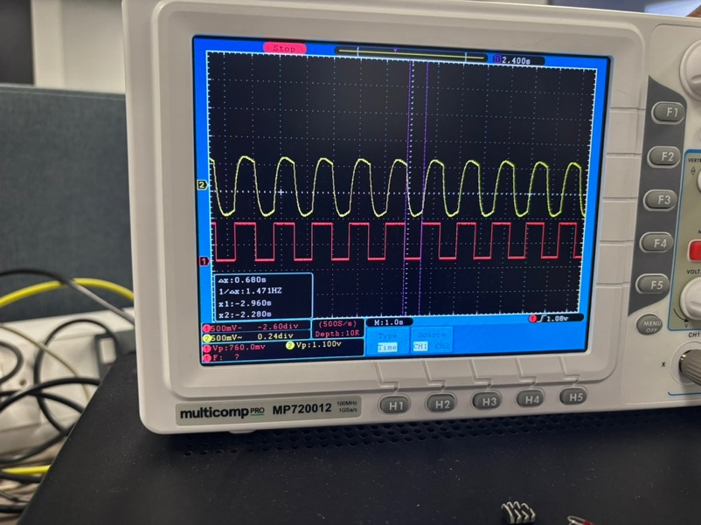
Figure 9
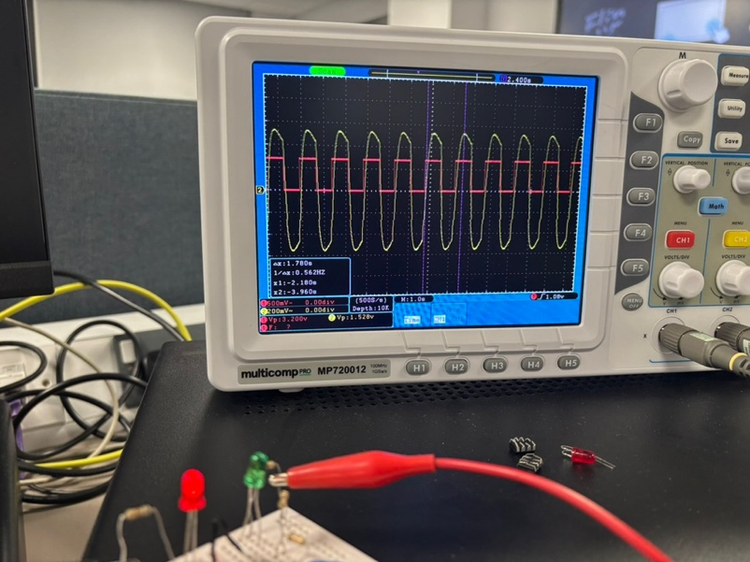
Figure 10
Figures 7-10 show the oscilloscope readings for the Bread Board. As can be seen for channel 2, the On time is 0.680 seconds, and the off time is 0.8 seconds. This shows that the period is 1.48 seconds for channel 2. This means the frequency for channel 2 is 1/1.48 which comes to 0.676 Hz / Hertz. For channel 1, the period is shown as 1.78 seconds. The On time is 0.78 seconds and the Off time is 1 second. The frequency for channel 1 is 1/1.78 which is 0.562 Hz / Hertz.

Differences
As it can be noticed due the results, there are differences in the results for both channels comparing the simulation and the bread board. For channel, 1 there is a slight difference in On times with being only 0.074, a difference of 0.4 in the Off times and a wave frequency difference of only 0.086 Hz/Hertz. For channel 2, there is a similar minimal difference for the On times with it being only 0.032s, a bigger difference in the Off times with is being 0.59s and the frequency having a difference of 0.2 Hz/Herts.

Conclusion
Simulating on Proteus is a good way to create a prototype and send it to clients or managers etc, so they can also see what the idea and it is an effective way of prototyping to check if all the theory is correct as it takes little time to do. Once the simulation on Proteus is complete, the Bread Board can be made and if there are any problems, it is known to be an issue with the circuit that has been built. Once working, an official circuit can be made using PCB and it can be soldered to finally be put into action. The fact there were minimal differences in the results given show it is an effective method. The fact that some parts in the bread board could be looser than others, there could be oily residue from hands or even dirt inside the bread board prove that the calculations for the resistors were correct and the Proteus simulation was correctly made as well. The Bread Board proved many challenges as some IC’s were dead, some capacitors were burnt out and as mentioned, the wires could be loosely placed inside and there was no way of telling until the circuit was completely stripped and remade. The Proteus software proved much easier and reliable to work on as none of the before mentioned problems were issues and there is unlimited space to work on. Because Proteus is a software, there is full one hundred percent reliability of all components and of them working unlike the bread board as mentioned previously. The bread board had many wires going over one another and looked messy and therefore was hard to establish if any components or wires were in the wrong place.

Table of Figures
Figure 1 4
Figure 2 4
Figure 3 5
Figure 4 6
Figure 5 7
Figure 6 7
Figure 7 9
Figure 8 10
Figure 9 10
Figure 10 10

References

[1] | T. E. o. E. Britannica, "Electric Circuit," Britannica, 3 December 2024. [Online]. Available: https://www.britannica.com/technology/electric-circuit. [Accessed 29 December 2024].
[2] | E. Club, "555 Astable," Electronics Club, [Online]. Available: https://electronicsclub.info/555astable.htm. [Accessed 30 December 2024].
[3] | T. Editor, "IC 555 timer (integrated circuit)," Polytechnic Hub, 14 April 2017. [Online]. Available: https://www.polytechnichub.com/ic-555-timer-integrated-circuit/. [Accessed 30 December 2024].
[4] | P. Kane, "How to Configure a 555 Timer IC," JAMECO, [Online]. Available: https://www.jameco.com/Jameco/workshop/TechTip/555-timer-tutorial.html. [Accessed 30 December 2024].
[5] | T. Connectivity, "Resistor Color Codes: What Do the Color Bands Mean?," TE Connectivity, [Online]. Available: https://www.te.com/en/products/passive-components/resistors/intersection/resistor-color-codes.html. [Accessed January 5 2025].

