Blog link: https://lukerisdonblog.weebly.com/

Blog Post 1 – Introduction to the Design Thinking Process
Introduction: Design thinking, initially rooted in product design, has become a widely adopted framework for problem-solving across various industries. Its application extends to the realm of music composition, providing a structured approach to nurture creativity and innovation. In this blog post, we will delve into the design thinking process, examining how it can be utilized in music composition and discussing its broader implications.
Understanding Design Thinking:
Design thinking is an iterative problem-solving approach that emphasizes empathy, collaboration, and iteration. It is structured around five key stages: empathy, definition, ideation, prototyping, and testing.
Empathy: Establishing a Connection with the Audience:
The empathetic stage of design thinking in music composition involves understanding the emotions, preferences, and cultural contexts of the audience. By immersing themselves in the listener's experiences, composers can create compositions that resonate on a deeper level, forging a meaningful connection.
Defining the Vision: Setting Clear Objectives:
The definition stage entails clarifying the purpose, goals, and constraints of the composition. Composers outline the intended message, musical style, and the impact they seek to achieve. This step provides a clear direction for the creative process.
Ideation: Exploring Creative Possibilities:
During ideation, composers generate a wide range of musical ideas and explore different approaches. They experiment with melodies, harmonies, rhythms, instrumentation, and explore unconventional techniques. This open-minded exploration allows for the discovery of fresh and unique musical expressions.
Prototyping: Transforming Ideas into
Tangible Forms: Prototyping involves transforming abstract musical concepts into tangible forms. Composers create preliminary versions of their compositions, experimenting with different arrangements, instrumentation, and structures. This step facilitates the refinement and iteration of musical ideas.
Testing: Gathering Feedback and Refining:
The testing phase involves gathering feedback from performers, conductors, or listeners. Composers seek different perspectives to evaluate the effectiveness of their compositions. Feedback guides further refinement and enables composers to enhance the overall quality of their work.
Beyond Music: Design Thinking's Broader
Applications: Design thinking extends its benefits beyond music composition. It
finds applications in diverse fields, such as product design, user experience,
business strategy, and social innovation. Its user-centric approach and
iterative nature makes it a valuable tool for addressing complex challenges and fostering innovation in various domains.
Conclusion: Design thinking offers a structured framework for creativity and innovation in music composition. By incorporating empathy, defining clear objectives, exploring creative possibilities, prototyping, and testing, composers can create compositions that deeply resonate with their audience. Design thinking's application extends beyond music, finding relevance in multiple industries where problem-solving and user-centric approaches are essential. While recognizing the merits of design thinking, it is crucial to explore and embrace other creative processes and methodologies that can enrich the world of music composition.

Blog Post 2 – Empathise
The first step of the design thinking process is to empathise. We were given the following 5 topics to explore for our project:
- Mindfulness and Wellbeing – Ancient Paradigms and Modern Methodologies
- An Inconvenient Truth – Visions of the Future
- The Future is Human – Rise of the Machines
- Disinformation – Knowledge and Ignorance
- Dreams and Psychodelia – Beyond Limitations
Immediately I decided to explore the idea of “Mindfulness and Wellbeing”. This is a topic that I relate to a lot and attempt to practice in my day-to-day life. I looked into the Wim Hof Method as a form of “Modern Methodology”. The Wim Hof Method includes various practices focused on breath work, meditation and cold exposure. This seems to have outstanding physical and mental benefits such as improvements to cardiovascular health and dealing with conditions such as depression and anxiety. To make the work site specific I found a cold swimming group based in Swansea. However, their meeting places are not consistent and largely depend on turn out as far as I could see. In terms of Ancient Paradigms, I researched some ancient Buddhist meditation practices. Although with less scientific backing than the more modern methods I found, the anecdotal evidence for the benefits of meditation where overwhelming. Many people report a reduction in stress levels, clearer heads and more energy. There is a Buddhist meditation centre in the Uplands, but this seemed too far to walk in order to link it to the rest of Swansea. Continually, a residential building did not seem very inspiring for a site-specific piece of music, especially considering the wealth of historic and natural sites in the area.

Blog Post 3 – Define
Our next step was to choose groups. No one else picked “Mindfulness and Wellbeing”, so I decided to join the group discussing “An Inconvenient Truth – Visions of the Future”. This did mean however, that my previous research was no longer relevant. However, I began to look into more areas that related to the group topic. My first thoughts included inspiration from science fiction such as Star Wars and Blade Runner, I also investigated the concept of speculative evolution. I became particularly interested in Dougal Dixon’s book Man After Man: An Anthropology of the Future. Whilst I enjoyed Dixon’s speculations about future human species, I was not inspired to write music on the subject and turned to some of the group’s ideas.
The groups skills are as follows:
Paul is a rapper.
Grace is a jungle DJ.
Liam makes music with loops on Logic pro.
Matt makes beats on Fl studio.
Our target audience was people who were interested in sound walks and visions of the future.

Blog Post 4 – Ideate
We discussed a multitude of ideas as a group such as: space exploration, pollution, climate change, and war. The idea of linking space exploration to the local observatory seemed ideal, however we quickly realised that it was no longer functional and now served as a café. Therefore, it did not feel like a fitting venue for a site-specific work discussing space exploration as a vision of the future, since it now represented a much more dystopian idea of capitalism and a decline in popular access to scientific tools. The first idea that I really pursued was that of climate change and pollution. This felt perfect as a topic for “An Inconvenient Truth – Visions of the Future” as the level of pollution and climate change is indeed an inconvenient truth that we will be confronted with in the near future. An appropriate location would have been the Swansea Bay water quality screen which has tracked water quality in the bay since at least 2013. They also tweet out the results and suggest whether the water is safe to swim in twice a day on twitter. This is a great symbol of the damage we are doing to the planet through pollution and an example of what we can do to prevent it. Another great site I explored in the “define” stage was the tidal power lagoon suggested for the bay. This project is a great example of how we could tackle the inconvenient truth of climate change by reducing our fossil fuel output since the energy generated would be clean and renewable. These sites linked nicely for the exploration of the theme of climate change, however they were too far apart to conveniently walk between as we were aiming for a sound walk of about 10 minutes. This would be incompatible with our target audience would not want to spend longer than this as we were aiming at people who like short sound walks (around 10 minutes funnily enough).

Blog Post 5 – Prototype
As a group we struggled to decide on a unifying idea to pursue. Dave our module lead suggested we should investigate the concept of war as the Russia-Ukraine conflict rages in eastern Europe. We decided to follow this theme as we thought it presented a compelling through-line of learning from the past and applying those lessons to the future directly. We thought that we could create a 3-piece soundwalk that was made up of the past, present and future. The past would focus on the second world war and be located at the war memorial on the river. The present would focus on more modern sensibilities of dissent and dissatisfaction with war as a persistent force, it would be based at the castle in the square. The future would focus on a more hopeful concept of human development and be based at the church with had been bombed in the war, showing the regenerative power of time and collective effort.
We spilt the 3 sections of the walk into groups: Grace did the future, Liam and I did the present and Paul and Matt did the past.
Liam and I wrote a modern pop/rock song about the uncertainty of the modern political climate to encapsulate our contemporary ideas about war. The song is titled “interesting Times” and is meant to denounce war as a concept and suggest that a brighter future is possible, despite the constant barrage of negative news making war feel inevitable. I recorded the song in a garage with a local band from Nottinghamshire (see pictures below). I then wrote an intro that incorporated the ending of Matt and Paul’s piece so that the two sections of the walk flowed together seamlessly (entirely dependant on your walking pace).

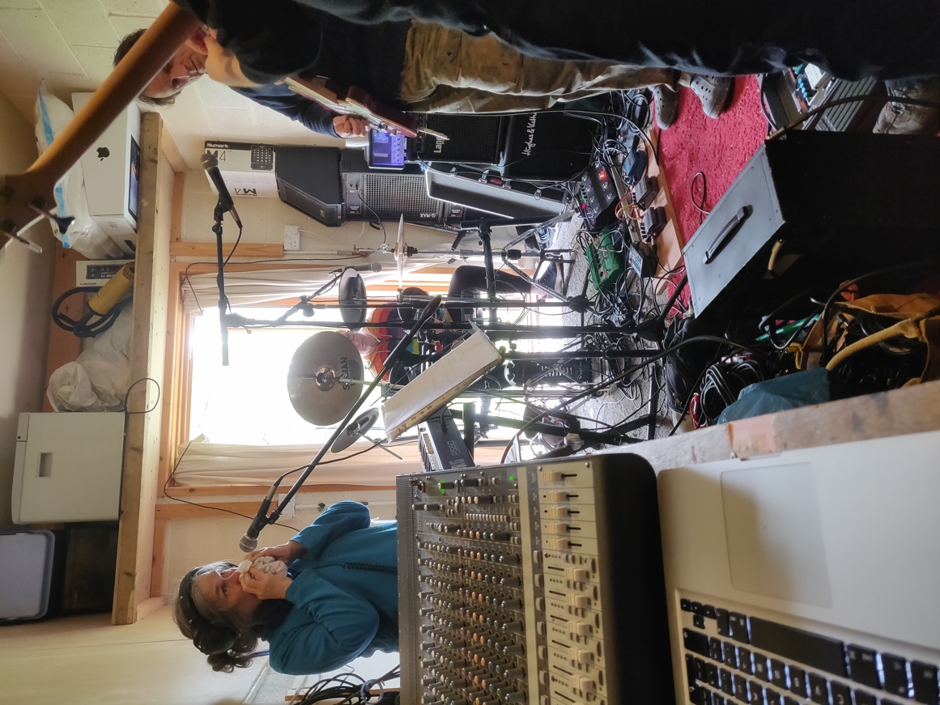
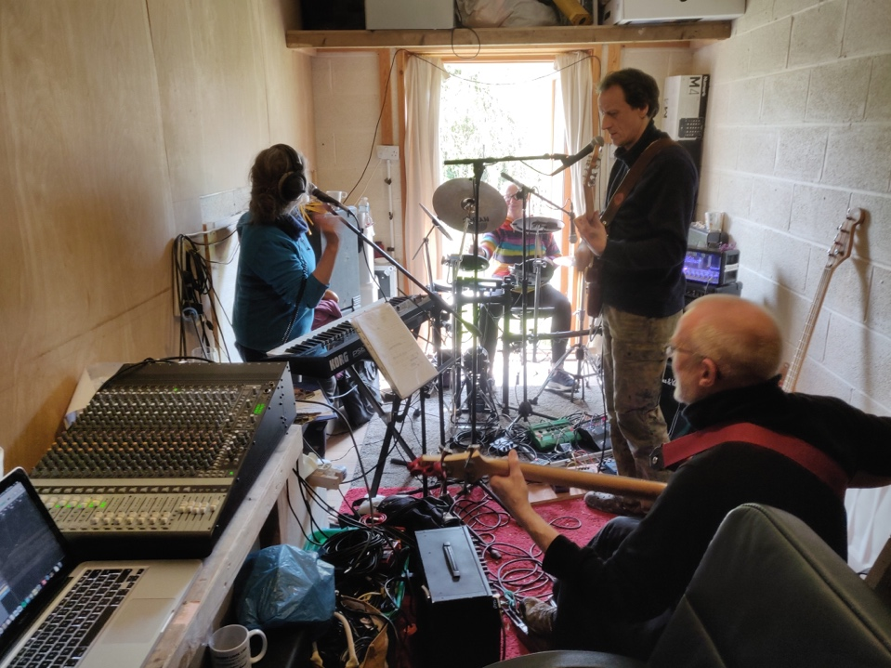

Blog Post 6 – Test
Our testing in general was extremely limited. Matt and I went to visit the war memorial site and walked to the church via the castle to test out the walk. We timed ourselves and found it came to roughly ten minutes which was quite fortunate. If we had given ourselves more time, we could have organised for other groups to test our work, however I never even managed to contact another group to ask them to test it out. My personal response to testing the walk was that it was provocative enough to inspire introspective thought. However, starting the walk next to a main round and walking past all the nightclubs in town did undercut the sombre but optimistic mood somewhat. The climax at the rebuilt church was the most effective since the area has an almost secluded fell when the trees are green and there are minimal people around.

Blog Post 7 – Launch Conclusions
In conclusion our project was a lacklustre effort at following the Design Thinking Process to create a piece of site-specific music. Lack of willingness to take initiative and lead from all members of the group led to a rushed attempt at the assignment. I think our most successful moment was the Ideation process, where we could all be our most creative. All group members produced good musical pieces that served the purpose of exploring a future where we learn from the wars of the past. However, this vision was poorly defined and led to an overall lack of cohesive writing that could have served the vision more specifically. Other parts of the Design Thinking Process were not engaged with at all, for example finding target audiences and testing the product did not fit the sensibilities of any of the group members and therefore largely fell by the wayside. Overall, I think the Design Thinking Process could be useful when writing music on commission for something like an advertisement or video game. I would like to try and use it again with people who are more set on using the process, like a team at a company. Conversely in our case, I felt more that the group and I were more focused on producing a passable piece of work than using the process to its full potential. We did not give ourselves enough time to take advantage of the iterative nature of the Design Thinking Process.

A Sales Development Representative (or SDR) focuses on building new business for an organization. This could include handling inbound leads or outbound prospecting. Seven more words to make two thousand. There have been several claims for the longest sentence in the English language revolving around the longest printed sentence.
Sentences can be made arbitrarily long in various ways. One method is successive iterations, such as "Someone thinks that someone thinks that someone thinks that someone thinks that...,"^{[1]} or by combining shorter clauses. Sentences can also be extended by recursively embedding clauses one into another, such as^{[2][3]}
"The mouse ran away."
"The mouse that the cat hit ran away."
...
This also highlights the difference between linguistic performance and linguistic competence, because the language can support more variation than can reasonably be created or recorded.^{[1]}
As a result, one linguistics textbook concludes that, in theory, "there is no longest English sentence."^{[4]}

https://www.healthline.com/health/wim-hof-method
https://shorturl.at/chmpw
https://www.facebook.com/gowerbluetits/?locale=en_GB
https://meditationinwales.org/
https://www.goodreads.com/uk/book/show/1266344
https://twitter.com/SwanseaBayWater
http://www.tidallagoonpower.com/projects/swansea-bay/

