Digital Skills and Research Methods

Name: Nkechi Jefia

ID: 1714551

Lecturer: Anupam mazumdar

Table of Contents
- Introduction
- Literature Review
- Research Methodology
- Findings, Analysis & Discussion
- Summary of findings
- Conclusion
- Reference List
- Appendix

LIST OF FIGURES
1. Chart 1 ......................................................................7
2. Chart 2 ..................................................................... 8
3. Graph 3 .....................................................................8
4. Chart 4 ...................................................................... 9
5. Chart 5 .......................................................................9

Introduction
The purpose of this report is to evaluate a relevant workplace topic, in this case zero Hours contract was chosen as a point of focus and it’s different factors and aspects, for instance the disadvantages and advantages of zero hours contract. While, evaluating this topic I will be using a range of research methodologies such as Quantitative and Qualitative methods as a way to collect information or findings to analysis and discuss the information gathered. The findings will be presented in different formats, for example bar charts, line graphs, Radar chart, and pie chart and area chart to illustrate the different opinions of zero hours contract jobs and reasons behind it.
2. Literature review of Zero Hours Contract
Zero hours contract can be describe as when an employer employs someone without specific contracted hours. There are risks attached to zero hour contracts which are numerous such as, no job security that will lead to no certainty of earnings and it will cause huge drawbacks in one’s life, lack of rights of employment such as getting sick pay, no holiday pay and potential disruption of family life where by the employee is given short notice of work.
The employee will only get paid when he or she work, but the advantages of zero hour contracts are all about flexibility. This is when an employer is not obliged to offer work to an employee as well as not being obliged to accept work when it is not conducive because of circumstances beyond their Zero hours contracts can be describe as when an employer employs control. The employer cannot do anything to stop a zero hour’s worker from getting work elsewhere. The law says they can ignore a clause in their contract if it bans them from such as looking for work, accepting work from another employer and employee are still responsible for health and safety of staff on zero hour contract
There is much despise towards the legitimacy of zero hour contracts for employees. Due to the fact they are offered no secure hours. This has led to people arguing that employees are left to undergo financial issues, anxiety, stress and often depression. On the flip side, zero hour contracts can be an amazing opportunity for workers of all ages. As now individuals are not being tied to their jobs and therefore have the freedom to choose a shift and commit to other things, for example school or University where they are able to now work around lectures and other educational activities, but if they have a clear schedule where they have nothing to do, they are able to accept more hours. Zero hour contracts are equally a good opportunity for employers, especially those who own a business where the daily outcomes can be uncertain.
Another great benefit of using zero hour contracts is that employers can keep hold of employees that may need to go from full time work to part time because of their lack of commitment to specific hours or the fact that the employee may not be fit to work that many hours. If a business owner is very pleased with a particular employee they might not need to replace them if they can no longer commit to long hours.
This also works the opposite way, if an employer hires staff on a zero hour contract but sees that they are performing particularly well they may keep them as a permanent member of the team. One could say that zero hour contracts are a convenient gateway to a more permanent job in the future. Furthermore, the advantage of using zero hour contracts in the hospitality sector is that employers can employ extra staff as needed. If a hotel is very busy particularly in a seasonal period then they may need to bring in more workers who can work as many flexible hours as possible.
However, a disadvantage of zero hour contracts is that there is no financial stability to those who are working under them and thus contributing to financial uncertainty. Employees have no assurance of solid working hours and therefore it can be a disastrous situation to be in. This financial issue is extremely risky for those who have young children, due to no guarantee of work they will not be able to plan for the future effectively or budget within their means. Some would prefer this option because if there is an individual, for instance a husband in the household with a constant income then the wife would be able to work on a zero hour because she would rather choose her shift around her busy life than juggle her work and home life. Zero hour contracts are concentrated more on the employees rather than owners. (Capify UK, 2015)
Research Methodology
According to surbhi S (2016), Qualitative Data refers to the data that provides understanding to a particular problem this method cannot be computed. Hence, the researcher should collect knowledge about the type of problem, prior to the collection of data. Qualitative data is termed as descriptive and in some cases hard to analyze it. The data collected is interpreted as spoken or written accounts rather than numerical and is concerned with the data that is observable. The forms of collecting qualitative data are as follows; focus Group, Observation and Interviews.
While, Quantitative Data deals with quantity or the numerical side of understanding a problem. It refers to the data which quantifies values which can be expressed in numerical terms. Most statistics analysis is conducted using this data. Quantitative date is presented in forms of tabular and diagrammatic presentation of data. The presentation of data is made up of charts, graphs and tables. Moreover, quantitative data can be classified as discrete or continuous data. The different forms of collecting Quantitative data methods are: Surveys, Experiments, Observations and Interviews.
The research method that I have chosen to use to present my findings is Quantitative data. As I will be presenting my findings using various charts and graphs such as Bar chart, pie chart and line graphs. Using Survey research which involves interviewing or administering questionnaires, or even written surveys, to a numbers of people, in this case 10 individuals. Using the data collected from this survey, we will use this to analyze the data obtained from surveys to learn about similarities, differences, and specific trends. With this information, I can make predictions about the population being collected.

A population is a discrete group of people that can be identified by at least one common characteristic or factor for the purposes of data collection and analysis. To gather information about a large population, data is usually gathered from a sample. (Rouse and Wigmore, 2015). Also, Taylor (2018) says that “it is important to understand the target population being studied, so you can understand who or what the data are referring to. If you have not clearly defined who or what you want in your population, you may end up with data that is not useful to you”
Sample Frame is a list of all the individuals within the population of interest. When collecting information or data from the sample. The only way apply your research findings to the population are through the sampling frame because it studies a subset of the population in question. (Sampling Population Sample and Generalizability, 2018)
A sample is a subset of a population. There are different kinds of sampling for instance Random sampling, stratified sampling, cluster sampling, purposive sampling and quota sampling. These types of sampling are all used in different ways and in different situations to collect specific type of individuals for the final sample size that will be used for data collection. The sample chosen from the population are employees that are in zero hours contract jobs. Lavrakas (2008) stated that a sample size of a survey most typically refers to the number of units (also, referred to as cases or individuals) that were chosen from which data was collected. The sample size chosen were 10 people that were asked 5 different questions regarding zero hour contract work. Using the sample size of 10 people has allowed me to make generalisations about the population overall.

Findings, Analysis & Discussion
- Do you enjoy being in zero contract?
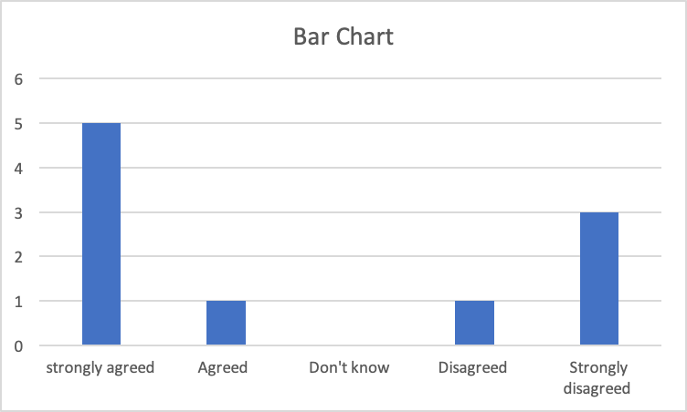

According to my sample size which is illustrated in the bar chart above. It shows that 50% of people responded positively ‘strongly agreed’ to the question posed to them which was whether they enjoy zero hour contract because of the flexibility. However, 30% of the people strongly disagreed with the question and stated that they clearly do not enjoy zero hour contract work because of the lack of job security and financial stability. The 10% who only ‘agreed’ and the other 10% who ‘disagreed’ said although zero hour contracts is conducive because you have the ability to chose or refuse work this however is not good for future planning and budgeting.

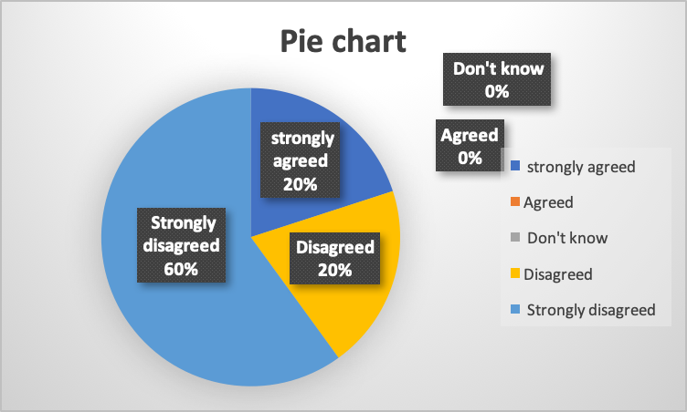
- Is a zero hours contract of any benefit?

The Pie chart demonstrates that 60% of people strongly disagreed that zero hours contract is beneficial because of employment uncertainty, while 20% disagreed because of lack of employment rights, while the other 20% strongly agreed that zero hours contract is very flexible and allows freedom to plan it around commitments.
- Does every organisation offer zero hour’s contract?
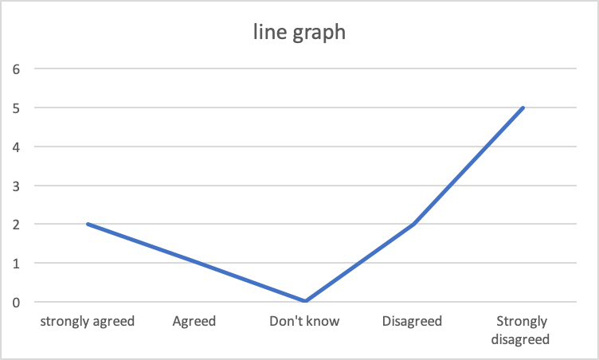
The Line graph above illustrates that 50% strongly disagreed that every organisation offers zero hour contract because it is a choice in a particular sector according to their procedure such as Hospitality. 10% agreed while the other 20% disagreed and 20% strongly agreed because it is beneficiary to the company to be able to employ people easily without the employment benefits.
- Do you get paid doing nothing in zero hours contract?
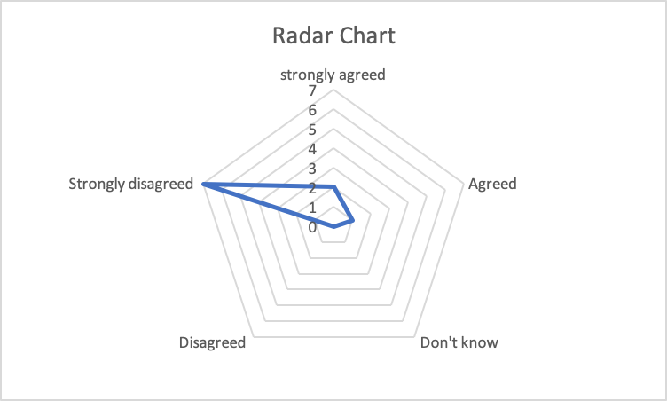
In the Radar chart it shows that 70% of people strongly disagreed that you cannot get paid doing nothing because it is a pay as you go job which means that if you do not go to work you do not get paid. This is difference from those who have permanent jobs and get holiday pay and employ benefits. While, 20% strongly agreed and 10% agreed that you will get paid not doing anything in their opinion.
- Why do people opt for zero hours contract?
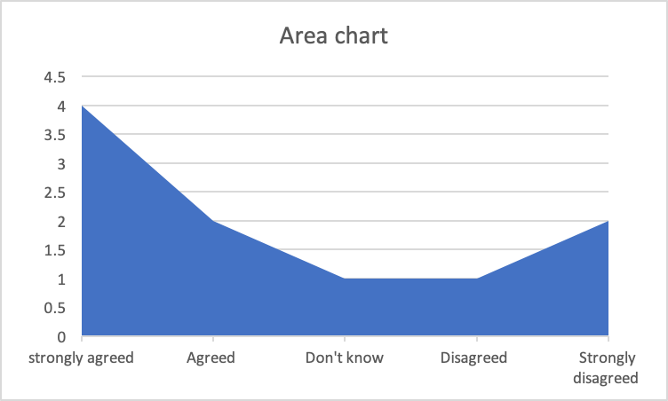
The Area chart illustrates 40% of people strongly agreed because of flexibility whereby an employee is not obliged to work when it is not conducive for them. 20% of people agreed with the same reason above. 10% said ‘I don’t know’ and 10% disagreed because there are no employment attached. 20% of people sampled said they strongly disagreed because zero hours contract can leave individuals undergoing stress anxiety, depression and difficulties with finances.
Summary of Findings
From the findings above, Key findings above suggests that Zero hour contracts are not enjoyed by most that are looking for a stable income, relatively good work pay and enough working hours. It is found that 60% of people found that zero contract hours do not generate any type of benefits and also found that 70% of people do find that if you do not go to work you will not get paid because you could be from an agency which means employ benefits cannot be enjoyed or holiday pay is not initiated. From the 5 questions asked, it is clear that Zero hour contracts are not the best for some people and are better for those who enjoy flexibility around there many commitments.
Conclusion
After going through the above findings and analysis it can be said that the 10 individuals chosen from the sample are a good measurement of zero hour contracts because they represent a larger population of people who undergo this type of work. The question posed towards these individuals identified specific trends such as the lack of job security, uncertainty of paid work hours, it being a pay as you go job so without the hours provided from the organization you are unable to be financial secure and this idea of no employee benefits because workers are not permanent staff in that chosen sector or organisation brings stress and anxiety to the individuals. It is clear that employees demonstrate the lack of care not given to them by businesses and there owners which is illustrated by the large amounts of people who disagreed with any benefits that came out of this type of work. However, by studying this report and understanding the motivation behind zero hours contract it is clear that individuals do clearly enjoy the freedom that this type of work gives because of the flexibility that is given and the fact that you are able to plan work around other important commitments such as university or school also, families may benefit from this type of work because the focus can be dedicated to both the family and bringing in income for the household.

References
Capify UK. (2015). The Benefits of Zero Hour Contracts. [online] Available at: https://www.capify.co.uk/advantages-disadvantages-zero-hour-contracts/ [Accessed 29 Dec. 2018].
Lavrakas, P. (2008). Encyclopedia of Survey Research Methods. SAGE.
Rouse, M. and Wigmore, I. (2015). What is population? - Definition from WhatIs.com. [online] WhatIs.com. Available at: https://whatis.techtarget.com/definition/population [Accessed 29 Dec. 2018].
S, S. (2016). Difference Between Qualitative and Quantitative Data (with Comparison Chart) - Key Differences. [online] Key Differences. Available at: https://keydifferences.com/difference-between-qualitative-and-quantitative-data.html [Accessed 29 Dec. 2018].
Sampling Population Sample and Generalizability. (2018). [video] Directed by P. Hozack. YouTube.
Taylor, C. (2018). What Is a Population in Statistics?. [online] ThoughtCo. Available at: https://www.thoughtco.com/what-is-a-population-in-statistics-3126308 [Accessed 29 Dec. 2018].

