

Marketing Management
(LCMB7024)
Assessment component 2: Marketing Portfolio

- Name: Shubh Bansibhai Modi
- Student ID: 2509172
- Faculty: Jayalakshmi Gopalkrishnan
- Program: MBA International Business
- Module: Human Capital Management
- Module Number: LCMB7024
- Words: 2750

Contents
Element 1: Choose a company and develop a Segmentation, Targeting, Differentiation, and Positioning (STDP) Analysis for a New Brand Concept 3
Segment 3
Demographic segmentation 3
Targeting Strategy 3
Differentiation 4
Style-Driven Technology 4
Rugged and Tough Build 4
Seamless Ray-Ban Ecosystem 4
Personalisation Options 5
Positioning 5
Positioning Statement 5
Positioning Strategy 5
Lifestyle Positioning 5
Tech-Fashion Hybrid 5
Durable & Dependable 5
Affordable Luxury Positioning 5
Conclusion : 5
Element 2: Marketing Mix (4Ps or 7Ps) 6
Product 6
Price 7
Place 7
Ray-Ban Samay watches will be sold via the following distribution strategies: 7
Promotion 8
People 9
Process 9
Physical Evidence 9
Conclusion 10
Element 3: Marketing Strategy Pitch 11
Element 4: Reflection 12
References : 13

Element 1: Choose a company and develop a Segmentation, Targeting, Differentiation, and Positioning (STDP) Analysis for a New Brand Concept

Segment
Market segmentation involves dividing a consumer market into smaller, manageable segments. In the case of SAYMAY, market segmentation can be performed in terms of demographics, psychographics, geography, and behavior.

Demographic segmentation
The main demographic target for SAYMAY includes:
- Age: 18-35 years. Corresponding to a younger generation of Millennials and Generation Z consumers, they are more receptive to technology-integrated fashion goods.
- Gender: Every gender. The design requirements will focus on accommodating personal style preferences.
- Income: Middle to high income, which corresponds with a positioning of smartwatches in a lifestyle segment. The consumers in this segment are presumed to show a preference for branded devices and be willing to pay a higher price for a combination of style, functionality, and brand equity (Kotler & Keller, 2020).

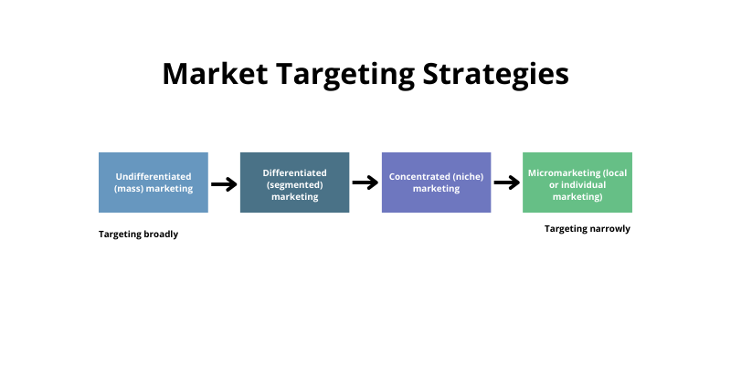
(Ansari, R.S. (2025) ‘Evidence-based content marketing: scientific approaches to effective digital strategy’, Blog, 20 August.)

Targeting Strategy

After identifying the segments mentioned above, the next phase will be to determine which segments are most viable to market to and then reach.
Primary Target Market - Urban Generation Z and Young Millennials (age range of 18-35):​This target demographic exhibits a high level of interest in, and expenditure on, technology in conjunction with clothing (style), as well as a strong focus on product convenience. Members of this cohort also tend to spend a great deal of money on smart devices and participate heavily in social trends. SAYMAY has a unique opportunity to attract this target group through social media, influencer marketing, and leveraging existing brand loyalty established through Ray-Ban’s established customers.

Secondary Target Market - Active Professionals (ages 25-40):​ Members of this target group have the need for smartwatches in order to for organization and facilitate connectivity. Additionally, they are looking for smartwatches that exhibit a high level of professionalism in their appearance while also having capabilities for workouts and travel. Finally, consumers in this target group would want to have an attractive alternative to standard fitness watches..

Differentiation
SAYMAY needs to identify how it is differentiated from Apple, Samsung, Fitbit, and Garmin in this competitive market.

Style-Driven Technology
SAYMAY is different from most wearable technology companies wherein technology is prioritised before aesthetics. A prime example of this is the fact that SAYMAY produces smartwatches that feature premium Ray-Ban designs featuring sleek frames, unique colours, and iconic Ray-Ban quality of material for the watch band. This design bridges the gap between fashion and digital functionality.

Rugged and Tough Build
SAYMAY's brand image is derived from the idea that "tough meets elegance."
SAYMAY has several features:
- Shock-resistant casing
- Water-resistant for use during sports and travel
- Scratch-resistant lenses based on Ray-Ban’s technology are used for eyewear
- These attributes are geared toward our customers' active lifestyles but do not sacrifice style.

Seamless Ray-Ban Ecosystem
SAYMAY integrates with Ray-Ban's smart glasses to offer a complete ecosystem for accessing music and receiving notifications/and making camera controls. This synergy creates the image of Ray-Ban being a technology-lifestyle brand as opposed to simply a company producing eyewear.

Personalisation Options
SAYMAY's interchangeable watch straps, custom watch faces, and limited-edition watch frames make it possible for users to have their smartwatches customized to fit their individual style — an important attraction to Gen Z.

Positioning
The fourth element of STDP is our customer's perception of Ray-Ban SAYMAY.

Positioning Statement
A young, style-conscious consumer who wants a smartwatch that fits with his or her personal style at the highest level of elegance and quality will find what they are looking for in Ray-Ban SAYMAY with its phenomenal design and world-class craftsmanship and technology and price point on the upper end of the smart watch category.

Positioning Strategy

Lifestyle Positioning
Ray-Ban SAYMAY will be promoted not only as a technological device, but also as an accessory that reflects an individual's sense of style and personality and a way to express themselves.

Tech-Fashion Hybrid
Ray-Ban SAYMAY will be marketed as the ultimate hybrid of technology and fashion, highlighting both its forward-thinking characteristics along with the classic styling associated with the Ray-Ban brand.

Durable & Dependable
Ray-Ban SAYMAY will be marketed as a timepiece that has exceptional durability and dependability and can accompany users during the busiest parts of their lives (i.e. work, travel, sports and social) and fits perfectly on the wrist of a young, active and successful consumer.

Affordable Luxury Positioning
Although priced significantly higher than budget smartwatches, Ray-Ban SAYMAY will be positioned at the most affordable price point when compared to a luxury designer watch fulfilling the need for a middle ground between budget smartwatches and luxury; it is priced lower than a luxury designer watch but at the highest quality level amongst the mid to top-end smartwatches.

Conclusion :
Ray-Ban's SAYMAY product line has an exceptional combination of technology and fashion, allowing consumers to express themselves and look great. The STDP model identifies the optimal target audience- differentiating itself from competitors- and positioning against a highly competitive market. With SAYMAY's emphasis on style, durability, and advanced features, this line is designed for young consumers who want a wearable product that conveys personal style, and not just a smartwatch.

Element 2: Marketing Mix (4Ps or 7Ps)
The 7Ps model helps in implementing the brand strategy of Ray-Ban Samay successfully by making it customer-oriented in the marketplace. The integration of product, price, place, promotion, people, processes, and physical evidence helps in implementing the consistent values and building a strong emotional association within the cognitive structure of the consumer, hence helping in positioning the brand as a fashionable, trustworthy, and desirable option in the watches market.
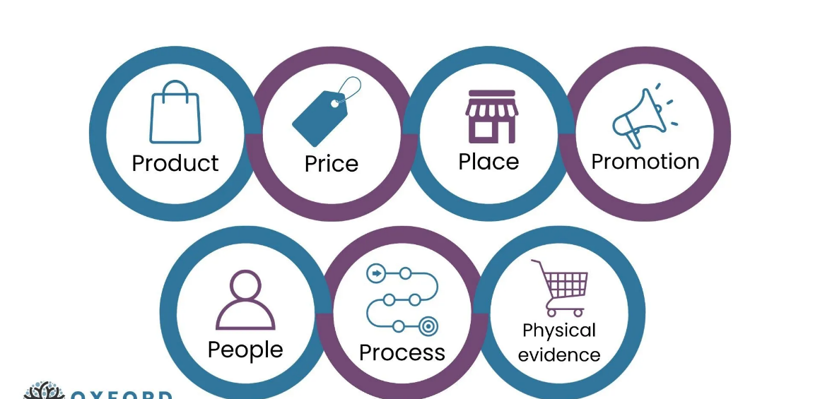
(McCarthy, E.J. (2023) Basic Marketing: A Managerial Approach. Updated edn. New York: McGraw-Hill Education.)

Product
Ray-Ban Samay's product strategy consists of providing customers with premium, accurate and stylish watches that align with an active and premium lifestyle. Our target consumers are young professional males and females, students, and anyone who is actively engaged in activities that demand reliability, fashion and a strong brand image.
At Ray-Ban Samay, we use quality materials to construct our watches, including stainless steel cases and scratch resistant mineral or sapphire glass and water resistant casings that work for both everyday wear and sports. All models will include either Annie, digital-analog hybrid or smart assisted features to keep up with the ever-changing consumer demands. All timepieces will incorporate design features from Ray-Ban's heritage through minimalist dials, bright colours and discreet Ray-Ban branding, while still maintaining a balance between current and timeless.
Functionality differentiates Ray-Ban Samay from other brands. The addition of a chronograph, date and luminous hands enhance usability. Select models will include fitness trackers and all models will provide maximum battery life. Packaging will reinforce the Ray-Ban brand image through premium packaging utilizing sustainable materials for consumers who are environmentally conscious.
According to Kotler, et al., a product's strategy must provide both functional and emotional value.

Price
Ray-Ban Samay employs a competitive pricing strategy that is value-based, situated within the mid-premium segment of the watch sector. The prices are indicative of quality, brand affiliation and design whilst still offering an affordable option for consumers under the age of 30.
The anticipated price range will be between £120 and £300 depending on the model and features of the timepiece. Entry-level models will mainly target those persons starting out at school, whereas advanced and limited-edition models will appeal primarily to professionals and those who identify as brand loyal customers. The tier pricing strategy employed by Ray-Ban Samay will enable the company to reach a more significant part of the market without diminishing its overall premium image.
Psychological pricing options (such as £199 vs £200) will also be utilised to further enhance customer perceptions of value. Additionally, occasional promotional prices at product launch and during major holiday events will motivate first-time customers to try the product while promoting repeat purchases, thereby creating an ongoing association of prestige with the brand.
According to Kotler and Keller (2016), the price must match the customers' perceptions of value rather than only reflecting the costs of production. Therefore, the pricing strategies of Ray-Ban Samay must reflect not only the physical attributes of the product but also include the brand awareness, lifestyle position and emotional bond that the brand has established. Through this process, consumers will perceive they received the best value for their expense.

Place
Ray-Ban Samay has developed its distribution strategy, with special emphasis on being easy to locate, use and have control over how it is sold. Its distribution strategy uses multiple channels to provide customers access to Ray-Ban Samay while providing an overall premium experience of the Ray-Ban Samay brand.

Ray-Ban Samay watches will be sold via the following distribution strategies:
- Ray-Ban stores
- Ray-Ban's websites (e-commerce)
- Select Premium Watch Retailers
- Amazon & Zalando (an example of an online marketplace)

As a primary strategy, online distribution will play an essential role for younger generations that favour the ease of digital shopping; on Ray-Ban's official site, customers will be able to browse collections, customise products and gain access to more detailed product information to engage with customers.

In addition, an offline presence through both Ray-Ban stores and authorised retailers will allow customers to see and try on Ray-Ban Samay watches. To create an atmosphere of trust and confidence in the purchase decision. One of the goals of an effective place strategy (Armstrong et al. 2021) is to make sure products are available in a timely and at an appropriate location and conditions. Ray-Ban Samay's distribution strategy enables the blending of physical and digital conveniences and supports this goal.

Promotion
According to Belch and Belch (2020), one of the objectives of all business communication is to create a consistent image using all forms of communications. By using an integrated approach to the promotion of Ray-Ban Samay to create awareness of the products as well as create an emotional bond with consumers, it is expected that Ray-Ban will successfully establish a connection with customers. The promotional mix for Ray-Ban is focused on an influencer-driven lifestyle and the promotion of Ray-Ban products through the use of social media, including Instagram, TikTok, and YouTube, that feature Ray-Ban products in use in practical applications such as travel, sports, music, and lifestyle. Additionally, partnerships with athletes, fashion designers, and lifestyle bloggers will help enhance the credibility of Ray-Ban products and aid in brand recognition.

Advertising campaigns will promote key messages through the tag lines "Time Your Style" and "Built for Every Moment" that reinforce the lifestyle use of the Ray-Ban products as well as the ability to represent individuality through design and style. Promotional partnerships and collaborations with celebrities and industry leaders as well as the introduction of limited-edition collections will generate excitement and urgency among potential consumers.

Sales promotions, including a student discount program, bundling Ray-Ban eyewear with Ray-Ban sunglasses, and establishing a referral program for current customers, will be used to attract consumers and assist in establishing a loyal customer base. Additionally, through public relations activities, such as product reviews, publications in fashion magazines, and sponsorships of lifestyle events, Ray-Ban will build on the brand image.

People
A key component of how a customer perceives Ray-Ban Samay is the people that represent the company. This includes the individuals who make up the retail sales force, customer service team and marketing department, along with the brand ambassadors promoting the company. All individuals associated with Ray-Ban Samay are trained to represent the brand story correctly and offer custom experiences to each customer.
Influencers and brand ambassadors are also recognised as contributors to the "people" aspect of Ray-Ban Samay, as they directly impact how consumers perceive the company. By aligning the people associated with Ray-Ban Samay with their core values, this provides consumer trust in the company and establishes an emotional connection to the brand (Kotler et al., 2021).

Process
One of the primary focuses of the process part of the customer experience is to provide a seamless experience throughout the entire customer journey, including browsing, purchasing, delivery, and after-sales service. The processes associated with each of these parts of the customer journey are all designed to be user-friendly and efficient.
When shopping or purchasing online, customers benefit from streamlined processes that include convenient and secure payment systems, order-status tracking, and simple return procedures.
After-sales services increase a customer's trust and satisfaction with the company, and it includes services such as warranty coverage and the ability to repair or replace broken or damaged straps. According to Lovelock and Wirtz (2016), processes that have been well-designed can decrease a customer's perception of the risk associated with a business and can increase the quality of the service provided, which are key to developing long-term brand loyalty.

Physical Evidence
The physical evidence supports Ray-Ban Samay's superior brand position in tangible ways. The product packaging is neat, elegant, and environment-friendly, with sophisticated materials and humble brand expression. Every watch comes in a chic box, which further supplements the unboxing process, thereby encompassing the brand's attention to detail.
The retail displays, the website structure, and promotion imagery all reflect a unified look that comes from Ray-Ban’s identité. The idea of physical evidence applies not only to the quality of the product and the environment of the store, including its digital interfaces.
Strong physical evidence helps build trust and strengthen the brand’s value proposition, thus helping Ray-Ban Samay’s brand to differentiate itself in the competitive market for watches (Aaker, 2017).

Conclusion
The 7Ps model helps Ray-Ban Samay in the effective implementation of its brand strategy by making it customer-centric in the marketplace. The synchronization of product, price, place, promotion, people, processes, and physical evidence helps the brand in delivering consistent values and building a strong emotional association in the customer’s mind, thus resulting in the positioning of the brand as a fashionable, trustworthy, and desirable brand in the watch segment.

Element 3: Marketing Strategy Pitch
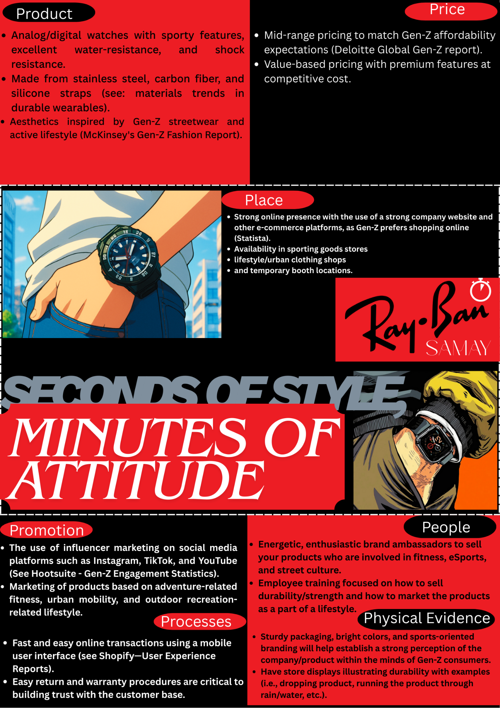

Element 4: Reflection
Being involved in the development of the Ray-Ban Samay brand concept, along with the marketing approach, has turned out to be a learning experience that has broadened my perceptions in the field of marketing. Initially, the perception about marketing that I held remained restricted to the graphical representation of the brand. While working on the development of Ray-Ban Samay, the realization dawned on me that the creation of a superior brand requires in-depth awareness about the behavior in the marketplace, along with a marketing focus. Extension of the Ray-Ban brand into a watch series, Ray-Ban Samay, demanded the development of a novel extension based on the conventional identity.

One of the major learnings that this project has given is related to the application of a structured framework in marketing. The application of STDP and Marketing Mix allowed for a systematic manner in which ideas could be organized. Moreover, segmentation theory has provided a premise related to how consumers do not respond alike and that their lifestyle, values, and attitudes play a critical part in their behaviors related to consumers. The aforementioned premise served as a basis for positioning Ray-Ban Samay as a fashionable and functional watch for young professionals and fashionable people alike. According to Kotler et al. (2021), "The key to effective branding is matching customer needs to a well-articulated value proposition."

The tool of marketing mix helped improve my strategic thinking abilities. While articulating each element of the overall marketing mechanism—the product design, pricing, place, promotion, people, process, and physical evidence—the fact became clear that higher pricing can help strengthen the overall brand image and exclusive distribution methods ultimately help sustain that exclusiveness. The lesson also drove home that service aspects, no matter the product being the central one, play important roles (Booms & Bitner, 1981).

The presentation of the marketing strategy and preparing for the pitch were additional crucial learning events. These events have helped bring improvement in communication skills, especially while discussing marketing ideas within a mass audience. This has taught me the significance of storytelling within the marketing pitch because the fact is that narratives are oftentimes more effective in marketing communications compared to mere facts and figures. This has further strengthened my abilities in explaining marketing ideas based on theory and research. Having reflected on the project, there are areas that could have been done differently. While secondary research validated the approach, more personalized research methods, such as surveys or focus groups, could have served to provide more information on consumer behavior patterns. Better time management could also have been achieved with more extensive practice preparation for the pitch. Moving forward with future projects, my aim is to make use of analytics and more comprehensive competitor research. This particular project has, in fact, helped to strengthen my analytical, creative, and communication skills and further expand my insight into branding and marketing planning (Aaker, 2017).

References :
- Kotler, P. & Keller, K. (2020) Marketing Management. 16th ed. Pearson.
- Statista (2024) Smartwatch Market – Consumer Adoption and Trends. Available at: https://www.statista.com (Accessed: date).
- Solomon, M. (2019) Consumer Behaviour: Buying, Having, and Being. 13th ed. Pearson.
McKinsey & Company (2023) State of Fashion & Technology Report.
- Armstrong, G., Kotler, P., Harker, M. and Brennan, R. (2021) Marketing: An Introduction. 14th edn. Harlow: Pearson Education.
- Belch, G.E. and Belch, M.A. (2020) Advertising and Promotion: An Integrated Marketing Communications Perspective. 11th edn. New York: McGraw-Hill.
- Kotler, P. and Keller, K.L. (2016) Marketing Management. 15th edn. Harlow: Pearson Education.
- Kotler, P., Kartajaya, H. and Setiawan, I. (2022) Marketing 5.0: Technology for Humanity. Hoboken: Wiley.
- Aaker, D.A. (2017) Strategic Market Management. 12th edn. New York: Wiley. Armstrong, G. and Kotler, P. (2019) Marketing: An Introduction. 13th edn. Harlow: Pearson.
- Kotler, P., Keller, K.L., Ang, S.H., Leong, S.M. and Tan, C.T. (2021) Marketing Management: An Asian Perspective. 8th edn. Harlow: Pearson.
- Solomon, M.R. (2020) Consumer Behavior: Buying, Having, and Being. 13th edn. Harlow: Pearson.
- McCarthy, E.J. (2023) Basic Marketing: A Managerial Approach. Updated edn. New York: McGraw-Hill Education.
- Ansari, R.S. (2025) ‘Evidence-based content marketing: scientific approaches to effective digital strategy’, Blog, 20 August.

