Program: Master of Business Administration

LCMB7024 Marketing Management

Assessment 2: Brand Extension Portfolio: BrewDog Pet Brew

Student Name- Minal Ramani
Student ID- 2423401
Lecturer's Name- Laila Maazouz

Table of Contents
1. Introduction 4
2. New Brand Extension: BrewDog Pet Brew 5
2.1 Overview 5
2.2 Product Representation (Flavour Variants) 6
2.3 Unique Selling Proposition (USP) 7
2.4 Strategic Fit 9
3. Segmentation, Targeting, and Positioning (STP) 9
3.1 Segmentation 9
3.2 Targeting Strategy 10
3.2 Positioning Strategy 11
4. Customer Persona Profile 12
4.1 Persona 12
4.2 Persona Summary and Justification 13
5. Marketing Mix Strategy (7Ps) 14
5.1 Product 14
5.2 Price 15
5.3 Place 15
5.4 Promotion 16
5.5 People 16
5.6 Process 17
5.7 Physical Evidence 17
6. Conclusion 19
7. References 20

Table of Figures
Figure 1: BrewDog company logo 5
Figure 2: Eco-friendly glass bottles styled for BrewDog beer 6
Figure 3: BrewDog's breweries are powered by wind and grain 8
Figure 4: STP Framework 12
Figure 5: Marketing mix strategy 14
Figure 6: BrewDog Pet Brew: Customer Experience Flow 18
List of Tables
Table 1: Flavour Variants for dog beers 7
Table 2: Customer Persona Profile 12

Introduction
Scottish brew company BrewDog, who pioneered the craft beer market in 2007, has disrupted the traditional beer business with their irreverent attitude, unique brand image and green values. Famous for their controversial marketing strategies and customer engagement, BrewDog has expanded overseas with bars in key cities and a strong online presence. As more people regard their pets as part of their family, the pet care market has seen explosive expansion. BrewDog aims to capitalize on this by introducing a brand extension: BrewDog Pet Brew, a non-alcoholic, healthy and wholesome drink. This report outlines developing this new product, segmentation, target market, positioning strategy, customer profile, and a thorough marketing mix.

New Brand Extension: BrewDog Pet Brew
Brand extension is a new product, or new product category, introduced under the umbrella of an existing brand name. It is sometimes called brand stretching. The theory of a brand extension is to leverage the current brand equity of the company to promote the launch of its latest product (Kopp, 2020).

Overview
BrewDog Pet Brew is the world's first range of fully alcoholic-free craft beverages for dogs. It's intended to provide hydration, nutrients, and the social element for pets, similar to the BrewDog experience for humans (Your Dog, 2018). This diversification launches in the exploding pet wellness and premium pet food and beverage space, placing BrewDog at the forefront of this growing niche.

Figure 1: BrewDog company logo
Source: (BrewDog, 2018)
Key Product Highlights:
- Balanced Nutrition: Made with chicken broth, sweet potato, herbs, and vitamins and minerals for total canine nutrition (Tanprasertsuk et al., 2022).
- Alcohol-Free Formulation: No alcohol, no hops, no carbonation, no artificial additives (Lamb, 2021). Safe and good for dogs.
- Health Benefits: Aids in hydration, encourages joint health and digestion; more of a wellness supplement than a treat (Lamb, 2021).
- Social Inclusion: Enables pet owners to engage their dogs in social activities such as visiting pubs, outdoor events or home gatherings (Obradović et al., 2021).
- Packaging: BrewDog can provide their beverage in eco-friendly glass bottles styled after BrewDog beer for consistency with their branding (Stone, 2018).
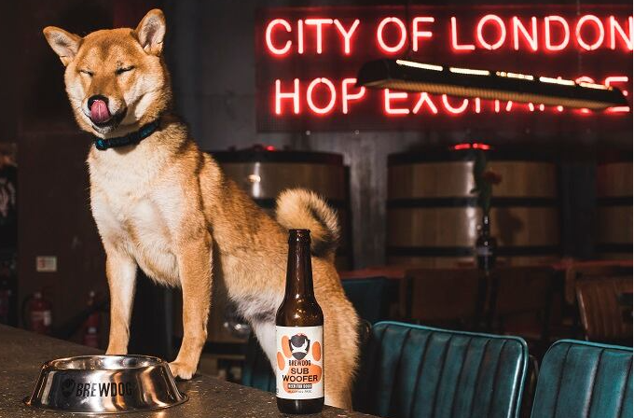
Figure 2: Eco-friendly glass bottles styled for BrewDog beer
(Stone, 2018)

2.2 Product Representation (Flavour Variants)
Each flavour is inspired by classic BrewDog beer varieties but repurposed in pet-friendly formats, furthering the brand's playful and innovative spirit:
Table 1: Flavour Variants for dog beers
Flavour Name | Description | Key Ingredients | Nutritional Value
Chicken Ale | A savoury and rich broth-flavoured drink, ideal for daily hydration and enjoyment (Samant et al., 2021). | Chicken broth, sweet potato, chamomile, Vitamin B complex (Samant et al., 2021). | High in protein, supports muscle and immune health.
Beef Stout | Hearty and aromatic, perfect for colder days or hearty meals. | Beef stock, carrots, rosemary, glucosamine (Tanprasertsuk et al., 2022). | Joint health support, rich in antioxidants.
Veggie IPA | A light, refreshing, plant-based option for dogs with meat sensitivities (Samant et al., 2021). | Pumpkin puree, apple cider vinegar, parsley, Omega 3 oils (Tanprasertsuk et al., 2022). | Digestive aid promotes coat and skin health (Stone, 2018).
Source: (Author)

2.3 Unique Selling Proposition (USP)
BrewDog Pet Brew positions itself as a unique e-commerce; differentiated value proposition based on BrewDog’s brand identity and customer experience:
- First-Mover Advantage
Unique within the pet care and beverage sector, BrewDog is the first UK beer brand to develop a purpose-brewed craft drink for dogs (Stone, 2018).
- Leverage of BrewDog Brand Equity
- Leverages BrewDog’s craft brewing and brand strength to naturally expand into the pet wellness space.
- Maintains BrewDog’s irreverent, humorous, and sustainable reputation to appeal to existing enthusiasts and new pet-loving consumers (Dezeen, 2020).
3. Emotional Connection and Inclusivity
- Builds emotional brand loyalty by allowing pet owners to share their dog's lifestyle and social experiences that were previously exclusive to humans.
- Appeals to pet owners who see pets as part of the family and value shared time and general wellness (Sandvik, 2023).
4. Sustainability Focus
- Complies with BrewDog’s eco-friendly mission by using sustainable sourcing and environmentally friendly packaging to offer ethical appeal to conscious consumers.
- Supports carbon-negative manufacturing methods with BrewDog compensating through reforestation and renewable energy sources and extending this to the Pet Brew range (Dezeen, 2020).
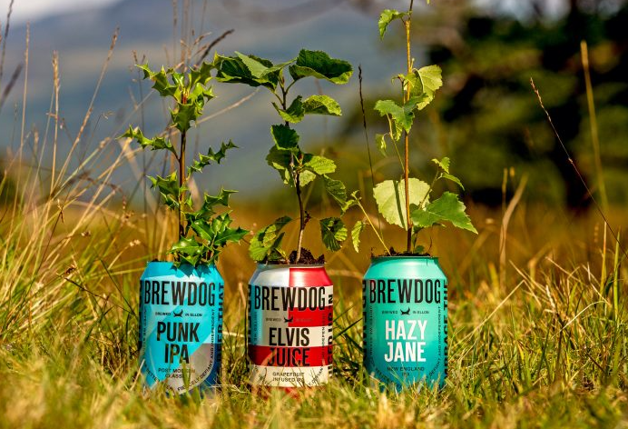
Figure 3: BrewDog's breweries are powered by wind and grain
Source: (Dezeen, 2020)

2.4 Strategic Fit
BrewDog Pet Brew aligns strategically with broader market trends and consumer demands:
Market Opportunity:
- Pet owners are collectively spending nearly £5 billion on pet veterinary costs each year. On top of this, pet insurance in the UK is also contributing to this trend as pet insurance is paying out £1 billion each year in the UK (IMARC, 2025). It is enabling pet owners to cover more treatments and contributing to higher market growth.
- The pet population in the UK increased by 9% between 2023 and 2022. An industrial survey identified that 57% of UK homes keep pets. Along with this, rising pet ownership is creating greater demand for pet care products of every type, including pet grooming and pet food. For example, pet owners spend £1.2 billion per annum on pet grooming products and about £500 on pet treats (IMARC, 2025). This is combined with the fact that pets are members of the family and are viewed as part of the home by individuals and families. This leads to investments in pet health and happiness in the long run.
- Customer changing behaviour: The pet economy is booming, with humans treating their pets more like family, leading to increased spending on expensive pet products.
- Online Synergy: Pet content is popular on social media (Hardy, 2021); BrewDog Pet Brew could provide high-quality, shareable moments that naturally spread and also improve organic reach to pet carers.

Segmentation, Targeting, and Positioning (STP)

Segmentation
To implement this segmentation approach effectively, it is essential to clearly define potential customers who will most likely purchase this premium dog-friendly craft beverage. Here are the segments based on demographic, psychographic, and behavioural criteria (Luthfiandana et al., 2024).
- Demographic Segmentation
- Demographics: Mainly 25–45 year olds. This age group is made up of young professionals and Millennials who make up BrewDog’s existing core customer demographic and are also more likely to own pets and spend on their wellness.
- Income level: Middle to upper-middle income in between £30,000–£70,000 per annum with flexible income available to pay for premium pet products.
- Occupation: Urban professionals in industry sectors such as creative, tech, and digital where pet ownership is ubiquitous and lifestyle-related spending is strong.
- Places: Urban and suburban, especially major UK cities for instance- London, Manchester, and Edinburgh where BrewDog has a solid retail/pub presence and a pet-friendly culture is predominant.
b) Psychographic Segmentation
- Treat pets as family members along with prioritizing their pet’s wellbeing and health (Sandvik, 2023).
- People who are searching for Life-improving, premium, as well as sustainable products.
- Search for social involvements of pets in everyday life just for instance, parts, pets friendly cafes and pubs, and other social events (Obradović et al., 2021).
- Greatly engage on social media platforms, sharing product reviews, pet experiences, and lifestyle content (Hardy, 2021).
c) Behavioural Segmentation
- Existing BrewDog consumers who are already aware of the brand and its values.
- People who regularly visit dog-friendly sights and events (Obradović et al., 2021).
- Will subscribe online, and they value convenience.
- Very reactive towards influencer marketing and user-generated content (Maumelat, 2024).

3.2 Targeting Strategy
BrewDog will employ a differentiated marketing strategy targeting Millennial and Gen Z consumers who are pet owners and seek premium, innovative, and sustainable products (Hodgson, 2017).
Primary Target Segment:
- Young professionals aged 25–35 years who are urban dwellers, socially active, along loyal to BrewDog customers.
- Dog owners are willing to spend on pet wellness and also want to socialize with that pet in inclusion.
- Digital natives who are shopping online, talking to brands and their consumers on social media, and are impacted by what their peers say and influencers (Maumelat, 2024).

Positioning Strategy
BrewDog Pet Brew will be placed as the finest, fun, and health-conscious beverage for dogs that will enrich shared experiences between pets and their owners, embodying BrewDog’s inclusive, innovative, along sustainable brand ethos (Hodgson, 2017).
Positioning Statement:
“BrewDog Pet Brew: The bottle of craft beer for your best friend. Fun, healthy and brewed with love because dogs should experience the good life, too.”
Key Positioning Elements:
- Emotional Connection: Encourages bonding and inclusivity, letting dogs be able to “join in” at social events (Obradović et al., 2021).
- Sustainability: Packaging and production aligned with BrewDog’s carbon-negative mission (Dezeen, 2020).
- Lifestyle Alignment: Designed for pet parents with an appreciation for social sharing. Premium experiences, and brand engagement.
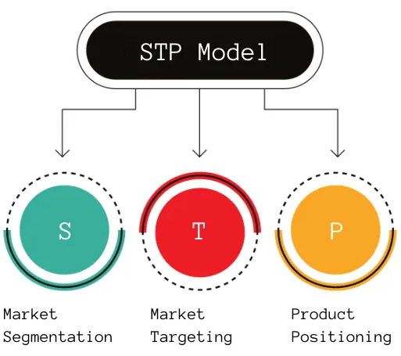
Figure 4: STP Framework
Source: (Product Mindset, 2022)

Customer Persona Profile

4.1 Persona
Table 2: Customer Persona Profile
Attribute | Details
Name | Lucy Thompson
Age | 32
Occupation | Digital Marketing Manager at a creative agency
Location | London, UK
Income Level | £45,000–£60,000 annually
Education | University degree in Marketing and Communications
Pet Ownership | Owns a 4-year-old Labrador Retriever named Max
Lifestyle | Active social life, visits BrewDog pubs and dog-friendly events.
Values | Health, sustainability, premium quality, inclusivity, and animal welfare.
Spending Habits | Regularly purchases premium pet products, invests in pet wellness and lifestyle experiences.
Tech Usage | Heavy user of Instagram, TikTok, and YouTube; shops online frequently.
Psychographics | Sees her dog as part of the family, enjoys pampering her pet, seeks social engagement.
Buying Motivation | Desires to include her dog in social outings and give him unique, fun experiences.
Media Consumption | Follows pet influencers, lifestyle bloggers, and brand accounts related to pets and wellness.
Shopping Behaviour | Influenced by reviews, brand values, packaging aesthetics, and social proof.
Source: (Author)

4.2 Persona Summary and Justification
Lucy is a highly valuable persona to understand and consider when formatting marketing strategies, products offered, and the best communication channels to utilize. Lucy, an extremely online Millennial, represents the intersection of who interior-focused BrewDog is marketing to now, and the premium pet products space. Being synergised with her principles of sustainability, quality, and social inclusion, BrewDog Pet Brew will make her highly open toward this innovative product.
So by concentrating on personas such as Lucy:
- There are targeted messaging that can be created to align with her lifestyle and values.
- Maximizing these channels does all the more for marketing (Instagram, pet influencers, in-pub promotions) (Maumelat, 2024).
- Her purchasing motivations correspond to product features such as eco-friendly packaging, premium ingredients, and health benefits.

Marketing Mix Strategy (7Ps)
To ensure the successful launch and growth of BrewDog Pet Brew, the marketing mix strategy will focus on the 7Ps framework: Product, Price, Place, Promotion, People, Process, and Physical Evidence (Hanlon, 2023). This comprehensive approach ensures alignment between the brand's values, customer expectations, and market trends.
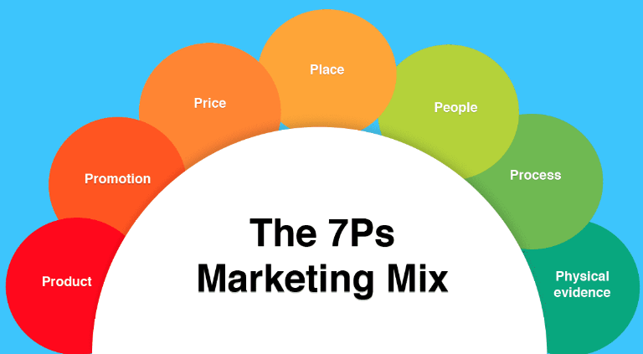
Figure 5: Marketing mix strategy
Source: (Hanlon, 2023)

5.1 Product
BrewDog Pet Brew is a non-alcoholic, nutrient-rich drink created specifically for dogs. It replicates the craft beer drinking experience that BrewDog is best known for but is made with pet-friendly, natural ingredients like chicken broth, sweet potato, herbs, and added vitamins (Samant et al., 2021). The product comes in three unique flavours:
Key Product Features:
- Dog safe, non-alcoholic, and calorie free.
- Enriched with vitamins and minerals that promote hydration and wellness in dogs.
- Sustainable, recyclable glass bottles with bright, dog-themed labels (Stone, 2018).
- Sold as individual bottles and in multipacks (e.g., 4-pack or 6-pack).
- Available with seasonal limited-edition flavours to encourage repeat purchases and excitement (Lamb, 2021).
- Branded serving bowls and accessories for upselling.
- The pet-friendly product not only meets a useful requirement (nutrition and hydration). but also improves the emotional experience of involving pets in public events.

5.2 Price
The price of BrewDog Pet Brew will be considered a premium, owing to its quality ingredients, focus on sustainability, and unique market position.
Pricing Tiers:
- Single Bottle: £3.99 per 330ml bottle.
- 4-pack (4 bottles): £13.99 (£3.50 per bottle) 10% discount.
- Subscription Plan: For £24.99, customers will receive 8 bottles of beverages (including brand new flavours) and exclusive merchandise.

5.3 Place
Strategy of Multi-Channel Distribution employ to maximize convenience and engagement for pet owners.
Primary Distribution Channels:
- BrewDog Pubs and Bars: Remain for purchase and served to dogs on-site in branded bowls to reiterate the in-pub experience (Stone, 2018).
- BrewDog E Commerce Website: They ship all across the nationwide and have direct-to-consumer online sales with subscription boxes (Brewdog.com, 2018).
- Pet Boutiques and Upscale Retailers: In-store promotion in premium pet stores, particularly in urban centers (i.e. Edinburgh, London, and Manchester).
Justification:
- Everything goes Digital: The omni-channel approach gives room for accessibility in the physical and digital spaces.
- In-pub sales help support brand engagement and realistic advertising.
- Digital presence integrates BrewDog’s existing e-commerce infrastructure (Maumelat, 2024).

5.4 Promotion
BrewDog will implement a diversified promotion plan that will create engagement, awareness, and sales.
Important Promotional Tactics:
- Influencer marketing: These would be partnerships with pet influencers and lifestyle bloggers who would features other lifestyle aspects (Maumelat, 2024) in Pet Brew.
- Social Media Campaigns: The use of branded hashtags such as #DogDayBrew and #PawsAndPints. Contests for user-generated content, such as a pet photo challenge (Cameron-Kitchen, 2021).
- Tracking Progress and Measuring Results: As part of execution plan, BrewDog will set up tracking for all campaign platforms and measure metrics accordingly after their campaign ends.
- Email Marketing: There will polite target email campaigns sent to a list of existing BrewDog subscribers promoting the benefits of the product along with offers (Rabab’ah et al. 2024).
- Reward Program: “BrewDog Paws Club” earn points with purchases, referrals and social media engagement. Redeem points for discounts or merchandise.

5.5 People
Customer-facing personnel and brand ambassadors play a pivotal role in creating a cohesive and memorable brand experience.
Key People Strategies:
- Staff Training: Staff training for BrewDog pub employees on Pet Brew serving procedures, customer benefits, and how to promote the product and provide excellent service (Hanlon, 2023).
- Customer Support: Dedicated customer service for pet product questions, available through chat, email, and social media.
- Brand Ambassadors: Selected doggie ‘Pet Brew Ambassadors’ show up across social media channels to help represent the brand and interact with followers (Hanlon, 2023).

5.6 Process
All these changes are made to provide a seamless, coherent, and delightful experience to customers and their pets.
Operational Procedures:
- E-commerce Fulfillment: Quick order processing + Delivery through BrewDog’s Online Shop.
- Subscription Management: Easy subscription service where users can manage their orders, flavours, and delivery schedules.
- In-Pub Service: The easy ordering of Pet Brew in bars and serving protocols with special dog menus.

5.7 Physical Evidence
Every physical attribute of the BrewDog Pet Brew enhances brand identity, sustainability, and quality.
Key Physical Evidence Elements:
- Packaging: Elegant, sustainable glass containers with canine-themed branding (Stone, 2018).
- Branded merchandise: pet bowls, collars, toys, and T-shirts with Pet Brew branding.
- Visuals in-Pub: Table cards, posters, and themed decor in the BrewDog pubs representing the product.
- Such as a visually-appealing website and social media displaying the benefits of BrewDog’s products, reviews, and current customer stories (Brewdog.com, 2018).
Figure 6: BrewDog Pet Brew: Customer Experience Flow
Source: (Author, 2025)

Conclusion
A thorough analysis revealed that BrewDog Pet Brew is a well-thought-out and ingenious extension of the BrewDog brand that resonated with the company's ethos of rebellion, sustainability, and customers. With the move into the rapidly expanding pet wellness category, BrewDog is not only building its product portfolio but also building deeper bonds with a loyal, pet-loving customer base. The unique position of the product along with a clearly articulated marketing mix and well defined customer persona ensure that the product is market able and eventually leads to market success. With its premium ingredients, sustainable packaging, and experiential marketing, BrewDog Pet Brew is an inclusive and lifestyle-oriented product for pet owners and their dogs. This extension not only enhances brand loyalty, but also creates new revenue streams, solidifying BrewDog’s status as a bold, innovative brand in the beverage and pet care sectors.

References
‌Brewdog.com. (2018), Our History. [online] Brewdog.com. Available at: https://brewdog.com/pages/history [Accessed 21 Mar. 2025].
Brewdog.com. (2018). BrewDog - Online Craft Beer Shop & Craft Beer Bars. [online] Available at: https://brewdog.com/ [Accessed 21 Mar. 2025].
Cameron-Kitchen, T. (2021), Brewdog’s Marketing Strategy (And How To Replicate It). [online] Exposure Ninja. Available at: https://exposureninja.com/blog/brewdogs-marketing-strategy/ [Accessed 21 Mar. 2025].
Dezeen (2020), BrewDog goes carbon negative with wind-powered breweries. [online] Dezeen. Available at: https://www.dezeen.com/2020/08/25/brewdog-carbon-negative-wind-powered-breweries-forest-news/ [Accessed 21 Mar. 2025].
Hanlon, A. (2023). How to use the 7Ps Marketing Mix strategy model? [online] Smart Insights. Available at: https://www.smartinsights.com/marketing-planning/marketing-models/how-to-use-the-7ps-marketing-mix/ [Accessed 21 Mar. 2025].
Hardy, T. (2021). The Best Examples of Brand Partnerships. [online] Canny Creative. Available at: https://www.canny-creative.com/brand-partnerships-co-branding-and-influencer-brand-collaborations-whats-the-difference/ [Accessed 21 Mar. 2025].
Hodgson, S. (2017), Breakthrough brands: The BrewDog marketing strategy, promotion for punks. [online] Fabrik Brands. Available at: https://fabrikbrands.com/branding-matters/brand-stories/breakthrough-brands-brewdog-marketing-strategy/ [Accessed 21 Mar. 2025].
IMARC (2025), UK Pet Care Market Share, Size, Trends and Forecast 2032. [online] Imarcgroup.com. Available at: https://www.imarcgroup.com/uk-pet-care-market#:~:text=Increasing%20Pet%20Ownership,-The%20increasing%20pet&text=The%20number%20of%20pets%20in,their%20health%20and%20well%2Dbeing. [Accessed 21 Mar. 2025].
Kopp, C.M. (2020), Brand Extension: Definition, How It Works, Example, and Criticism. [online] Investopedia. Available at: https://www.investopedia.com/terms/b/brand-extension.asp#:~:text=A%20brand%20extension%20is%20when,it%20launch%20its%20newest%20product. [Accessed 21 Mar. 2025].
‌Lamb, J. (2021), BrewDog Punk AF Is A Traditional Alcoholic Brewery Leading The Way In Non-Alcoholic Beers. [online] The Sober Curator. Available at: https://thesobercurator.com/happy-every-hour-with-justin-lamb-brewdog-punk-af-is-a-traditional-alcoholic-brewing-leading-the-way-in-non-alcoholic-beers/ [Accessed 21 Mar. 2025].
Luthfiandana, R., Barus, G.A., Nuraeni, N., Yanthy, S. and Pujiati, H., (2024), ‘Marketing Strategy: Segmenting, Targeting, and Positioning for Digital Business (Literature Review)’, Siber International Journal of Digital Business (SIJDB), 1(4), pp.11-22.
Obradović, N., Lagueux, É., Latulippe, K. and Provencher, V., (2021), ‘Understanding the benefits, challenges, and the role of pet ownership in the daily lives of community-dwelling older adults: A case study’, Animals, 11(9), p.2628.
‌Product Mindset (2022), STP Model: Segmentation, Targeting & Positioning. [online] Substack.com. Available at: https://productmindset.substack.com/p/stp-model-segmentation-targeting [Accessed 21 Mar. 2025].
Rabab'ah, G., Yagi, S., Alghazo, S. and Malkawi, R., (2024), ‘Persuasive strategies in email marketing: An analysis of appeal and influence in business communication’, Journal of Intercultural Communication, 24(2), pp.12-25.
‌Samant, S.S., Crandall, P.G., Jarma Arroyo, S.E. and Seo, H.S., (2021), ‘Dry pet food flavor enhancers and their impact on palatability: a review’, MDPI, 10(11), p.2599.
Sandvik, K.B., (2023), ‘The Ukrainian refugee crisis: Unpacking the politics of pet exceptionalism’, International Migration, 61(4), pp.292-304.
Stone, S. (2018), BrewDog launches ‘craft beer for dogs’. [online] MorningAdvertiser.co.uk. Available at: https://www.morningadvertiser.co.uk/Article/2018/11/28/BrewDog-launches-craft-beer-for-dogs/#:~:text=Subwoofer%20IPA%20is%20an%20alcohol,its%20craft%20beers%20for%20humans. [Accessed 21 Mar. 2025].
‌Tanprasertsuk, J., Tate, D.E. and Shmalberg, J., (2022), ‘Roles of plant‐based ingredients and phytonutrients in canine nutrition and health’, Journal of Animal Physiology and Animal Nutrition, 106(3), pp.586-613.
‌Your Dog (2018), BrewDog launches first bespoke craft beer for dogs! [online] Your Dog. Available at: https://www.yourdog.co.uk/the-your-dog-blog/brewdog-launches-first-bespoke-craft-beer-for-dogs/ [Accessed 21 Mar. 2025].
‌

