NAME: DEIRDRE GOULD

STUDENT NUMBER: 1809630

MODULE TITLE: GENERATING BUSINESS DATA AND ANALYSIS

CODE: BMSP4004

ASSIGNMENT 2

Essential Concepts and Principles of Modelling and Analysing data

INTRODUCTION

Dan Bricklin in 1978 invented the first Electronic Spreadsheet whilst in Harvard Business School and named it VisiCalc. “Instead of doing financial projects with manually calculated spreadsheets, and having to recalculate with every single cell in the sheet, VisiCalc allowed the user to change any cell, and have the entire sheet automatically recalculated.” (wikipedia) A spreadsheet is “an electronic document in which data is arranged in the rows and columns of a grid and can be manipulated and used in calculations” (Dictionary). Spreadsheets have become a very important role in modern technology. It is used to gather information and to summarise different information from different sources which then gets stored into one place. A spreadsheet is precise and a well-structured programme, which gives a more specific view with the data that has been stored. It is then used to present information in a format so whoever is looking at the information can see what can help in decision making or to see the financial information, as numerical data can be calculated also. “The three most common general uses for spreadsheet software are to create budgets, produce graphs and charts, and for storing and sorting data. Within business spreadsheet software is used to forecast future performance, calculate tax, completing basic payroll, producing chats and calculating revenues.”” Spreadsheets are preferable to manual calculation and recording of data for a variety of reasons, one very obvious reason is the unlimited space allowed to the user by the ‘spreadsheet’, hence the name!” (institute).
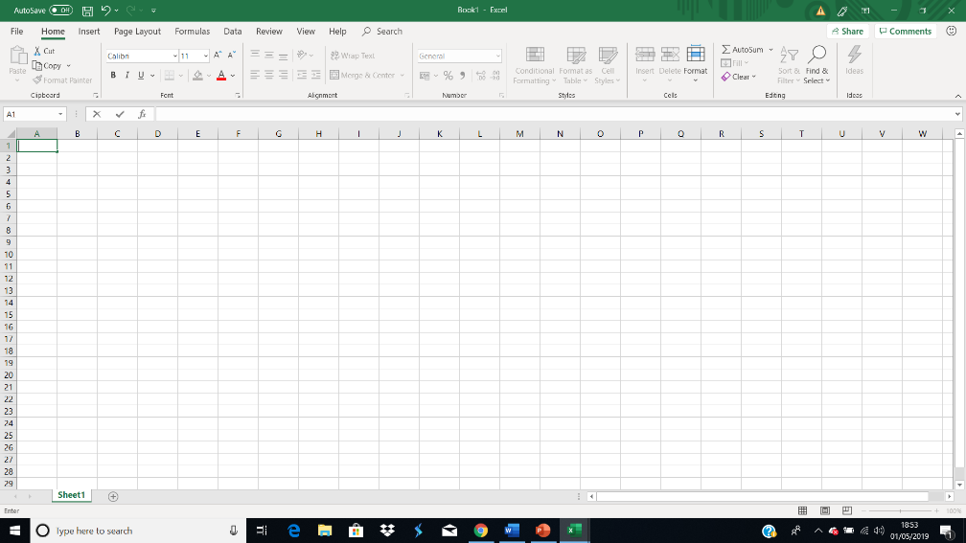

Spreadsheet modelling can simulate a prediction of what might happen in certain situations. Entering data into a spreadsheet is like typing in a word processing program, first click the cell in which the data is to be placed then type the data in. The spreadsheet has a grid of columns and rows which form the cells, which can have three types of data, labels, values, and formulas. Labels also known as text are descriptive type of information, like names, months, or any other types off identifying statistics, usually include some form off alphabetic character. Values are numbers that are then entered into the spreadsheet cell. A formula calculates the value of a cell, these functions are predefined and are already available in the software of excel.

DATA ANALYTICS
“Data analytics is the science of analysing raw data in order to make conclusions about that information. Many of the techniques and processes of data analytics have been automated into mechanical processes and algorithms that work over raw data for human consumption. Data analytics techniques can reveal trends and metrics that would otherwise be lost in the mass of information. This information can be then be used to optimize processes to increase the overall efficiency of a business or system” (Frankenfield, 2019).
Many types of information can be subjected to data analytics techniques to get an insight to which can then be used to improve things being analysed. First determine what data requirements are needed or to group the data into different categories. The data can be separated by for example age, gender, date, price. When the data has been collected and organised it can then be placed into it the spreadsheet. It can then be analysed using different functions within the spreadsheet for example duplications or errors. It is important to do this to see what the data is doing.

DATA VISUALISATION
“Data visualisation is the graphical representation of information and data. By using visual elements like charts, graphs and maps, data visualisation tools provide an accessible way to see and understand trends, outliers and patterns in data. In the world of big data, data visualisation tools and technologies are essential for analysing massive amounts of information and making data-driven decisions.” (tableau).
Data visualisation is another form of visual art as it can grab your interest. It will turn numbers and letters into appealingly visuals, making it easier to recognise patterns and find exclusions. It enables to quickly interpret the data and adjust different variables to see the effect.

STAGES OF MODELLING
The data model structure

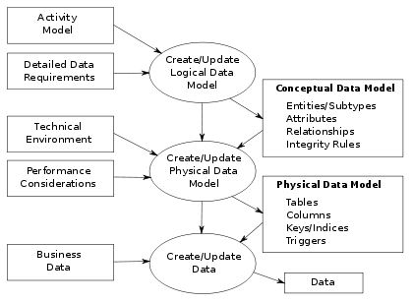
“The data modelling process. The figure illustrates the way data models are developed and used today. A conceptual data model is developed based on the data requirements for the application that is being developed, perhaps in the context of an activity model. The data model will normally consist of entity types, attributes, relationships, integrity rules, and the definitions of those objects. This is the used as the start point for interface or database design.” (wikipedia, Data modelling).
Start with all the relevant information of data that has been decided on being analysed onto a new spreadsheet. Enter the information into the cells, making sure that you have headings for each column and row, to make it easier to get the valued information needed at different times. Name the worksheet in the tab at the bottom where it will say sheet1, this will make it easier again to get relevant data. To widen the column to fit the data in the cell if to big then place the curser at the top off the cell where the ‘A’ is, until it changes into a small like plus sign then drag the cell across until the desired size it met. The same principle applies to the rows. Bold the write words or digits if required or change size of text.
Once all the data has been imputed the data may need to be checked for duplications which can be done via the duplication tool found in the data button in the commands this will automatically get rid off any. If numbers have been inputted with true values so they look like this ‘12.454’ perhaps the decimal point can be moved to tidy up the numbers, this is found in the home command at the top of the worksheet.
To use the actual advanced functions, press the formulas command at the top off the worksheet and they will appear look for the Greek sigma sign.

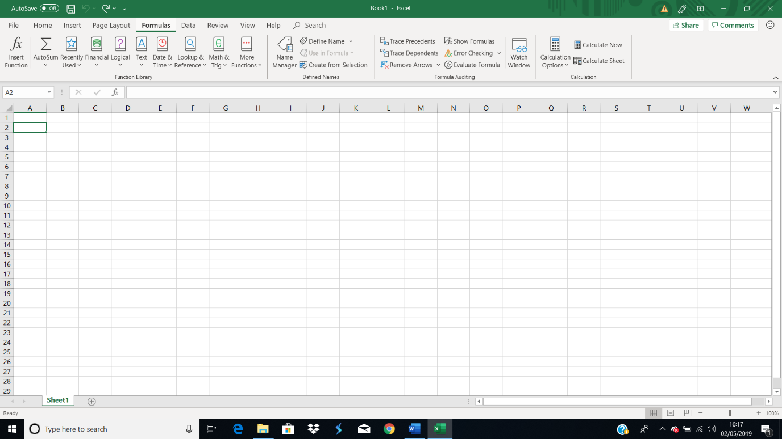

Autosum: press the autosum and a drop list will appear saying SUM, AVERAGE, COUNT NUMBERS, MAX, MIN or MIN functions. Highlight the cells or column press one of the function options and it will do it automatically once you press enter, simply select SUM and the total will appear in the cell relevant to the command. Insert function AVERAGE and it will again do this automatically. If you select COUNT NUMBERS a function argument table will appear so the data numbers from the cells desired for analysis it will then give you a numeral argument figure. This can also be found in the fx button on the formula bar the same function argument table will appear.
Select the fx button and the function table will appear select IF function, this will give you a returns value from the data if the condition is TRUE, or another figure if the conditions are FALSE.
The “VLOOKUP is an Excel function that allows you to search and retrieve a cell’s content from another column. As you might guess, that ‘V’ stands for vertical and relies on looking up data from the leftmost column of a lookup table. This column could be on the worksheet you’re using or another. The function requires a common field or key and four arguments. The function allows you to specify whether to use an exact match or approximate match. A common example might be looking up the name of a product from its sku.” (Hennegar, 2019)
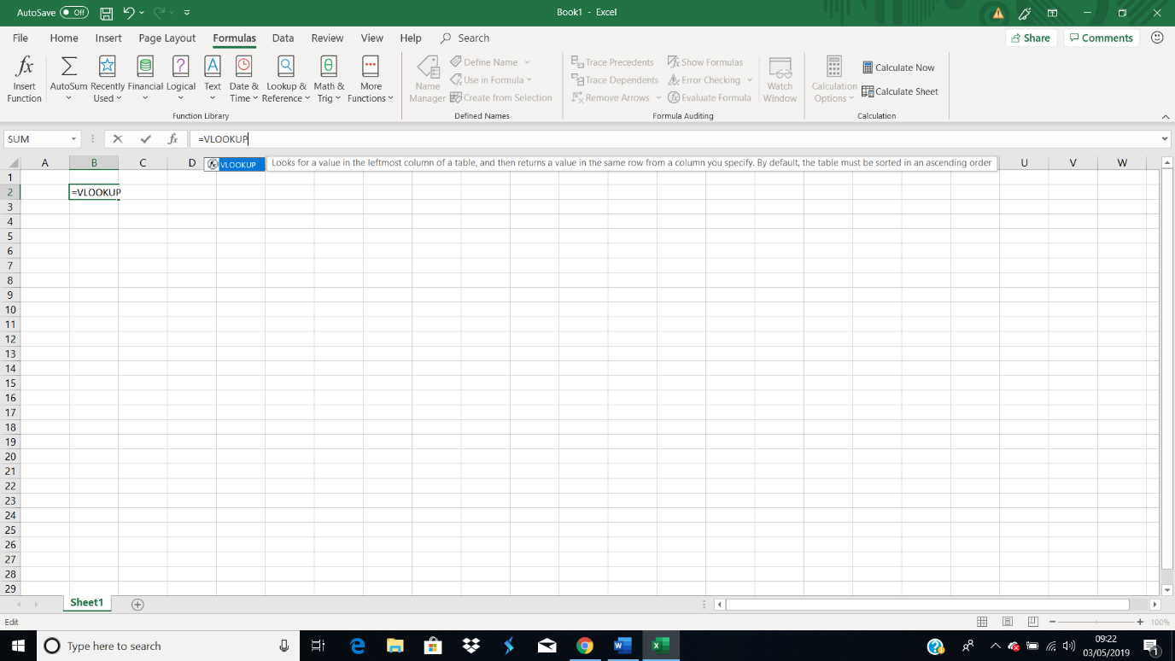

Pivot tables: This is selected via the insert command button then select pivot table, a table will appear for data to be chosen.
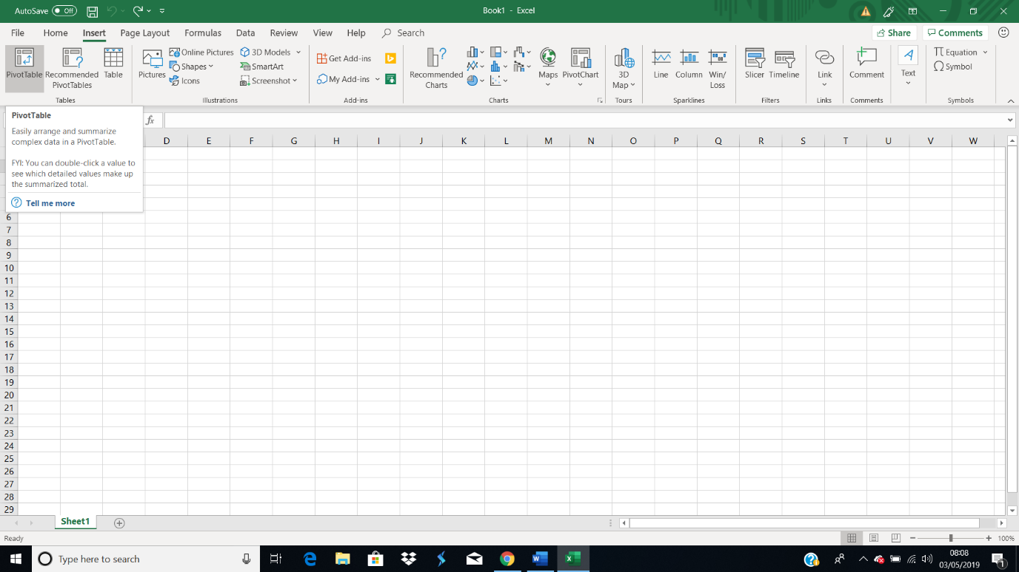
With the pivot table this allows significance extract of data from a larger more detailed spreadsheet to obtain a report that is summarized, or it can be used to find a more detailed unique value in a field for a report. Bar charts can be selected, and this can be used to visually compare values across a few categories. Map charts can be selected, and this can be used to compare values and show categories across geographical regions. Where as the pivot chart can be selected, and this can be used to graphically summarise data and explore complicated data.

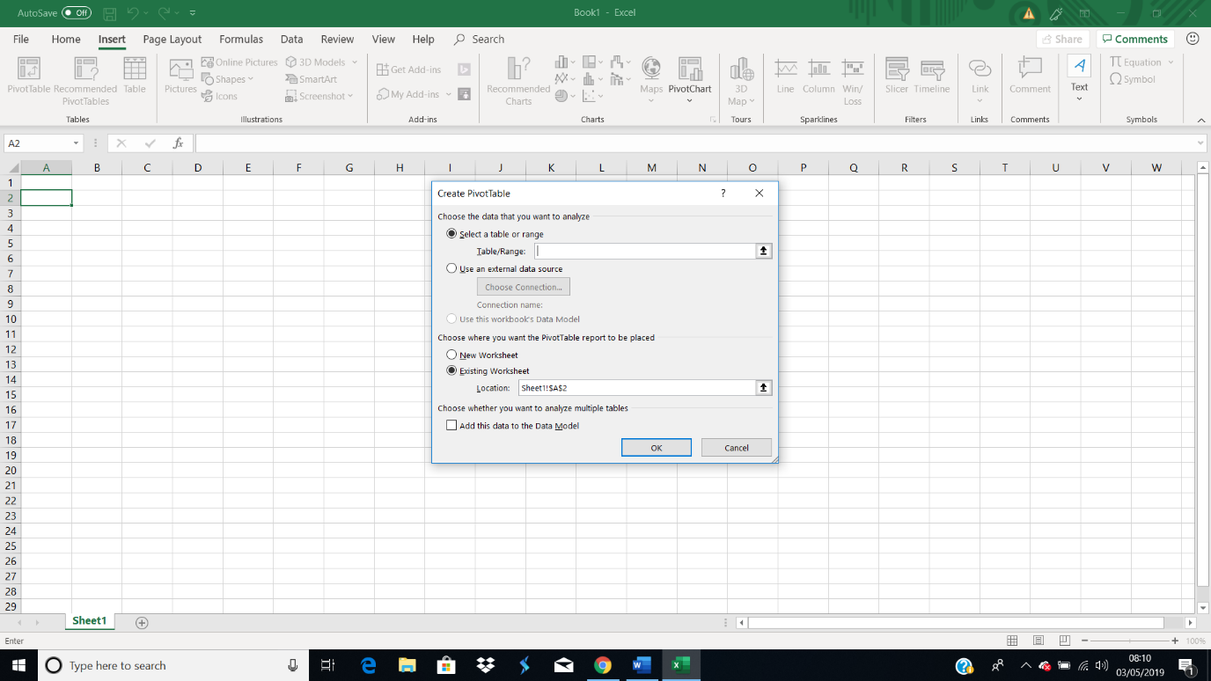

CONCLUSION
Spreadsheets in excel are becoming more and more important in the digital world. It is an important versatile tool for business in all sectors of the world. They hold and store a variety of information big or small that can be analysed to highlight certain information from data and then studied quickly and more efficiently. With some spreadsheet programs they can also work together with other programmes, like word processing or presentation software.
“Spreadsheets offer a range of advantages, particularly to business users. Popular spreadsheet programs such as Microsoft Excel provide the tools to analyse and visualise data sets in accessible ways. If you have a set of data related to numerical, financial, statistical or other information, you can use a spreadsheet not only to store this data but also to manage it, perform analytical processing on it and present it. Spreadsheets provide complex processing in ways that even people with little technical experience can access.” (Smith)
With data analytic, which is a science of analysing raw data. The techniques and process of the data analytic have been automated into a mechanical process and algorithms for data visualisation and this helps in so many different fields in government, finance, marketing, history, consumer goods, service industries, education, sport, healthcare and so on. It is becoming a increasingly valuable for professionals to use data to make decisions and optimize their performances. It can also be used to help analyse trends, which can lead to new and better services or products that will increase profits as well as keeping the consumer happy.

References
Dictionary. (n.d.). google search. Retrieved from google dictionary: https://www.google.com/search?q=what+is+a+spreadsheet&oq=what+is+a+spreadsheet&aqs=chrome..69i57.31863j1j8&sourceid=chrome&ie=UTF-8
Frankenfield, J. (2019, April 27). investopedia. Retrieved from Data Analytics Definition: https://www.investopedia.com/terms/d/data-analytics.asp
Hennegar, A. (2019, march 14). timeatlas. Retrieved from productivity portfolio: https://www.timeatlas.com/vlookup-tutorial/
institute, m. (n.d.). investgate common uses for a spreadsheet. Retrieved from https://www.fess.ie/images/stories/ResourcesForTutors/Resource_Lists_Level_5/InvestigateCommonUsesForSpreadsheets.pdf
Smith, S. (n.d.). your business . Retrieved from azcentral: https://yourbusiness.azcentral.com/advantages-using-spreadsheets-3647.html
tableau. (n.d.). Data visualisation. Retrieved from tableau: https://www.tableau.com/en-gb/learn/articles/data-visualization
wikipedia. (n.d.). Dan Bricklin-wikipedia. Retrieved from wikipedia: https://en.wikipedia.org/wiki/Dan_Bricklin
wikipedia. (n.d.). Data modelling. Retrieved from wikipedia: https://upload.wikimedia.org/wikipedia/commons/thumb/5/5d/4-3_Data_Modelling_Today.svg/1024px-4-3_Data_Modelling_Today.svg.png

