10/1/2019
Nicholas Evans
1704662
Internet Technology and Security
[Document subtitle]
Contents

Abstract 2
1. Introduction 3
2. Related work 4
What is BYOD? 4
BYOD policies that are in place and how are they maintained. 4
Acceptable Use 4
Devices and Support 4
Security 5
3. Problem formulation 6
What is the problem? 6
How do these problems occur? 6
Strategies on solving them 6
Advantages and disadvantages of BYOD? 6
Advantages 6
Disadvantages 7
Separation of business and personal 7
Different brands and operating systems 7
Preventing access once worker leaves 8
4. Implementation 9
Packet Tracer 9
Data flow diagram of the BYOD architecture 10
5. Results/Findings & discussions 11
6. Conclusion 12
What have I discovered? 12
Personal input 12
7. References 13

Table of Figures
Figure 1 - Packet Tracer 9
Figure 2 – Flowchart 10

Abstract

The main topic of this report is on how much BYOD effects the business world and how best to combat the complications it brings and using software such as Packet Tracer to design a network which can be accessed on a global scale via wireless access for employees working for the company Hyper-Fort.
There are many things to consider though, with BYOD bringing to the table many advantages to the workplace for all involved, the disadvantages can be said to easily out way them. With the threat of huge financial loss to the breakdown of the company’s network infrastructure as a whole, it wouldn’t come as a surprise if businesses decided to not bother with the practice. With the populace owning high tech smart devices being the norm, and the convenience of having the ability to work from anywhere with the devices which are already owned by the person, the pressure became too great for any business to stop the movement.
With the change, came a number of difficult hurdles to overcome. There’re the standard online threats which includes viruses, spyware and all sorts of malicious programs to contend with, hacking is also a growing concern, with more people having the knowledge to do so.
Human nature itself, with people accidently leaving the devices with company owned data saved in public places for anyone to find and ex-employees with grudges from having their contracts terminated, using that data to hurt the company out of spite.
With so many threats to contend with, there will of course be systems and policies in place designed specifically to combat each of them.

Introduction

The task has been given to an IT consultant employed by a large company with a global presence names Hyper-Fort, which has 95% of its network wireless based, come under pressure to allow both its staff and customers to use their own personal devices to access the companies network. The main concern would be the security for its own staff and client’s data and of course securing the safety of its intellectual property which is worth billions. Which could be in real danger without a fully comprehensive BYOD framework and security policies that will help protect the entirety of its enterprise network which includes online and offline recourses.

Related work

What is BYOD?
BYOD (bring your own device/tech) is a term used to describe the policy of companies allowing their employees to use their personally owned devices at the work place and connected to the company’s network. This of course can have major repercussions in regard to the company’s online security and the protection of their assets which includes everything from the workers and client’s personal data, to their own intellectual data which could be worth billions.

BYOD policies that are in place and how are they maintained.
Even though the term BYOD has been around for a number of years now, there still hasn’t been a widely adopted policy that every company follows. Each and every company do have rules in place to help maintain their security but the practice of it can differ by a surprising amount.
There are some rules though that even if written differently in the compony rulebook, are generally the same that are most often used. These are summed up wonderfully by Megan Berry [1].

Acceptable Use
- Devices are not to be used unless on break without permission or reason.
- All forms of media recordings are forbidden.
- If used for work, the device cannot have any downloaded Apps that aren’t from iTunes or Google play.
- Devices can be used to log into work emails, documents etc.
- Devices are never to hold any illegal content, other company’s data or cause harassment of any kind.

Devices and Support
- Only recognised brands and software are permitted.
- Any connection enquiries are to be dealt with by company IT department.
- All devices must be checked thoroughly by IT department before being permitted any connectivity to any work files.
- The company does not take any responsibility if the devices are damaged or stolen whilst on company property.

Security
- Password protected using a set number of letters, numbers and symbols with limited number of attempted logins.
- Unable to download any software that is prohibited by the company.
- Only permitted devices are allowed to connect to the network.
- The company holds the right to remotely wipe all data from the device if the device is lost/stolen, employment is terminated, or the company feels the data is at risk of harming the company via a virus or similar threat.

There are more terms and conditions which go in further in the fine print, but this is the most widely known practices. This way of thinking is still relatively new to companies, only having to start worrying about portable devices being more widely available in 2009, causing businesses to worry about their employees and customers alike from gaining access to their own information worth a lot of money from going public or even held ransom.

Problem formulation

What is the problem?
The biggest problem to solve here is designing a global network which will enable customers and employees the use of the company’s network using their personal devices but also keeping everyone’s data secure.

How do these problems occur?
With so many unregulated devices being attached to the network, the threat of data breaches or hacks are high. Anyone with hacking knowledge can in theory, present a danger of unearthing files or company assets which can be worth in the millions, to either use as blackmail for payment or even leaked online for the world to see.
Viruses and other such malicious programmes can also wreak havoc within the network. Causing irreplaceable files to be lost or even devices becoming unusable. These can be found on many unsecured devices that can attach to the network.

Strategies on solving them
A common solution is to have the intranet that only specific devices can be used by people who have permission to have access to the more important files, whilst having a separate network for contracted employees and customers alike to use.
Staff training on proper use of devises used, and for the workplace. To show the dangers using BYOD and the best way to help protect themselves from them.
Restricting which sites can be accessed and what content can be downloaded on the devices connected to the network.

Advantages and disadvantages of BYOD?
Like most things in life, BYOD has both its advantages and disadvantages. The tricky question here is, is it worth it? But even though that question is sound, it is also irrelevant. The modern world has proved to be an unstoppable force of swift change, and for companies to survive, must change with it. By listing the advantages and disadvantages of BYOD, it would help pin point what will help any business grow and of course, what can be a problem.
Here are a few of them by Krishnan Chellakari [2]

Advantages
- Increased Productivity – The ability to work from anywhere, anytime.
- Employee Satisfaction – Allowing the use of their favourite devices.
- Single Device Solution – One device for both work and personal.
- Cost Savings – No need to supply devices to workers.

Disadvantages
- Application Control – Unsecured apps and software installed by user.
- Potential Data Loss – Via hacking or accidental misuse by the user.
- Regulatory Requirements – Certain lines of work could have data which by law needs to be protected, which could prohibit the full use of the device.
- Loss and Theft – The device could be left in a public place by mistake or stolen.

Separation of business and personal
One of the biggest concerns with BYOD is the fact that very confidential and important data will be saved on the same device that people could potentially use to stream videos from unsecured sites, downloading software which can carry any sort of malicious software or program which in turn could put the business data at serious risk, and of course, mistakenly or not, sending the important data to 3rd parties causing the business to lose potentially millions.
Training would need to be a forefront in any workplace regarding the dangers of this to help decrease these risks as much as possible. Terms and conditions will need to be set up to help decrease the dangers that can occur by limiting the number of users to have access to such data using their own devices.

Different brands and operating systems
Before the days of BYOD became mainstream, businesses generally supplied their employees with devices that were of the same brand and also ran on the same operating software (generally Blackberry). This was due to the ease of protecting the data within the network due to the IT department only having to be concerned for one operating systems faults and vulnerabilities. When Apple and Android operating systems became more popular though, The increasing risk for IT Technicians to fight against became too difficult to cope with due to the hazards that each OS presented, and with the pressure of peoples demands to use their own choice of device, something needed to be done to help have a new system in place to allow the different OS devices to be used in a safe and secure manner for all.
The answer to this problem was MDM (Mobile Device Management). The software which is typically a server component, can help IT departments take control and also secure any device which is attached to the network they supplied.
‘IT administrators configure policies through the MDM server’s management console, and the server then pushes those policies over the air to the MDM agent on the device. The agent applies the policies to the device by communicating with the application programming interfaces (API’s) built directly into the device operating system.’ [3]
Even with this system in place, it still couldn’t handle mobile content such as Apps or even Windows devices and new IOS systems. This caused MDM to evolve through the years when new challenges arose, changing into EMM (Enterprise Mobility Management) which today is now known as UEM (Unified Endpoint Management).

Preventing access once worker leaves
A big issue for any business is the reactions of employees when they leave the company to work elsewhere by choice, or more so, when their contracts are terminated for any reason. It isn’t difficult to see people wanting to out of spite, act out against said compony in a harmful way if possible. BYOD can give them the means to do so. Due to the nature of BYOD, an employee can have any amount of sensitive data belonging to the company save on the device. If that employee feels mistreated, or is let go by the company, they could lash out by selling this information to competitors or even posting them online for anyone to see. For obvious reasons, this is a major concern for employers and a danger which needs to be addressed with.
Thanks to UEM, IT technicians can manually check up on and erase any files associated with the company to ensure the safety of its own assets, preventing any misuse with the data that any persons might maliciously use. There would also be steps in place to make this easier. Here is a list of tips and tricks by Sameer Kotian [4] which can help solidify security.
Compartmentalizing the Risk – Separate important data into files with different degrees of sensitivity.
Monitor Data Transactions – Having a policy which states that all compony owned data can not be copied and will have notifications if an attempt at this is made.
Intermediary Technologies – Limits the amount of data and applications that can be downloaded from the network.
Regular Checks – Ensure users that their devices are subject to regular checks to make sure nothing is amiss.

Implementation

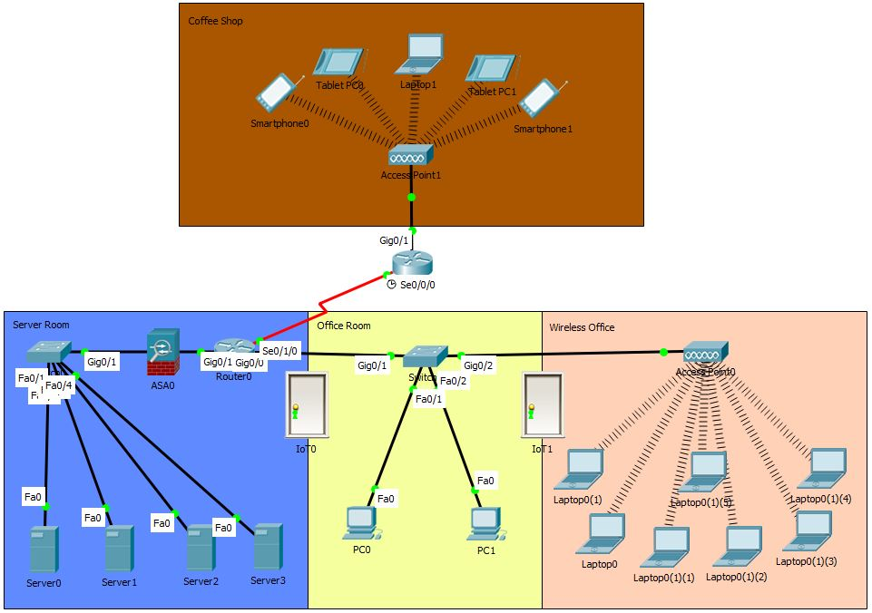
Packet Tracer

Figure 1 - Packet Tracer

The software used to design the structure of this network was done in Packet Tracer version 7.1 [5]. As displayed above, the design was built with large scale use in mind, meaning the network is accessible across a great distance. This allows the use of BYOD for anyone associated with the company to gain access onto their network from not only their own offices, but also as suggested, a coffee shop, which could be located anywhere in the world.
Security has also been put in place within the network, preventing access to anyone which doesn’t have authorisation to use the network. Internet security is also in place to prevent any malicious software or programs from entering the network. Physical security has also been implemented into the design. Showing the importance of not only the online security, but also preventing anyone from gaining access to the physical side of the network.
Packet Tracer as a software has been designed with ease of use in mind. Every component which a user might need can be located relatively easily with common sense, the drag and drop feature is without fault and the software itself runs smoothly. The only downside to using this software would be for people who are unsure of what each component does and how to connect them. With no quick help guides and easy to follow tutorials, it can come across as confusing for the untrained user.

Data flow diagram of the BYOD architecture

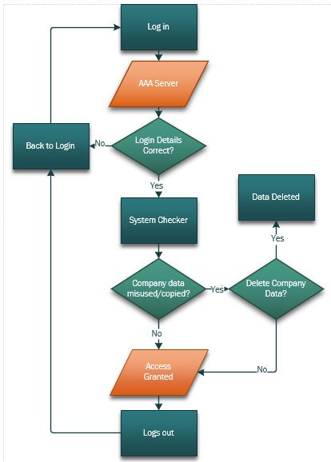
Figure 2 – Flowchart

The flowchart displayed above shows the most basic layout on how the login process would work once a user attempts to log into the network. To expand further, once a user attempts to log in, a few processes occurs that starts to run checks on the device attempting to gain access. Due to company data being saved on the employee’s personal devices, the system will scan the system to see if any misuse of the data such as evidence of the data being copied or if it has been saved onto public folders which can be easily accessed. If evidence of any foul play has been found, the system will notify the IT department with the results and evidence of what it has found, resulting with the IT department to deicide if any action needs to be taken, such as requesting a meeting with said employee or manually erasing any and all data which is considered as company property off the device and preventing further access to the network.

Results/Findings & discussions

The concept of BYOD is still considered a relatively new concept which all businesses has had to not only implement, but also find how best to deal with this new way of how employees work. As mentioned previously, the positives concerning BYOD can not only benefit the compony financially, but also has the potential to have productivity rise greatly thanks to the moral of its employees using devices that they favour and comfortable using, resulting in people being more inclined to also work away from the workplace.
The downsides though are cause for great concern. From infestation of the company network from malicious programs, to potential loss of data costing the business huge financial loss. To combat this, a great deal of resources was needed to swiftly design a policy and an online security system which could help prevent the loss of as many assets as possible.
With all this at stake, sometimes the simplest of designs can help any security be iron tight. Having a secure online security is of course a must, as this is where most problems can arise, especially with BYOD involved. With a system in place to not only actively seek out potential threats, but also the means to erase them, gives any business using the system the confidence to allow its employees the use of their own equipment connecting to the network. This isn’t the only threat that needs addressing though, as the employees themselves which resides in the workplace can also be a potential threat to the network. As anyone with the knowledge of how systems work, can easily plug in their device directly into the system manually, bypassing all security.
Here is where simple solutions shine. A door [6] that automatically locks once closed, which can only be accessed using a passcode or cardkey dedicated to only specific personnel which tells the system and in turn, the IT department, who is accessing the room at any given time. This alone is a proven strategy on not only preventing, but also detouring any and all potential threats to even consider attempting.

Conclusion

What have I discovered?
The concept of BYOD was never something that was ever considered. The simple action of taking a personal device such as a mobile phone into work was considered a standard practice for many reasons. Family and friends being able to keep contact in case of emergencies, or to simply respond to a parent or partner what they would like for their evening meal.
With this attitude in mind, Researching the origins and problems this simple act created revealed just how problematic a change in technology can be for businesses and the systems in place during the time of change, the inability to combat the new threats they presented. Having not only the new technology itself and the capabilities of it, but also the software it runs can put serious strain on any IT department trying to keep up with the security of its employers’ assets.
Considering how new a concept BYOD actually is, the speed in which such tech is evolving is staggering, causing yet even more problems all business will have to face and prepare for. With the BYOD practice only being the norm for less than a decade, businesses of all sizes has had to combat many faults and problems to update not only their own policies with how best to secure their precious assets, but also the data of their own employees which by law, must be safeguarded.

Personal input
Putting into perspective the time span that businesses has had to update and change with the rise of how society works is staggering. Considering how quickly technology is advancing, the pressure to keep changing still due to new threats these presents must be extremely stressful for the IT departments. With the different models and software each device can have onboard, the work involved to try and keep ahead is easy to see. And with competition between each manufacture to outdo each other, the speed in which these devices change will just cause more strain on trying to maintain security for all involved.
Using Packet Tracer helped to see only the basics involved in how much work goes into such an ever growing concern BYOD is. The number of ways a system can be breached all thanks to employees which are uneducated or just uncaring of the seriousness of the situation is terrifying.
Just like all problems though, education can help make the battle easier. With the new generation growing up into this ever changing world of updating tech, bringing forth the knowledge and consequences of their own actions which could not only affect their workplace, but themselves on a personal level. Especially with life being more online than ever before, any threat to anyone’s online presence, can be devastating.

References

[1] | M. Berry, “IT Manager Daily,” [Online]. Available: http://www.itmanagerdaily.com/byod-policy-template/. [Accessed 20 12 2018].
[2] | K. Chellakari, “searchsecurity.techtarget.com,” [Online]. Available: https://searchsecurity.techtarget.com/feature/Developing-a-BYOD-Strategy-Weigh-the-Risks-Challenges-and-Benefits. [Accessed 10 12 2018].
[3] | M. Rouse, “techtarget.com,” [Online]. Available: https://searchmobilecomputing.techtarget.com/definition/mobile-device-management. [Accessed 11 12 2018].
[4] | S. Kotian, “techshout.com,” 23 10 2018. [Online]. Available: https://www.techshout.com/internet/2018/23/byod-security-what-happens-when-employees-leave/.
[5] | Cisco, Packet Tracer, 2016.
[6] | K. M. Hess, Introduction to Private Security, 5th ed., Cengage Learning, 2008.

