Jean-Paul Marshall
Marshalls LTD
Date: 10/01/2023
Project: Ysgol Glangwili
Project Number: 5010
Subject: Proposal Letter to a client

Dear sir/madam
I Jean-Paul Marshall am writing this letter on behalf of Marshalls LTD. The purpose of this letter is to highlight our understanding of Building information modelling (BIM) maturity regarding your project, mainly how information will be shared, coordinated, and managed with the appropriate international standards included with reference to your BIM execution plan (BEP). The main purpose is to supply the information that you need, highlighting what’s most relevant to your project and explaining the terminology and processes. If we begin with what is BIM and then go through the information that goes along side, it.
The NBS state that “BIM is a process for creating and managing information on a construction project throughout its whole life cycle. As part of this process, a coordinated digital description of every aspect of the built asset is developed, using a set of appropriate technology. It is likely that this digital description includes a combination of information-rich 3D models and associated structured data such as product, execution, and handover information. Internationally, the BIM process and associated data structures are best defined in the ISO 19650 and 12006 series of standards” (Hamil, 2021). So, by following these procedures and standards we make the sharing of information seamless, this is done because information is shared fluently between all trades and professions. It’s important to talk about BIM maturity, BIM maturity has three levels. Level one introduces 3D cad, but mainly uses 2D cad software and is used mainly for conceptual work. When using cad, the standards that we must work to are BS 1192:2007 these standardise the spatial coordination, naming conventions and project specific codes. BIM level 2 is where we start to store information collectively to be shared, to do this we use a common file format such as IFC Construction Operations Building Information Exchange (COBie) for ease of entry and the sharing of information. Cobie’s system allows that information from construction teams and professionals to be shared in a clear regimented fashion and following BS 1192-4:2014 which is the British standard for how information is shared (Law, 2019) (Builkdings, 2022). At this stage the RIBA working stages are followed, these are followed to show the client the information they need and why. By doing this everyone has the same picture of the project, what is needed and why. This is a much better process than the old school way of a big unorganised data transfer at the hand over stage, but I will go into this in more detail in the appendix at the end of this letter APPENDIX ONE.
. This is done by using 3D software. This level of maturity brings your BIM execution plan into play. It is also worth mentioning that your project will need a maturity level of 2 as it is a public sector project and must be completed at BIM level 2. When looking at your execution plan, it would be the project team or the lead appointed party that would establish your BEP. It will be highlighted in your EIR how your BEP will be met. So, in the EIR it will show who is doing it and can they do it, there company details and the team they supervise., The standards they will follow such as the software they use, the coordination and collaboration methods used, the level of information needed (LOD and LOL), asset information requirements, classifications to be used, health and safety, security, model constraints and file format delivery and exchange (Law, 2019). There is also a BIM maturity level known as level 3, however this level is not fully developed yet, but the government does have a level 3 plan that involves the process of new data standards that allow stake holders and team members to work together on the same project at the same time. The government has put in plans to use level three to train clients of the public sector to use BIM and to allow further collaboration. We would start by looking at the employer’s information requirements known as the EIR, this shows what information the client must provide, why the information is given, who will work on the project, the suppliers as well as other information that is required for the project. The EIR is used for you the client to decide what you want from each stage and what detail the working designs will come in, and what you want added in each stage. The next document we would look at is the BEP also known as the BIM execution plan, this is a document that outlines everything that happens from conception to end of life. It includes what is going to happen, who it is done by, why it’s being done and adds in all calculations and designs. This is done so everything is planned for and to minimise anything going wrong and what to do if it does. There are two stages to BEP, first stage is pre contract, this is where the early plans are set out and how they might work. The second stage is a much more detailed version, setting out exactly what is going to happen, bye who and is then confirmed by a regional designee (Law, 2019) (Buildings, 2021). When looking at the Employers information requirements known as EIR, we must follow the EN ISO 19650-2:2018 as this supplies the project information such as, who is responsible for Establishing the project’s information requirements: Organizational Information Requirement (OIR), Asset Information Requirements, Establishing the project’s information delivery milestones, Establishing the project’s information standards, Establishing the project’s information production methods and procedures, Establishing the project’s reference information and shared resources, Establishing the project’s common data environment, Establishing the project’s information protocol and the activities for assessment and need. It’s important to look at if the organisation has the team got the correct training, experience, and technology training to understand BIM and the technology it uses to deliver your project. Also do they have the correct software to provide you with all the relevant information in the correct format delivered under ISO 19650 ½ and COBie. Also, it’s worth mentioning are they using the correct security measures put in place (Law, 2019) (Buildings, 2021). When looking at the CAD and modelling standards, we must ask are the correct procedures being followed to ensure all information is presented and shared in a format that is clear for everyone. Some examples are revision notes to be included, Grammar and spelling checks are carried out, Layering and object naming is consistent, Drawing or model files are cleaned up, all annotation styles are to industry standards, correct title sheets are used, and Model files have been detected from central and work sets removed. The Revit model check can be used to take on some of these tasks (Buildings, 2021). Correct coordination is very important as this makes sure that all disciplines are in alignment when it comes to the project model, for example they are all using the same model’s geographical location setting, this is det bye the lead designer and all members would follow. This is set out in the BEP. This is a very important aspect of collaborating as a whole team. If this is not done it could cause severe issues and potential rework and designs. I would suggest using the BIM 360 suite of tools as they allow you to collaborate and coordinate easier (Building, 2020) A link to this tool is https://www.autodesk.com/bim-360/construction-management-software/trade-coordination-collaboration/bim-model-coordination-solution/. The Level of information need LOI and LOD level of detail, when looking at the LOI or LOD, we need to refer to EN ISO 19650-1, this is because it highlights the level of information needed not the level of information. That why we have level of information (LOI) and level of detail (LOD). When setting these out each information section should be set out according to its purpose and level of information. When doing so it’s important to know the correct level of information that is needed, this makes sure we supply enough information but not too much as this increases cost and offers no added value. The same can be said for when we are using Revit to build the 3D modelling. Different projects will call for a varied amount of different information for example a structural model will have more information than a drawing for services as there is a difference ion maintainable asset (Law, 2019). The file exchange format is when exchanging information in the project it’s critical that all information that is created or shares is in the correct format. To make sure this is done correctly we should follow the EIR as these states the required software to use, I will add researched examples in the APPENDIX TWO.
. So, the same software and version should be used as the deliverables could be RVT, NWC and IFC (Law, 2019). The model volume strategy varies from project to project, but it would still follow a certain principle such as subdisciplines or originating disciplines. But these can be split even further for example concrete frame, steel frame, substructure, and superstructure. An example would be the architect would have, interior, exterior and furniture. Building services would have mechanical, electrical and fire. Structural engineer would have sub structure and superstructure (Law, 2019). Project hand over is when it comes to the point the project is ready for hand over, the main contractor will supply the operational maintenance (O&M) and health and safety files this includes the as build documentation. When looking at the owner ships of models it is a very grey area as so many people work on the. It usually belongs to the originator. When it comes to the operational model use, it will be checked and will remain in the health and safety file. Th structural models don’t normally change unless there is a redevelopment. But sometimes there is a need to push some of the data into the CAFM system. All the information should upgrade to a current version to keep from losing data and is done by the assert operator (Law, 2019).

Thank you for giving us your valuable time and we are looking forward to your response.
Yours truly
Jean-paul Marshall
Owner, Marshalls LTD
JPMarshall

References
Building, D. a., 2020. BIM execution plan BEP. [Online]
Available at: https://www.designingbuildings.co.uk/wiki/BIM_execution_plan_BEP
[Accessed 11 January 2023].
Buildings, D., 2021. Employerss information requirments. [Online]
Available at: https://www.designingbuildings.co.uk/wiki/Employer%27s_information_requirements_EIR
[Accessed 11 January 2023].
Buildings, D., 2021. Level of development LOD. [Online]
Available at: https://www.designingbuildings.co.uk/wiki/Level_of_Development_LOD
[Accessed 11 January 2023].
Buildings, D. a., 2021. Computer aided design CAD. [Online]
Available at: https://www.designingbuildings.co.uk/wiki/Computer_aided_design_CAD
[Accessed 11 January 2023].
Builkdings, D., 2022. Building information modeling BIM. [Online]
Available at: https://www.designingbuildings.co.uk/wiki/Building_information_modelling_BIM
[Accessed 11 January 2023].
Hamil, D. S., 2021. what is BIM. [Online]
Available at: https://www.thenbs.com/knowledge/what-is-building-information-modelling-bim
[Accessed 11 January 2023].
Law, M., 2019. Understanding BIM Project Requirements. [Online]
Available at: https://www.augi.com/articles/detail/understanding-bim-project-requirements
[Accessed 11 January 2023].

APPENDIX ONE

The Royal Institute of British architects (RIBA) plan of work has been around since 1964, but in its primitive form, it was updated to what it is today in 2013 and then was upgraded to its new version in 2020. There are eight stages to RIBA that we need to look at

Strategic definition
At this stage we will look at the client’s business case and core project needs. You would then look at what sort of team you need to for the project. After looking at several sites the program would be made. Then the consultant and the client come up with a scope of works for the project.

Preparation and brief at this stage the project team is put together and their roles sorted out and defined, at this stage its necessary to look for the outcomes, the budget and add in the risk assessments. Its best to do this based on previous projects. The procurement strategy should be developed along side the project programme.

Concept and design
At this stage the concept design initial response is given on the project brief, concept design is made in line with the initial project’s brief requirements. The project team makes up a few different strategies for the project, these include hand over, operational, sustainability and maintenance. These strategies must include the buildability, post-occupancy, and operational issues. When this is done its all put together to form the final project brief.

Developed design
At this stage concept design is refined and the base designs are formed. So, the architecture, and engineering designs will have been done and checked by the lead designer. After the lead designer has checked the work, the project strategies will be developed and detailed ready to be signed of by the client.

Technical design
At this stage the lead designer oversees the preparation of the technical designs as this incorporates the base design team and possible a sub-contractor specialist. At this point the architecture, structural and mechanical specifications and designs should be complete and show all main parts. There will also be a list for specifications and how all the parts fit together.

Construction
At this stage the procurement strategy should be in place ready to respond to design queries from site. The construction of the building will follow the project programme and include all the aspects from the building contract. The project specific schedules of services are also followed when looking at other services.

Hand over and close out
At this stage the hand over is dealt with by the project team and following the project programme, they will also conclude the contract. Other services may be required so it’s important to look at the procurement and hand over strategies.

In use
At this stage RIBA has made it apparent that using the design specifications will make the operational use of the plan successful (Marshall, 2018) (MA, 2020).

I have included the framework below from it shows what I have gone through above (MA, 2020).
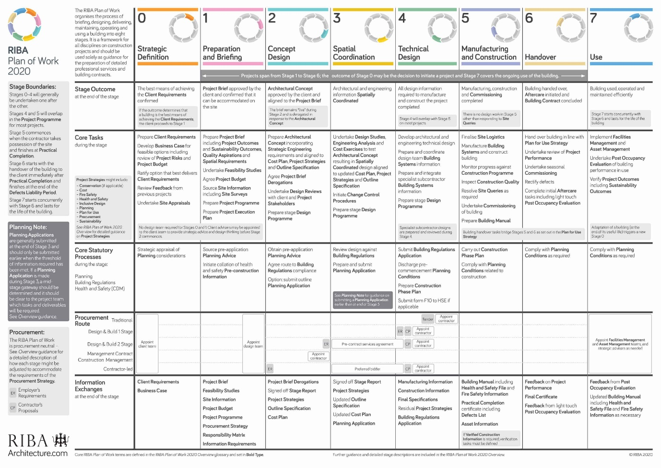

APPENDIX TWO

researched examples of items to add into the employer’s information requirements (EIR)
I will add in some information and examples I think are important for you to look at for your project. This start with PAS 1192-2 as this is the standard we work to, as this sets out the code of conduct when dealing with the information requirements. Its then important to look at what this all means, so the EIR dictates the management characteristics, production, and delivery process. So that leads us to what do we need there are several different researched routes some of are
- Organisational information requirements (OIR)
- Asset information requirements AIR)
- Project information requirements (PIR)
- Project information model (PIM)
- Asset information model (AIM)

This can be seen clearer in the image below from (Biblus, 2021)
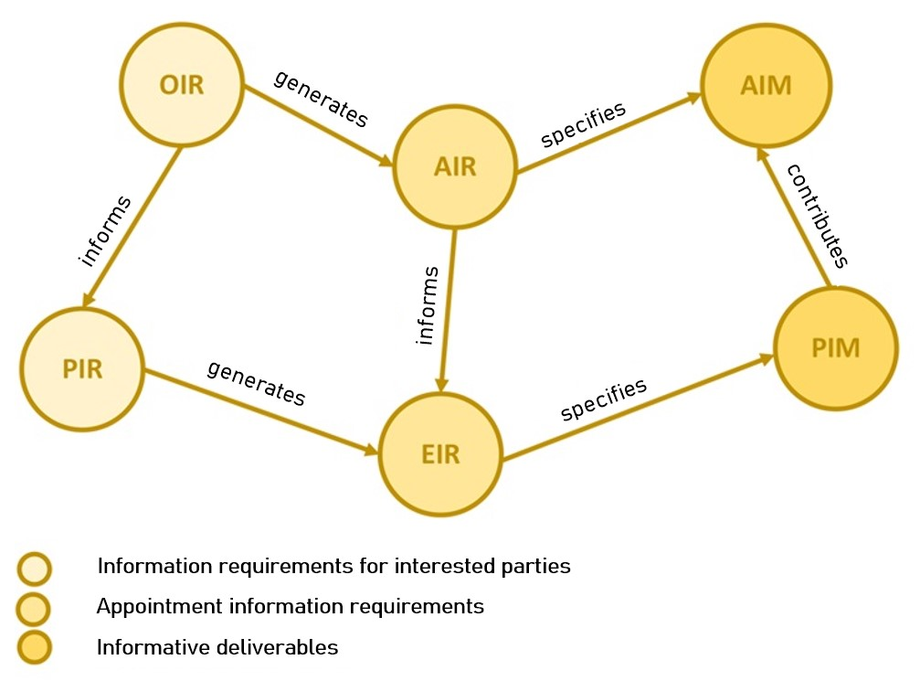

To prepare correctly, there are three areas we must look at to include these are

1, technique this includes formats, level of detail, software platforms, coordinates, and level of training. 2, management this includes standards, responsibilities, roles, data security, coordination process, collaboration process, scheduling model review meeting, design health and safety management, constraints, compliance plans and asset information delivery mode. 3, commercial this includes strategic objectives, BIM results to be achieved and competency assessment (Biblus, 2021).

Appendix references

References
Biblus, 2021. Exchange Information Requirements: What is an EIR in BIM?. [Online]
Available at: https://biblus.accasoftware.com/en/exchange-information-requirements-what-is-an-eir-in-bim/
[Accessed 12 January 2023].
Building, D. a., 2020. BIM execution plan BEP. [Online]
Available at: https://www.designingbuildings.co.uk/wiki/BIM_execution_plan_BEP
[Accessed 11 January 2023].
Buildings, D., 2021. Employerss information requirments. [Online]
Available at: https://www.designingbuildings.co.uk/wiki/Employer%27s_information_requirements_EIR
[Accessed 11 January 2023].
Buildings, D., 2021. Level of development LOD. [Online]
Available at: https://www.designingbuildings.co.uk/wiki/Level_of_Development_LOD
[Accessed 11 January 2023].
Buildings, D. a., 2021. Computer aided design CAD. [Online]
Available at: https://www.designingbuildings.co.uk/wiki/Computer_aided_design_CAD
[Accessed 11 January 2023].
Builkdings, D., 2022. Building information modeling BIM. [Online]
Available at: https://www.designingbuildings.co.uk/wiki/Building_information_modelling_BIM
[Accessed 11 January 2023].
Hamil, D. S., 2021. what is BIM. [Online]
Available at: https://www.thenbs.com/knowledge/what-is-building-information-modelling-bim
[Accessed 11 January 2023].
Law, M., 2019. Understanding BIM Project Requirements. [Online]
Available at: https://www.augi.com/articles/detail/understanding-bim-project-requirements
[Accessed 11 January 2023].
Marshall, L., 2018. The RIBA Plan of Work: Eight Key Project Stages Explained. [Online]
Available at: https://www.novo.eu.com/post/the-riba-plan-of-work-eight-key-project-stages-explained
[Accessed 12 January 2023].
MA, U. B. B. (., 2020. How to Use RIBA 2020 Plan of Work: RIBA Design Stages Explained [Updated]. [Online]
Available at: https://urbanistarchitecture.co.uk/riba-plan-of-work-stages/
[Accessed 12 January 2023].

