

EFFECTIVE TEAM WORKING AND COMUNICATION

ASSESSMENT GROUP 12

Student Name: | ANAMARIA FERMESANU
Student Number: | 1907760
Module No: | BMSW4002_LON
Module Title: | EFFECTIVE TEAM WORKING AND COMUNICATION
Lecturer: | MOLLY JACK
CONTENTS:
- INTRODUCTION
- TEAM AND TEAMWORKING
- DEFINITION OF THE TEAM
- TEAMWORKING
- COMUNICATION SKILLS
- DEFINITION OF COMUNICATION
- VERBAL COMUNICATION
- NON-VERBAL COMUNICATION
- MODELS OF COMUNICATION
- SHANNON AND WEAVER
- SCHRAMM
- BERLO
- WRITTEN COMUNICATION
- EFFECTIVE COMMUNICATION AND LISTENING
- CONCLUSION
- REFERENCES

- INTRODUCTION
Communication is one of our life's most important factors. It dictates the personal and professional relationships that are formed with the individuals. Effective communication provides a basis for increasing trust and respect. It also helps to better understand a person and the conversation meaning.
Knowing how to communicate effectively can strengthen one's home, work and social relationships. Having communication skills like listening, non-verbal communication and stress management can help improve one's relationships with others.
The present material aims to show that teams, as well as individuals, must exploit human potential, unique and extremely powerful. We can learn a lot by using the awareness we possess. Unlike animals, we are able to reflect on experiences and adapt - consciously - what we do to varying circumstances. In addition, we can use this ability in order to improve the functioning of the team, instead of relying on simplistic ideas that prove useless in the various situations facing the group.

2.TEAM AND TEAMWORKING
According to Business Dictionary (2019) a team is a group of individuals with a complete set of complementary skills needed to complete a task, job or project.
A team is a group of individuals assembled to achieve a common purpose, autonomous, representing themselves and other members (persons) as a team, that has a variety of sub-tasks. There are teams in large organisations. They are not isolated, but also communicate in the company with other departments as well as with the organisation itself. Teams are the only way the organisation can receive input from its members and give the sense of participation to the members of the organisation in order to achieve the organisational objectives. In addition, teams allow organisations to be flexible in assigning members to different tasks and projects. To work well within a team, effective collaboration skills are needed.
Teamworking is a term that describes people working together in different fields as in a sports team, in a cooperative manner. Projects often require people to work together to achieve a common goal, so in most organisations teamworking is the most important factor.
Teamwork is the team's ability to work effectively together to achieve common organisational goals and is crucial to the success of business. That's why companies are actively seeking to improve the performance of the team. Organizations aim to create and support high performance teams that are capable of understanding the organization's business goals and thus contributing to organisational success.
Operating in a team needs a range of skills so every member of the team can accomplish a common objective. The attributes required to ensure 100% participation by team members are as follows:
- Communication skills
- Problem solving skills
- Listening skills
- Conflict management skills
- Positive attitude
- Flexible
3.COMMUNICATION SKILLS
Maybe the most important thing of all life skills is being able to communicate effectively. It helps us to transmit information to others and to know what we are talking about. The simplest way to communicate is to transmit information from one place to another. It can be verbally (use of voice), written using printed or digitally media like books, journals, web sites or e-mails, visually (use of logos, maps, diagrams or charts) or nonverbally (use of body language, gestures and sound and voice pitch). In reality several of these are often mixed.
Verbal communication is all about what we say, an essential way to convey our message and it can be both written and spoken. The vocabulary we choose can make a big difference in our interpretation by others. There are many different skills in verbal communication. These vary from the obvious to the subtler (for example, to be able to speak clearly or to listen), (for example, to reflect and clarify).
““When enough people have similar talents, and are competing for the same positions and opportunities, the real differentiator is your interpersonal skills. The way you present yourself, how you communicate with other people, whether it’s in an interview or with management at work, can make or break your personal brand. More and more people are starting to realize that the little things matter, especially in our current competitive environment.” (Dan Schawbel, 2011).
Below is a list with some tips for an effective verbal communication:
- Be pleasant. Those who connect with a friendly tone and warm smile have the advantage almost always. The reason is simple: we are subconsciously attracted to people who are nice because they make us feel good and bring more joy to our lives.
- Be clear. Most of us have no time and do not want to waste our emotional energy to find out what someone else is trying to say. Indirect people, who prefer to point at issues without saying what they really mean, are seldom valued.
- Be your authentic self. People are drawn to someone who is honest, clear and truthful, speaking from the heart.
- Speak with confidence. Self esteem is a confidence that comes from the appreciation of the true ability, whereas humility has its own modest opinion. The words you choose, the tonne of your voice, your eye contact and the body language are part of your confidence.
- Be a good listener. In verbal communication, being an attentive listener is more critical than any word coming out of your mouth. In what is being said, you must show sincere interest, ask good questions, hear the message in the conversation and do not disturb it.
Non- verbal communication is defined as behavior and speech elements other than words which convey meaning. Nonverbal communication involves voice pitch, rhythm, tone and volume, facial expressions and movements, body posture, attitude and the presence of the listener, eye and touch, and dress and aspect.
Research has suggested that only five percent of the effect of the spoken word, 45 percent of the tone, inflexion, and other voice elements, and 50 percent of the effect of bodily language, eye contact, are produced.
Kunkzick and Zipfel distinguish forms of non-verbal communication according to the channels of information transmission:
- the auditory channel: verbal and paraverbal communication
- visual channel: mimicry, gesture, attire, clothing
- the tactile channel: the voluntary or involuntary touch
- olfactory channel: the smells the receiver perceives
Another classification of nonverbal forms of communication is proposed by John
Fiske, taking as a criterion the codes, the forms of transmission of the messages. Ten categories are listed:
- body contact refers to the ways in which we reach the people around us and messages transmitted in this way.
- Proximity is related to the use of space, more precisely, to the physical distance between people when a communication process takes place.
- orientation or positioning of the interlocutors in the communication process
- appearance
- head movements play an important role in the interaction between individuals and especially in the exchange of roles between the sender and the receiver
- facial expression is one of the variables that undergo few changes depending on the culture of origin of the interlocutors.
- gestures or kinesics refer to the movements of the arms and legs and come to complete verbal communication.
- posture means the position of the interlocutors at the time of communication (standing, sitting)
- eye movements and eye contact. The frequency of eye contact between participants in the communication process is an important way of transmitting messages.
nonverbal aspects of speech include prose codes, more precisely, intonation and syllabification, as well as paralingual codes, that is, those that betray issues related to the emitter (tone, rhythm, errors).
4. MODELS OF COMMUNICATION
4.1 Shannon and Weaver model:
The fundamental model of communication, subsequently improved by many other sociologists, is that of the Americans Claude Shannon and Warren Weaver, from 1949. The model is typical for transmission current. These models focus on the process of transmitting the message and not on the transmitted meaning. Shannon and Weaver, being of technical and mathematical training, based their model on radio transmissions, considering the meaning as being included in the message.


4.2 Schramm model:
Named the "father of studies in communication", Wilbur Lang Schramm proposed in 1954 a new model of communication that is noticeable through its circular component. Coming in response to the linear model, Schramm notices a simple truth in appearance, but is able to influence the theories that followed, namely that one cannot talk about communication that begins at one point and ends at another, like a road one-way. It is not a transmitter and a receiver, but interchangeable roles, where the communicator successively performs coding, interpreting and decoding messages.
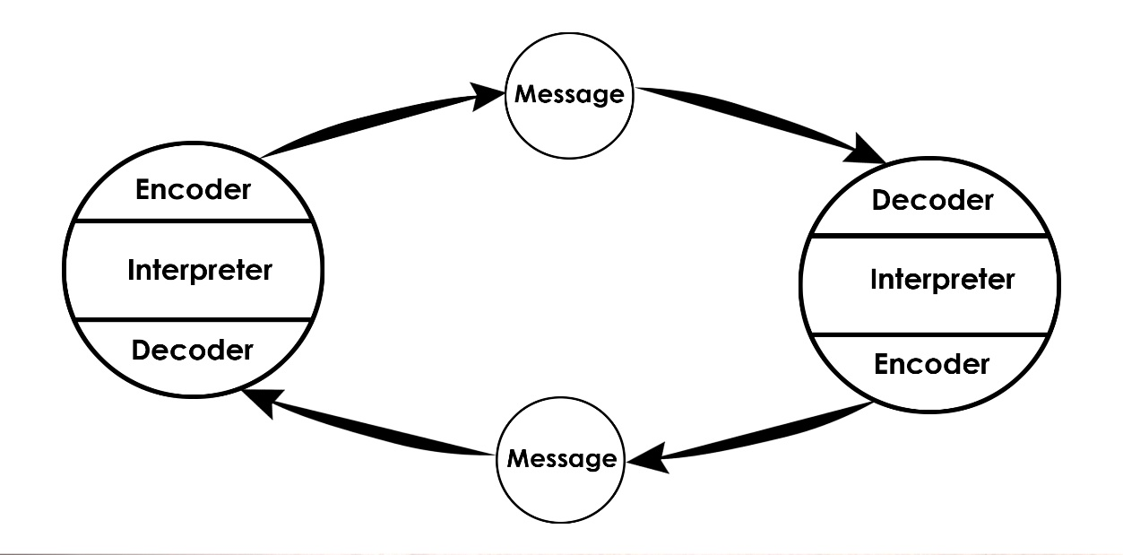

4.3 Berlo model:
Berlo's model highlights the psychological nature of communication. It focuses on different components, including attitudes, intentions and specifies the conditions for an efficient transmission.
SMCR represents the source (S), the message (M), the channels (C) and the receiver (R)
The source wants to transmit something, the message consists of elements and has a structure, the channel is represented by the five senses, the receiver has the same characteristics as the source, influencing communication. In Berlo's conception, communication is a dynamic and continuous process between two persons who can be separated and simultaneously, and transmitter, and receiver. It is a linear and sequential model, not realizing a dynamic relationship between the different elements of the model.
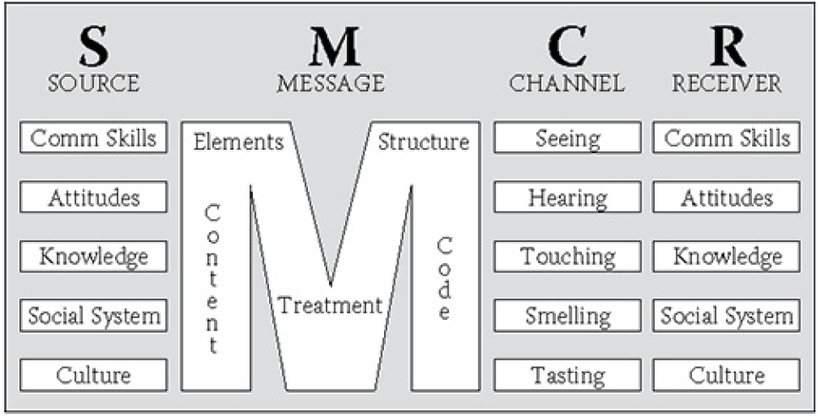
5. WRITTEN COMMUNICATION
The written Communication refers to the process of transmitting a message through the written symbols. In other words, any message that is exchanged between two or more people using written words is called written communication. The most popular and efficient form of business communication is written correspondence. Some of the widely used types of written communication are the electronic mails, emails, reports, papers, letters, journals, job descriptions, employee manuals, in any organisation.
The advantages of written communication are stated below: It is ideal for repeated standing orders and long-distance communication; It creates an ongoing record of evidence; it gives enough time to think, act and respond to the receiver;
it can be used for legal purposes; it can be forwarded at a time to many individuals; good writing will build goodwill and improve business.
Written communication should be transparent, detailed, succinct, right and courteous in order to be effective.
6. EFFECTIVE COMMUNICATION AND LISTENING.
Active listening is one of the principles of effective communication. With her help you can increase your efficiency at work, and you can improve the quality of all relationships. The principle of active listening is one of the most famous principles of interpersonal communication. This principle was greatly emphasized in the communication courses held by Dale Carnegie. It is a principle meant to pay attention to the interlocutor, to take our attention from the internal dialogue. Many times when we are in a conversation, we rarely listen carefully to what our caller is telling. During this time, our thinking is busy judging the words of the person concerned, comparing, justifying themselves, or simply preparing his next reply. This inner dialogue is a real wall between us and the discussion partner, leaving us to be truly present in the conversation. The effect of our inattention is the lack of total interest, which can be read from the gestures, at the level of the subconscious of the interlocutor. Thus, without us realizing, we can send signals of lack of interest or boredom of the discussion partner, deciphering them all at the level of the subconscious. This leads to inefficient communication, and all due to lack of attention.
To be a good listener you need: Attention-to listen carefully to what others have to say; patience - to be calm when you cannot keep your attention to the interlocutors words; curiosity - as motivation to keep your attention.
Communication is more important than ever in today's high-tech high-speed, high stress world, but we are looking to listen to each other less and less. Real listening has become an uncommon donation— a gift of time. This promotes building connexions, addressing problems, comprehension, conflict resolution and improving accuracy. Efficient listening at work means fewer mistakes and less time wasted. Here are some ideas to help develop good listening skills:
- face the speaker and maintain eye contact.
- be attentive, but relaxed.
- maintain your mind open.
- hear the words and imagine the speeches of the speaker.
- do not disturb or enforce your "ideas."
- wait for a break from the speaker to ask questions for clarification.
- only ask questions to ensure clarification.
- try to perceive the feeling of your speaker.
- provide feedback to the speaker.
- look out for what is not said, for nonverbal signals.
We need to educate our focus, our emotions, carry them into the present action or discussion in order to become a good listener. Working with patience, trusting in our abilities, focusing on defects and other aspects, our attention and curiosity to improve our communication skills can also be developed and maintained. Over time, we will build successful relationships and partnerships over self-education and perseverance.
7. CONCLUSION
Good communication is an indispensable tool in order to achieve efficiency and to maintain strong working ties at all organisational levels. Workers who invest in clear communication lines would quickly create trust in workers, resulting in increased efficiency, success and morality in general. Furthermore, workers who effectively communicate with peers, supervisors and clients always have valuable assets for the organisation and are often willing, when they apply for jobs, to differentiate people in their competition. Weak organisational communication can inevitably lead to frustrated workers who may start questioning their own trust in their skills and ultimately in the business.
8. REFERENCES
www.businessdictionary.com
www.skillsyouneed.com
www.thebalancecareers.com
“The Wiley Blackwell Handbook of the Psychology of Team Working and Collaborative Processes” John Wiley & Sons, 2017
www.forbes.com
“Certificate in Higher Education: Skills for the Workplace Student Yearbook” Andrew Maund, Michaela Schriek, Paul K. Tinkler, 2017



