UNIVERSITY OF WALES TRINITY SAINT DAVID

PROGRAMME: BA BUSINESS MANAGEMENT
MODULE: MANAGING PEOPLE (LCBB5004)- A1
STUDENT NAME: ANA-MARIA RIZEA
STUDENT NUMBER: 1917143

Table of Contents
Task 1: Briefing statement 3
Task 2: Report 6
1.0 Introduction 6
2.0 Discussion 6
2.1 Organisational objectives within resourcing activities which HR function delivers 6
2.2 Evolving of the same in Bupa Care Home 8
3.0 Conclusion 9
Reference list 10
Appendices 11

Task 1: Briefing statement
Introduction
In the present briefing statement, I will try to evaluate the meaning of the HR Professional and the functions of the same role. From the professional map developed in this section, I would try to deliver the explanation of the role and the evaluation of the role according to the duty that would be done.
What it means to be an HR Professional
The HR professionals mean the person within an organisation who advocates the company and the employees. Basically, the HR Professionals develop, maintain, establish, and manage the policies of the company to maintain the labour laws (Hook and Jenkins, 2019). The HR professionals need to have knowledge of communication, administration, HRM activity, and others.
The function of the role
The functions can be described through the different functions as follows:
Recruiting the right employees
The main function of the HR professionals has been to plan the recruitment process and to hire the employees. The HR professionals prepare the job roles according to the needs of the organisation and prepare the advertisement accordingly (Hook and Jenkins, 2019). Choosing the right employee from the candidates has been one of the main functions.
Training and retention
Once the employee selection is done, the role of HR has been to train the employees. For example, in organisations like Bupa Care Home, the employees are to look after the patients with Dementia, Cancer and others. The caring process and strategies are to be trained to the employees which is an HR function. The retention of talented employees through promotion, rewards, and others are the functions of an HR Professional.
Communication strategy
One of the main functions of an HR professional has been to maintain communication with all parties. For example, the management of the labour policies and others are communicated with the management while the employee issues, the feedback and others are communicated with the employees (Ulrich et al., 2013). Besides, digital communication to talk with the candidates, and others are associated.
Workforce strategy
Workforce strategy to place an employee in the right position has been one of the main duties of an HR professional. For example, the recruitment of the care employees within Bupa Care Home has been done and the placement within the necessary places has been one of the main HR functions.

Evaluating the same with the CIPD profession map
From the diagram of the Profession map of an HR Professional, I would like to evaluate the functions of the HR Professional job role. At first, the specialist knowledge required in this profession is recruitment knowledge, training and retention of the employees through different methods (eg. performance appraisal, rewards, benefits etc.), communication with all the people within the organisation (eg. management authority, employees etc.), and to plan the workforce (eg. recruiting the right people in the right place) (CIPD, 2021).
The core behaviour needed in this role are including working (eg. willingness to work with others), valuing people (eg. listening to the employees and their issues), ethical practice (eg. abiding by the labour law, maintaining equality & diversity, providing equal opportunity), and situational decision-making according to the necessity (CIPD, 2021).
The core knowledge needed for the same has been people and evidence-based practice where the decisions are made on the basis of the evidence.
At last, the main purpose of the HR professional job role has been to recruit and maintain the right people in the right department and communicate with different entities within an organisation.

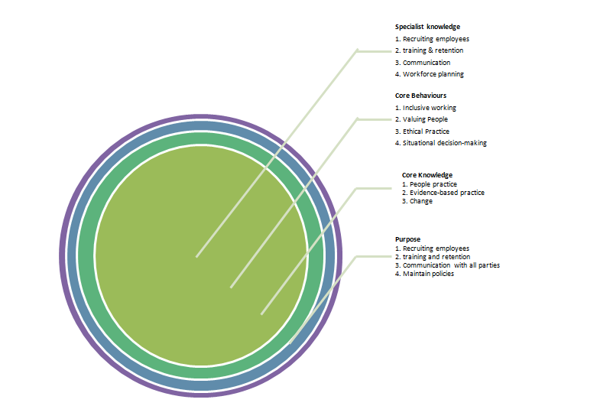
Figure 1: CIPD Profession Map
(Source: https://peopleprofession.cipd.org/profession-map)

Task 2: Report

1.0 Introduction
This report will lay out the organisational objectives, which allow the organisation of 'Bupa Care Home' to execute their human resource-related decisions. These further involve the elements surrounding an HRM activity within the firm, including planning for the manpower, recruiting suitable staff members and assistant staff members, and training them to finally distribute them around the roles. Apart from these factors, other considerations of the HRM activities will also be evaluated throughout the report.

2.0 Discussion

2.1 Organisational objectives within resourcing activities which HR function delivers
As per the notions of Michael (2019), human resource management is more than simply resolving people-related issues in any organisational setting. It provides assistance to the organisation in terms of strategic planning, but also establishing a workplace culture. These enable the company to distribute their resources and allow the talent that they have hired, to ensure they benefit numerous consumers or patients. Similarly, organisational objectives are developed in a same manner, that helps them to promote the actual elements. That includes recruitment, selection, training, and evaluating performance management. Another important criterion around these elements is the way human resource staff resources activities and balances the same to deliver the required assistance.
Planning the activities
Initially, it is important for the organisation to understand the manpower requirements altogether. That enables them to first account for different consumers and their queries which can be addressed through sufficient execution (Karami et al., 2017). This will create the important objectives centring the organisation, that allows them to fit the right amount of people for the right amount of consumers. In the case of health care organisations, the investment considerations are connected with the type of staff to be hired. This decides the crew of the employee groups that will be involved alongside the patients (Kanagavalli et al., 2019).
As a result, the requirements are carefully distributed among the recruitment process through panel creation and clarification in advertisements. That sets upon the objective of recruiting and selecting staff members through the selected panel, as they understand which roles to fulfil and how to fit around the same. Therefore the objective sets upon the notion of administering patient requirements, rather than making the employees simply feel at home. This could result in a demotivated staff as well.
Recruitment of staff members
The recruitment process in certain organisations is different from other organisations. That mainly depends on the nature of work they deal with to a large extent. For instance, in any retail or manufacturing firm, the skills and talents of the employees are tested for the long term before selecting them for any diverse roles. On the other hand, health care firms look towards testing the personality and character of candidates. With the aspect of assessing their capabilities to monitor leadership traits, and overall attitude that the candidate might possess in the near future (Kanagavalli et al., 2019). That means that the general process of hiring does not alter, despite their own way of looking at candidates and if they can further support patients for the long run.
Therefore, the job descriptions adequately explain in which positions the candidate is desired. This helps the staff to properly apply for the positions, before being screened for the roles. The job positions are posted on the company website or any other third party recruitment organisation websites (Karami et al., 2017). That enables the candidates to understand how exactly the process will pan out, to ultimately being called for interviews. [Referred to appendix 1]
Selection of a select few professionals
This process does not simply allow the organisations to match the requirement of the job role with the candidate ability. It also requires them to understand if the organisation is feasible to match their needs as well as vice versa for the long run. In the case of health care settings, the selection process exposes the candidate to the culture he or she is most likely to experience. This brings around the aspect of caring for a person and adjusting to the flexible resources that can match the patient's needs (Kanagavalli et al., 2019). Apart from that, it also challenges the candidate at every turn, to understand if they are capable of responding to a resilient change revolving around the firm.
This process is completely different from other organisations that also include retail, manufacturing, IT and others. That only cares if the candidate has the capability to utilize the resources and work for the long run. There are common intrigues mentioned above, that are tested through the selection activities of health care organisations. These activities involve being allowed to work in nursing roles, helper roles, or simply understanding the patient requirements.

2.2 Evolving of the same in Bupa Care Home
The evolving of the HR function, i.e, the recruitment, planning and selection is there within the organisation Bupa Care Home has been seen in recent years. For example, the recruitment process within the organisation is done through different steps such as core competency interview, technical interview, online profiling assessment, presentation, written task, role play, and assessment. The aspiring candidates search and register for Bupa jobs, either based in the UK or global jobs. The CV is uploaded or the necessary fields are filled by the candidates which our HR managers look after. If the interview call is sent, the first round of the same would be a digital/phone interview which has evolved after the pandemic of Covid 19 (Bupa, 2021).
Through the different rounds, the employees are selected within our organisation. The process of the selection comes after the planning of the recruitment and the receiving of the application from the aspiring candidates.
Now, to review the resourcing process within the organisation to meet the organisational objectives, the HR professionals within the organisation would design the plan accordingly. For example, while our organisation is looking for a registered nurse, the planning of the requirements is done accordingly. Basically, the salary is designed as £17.11/hour with a duty of 8 am to 8 pm. The duties and responsibilities of the nurse are to take care of the wellbeing of the residents, assessment of individual care plan development, and maintain work areas according to the standards (RCN Bulletin Jobs, 2021). Besides, we have areas in websites where one can register his special interest through free mail job notification. Bupa will notify the person when a similar job requirement is there.
The primary change in the HR recruitment and selection process in BUPA has come after the Covid-19 pandemic. The pandemic has inferred excessive pressure on the different healthcare organisations in the UK for the lack of facilitation in the government and NHS medical facilities. The selection and recruitment process also had to change and evolve in order to process the countless job applications for a plethora of job roles and designations. While previously BUPA had depended upon its traditional recruitment process with the help of job search websites it was somehow restricting when dealing with the global aspirants. As of 2020 BUPA currently deals with 84,000 employees internationally. Among the close to 20% of employees are international or from foreign countries working with a Tier-2 work visa. This further complicated the recruitment and selection process for the process of application and response took too much time in the end. This predicament has been solved with the introduction of the BUPA Global recruitment and selection process which seeks to bring a level of uniformity and standardisation across the R&S process for BUPA. For starters, the applicants are free to register their profiles on the actual website. The need for a third party job searching process can now be seen as a secondary option. Moreover, the applicants are also free to select any job role for which the notifications are given. They can apply for close to five different job roles all at once. (Bupa, 2021)
These changes have been translated in the internal HR department and their selection, inclusion and exclusion process as well. For instance, due to the lockdown, the HR department and the HR employees were compelled to make work with the backdoor recruitment process with the help of the website. They had to manually review each application for further progressing the R&S process as well. However, in the middle of all of these, there are five primary considerations included in the HR department. For instance, core-competency interview process, online profiling of applicants, function and technical interviews, presentation, written and role-play skills and lastly additional assessment centre.

3.0 Conclusion
The assessment concludes with the specifications that while the roles and responsibilities of different departments in BUPA UK have changed due to the pandemic and the subsequent lockdowns, the HRM policies and actions have endured the most drastic changes. However, in doing so the company has been able to maintain a flow of good and effective healthcare workers across their organisational body.

Reference list
Bupa, 2021. Recruitment Process | Bupa Global. [online] Bupaglobal.com. Available at: <https://www.bupaglobal.com/en/careers/our-process> [Accessed 12 July 2021].
CIPD, 2021. Profession Map | CIPD Profession Map. [online] CIPD People Profession. Available at: <https://peopleprofession.cipd.org/profession-map> [Accessed 12 July 2021].
Hook, C. and Jenkins, A., 2019. Introducing Human Resource Management: 8th Edition. UK: Pearson.
Kanagavalli, G., Seethalakshmi, R. and Sowdamini, T., 2019. A Systematic Review Of Literature On Recruitment And Selection Process. Humanities & Social Sciences Reviews, [online] 7(2), pp.01-09. Available at: <https://core.ac.uk/download/pdf/268004252.pdf> [Accessed 12 July 2021].
Karami, A., Farokhzadian, J. and Foroughameri, G., 2017. Nurses’ professional competency and organizational commitment: Is it important for human resource management?. Plos One, [online] 12(11), p.e0187863. Available at: <https://storage.googleapis.com/plos-corpus-prod/10.1371/journal.pone.0187863/1/pone.0187863.pdf> [Accessed 12 July 2021].
Michael, A., 2019. A handbook of human resource management practice. 10th ed. London: Kogan Page Publishers, pp.1-977.
RCN Bulletin Jobs, 2021. Registered Nurse - London job with Bupa Care Homes | 184781. [online] RCN Bulletin Jobs. Available at: <https://www.rcnbulletinjobs.co.uk/job/184781/registered-nurse-london-/?utm_campaign=google_jobs_apply&utm_source=google_jobs_apply&utm_medium=organic> [Accessed 12 July 2021].
Ulrich, D., J. Younger and W. Brockbank., (2013). The state of the HR profession, Human Resource Management. 52 (3), pp. 457–471.

Appendices
Appendix 1: Subtle requirements for healthcare recruitment considerations
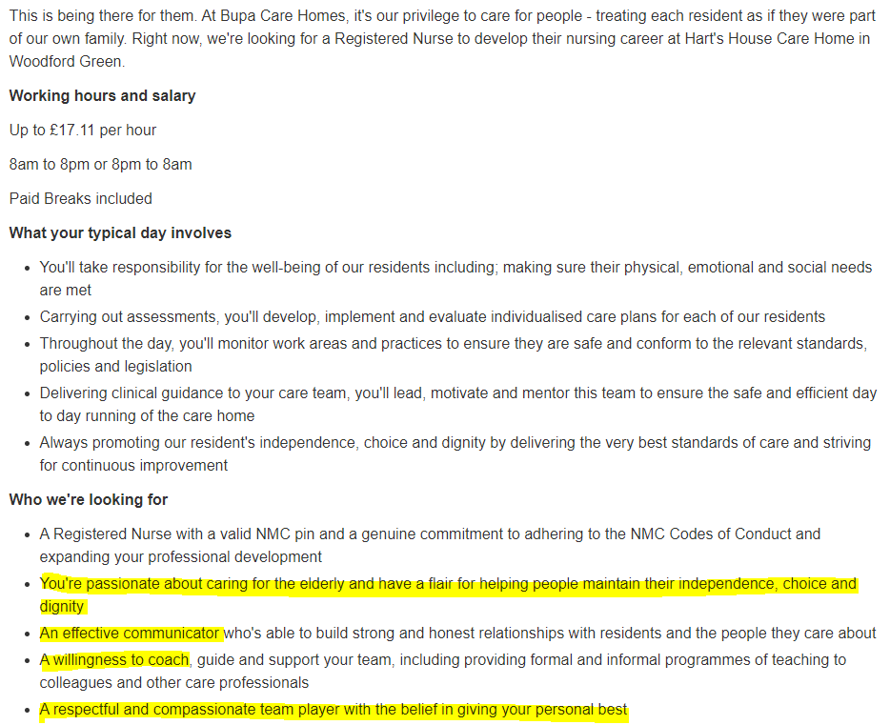
(Source: https://www.adzuna.co.uk/jobs/details/2331596914)

