Time
Independent project by Niamh Thomas
Surrounding question “Why do women return to their toxic partners and how do they heal once left?”

Contents Page

Element 1- research
Introduction………………………………………………………………………………3
Proposal…………………………………………………………………………………..3
Literature Review………………………………………………………………………..4

Element 2- Process
Stimulus…………………………………………………………………………………..11
Writing exercises…………………………………………………………………….....13
Choosing my fundamental question………………………………………………..18
Structure………………………………………………………………………………….19
Scenes in order………………………………………………………………………….21
Script writing…......................................................................................................22
Lighting and sound…………………………………………………………………….24

Physical Application
Set and Design……………………………………………………………………………25
Scheduling and Rehearsals……………………………………………………………..27
Rehearsal process…………………………………………………………………………30
Dress Run and Tech……………………………………………………………………33
The Performance ………………………………………………………………………..33

Bibliography………………………………………………………………………………36

Element 1- Research

Introduction
During my independent project I will be responding to the question, "Why did I stay?”. By writing and creating a play about a young woman getting over a bad relationship. She will learn as she recovers that the relationship had to end in order for her to move on and accomplish greater things. As she heals, she discovers that her hands were also covered in blood, meaning she was guilty too. She eventually writes a song about her relationship and gets it on the radio, leaving her to figure out who she is and what she loves. Her self-growth will make her question why she ever stayed. The themes of self-improvement, love, obsession, guilt, rage, imagination, passion, and anxiety will all be prominent in my play, along with study and research behind these subjects to aid me in my directing. I was able to answer this question with authenticity, passion, and raw emotion since I had personally experienced something similar—I created a dramatized version for the play.

Proposal

‘Time’
I would like to create two different takes on the same character, "Cassie," who is recovering from a breakup. In the first, she is depicted as having recently ended a relationship and needs to move on, while in the second, she is her healed self and all that she has accomplished since. To accomplish this, I will have two performers and a split set on stage: "present Cassie" in her kitchen, listening to her music for the first time, and "past Cassie" in her filthy, unkempt bedroom, having recently ended a relationship. Her present side, talking about her relationship in third person, and her past self on the other side of stage is experiencing it. Since this is about her journey, I will go into more detail about the kind of relationship she had with her lover while also paying closer attention to herself. In order to accomplish this, I want to use music, duologues, and monologues to create different moods and atmospheres for my play. While making this, I want to inspire people to think that they can accomplish anything they set their minds to, that no matter how difficult things get in life, they will succeed in the end. I wish to bring happiness and love to those who view it.

Literature Review

During my literature review, I will explore the topic of toxic relationships within the scope of my independent project, "Time." My primary objective is to answer the pivotal question: "Why do women return to their toxic partners, and how do they heal once they have left?" This question will serve as a central theme throughout my review.

To aid in answering this question, I will explore several key points. First, I will investigate what constitutes a toxic relationship. Next, I will examine toxic individuals and how people end up in these situations. Finally, I will discover how people rebuild themselves after experiencing a traumatic breakup. I will then utilize my research to address the primary question. By drawing from books, academic journals, dissertations, relevant sources, and insights from therapists and psychologists, these points will guide me in developing my main character, who will grapple with the question of why she remained in her toxic relationship.

Research suggests that young people often fail to recognize when their relationships are unhealthy. According to John Gottman, there are four commonly studied relationship communication issues, often referred to as the "Four Horsemen of the Apocalypse": contempt, criticism, defensiveness, and stonewalling. These behaviors reduce communication and commitment within a relationship (Gottman, n.d.). Contempt involves actions like eye-rolling, mocking, or name-calling, conveying feelings of disgust towards one’s partner. Criticism includes complaints that point out perceived deficiencies in the partner's character. Defensiveness occurs when an individual responds to criticism by blaming their partner instead of addressing the issue. Stonewalling, often a response to contempt, involves shutting down communication, such as not responding or leaving a conversation. Understanding these behaviours is crucial in identifying the elements that contribute to a toxic relationship (ProQuest, n.d.).

Unhealthy communication patterns, termed 'danger signs,' include escalation, invalidation, withdrawal, and negative interpretation of a partner's behaviour (Stanley and Markman, 1992). While extensive research has explored the traits of toxic relationships, there is limited insight into how these dynamics emerge. Individuals with low emotional intelligence often struggle with effective communication (Psychology Today, n.d.), which is a prevalent issue in these relationships.
Unhealthy communication patterns, termed 'danger signs,' include escalation, invalidation, withdrawal, and negative interpretation of a partner's behavior (Stanley and Markman, 1992). While extensive research has explored the traits of toxic relationships, there is limited insight into how these dynamics emerge. Individuals with low emotional intelligence often struggle with effective communication (Psychology Today, n.d.), which is a prevalent issue in these relationships.
One of the most discussed toxic relationship traits is narcissism. However, only 10 out of 100 people are considered narcissists with narcissistic personality disorder (NPD), which is more common in men and often develops during childhood (Harrison and Dixon, 2019). Narcissists believe they are superior and deserve better treatment, using this belief as a defense mechanism due to past trauma, which causes them to dissociate (Vaknin, 2005). Women may feel compelled to stay in these relationships, believing they can help their partners despite the damage to themselves (Polk, 2022).

In contrast, healthy relationships are characterized by good communication. Couples who communicate well report higher satisfaction in their relationship (Baucom et al., 1990). Researchers can accurately classify 80 percent of couples as distressed or non-distressed by observing their communication during disagreements (Gottman et al., 1997; Gottman, 1979; Weiss & Heyman, 1990). Affiliation, which includes companionship and shared activities, also positively affects relationships (Furman & Weiss, 1998). These traits are nurtured by effective communication and positive moods, which enhance mental flexibility and creativity (Isen, 1999). These aspects collectively encourage relationships to grow stronger and ensure their longevity (Berger, McMakin, & Furman, 2005).

Women may feel accountable in a toxic relationship, believing they need to stay. Narcissists manipulate situations to their advantage and become aggressive when challenged. They are undermining, dishonest, and untrustworthy (Cantopher, 2017). Toxic men often target kind, caring, and anxious women (Carruthers, 2013). Women who question their role in the toxicity are likely not to blame, as most toxic individuals are unaware or resistant to recognizing their toxicity (Greyman et al., 2023). Once out of the relationship, women can see from an outsider's perspective that they were not the toxic ones (Mackenzie, 2015).

There are more men than women under the influence of alcohol and drugs in their relationships (Schafer & Lecturer, 2011). Schafer's study found that young adults, particularly 18-24-year-olds, suffer from alcoholism, while men over 25 often have nonmedical prescription drug addictions. These addictions significantly impact relationships, causing stress and leading to toxic dynamics (Berry & Sellman, 2001; Velleman, 1992).

Being in a narcissistic relationship is a vulnerable and isolating experience. Admitting victimhood can be scary (Harrison & Dixon, 2019). Understanding the types of narcissists is crucial for healing. Practical techniques, such as cutting ties and working through trauma, are essential for recovery (Robinson, Smith, & Segal, 2019; CRC, 2018). Many women lose sight of their ambitions and goals while in these relationships (CRC, 2018b).

Healing often involves going through the five stages of grief: denial, anger, bargaining, depression, and acceptance (Kübler-Ross, 1969). People cope by caring for themselves, engaging in activities that bring joy, and seeking support from friends and family (Healthline, 2019). Music also helps individuals express their emotions and find a sense of identity (Heshmat, 2019). Through my literature review, I have explored what constitutes a toxic relationship, the role of narcissism, the impact of addiction, and the process of healing. Leaving unhealthy relationships helps individuals understand their effects and learn that healing and moving on involve achieving personal goals and finding freedom.

Element 2- process

Stimulus
I think it's a good thing I didn't follow my initial plan because this was based on a true story. Most of my research and supporting material comes from a period when I was able to write honestly, which I believe enabled me to produce the most authentic play possible. I drew inspiration from how I was feeling at the time. For me, this endeavour has been beneficial. "Time" assisted me in many ways, as a person and as an artist in the field, in projecting my negative emotions and transforming them into positive ones. It also helped me recognise that I am capable of far more than my circumstances had led me to believe. Originally, I planned to do a comedy about a disastrous first date, but because of how I was feeling at the time, I struggled to find any source of inspiration to make the play comedic. In response to the question in my introduction, I was inspired by a few factors, including, my relationship breaking down, poetry and quotes on social media sites like Google and Tiktok; I used to read these quotes late at night and I remember feeling like I had at last connected with something, which encouraged me to write more. The phrase "as a child I never understood how love could hurt" has lingered with me. Nevertheless, I took inspiration from it and used it to come up with the idea of presenting the female character in the play as her past and present self. Even though I had comparable experiences, I didn't want the play to be about my life, but my research, which is attached, helped me create and direct this play by allowing me to go back and read statistics and by giving the play life and realism. I believe that my study helped me stay focused and on course so that I could still produce the tale as intended and to in fact not make it about my relationship breaking down.
Additionally, I drew inspiration from my research, where I looked for words to help me create my monologues and duologues. Along the way, I came across startling facts and statements, such as: put the quote from phoebe email.
The words "Anxiety, Stress, Depression, Dissociation" helped me understand how I might have been feeling at the time and helped me realise how many other women had experienced similar feelings to mine.
Whilst writing the monologues for the play I was allowed to channel my anger that I had consumed myself and then felt everyone else who had experienced similar feelings in the past, and it had healed a part of me. In my play "Time," I was able to guide my actors in expressing their sensations and emotions of anxiousness by having one of the characters—the one portraying Past Cassie—act out a panic attack. In addition, I incorporated the set-in order to portray the states of anxiety and depression by designing the bedroom to resemble a certain state that individuals with depression often claim to experience, such as being incredibly dirty and chaotic. In a scene from the play, "cassie" would constantly bug her ex, demanding to know where he was and worried about if he still loved her. You can see how distressed and anxious she gets during this phone call. "To heal" is a sentence that gave me the idea for more scenes and a resolution. By showcasing Cassie cleaning her room and highlighting her experiences and chances, including hearing her song on the radio, I was able to demonstrate to the viewer Cassie's strength and her ability to move on from her toxic past. This demonstrates how I was inspired to write a play by the voices of people who had survived toxic relationships in real life. It gave the show a more authentic feel and strengthened my connection with my work.

Writing Exercises
My process began with myself creating a lot of comedy monologues, I began to do exercises to see my style of writing, they began to sound characterised and comedic, however the more exercises I did, the deeper they became, and I realized that I enjoyed creating monologues with a deeper theme. Here’s some examples. However, before doing any exercises I set some.
aims and goals for my piece, some of them being:

- Show beliefs and goals of my chosen subject.
- To portray someone who is finding herself.
- To create a clear target audience
- To answer my question within my piece
- To have a strong message and ensure I’m constantly referring to my message.

2-minute monologies
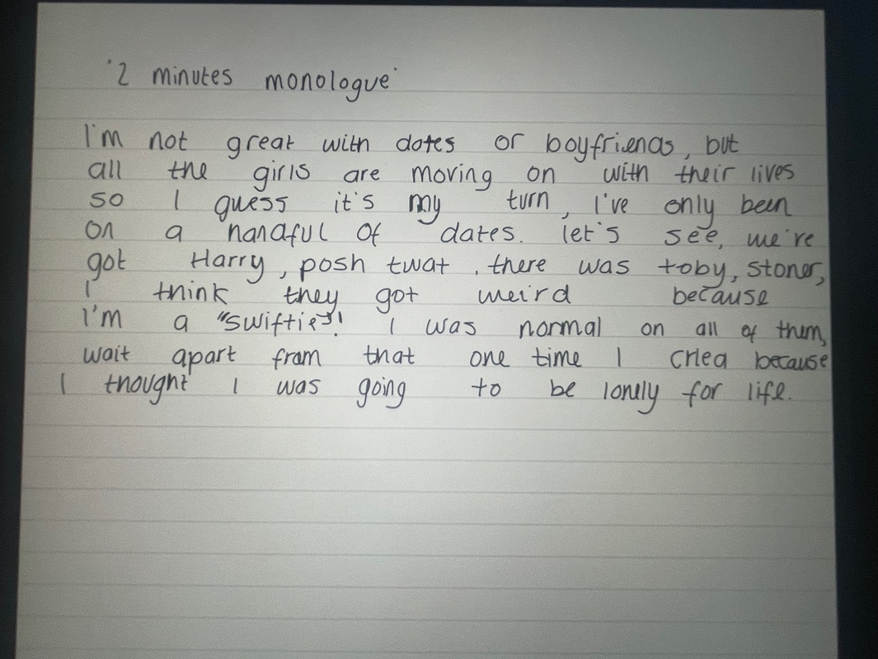

However, the more exercises I did, I discovered that my context and reasoning were behind toxic relationships or drug abuse, and shortly after this I began to create more and more creative pieces through the mind that my main character has had a hard life.

Object story
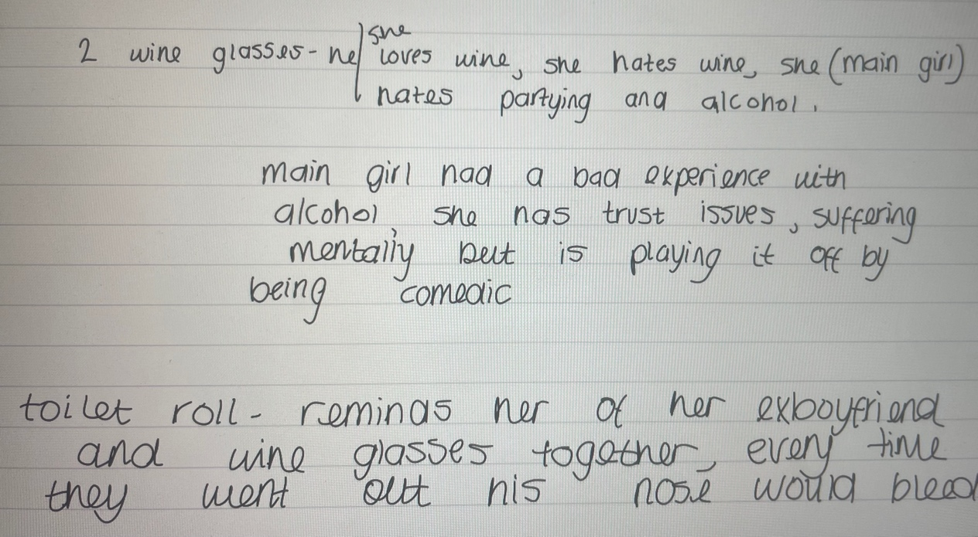
In this exercise, Elen placed many objects on the table, and we had to create a story with them and our main characters in our independent project. This exercise again became easier and more natural to me as there were more heavy stuff to fi suss and to delve into.

3-word exercise
G: Um Hello
B. Hi, you alright
G: Yeah, I guess…
B: How are you?
G: Sorry I’m nervous
B: What do you do?
G: As in work
B: Anything literally anything
G: Stay in and cry? (to audience)
B: lots of stuff.

Another writing exercise I did was to create a duologue using 3 words or less. I did this exercise before creating my plot or characters, I decided to use these exercises to practice my writing skills and discover how I felt writing and what I enjoyed considering i was required to write a whole play by myself. In the 3 word or under exercise I created and awkward atmosphere which I enjoyed and continued to grow by doing more exercises. The more and more exercises I did, I began to use these to create my final scripts, plot and character developments.

‘Last Letter’ exercise

Last Letter to my ex-partner

I loved you; I loved you so much, you were everything I ever wanted in the beginning, we were so happy, what were you scared of? Was it because I’m following my dreams. I wasn’t myself when i was with you, I lost my spark when you met me, I was young and naive, you didn’t know me, and you never got to know me, I tried to be myself, but I never was, maybe that’s my fault. I may as well tell you now, I never liked your music, your games, your sport, it’s like when you’re a kid and you try coffee and you try your hardest to like it, and I hate coffee, I really hate coffee, it’s the same thing, we aren’t the same, I like the stuff when they break out into a song and dance, the cheesy stuff. We aren’t the same and we never were, I know everything about you, you drink, you love football, you love dogs and yes these are simple things, yes these are the simplest things, but you couldn’t even remember my fucking birthday. I did nothing to you, but you wanted everything your way and you sucked the life out of me like some greedy fucking scum. I came to you about my family and you laughed in my face, you hated when I accomplished anything, you wanted me to be miserable and you just kept taking it all out in me, everything my fault, im useless, unworthy, rich, ungrateful, ugly and well like I said we aren’t the same, you might’ve thought you ‘knew the real me; well yeah you could say you knew me, but you never understood me.

6k9yLast Letter to my mother:

You are what I aspire to be, you know how to make me laugh, how to make me cry, I can come to you about anything and that’s what I love about you, I love that you care for everyone apart from yourself, you are strong and passionate, you have always been my biggest supporter, you took me to every class, paid for everything I’ve ever wanted and you deserved more. You deserve a bigger thank you, you deserve the biggest thank you. So, thank you, thank you for every meal, every laugh, every cry, every song, I wouldn’t be the person I am today. You have moulded me into the best version of myself and I can’t describe how much you’ve done for me. Thank you for making me who i am. I love you forever.

I had ten minutes to write without stopping, and composing the letters allowed me to reflect and become aware of my profound emotions. For the first time, the task allowed me to feel certain emotions, acknowledged the hurt and agony I had experienced, and forced me to consider how I would get better. I realised that I had been lying to him and myself about our connection because it was all revealed in that letter. This offered me the courage to express and act upon the obsession, guilt, fury, anxiety, and depression that I included into the play. Even though I hadn't really spoken to anyone, I feel like I used this work to learn more about myself, understand my emotions, and experience what it's like to be recognised and heard. I felt validated by it, and I know that I will keep going for my goal no matter what challenges I encounter in life. In any obstacle I face I now know to Set a timer for ten minutes and write down everything that comes to mind. Writing the letter assisted me in writing the play. I quoted a few of the lines I wrote in the script: "" quote here Even though it was personal to me, I felt comfortable sharing my letter with the cast so they could see how true to the play I really was attempting to be and gain an understanding of how I was feeling at the time. This truly did show in the final performance, and I'm glad I did it. It also helped my cast members feel even more connected to the character and plot of Cassie since it was real.

Choosing my fundamental question
Why did I stay?
Didn’t I love him?
Did he know how much it hurt?
Did I give him any clues?
Did I let this happen to myself?
Are my hands covered in blood?
Was it my fault?
Was I the problem?
What was the problem?
Were my goals in the way?
Does he have any goals?
Is anyone proud of me?
Am I proud of me?
Have I done enough?
Enough for what?
Have I got what it takes to be successful?
What is successful to me?
Who is successful?
Does he think I’m successful?
Does he think he’s successful?
What have I done to be successful?
What if all of this is payback because I’m lazy?
Am I lazy?
Should I be working harder?
Is this worth it?
What’s wrong with a 9-5 job?
Is this what I desire?

In the early stages of creating my project, I knew that I had to choose a question to ask and base my story around that question. I was really stuck with picking out a question, so a task I did was to start with a random question and answer it with question upon question. This gave me a whole variety of thoughts and ideas of what I could create. This is another exercise that made me realise that I would be answering a heavy question. I realised that I was covering my ideas and thoughts with funny emotions, just because that’s the type of character I liked to play, my thoughts and ideas became apparent that my piece was going to be based on a toxic relationship. After carefully looking at the list of questions I created, I narrowed it down to 3 questions, ‘Why did I stay?’, ‘Have I got what it takes to be successful?’ , and ‘ Are my hands covered in blood?’ After researching into toxic relationships, and learning how other individuals healed, I decided that the most appropriate question to use was ‘Why did I stay?’ to convey my main message, ‘some things have to end in order to accomplish greater things in life.’

Structure
Character creation
After I did some writing exercises, I knew what themes I wanted to use, I knew my final version was going to be based around a female character ‘Cassie’ going through a breakup. I decided to create a mind map of how I wanted to portray Cassie.

Cassie
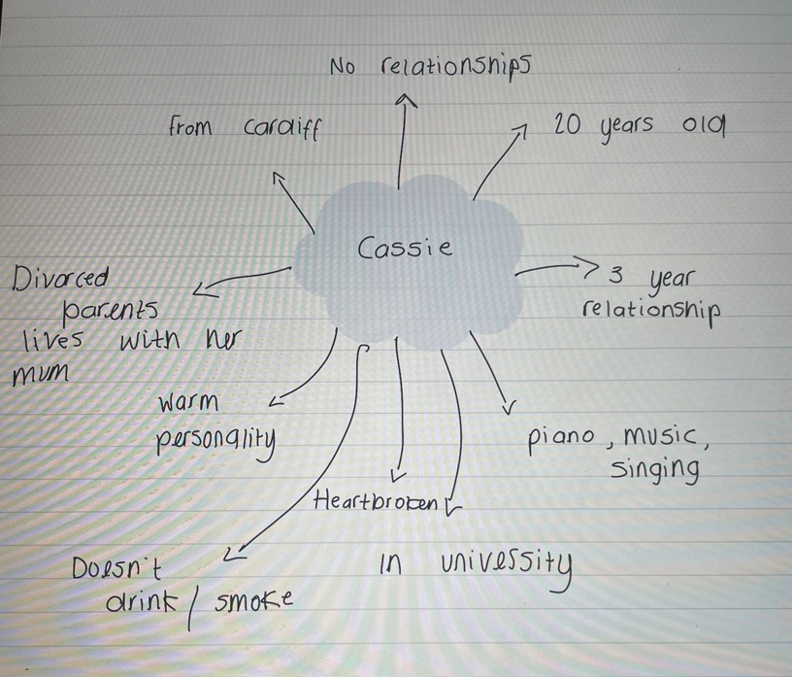

This is the basic version of what I envisioned. I wanted Cassie to be shown as if she’s lost herself, as if she has no purpose to life anymore and is depressed, I wanted her to gradually learn how to get out if depression on her own and to learn how to pick herself up. I realised that her healed self would practically be a different person because she’s lost herself so much, that’s when I had the idea that ‘Cassie’ would be played by two different people but portraying different versions of her.

Ex

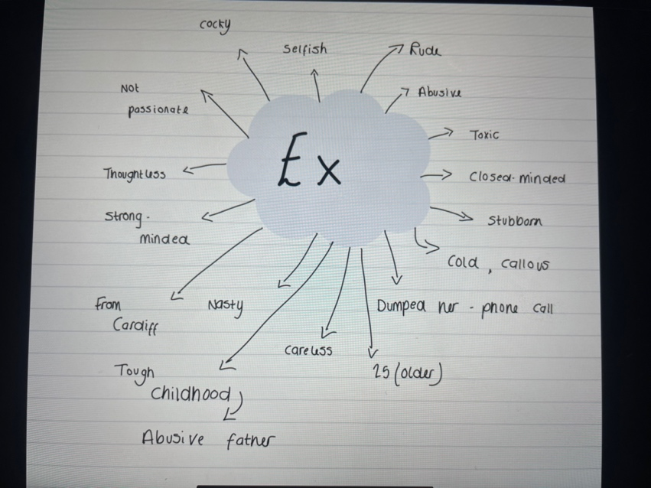
Even though ‘Cassie’ was the focus of my piece, I decided to use voice recordings of the ex’s voice in order to show the kind of things he would say to Cassie and how that impacted on her. I decided not to use someone physically acting on stage, because this is about Cassie and her journey. I felt that the ‘ex’s character didn’t deserve to have a name and to be a part of her healing process or even what he looked like because of how he treated Cassie. Even though the ‘ex’ had a few lines, I still wanted to create a mind map of the type of person he was.

Scenes in order

After learning my main message of my piece, I knew that I wanted to use Brecht to portray my message. However, I understand that there are a lot of dark and powerful themes when it comes to creating a piece on ‘toxic relationships’ and I felt I had a duty to take the audience on board on my story with as many colours as possible. To ensure I was looking after my audience, I used a narrator to look after my audience and remind them that the main character is okay, and she’s getting through it. I used the past and present to present this. The present version, her healed self, looking back to her past self. The audience can see her growth, they know she’s okay. I thought this was the best way to add colours and not too much heaviness.

I then created my scenes/beats in order to piece my story together and then filled in the gaps to create my script.
Scenes in order

Scene 1 – Physical movements of Cassie’s relationship ending.
Scene 2- Present Cassie explaining her relationship and how he left. Dialog
Scene 3- Past Cassie- physical panic attack. Destroys her room.
Scene 4- Present Cassie dialog. She’s hit rock bottom.
Scene 5 – Past Cassie. Trying to get hold of her ex-partner, constantly ringing him. I miss your monologue.
Scene 6- Present Cassie explaining that past Cassie had no one by her side by this point in her life, and she needed to heal, but didn’t know how.
Scene 7- Past Cassie, finding old memories of him in her bedroom. Goes into flashback scene of a terrible argument. Another panic attack (not as intense)
Scene 8- Past Cassie has a dream and present Cassie appears in the dream. This is what urges Cassie to start to write music again.
Scene 9- Past Cassie wakes up from the dream, and reaches for her old songbook, and starts to think all her childhood memories, and what made her, her, which is performing and creating music.
Scene 10- past Cassie, begins to tidy her room, a bit, (she’s healing) she finally starts to play around on her dusty piano again, and enjoys it again, it doesn’t admit that.
Scene 11- present Cassie explains the feeling it gave her and why she was so reluctant to play it.
Scene 12- past Cassie- ignores what her ex-partner thought about her creating music, she sits down and just pours her heart out in her own song. Her room is now even tidier; therefore, her mind is now clearer and healthier.
Scene 13- 6 months later, past Cassie is now creating more music, she’s sitting down at her piano, in her clean room, dressed for the day, and gets an exciting phone call from her agent.
Scene 14- a year later, which is present Cassie, she’s sitting in her kitchen she turns on the radio and hears her first original song for the first time.

Script writing

When I was writing my script, one of the first questions I asked myself was how do I want my audience to connect to my story? And I wanted them to feel inspired to feel like they can achieve anything they want to.
I then began to look at my scenes and what I wanted to show, and from BBC’s guidelines I asked myself these questions when I created every scene in my project. (www.bbc.co.uk, n.d.)
1. ‘What effect does this scene have on the character within the moment?’
2. ‘What effect does it have on the subsequent events of the story?’
3. ‘What impact does it have on the world of the story?’
4. ‘What else is going on below the surface and beyond the text?’
I found that answering these helped me create my scenes and the depth behind them. I found that it made a bigger impact to the story, and it made my stage directions very clear, that it helped me envision it before even getting it on its feet. Because I followed these steps and guidelines, I only had two drafts of my script with a few alterations and suggestions from my 1-2-1 tutor. After creating my scene-by-scene structure, I didn’t have many changes, and I was happy with my script. However, one notes I often had was that I repeated myself in my writing, especially in monologues, therefore, I changed a few aspects in my script and ensured I wasn’t repeating myself in my monologues and ensured the story was flowing and not put at stop because of how much I felt I had repeated myself in ‘Cassie’s’ monologues.

Lighting and Sound
For my lighting and sound, I envisioned natural lighting for majority of the scenes, apart from the dream sequence, where it allowed me to go unnatural and unexpected because it’s a fantasy. I also knew that I needed a snap blackout in the middle of my piece in order to get the best effect possible.
As for sound this had a huge impact to the plot of my play. Cassie’s childhood was music, she grew up with music, creating music, with classical piano music, she specifically used to sit down at her piano and just create music, she created songs, pieces, all through her childhood, and I wanted to portray this throughout the beginning until the end, it’s always been an important factor of her life, she just lost it when she got caught up in her relationship. This is why I decided to use a classical piece, ‘Adagietto’ (open.spotify.com, n.d.) for Cassie’s physical theatre sequence at the beginning, to show her musical background and how well she connects with music as a character. I also used sound effects to add more layers like a beating heartbeat, phone calls, and ringers. Another important sound in my play was the tuning of the radio, when you hear the second tuning of the radio that present Cassie is trying to listen, that’s when the two versions of her, the reason why she’s telling this story clicks and the audience piece the story together, that they are the same person, and this is her story, she’s just telling it in the 3rd person because she’s. changed so much.

Physical Application
Set and Design
When designing set, I wanted to use a split set to portray Cassie’s two different worlds, her present side showing her in her kitchen and tuning into her radio, and her past side in her messy, dump of a room going through depression to show the growth and development she’s had since her traumatic breakup. I used the back of 3 mirrors to enclose the space in order to portray the state of mind Cassie and her room was in. I felt that creating my set as naturalistic as possible really set the tone for my piece and the audience can physically see how much ‘Past Cassie’ was struggling g. By using Stanislavski’s naturalistic set, I believe it really believe my actors would be able to ‘inhabit the role’ they played. (BBC Bitesize, 2019)
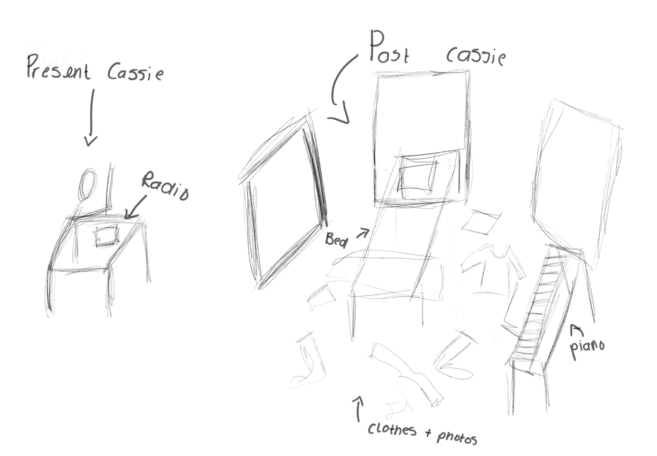
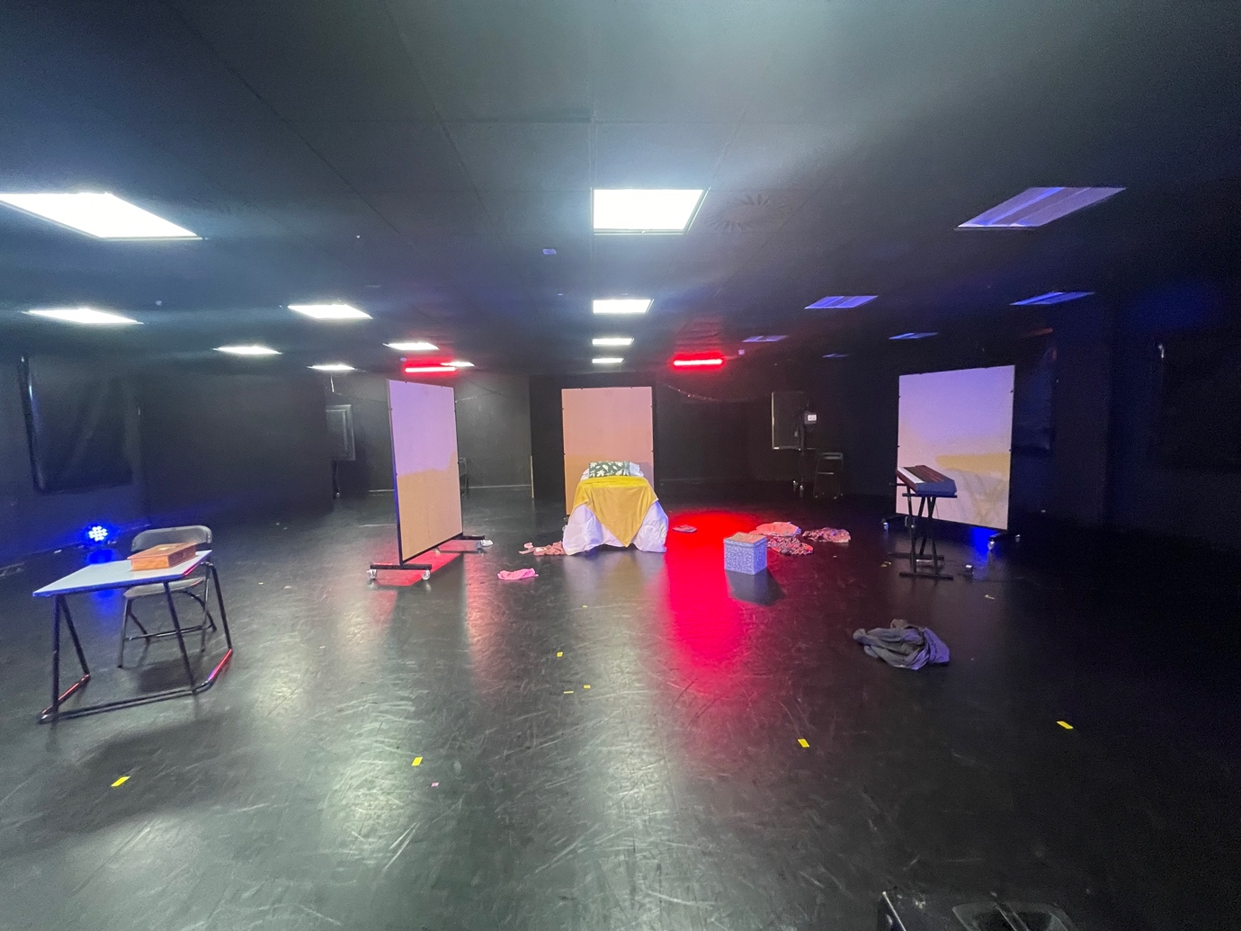
Scheduling and Rehearsals
Before I was able to schedule rehearsals, I had to find a cast, I sent out an email to members of the first years at the University including audition packs, synopsis, and the style of the piece. I was seeking someone who can play piano well and would be comfortable playing it in front of an audience. Other than that, I wasn’t looking for anything specific. In these audition packs I gave an outline of the character and what would be required from them.
Audition pack- all characters
Though it would’ve been ideal to host auditions, I had very little interest received back, due to this, I decided to contact with some performers myself to see who would be available and best suited for the roles, this left me with a cast of 3, Holly Roberts, Seren Tyleri, and David Harding. Once I had my cast and they committed, I scheduled some rehearsals for the final 3 weeks before the performance. I was very lucky with my cast, as I there were no difficult clashes with anyone else’s cast, they were good with contacting me, and they came to every rehearsal. I included my 1-2-1 sessions with Llinos on my schedule, but then replaced this for myself, so I was able to keep on track with any admin work I had.

Week 1 o rehearsals 6th of May- 11th of May

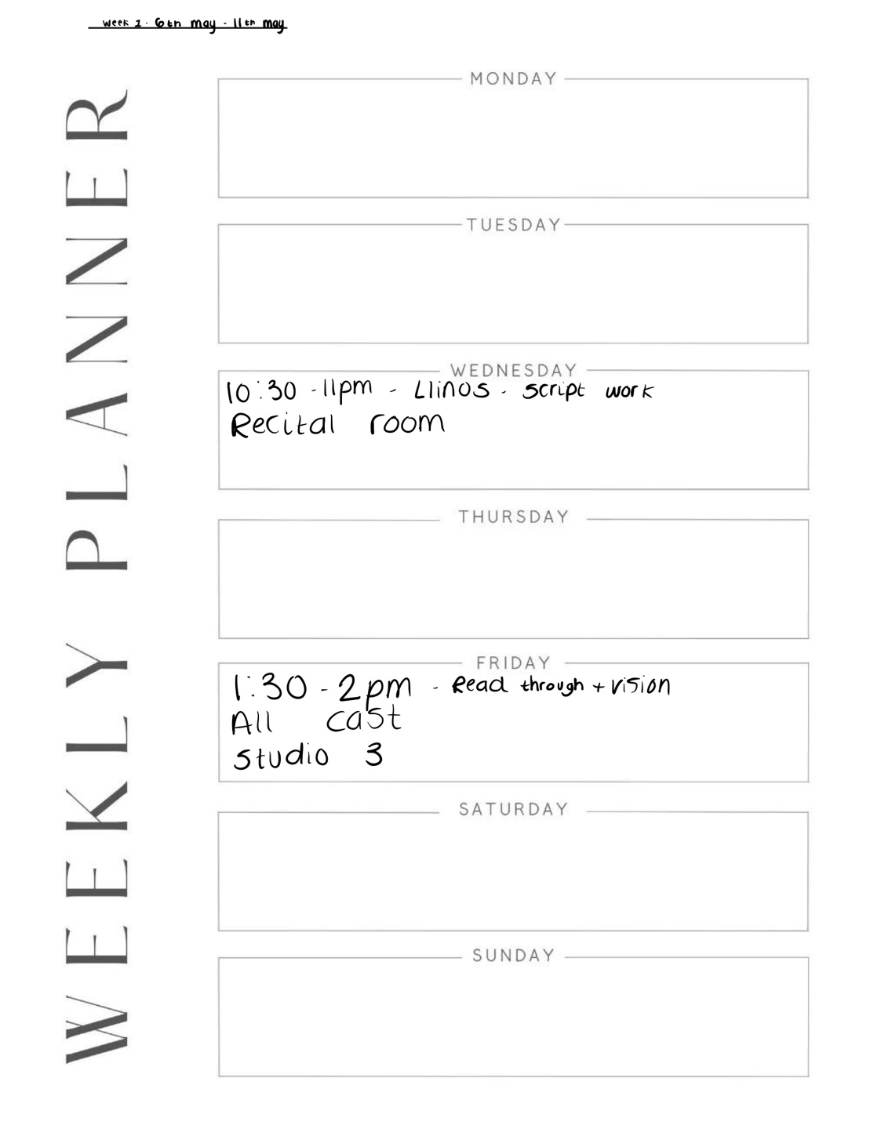

Week 2 of rehearsals 13th of May- 18th of May

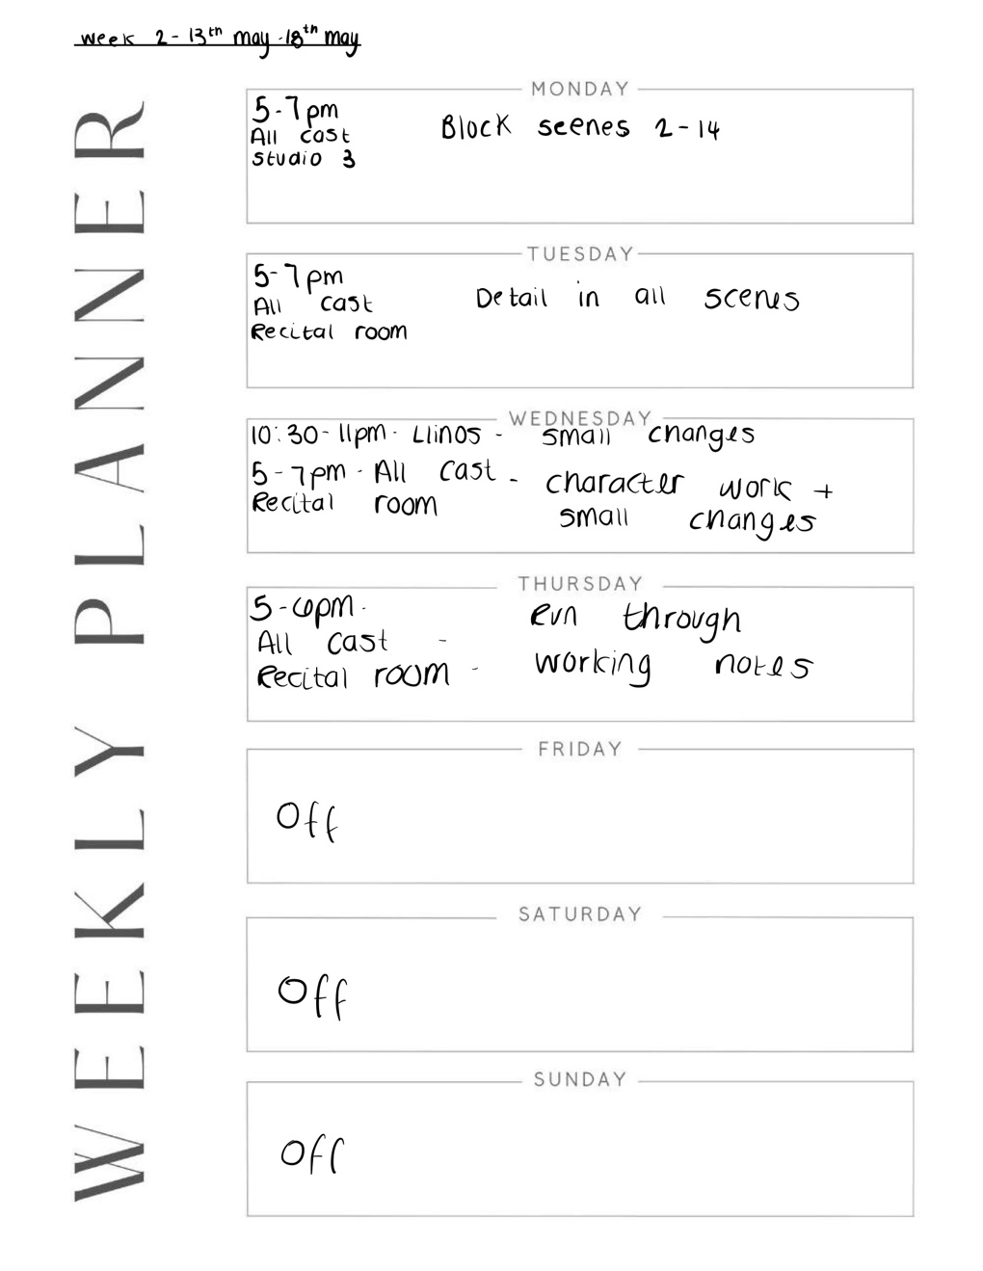

Week 3 of rehearsals 20th of May – 24th of May

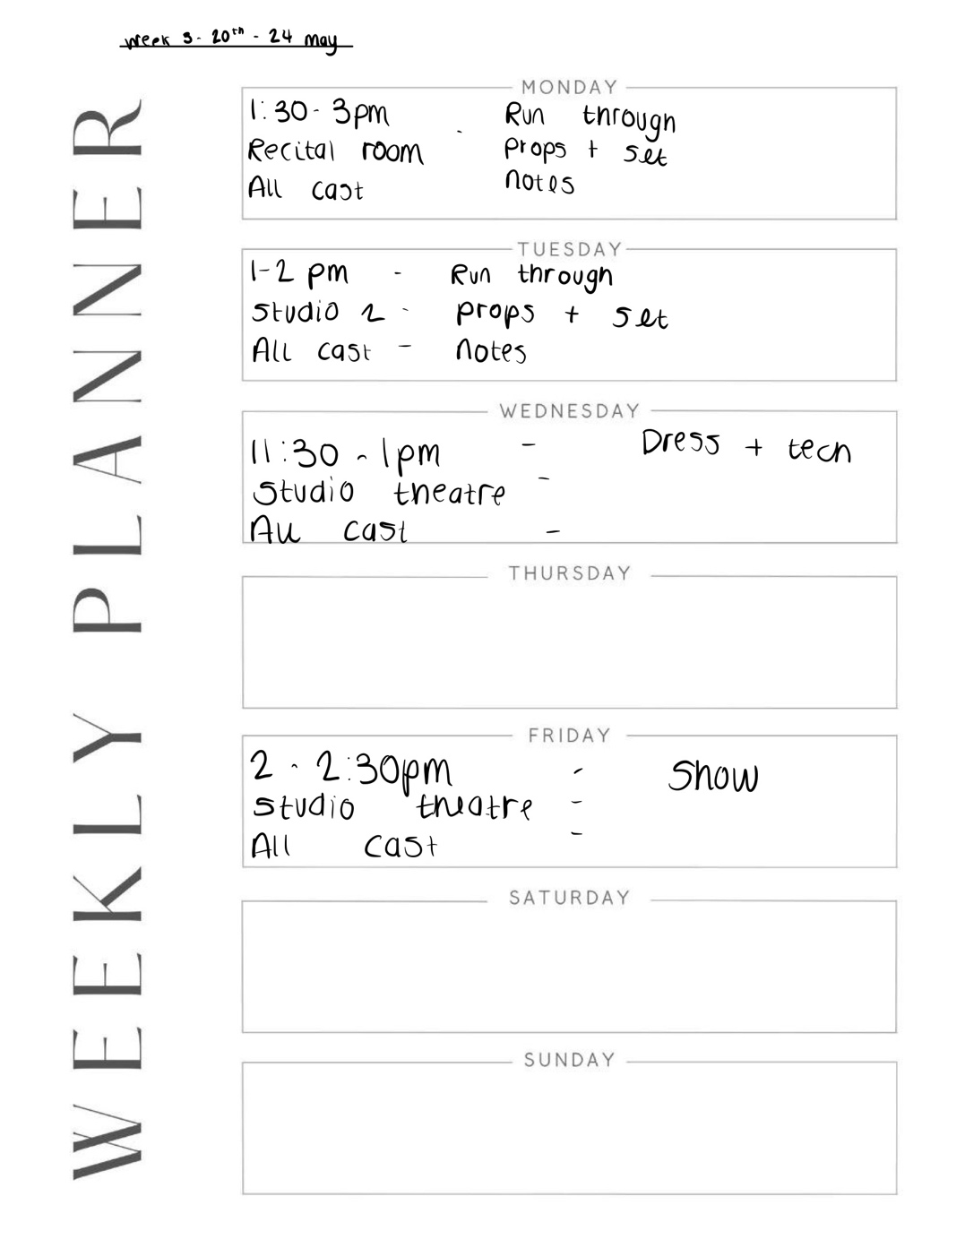

Rehearsal process
I began my rehearsal process with all my cast with a deeper introduction of the plot, characters, style and synopsis and then ended the rehearsals with a read through. I introduced my cast to the mind maps I had created and gave them the chance to expand on this by themselves.
During the second week of rehearsals, I believed that establishing a solid frame would be the most beneficial approach. I envisioned to gradually add more details and develop the scenes further. However, despite my efforts to enhance the details, I noticed that the cast members did not fully embody their roles or deliver the scenes to their utmost capability. They remained heavily dependent on their scripts at this stage. I decided to introduce Meisner ‘s repetition exercise, which I was familiar to doing in my Acting 2 module with Robbie Bowman, I chose to have Holly and Seren sit opposite one other with their knees touching and their palms resting on their legs while they constantly repeat the same word to one another. I paired them together as A and B, with A giving B a fact about B, such as "You have eyes." I made them repeat this several times so that it would come to them naturally. I instructed them to repeat a line to each other when they were familiar with the exercise. The goal of this activity is to help them "think too little" and "act in the moment." (Ates, 2019).
When directing Seren’s panic attack scene, I wated this to feel frantic, as if she didn’t know what was happening and her body was taking over her mind.
I also wanted to do some character work with Holly and Seren, they needed to be the complete opposite to each other to show the growth Cassie as a character has made, I intended on ‘Present Cassie’ to have some more personality about her, and a funny side to her, however I felt like my actor felt like she was telling a story, rather than playing a character. Holly delivered her lines well, but given her funny nature as a human, I would’ve loved to have seen some personality whilst narrating, not just a narrator. And, as for Seren’s character, ‘Past Cassie’ is a depressed version of ‘Present Cassie’ and I don’t believe they really grasped onto the idea that they are playing the same person. I created profile backgrounds on their characters with as much detail, and I would’ve loved for them to incorporate that in their acting, but at this moment in the rehearsal process they were doing that, so I decided to ask them if they could be off copy by the following Monday to see if that could improve.
On the Thursday of the second week of rehearsals, we did our first run where i directed notes, one of the notes I gave to Holly was to add more personality like I’ve previously mentioned, and one of the notes I gave Seren was to keep her movements active. Seren had more to do rather than say, so it was important that we could always see what she was doing whilst going through heartbreak, I wanted her to be still but active and not frozen in the moments when Holly was narrating. I felt that Seren began to apply this to her performance, however being off script would have given her more of an opportunity to do that, I gave my cast, Friday until Monday’s rehearsal to be off script.
On the final week of rehearsals, my cast were confident in what they were doing by this point, however, Holly or Seren didn’t make an effort to learn their lines due to other important projects they had going on at the time, therefore I felt like they didn’t apply the notes I gave them, in the following run throughs, I felt like I kept applying the same notes, and my cast weren’t bothered to make the small, but important changes I directed hem to do.
Dress Run and Tech
After seeing my set, and props in the studio theatre for the first time, it looked exactly how I envisioned I sued a table with a blanket and some cushions for the bed, and my own clothes and belongings to create the messy look in her room. The tech rehearsal for me was simple, as I knew what I wanted and it was very simple and naturalistic, and the dream sequence had a visible difference to my other scenes, which was my initial goal. Firstly Nick, who was overseeing lighting and sound production helped programme the lights, where my tech teams, Ellie and Elise got used to the cues before doing a run with my cast. The dress performance was my cast’s best run overall, they knew their cues, they had applied some of the notes I gave them, and I felt like they were ready to show this in front of an audience.
The performance
After watching the final performance of “Time” I found that there would have been a few things I would have done differently, I would have given ‘Past Cassie’ more dialog throughout her healing process, because sometimes I felt like the audience were missing some of her emotions and how she delt with them, I personally would’ve given ‘Present Cassie’ a character with a bigger personality. Her character was supposed to show that she’s found herself again, however I felt that her personality on stage was lacking, and I was struggling to see her true self.
From looking at the audience responses, I believe that the message was spread very well, however there were some comedy aspects which failed to land. I don’t know if that came from poor directing or script writing from myself or poor acting from my cast. These were one of the notes I allocated to Seren therefore I’m unaware if this came from miscommunication.
During the last performance, I had some tech issues, the biggest one being the fade blackout rather than the snap blackout Nick had programmed in the tech rehearsal. For that moment in the play, Cassie’s head was about to explode when she hears everything her ex-partner had ever said to her as she rummages through her memories with him. This was one of the build ups I had been rehearsing with my cast for the timing to be precise, however my cast member was meant to let everything out in an effective scream, however she didn’t, which made that moment look mediocre and not effective in the slightest. Another part of the performance went pear shaped was Holly’s timing, I felt as though she rushed to get on stage, where the tuning of the radio started before, she was sat to tune it, she rushed to get to Seren for the dream sequence and leaving the dream sequence. This is something that hadn’t happened in rehearsals, therefore was a shock for me, it looked like she was uncertain of when she was moving but had never got it wring before and is something I blocked on the second rehearsal.
Through this process, I have learned that there are many different, creative ways to show the same message, I’ve had experience in directing and creating something of my own, creating a bond with a professional cast of performers and explored and discovered my question “Why did I stay?” where I learned that some things have to end in order to move on a accomplish greater things by creating and producing a finalised play including, physical theatre, music and dialog.

Bibliography
www.bbc.co.uk. (n.d.). Scriptwriting Essentials. [online] Available at: https://www.bbc.co.uk/writers/resources/scriptwriting-essentials/.
BBC Bitesize (2019). Naturalism and Stanislavski - Revision 1 - GCSE Drama - BBC Bitesize. [online] BBC Bitesize. Available at: https://www.bbc.co.uk/bitesize/guides/zxn4mp3/revision/1.
Ates, A. (2019). The Definitive Guide to the Meisner Technique. [online] www.backstage.com. Available at: https://www.backstage.com/magazine/article/the-definitive-guide-to-the-meisner-technique-67712/.
open.spotify.com. (n.d.). Spotify. [online] Available at: https://open.spotify.com/track/3EO1jW8meUV5olvl3UTD6W?si=622e4a9ee135445c
Gottman, J. (n.d.). The Four Horsemen: Criticism, Contempt, Defensiveness, and Stonewalling. [online] Available at: https://keepingitrealcf.org/wp-content/uploads/2020/11/FourHorsemanGOTTMAN.pdf.
www.proquest.com. (n.d.). Detection of Unhealthy Communication Patterns in Romantic Relationships - ProQuest. [online] Available at: https://www.proquest.com/openview/cb14dd57f10cc20957f161993c232ec4/1?pq-origsite=gscholar&cbl=18750&diss=y.
Stanley, S.M. and Markman, H.J. (1992). Assessing Commitment in Personal Relationships. Journal of Marriage and the Family, 54(3), p.595. doi:https://doi.org/10.2307/353245.
Le Poire, B.A., 2003. The influence of drugs and alcohol on family communication: The effects that substance abuse has on family members and the effects that family members have on substance abuse. The Routledge Handbook of Family Communication, pp.633-652.
Cantopher, T. (2017). Toxic People: Dealing with Dysfunctional Relationships. [online] Google Books. John Murray Press. Available at: https://books.google.co.uk/books?id=F8iHDwAAQBAJ&lpg=PT11&ots=t5Fqx3I3No&dq=toxic%20relationships-%20who%20is%20at%20fault%20&lr&pg=PT46#v=onepage&q=toxic%20relationships-%20who%20is%20at%20fault&f=false
Carruthers, A. (2013). Freedom from toxic relationships : moving on from the family, work, and relationship issues that bring you down. New York: Tarcher/Penguin.
Greyman, L., Flaxington, B.D., Piper, C., Christina (Common Ego, Lancer, D., Inkrott, D., Talley, F., Greenberg, E., Williams, J., Gressel, J., Hall, J.L., Davin, K., Saeed, K., Gillis, K., Jansen, M., O’Connor, P. and Hegestand, S.M. (2023). Toxic Love Disorder. Minds Journal Pvt Ltd.
Mackenzie, J. (2015). Psychopath free : recovering from emotionally abusive relationships with narcissists, sociopaths, and other toxic people. New York: Berkley Books.
www.psychologytoday.com. (n.d.). 12 Signs That Your Partner Lacks Emotional Intelligence | Psychology Today. [online] Available at: https://www.psychologytoday.com/us/blog/cutting-edge-leadership/201507/12-signs-that-your-partner-lacks-emotional-intelligence
Vaknin, S. (2005). Diary of a Narcissist. Narcissus Publishing.
Robinson, L., Smith, M. and Segal, J. (2019). Emotional and Psychological Trauma. [online] HelpGuide.org. Available at: https://www.helpguide.org/articles/ptsd-trauma/coping-with-emotional-and-psychological-trauma.htm.
Polk, A.A. (2022). The Cuckoo Syndrome: The Secret to Breaking Free from Unhealthy Relationships, Toxic Thinking, and Self-Sabotaging Behavior. [online] Google Books. Simon and Schuster. Available at: https://books.google.co.uk/books?id=biZoEAAAQBAJ&lpg=PT5&ots=kojpQTwe2f&dq=toxic%20relationships-%20who%20is%20at%20fault%20&lr&pg=PT8#v=onepage&q=toxic%20relationships-%20who%20is%20at%20fault&f=false
CRC, D.J.A.M.P.D. (2018). Cutting Your Losses from a Bad or Toxic Relationship. [online] Google Books. Xlibris Corporation. Available at: https://books.google.co.uk/books?id=S6VxDwAAQBAJ&lpg=PT5&ots=ZedBmV91qy&dq=how%20to%20heal%20from%20a%20toxic%20relationship&lr&pg=PT17#v=onepage&q=how%20to%20heal%20from%20a%20toxic%20relationship&f=false
Kübler-Ross, E. (1969). On Death and Dying. New York: Touchstone Book/Simon & Schuster.
Maciejewski, P.K., Zhang, B., Block, S.D. and Prigerson, H.G. (2007b). An Empirical Examination of the Stage Theory of Grief. JAMA, 297(7), pp.716–723. doi:https://doi.org/10.1001/jama.297.7.716.
Healthline. (2019). What to Do After a Breakup: 21 Do’s and Don’ts. [online] Available at: https://www.healthline.com/health/what-to-do-after-a-breakup#self-care.
Heshmat, S. (2019). Music, Emotion, and Well-Being. [online] Psychology Today. Available at: https://www.psychologytoday.com/us/blog/science-choice/201908/music-emotion-and-well-being.
Mallik, A., Chanda, M.L. and Levitin, D.J. (2017). Anhedonia to music and mu-opioids: Evidence from the administration of naltrexone. Scientific Reports, 7(1). doi:https://doi.org/10.1038/srep41952.

