  Component One: Student Journal (Learning Log) 750 words +/- 10%  Contribution to Overall Module Assessment: 25% | Student No: 2234901  Module Title: Operating Hotel Facilities  Module Code: BMIH 4006  Lecturer: Scoot James
Operating Hotel Facilities
Introduction
Being a member of the housekeeping staff at the Premier Inn Dartford Hotel requires a certain set of abilities beyond simple cleaning duties. I will list the essential abilities needed to succeed in the housekeeping department in this learning log, along with a reflection on my personal abilities and experiences utilising the Gibbs Reflective Cycle. I will be able to connect theoretical concepts with practical examples from the hospitality sector thanks to this procedure.
Key Skills in Housekeeping:
- Attention to Detail: Meticulous attention to detail is a basic housekeeping ability. It entails meticulous organisation, cleansing, and the ability to see even the smallest flaws (Williams, 2020). This ability guarantees that the guest rooms fulfil the high standards required by the Premier Inn Dartford Hotel in addition to being clean.
- Time Management: Effective time management is essential in housekeeping, because every room needs to be cleaned quickly to allow for guest check-ins and keep the hotel operating smoothly (Tesone, 2017). Setting priorities and using time management techniques are critical elements of this ability.
- Communication: Proficiency in communication is crucial for fostering productive teamwork in the housekeeping division. Good communication makes sure that assignments are given and completed on time, which improves the working atmosphere.
- Adaptability: The hospitality industry is dynamic, and housekeeping staff must be adaptable to changing circumstances (Singh, 2019). This could involve adjusting to varying workloads, responding to guest requests, or accommodating unexpected changes in the schedule.
- Customer Service: While housekeepers may not interact with guests directly, the quality of their work contributes significantly to the overall guest experience. Housekeeping staff should exhibit a customer-focused mindset, understanding that their efforts directly impact guest satisfaction.
Reflective Practice using Gibbs Reflective Cycle:
- Description: My role in the housekeeping team involves cleaning guest rooms, ensuring they meet Premier Inn Dartford Hotel's high cleanliness standards (Rowson, 2017). Recently, I was assigned a tight schedule due to increased occupancy, requiring swift yet thorough cleaning.
- Feelings: Initially, I felt a bit overwhelmed by the tight schedule, but I recognized the importance of maintaining standards. I communicated with my team to streamline tasks and ensure everyone was on the same page.
- Evaluation: My attention to detail was put to the test during this period. I meticulously cleaned each room, prioritizing high-touch surfaces and ensuring no detail was overlooked (Williams, 2020). Time management became crucial, and I successfully adapted to the increased workload.
- Analysis: Reflecting on this experience, I see the interconnectedness of key skills. Attention to detail complemented time management, and effective communication with my team enhanced our collective efficiency. Adaptability was crucial in responding to the sudden surge in occupancy.
- Conclusion: The experience reinforced the importance of honing these skills. I recognize the need to continually improve my time management and communication skills, ensuring they remain assets in my role (Tesone, 2017). The adaptability displayed in this situation is a testament to the relevance of these skills in the dynamic hospitality industry.
- Action Plan: Moving forward, I will actively seek opportunities to further develop my communication skills, perhaps by engaging in team-building exercises (Singh, 2019). Additionally, I will explore time management techniques to enhance efficiency without compromising quality.
Industry Examples and Theoretical Principles:
Theoretical principles from organizational psychology and hospitality management courses have emphasized the significance of teamwork, time management, and customer service in the hospitality sector (Rogers, 2020). Industry examples, such as Premier Inn Dartford Hotel's commitment to cleanliness and guest satisfaction, directly align with these principles. My reflective practice reinforces the theory-practice connection, highlighting the practical application of these skills in a real-world context.
Conclusion
Working within the housekeeping team at Premier Inn Dartford Hotel requires a nuanced blend of skills. Reflecting on my experiences using the Gibbs Reflective Cycle has deepened my understanding of the importance of attention to detail, time management, communication, adaptability, and customer service. By continually refining and applying these skills, I am better equipped to contribute to the success of the housekeeping team and enhance the overall guest experience at the hotel.
References
Rogers, T. (2020). Conferences and conventions : a global industry. 3rd ed. Abingdon ; New York: Routledge, Cop.
Rowson, B. (2017). Modern hotel operations management. Wolters-Noordhoff B.V.
Singh, V.K. (2019). Management techniques for employee engagement in contemporary organizations. Hershey, Pa: Igi Global, Business Science Reference, An Imprint Of Igi Global.
Tesone, D.V. (2017). Principles of management for the hospitality industry..
Williams, K. (2020). Reflective Writing. Bloomsbury Publishing.

Component Two: Housekeeping cleaning checklist
Contribution to Overall Module Assessment: 25%
In response to identified inconsistencies within the housekeeping department leading to guestroom complaints, the development of a room cleaning checklist is imperative to uphold Premier Inn Dartford Hotel's brand standards (Raghubalan and Raghubalan, 2015). This essay will outline strategies to ensure that rooms are consistently cleaned to brand standards, introduce measures to improve team effectiveness, and justify the effectiveness of the proposed checklist.

General Cleaning Procedures:  - Preparation:  - Gather all necessary cleaning supplies (Quick, 2020).  - Ensure personal protective equipment (PPE) is worn at all times.  - Room Entry:  - Greet guests courteously, if present.  - Knock before entering the room.  - Visual Inspection:  - Assess the overall cleanliness of the room.  - Identify any maintenance issues or items that require attention.  - Trash Removal:  - Empty and replace trash bags (O’fallon and Rutherford, 2019).  - Check for any trash in drawers or hidden areas.  - Bedding:  - Strip beds and remove all linens.  - Replace with fresh, clean linens.  - Surface Cleaning:  - Wipe down all surfaces, including nightstands, tables, and desks.  - Disinfect high-touch surfaces such as light switches and remote controls. | Bathroom Cleaning:  - Toilet:  - Clean and disinfect the toilet bowl, seat, and surrounding areas.  - Replace toilet paper and refill tissue dispenser.  - Sink and Vanity:  - Wipe down the sink and countertop.  - Clean mirrors and replace any used toiletries.  - Shower/Bathtub:  - Clean and disinfect the shower or bathtub.  - Replace used towels and replenish toiletries.  - Floor:  - Mop the bathroom floor.  - Check for any stray toiletries or items left behind.  Team Collaboration and Communication:  - Team Meetings:  - Attend regular team meetings to discuss challenges and best practices.  - Buddy System:  - Implement and participate in the buddy system for mentoring and support.  - Training Sessions:  - Attend and actively engage in regular training sessions to stay updated on brand standards.

Ensuring Rooms are Cleaned to Brand Standards:
To maintain consistency and align with brand standards, the checklist must encompass detailed cleaning instructions for every aspect of a guestroom. This includes, but is not limited to, the following:
- Detailed Cleaning Steps: The checklist will provide step-by-step instructions for each cleaning task, leaving no room for ambiguity (Mullins, 2013). This ensures that all housekeeping staff follow a standardized process, leaving no aspect of the room untouched.
- Visual References: Incorporating visual references, such as images or diagrams, alongside each task on the checklist will offer a clear representation of the expected standards (Martin, 2022). This visual aid supports staff members in understanding and replicating the desired outcome.
- Time Allocation: Each task on the checklist will be assigned a reasonable time frame to prevent rushed cleaning and ensure thoroughness. This promotes efficiency without compromising the quality of the cleaning process.
Measures to Improve Team Effectiveness:
- Training and Development: The housekeeping team needs intensive training on the new checklist. The necessity of maintaining brand integrity is emphasised in both in-depth training and periodic refresher courses.
- Regular Audits and Feedback: Establish a routine auditing system in which supervisors evaluate completed checklists (Quick, 2020). To address any discrepancies and give the team opportunity for continual improvement, constructive feedback sessions will be held.
- Open Communication Channels: Foster an environment where team members feel comfortable communicating concerns, suggestions, or challenges they face in adhering to the checklist. This open dialogue can uncover potential issues and facilitate timely resolutions.
- Recognition and Incentives: Establish a recognition programme to honour team members who show excellence in upholding brand standards and who faithfully follow the checklist (Raghubalan, 2015). Rewards can take many forms, from material goods to achievement certificates, which helps to foster an inspiring and upbeat work environment.
Justification for Checklist Effectiveness:
- Comprehensive Coverage: The checklist makes sure that every part of a guestroom is completely cleaned with its comprehensive processes and visual aids (Martin, 2022). This thorough coverage greatly lowers the possibility of errors or discrepancies.
- Standardization: By standardising the cleaning procedure, the checklist eliminates any possibility for interpretation. Because of this consistency, each team member is guaranteed to adhere to the same procedure, resulting in a reliable and excellent product.
- Efficiency without Compromise: The checklist encourages efficiency while preserving the integrity of the cleaning process by giving each task a suitable amount of time (Mullins, 2013). This avoids hurried cleaning, lowers the possibility of error, and guarantees that every room satisfies brand requirements.
In conclusion, the Premier Inn Dartford Hotel's housekeeping staff created a room cleaning checklist as a calculated step to maintain brand standards and solve consistency difficulties. The suggested checklist is intended to be the most efficient means of guaranteeing that rooms are always cleaned to the highest standards. It includes comprehensive instructions, visual aids, and time allotments. When combined with team-building activities like training, audits, transparency, and awards, the checklist offers a complete way to improve the housekeeping department's overall performance and, in turn, increases guest happiness.
References
Martin, R.J. (5AD). Professional Management of Housekeeping Operations.
Mullins, L.J. (2013). Hospitality management and organisational behaviour. Harlow: Pearson.
O’fallon, M.J. and Rutherford, D.G. (2019). Hotel management and operations. Hoboken, N.J.: Wiley.
Quick, L. (2020). Managing Events. SAGE.
Raghubalan, G. and Raghubalan, S. (2015). Hotel Housekeeping : Operations and Management. New Delhi, India: Oxford University Press.

Component 3: Presentation
Slide 1: Introduction
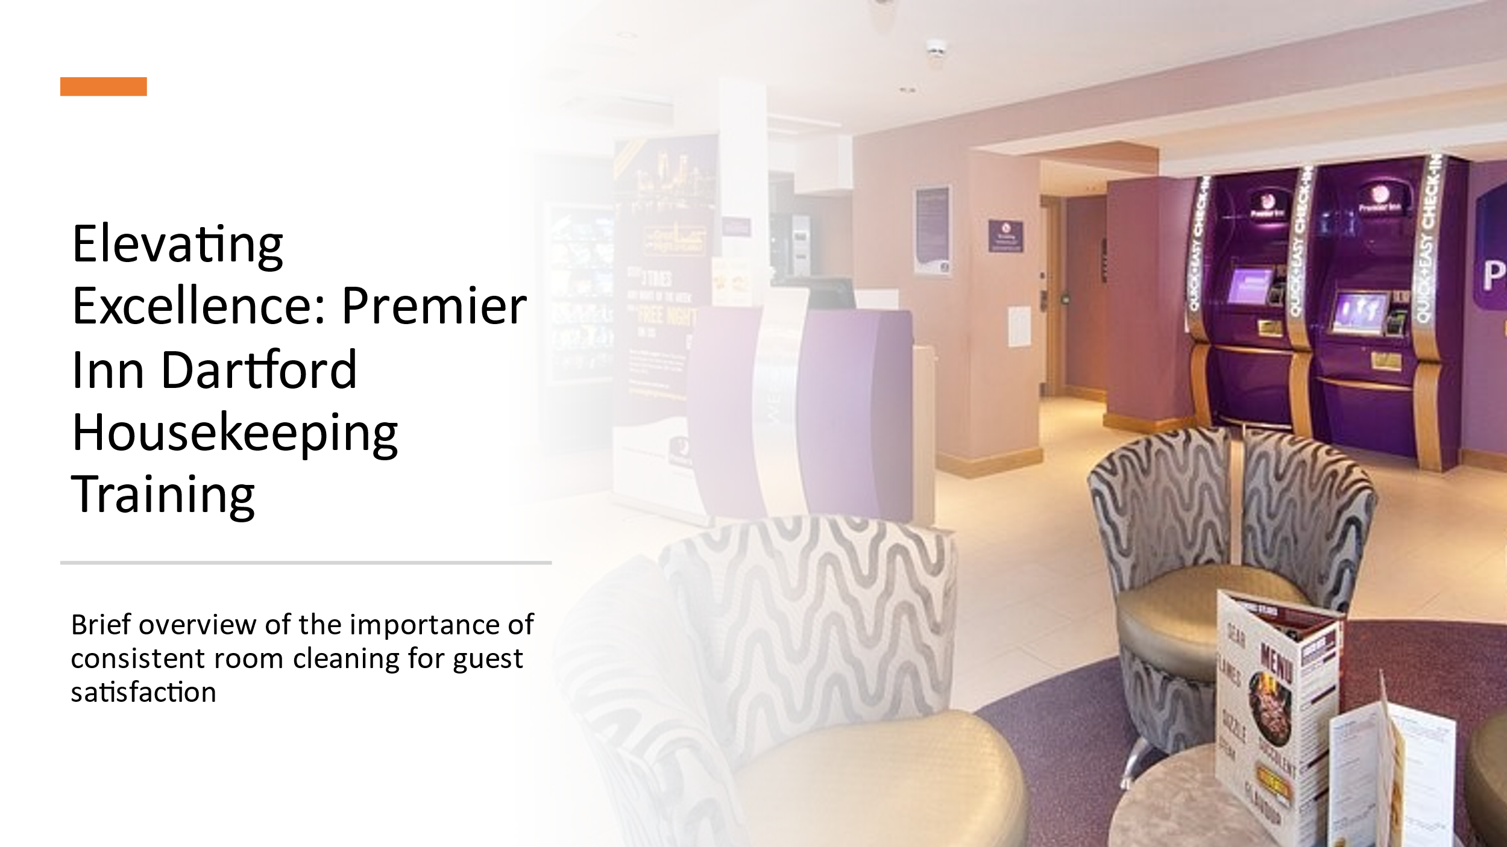
Welcome to the presentation "Elevating Excellence: Premier Inn Dartford Housekeeping Training". Our journey begins with a cordial greeting, which represents the essence of Premier Inn Dartford's hospitality. The warmth of our brand envelops this presentation, creating a learning environment. As we begin this training, we recognize that our constant commitment to continuous room cleaning is critical for visitor happiness (Rogers, 2020). The inclusion of Premier Inn Dartford logo across the slides underscores our dedication to a common identity and goal—a team that strives for excellence in every detail.

Slide 2: Table of Contents
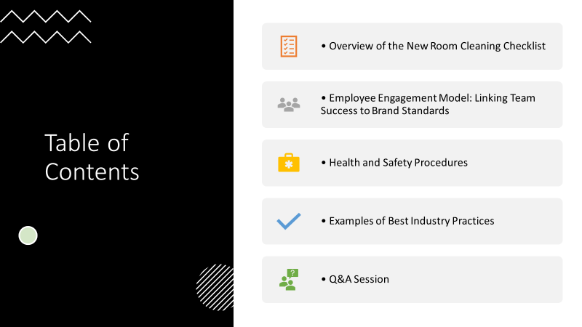
This lecture follows a defined agenda that is intended to create a thorough grasp of our core objectives. The New Room Cleaning Checklist, a tool rigorously created to line with Premier Inn Dartford's exacting brand standards, is the first step. Moving on, we'll look at the Employee Engagement Model, emphasizing the link between engaged employees and brand standards attainment. We then go over Health and Safety Procedures, look at examples of Best Industry Practices, and finish with an open discussion during the Q&A session. This well-planned agenda guarantees that each team member obtains insight into the factors critical to preserving and elevating our commitment to excellence.

Slide 3: New Room Cleaning Checklist
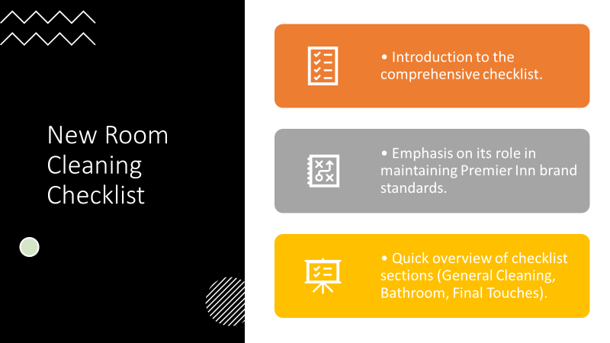
Slide 3 introduces a game-changing tool: the New Room Cleaning Checklist. This precisely developed and aligned checklist is the cornerstone of Premier Inn Dartford's dedication to cleanliness excellence (Bridger, 2018). The checklist instills a thorough approach to room cleaning through its precise task breakdown. Each piece is meticulously created to ensure that no detail is overlooked. The checklist serves as a guide, a blueprint for our housekeeping team to negotiate the complexities of room cleaning, leaving no space for ambiguity and setting a new industry benchmark for excellence.

Slide 4: Employee Engagement Model

Slide 4 opens the gateway to a fundamental aspect of our training—the Employee Engagement Model. At the core of our success lies the engagement of our team members (Ferdinand and Kitchin, 2018). This model, represented graphically on the slide, emphasizes the critical components: Communication, Recognition, and Development. Effective communication is cultivated through regular team meetings and open feedback channels. Recognition serves as a powerful motivator, encompassing acknowledgment of outstanding performance and the establishment of a supportive buddy system (Mullins, 2013). Continuous development is fostered through ongoing training sessions and mentorship opportunities. By embracing and implementing these components, our team transforms into a cohesive force, collectively committed to achieving and exceeding Premier Inn Dartford's brand standards.

Slide 5: Model Components
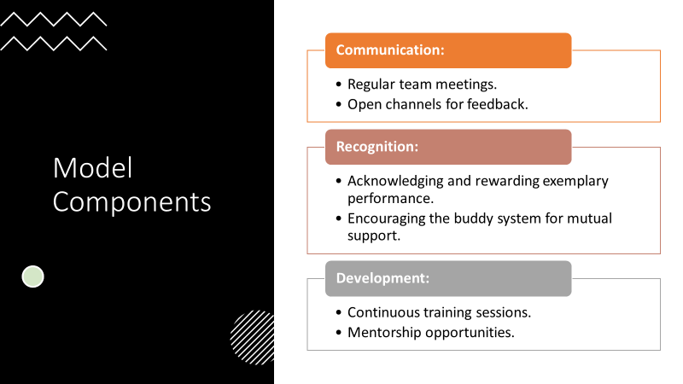
Building upon the Employee Engagement Model, Slide 5 delves into its intricate components. Communication stands as the bedrock, facilitated through regular team meetings where ideas flow freely, and open channels for feedback ensure a transparent and responsive work environment(Raghubalan, 2015). Recognition becomes a motivational catalyst, celebrating individual and collective achievements, bolstered by the buddy system, fostering a culture of mutual support. Development takes center stage with ongoing training sessions tailored to individual and team needs, supplemented by mentorship opportunities for professional growth (Rowson, 2017).. Each component intertwines, forming a synergy that propels our team towards success and aligns seamlessly with Premier Inn Dartford's brand standards.

Slide 6: Employee Engagement Examples
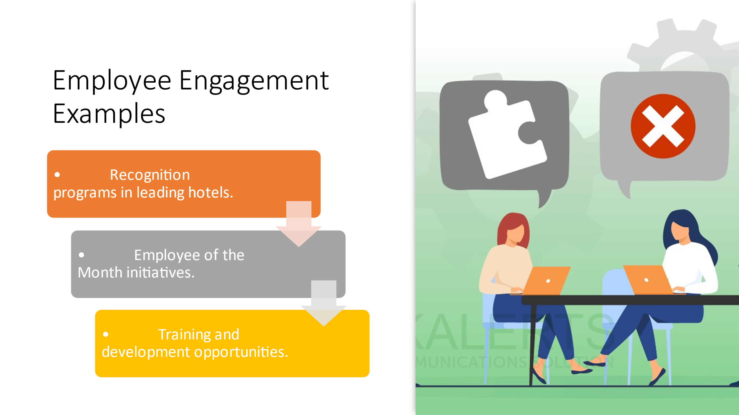
Slide 6 illuminates the concept of employee engagement through tangible examples. Recognizing outstanding performance and dedication is exemplified by leading hotels globally through initiatives like "Employee of the Month" programs. The impactful buddy system, demonstrated by fostering mutual support, showcases how engagement extends beyond individual achievements (Rutherford, 2019). Training and development opportunities, such as skill-building workshops and career advancement programs, serve as real-world instances of investing in our team's growth. These examples reinforce that employee engagement is not just a concept but a lived reality, fostering a positive and thriving work culture.

Slide 7: Linking Engagement to Brand Standards
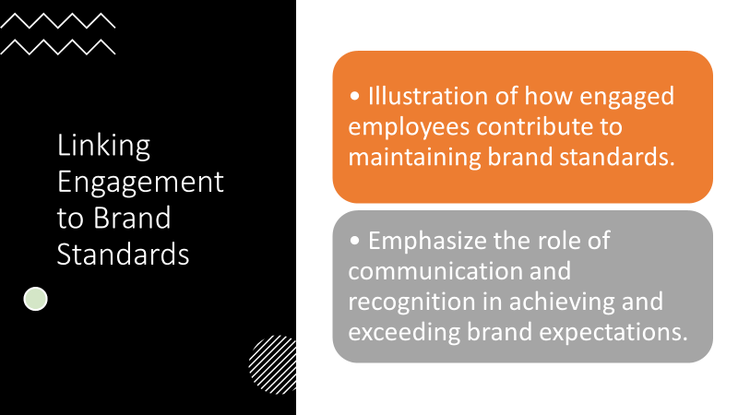
Slide 7 establishes a crucial connection between employee engagement and the consistent delivery of Premier Inn Dartford's brand standards. Effective communication and recognition, as highlighted in the Employee Engagement Model, directly influence the meticulous execution of our New Room Cleaning Checklist (Casado, 2019). The engaged team becomes a driving force behind the brand's reputation for excellence, translating the principles of engagement into tangible, high-quality results. This slide reinforces that our commitment to brand standards is not just an expectation but a shared responsibility that each engaged team member contributes to daily.

Slide 8: Health and Safety Procedures
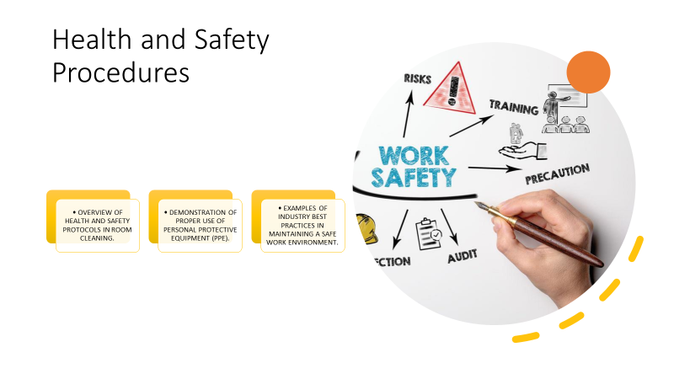
Slide 8 shifts the focus to another critical aspect—Health and Safety Procedures. A visual depiction of team members donning personal protective equipment emphasizes the paramount importance of safety. The slide outlines the key protocols within the checklist, ensuring team members are well-versed in maintaining a secure work environment(Tesone, 2017). Real-world industry examples of hotels excelling in health and safety practices, coupled with our commitment to best practices, reinforce the significance of adhering to these procedures (Hogg, 2015). This slide serves as a reminder that achieving excellence extends beyond cleanliness to the holistic well-being of our team and guests.

Slide 9: Best Industry Practices
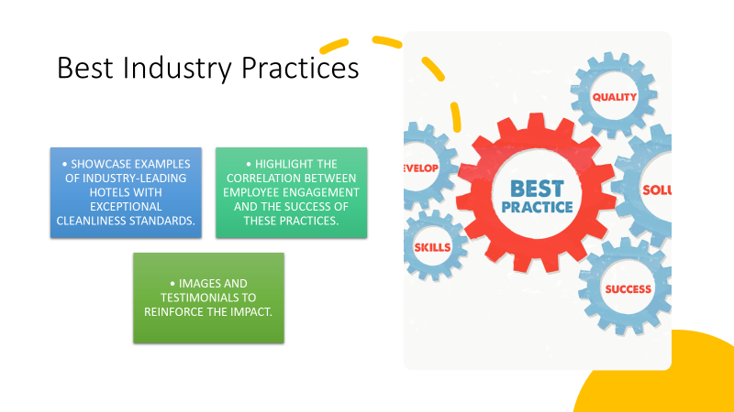
Slide 9 showcases industry leaders with exemplary cleanliness standards. Images and testimonials highlight hotels globally recognized for their commitment to excellence (Quick, 2020). These real-world examples serve as inspirations, illustrating that our goals are not just aspirational but achievable (Singh, 2019). Premier Inn Dartford's adherence to industry best practices, combined with an engaged team and a meticulous checklist, positions us among these industry leaders. The slide instills a sense of pride and motivation, reinforcing that our pursuit of excellence aligns with and even surpasses the benchmarks set by the best in the industry.

Slide 10: Conclusion
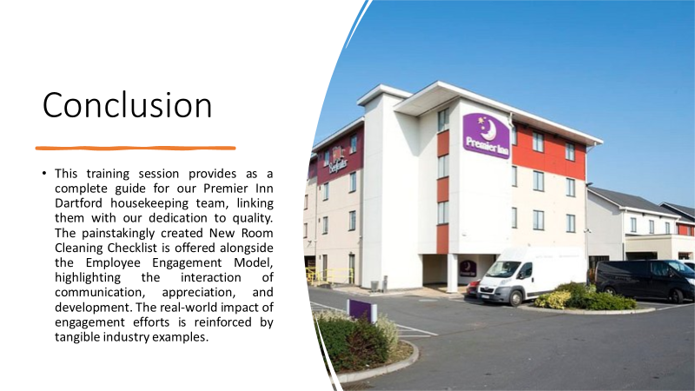
This training session provides as a complete guide for our Premier Inn Dartford housekeeping team, linking them with our dedication to quality. The painstakingly created New Room Cleaning Checklist is offered alongside the Employee Engagement Model, highlighting the interaction of communication, appreciation, and development. The real-world impact of engagement efforts is reinforced by tangible industry examples. Health and safety procedures, as well as best industry practices, highlight the comprehensive approach to excellence, which extends beyond cleaning to general well-being. The lecture is followed by a Q&A session to encourage open conversation and continuous growth. As we embark on this adventure, our staff is empowered to not only meet, but also surpass Premier Inn Dartford's high standards, contributing to a culture of quality, engagement, and steadfast dedication.

Slide 11 References
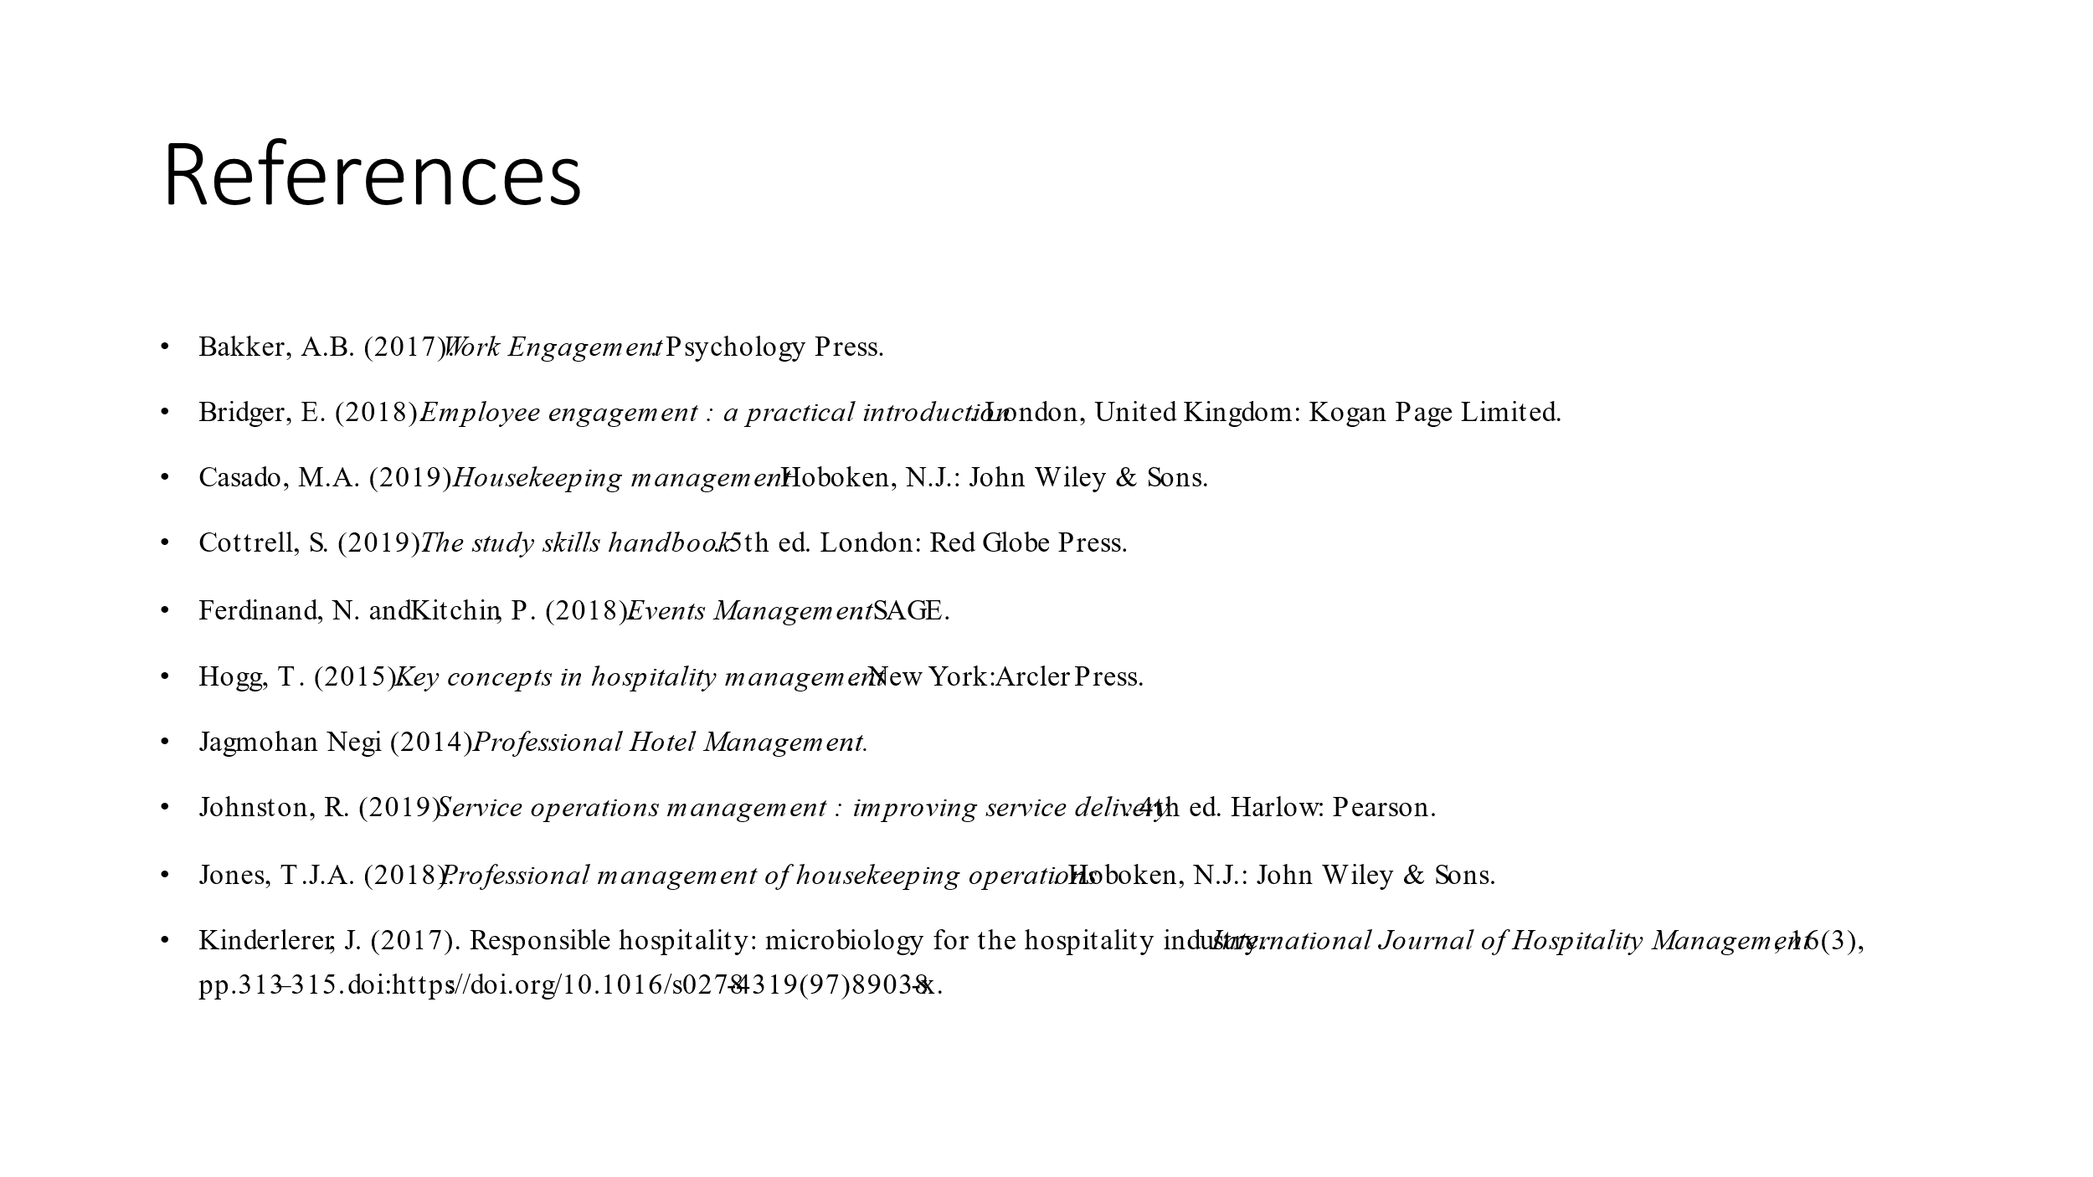
Bakker, A.B. (2017). Work Engagement. Psychology Press.
Bridger, E. (2018). Employee engagement : a practical introduction. London, United Kingdom: Kogan Page Limited.
Casado, M.A. (2019). Housekeeping management. Hoboken, N.J.: John Wiley & Sons.
Cottrell, S. (2019). The study skills handbook. 5th ed. London: Red Globe Press.
Ferdinand, N. and Kitchin, P. (2018). Events Management. SAGE.
Hogg, T. (2015). Key concepts in hospitality management. New York: Arcler Press.
Jagmohan Negi (2014). Professional Hotel Management..
Johnston, R. (2019). Service operations management : improving service delivery. 4th ed. Harlow: Pearson.
Jones, T.J.A. (2018). Professional management of housekeeping operations. Hoboken, N.J.: John Wiley & Sons.
Kinderlerer, J. (2017). Responsible hospitality: microbiology for the hospitality industry. International Journal of Hospitality Management, 16(3), pp.313–315. doi:https://doi.org/10.1016/s0278-4319(97)89038-x.

