Supporting Pupil Progress: A detailed analysis of one child’s holistic development, with justification for the next steps in learning.
Contents Page:
Contents Page ..................................................................................................................................... 1
Introduction ........................................................................................................................................ 2
Data Collection ................................................................................................................................... 2
Analysis of Learner ............................................................................................................................ 4
Strengths and Limitations ................................................................................................................ 8
Next Steps ............................................................................................................................................ 9
Conclusions ......................................................................................................................................... 11
Reference List ..................................................................................................................................... 13
Appendix 1 – Letter of consent ....................................................................................................... 16
Appendix 2 – Photographs of indoor areas ................................................................................... 18
Appendix 3 – Photographs of outdoor areas ................................................................................. 19
Appendix 4 – Verbal responses during tour................................................................................... 20
Appendix 5 – Child Conference responses .................................................................................... 21
Appendix 6 – Observation ................................................................................................................ 22
Appendix 7 - Examples of Literacy work ....................................................................................... 23
Appendix 8 – Examples of Numeracy work .................................................................................. 26
Appendix 9 – Examples of Religious Education work ................................................................ 28

Introduction
School A is a large Church in Wales school located in South East Wales; with approximately 300 children on role. Within the school there eleven classes; four Foundation Phase classes, five Key Stage two classes and an Early Years unit for children who attend the Nursery and Reception to access. Generally the children, who attend the school live within the school catchment area however, the school provides transport via a bus or taxi for those who need to commute. According to Estyn (2013), the children who attend the school come from areas that are neither economically disadvantaged nor advantaged and the schools free school meals (FSM) entitlement continued to be below the average in Wales, with 9.7% entitlement in 2017 (My Local School 2017).
During my professional teaching experience (PTE), I have been placed in the schools reception class within the Early Years Unit. Within the class there are 30 children aged 4 to 5 years however, during phonic, literacy and numeracy sessions children of nursery age also join the class to ensure the activities/ tasks provided meet their needs. From working with the children and also observing their participation during activities, I decided to focus my research on the holistic development of a 5 year old girl named Child A. She is working within the higher ability group throughout all subjects and chooses to practise the skills she has learnt independently during free choice.
To ensure ethical considerations are followed, the name of the school, the staff and all learners will remain anonymous throughout this project to ensure confidentiality for all who participated in the research. The school will be referred to as School A and the focus child will be referred to as Child A.
Data Collection:
To carry out the research and obtain information about Child A, the primary research method used was the Mosaic Approach. This being a method of qualitative data collection described by Clark (2011) as a method of evaluation for multiagency networks that enables the ‘voice of the child’ to be acknowledged. The Mosaic Approach has been defined by Clark et al (2001), as a combination of observations and interviews as well as participatory methods including map making, photographs and child led tours. This being recognised in the research carried out as the views and opinions of Child A were obtained through a variety of methods i.e. observations, interviews/ discussions and photographs during a child led tour of School A.
The observations conducted during the research were carried out through a non-participant method to enable identification of how Child A plays, interacts with others and engages with resources during free choice and focused tasks. By doing so, such methods enabled a large amount of information to be obtained in relation to the observed as focus on Child A remained uninterrupted. This being considered a benefit of non-participant observations as Macfarlan (2017) explains they enable information to be obtained that may not be easily gained through other methods of data collection. Alongside this, Gledhill et al (2007) highlights the effectiveness of non-participant observations as they enable the researcher to immediately record their findings rather than during recall at a later time therefore, resulting in missed information.
However, Macfarlan (2017) also identifies limitations to using such methods as she suggests observers are unable to capture everything that occurs therefore resulting in important information being overlooked. Alongside this, she also suggests the presence of a researcher can impact upon the actions of the observed therefore resulting in the information obtained being hindered and an inaccurate reflection (Macfarlan 2017). To prevent such occurrences, the observations were carried out from a suitable distance to ensure the events recorded were natural and unhinged.
In accordance to the Mosaic Approach, child conferencing was also carried out with Child A to highlight her opinions and point of views. Clark et al (2011) has defined child conferencing as short interviews/ discussions with a focus child. While doing so, the conferencing with Child A was an informal discussion based upon three questions, these were ‘What helps you learn?’, ‘Could you tell me about your learning in school?’ and ‘Can you tell me about the things that are important to your learning?’ While doing so, the discussion took place within Child A’s usual learning environment whilst other children and adults were present but not involved. By doing so, this prevented Child A experiencing any feelings of stress or anxiety and ultimately ensured she felt safe during the process.
Alongside this, Child A also took photographs of areas and resources that she considered important to her within school and also what she considers to help her learn. As suggested by Clark et al (2011), these enable the responses received from Child A to be strengthened as they provide further information during a child led tour; of School A. Clark et al (2001:24) cited by Cowie et al (2013) highlights how providing children with opportunities to take photographs provides them with a fun ‘powerful new language’ to express their thoughts and ideas. This therefore, enabling the ‘voice of the child’ to be expressed and understood which according to Ring (2016), enhances children’s confidence, self-esteem, social competence and independence. By doing so, such strategies and those within the Mosaic Approach may support children’s holistic development and well-being.
However, as suggested by The University of Sheffield (2012), there may be limitations to using visual methods of data collection i.e. photography, as the outcomes of the process and what the participants provide may not entirely meet the researchers expectations and needs. To prevent such occurrences in practice, Child A led the tour of her learning environment but we only ventured areas and resources that she has access to. By doing so, this enabled all data provided to be of sufficient use as she was able to take photos of areas or resources that she uses on a regular basis.
Analysis of Learner:
Throughout all that has been discussed, ethical considerations were followed to ensure Child A was aware of her rights and to ensure confidentiality was maintained. To support this, Child A was advised about the process of the research and asked for verbal consent to participate (see appendix 1). She was also made aware of her right to refuse or withdraw from participating at any point of the process; this in line with guidelines outlined by UWTSD (2017). Alongside this, a letter providing information and requesting permission was provided to the class teacher within the Early Years unit (see appendix 1).
The first aspect of the Mosaic approach to be carried out was the child led tour. Whilst doing so, Child A was a little reluctant to visit various areas within School A and therefore mainly focused upon her daily learning environment i.e. the Early Years unit, the play ground and garden area. This may be a result of Child A being fairly young or due to her feeling unfamiliar with the environment in various parts of the school. Alongside this, she focused on areas within the indoor environment that enabled her to work alongside peers while also accessing the enhanced provision. When touring her class, she photographed areas that frequently have challenges provided by the teacher within them i.e. the maths area, the creative table, the literacy worktop and the sandpit (see appendix 2). By doing so, this highlighted that she may consider working alongside peers to be important to her while also applying and developing her skills and knowledge. This was further established while taking the photos as she verbally explained that the maths area helps her to learn numbers and the literacy area helps her to ‘colour inside the lines’. According to Pentagon Play (2016), such opportunities for child led play within the classroom enable children to ‘practise and process’ information they have learned and also apply this within their imaginative and creative play. However, it is important to acknowledge that whilst touring the indoor environment it was identified that Child A did not acknowledge areas that encourage imaginative play i.e. the role play and small world area; which according to Kaufman (2012) can support children’s social and cognitive development; and she also refrained from mentioning any of her peers or highlighting participating in activities with others.
Although, when Child A accessed the outdoor environment and toured the garden area she highlighted on numerous occasions how she participates in play with peers. An example of this was when she took a photo of the garden area and explained she likes this area because she can ‘ride the bikes’ with her friends. Alongside this, she also highlighted how she plays with her peers in ‘the hut’ and races them on the race track within the school play ground (see appendix 3 and 4). This may highlight that she considers her friends and socialising more of an important aspect of her outdoor play rather than when accessing areas within the classroom. As highlighted by Life Education (2018), positive relationships and friendships support children’s social and emotional development whilst also encouraging new interests and enhancing children’s self-esteem, confidence, social competence and altruism. Alongside this, Vygotsky’s social theory also emphasises the link between social and cognitive development whereby children are provided with opportunities to collaborate and learn from each other (Sincero 2011). From this, it may be considered that Child A’s relationships with other children support her development and possibly enhance her progression within education.
To support this further, observations and evidence of work completed by Child A has also been obtained. From doing so, it was recognised that Child A is fairly confident while participating in class or group discussions and also group tasks whilst an adult is present. Whilst doing so, Child A is often willing to share her thoughts and ideas with peers and also demonstrates willingness to listen while others are speaking. However, whilst having something to add to the discussion, Child A will often sit with her hand up to suggest she is eager to speak. This is considered an important aspect of children’s social development, as they need to become aware of other peoples viewpoints whilst also responding appropriately to questions and the opinions of others (Nottingham 2013).
Alongside this, it is also evident that when Child A is provided with free choice while indoors, she quite often participates in independent tasks alone and does not appear to search for any peer support while doing so (See appendix 6). According to Nottingham (2013), such behaviours suggest she is developing positive social skills as she is able to work as part of a team or as an individual. Such information obtained in relation to this also suggests that Child A meets some of the expectations for her Personal and Social Development within the Foundation Phase curriculum, as it emphasises the importance of children being provided with opportunities to ‘become independent thinkers and learners’ and also the importance of children forming relationships whilst feeling confident with playing with others and working in collaboration (Welsh Government 2015:12).
As well as Child A’s personal and social development, it is also evident within the pieces of literacy, numeracy and religious education (RE) work obtained (see appendix 7, 8 and 9) that she has made steady progression throughout the school year. Within literacy, she has developed understanding of phonics and how words can be sounded out and segmented therefore supporting her development with reading, writing and oracy skills. By doing so, Child A is becoming confident with identifying and naming phonemes within a word. This has been supported through the school’s phonics scheme called ‘Letters and Sounds’; whereby children attend sessions that focus upon developing their understanding of sounds/ letters before beginning to read. Within the phonic sessions, Child A now attends a group that only children of her age attend and is lead by her class teacher. These sessions alongside her weekly reading book enable Child A to develop in confidence whilst reading and accessing comprehension activities. Child A now receives a level two reading book that she practises both at home and in school to support her development whilst also providing consistency and communication between home and school. As suggested by Oxford Owl (2017), such practice that enables understanding of phonics alongside ‘good comprehension skills’ is essential to ensure children’s development with reading; as by allowing children to access a range of books, they will be encouraged to gain understanding of new vocabulary whilst also gaining knowledge of the world.
Alongside this, Child A also demonstrates increased awareness of how sentences are structured i.e. capital letters; full stops, finger spaces etc (see appendix 7). Although within practice she sometimes requires reminding from an adult to include capital letters and full stops within her work; this possibly due to her concentrating on the contents of what she is writing. However, Child A development of such skills demonstrates she has good knowledge of writing skills as whilst in a Reception class, children are expected to ‘discriminate between letters’ and ‘produce pieces of emergent writing’ (Welsh Government 2015). This suggesting, that Child A is achieving what is expected for her age group and is working towards becoming confident with skills that are expected of a year one child; for example, she is beginning to ‘write words, phrases and simple sentences and read back own attempts’ (Welsh Government 2015) with support. This is further evidenced through work that has been moderated and considered to have met Outcome three standards for writing; as Child A is able to identify the initial sound and use spelling strategies learnt to write consonant– vowel –consonant (CVC) and high–frequency words (HFW) as well as distinguishing between upper and lower case letters (Welsh Government 2015) (see appendix 7).
Alongside literacy, Child A has also made steady progression within numeracy. She consistently demonstrates awareness of formation, order and value of numbers and is beginning to gain greater understanding of how simple subtraction and addition sums are formed and worked out. Alongside this, she also shows willingness to participate in various numeracy activities independently i.e. create a number line, colour by number, create a pattern, addition sums etc while accessing the enhanced provision and is confident while doing so. Again, these are activities that she can usually complete without any peer engagement but once completed she often looks for adult reassurance or approval. This suggested by Reigh (2004) may be a result of her requiring praise or adult attention to support her self-belief and to feel positive about herself; and the work she has completed. To support this within the Early Years Unit, the children are provided with a ‘Look at my work’ display; whereby the children can freely peg any work they have completed and feel proud of. By doing so, this enables the children to acknowledge the value of the work or activities they have completed (Dunne 2015) as well as those that have been completed by their peers. Within practice, Child A will regularly use this display and will often put work she has completed all on one peg; therefore suggesting she feels it is important for other children’s work to be displayed alongside hers and for space/ pegs to be left for them to do so.
When reflecting upon the numeracy work completed by Child A (see appendix 8), it has been recognised that she is on track to achieve the expected outcome for her age; this being Outcome 3 whereby children are expected to recite numbers up to 20, ‘read, write, compare and order numbers up to 10’ and ‘recognise and name simple 2D shapes and 3D shapes’ (Welsh Government 2015). All of which, Child A has demonstrated through her work and independent involvement within the enhanced activities provided.
Child A’s holistic development as well as progression in all subjects taught may be influenced by her positive attitude and willingness to learn, as she is always seen to be trying her best and eager to get involved. Alongside this, she consistently has a good level of focus and concentration while completing a task or activity. According to Nottingham (2013), such attributes within a learner alongside curiosity, focus, wonder and a willingness to ask for support enables children to develop into outstanding learners. These being some of the attributes recognised within Child A as she is fairly confident with asking for support from an adult when needed and she is often curious about what she will be learning during a school day. She demonstrates this by wanting to venture into various areas of the classroom to see the activities/ challenges that have been provided as well as questioning an adult on the expectations of tasks. Such curiosity according to O’Toole (2013), is considered essential in children’s development as it is ‘the force that drives personal development’, as it allows children to gain knowledge through new ideas and concepts that are provided.
From all that has been discussed, it can be recognised that Child A is a competent child who is able to independently complete most tasks/ activities given whilst also having a positive attitude to learning. Alongside this, it can also be identified that Child A is achieving the expected outcomes for her age within the Foundation Phase curriculum and therefore has the potential to stay on track for future years within her education. However, an area for improvement within her development that may require future support is her communication and collaboration with children during free choice within the classroom; as it has been recognised that she often prefers to complete activities with little play or communication with others.
Strengths and Limitations of data collection:
Whilst carrying out data collection with young children, it is important to acknowledge that there may be strengths and weaknesses in the data collected. Whilst carrying out The Mosaic Approach, Clarke (2011:13) highlights the strength of using a ‘multi-method’ approach as it enables the children to voice their opinions whilst also being involved in participatory activities i.e. child led tour and taking photographs. This being a strength within the research carried out as Child A independently led the tour of her learning environment whilst also providing both photographic and verbal evidence of what she considers important to her and her learning (see appendix 2, 3 and 4). By doing so, such opportunities enabled Child A to share her perspective of the environment provided.
Alongside this, Child A also participated in a child conference discussion whereby three questions were asked. This enabled further information to be obtained in relation to what she thinks is important and helps her to learn. Using such strategies can be useful as they provide opportunities for her responses to extended therefore providing further information to what was obtained during the tour. However, as recognised in Child A’s responses (see appendix 5), the answers provided were short and brief and as a result did not entail a lot of information. Due to this, it may be considered a limitation to using discussions as a research method as only a small amount of information was obtained in relation to her perspective; which cause the data to be considered insufficient as there may be gaps within the information obtained (Robinson, K.A. 2011).

Next steps:
In relation to the data collected about Child A’s development, there are a number of recommendations to be discussed that may support her progression in education and also her holistic development.
The first to be discussed is to encourage Child A’s social development during focused tasks and free choice within the enhanced provision; as whilst indoors Child A often chooses activities that can be completed independently and with little interaction with others. To encourage her to communicate with peers, use of Assessment for Learning strategies could be incorporated into group work and encouraged in enhanced activities i.e. partner work, games and role play.
One that may be considered useful for Child A is the use of ‘Talking Partners’ or ‘Think, Pair, Share’ activities as these may encourage her to develop confidence with talking to children whilst also gaining information from their thoughts and ideas. This is highlighted by Clarke (2009), as she suggests talking partners ‘enables children to learn from each other’ whilst providing opportunities for ‘greater pupil engagement’ and excitement; as they can continually learn and develop relationships whilst changing partners. This therefore could support Child A’s development of friendships and confidence to participate in activities with others, as she will be provided with opportunities to engage and communicate with children she may not normally do so with. Alongside this, providing such opportunities for collaboration will also enable the class teacher to gain responses from a wider range of children and gage further with ‘the level of understanding’ the children have in relation to what is being taught (Clarke 2009). By doing so, this will also enable challenges to be provided to extend Child A’s understanding and therefore encourage her progression.
As well as Child A’s social development, an area that may also require targeting is her reading skills; as she is currently accessing Stage 2 books which are aimed at 4 to 5 year olds (Oxford Owl 2018). This highlighting that she is currently on the expected stage for her age but may need activities that can further develop her reading in preparation for Year 1; as expectations within the Foundation Phase curriculum extend beyond the stage she is currently at. An example of this is how in Year 1 children are expected to ‘read suitable texts with accuracy and fluency’ while also showing awareness of punctuation (Welsh Government 2015). To support Child A in doing so, guided reading sessions could be implemented whereby activities are provided in a carousel throughout the week. An example of this may involve the children being grouped according to their reading ability and accessing in rotation; a reading book; a spelling activity; an audio/ online story and a comprehension activity. By doing so, such sessions will enable a range of Child A’s reading skills to be targeted and developed; whilst encouraging independent application of skills (Kreul 2018) she has learnt.
However, when implementing guided reading within a class it is essential to ensure the resources available meet the children’s needs; as if the activities provided are too challenging or not challenging enough then the children will become disengaged and lose concentration. To prevent such occurrences Kreul (2018) recommends identifying and grouping the children in accordance to their reading ability to ensure the resources and activities provided are accessible. Alongside this, she is also recommends ongoing assessments and observations to be carried out to ensure the children remain within a suitable group (Kreul 2018). To support this within practice, I would work in collaboration with staff to introduce a scheme or method of guided reading that enables progression whilst also ensuring consistency of strategies implemented throughout all year groups. An example of this may be the Collins Big Cat reading scheme whereby a wide range of books are available to support children’s progression from supported to independent reading and later leading to whole class reading (Collins Reading 2018). Therefore by implementing such a scheme, Child A alongside all year groups will be catered for and following a format that progresses with the skills they develop.
Alongside the development of Child A’s reading skills, she will also need to develop her confidence and development with writing skills. To support her in doing so, she will need to further develop her understanding of how sentences are structured i.e. capital letters, fingers spaces and punctuation whilst also engaging in creative writing to ensure she progresses as expected within the Foundation Phase curriculum; as within Year one she will be expected to’ develop the use of a storyline within imaginative writing’ (Welsh Government 2015). To support her in doing so, I would introduce the use of Pie Corbett strategies whereby children begin with imitating language they require ‘for a particular topic orally before reading and analysing it and then writing their own version’ (Talk 4 Writing 2016). This will enable Child A to be introduced to more creative and imaginative vocabulary whilst developing her understanding of punctuation through body movements and actions developed as a class. Alongside this, Corbett (2008:5) also emphasises the importance of ‘shared writing’ whereby the teacher models what is required for a good piece of writing whilst engaging the children through ‘brisk and interactive’ (Corbett 2008:6) activities that enable them to gain involvement with the shared piece of writing..
However, it is important to acknowledge that strategies like Pie Corbett’s Talk for Writing are usually implemented as a whole school approach and therefore will require staff training, purchase of resources and ultimately funding. As a result, this may a limitation to incorporating such strategies as staff training is quite expensive at £1000 plus expenses for sixty delegates (Talk 4 Writing 2016). To support the school in developing the approach and to ensure the children gain access to such strategies, it may be recommended that a small amount of staff attend training in collaboration with other schools and later feedback within staff meetings to develop the knowledge of all staff. By doing so, this will enable Child A and other children to develop their knowledge of writing skills in a fun and exciting way that will encourage their involvement in creative writing.
As well as this, it is also important to acknowledge that Child A is currently confident whilst engaging with numeracy activities that target expectations within Outcome three however; her skills will require further development to ensure she progresses as expected within Year 1. An area that may need to be focused upon is her use of ‘number facts’ for example, ‘doubling and halving’ (Welsh Government 2015) as these are concepts that she is yet to be introduced to. To support Child A in doing so, it may be recommended that she participates in a variety of ‘hands on’ practical activities; to ensure those that are provided are engaging and stimulating (UC Education 2018) therefore encouraging Child A’s development of new skills and knowledge. An approach that is currently being implemented within School A and may support Child A’s development with numeracy is the Big Maths scheme whereby children participate in 20 minute ‘CLIC’ sessions that involve 5 minutes on each area of ‘Counting, Learn its, It’s nothing new and Calculation’ (Big Maths 2018). Therefore, during these sessions Child A and all the children within the class will be provided with activities that encourage participation whilst developing new skills and applying those already learnt.
Throughout all the next steps discussed, it is essential to ensure Child A and all other children are provided with praise and appreciation for the progression they have made and the achievements they have attained; as this will encourage their willingness to engage within lessons and will ultimately support their well-being.
Conclusion:
From the research carried out and all the information obtained in relation to Child A and her perspective of school life, it has been recognised that there are a variety of ways that can be implemented within practice to ensure children have ‘a voice’ within their education; therefore enabling their thoughts and ideas to be expressed and listened to. Within practice, I would like to implement use of ‘One Page Profiles’ to support both the children and I in gaining awareness of what is important to them and also how they can best be supported within their education (Welsh Government 2015). By doing so, this will support my practice by enabling a more personalised education to be delivered to children; therefore ensuring their voices are heard and their needs are met.
Alongside this, the research obtained has also increased my understanding of how important it is to be aware of the next steps required within children’s education; by assessing their development and acknowledging the expected skills within the Foundation Phase Curriculum for future year groups. By doing so, this will enable children who are of high ability to gain access to lessons and activities that provide accessible challenges whilst encouraging application of skills they have learnt. To support this further, I have also gained increased awareness of a variety of schemes and approaches available to support children’s development in reading, writing and numeracy skills. By doing so, this will support my future practice as I will fully engage with the approaches available within schools to ensure they are purposefully implemented and ultimately used to encourage children to progress to their full potential.

Reference List:
Big Maths (2018) A Big Maths Lesson. Step by Step. Available [online] at: https://www.bigmaths.com/ Accessed on 29/05/2018
Clark, A. (2011) Ways of seeing: using the Mosaic approach to listen to young children’s perspectives. Available [online] at: http://learningaway.org.uk/wp-content/uploads/RL56-Extract-the-Mosaic-Approach-EARLY-YEARS.pdf Accessed on 21/05/2018
Clark, A. and Moss, P. (2001) Listening to young children: The Mosaic approach. Available [online] at: https://www.jrf.org.uk/report/listening-young-children-mosaic-approach Accessed on 21/05/2018
Clarke, S. (2009) Why use the strategy of Talk Partners? Available [online] at: https://www.shirleyclarke-education.org/research/talk-partners-2009-year-5-4th-grade-us/ Accessed on 28/05/2018
Collins Reading (2018) Collins Big Cat Guided, Independent and Whole-Class Reading. Available [online] at: https://collins.co.uk/pages/primary-english-collins-big-cat-guided-and-independent-reading Accessed on 28/05/2018
Corbett, P. (2008) The National Strategies ‘Good Writers’. Available [online] at: https://www.foundationyears.org.uk/files/2011/10/Good_Writers1.pdf Accessed on 29/05/2018
Cowie, H. Huse, R, C. and Myers, C. (2013) The Use of Participatory Methods in Researching the Experiences of Children and Young People. Available [online] at: file:///C:/Users/user/Downloads/CJE_Vol_16_Sp_Ed_No_2_Cowie_Huser_and_Myers%20(3).pdf Accessed on 22/05/2018
Dunne, D.W. (2015) Children’s Work: Visibility Leads to Value. Available [online] at: www.educationworld.com/a_curr/curr274.shtml Accessed on 27/05/2018
Estyn (2013) A Report on *****Primary School. Available [online] at: https://www.estyn.gov.wales/sites/default/files/documents/Inspection%20report%20*****%20*****%20*****%20Primary%20School%202013%20%28English%20only%29_0.pdf.pdf.pdf.pdf.pdf.pdf.pdf.pdf.pdf.pdf.pdf.pdf.pdf.pdf.pdf.pdf.pdf.pdf Accessed on 20/05/2018
Gledhill, A. Mulligan, C. Saffrey, G. Sutton, L. and Taylor, R. (2007) BTEC National Sport and Exercise Science Student Book. Oxford: Heinemann
Kaufman, S.B. (2012) The Need for Pretend Play in Child Development. Available [online] at: http://www.google.co.uk/amp/s/www.psychologytoday.com/us/blog/beautiful-minds/201203/the-need-pretend-play-in-child-development%3famp Accessed on 26/05/2018
Kreul, M. (2018) Guided Reading in the Primary Classroom. Available [online] at: https://www.scholastic.com/teachers/articles/teaching-content/guided-reading-primary-classroom/ Accessed on 28/05/2018
Life Education (2018) Children and the benefits of friendships. Available [online] at: https://www.lifeeducation.org.au/parents/children-and-the-benefits-of-friendship Accessed on 23/05/2018
Macfarlan, A (2017) Non Participant Observation. Available [online] at: https://www.betterevaluation.org/en/evaluation-options/nonparticipantobservation Accessed on 21/05/2018
My Local School (2017) ***** Primary Available [online] at: http://mylocalschool.wales.gov.uk/School/*****?lang=cy Accessed on 21/05/2018
Nottingham, J. (2013) Encouraging Learning. Oxon: Routledge [e-book]. Available at: https://www-dawsonera-com.ezproxy.uwtsd.ac.uk/abstract/9780203559079 Accessed on 23/05/2018
O’Toole, V. (2013) Why Curiosity Is The Most Important Skill To Teach Your Child. Available [online] at: https://www.howtolearn.com/2013/05/why-curiosity-is-the-most-important-skill-to-teach-your-child/ Accessed on 27/05/2018
Oxford Owl (2017) Reading at School. Available [online] at: https://www.oxfordowl.co.uk/for-home/starting-school/reading-in-school/ Accessed on 28/05/2018
Oxford Owl (2018) Stage Two: Introduction. Available [online] at: https://www.oxfordowl.co.uk/for-home/find-a-book/read-with-oxford/about-rwo-stage-two/ Accessed on 28/05/2018
Pentagon Play (2016) Why Free Play is Crucial For Early Years Children. Available [online] at: https://www.pentagonplay.co.uk/news-and-info/why-free-play-is-crucial-for-early-years-children# Accessed on 24/05/2018
Reigh, M. (2004) 9 Ways To Bring Out The Best In You and Your Child. Canada: Northstone Publishing [e-book]. Available [online] at: https://books.google.co.uk/books?id=PTISx4515wQC&printsec=frontcover#v=onepage&q&f=false Accessed on 27/05/2018
Robinson, K.A., Saldanha, I.J., & Mckoy, N.A. (2011). Frameworks for determining research gaps during systematic reviews. Methods Future Research Needs Report No. 2 Available [online] at: http://www.nccmt.ca/knowledge-repositories/search/118 Accessed on 28/05/2018
Sincero, S. (2011) Social Development Theory. Available [online] at: https://www.explorable.com/social-development-theory Accessed on 25/05/2018
Sing, E. (2016) The Voice of the Child in the 21st Century education matters, now more than ever. Available [online] at: https://www.aare.edu.au/blog/?tag=emer-ring Accessed on 23/05/2018
Talk 4 Writing (2016) About Talk for Writing. Available [online] at: http://www.talk4writing.co.uk/about/ Accessed on 28/05/2018
The University of Sheffield (2012) Learning and Teaching Services. Available [online] at: https://www.sheffield.ac.uk/lets/strategy/resources/evaluate/general/methods-collection/visual Accessed on 23/05/2018
UC Education (2018) Top Five Benefits of a Hands-On Learning Approach. Available [online] at: https://www.universities-colleges-schools.com/top-5-benefits-of-a-hands-on-learning-approach Accessed on 29/05/2018
University of Wales Trinity of Saint David (UWTSD) (2017) Research Ethics & Integrity Code of Practice. Available [online] at: http://www.uwtsd.ac.uk/media/uwtsd-website/content-assets/documents/research/research-ethics-integrity-code-practice.pdf Accessed on 23/05/2018
Welsh Government (2015) Foundation Phase Framework. Available [online] at: https://gov.wales/topics/educationandskills/foundation-phase/?lang=en Accessed on 26/05/2018
Welsh Government (2015) Person-centred practice in education: a guide for early years, schools and colleges in Wales. Available [online] at: http://learning.gov.wales/docs/learningwales/publications/151210-person-centred-practice-in-education-en.pdf Accessed on 29/05/2018

Appendix 1:
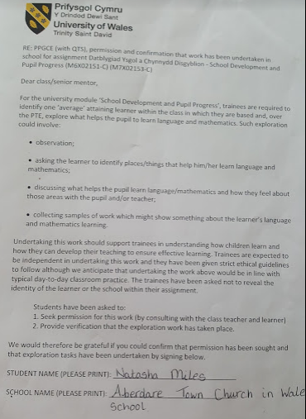

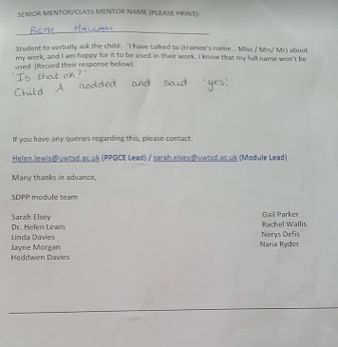

Appendix 2:
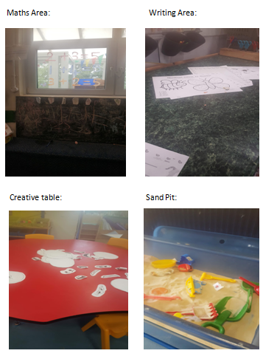

Appendix 3:
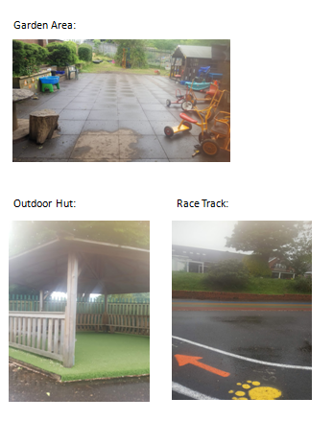

Appendix 4:
Verbal Responses during Child Led Tour:
Number Area:
Child A - ‘Numbers help me learn’
Writing Area:
Researcher - ‘Why is the writing area important to you?’
Child A – ‘Cause of colouring. I need to colour in the lines’
Creative Area:
Child A – ‘I can make things’
Researcher – ‘What can you use whilst making things?’
Child A – ‘Glue’
Sandpit:
Child A – ‘You can find the matching pair of mini beasts’
Garden Area:
Researcher – ‘What do you like about the garden area?’
Child A – ‘All of it. It is fun to play on the bikes and we can dig up the weeds.’
Outside Hut:
Child A – ‘I like playing with my friends down here.’
Racing track:
Child A – ‘I like racing with my friends’

Appendix 5:
Discussion during Child Conference:
Researcher – ‘What helps you learn?’
Child A – ‘Numbers, they help me count high numbers’
Researcher – ‘Does anything else help you learn?’
Child A – ‘The teachers, they help me spell things right’
Researcher - ‘Can you tell me about your learning in school?’
Child A – ‘I learn words in school like tricky words. The teachers tell me how to spell them right. It is fun.’
Researcher - ‘Can you tell me about the things that are important to your learning?’
Child A – ‘To listen’
Researcher – ‘Is there anything else that is important to your learning?’
Child A – ‘Colouring because you got to colour in the lines’

Appendix 6:
Observation notes:
Free Choice within the Enhanced Provision.
Child A collects a small whiteboard and pen and sits alone by the investigation table. She looks around the class but does not interact with peers. She begins to independently write numbers on the whiteboard. She writes numbers one to five in the correct order and then stands up and takes her work to an adult nearby for approval. The adult praises her and Child A smiles but does not verbally respond. She then walks away and returns to the same seat by the investigation table. Once seated, Child A continues writing numbers independently from the number five she has written and continues writing numbers up to twelve. Once she finishes writing number twelve, she brings her whiteboard to me and says ‘I know why there is a zero’ whilst pointing to the number ten. I ask her ‘Why is there a zero?’ Child A replies ‘because it is ten’. I replied ‘well done, you are right that is number ten’. Child A looks at me whilst smiling but does not respond.

Appendix 7:
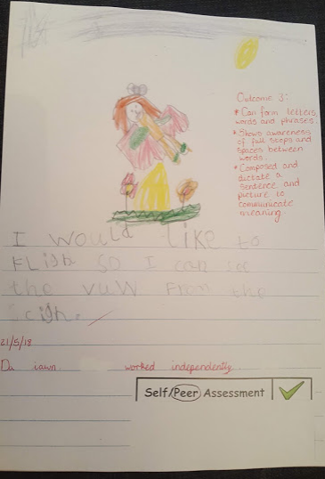

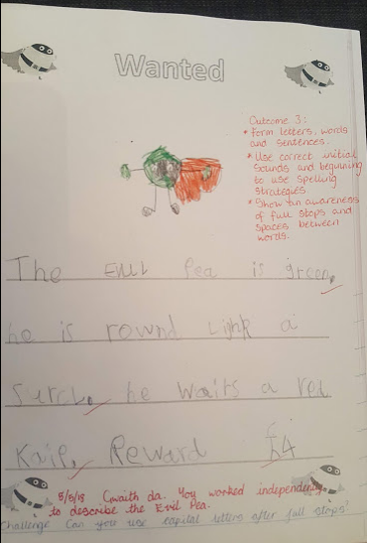

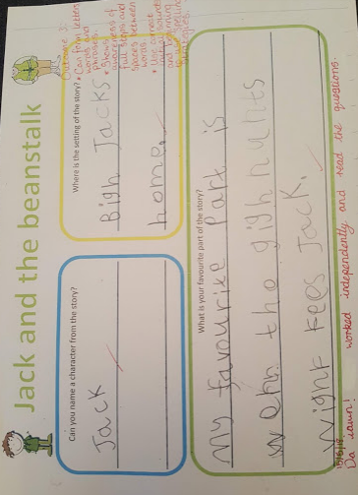

Appendix 8:
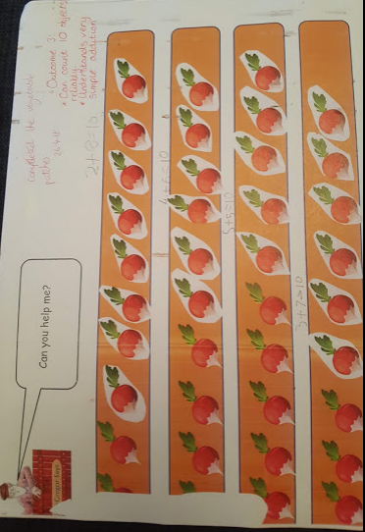

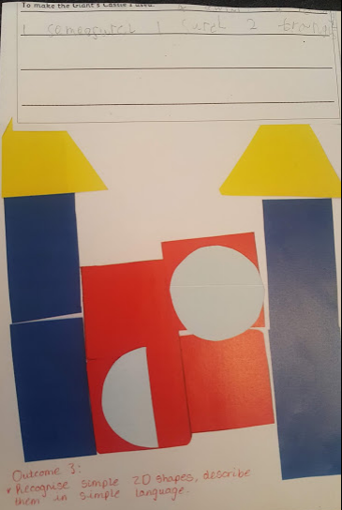

Appendix 9:


