Assessment 2 – Digital Business (BMSP6002)
This report was written by Harri Gerald Dendle. [This essay is formatted in print layout Microsoft Word .docx style]

Introduction

In this report, I will conduct a comprehensive analysis of Airbnb, using it as a representative case study within the sharing economy. This analysis will cover a thorough assessment of several factors, such as the contemporary Airbnb business model, the financial environment, the dynamics of the peer-to-peer market, target demographics, current obstacles, overall strategy, and the current situation Airbnb faces. More specifically I will be examining business model theories, like the Business Model Canvas, as well as how to employ other tools like Strategic Formulation Framework, or the Grand Strategy Matrix as well as other information miscellaneous systems that apply to Airbnb. In addition, I will investigate potential solutions for the problems that have been found and make suggestions that should help Airbnb expand in the future.

Airbnb Landscape

Before critically analysing Airbnb and the theory models they employ it’s important to understand how Airbnb was founded and how they choose to operate their company today, as well as what the sharing economy is and what is represents.

Airbnb is an online marketplace and platform for hospitality that links travellers looking for short-term housing with hosts who have rooms available. The website, which was established in 2008, provides a wide variety of housing choices, such as hotel rooms, holiday rentals, and homestays. Airbnb offers a substitute for conventional hotel stays, enabling guests to enjoy distinctive and frequently more economical lodgings while promoting a feeling of community and cross-cultural interaction.

Brian Chesky, Joe Gebbia, and Nathan Blecharczyk were the three individuals who came up with the idea for Airbnb. Living in San Francisco and experiencing financial difficulties in 2007, the founders saw an opportunity during a design conference that left hotels completely filled. In response to the lack of available lodging, they made the decision to rent out their apartment by setting up the straightforward website "Airbed & Breakfast." The idea was to provide breakfast and air beds to conference goers looking for low-cost lodging. [1]

Travellers who value a variety of lodging options and customised stays, and who are frequently between the ages of 25 and 45, are among Airbnb's target demographics.

Now it’s essential to establish what is meant when the term sharing economy is used to describe Airbnb, Academically speaking, the sharing economy—also referred to as the collaborative economy or peer-to-peer economy—is an economic system in which people or organisations share access to resources, goods, services, or skills, frequently on a temporary basis. These transactions are facilitated through digital platforms.
The concept prioritises peer-to-peer interactions, maximises the use of underutilised assets, and encourages collaborative consumption. Scholarly discourse pertaining to the sharing economy frequently delves into its socio-economic ramifications, encompassing concerns regarding regulation, trust, and the effect on conventional sectors. All things considered, the sharing economy is a movement towards access rather than ownership, propelled by technology and the need for more environmentally and socially conscious patterns of purchase. [2]
As it currently stands, Airbnb is in a favourable position in their market, growing substantially in a short period of time, the primary cause of Airbnb’s decline over 2020 was the result of the covid-19 pandemic, restricting travel and vacation opportunities for the public.

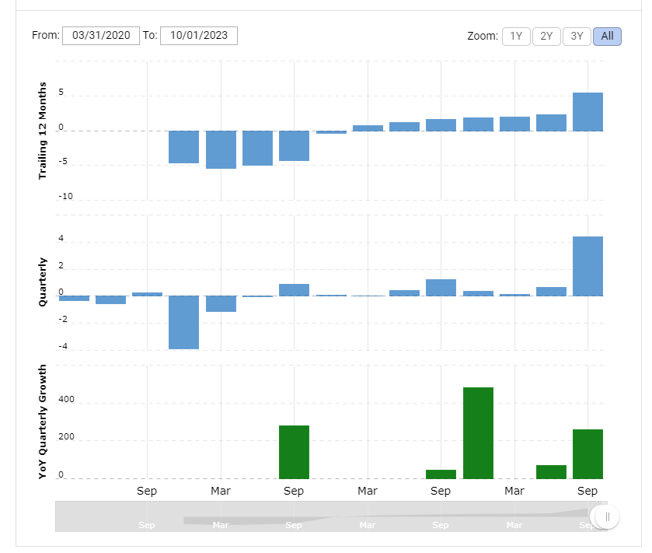

Source: Macrotrends [3]

Along with other peer-to-peer platforms, Airbnb competes in the market and must navigate regulatory obstacles while adjusting to changing customer demands for distinctive experiences. The success of the platform depends on building trust, utilising technology, and upholding a favourable reputation via user reviews. Local and global economic factors affect how much demand there is for travel services. Airbnb's market positioning is influenced by strategic alliances and collaborations, and its user resonance is also influenced by societal and cultural trends. The market becomes more dynamic with the arrival of new firms and players, which challenges Airbnb's hegemony and changes the dynamics of the sector. [4]

Lastly, it is imperative to understand what is Airbnb’s current financial position, and what are the market challenges they face? As of Q1 2024, Airbnb is valued at a little under 90 billion US dollars, with a share price of 139 dollars per share. [5] Although the COVID-19 pandemic was having a positive financial impact on Airbnb, the company was still facing challenges from competition, regulations, and the ongoing effects of uncertainty surrounding international travel on its operations. Overall Airbnb is in a very secure and stable position, to compete with traditional hotel operators across the world.

Business Model Canvas
.
A Business Model Canvas is a tool for strategic management and innovation that offers an organised framework for the ideation, illustration, and examination of the essential elements that make up a business model. The canvas, created by Yves Pigneur and Alexander Osterwalder, consists of nine basic construction components, each of which stands for a crucial facet of the company. Customer segments, value propositions, channels, customer relationships, income streams, important resources, important activities, important alliances, and cost structure are all included in these building blocks. [6]
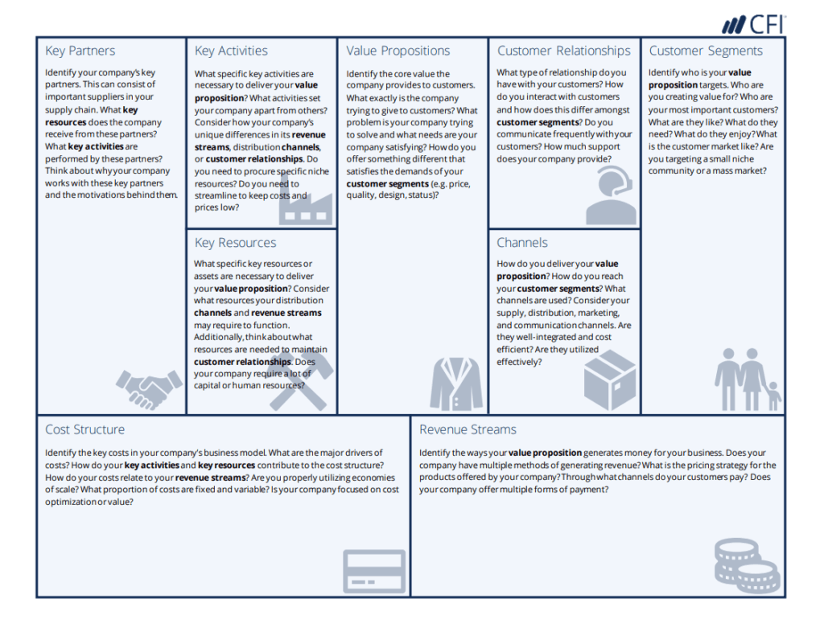

Source: Corporate Finance Institute

The canvas functions as a comprehensive and graphical depiction that enables people and companies to methodically explain and examine their business strategy. Academic discourse frequently highlights its usefulness in promoting interdisciplinary cooperation, advancing a thorough comprehension of company dynamics, and streamlining strategic decision-making procedures. The Business Model Canvas can be used as an educational tool by researchers and teachers to teach strategy, innovation, and entrepreneurship as well as to evaluate and contrast different business models from different industries.
In the Business Model Canvas, developed by Alexander Osterwalder and Yves Pigneur, Airbnb's integration is represented across several key components:
- Customer Segments: Airbnb serves a range of clientele, from homeowners hoping to make money from their rooms to tourists searching for distinctive and reasonably priced lodging.
- Value Propositions: Airbnb provides a wide variety of housing choices, customised experiences, and a feeling of absorption in the local culture for visitors. Airbnb gives hosts a way to make money by renting out their homes and knowledge. [7]
- Channels: Airbnb offers a smartphone app and an internet platform for users to search, book, and list properties or activities.
- Customer Relationships: Through its user-friendly platform, customer service, and the trust that is built through user reviews, Airbnb cultivates connections with its customers.
- Revenue Streams: The main sources of income for Airbnb are host service fees, guest booking fees, and occasionally extra costs for activities.
- Key Resources: The primary assets of Airbnb are its digital platform, technological framework, trademark, and host and guest community.
- Key Activities: Managing the online marketplace, maintaining safety and trust, and developing new ideas to improve customer experiences are among Airbnb's main tasks.
- Key Partnerships: In order to guarantee adherence to regional laws and preserve a healthy ecology, Airbnb works in conjunction with hosts, authorities, and other stakeholders.
- Cost Structure: Airbnb incurs costs for marketing, customer service, technological upkeep, regulatory compliance, and investments in user safety. [8]
- Chanels: Airbnb uses partnerships, social media, and digital marketing to reach a worldwide audience and draw both hosts and guests.

Through integration with these elements, Airbnb has developed a revolutionary business model that emphasises shared economies and distinctive travel experiences, connecting people globally. The intricacies of Airbnb's economic strategy could change, so it's vital to keep an eye on the most recent data for the most accurate picture.

Strategic Formulation Framework

In the business world, the concept of "Strategic Formulation Framework" describes the organised procedure used to create and specify an organisation's long-term goals and action plans in order to gain a sustained competitive edge. It entails assessing the corporate environment's external opportunities and risks in addition to internal strengths and shortcomings. Defining the company's mission, establishing clear goals, analysing the market and competitors in-depth, and developing plans to take advantage of opportunities and strengths while resolving threats and weaknesses are all common components of the framework. Businesses may achieve their goals and remain adaptable to changing market conditions by using strategic formulation to help them make well-informed decisions regarding resource allocation, market positioning, and overall direction. [9] Some key examples of SFF are:

- SWOT Analysis: Evaluates the opportunities, threats, and internal and external strengths and weaknesses of an organisation in order to guide strategic planning.
.<
- PESTLE Analysis: Assesses an organisation's exposure to Political, Economic, Social, Technological, Legal, and Environmental issues in order to pinpoint opportunities and hazards.
.<
- Porter’s Five Forces: Examines the factors that drive competition in a market, including as suppliers' and buyers' negotiating strength, the threat of new competitors, the threat of replacement products, and the level of rivalry amongst rivals. [10]
.<
- Ansoff Matrix: Assists companies in selecting their growth plans, such as diversification, product development, market penetration, or market expansion.

By giving organisations a methodical way to assess internal and external variables, match resources with long-term goals, and make well-informed decisions to successfully traverse a changing business environment, the Strategic Formulation Framework promotes strategic thinking. In order to develop effective strategies for growing its worldwide presence, enhancing user experiences, and adjusting to changing customer preferences in the competitive and dynamic hospitality sector, Airbnb uses the Strategic Formulation Framework to help with strategic thinking. The framework directs the analysis of market trends, competitive dynamics, and internal capabilities.

Benefits of SFF
.
Using a framework for strategic development has various advantages for Airbnb. First of all, it makes it possible to do a thorough study of the competitive and dynamic environment that exists within the hospitality sector. This aids Airbnb in recognising market trends, evaluating its own internal strengths and weaknesses, and foreseeing future possibilities and dangers. Through a methodical evaluation of variables like as technical developments, changing consumer tastes, and regulatory obstacles, Airbnb is able to make well-informed decisions about product development, resource allocation, and market positioning. A strategic framework further offers a long-term planning road map, enabling Airbnb to match its goals with a distinct vision and react early to shifts in the industry. All things considered, Airbnb finds that a strategy formulation framework is a useful tool for navigating complexity, streamlining processes, and maintaining competitive advantage. [11]

Limitations of SFF

Although useful, some frameworks for strategic formulation are not appropriate for Airbnb. The dynamic sharing economy and unclear regulations might make the frameworks less flexible. In order for Airbnb to succeed, it will be necessary to strike a careful balance between strategic planning and in-the-moment adaptation. Relying exclusively on past data may impede prompt responses to developing patterns.

Grand Strategy Matrix

The Grand Strategy Matrix is a tool to chart the position of a product or company within a market, much like the ADL Matrix, and select certain strategies, similar to the Strategy Clock or Generic Strategies. [12]
- Aggressive/Concentric: Highly competitive position and high industry attractiveness.
.<
- PESTLE Analysis: Weak competitive position but high industry attractiveness.
.<
- Porter’s Five Forces: Weak competitive position and low industry attractiveness.
.<
- Ansoff Matrix: Highly competitive position but low industry attractiveness.

A thorough examination of Airbnb's competitive position and the allure of the hospitality sector would be necessary to pinpoint the company's precise positioning on the Grand Strategy Matrix. As of my most recent knowledge update in January 2022, Airbnb was a prominent competitor in the internet lodging business. However, the industry's appeal may change depending on a number of variables, including changes in customer tastes, economic situations, and regulatory obstacles. A more precise evaluation of Airbnb's Grand Strategy Matrix placement would come from examining the business climate and its strategic positioning.

(End of page)
Tools / Systems (CRM SCM ERP)

Lastly, we arrive at the additional tools and systems employed by Airbnb, here we will examine how they support Airbnb’s business activities.

Supply Chain Management: The end-to-end coordination and optimisation of procedures involved in the manufacture, distribution, and delivery of goods or services is known as supply chain management, or SCM. Even though its main business is providing services, Airbnb's supply chain includes a number of components that are essential to its business plan. Managing connections with hosts who offer lodging and experiences, guaranteeing a smooth booking procedure, and upholding a dependable platform for safe transactions are all part of Airbnb's supply chain management (SCM) responsibilities. The company's main priorities include improving user experiences, guaranteeing the calibre of listings, and streamlining its digital platform to connect hosts and guests effectively. In addition, Airbnb uses technology and data analytics to improve platform dependability, expedite operational procedures, and provide consumers real-time support. An efficient supply chain that promotes confidence, scalability, and a satisfying customer experience throughout the lodging booking process is essential to Airbnb's commercial success. [13]
Enterprise Resource Planning: A complete software programme called enterprise resource planning unifies and streamlines key corporate operations including supply chain management, finance, and human resources. Although specifics on Airbnb's ERP usage are kept private, it's typical for businesses to use ERP systems to improve decision-making, data accuracy, and operational efficiency. An ERP system might make it easier for Airbnb to integrate reservation data, financial transactions, and customer information, giving management of many business elements a centralised platform. This might involve resource allocation, financial reporting, and collaboration across different organisational roles. Through the use of ERP capabilities, Airbnb may assist its business operations and help create a more unified and effective operational infrastructure by achieving simplified procedures, enhanced collaboration, and data-driven insights. [14]
Customer Relationship Management: Customer relationship management refers to the methods, procedures, and technological tools that companies employ to handle their contacts with both present and future clients. CRM is essential to Airbnb's ability to build a good rapport with both hosts and guests. CRM systems are used by the platform to gather and examine user information, preferences, and behaviour. This enables targeted marketing and personalised communication. CRM systems are used by Airbnb to improve user experiences, respond to customer questions, and foster community trust. Effective CRM techniques are made possible by the platform's review system, messaging capabilities, and customer support systems, which guarantee that hosts and guests feel appreciated and supported at all times. Through the usage of CRM, Airbnb is able to maintain a strong sense of community within its platform, optimise customer interaction, and customise its offerings to meet user needs—all of which ultimately assist the company's commercial operations and expansion. [15]

Conclusion
Airbnb embodies the sharing economy by transforming the traditional hospitality model through peer-to-peer interactions. Through the website, people may share their unused living spaces with tourists, highlighting the effective use of already available resources. By using extra rooms, flats, or whole houses, hosts support a consumption pattern that is more cooperative and sustainable. The key component of Airbnb's sharing economy business strategy is its global online marketplace, which links hosts and travellers. The platform manages payments, enables smooth transactions, and establishes community inside the network by means of a review system that fosters trust. Travellers may have a personalised and local experience thanks to the wide variety of lodgings made possible by this decentralised strategy.

Moreover, by enabling hosts to make money from their homes, Airbnb contributes to economic empowerment. This is consistent with the sharing economy's philosophy of generating revenue from idle resources. Airbnb is a prime example of how the sharing economy can transform businesses, promote community-driven connections, and maximise resource utilisation in an increasingly globalised society by developing an adaptable and easily accessible business model.

Sources:
- Investopedia – Jean Folger (2023) How Airbnb Works-for Hosts, Guests, and the Company Itself https://www.investopedia.com/articles/personal-finance/032814/pros-and-cons-using-airbnb.asp - Accessed on 28/12/2023
- Corporate Finance Institute (2022) https://corporatefinanceinstitute.com/resources/economics/sharing-economy/ - Accessed on 06/01/2024
- MacroTrends (2023) Airbnb Net Income 2018-2023 ABNB https://www.macrotrends.net/stocks/charts/ABNB/airbnb/net-income#:~:text=Airbnb%20net%20income%20for%20the%20twelve%20months%20ending%20September%2030,a%2092.32%25%20decline%20from%202020. - Accessed on 06/01/2024
- Airbnb (2021) P2PF Wiki https://wiki.p2pfoundation.net/Airbnb - Accessed on 06/01/2024
- Market Capitalization of Airbnb (ABNB) (2024) Companies Market Cap https://companiesmarketcap.com/airbnb/marketcap/
- Business Model Canvas Examples (2022) Corporate Finance Institute https://corporatefinanceinstitute.com/resources/management/business-model-canvas-examples/ - Accessed on 06/01/2024
- Airbnb Business Model (2023) The Business Model Analyst https://businessmodelanalyst.com/airbnb-business-model/ - Accessed on 12/01/2024
- Airbnb Biz Model Canvas (2022) DigitalBizModels https://www.digitalbizmodels.com/blog/airbnb-business-model-canvas - Accessed on 14/01/2024
- 5 TIPS FOR FORUMALATING A SUCCESSFUL STRATEGY (2020) Harvard Business School Online https://online.hbs.edu/blog/post/strategy-formulation#:~:text=What%20Is%20Strategy%20Formulation%3F,and%20validation%20of%20business%20goals. - Accessed on 14/01/2024
- The Five Forces (2023) Harvard Business School https://www.isc.hbs.edu/strategy/business-strategy/Pages/the-five-forces.aspx - Accessed on 15/01/2024
- Strategy Formulation (2018) Reference for Business https://www.referenceforbusiness.com/encyclopedia/Str-The/Strategy-Formulation.html - Accessed on 15/01/2024
- Introduction to the Grand Strategy Matrix (2016) https://getlucidity.com/strategy-resources/introduction-to-the-grand-strategy-matrix/#:~:text=The%20Grand%20Strategy%20Matrix%20is%20a%20tool%20to%20chart%20the,Strategy%20Clock%20or%20Generic%20Strategies. - Accessed on 18/01/2024
- What Is Supply Chain Management, and Why Is It Important? (2021) https://onlinebusiness.umd.edu/mba/resources/what-is-supply-chain-management-and-why-is-it-important/ - Accessed on 19/01/2024
- What is enterprise resource planning (ERP)? (2023) IBM https://www.ibm.com/topics/enterprise-resource-planning - Accessed on 19/01/2024
- What is CRM? (2022) Sales Force https://www.salesforce.com/eu/learning-centre/crm/what-is-crm/ - Accessed on 19/01/2024

