  Critical Appraisal Report | Daniel Ramsey

Contents
Executive Summary 2
Introduction 3
Overview 4
Carmarthenshire County Council Digital Transformation Strategy 5
Initial Brief 6
Effective Planning 8
Limitations 9
The Beginning of The End 9
Time Management 11
Limiting Beliefs 11
Pre & Post Skills Audit 12
Recommendations 12
Personal 12
Carmarthen Market 12
Conclusion 13
References 15

Executive Summary
This report highlights the timeline of a twenty-day internship based in Carmarthen Market. It discusses the challenges faced by Daniel Ramsey in his quest to enhance a market stall holder’s revenue through the use of various digital marketing tools. It is a journey of self-discovery, both on a personal and professional level, one that has highlighted various areas of improvement.

Introduction
This report has been commissioned by Daniel Ramsey whilst undertaking a twenty-day internship based in the Carmarthen market. Internships, used on the whole to afford students an opportunity to enhance their personal and intellectual growth, both ethically and professionally ( Kapoor & Gardner-McCune, 2020), are also widely used as a means to build resumes for future job prospecting (Lucan, 2014). Overall, internships are primarily successful, and the student undertaking them gains experience and personal insight into future life in terms of employment aspects. Furthermore, internships are usually chosen by students with a passion or area of interest in the field where the internship is based.
This internship arose from my interest in digital marketing. As I have been a keen digital marketer for over two years, I was approached by my lecturer, Dr Alex Bell, as there was an opportunity for a student to work in conjunction with Carmarthen market. This was in order to generate more revenue and footfall and also to enhance the markets’ current development and usage of digital marketing and its capabilities. Consumer behaviour patterns shift on a regular basis and contained within this report are valuable insights into the reasons that Carmarthen market, in my opinion, desperately requires a digital transformation.
The purpose of this report is to critically analyse and appraise my participation in the internship, drawing on relevant academic literature, completed skills audits and research to gain further insight into my personal development and areas of improvement. The skills audit completed preplacement will allow me to compare, contrast and further analyse my suitability for an environment such as Carmarthen market. Furthermore, the critical analysis of the stall holders and their business acumen will be undertaken, highlighting areas that need improvement, and recommending a variety of ways that these improvements can be implemented. Similarly, recommendations will be made on future development of my personal skills and attributes, taking into consideration the earlier mentioned comparison and contrasting of the skills audit.

Overview
The area of Carmarthen is located on the River Tywi, is a historic town at the centre of the county of Carmarthenshire. Although various industries exist today, Carmarthen is predominantly known as an agricultural town, and most recently, a busy central shopping hub for surrounding areas (The Editors Of The Encyclopedia of Britain, 2020). Furthermore, situated in Carmarthen is a thriving university, catering for a plethora of students, both national and international, offering a variety of courses accommodating English and Welsh speakers. In recent times, the university’s credibility has been further enhanced by the arrival of the S4C headquarters, relocating from Cardiff, to work in conjunction with the university (University of Wales Trinity Saint David, 2019).
Carmarthen is now known for its wide range of superstores and national retail outlets. Pre development, and the main interest to it’s shopping community was the market, known as the oldest market in Wales, one in which stocked local produce and varying items of interest (Davies, 2018). The development of the new shopping arcade, although introducing national outlets to the retail sector of Carmarthen and attracting over 60,000 visitors per week (New River, 2020), I feel the market is now of lesser importance than before. After having many discussions with the market manager Paul, he has stated that in recent times the footfall has dramatically decreased due to the relocating of the market from its original position on the mart, to a more centralised position. Although the market is now more centralised, there are various factors that limit the footfall to the market. Having spoken to several potential customers, one in particular has stated that, “it really boils down to a lack of convenience as there is a lack of parking, the parking available is too far away and expensive therefore there is no use of shopping trolleys in the market. It is impossible to do a big shop” (Phillips, 2020). This poses a great restriction to footfall in the market. Furthermore, having frequented the market myself, and spent countless hours in there due to my internship, the demographic of the market and its users comprises of school children and the elderly. There is also a limitation in terms of goods available to cater to all demographics. The stall in the market predominantly cater for customers of the older persuasion, which is likely the cause of the reduction in visitors, not in keeping with the description of the market on the main website, outlined as offering a great variety of choice.
Carmarthen market, owned and managed by Carmarthenshire County Council, has recently been named the Best Market in Wales by Slow Food Cymru (Carmarthenshire County Council, 2020). However, although the market has been recognised as the best in class for its occupant’s physical presence and produce, my view is that the market is light years behind in terms of its digital marketing and the stall holders knowledge and confidence in their use of technology. Throughout this report I will highlight my experiences, challenges and pitfalls I have regularly faced when working in conjunction with stall holders. I feel that although the market has potential to be vibrant, on current standing and without the will of the stall holders to evolve, they’re in grave danger of being left behind.

Carmarthenshire County Council Digital Transformation Strategy
The need for evolution is apparent in Carmarthenshire. None more so than in the digital aspect, and having recognised the problem at hand, the solution is the birth of a digital transformation strategy to encourage “A Digitally Enabled Carmarthenshire” (Carmarthenshire Coiunty County, 2017). Firstly, what is a Digital Transformation Strategy? Research has found that it has varying degrees of meaning across the different sectors and pursue different goals. From a business perspective, the focus is primarily placed on the transformation of its products, services or processes, ones in which are transformed using technology (Matt, Hess, & Benlian, 2015).
Digital Transformation Strategies vary from county to county. In respect of Carmarthenshire, their overarching aims and bold vision must be achieved by:
- Providing inclusive and user-friendly services which can be accessed online.
- Deliver effective and efficient services for its residents by way of technology which will enable them to transform the way face to face services are delivered.
- Transform the workforce by making it digitally agile and mobile. This will be achieved by using the appropriate technology available to them.
- Enable technology access for residents that do not have it. Providing support to its residents in the use of digital technology.
- Enable businesses to thrive in the ever-changing digital economy.
- Be able to seamlessly share and use data, whilst utilising digital technology to collaborate with agencies and partners associated with Carmarthenshire County Council (Carmarthenshire Coiunty County, 2017).
Having had sight of Carmarthenshire County Councils (CCC) Digital Transformation Strategy document, I can now confirm that whilst undertaking my internship, their initial remit has been a failure due to the lack of roll-out to Carmarthen market, evidenced by their need to engaged with the university for a student to improve and enhance their digital capabilities. Whilst I am capable of thinking about systems as a whole when working to solve problems and developing ways of doing things, as evidenced in my post skills assessment (Appendix A), the ownness should be placed on Carmarthenshire County Council to rectify these issues.

Initial Brief
Before commencement of the internship, it was imperative that a meeting was held between myself and the market manager Paul to discuss his requirements for my placement. Initially, and to my disbelief, a brief was given that 3 key areas of the market and its regeneration needed to be looked at and resolved. These key areas were:
- A comprehensive study of the reasons as to why the market’s footfall has dwindled. This would involve surveying passing shoppers who frequented Carmarthen to explore the reasons as to why they are reluctant to visit the market.
- An exploration of the facilities and stalls that potential customers would require that would enable them to visit the market more often. This would involve more extensive research and surveys.
- Formulate a comprehensive plan using the research collated which would enable the market to completely transform and enhance the footfall, which in turn, generates additional revenue.
As I am a third-year university student, a task such as this is very daunting, and one that cannot be achieved in the allotted time. A brief such as this would require hours of planning and countless deliberations. In my opinion, the task outlayed in the initial brief is more suited to consultancy level, and with my limited experience and lack of expertise in this area, a revision was needed to be made as to the requirements as laid out by Paul. Following my reservations, a consultation ensued with Dr Bell and myself, who informed me that the internship should be in keeping with my capabilities and although engaging and conforming to requirements, limitations should be adhered to by both parties. Having now reconsidered my position, it was decided that the brief will now comprise of choosing one or two market traders, assessing their digital use and formulating a strategy to enhance their business to achieve digital competency. A new level of comfort was now realised, and my initial fears of the work being beyond my remit have now been alleviated. However, the task at hand is still a difficult one. Having frequented the market and conversed with several traders, the general consensus was that the capacity to change and self-belief was non-existent. I would have to utilise my engaging and dynamic skills as a communicator, both written and orally, to somehow engage with the market traders and aid in their digital innovation. Initially, the new brief and challenge filled me with enthusiasm and excitement, however, this feeling dissipated rapidly upon commencement of the meetings with the traders. The reasons as to why will become apparent later in this report.

Effective Planning
For an internship of this magnitude to be a success, effective planning and collaboration is needed from both the market traders and myself, with research stating that planning is the most vital function of any organisation, and without said planning, decisions in business become meaningless and adhoc (Sarker, 2019). To aid in the planning process, a Gannt chart was devised. This would document my journey throughout the internship, highlighting any work that needed to be carried out and any meeting that would be attended. In principle, this Gannt chart should have effectively laid out a step by step plan that I would rigidly adhere to, however, at the time of writing this report, I now realise this Gannt chart had no bearing on the completion of tasks and meetings. For all intents and purposes, I had full intention to use the Gannt chart to map out a meticulous course of action to aid in the completion of my internship. However, during the early days of the internship the Gannt chart had to be revised on several occasions which led me to question how effective they really are. Although used for project management across several industries, the creation and constant editing of the Gannt chart left me feeling somewhat confused at the complexity of managing the tasks, and the constant updating was very time consuming.
Although the intention to improve my effective planning and time management was evident, as realised in my pre skills assessment audit, unfortunately, this never came to fruition. I am afraid my effective time management and planning skills are somewhat lacking. This could be owing in part to the market traders’ inability to also follow a time schedule and plan. As they are mostly sole traders, their time is limited (Young, 2018). This has had a great impact on my ability to effectively plan next steps in their development, which in turn, demotivated me to continue the internship to the best of my ability. In retrospect, I should have been more aware of the of sole traders modus operandi. I should have allowed for planning to incorporate meetings and implementation of changes outside of their normal working hours. It was unrealistic of me to suggest or think that work could be completed alongside their busy workday schedule.

Limitations
While undertaking this internship, several limitations arose. These limitations not only were present in the planning and implementation of my digital strategy, but also in the collaboration with the market traders. The limitations in the sub-headings below greatly impacted on my ability to complete this internship, with some being more of a hinderance than others. Although I am committed to supporting others with life-long learning, as recognised by my pre and post skills audit, I feel that the limitations highlighted below will give the reader a more detailed insight as to why the internship proved difficult, and the main reasons as to why it was discontinued before the allotted twenty days. Furthermore, this section will further critically analyse my failings as a proposed digital marketing strategist, and my failure to be more diplomatic in my approach to the market traders and their needs.

The Beginning of The End
Following several meetings with the market manager Paul, a questionnaire was devised to distribute throughout the market. This questionnaire gathered pertinent information that aided in my selection of the market trader that I felt my services would benefit the most. One who had little or no digital marketing/social media usage, and one who would be accepting of any recommendations made. The distribution and collection of questionnaires ensued, and after careful review, a quaint little wedding stall was chosen as the internship project. Little did I know, this was the beginning of the end of the internship.
Following selection of the market stall holder I proposed to work with, a social media audit was conducted to gain a better understanding of the work that was needed to be carried out. I found that her social media channels were non-existent, and my initial feelings were of excitement at the prospect of creating new channels for her to grow her business. A meeting was set whereby relevant questions were asked as to the requirements that she sought from myself as an intern, the direction in which she would like her business to go, and any fears that she had moving forward. Having collated all the information required, a recommendation plan consisting of various steps and actions that would need to be adhered to was devised. Although the majority of the work would be carried out by myself, as per the internship remit, this recommendation plan would require some implementation from the selected stall holder. What followed was a series of unsuccessful meeting attempts due to my poor time management and organisational skills, and I felt there was negative feelings towards the recommendations made from the outset. As a stall holder, her skills in digital marketing knowledge is lacking. Upon reflection, I now know that the recommendations given should have been given in manageable increments. This would have allowed her to better digest the information given, which perhaps would have alleviated all overwhelming fears. However, this was not the case. Furthermore, my feelings towards the internship changed somewhat following the pushbacks from the stall holder, and combined with her feelings of overwhelm, unfortunately, the stall holder decided that she did not want to continue working with me. I now take full responsibility for the breakdown in the working relationship. The knowledge I possess of digital marketing was not projected in a way that is understood by everyone. Perhaps the assessment of myself in the post skills assessment audit as being an oral dynamic communicator is false. Whilst I am adept at communicating on a social level, I now know that my soft skills and comprehension of the learning styles and capabilities of different individuals would greatly need to be improved. Soft skills play an important part in the successful development of any career and greatly aids in an individual’s progression (Majid, Liming, Tong , & Raihana, 2017), and although recognised as the main contributing factor to the breakdown ion relationship, the internship was not given up without trying to resolve the issues that the stall holder presented. However, this was not possible due to, in my personal opinion, her fear of change. This confused me somewhat as being a business owner myself, I would welcome anyone with open arms that would improve my revenue stream and my public standing.

Time Management
The improvement of time management skills should effectively refine ones working habits to enable any individual or management figurehead to function more productively (Abban, 2015). Unfortunately, due to family issues and a busy university schedule, my time wasn’t managed effectively, as recognised in the post skills audit. Following the pre skills audit, time management was a key area that needed improvement, and unfortunately, for the reason stated in the previous sentence, I feel I have failed abysmally in growth in this area. The market trader’s sole trader status was also a major factor that aided in the poor time management issue I faced. As the chosen market trader was predominantly working alone, the times for meetings set were unsuited to both, thus hindering the process of change. Upon reflection, concessions should have been made on my part to better accommodate her time and allow for the work to be carried out without impacting on her day to day running of her business.

Limiting Beliefs
During the course of this internship, it was discovered that the market trading suffered in part with limiting beliefs. These affected the market trader’s ability to accept the changes that needed to be made, which could possibly be attributed to the lack of self-confidence or belief in the process for the individual. Motivation is generally enhanced by confidence in one’s ability and vice versa (Benabou & Tirole, 2017), making this asset an extremely powerful one. However, it is my assessment that the motivation to enhance her business was non-existent.

Pre & Post Skills Audit
Before commencement of this module, a pre skills audit was undertaken in the hope of measuring my skill set and areas to improve upon. Post internship, a further skills assessment was completed in order to assess if the areas recognised as lacking were improved. Unfortunately, there was no improvement. As the internship lasted only eight days, a full and complete assessment of my skills could not be completed, and any representation made by the post skills audit is not fully justified. As a student who aims for perfection in all areas of life, this is somewhat disappointing. The hope for improvement and growth has not been realised, and I feel that the internship has not benefitted me in any way, shape or form.

Recommendations

Personal
For any individual, the need for continuous improvement should be apparent. In writing this report, I have recognised several key areas that, to realise self-actualisation, would need to be greatly improved. To develop myself further, perhaps a training course or further reading would need to be done to improve my soft skills. As recognised in this report, the main cause of the break down in the working relationship was my failure to convey my message in such a way that could be understood by the market stall holder.

Carmarthen Market
Carmarthen market could be improved in several areas, but for the purpose of this report, I am limiting it to one recommendation. Having conducted primary research with the stall holders, it was found that there was no formal training available to the market stall holders on how to grow their business using social media or any other platform. My recommendation is this. There should be formal basic training available for all market stall holders held once a month at a time suitable to them. This could be a course on Applied Digital Marketing or Social Media Etiquette. This would eliminate need for the hiring of outside agencies to aid in the growing of their business and provide them with the tools to grow and sustain a profitable venture in any climate.

Conclusion
To summarise, this report has highlighted the timeline of an internship facilitated by University of Wales Trinity Saint David, Carmarthen Market and myself, Daniel Ramsey. While there was every intention to complete the internship, certain circumstances meant that the internship could not be completed. This has been a journey of self-discovery, with many areas of self-improvement recognised. Furthermore, although a good communicator, I am now aware of the deeper and more intrinsic skills needed to connect with business colleagues on a deeper level. This internship, although not completed has taught me a lot. It has made me more aware of how I should conduct myself on a professional level, how best to engage with the various individuals I align myself with and how to be more adaptable and sensitive to potential clients needs. Finally, if given the opportunity again, the internship would be approached in a completely different manner.

Appendix A
Pre Skills Audit
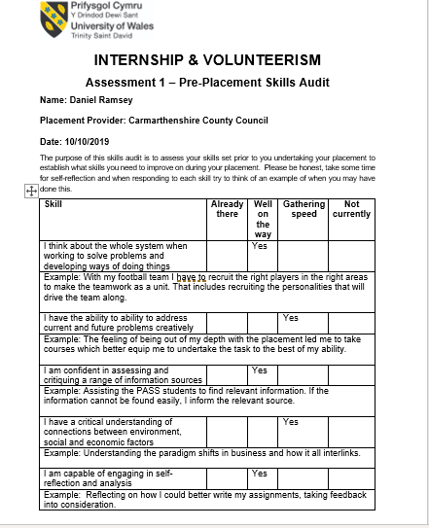

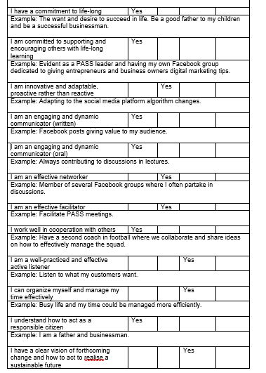
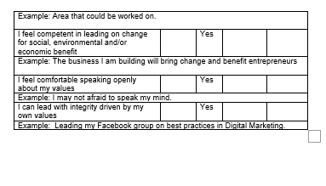
Post Skills Audit
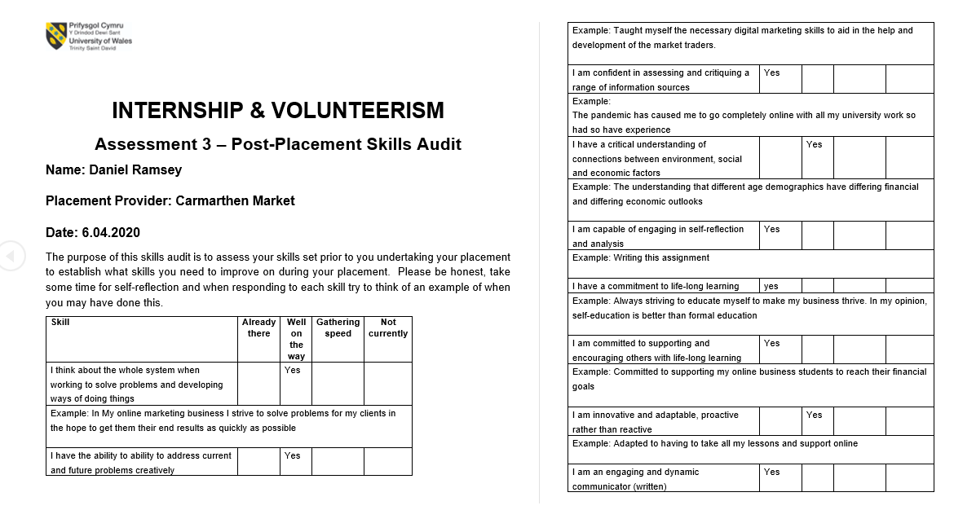

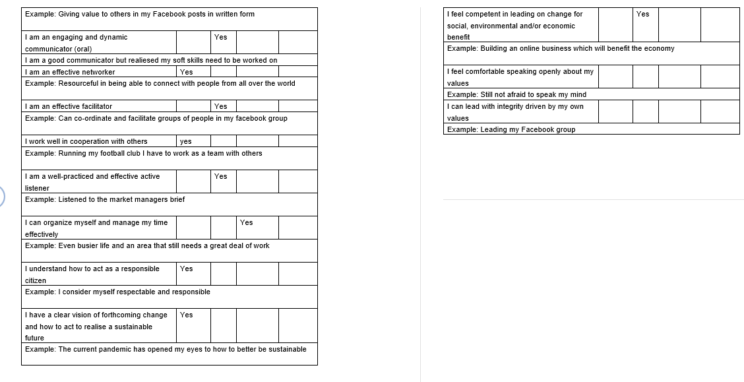

References
Kapoor, A., & Gardner-McCune, C. (2020). Exploring the Participation of CS Undergraduate Students in. Florida. Retrieved from https://www.researchgate.net/profile/Amanpreet_Kapoor/publication/337681987_Exploring_the_Participation_of_CS_Undergraduate_Students_in_Industry_Internships/links/5de55eac4585159aa45ca34a/Exploring-the-Participation-of-CS-Undergraduate-Students-in-Industr
Abban, K. (2015). UNDERSTANDING THE IMPORTANCE OF TIME MANAGEMENT TO. International Journal of Scientific & Engineering Research, 3(12). Retrieved from https://www.ijser.org/researchpaper/UNDERSTANDING-THE-IMPORTANCE-OF-TIME-MANAGEMENT-TO-ASSISTANT-REGISTRARS-IN-THE-REGISTRARS-DEPARTMENT-OF-THE-UNIVERSITY-OF-EDUCATION.pdf
Benabou, R., & Tirole, J. (2017). SELF-CONFIDENCE AND PERSONAL MOTIVATION. Retrieved from https://www.princeton.edu/~rbenabou/papers/papers/CONFQJE2.pdf
Carmarthenshire Coiunty County. (2017). Our Vision For Carmarthenshire. Retrieved from Carmarthenshire County Council: https://www.carmarthenshire.gov.wales/media/1213933/digital-transformation-strategy-2017-2020.pdf
Carmarthenshire County Council. (2020). Carmarthen Market named best in Wales. Retrieved from Carmarthenshire County Council: http://newsroom.carmarthenshire.gov.uk/2019/04/carmarthen-market-named-best-in-wales/#.Xn85CKj7TIU
Davies, G. (2018). Carmarthen. Retrieved from Enchanted Towy: http://www.enchantedtowy.co.uk/carmarthen.htm
Lucan, D. (2014). My Best Career Advice to my High School Student. Lulu.com. Retrieved from https://books.google.co.uk/books?id=HOV0BgAAQBAJ&dq=internships+as+a+good+experience&source=gbs_navlinks_s
Majid, S., Liming, Z., Tong , S., & Raihana, S. (2017). Importance of Soft Skills for Education and Career Success. International Journal for Cross-Disciplinary Subjects in Education (IJCDSE), Special Volume 2(2). Retrieved from https://www.researchgate.net/publication/307710561_Importance_of_Soft_Skills_for_Education_and_Career_Success
Matt, C., Hess, T., & Benlian, A. (2015). Digital Transformation Strategies. Business & Information Systems Engineering, 57, 339. Retrieved from https://www.researchgate.net/publication/281965523_Digital_Transformation_Strategies/citation/download
New River. (2020). New River. Retrieved from Merlins Walk: Merlins Walk
Phillips, S. (2020, March Saturday). Why I Do Not Visit The Market. (D. Ramsey, Interviewer)
Sarker, A. (2019). Planning Function of Management. Anupom Publications, 4. Retrieved from https://www.academia.edu/38304841/PLANNING_function_of_Management
The Editors Of The Encyclopedia of Britain. (2020). Britannica. Retrieved from Carmarthen: https://www.britannica.com/place/Carmarthen
University of Wales Trinity Saint David. (2019). CANOLFAN S4C YR EGIN NAMED ONE OF THE BEST BUILDINGS IN WALES. Retrieved from University of Wales Trinity Saint David: https://www.uwtsd.ac.uk/news/press-releases/press-2019/canolfan-s4c-yr-egin-named-one-of-the-best-buildings-in-wales.html
Young, L. (2018). A Report on Growing Micro Business. Retrieved from https://assets.publishing.service.gov.uk/government/uploads/system/uploads/attachment_data/file/198165/growing-your-business-lord-young.pdf

