MARKETING ESSENTIALS
BMIH4005
Student name: Paul Adrian Axente
Student Id: 2234367
Tutor: Luciana Suardi
Table of contents

Component A: Marketing Plan 2
Introduction 2
The purpose of the marketing plan 2
SOSTAC framework 2
Conclusion 11
References 13
Appendices 15
Component B: Presentation 15

Component A: Marketing Plan

Introduction
A marketing plan consists of an investigation of the current marketing situation of a company and identifies different market gaps. The study sheds light on the marketing process of Hilton Hotel. It is the flagship brand of the American multinational hospitality organization. Hilton is one of the largest organizations that provide resort and hotel services across the world. The study aims to create a communication strategy for Hilton Hotel in its current climate. Also, the macro and microenvironment analysis are based on the SOSTAC framework analyzing current customers, competitors, company profiles along with marketing mix.

The purpose of the marketing plan
The marketing plan relates to the proposed communication strategy for Hilton Hotel based on public relations to introduce their new competitive products. The biggest market gap is the availability of too many communication platforms, social media, and also digital marketing which are easy to access and become popular internationally (Kent, and Li 2020). Hilton Hotel is targeting to connect to the right audience across achieving desired goals by communicating them through public relations.

SOSTAC framework
- Situation Analysis
5 'C's
Company | Hilton is becoming famous due to its better hospitality service, a large loyal customer base, and a satisfied workforce.
Collaborators | The collaborators of the hotel are mainly hospitality and leisure management, following three of the major brands such as Curio collection, Hampton, and Embassy (Smith 2020).
Customers | Hilton Hotel develops maximum revenue with strong customer relationships to look after social media marketing. This organization registered over 112 million members in its loyalty membership program.
Competitors | However, the competitors are mainly Marriot, and Holiday Inn throughout the world.
Context | The company aims to grow its success in market shares across the inter-portfolio of Hilton brands (Dhanesh, and Duthler 2019)

SWOT analysis (Micro-analysis)
Strengths  - Hilton is the largest hotel group in the world (Mtapuri, and Giampiccoli 2019).  - It has the best appraisal and performance management system.  - Hilton has a strong brand image and global presence with more than 6400 properties in 100 countries.  - Hilton has over 112 million members registered in the world. | Weaknesses  - Some customers have shared their unsatisfactory experience regarding the brand’s customer service on various social media.  - The credit cards of Hilton were affected by a data breach. Hilton had to pay $700,000 fine for two credit card data breaches.
Opportunities  - Hilton should look into social media marketing to reach new customers and generate more revenue.  - The opportunities can develop the increasing social concern of ecotourism significantly, reducing environmental impact by 2030 (Wondirad 2019). | Threats  The major competition with the big brands of the UK such as Hyatt Hotels, Holiday Inn, Intercontinental Hotel and Marriot, can create intense competition for Hilton hotels.

Segmentation and Targeting/ Customer Profile
Targeting: Hilton Hotel mainly target those customers and individuals who pursue luxury lifestyle and prefer the high-end hospitality service at premium price.
Segmentation:
- Geographic segmentation: popular locations around the UK, England, and London.
- Demographic segmentation: higher and middle income, women and men around 35 to 60
- Psychographic segmentation: people who love group travel, corporate, and transient, according to their travel patterns (Ramaano 2021).
- Behavioral segmentation: targeting eager customers, who love, and perceive high quality and unique ambience and experiences.
Perceptual positioning map
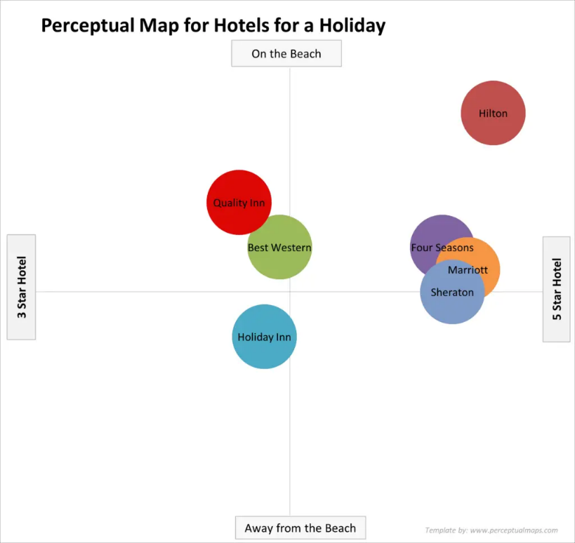
Figure 1: Perceptual positioning map
(Source: as created by the learner)
It can be related to other competitors present in the UK. Based on the five-star category, Marriot, Sheraton and Four seasons can be the competitors for Hilton Hotel. On the other hand, Carvache-Franco, Segarra-Ona, and Carrascosa-Lopez (2019) stated that Holiday Inn and Marriot can be an indirect competitor. Also, Best Western and Quality Inn can be the direct three-star hotel that is on the beach to compete with Hilton.
Bowman’s strategy clock
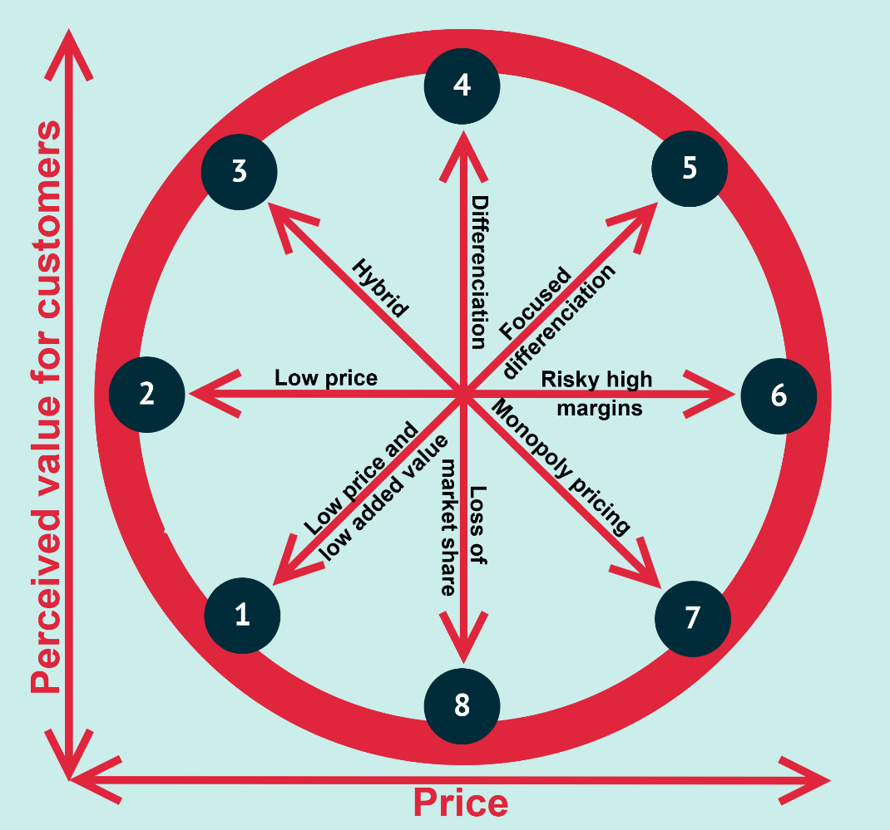
Figure 2: Bowman’s strategy clock
Source: Ramaano 2021)
The strategic positioning of Hilton Hotel can choose the most competitive options as cheap with quality and hope that no one as the player can undercut the brand value. Hilton Hotel can cater to the preferences and needs of various customers. Based on the needs of guests, Hilton is able to offer the necessary services and facilities. The beneficial strategic clock enables the chosen brand in presenting price and perceived value as product differentiation which lets customers pay premium prices for high quality.
Demonstrating an awareness of the organizations (B2B Relationships, Partnerships, Franchises)
Hilton Hotel manage most B2B deals through effective hotel sales strategies and selling preferred rooms by third-party owners and maximizing their revenue in the hospitality industry. Hilton Hotels has. The organization has more than 112 million members registered in its loyalty membership program at more than 6400 properties in 100 countries.
The hotel is partnering with local vendors and suppliers around the world to adapt local boutique lifestyles, providing locals with a place in the neighborhood to recharge and relax with comfortable spaces and guest-directed services. The franchising strategy was also introduced by the mega Hilton brand specializing in upscale models (hilton.com, 2023).
PESTLE (Macro analysis)
- Political: the strong factors related to Brexit and instability in the UK, reduce the number of traditional visitors.
- Economic: strong competition, higher inflation, rates, and the high GDP due to Covid 19 impacted competitors to offer the same services at cheap rates (Turobovich, Uktamovna, and Turobovna 2020).
- Socio– cultural: people are more targeted by competitors to spend comparatively low on their leisure activities which can create challenges for uniqueness.
- Technology: due to huge advancements in the technological sectors in the UK, the brand is operating its value proposition with the help of technology and enhancing customer experience.
- Legal factors: Due to strict regulations and compliance, Hilton can face challenges regarding privacy breaches and cyber security errors. Hilton paid $75 million to Starwood after a lawsuit accused Hilton executives of stealing confidential documents. In addition, Hilton had to pay $700,000 fine due to credit card data breaches.
- Environmental: due to different demands in a carbon-neutral economy, the brand is also focusing on ecotourism to reduce emissions and cut costs.
Objectives of the marketing plan (SMART target)
Specific | The specific objective can be brand building, including legislators, employees, events, sponsors, and community partners to connect with them.
Measurable | Introducing ecotourism by attracting purposeful travelers and inspiring them to keep the health of natural destinations around the UK.
Attainable | Developing and marketing competitive and diversified eco-tourism products through public relations.
Relevant | Maximizing economic benefits and promoting a culture of environmentally friendly strategies and investments.
Time frame | April 2023 to March 2024

Strategy
- Explaining the value proposition statement and how to communicate the value proposition, how will it be delivered
The value proposition of Hilton Hotel will be deal with ideal behavioral segmented customers who love to travel with sustainability and manage the tendency to use open innovation. Hilton always seeks to develop loyalty among its guests by offering the high-end hospitality service in order to meet the ever-changing customer needs. This can impact the targets and positioning of the brand to mostly communicate with premium and luxury customers. It can position eco-tourism products both offline and online by anticipating their ever-changing desires for satisfaction (Yue, Men, and Ferguson 2019).
Based on high-income men and women segmentation, the brand comprises, quality, uniqueness, integrity, and ownership, that relies on guests’ needs around London, UK, and England. On the other hand, the unique values focus on thoughtfulness, innovation, and increased operational efficiency to meet the requirements for ecotourism. It includes local economic benefits and continued to target tourists for years to come to the most preserved sites in the UK (Debata, Patnaik, and Mishra 2020).
Tactics (Marketing mix):
- Product strategy: the products can be based on eco-tourism, facilities of sustainable tourism planning, and increasing safety of travelers and leisure participants.
- Price strategy: affordability can target lower-income demographics than only targeting high and premium-priced customers (Tirachini, and Cats 2020)
- Distribution/ place: by placing public relations, the company can communicate more health and environmental-conscious participants, stakeholders, community development actors, and sponsors.
- Promotion: both offline and online tools can be utilized for promoting. Leaflets and brochures can be distributed throughout public relations events, and media shows. Also, sharing videos, surveys, other online events, and live content can target wider customers as a promotional tool for eco-tourism (Brint 2020).
Action
Table: Gantt Chart of marketing activities
Activities | Apr | May | Jun | Jul | Aug | Sept | Oct | Nov | Dec | Jan | Feb | Mar
Developing marketing goals
Event planning
Estimating the cost of services
Application for funding
Planning for marketing and promotion
Media Planning
Developing awareness program on eco-tourism
Implementation

Table: Marketing channels schedule
Schedule | Channels | Cost ($) | Responsible authorities
1-3 months | Press release | 17,000 | Event manager
5-6 months | Meeting and one-to-one | 25,000 | Project manager
10 months | Focus groups | 20,000 | Project lead, team members

Control
Strategies to measure success | Resources
New customers | Measuring customer satisfaction score, customer retention cost
Positive attitudes toward brands | Reviews and feedback on their website, one-to-one or telephonic surveys
Increase profits | Measure ROI, daily audits, performance evaluators, and KPIs (Khanra et al. 2021)

Conclusion
The conclusion can be based on public relation communication, where the company can build a relationship with community development actors, price, a wide range of customers, and other publicity opportunities. The main challenge that can be posed in the chosen communication strategy is having to rebuild face-to-face relationships. It is beneficial for creating networks for organizations. However, the strategy can be evaluated and recommended to use public sponsorships, maintaining daily scheduled meetings with investors, media, and other actors in the community development agenda to overcome the lack of public participation.

References
Brint, S., 2020. In an age of experts: The changing roles of professionals in politics and public life. Princeton University Press.
Carvache-Franco, M., Segarra-Oña, M. and Carrascosa-López, C., 2019. Segmentation and motivations in eco-tourism: The case of a coastal national park. Ocean & Coastal Management, 178, p.104812.
Debata, B., Patnaik, P. and Mishra, A., 2020. COVID‐19 pandemic! It's an impact on people, the economy, and the environment. Journal of Public Affairs, 20(4), p.e2372.
Dhanesh, G.S. and Duthler, G., 2019. Relationship management through social media influencers: Effects of followers’ awareness of paid endorsement. Public Relations Review, 45(3), p.101765.
hilton.com, 2023. About Us. Available at: https://www.hilton.com/en/hotels/lonpypy-canopy-london-city/ [Accessed on 18th Feb, 2023]
Kent, M.L. and Li, C., 2020. Toward a normative social media theory for public relations. Public Relations Review, 46(1), p.101857.
Khanra, S., Dhir, A., Kaur, P. and Mäntymäki, M., 2021. Bibliometric analysis and literature review of ecotourism: Toward sustainable development. Tourism Management Perspectives, 37, p.100777.
Mtapuri, O. and Giampiccoli, A., 2019. Tourism, community-based tourism and ecotourism: a definitional problem. South African Geographical Journal= Suid-Afrikaanse Geografiese Tydskrif, 101(1), pp.22-35.
Pham, H.S.T. and Khanh, C.N.T., 2021. Ecotourism intention: the roles of environmental concern, time perspective and destination image. Tourism Review, 76(5), pp.1141-1153.
Ramaano, A.I., 2021. The potential of ecotourism as a mechanism to buoy community livelihoods: the case of Musina Municipality, Limpopo, South Africa. Journal of Business and Socio-economic Development, 1(1), pp.47-70.
Setini, M., Wardana, I., Sukaatmadja, I., Ekawati, N., Yasa, N. and Astawa, I., 2021. Policy models for improving ecotourism performance to build quality tourism experience and sustainable tourism. Management Science Letters, 11(2), pp.595-608.
Smith, R.D., 2020. Strategic planning for public relations. Routledge.
Tirachini, A. and Cats, O., 2020. COVID-19 and public transportation: Current assessment, prospects, and research needs. Journal of Public Transportation, 22(1), pp.1-21.
Turobovich, J.A., Uktamovna, M.N. and Turobovna, J.Z., 2020. Marketing aspects of ecotourism development. Economics, (1 (44)), pp.25-27.
Wardana, I.M., Sukaatmadja, I.P.G., Yasa, N.N.K. and Astawa, I.P., 2019. Cultural tourism and ecotourism empowerment in sustainable tourism development and destination competitiveness enhancement. Journal of Environmental Management & Tourism, 10(4 (36)), pp.753-762.
Wondirad, A., 2019. Does ecotourism contribute to sustainable destination development, or is it just a marketing hoax? Analyzing twenty-five years contested journeys of ecotourism through a meta-analysis of tourism journal publications. Asia Pacific Journal of Tourism Research, 24(11), pp.1047-1065.
Yue, C.A., Men, L.R. and Ferguson, M.A., 2019. Bridging transformational leadership, transparent communication, and employee openness to change: The mediating role of trust. Public relations review, 45(3), p.101779.

Appendices

Component B: Presentation
Cover page:
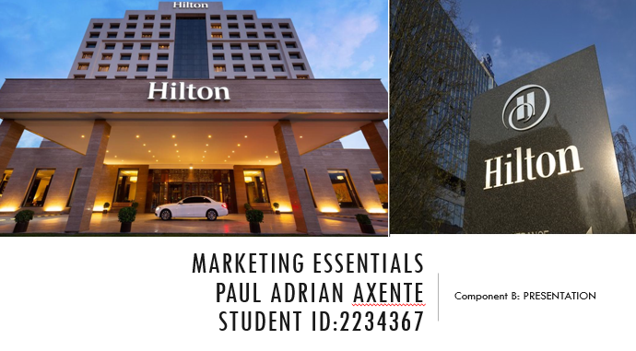

Slide 2:
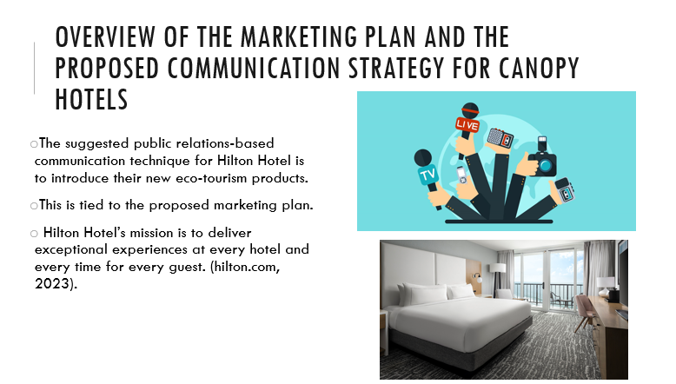
Notes: The most significant market gap is the profusion of social media, digital marketing, and available communication platforms, which take off globally and are easily accessible. Also, the business is promoting sustainable travel internationally by utilizing the ESG concept. The study's goal is to develop a public relations communication strategy communication plan for the selected hotel in light of the existing situation.
Slide 3:
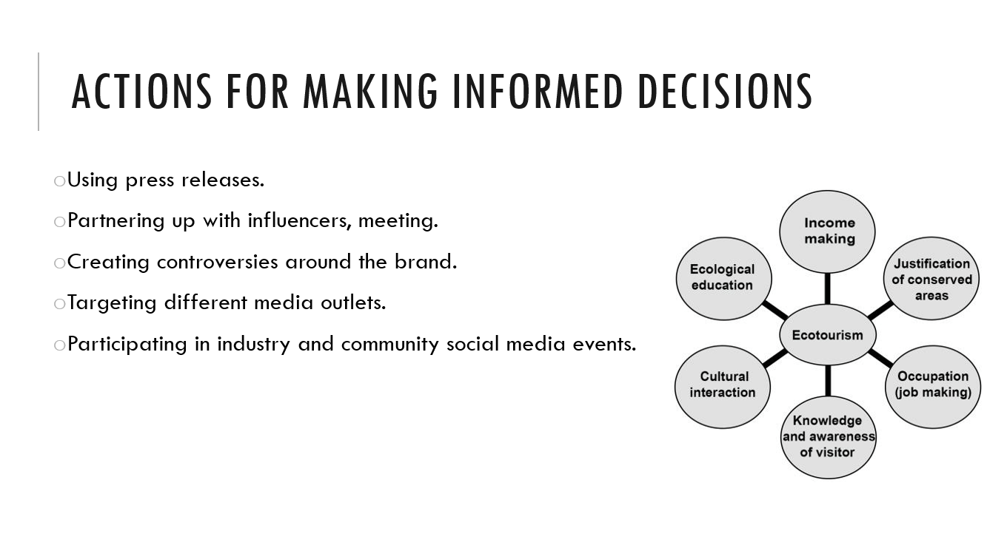
Notes: Using peer events, social media mentions, hashtags (#), positive reviews on websites as well as feedback by comments can be the performance indicator of the communication strategies’ effectiveness. Hilton Hotel must consider their success by the number of new followers and measure signifying completed goals, calculating the peer value from the media clip along with major engagement of the public on social media as a media monitoring tool (Wardana et al. 2019)
Slide 4:
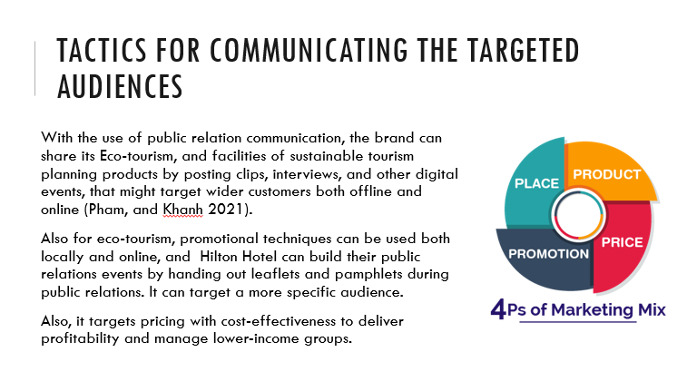
Notes: Hilton Hotel wants to increase its market share success in the global hospitality industry. Based on the segmentation of high-income men and women, the brand consists of quality, originality, integrity, and ownership and is based on the needs of visitors to London, England, and the United Kingdom. To satisfy the demands of ecotourism, on the other hand, the distinctive values emphasize thoughtfulness, creativity, and greater operational efficiency. It contains benefits for the local economy and has continued to draw visitors to the UK's best-preserved sites for years to come.
Slide 5:
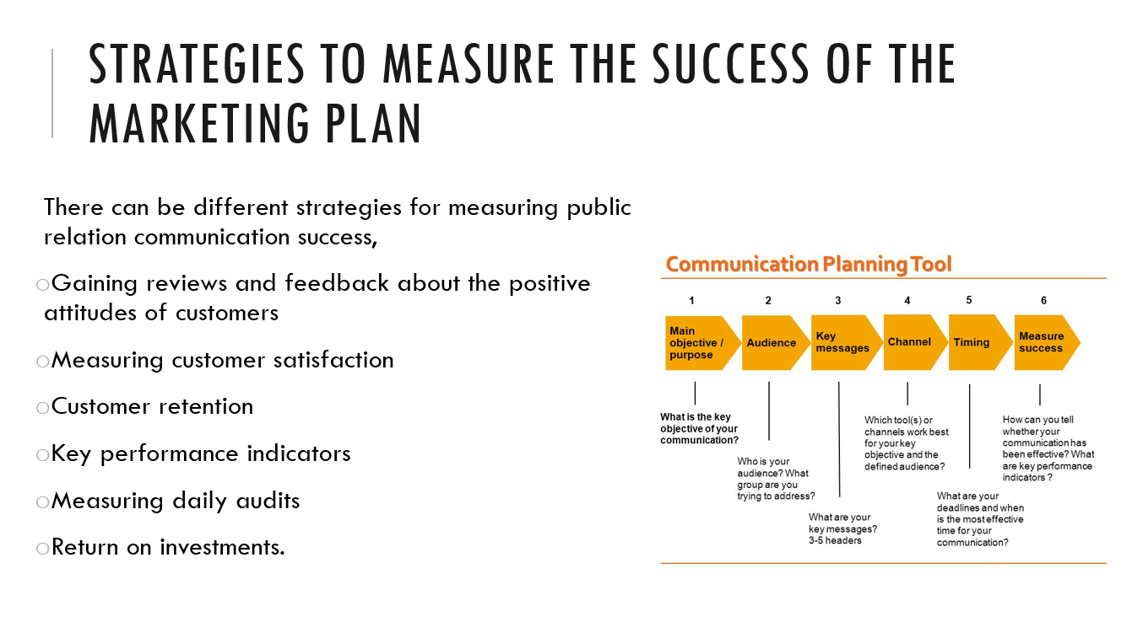
Notes: The indicator for measuring public relations can decide how effectively the brand can achieve its strategic objective. Essentially keeping the strategies on track. Website, traffic, content, and analysis, as well as market surveys, can decide how customers will choose the brand and how often does products are (Setini et al. 2021)
Slide 6:
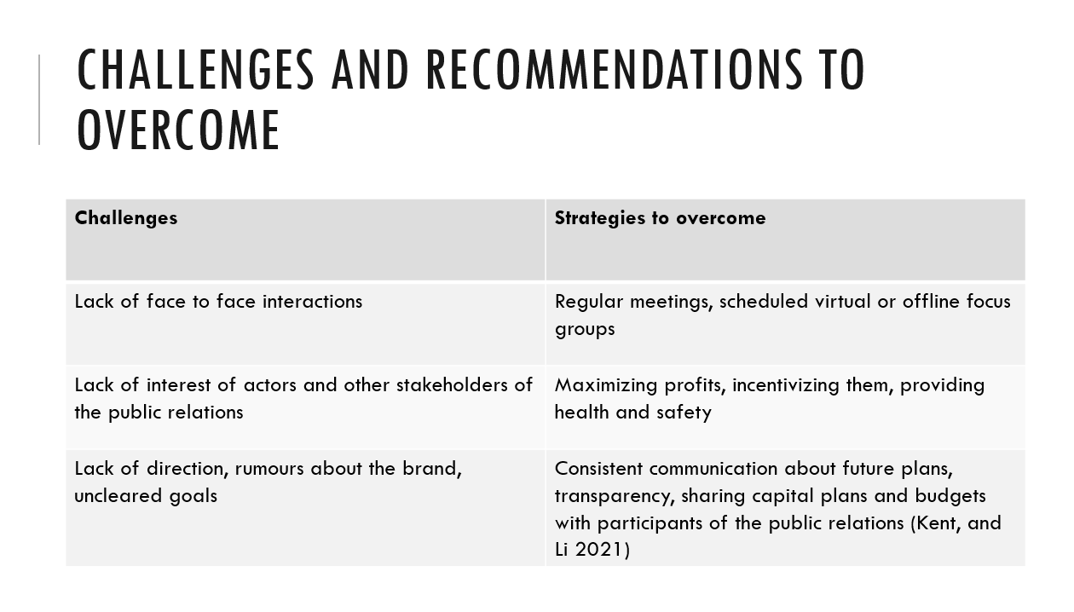
Notes: Rebuilding face-to-face relationships is advantageous when building networks for Hilton Hotel. Also, it might be one of the key hurdles in the communication plan that has been chosen through public relations. To address the lack of public participation, the approach can be assessed and advised to employ public sponsorships, keeping daily scheduled meetings with investors, the media, and other actors in the community development agenda.
Slide 7:


