
project planning and management in workplace
Nasima Haydory 1709654

December 20, 2019
University of Wales Trinity Saint David

Table of Contents
Introduction 2
Findings 3
Project Life Cycle 3
Project Initiation and Planning 3
The Quad Chart 4
Stakeholder Analysis 5
Project Execution 6
Work Breakdown Structure 7
Network Diagram 8
Monitor and Control 8
Risk Analysis 9
Iron Triangle 10
Project Closure 10
Gantt Chart 11
Conclusion 12
Reference List 14

Introduction

Project management refers to the application of skills, tools and techniques of activities to meet project requirements (Wrike, 2019). Engaging in essential practises and processes can lead to a successful project. Project management also includes the actions to create and execute project plans and applies skills to processes to bring a project from conception to completion. Naybour (2016) states, a step by step process can help improve quality and control by breaking large projects into more manageable stages.

Wilson (2019) suggests, project management tools and techniques allow effective ways to organise and manage project tasks. It initiates thorough planning and allows work to be delegated appropriately. Project management can be a powerful business tool delivering many advantages within a workplace. Processes can help manage individuals involved, increasing success probability. The advantages of following good practises can help achieve specific deliverables and improve chances to acquire desired goals (Dragan & Iewwongcharoen, 2004).

This report will look at the implementation of tools in managing a project within an organisation called Ethnic Youth Support Team (EYST), an institute coordinating the All Wales Black Asian Minority Ethnic engagement programme. The programme’s main aim is to gather experiences of BAME graduates within Wales labour market. The objective is to collect data which may positively influence the Welsh Government, to better reflect the needs of BAME graduates (EYST, 2019). Project EYST was created to collect the relevant information which would contribute to EYST’s evidence paper.

Findings

Project Life Cycle
Figure 1.
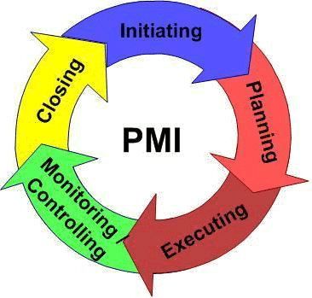

A project life cycle (figure 1.), addresses collective phases which make up a project from the initiation stage to the closure. It can be modified and defined according to the needs of the organisation and applies a wide range of deliverables and activities (Project Management Skills, 2019). The cycle proposes a foundation for the actions required using four levels of characteristics-project initiation and planning, project execution, monitor and control and project closure.

Project Initiation and Planning

According to Westland (2007), the initiation phase helps define and authorise project requirements. This can be created via a project charter. The main purpose is to document the initial requirements of the project. This includes project purpose, mission and vision using measurable objectives and success criteria. Planning determines the approach required to execute the project using relevant details. This can be achieved using two methods strategic planning-developing the entire approach for the project and implementation planning-deciding factors of how the project will be completed (Project Management Skills, 2019). A tool used to identify and document project requirements for Project EYST was a quad chart.

The Quad Chart
Figure 2.
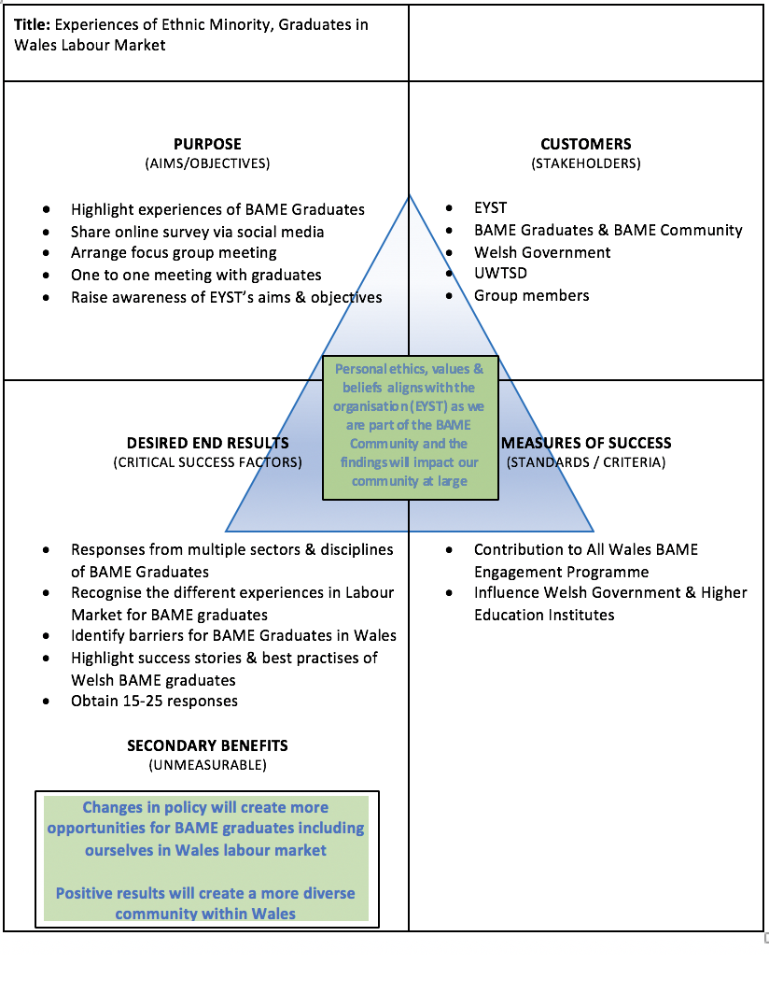
A quad chart (figure 2.), is a technical documentation describing inventions and innovations through words and diagrams (Chegg, 2019). It is divided into four sections which help to identify the purpose-main reason of the project, customers-who customers are, desired end results-expected goals and measures of success-measuring project success. However, Frost (2019) suggests, a quad chart is a relatively brief overview of projects and may sometimes be misconstrued
Project EYST’s quad chart identified the main objective of the project was to collect BAME graduate responses to influence changes within Welsh government policies. BAME graduates being a high priority stakeholder for the project played a key role to the successful completion. The project achieved the desired end results as responses included information to help understand experiences of BAME graduates in Wales labour market. The project success was measured using relevant feedback from top priority stakeholder EYST, indicating vital contributions were made. The secondary benefits suggested, changes within the Welsh government may bring diverse opportunities for BAME graduates. The quad chart became an essential tool, laying the foundations for project EYST.

Stakeholder Analysis
Figure 3.
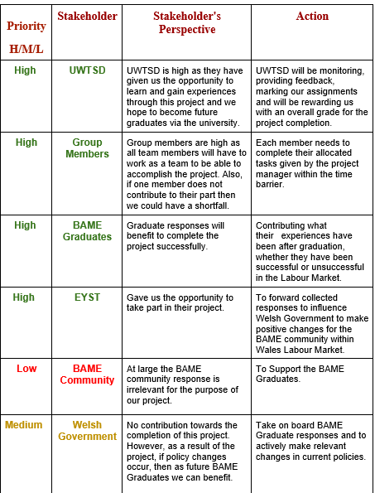

An additional important tool used was a stakeholder analysis (Figure 3.). According to Friedman & Miles (2006), a stakeholder analysis identifies key individuals involved with the project. It can help shape up powerful stakeholders from the beginning and secure essential support which may contribute valuably to a successful project. The process involves grouping individuals or organisations according to, level of participation, interests and influence and can be used for many strategic reasons. This can include, enlisting key organisational players allowing effective communication. Collaborating and communicating with important stakeholders can ensure project plans are reflecting the real needs and priorities of the project, which may help reduce conflicts. However, failure of regular and effective communication can lead to lack of internal support as highlighted in the case of project EYST (Anastasi, 2018).

Identifying key stakeholders from the beginning played as essential part to completing project EYST and it enabled regular effective communication with high priority stakeholders like UWTSD, assisting group members towards the right direction. However, communication with stakeholder EYST was very limited due to the lack of response from the project facilitator, causing some demotivation among team members. The analysis also identified group members to be high stakeholders, remaining high throughout the project as group members completed allocated tasks to accomplish set goals. Furthermore, BAME community as a whole was analysed as low priority stakeholders and remained low as any contributions would be irrelevant for the project.

Project Execution

Project execution is performing the activities identified initially. This stage is where all the action takes place and uses the most time, money and people. Project managers need to keep activities moving forward using a coordinated manner to ensure the project is being completed accordingly. In order to address and manage activities appropriately, a Work Breakdown Structure was implemented (Westland, 2007).

Work Breakdown Structure
Figure 4.
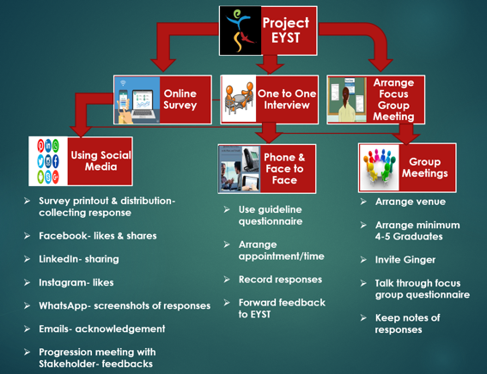

A Work Breakdown Structure (WBS, Figure 4.) breaks down the project’s deliverables, tasks and subtasks into a hierarchical form. It helps to organise project tasks into more manageable components to easily understand the project scope (Norman, Brotherton & Fried, 2008). Project objectives can be accomplished using either a top down or bottom up approach. However, according to Reddy (2019), the step by step process to achieve deliverables can lead to micromanagement from project leaders, which may not be appealing to some team members.

The step by step process of WBS framework identified project EYST’s set deliverables and the smaller tasks that needed to be achieved to execute the project. One of the main deliverables, the completion of online surveys, was achieved using social media platforms which was most effective as it collected majority of the BAME graduate responses. Additionally, another contributing method was one to one interview, as this was some graduate’s preferred way to participate. However not all deliverables were met, the lack of BAME graduates resulted in no focus group meetings and loss of potential responses which has been highlighted in monitor and control.

Network Diagram

An alternative tool which may have been useful is the network diagram. The diagram displays a distinct representation of all tasks, responsibilities and work-flow of a project. Rumane (2013) suggests, it maps out schedules and work patterns as well as tracking each stage’s progression until completion. It illustrates the project scope by encompassing every action associated with the project to help boost performance and productivity, improving comprehension. However, according to Black (2019), the network diagram must be implemented and managed effectively using reliable and accurate information for a project to be successful.

The complexity of the network diagram may have been time consuming for project EYST therefore it was decided not to implement this tool. Alternatively, the WBS proposed a more efficient way to identify and control deliverables making it a more appropriate choice for project EYST.

Monitor and Control

Monitoring and controlling requires each activity to be tracked regularly maintaining project progression (Westland, 2007). Situations may change at any time therefore project managers must be prepared to make adjustments. The constant reviewing can ensure the agreed deliverables are implemented when executing the project. By monitoring project deliverables, potential problems were identified however issues were controlled using planned actions. This was achieved using a risk analysing tool.

Risk Analysis
Figure 5.
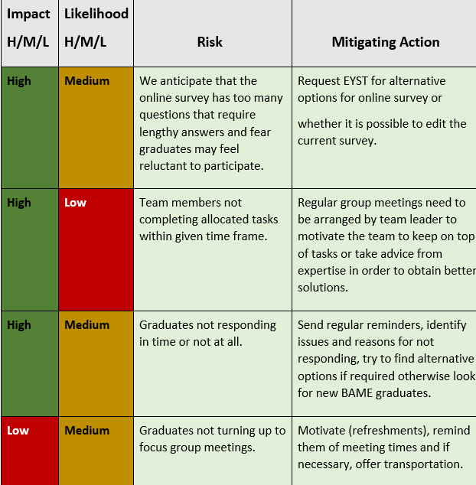

A risk analysis (figure 5.), is a process which helps identify and manage possible problems that may undermine the project initiatives according to Aven (2015). It recognises threats and estimates the likelihood of it materialising. Although it may be complex and requires detailed information, it can be an essential tool saving time, money and reputation. A risk assessment can create a strategic plan to mitigate and overcome potential threats ensuring project deliverables are achieved. However, achieving meaningful and valuable assessments would only be possible with relevant knowledge and experience which identifies hazards and recognises risk likelihoods and severity (Iirsm, 2016).

While conducting project EYST’s risk assessment, it was anticipated the online survey was lengthy with too many questions. Concerns arose as the identified risk would have highly impacted the successful completion of project EYST. Therefore, the planned mitigating actions were implemented where alternative options were made available for BAME graduates.

Iron Triangle

A tool associated with risk analysis is the iron triangle. The model consists of the basic parameters required in order to assess project performance. It identifies if the project is completed within the time limit and cost limit, as well as recognising if the specified level of quality is achieved. As most projects require more broader perspectives, these three elements are very limited measures to ensure project success (Pollack et al 2018).

When looking at EYST as a project, time was a huge constraint, which effected the quality of service of the project deliverable. For example, given more time, the deliverable of focus group meetings could have been managed by looking at alternative options. However, as the project needed to be completed within five to six weeks and with no additional costs, it failed to deliver as planned.

Project Closure

Project closure is the formal closing of the project. The key activity in this stage is identifying deliverables have been met for project completion. Recognising if project objectives have been met can be essential. Organised artifacts and lessons learnt can be key contributions applied to future projects. A Gantt chart was used to evaluate the successful completion of the project and to recognise if the series of deliverables have been achieved (Westland, 2007).

Gantt Chart
Figure 6.
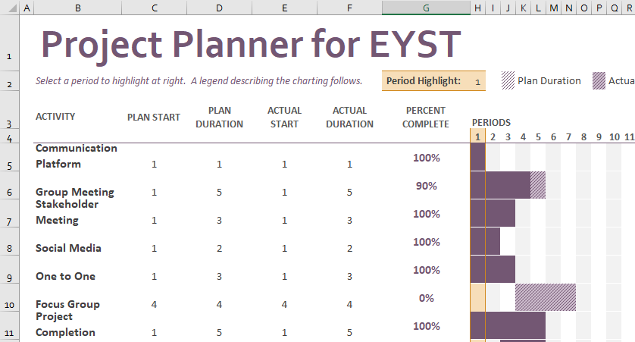

A Gantt chart (figure 6.), is a tool which assists plans and schedules and can be used to simplify complex projects. It demonstrates timelines and tasks displaying start and end dates as well as scheduled deadlines including how much of tasks have been completed (APM, 2019). It is an effective method to keep tasks on track especially with large teams or multiple stakeholders. However, creating and managing a Gantt chart can require a lot of effort which may be time consuming (Analysis Tab, 2019).

Project EYST’s Gantt chart displays a clear and accurate reflection of what has been achieved throughout the project’s completion. It suggests anticipated aims and objectives within the quad chart was mostly achieved within the set time frames apart from focus group meetings. Overall the Gantt chart indicates, project EYST was successfully completed using designated tasks, contributing effectively to EYST’s BAME graduates engagement programme.

Conclusion

A subjective evaluation indicates project EYST required a strategic plan to accomplish the main objective. Although effective tools and techniques helped greatly to achieve successful outcomes (Dragan & Iewwongcharoen, 2004), the project also required a firm leader to accumulate relevant data and delegate tasks appropriately between team members.

A key attribute the project manager shared was excellent communication skills with high priority stakeholders. This ensured project deliverables were being met within the time frames and most importantly, project EYST was being executed as per quad. The result-project EYST obtained the target of fifteen responses from BAME graduates, giving valuable data to EYST to support the evidence paper being produced for the Welsh Government.

Project EYST was completed within the set time and most planned aspects were completed to the best ability however, lacked completing a particular deliverable of arranging a focus group meeting. Stakeholder EYST proposed such meetings can produce a more informal connection with BAME graduates and can operate in an interesting way (EYST, 2019). Due to the challenges of available BAME graduates willing to attend, this task was left uncompleted. This risk was anticipated within the risk analysis (Iirsm, 2016), allowing team members to use the mitigating actions to overcome the shortfall however despite efforts, the deliverable remained unsuccessful. This did not stop the project’s progression as other options helped to achieve target.

For future projects it is highly recommended to invest more time in similar activities and to create a more thorough plan to execute comparable tasks. Project EYST may have benefited by finding better solutions to overcome this challenge, such as providing convenient venues and by narrowing the search to invite struggling BAME graduates who may have been more willing to contribute. Additionally, shadowing focus group meetings arranged and executed by EYST (EYST, 2019), may have helped the project, giving individuals innovative ideas to prepare and execute plans.
Project EYST achieved measurable and solid visual outcomes through positive feedback from the project facilitator, indicating rich and insightful context was provided. The feedback suggests, responses came from a diverse range of BAME graduates and from multiple sectors, which will contribute highly to EYST’s programme. The successful completion of project EYST also allowed the development of many soft skills. Team members experienced and overcame real challenges and identified contributing success factors as well recognising areas in need of improvement. Furthermore, it allowed individuals to learn and understand the experiences of BAME graduates in Wales labour market, giving an insight into the possible threats expected for current and future graduates of BAME community. The participation in project EYST has empowered self-motivation and the willingness to take on board more influential projects in the near future.

Reference List

Analysis Tab (2019), ‘Advantages & Disadvantages of Gantt Charts’, [Online] https://analysistabs.com/gantt-chart/advantages-disadvantages/, Accessed Date 13th December 2019

Anastasi, C. (2018), Strategic Stakeholder Engagement, Oxon: Routledge

APM (2019), ‘What is a Gantt chart?’, [Online] https://www.apm.org.uk/resources/find-a-resource/gantt-chart/, Accessed Date 12th December 2019

Aven, T. (2015), Risk Analysis, (2nd Ed), United Kingdom: John Wiley & Sons

Black, J. (2019), ‘Pros and Cons of Network Diagrams’, [Online] https://www.askwillonline.com/2012/01/pros-and-cons-of-network-diagrams.html, Accessed Date 12th December 2019

Chegg Study (2019), ‘What Is A Quad Chart?’, [Online] https://www.chegg.com, Accessed Date 10th December 2019

Dragan, M. & Iewwongcharoen, B. (2004), ‘Project Management Tools and Techniques’, [Online] https://www.pmi.org/learning/library/project-management-tools-techniques-impact-success-8349, Accessed Date 10th December 2019

Friedman, A. L. & Miles, S. (2006), Stakeholders Theory and Practise, New York: Oxford University Press

Frost, E. (2019), ‘So What’s A Quad Chart, Exactly?’, [Online] http://isuwriting.com, Accessed Date 11th December 2019

Iirsm (2016), ‘Limitation of Risk Assessment’, [Online] https://www.iirsm.org/limitation-risk-assessment, Accessed Date 13th December 2019

Naybour, P. (2016), ‘The Benefits of Following a Project Management Method’, [Online] https://www.apm.org.uk/blog/the-benefits-of-following-a-project-management-method/, Accessed Date 09th December 2019

Norman, E. S., Brotherton, S. A. & Fried, R. T. (2008), Work Breakdown Structures: The Foundation For Project Management Excellence, New Jersey: John Wiley & Sons
Pollack, J., Helm, J. and Adler, D. (2018). ‘What is the Iron Triangle, and how has it changed?’, International Journal of Managing Projects in Business, 11:2, pp. 527-547
Project Management Skills (2019), ‘The Project Life Cycle’, [Online] https://www.project-management-skills.com/project-management-life-cycle.html, Accessed Date 10th December 2019

Reddy, C. (2019), ‘Work Breakdown Structure: Advantages and Disadvantages’, [Online] https://content.wisestep.com/work-breakdown-structure-advantages-disadvantages/, Accessed Date 13th December 2019

Rumane, A. R. (2013), Quality Tools for Managing Construction Products, Boca Raton: Taylor & Francis Group

Westland, J. (2007), The Project Management Life Cycle, (2nd Ed), London & Philadelphia: Kogan Page

Wilson, F. (2019), ‘Project Management Tools and Techniques That Really Work’, [Online] https://www.ntaskmanager.com/blog/project-management-tools-and-techniques/, Accessed Date 10th December 2019

Wrike (2019), ‘What is Project Management?’, [Online] https://www.wrike.com/project-management-guide/faq/what-is-project-management/, Accessed Date 09th December 2019

