Lab 5 write up

List out the options which are available in your virtual machine menu.
The options available to me are the “Tools” bar which contains the Preferences, Import, Export, New and Add buttons. The Ubuntu virtual machine is the only other option available to me in the virtual machine menu.

Find out the IP address of your virtual machine.
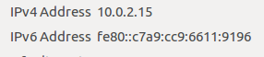
The screenshot above shows the IPv6 and IPv4 addresses of the virtual machine

Could you browse through the Internet?
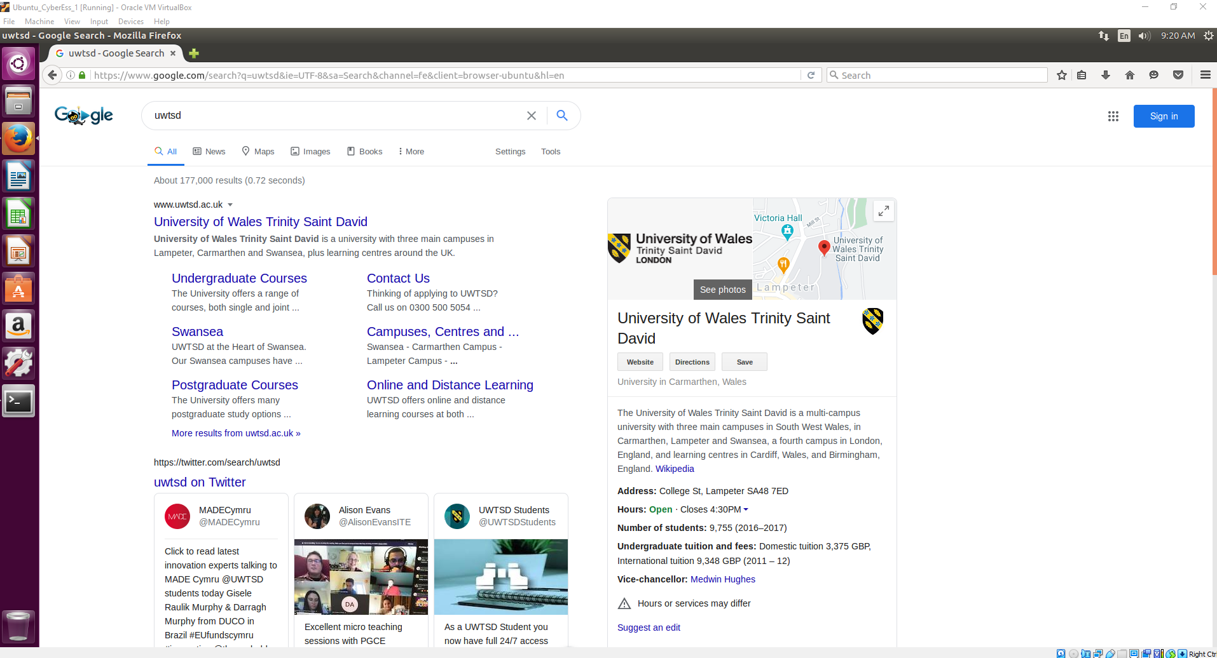
As shown in the screenshot above, I could browse the internet perfectly fine.

On your own words, share your experience on setting up the virtual machine.
Setting up the virtual machine was rather easy and I had no problems setting it up and getting it running. I haven’t used ubuntu before so it took a little bit to get used to where everything is which made some of these other tasks take longer than necessary.

What do you think as the pros and cons of using virtual machines?
Pros:
- Anything you do on a virtual machine does not affect your actual system.
- Can technically have multiple systems with different operating systems on one machine

Cons:
- Virtual machines tend to be very slow unless your main machine is powerful enough to have plenty of resources to spare to the virtual machine, such as allocating more RAM or processor cores.
- Using a virtual machine may not be the most beginner friendly experience.

Why would a user be able to browse to an IP address but not a FQDN?
The browser cannot understand IP addresses if it doesn’t have the DNS to convert the domain name.

Why is the user able to browse to an FQDN?
The DNS takes the domain name and converts it to an IP address to allow the browser to make a connection.

Why does the Email service require both SMTP and POP3 to be activated?
The SMTP (Simple Mail Transfer Protocol) is the protocol that allows users to send emails over the server while the POP3 (Post Office Protocol) is the protocol that allows users to receive emails over the server.

