

Student name: | William Young | Student ID number: | 2113840
Programme: | BSc Ordnance, Munitions and Explosives
Module: | Computer Aided Engineering
Module code: | ACDB5007 | Contribution to Overall Module Assessment (%): | 100%
Lecturer: | Andrew Noble | Internal Verifier: | Ryan James
Assignment Title: | Application of Computer Aided Engineering Processes | Word count (or equivalent): | 3359
Submission deadline: | 01/05/2023 22:00 PM | Return date of provisional marks & written feedback: | 20 Term Time Days From Submission
Submission method: | All written assessments, where practical and possible, must be submitted via Turnitin unless otherwise instructed by the Lecturer. (Please DO NOT put this assessment specification into Turnitin or it will match many similarities with other students’ submissions.)  Alternative submission method (if applicable):  Late submission of the assessment will result in a late penalty mark. Penalties for late submission: Up to one week late, maximum mark of 40%. Over one week late, 0%. Only the Extenuating Circumstances Panel may approve a change to submission dates.
Academic honesty / referencing: | Academic honesty is required. In the main body of your submission you must give credit to authors on whose research and ideas your work is based. Append to your submission a reference list (IEEE format) that indicates the books, articles, etc. that you have used, cited or quoted in order to complete this assessment.

Application of Computer Aided Engineering Processes
Abstract
This report discusses Computer Aided Engineering, its usefulness and limitations in the design process, as well as material properties and thermal conditions that will affect the models used. Due to difficulties accessing UWTSD’s remote working tools, the initial ARL BS41 bullet impacting 7039 aluminium armour model design was not able to be used in the report and an open-source experiment was used as a reference instead.

Contents Page
- Introduction
- SolidWorks and Ansys
- Initial Material Background
- Open-Source Material and Results Discussion
- Benefits and Limitations of CAE
- Conclusion
- Bibliography

- Introduction
This report is written on the subject of Computer Aided Engineering’s (CAE’s) uses and limitations in the design of an effective Ordnance, Munitions and Explosives (OME) system. One method of assessing the effectiveness of a weapon or armour system is through the use of bullet penetration testing, completed either in the field or simulated through the use of computer software. These assessments play a vital role in ensuring the effectiveness of weapons against a variety of materials and targets, as well as the safety of operators and testing personnel by providing adequate safety conditions during the design of containers, pressure vessels, vehicles, armour and barricades. [1] With proper design testing at an early stage of product development, significant increases in safety and reductions in time and cost can be provided by reducing the likelihood of faulty or ineffective equipment being put into production or use by operators.
A discussion on the use of Computer Aided Engineering was to be based around each student’s model design from SolidWorks being imported into Ansys for use with bullet penetration simulations. Due to difficulties using the University’s remote access system from Scotland however, the discussion in this report will be focused on open-source material, using this as a foundation to discuss the engineering principles involved with bullet penetration testing, as well as how the accuracy of results can be improved through the fine-tuning of material properties. This report will then discuss the usefulness and limitations of Computer Aided Engineering, using live-round testing as a comparison.

- SolidWorks and Ansys
SolidWorks is a solid modelling CAE application published by Dassault Systèmes and is used by over two million designers and engineers worldwide. [2] The application can be used to create complex parts and assemblies of 3D models for use with design, testing and cost estimation, as well as eliminating errors and rework with integrated motion and stress analysis tools. [2] The purpose of its use with this report was to build a 3D model of a 14.9mm ARL BS41 projectile and a Titanium Ti-6Al-4V armour target, simulating a real-world example of a complex and highly effective projectile and an armour material commonly used in military vehicles such as the M2 Bradley infantry fighting vehicle. [3]
Ansys is a CAE and Finite Element Analysis (FEA) software that uses computer models to simulate the behaviour of structures, electronics and components under certain conditions to analyse their strength, toughness, temperature distribution, elasticity, electromagnetism and fluid flow. [4] The models created in SolidWorks were to be imported into Ansys in order to simulate the projectile being fired at the target. Penetration results could then be computed from the finished simulation.

- Initial Material Background
Due to difficulty using the remote access, these material simulations were unable to be used in the report, however background information will be provided to illustrate the OME context of work done previously. The projectile was based off of the ARL BS41 model of projectile, which was produced to replenish the supply of the original BS41 model. The BS41 model was initially designed as ammunition for the former Soviet 14.5mm heavy machine gun, predominantly used on wheeled combat vehicles worldwide, before U.S. surrogates were produced by Brass Extrusion Laboratories of Bensenville, Illinois, in 1961. [5] The U.S. produced 30,000 BS41 projectiles which were used extensively for armour development and ballistic acceptance of steel, aluminium and titanium armour plates. The ARL BS41 was produced by New Lenox Machine Company of Dwight, Illinois, after issues with the finite supply of Brass Extrusion’s BS41. The original surrogate BS41 contained incendiary filler which was replaced by inert powder by the ARL surrogate, thereby allowing the ammunition to be stored outside of explosive bunkers while retaining the same ballistic performance as the original. [5] Inert fillers will be discussed further when assessing the safety of CAE usage compared to live round testing. Figure 1 compares the original and ARL BS41 surrogates, while Figure 2 shows a schematic of the ARL BS41 projectile.
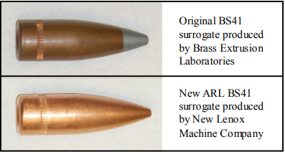
Figure 1: Original BS41 and ARL BS41 surrogate projectiles. [5]

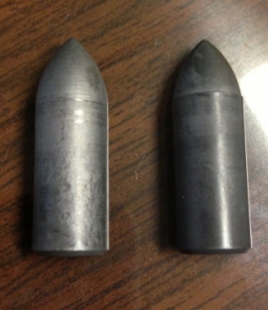
Figure 2: Original BS41 core (left) and ARL BS41 core (right). [6]
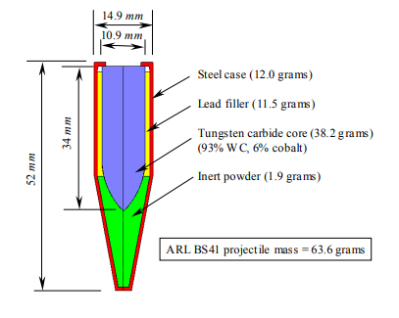
Figure 3: ARL BS41 schematic showing tungsten carbide core. [5]
The core of the ARL BS41 is made from a cemented carbide, where carbide particles are bonded by a metallic binder. The constituent materials are 93% WC, the carbide particles, and 6% cobalt acting as a metallic binder. The cemented carbide means that the BS41 core has high strength and low ductility, resulting in excellent penetrative properties. [5]
The titanium alloy Ti-6Al-4V was used as a target in this experiment due to its common usage in industry, meaning that any results could be extrapolated to a large number of applications. Titanium alloys are widely used in industries such as aerospace, automotive, medicine and the military. These alloys have been found to be almost immune to corrosion-related failures in marine environments, while in the medical industry they can be used for surgical implants due to their excellent biocompatibility. [7] Consumer goods are also increasingly making use of titanium alloys, with products such as cameras and sports equipment now containing them. Perhaps the most significant use of titanium alloy is in the aerospace industry, where these alloys can be utilised in compressor discs and blades in jet engines, as well as airframe structures in aircrafts due to their high specific strength ratio, particularly at higher heats when compared to other suitable materials. [8] This titanium alloy is also used extensively in the armour of military ground units such as the M2 Bradley infantry fighting vehicle and the M113 armoured personnel carrier. [3] The primary goal of armour design is to obtain the maximum protection per unit weight at a minimum cost. [9] Through the replacement of materials such as steel or aluminium with Ti-6Al-4V, significant advancements have been made over the past twenty years to maintain the ballistic properties of combat vehicle armour while reducing the weight and cost of its production and maintenance. [3] Figure 3 shows the commander’s hatch of an M2 Bradley. This was initially made from forged aluminium but, having been replaced by Ti-6Al-4V, has been reduced in mass by 35% while providing superior ballistic protection. The mass of future combat vehicles is a constant problem in the design stage of product development and so titanium is widely used as a lightweight, cheaper and ballistically equivalent or superior replacement to aluminium and some steel alloys. [3] The use of Ti-6Al-4V as armour for combat vehicles such as fighter jets, tanks and armoured transport is therefore the main focus of this simulation. A 33mm thickness was used for the target to align it with the thickness of armour found on combat vehicles such as the BMP-1 Armored Personnel Carrier, while a 500 m/s velocity was used to simulate the projectile’s speed out of the barrel. [10]
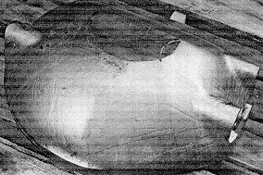
Figure 4: A forged and machined Ti-6Al-4V M2 Bradley infantry fighting vehicle commander’s hatch. [11]
An alternative target material could have been the carbon steel AISI-1045, with a chemical composition of: 98.51-98.98% Fe, 0.60-0.90% Mn, 0.42-0.50% C, ≤0.05% S and ≤0.04% P. [12] It can be used as the protective cover for battle tanks and armoured vehicles. [13] Both options were suitable targets for the 14.9mm ARL BS41, but the Ti-6Al-4V armour was ultimately chosen due to the expectation of better results as well as its more common usage in combat vehicles due to its excellent mass efficiency and ductile behaviour under ballistic attack. [3]
The following material parameters were used for the projectile and target:
ARL BS41 Projectile
Density (kg/m^3) | 14,770
Young's Modulus (GPa) | 620
Poisson's Ratio | 0.215
Melting Temperature (K) | 1768
Bulk Modulus (MPa) | 3000
Shear Modulus (MPa) | 89,000

Table 1: Material parameters for the ARL BS41 projectile
Titanium Ti-6Al-4V Target
Density (kg/m^3) | 4430
Young's Modulus (GPa) | 105
Poisson's Ratio | 0.34
Melting Temperature (K) | 1880
Bulk Modulus (MPa) | 790
Shear Modulus (MPa) | 478

Table 2: Material parameters for the titanium Ti-6Al-4V armour target

- Open-Source Material and Results Discussion
Using open-source material from the ‘skill-lync’ website, a bullet penetration simulation will be discussed. It should be stressed that the images in this section are the work of the website’s author, and are here for illustration purposes only. The information used from this website is based on a bucket-shaped target and a bullet-shaped projectile shown in Figure 5, both of which were created in SolidWorks and then exported to Ansys for simulation testing. [14] The projectile was made from tantalum, with three different materials being used for the target as shown in Tables 3-5. A triangular mesh was used for this simulation, with 5126 and 12,538 nodes and elements being generated for the models and a resultant average mesh quality value of 0.55838. [14] The projectile was fired at a velocity of 139 m/s. [14]
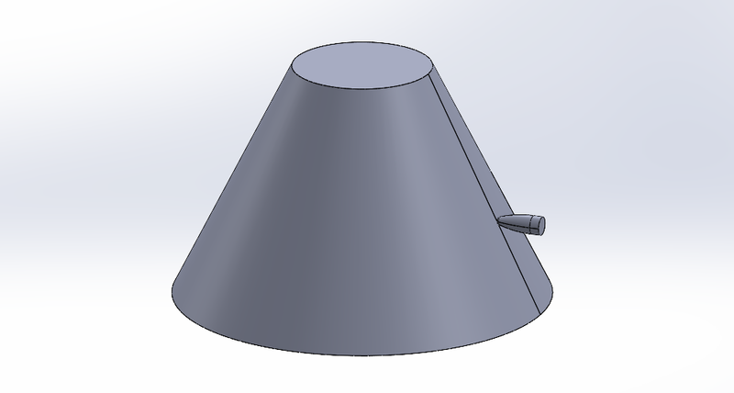
Figure 5: SolidWorks models of a bucket-shaped target and bullet-shaped projectile [14]
Tantalum Projectile
Density (kg/m^3) | 16,600
Gruneisen Coefficient | 1.69
Parameter C1 (mm/s) | 0.215
Parameter S1 | 1768
Parameter Quadratics S2 (s/mm) | 3000
Shear Modulus (MPa) | 65600

Table 3: Material Parameters for the Tantalum Projectile. [14]
Aluminium Alloy NL Target
Density (kg/m^3) | 27,700
Young's Modulus (GPa) | 71
Poisson's Ratio | 0.33
Bulk Modulus | 69608
Shear Modulus | 26692

Table 4: Material Parameters for the Aluminium Alloy NL Target. [14]

Magnesium Alloy NL Target
Density (kg/m^3) | 18,000
Young's Modulus (GPa) | 45
Poisson's Ratio | 0.35
Bulk Modulus | 50,000
Shear Modulus | 16,667

Table 5: Material Parameters for the Magnesium Alloy NL Target. [14]

Stainless Steel Alloy NL Target
Density (kg/m^3) | 77,500
Young's Modulus (GPa) | 193
Poisson's Ratio | 0.31
Bulk Modulus | 169,300
Shear Modulus | 73664

Table 6: Material Parameters for the Stainless Steel Alloy Target. [14]

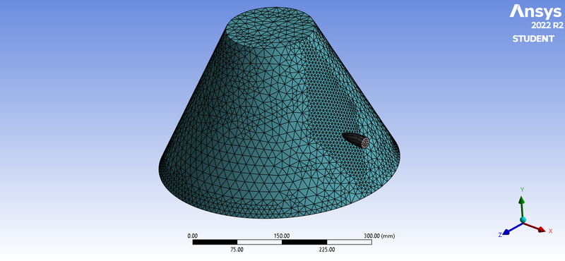

Figure 6: The mesh used for the models. [14]
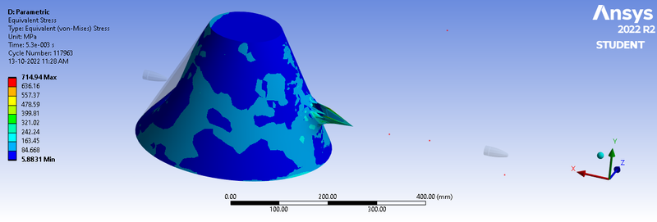

Figure 7: Equivalent Stress. [14]
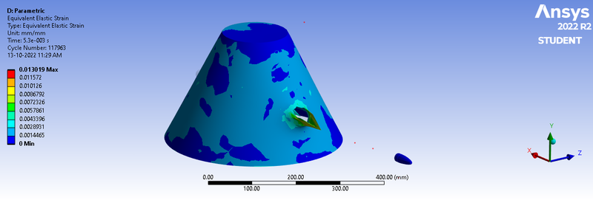

Figure 8: Equivalent Strain. [14]

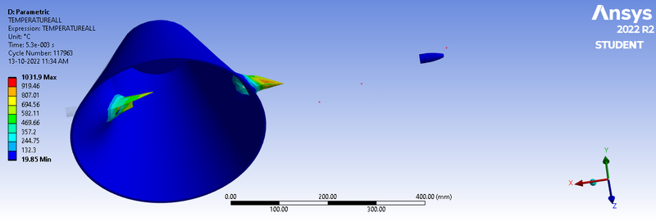

Figure 9: Temperature. [14]
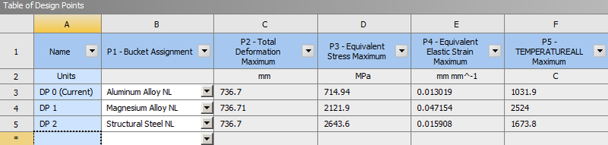
Table 7: Results of simulation. [14]
In all simulations the projectile successfully penetrated one side of the target and followed through the other side. From the results shown in Table 7 it can be seen that the highest maximum stress value is attributed to the Stainless Steel bucket. This is due to its significantly higher density and hardness/strength, despite an inverse relationship of strength and ductility. [9] The damage shown in the above figures resulted in petal deformation, produced by high radial and circumferential tensile stresses after the initial stress wave upon projectile impact. [9] This was a consequence of bending moments produced by bulging through the ductile deformation of the target as it pushed ahead of the projectile. [9]
One way to improve this simulation would be to improve the quality of the mesh used. Changing from a triangular shape to a hexahedral shape would provide a more accurate assessment of the damage area and the resultant stress and strain on the target and projectile. [15]
Very little damage was observed to the projectile due to tantalum’s armour-piercing properties, leading to similar results compared to the initial materials of the tungsten carbide ARL BS41 projectile and titanium Ti-6Al-4V target that this report was to be based upon. An improvement to this would therefore be to move to a denser target material or to increase the target’s thickness, thereby preventing total deformation at the projectile’s exit. Semi-infinite penetration simulations are generally accepted to yield more useful ballistic data and the full penetration of the target was a weakness of the experiment. [6] An improvement would therefore be to increase the thickness of the target material. The design target of the initial materials was to ascertain whether an ARL BS41 projectile could penetrate a 33mm thick section of armour at 500 m/s, simulating a real-world example of a heavy machine gun firing ARL BS41 rounds at a BMP-1 Armored Personnel Carrier. The simulation would have shown similar results to the images above, due to the speed at which the projectile is fired and the density and the well documented armour-piercing properties of the ARL BS41. [5] An improved design target could therefore have been to increase the thickness of the armour to gain improved ballistic data from a semi-infinite penetration simulation.
Another method to improve the simulation would be to vary the impact angle of the projectile, simulating a real-world firing of a projectile. This is due to the fact that bullets do not generally impact a target head-on, instead dropping in a 0°-60° arc due to their own inertia. [16] A semi-infinite penetration simulation would provide values for the depth of penetration into the material, thereby allowing the user to experiment with different angular and linear velocities of the projectile to control the penetration depth. An improved simulation would have been to assess the effective range of the projectile, initially using a full penetration simulation before increasing the distance of the fired projectile to ascertain at which distance the penetration, and therefore the armour-piercing effectiveness of the weapon, becomes semi-infinite. [6]

- Benefits and Limitations of CAE
The main benefit of CAE is the major safety improvement it brings to the OME industry. There are significant hazards involved in the use, storage and transportation of OME and these are completely alleviated through the use of computer software, eliminating the risk to operators in the field while testing for design or compliance purposes. CAE can also negate the need to involve Suitably Qualified and Experienced Personnel (SQEP) as well as the time-consuming safety planning and coordination that is involved in any explosives work. This will also reduce the legislative burden on site operators required to evidence safe explosives work.
Industry also majorly benefits from the use of CAE through the time and cost savings when compared to live testing. It can take months to gain access to a testing site which can significantly slow the testing process while increasing costs. While live testing is limited by a number of factors; such as safety, space planning, explosive availability and SQEP availability, CAE is limited only by the complexity of the models and resultant length of the simulation. CAE therefore offers major time and financial benefits when compared to live testing.
However, explosive hazards can be reduced while using live OME. Using the ARL BS41 projectile discussed previously for example, it can be seen in Figure 3 that an inert powder has been used to replace the explosive filler. There is a modern drive to move towards Inert Munitions (IM) and this can provide significant risk reduction while explosive materials are being used or prepared for use. [17]
The accuracy of OME properties obtained from CAE simulations may not always be as reliable or accurate as the same OME tested in a real-world simulation. The value of the results may differ as well, as live testing will provide information beyond the parameters of a computer simulation, such as how well an explosive performs after having been stored in certain conditions, for example a cold storage room or under direct sunlight. A computer simulation may also provide unrealistically perfect results and not accurately reflect the condition of the OME that will be used in an operational capacity, such as its age or state of chemical decomposition.

- Conclusion
In conclusion, it is unfortunate that the initial material information was not able to be used for this report. It was based on a real-world example of an OME system and provided useful ballistic information for a commonly used ammunition in bullet penetration simulations. From the open-source simulations it can be seen that the steel material provides the greatest resistance to penetration. This was to be expected, however, and a titanium armour was chosen instead of steel as it provides a significantly greater mass efficiency and is commonly used in modern combat vehicles as a lightweight steel alternative.
CAE simulations have seen widespread usage throughout industry in recent history and provides clear benefits over real-world testing of OME. However, it is important that live testing is not replaced entirely, as it remains the most accurate method of testing the safety and lethality of OME, equipment which is ultimately limited by its own shelf-life, chemical compatibility and temperature limits.

Bibliography

[1] | S. e. a. Soriano-Moranchel, "Simulation of Bullet Fragmentation and Penetration in Granular Media," 20 November 2020. [Online]. Available: https://www.mdpi.com/1996-1944/13/22/5243. [Accessed 12 March 2023].
[2] | "Product Page," 2023. [Online]. Available: https://www.solidworks.com/domain/design-engineering#brick--5002--custom-text-condensed--en. [Accessed 25 April 2023].
[3] | S. e. a. Montgomery, "Low-Cost Titanium Armors for Combat Vehicles," 1997. [Online]. Available: https://www.tms.org/pubs/journals/jom/9705/montgomery-9705.html#:~:text=Titanium%20alloys%20offer%20many%20advantages,additional%20appliqu%C3%A9%20armor%20is%20necessary.. [Accessed 12 March 2023].
[4] | Pennsylvania Technology Directory, p. 25, 1999.
[5] | T. e. a. Holmquist, "Modeling the 14.5 mm BS41 projectile for ballistic impact computations," WIT Transactions on Modeling and Simulation, vol. 40, no. 1743-355X, pp. 61-75, 2005.
[6] | D. e. a. Little, "Evaluation of Surrogate 14.5-mm BS41 Armor-Piercing Projectiles," December 2020. [Online]. Available: https://apps.dtic.mil/sti/pdfs/AD1118640.pdf. [Accessed 25 April 2023].
[7] | L. e. a. Xinjian, "Optimization on the Johnson-Cook parameters of Ti-6Al-4V used for high speed cutting simulation," Journal of Physics: Conference Series, vol. 1653, no. 012034, 2020.
[8] | R. Pederson, "Microstructure and Phase Transformation of Ti-6Al-4V," Lulea University of Technology, Lulea, 2002.
[9] | J. e. a. Chinella, "Processing, Mechanical Properties, and Ballistic Impact Effects of Austempered Ductile Iron," Army Research Laboratory, Aberdeen Proving Ground, 1998.
[10] | "RIA Self-Guided Tour: BMP-1 Armored Personnel Carrier," 15 April 2019. [Online]. Available: https://www.army.mil/article/220341/ria_self_guided_tour_bmp_1_armored_personnel_carrier#:~:text=Weighing%20over%2014%20tons%2C%20the,a%207.62mm%20machine%20gun.. [Accessed 12 March 2023].
[11] | P. Bani, "Recent Developments in Low Cost Titanium," in Metallic Materials for Lightweight Applications (40th Sagamore Army Materials Research Conference Proceedings, Washington D.C., 1994.
[12] | M. a. D. W. J. Murugesan, "Johnson-Cook Material and Failure Model Parameters Estimation of AISI-1045 Medium Carbon Steel for Metal Forming Applications," Materials, vol. 12, no. 609, pp. 1-18, 2019.
[13] | A. e. a. Banerjee, "Determination of Johnson-Cook material and failure model constants and numerical modelling of Charpy impact test of armour steel," Materials Science and Engineering, vol. 640, pp. 200-209, 2015.
[14] | J. Jafar, "ANSYS Project: Bullet Penetrating a Bucket," 13 October 2022. [Online]. Available: https://skill-lync.com/student-projects/week-10-bullet-penetrating-a-bucket-challenge-125. [Accessed 25 April 2023].
[15] | Ansys, "Mesh Quality," Ansys, 29 January 2009. [Online]. Available: https://www.afs.enea.it/project/neptunius/docs/fluent/html/ug/node167.htm#:~:text=The%20quality%20of%20the%20mesh,of%20your%20mesh%20is%20essential.. [Accessed 12 March 2023].
[16] | D. e. a. Jena, "Simulation of Bullet Penetration using Finite Element Method," in International Conference on Range Technology (ICORT), Chandipur, 2019.
[17] | Cobra Tactical Solutions, "INERT, DEACTIVATED OR NEUTRALIZED AMMUNITION, WHAT IS IT AND WHAT IS THE LAW SAYING ABOUT IT?," Cobra Tactical Solutions, 13 March 2020. [Online]. Available: https://www.cobra-ts.eu/en/blog-article/inert-deactivated-or-neutralized-ammunition-what-is-it-and-what-is-the-law-saying-about-it. [Accessed 12 March 2023].

