

Postgraduate/Distance Learning
Assignment coversheet & feedback form

THIS SHEET MUST BE THE FIRST PAGE OF THE ASSIGNMENT YOU ARE SUBMITTING (DO NOT SEND AS A SEPARATE FILE)

For completion by the student:
Student Name: Sintija Barakat

Student University Email: 1706722@student.uwtsd.ac.uk
Module code: HPCA7008  Module title: Heavenly Discourses | Student ID number:  1706722 |  |  | Educational support needs:  Yes/No
Assignment title: Essay based on a Sky Journal
Changing weather and moods in my garden.

Assignment due date: 24th August 2020
This assignment is for the 1st 2nd 3rd 4th 5th 6th module of the degree
I confirm that this is my original work and that I have adhered to the University policy on plagiarism.
Signed Sintija Barakat ……………………………………………………………
Email submission:if you are submitting this form via email, please tick this box
(as a substitute for your signature) to confirm that you agree to the above declaration.
Assignment Mark
1st Marker’s Provisional mark
2nd Marker’s/Moderator’s provisional mark
External Examiner’s mark (if relevant)
Final Mark

NB. All marks are provisional until confirmed by the Final Examination Board.

For completion by Marker 1 :
Comments:

Marker’s signature: |  |  | Date:
For completion by Marker 2/Moderator:

Comments:

Marker’s Signature: |  | Date:
External Examiner’s comments (if relevant)

External Examiner’s Signature: |  | Date:

Introduction

This essay is based on a Sky Journal which looks at the changing weather and moods in the garden. This essay is divided into four main themes: Changing weather and moods, Inner and outer weather, Imagination and clouds, and Weather as inspiration. The Sky Journal field work was conducted in South Germany, in Herdwangen-Schoenach municipality, in my garden. This lasted from 1st to 31st July 2020, at different times of the day. This essay will compare and contrast Sky Journal findings, such as pictures and notes with academic literature related to this essay topic. The fundamental literature for this essay is Alexandra Harris (2015), ‘Weatherland: Writers and artists under English skies’. Harris’ ‘Weatherland’ will provide the link between the Sky Journal and weather, sky, feelings, as well as inspiration and imagination for this essay. As the weather has an ability to influence people’s moods, I observed myself in the garden: my moods, feelings, thoughts and the way they changed along with the weather. As well as the way it all reflects on me and my garden. The main methodological approaches in this essay are reflexivity and phenomenology of qualitative research. These and other approaches will be discussed under the next heading – Methodology.

Methodology

This essay’s methodology is based on different qualitative research approaches, used in field work. For instance, visual methodology, namely photography with a digital camera, a cell phone and a telescope. According to Hennink, Hutter and Bailey in qualitative research such visual aids ‘observe only the situation at the particular point in time when the image was captured. It is also useful to combine photographs with your observation’. Therefore, photographs supported my observations with a captured specific date and time of the described situation in the field work.
In this essay self-awareness is acknowledged as a major process. As I – a researcher will understand my position in the project and review on my subjectivity. According to Hennink, Hutter and Bailey, such a process is called reflexivity, a researcher - ‘conscious self-reflection’ and ‘their potential influence on the research process. Through reflexivity, qualitative research reflect on their subjectivity, on how their ‘social background, assumptions, positioning and behaviour impact the research process’. For example, on 1st of July, in the evening, I made my first entry in my Sky journal. As I observed myself feeling impassioned about my new plants which I planted in the garden. So, I wrote: ‘I came to my garden excited, with lots of positive energy. I had new plants….’. As I continued writing a note, ‘In my excitement I acted without thinking. I was enjoying the moment.’ These are examples of reflexivity due to my self-awareness and subjective influence in my research.
Researchers’ personal involvement in research leads to experiences which can be named as phenomenology. According to Edmund Husserl, ‘Phenomenology is accordingly the theory of experiences in general…’. As such, the Sky Journal is all about my experiences of the weather and moods, of my own garden.

Changing weather and moods

The weather is constantly changing, one day it could be sunny but the next rainy or windy. As such mood changes every single day. In some way the weather influences people’s moods, my mood in this case. On the eleventh of July in the afternoon, I took a picture (Fig.1) and wrote a note in my Sky Journal:
Grey, grey sky in the middle of the day. The mood of the garden and mine are neutral and balanced. How interesting it is to look at my garden and how weather changes its’ atmosphere, how it changes my mood in it. Every day is a different day with a different set of moods. It is never the same. Always changing. Always different. Like people’s lives, constantly changing, never the same.

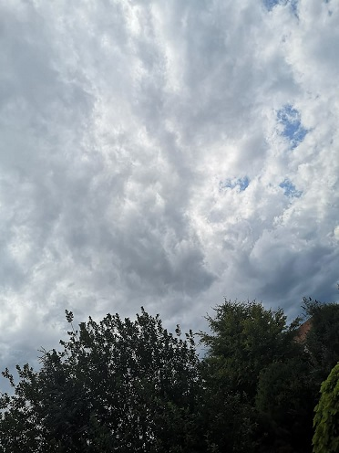
Figure 1. Grey sky. Saturday 11 July, 14.14 - in my garden, Herdwangen, Germany. Photo: Sintija Barakat
Harris explains that ‘Our thoughts will be affected by the kind of weather we’re in. Dark clouds are liable to engender gloomy feelings.’ Harris idea that people act on the weather correspondingly can be pointed out in my Sky Journal, for instance the entry from the 11th July. Respectively, the point where the dark or grey clouds shape the day in a darker shade. This phenomenon can be seen also in another entry from my journal (Fig. 2), from the 15th July:
My day starts with a coffee in an-expressive garden. The weather is grey, with a slight cool breeze. Just like my current mood – without any bright colourings, slow and emotionless. This morning feels blank. Do my neighbours feel this morning the same as I do?

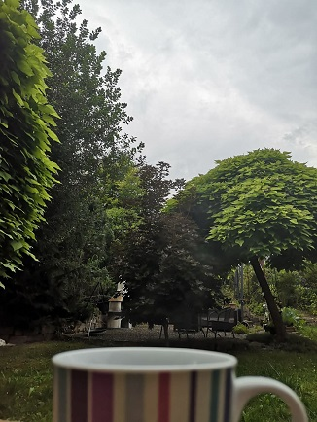
Figure 2. Morning coffee in the garden. Wednesday, 15th July, 9.00 - in my garden, Herdwangen, Germany. Photo: Sintija Barakat

The weather has the ability to set people’s moods collectively by experiencing it at the same time and space. Perhaps my neighbours felt something similar that morning, like gloominess or emotionless. As Harris states, ‘Weather is one of the most powerful threads holding us together: it is what we share with everyone else who is in it, or under it.’ Even if people share similar moods according to weather influence, their feelings are personal, they are their own. According to Harris, the weather that people share is largely ‘personal and unpredictable’, and it ‘is made up of personal memories and moods.’ As an example, on 21st July heavy rain in the evening triggered a memory and with it came feelings, that were familiar to me, as I had lived it before. In my Sky Journal I wrote:
I stood in the doorway leading to the garden terrace. The heavy rain started to tickle my feet, they got wet very quickly. The fresh air and the freshly cut grass in the garden smelled so good and refreshing that I immersed myself in a distant memory of my childhood that felt like Déjà vu. As if I was experiencing this exact moment once again. It felt very strange but at the same time very pleasant, as it was a happy memory. A moment of pure joy in the heavy summer rain.

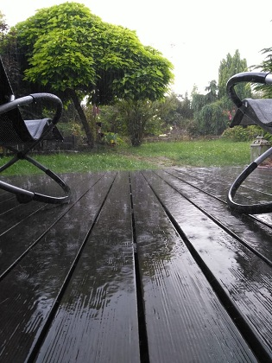
Figure 3. Heavy rain. Tuesday, 21 July, 17:45 - in my garden, Herdwangen, Germany. Photo: Sintija Barakat

These feelings that I had at that moment were my personal memory triggered by the weather. The weather that emerged with the garden caused a memory. Therefore, even though rain or ‘rainy days turn people in upon themselves’; the rain on 21st July turned my day pleasantly memorable.

Inner and outer weather

The weather poses meaning to people not only in the material world but also in the spiritual sense. Harris suggests, that ‘The immateriality of weather has made it a potent means of figuring not only our gods but the most immaterial parts of ourselves – our ‘spirits’ and our thoughts.’ Sometimes the weather can bring a person to a deeper thought or to find oneself in a deeper meaning; in a deeper state of mind. This idea is represented through my Sky Journal. I talk about deep thoughts that came to me by observing the weather and nature in the garden (Fig.4). On the 4th of July at 16.30 I wrote:
I am sitting in my favourite spot in the garden on a rocking-chair. From here I can see most of my garden. I can see how it breathes; how alive it is. A light breeze touches leaves in the trees. They move together in harmony with the breeze. The afternoon sun shines through these same leaves. Giving them a warmth and a comfort. They are in harmony with the sun. I feel the same breeze and the warmth on my skin. I feel like a leaf from the tree. I am in harmony with my garden and the sky.


Figure 4. Leaves in the tree and the sky. Saturday, 4 July, 16.30 - in my garden, Herdwangen, Germany. Photo: Sintija Barakat

The weather can influence people’s personal feelings, thoughts and, moods but it comes to a stronger sense when the weather drastically changes. In that moment, people tend to make a new revelation, as Harris points out ‘when the world is a new place’, and it happens because of these weather changes. For instance, in my case it happened when, after rainy days, a sunny day appeared (Fig.5). It felt sudden, out of nowhere but like a new beginning. I could hear and feel things that I could not on the rainy days. As I wrote in my journal on the 18th of July at 12 o’clock in the afternoon:
After almost a week of rain, today the weather changed completely, and my inside and outside world changed with it. Today the sun is shining and warming up my skin, with its gentle touch. I can hear the village’s church bell, whose sounds are carried through the blue sky; through the garden; and through my mind. The sound of the bell feels like a cleansing process of the sky and of my thoughts. A new day is born. I am feeling calm and peaceful. Nothing else matters at this moment.

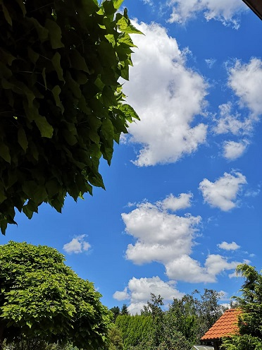
Figure 5. Garden and sky. Saturday, 18 July, 12.00 - in my garden, Herdwangen, Germany. Photo: Sintija Barakat

Not always does weather change people’s perception about how they see and feel the world. It is not always from outside in. As Harris calls them: ‘outside weather’ and ‘inside weather’. Thus, people’s inner weather has the ability to interact with the outside weather before it happens the other way around. Harris mentioned in her book the social scientist Steve Rayner, and that he approves narrator’ Marcel Proust’s idea: ‘a change in the weather is sufficient to recreate the world and ourselves anew.’ This is the idea of outside weather influences inside and can be linked to Harris, as she notes ‘we find the external image of the thing we need to express.’ But, the idea of inside influencing outside comes back to Rayner. He, at the same time, also believes that ‘a change in ourselves is sufficient to recreate the weather.’ Transformation in people and their inside weather in general is capable of recreating the outside weather. According to Harris, weather ‘is daily recreated in the human imagination.’ These ideas, representative of outer weather coming from the inner weather, can be seen in my journal where the weather was recreated by my thoughts. I imagined comparing my thoughts of nothing with the cloudless weather. As I noted in my Sky Journal on the 4th of July at 16.40:
It is Sunday afternoon. Blue, blue sky above me. No clouds in the sky-sea. It feels like infinity. Infinite space for thoughts. Where are my thoughts? I had so many – suddenly none. Like the blue sky without any clouds. Everything is clear and calm in the garden – Just me and my Sky Journal.

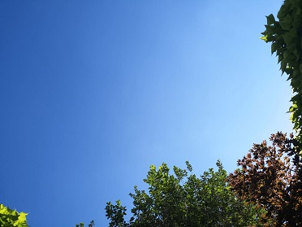
Figure 6. Blue sky. Saturday, 4 July, 16.40 - in my garden, Herdwangen, Germany. Photo: Sintija Barakat

Imagination and clouds

There is no limit to the human mind when it comes to imagination: looking up at the sky, watching clouds and imagining. The images of a creative mind come from the endless cloud formations, always changing their shape. Harris points out that, ‘We long for shape as we long for narrative.’ People see endless variations of different cloud formations, that turn into things of imagination, that turn into stories. When I look at the clouds, how they flow in the sky I practically always see something imaginative, some being changing into something else, into another being. Harris explains that it is almost impossible to watch the clouds and not imagine creatures. And from the point when a person starts to see something imaginative, the thoughts start to hop around the mind and narrative begins its course. One early evening in the middle of the summer, I started to observe clouds – how they move, re-shape and so on. And I noticed a cloud formation that shaped into a creature and from that point the story was came to me - the thoughts came alive. As I wrote in my Sky Journal on the 19th of July at 17.45:
Who are these giants in the sky? A fire breathing creature formed out of the dark clouds. Floating around in the sky like a weightless feather, but at the same time as a tremendous sky giant eating the sun. This giant looks like a mythical creature, monster like – scary. It makes me feel small and vulnerable. It makes me think of the gods, or the great architects of the universe, and mortality.

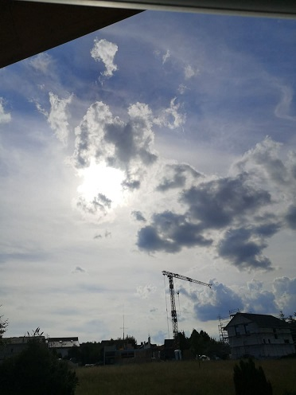
Figure 7. Sky giant eating the sun. Sunday, 19 July, 17.45 - in my garden, Herdwangen, Germany. Photo: Sintija Barakat

Figure 7 captures the dark cloud formation which is described in my journal. Perhaps someone else would see something else. Although according to Harris, people see what they are told to see. Therefore I wonder, if everyone would see the same creature as I did – a sky giant breathing fire or eating the sun? Figure 8 shows the cloud formations that were captured a couple of minutes before the creature of my imagination (Fig.7) appeared in the sky. This is an example of how vibrant the clouds are, how rapidly they transform and move. Harris points out, ‘…there is no single authoritative version of a cloud. The cloud-form is constantly revised and never finished’. Therefore, one can say that cloud imagination – images, narratives are individual for everyone. Clouds are a continuously changing imagination for everyone who will look, see, and open their minds to creative thinking.
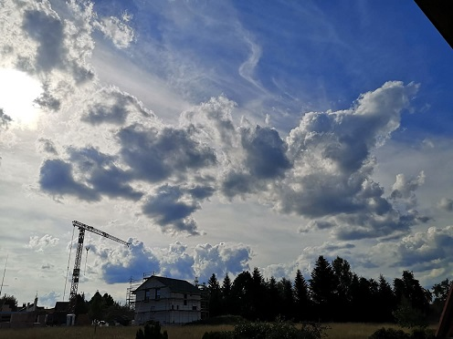,
Figure 8. Sky giants. Sunday, 19 July, 17.43 - in my garden, Herdwangen, Germany. Photo: Sintija Barakat

Figure 9 shows another example of imaginative cloud formation. On 31st of July at 15.56 I captured this beautiful cloud formation from my garden that could be called a ‘cloud-city’. It was tremendous, very impressive looking. I still remember the feeling of something greater and powerful when I look at this picture (Fig.9). Therefore, I imagined it as a city of gods. It reminded me of what Socrates said about the large group of clouds in Aristophanes comic drama Clouds, in 423 BC. He said: ‘They are celestial Clouds, the patron goddesses of the lay-about. From them we get our intelligence, our dialect, our reason, our fantasy and all our argumentative talents.’ These words hide a truth, especially when it comes to fantasy or imagination. Therefore, assumably for some people clouds are more than clouds in the sky, shaped by the weather.

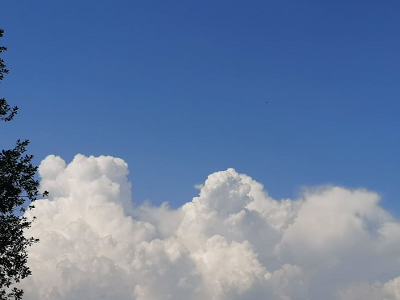
Figure 9. Cloud city. Friday, 31 July, 15.56 - in my garden. Photo: Sintija Barakat

Weather as inspiration

On the 10th of July I got inspired by the wind - how strongly it moved through the garden, through me. Figure 10 shows the moment of the day when the wind was intense – strong and loud. But of course, a picture will not give the reflection of the right feeling – how I felt in that moment. I can only describe it in words. So to speak, nothing was standing still in the garden, everything was moving fast: trees, leaves, grass, my hair, clouds and much more. According to Harris, when the weather moves fast, it can get impressively inspiring. The weather that day was magnificent and inspiring. As I noted in my Sky journal on the 10th of July at 16.15:
It is afternoon. Today garden is impressively louder than usually. It is exciting and terrifying at the same time. The wind is so strong that it feels like my garden and the sky are blending – they are one. It feels like there is no space between heaven and earth. Wind is like a breath of this unity - it breathes in and out. And I breathe with it, as I feel a part of it, in the centre of it all.
The weather was so inspiring that day that I wrote a poem about it. Harris points out, that to some extent artists and writers create the weather for others by catching the moment of it. My shared inspiration of the weather is about the strong wind – how loud it can get, so that imagination crossed my mind: inspiring weather talked to me, like it had lots to say but nobody is listening. Harris believed that ‘The weather talks too: winds and clouds are given voices.’ So I listened, I tried to understand it, but it was hard. Later that day I wrote:

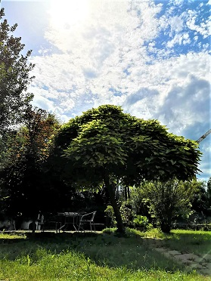
Figure 10. Wind in the garden. Friday, 10 July, 16.15 - in my garden, Herdwangen, Germany. Photo: Sintija Barakat
The wind wants to say something.
I am here, I am listening.
What is your mood today? Tell me, dear wind,
What is on your mind?

Wind is blowing stronger and stronger,
Like it is shouting or perhaps chanting?
I can hear you; I am listening.
Are you mad and suffering?
Or are you joyful and celebrating?

I wonder, what is your mood today?

Conclusion

The Sky Journal and Harris’ Weatherland provided a vibrant and diverse perspective of the weather, where the ‘outside weather’ is strongly connected to people’s ‘inside weather’. My notes and pictures in the Sky Journal as well as Harris’ ideas about the weather brought conclusions. This interplay of inside and outside weather works both ways as the weather can influence people’s moods, feelings, thoughts, imagination and creativity, just as people’s inside worlds can create the outside world. The weather in my garden had the ability to create my personal mood of the day and cloud imagination, as they are based on a highly individual features, such as memory or thoughts. However, the mood of the weather and cloud imagination could be seen as a collective aspect, as the weather can influence people in the same area similarly and imagination can be influence by others. But on the larger scale, the weather in my garden influenced me not only in the material world but also in a spiritual way. As the connection between the weather, garden and me is based on a deeper level – a personal relationship that always changes my moods, like the changing clouds of a never ending story.

Table of Images

Figure 5. Grey sky. Saturday 11 July, 14.14 - in my garden, Herdwangen, Germany. Photo: Sintija Barakat
Figure 6. Morning coffee in the garden. Wednesday, 15th July, 9.00 - in my garden, Herdwangen, Germany. Photo: Sintija Barakat
Figure 7. Heavy rain. Tuesday, 21 July, 17:45 - in my garden, Herdwangen, Germany. Photo: Sintija Barakat
Figure 4. Leaves in the tree and the sky. Saturday, 4 July, 16.30 - in my garden, Herdwangen, Germany. Photo: Sintija Barakat
Figure 5. Garden and sky. Saturday, 18 July, 12.00 - in my garden, Herdwangen, Germany. Photo: Sintija Barakat
Figure 6. Blue sky. Saturday, 4 July, 16.40 - in my garden, Herdwangen, Germany. Photo: Sintija Barakat
Figure 7. Sky giant eating the sun. Sunday, 19 July, 17.45 - in my garden, Herdwangen, Germany. Photo: Sintija Barakat
Figure 8. Sky giants. Sunday, 19 July, 17.43 - in my garden, Herdwangen, Germany. Photo: Sintija Barakat
Figure 9. Cloud city. Friday, 31 July, 15.56 - in my garden, Herdwangen, Germany. Photo: Sintija Barakat
Figure 10. Wind in the garden. Friday, 10 July, 16.15 - in my garden, Herdwangen, Germany. Photo: Sintija Barakat

Bibliography

Aristophanes, ‘Clouds’, ll. 332-34, 316-19.8 Ibid., ii. 344-45.9, in Alexandra Harris, ‘Weatherland: Writers and artists under English skies’, (Thames & Hudson, 2015).
Barakat, Sintija, Sky Journal, from 1st - 31st July 2020, Herdwangen-Schoenach, Germany.
Finlay, L. and Gouch, B., ‘Reflexivity: A Practice Guide for Researchers in Health and Social Sciences, (Oxford: Blackwell, 2003), in Hennink, Monique, Hutter, Inge, Bailey, Ajay, ‘Qualitative research methods’, (Los Angeles; London; New Delhi; Singapore; Washington DC, SAGE Publications Inc., 2011).
Harris, Alexandra, ‘Weatherland: Writers and artists under English skies’. (Thames & Hudson, 2015).
Hennink, Monique, Hutter, Inge, Bailey, Ajay, ‘Qualitative research methods’, (Los Angeles; London; New Delhi; Singapore; Washington DC, SAGE Publications Inc., 2011).
Husserl, Edmund, in Moran, D., ‘The Phenomenology Reader. Moran, D.’, (Routledge).
Proust, Marcel, ‘The Guermantes Way’ (1921), trans. C. K. Scott Moncrieff and Terence Kilmartin, rev. D. J. Enright (1992; Vintage, 1996), 398., in Alexandra Harris, ‘Weatherland’: Writers and artists under English skies’. (Thames & Hudson, 2015).
Rayner, Steve, ‘Domesticating Nature: Commentary on the Anthropological Study of Weather and Climate Disclosure’, in Strauss and Orlove, Weather, Climate, Culture, 289., in Alexandra Harris, ‘Weatherland’: Writers and artists under English skies’. (Thames & Hudson, 2015).

Monique Hennink, Inge Hutter, Ajay Bailey, ‘Qualitative research methods’, (Los Angeles; London; New Delhi; Singapore; Washington DC, SAGE Publications Inc., 2011), p. 187.
L. Finlay and B. Gouch, ‘Reflexivity: A Practice Guide for Researchers in Health and Social Sciences, (Oxford: Blackwell, 2003), in Hennink, Monique, Hutter, Inge, Bailey, Ajay, ‘Qualitative research methods’, (Los Angeles; London; New Delhi; Singapore; Washington DC, SAGE Publications Inc., 2011), p. 19.
Sky Journal, ‘Planting’, 1st July, 5.15, Herdwangen-Schoenach, Germany.
Sky Journal, ‘Planting’, 1st July, 5.15, Herdwangen-Schoenach, Germany.
Edmund Husserl, in Moran, D., ‘The Phenomenology Reader. Moran, D.’, (Routledge), p. 7.
Sky Journal, ‘Grey sky’, 11th July, 14.14, Herdwangen-Schoenach, Germany.
Alexandra Harris, ‘Weatherland: Writers and artists under English skies’. (Thames & Hudson, 2015), Loc 193.
Sky Journal, ‘Morning coffee’, 15th July, 9.00, Herdwangen-Schoenach, Germany.
Alexandra Harris, ‘Weatherland’, Loc 193.
Alexandra Harris, ‘Weatherland’, Loc 200.
Sky Journal, ‘Heavy rain’, 21st July, 17.45, Herdwangen-Schoenach, Germany.
Alexandra Harris, ‘Weatherland’, Loc 193.
Alexandra Harris, ‘Weatherland’, Loc 169.
Sky Journal, ‘Leaves, sky and me’, 4th July, 16.30, Herdwangen-Schoenach, Germany.
Alexandra Harris, ‘Weatherland’, Loc 208.
Sky Journal, ‘The moment’, 18th July, 12.00, Herdwangen-Schoenach, Germany.
Alexandra Harris, ‘Weatherland’, Loc 208.
Alexandra Harris, ‘Weatherland’, Loc 216.
Marcel Proust, ‘The Guermantes Way’ (1921), trans. C. K. Scott Moncrieff and Terence Kilmartin, rev. D. J. Enright (1992; Vintage, 1996), 398., in Alexandra Harris, ‘Weatherland’: Writers and artists under English skies’. (Thames & Hudson, 2015), Loc 208.
Alexandra Harris, ‘Weatherland’, Loc 208.
Steve Rayner, ‘Domesticating Nature: Commentary on the Anthropological Study of Weather and Climate Disclosure’, in Strauss and Orlove, Weather, Climate, Culture, 289., in Alexandra Harris, ‘Weatherland’: Writers and artists under English skies’. (Thames & Hudson, 2015), Loc 216.
Alexandra Harris, ‘Weatherland’, Loc 216.
Sky Journal, ‘Blue sky’, 4th July, 16.40, Herdwangen-Schoenach, Germany.
Alexandra Harris, ‘Weatherland’, Loc 1664.
Alexandra Harris, ‘Weatherland’, Loc 1664.
Sky Journal, ‘Sky giant’, 19th July, 17.45 O, Herdwangen-Schoenach, Germany.
Alexandra Harris, ‘Weatherland’, Loc 1664.
Alexandra Harris, ‘Weatherland’, Loc 3830-3839.
Alexandra Harris, ‘Weatherland’, Loc 3879.
Alexandra Harris, ‘Weatherland’, Loc 3892.
Aristophanes, ‘Clouds’, ll. 332-34, 316-19.8 Ibid., ii. 344-45.9, in Alexandra Harris, ‘Weatherland: Writers and artists under English skies’, (Thames & Hudson, 2015), Loc 3892.
Alexandra Harris, ‘Weatherland’, Loc 5996.
Sky Journal, ‘Loud wind’, 10th July, 16.15, Herdwangen-Schoenach, Germany.
Alexandra Harris, ‘Weatherland’, Loc 204.
Alexandra Harris, ‘Weatherland’, Loc 613.
Sky Journal, ‘Talking wind’, 4th July, 16.15 O, Herdwangen-Schoenach, Germany.

