Assessment component: Individual report

Student Name : Krishna Lakhu Khunti
Student ID : 2515605
Module Name: InternationalMarketing: PrinciplesandPractices
Module Code: LCMB7026
Lecturere’s Name: TusharaBalendran
Word Count : 5000 words (± 10%)
Term 2

Table of contents
Section 0: Introduction to the report ………………………………………………..….. 3
Section 1 : Comparative Analysis …………………………………...……………….... 4
Organisational Context and Overview …....………………………………………... 4
Macro Environmental Analysis (PESTLE) ...………………………………………... 6
Cultural Analysis (Hofstede’s Cultural Dimensions) …………………………….... 7
Critical Evaluation of STP Strategies …...………….………………………….…... 8
International Marketing Mix (7Ps) Analysis …………………….…………….…... 10
Market Entry Strategy Analysis: United States …...………….….…………….…... 14
Critical Evaluation of Corporate Ethical Issues (Japan) …...………….……….…... 16
Strategic Future Recommendations …...…...……….………………………….…... 17
Section 2: Reflection …………………………………………………………..……... 19
References …………………………………………………………………………..… 20

1. Introduction of Toyota
Toyota is one of the world’s top selling automaker originally from Japan. Toyota is renowned for its Just-In-Time production system and Kaizen manufacturing philosophies. Mobility landscape is rapidly evolving because of hydrogen, hybrid and Battery Electric Vehicles (BEVs); and Toyota is navigating this complex landscape while integrating advanced AI into it’s logistics and manufacturing operations.
This report critically evaluates Toyota’s international marketing strategies between two contrasting markets with completely different socio - economic environments: its home market of Japan and its primary host market, the United States. Report uses macro environment frameworks like PESTLE, Hofstede framework for macro environmental analysis and STP and 7Ps for internal analysis against external factors.
Based on this analysis, the report provides market entry strategy for USA, evaluates ethical concerns related to brand’s marketing mix in Japan and finally recommends how Toyota should move forward with their international marketing strategies.

Background History of Toyota
Founded in 1937 by Kiichiro Toyoda, Toyota has maintained its dominance as world’s best selling automotive manufacturer for past 6 years (Anadolu Ajansı, 2026). Despite facing multiple macroeconomic challenges, the Toyota Group sold over 11.3 million vehicles in 2025 and it is projected to reach consolidated revenue of 50 trillion Japanese Yen in 2026 (Anadolu Ajansı, 2026). This resilience and growth is mainly driven by its robust global supply chain and cost improvement initiatives.
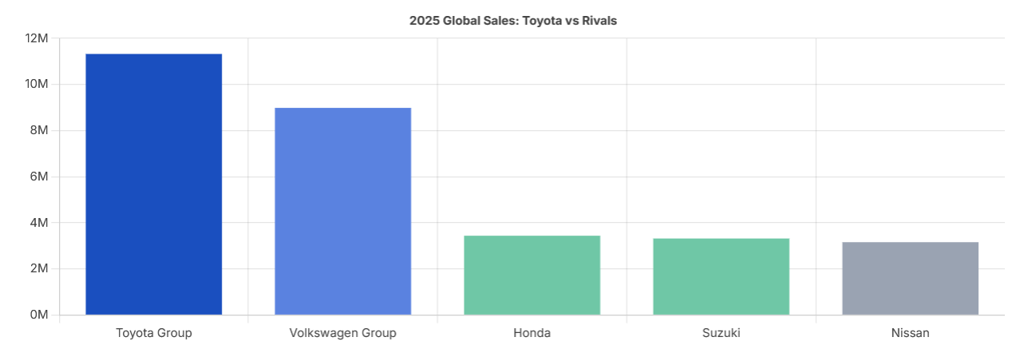
(Source: https://www.quantumrun.com/consulting/toyota-statistics/ )
Vision Statement :
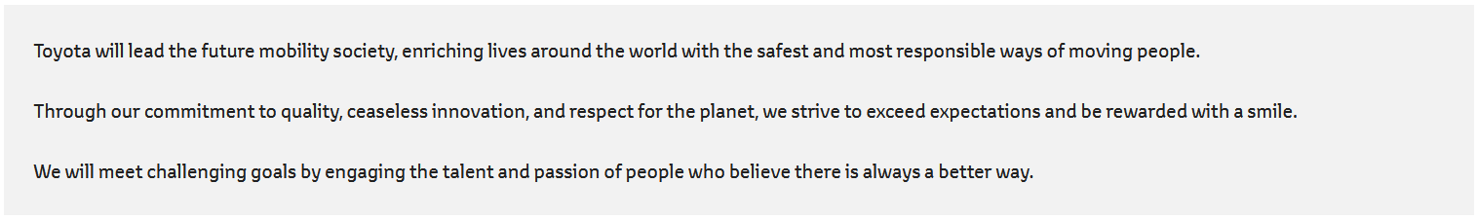
(Source: https://global.toyota/en/company/vision-and-philosophy/global-vision/)

1.1 Markets Overview
Japan (Home Country): Japan is Toyota’s domestic headquarters and it’s 3rd largest market globally, where brand dominates this market with 37.7% market share. It is Toyota's most critical production hub with vehicles output of 3,275,268 in 2025 (Quantumrun, 2026). Toyota recorded 4.1% year-over-year increase in sales with 1,501,263 vehicle sold within Japan (Quantumrun, 2026).

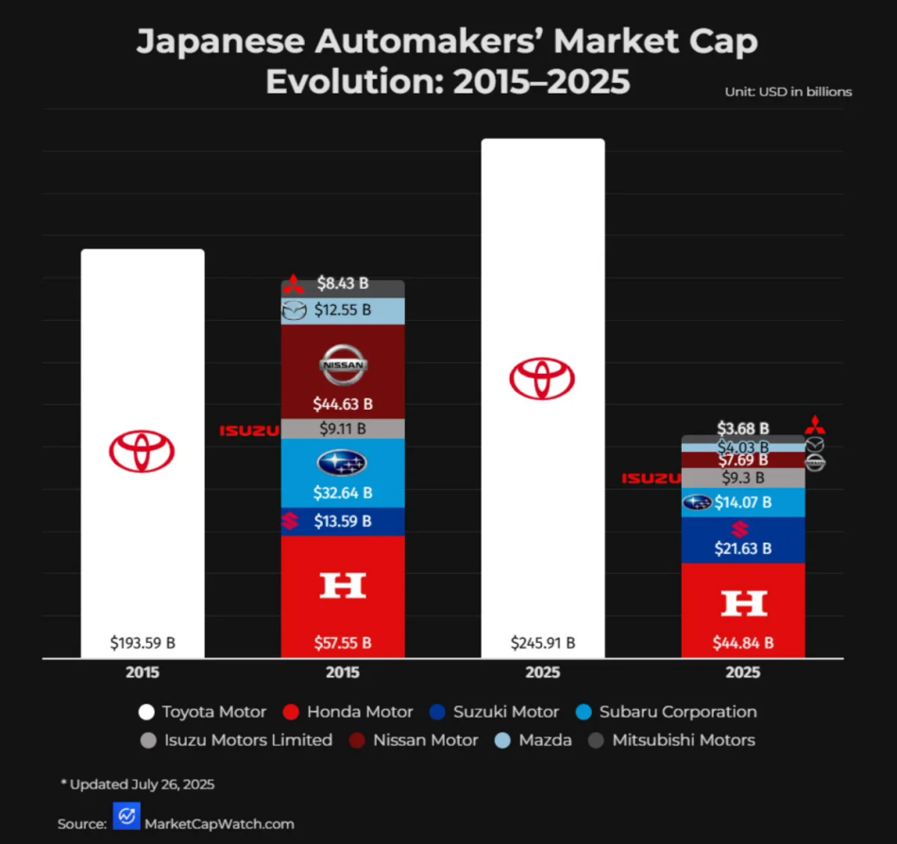
(Source: https://www.quantumrun.com/consulting/toyota-statistics/ )

USA (Primary Host Market): Since entering USA market in 1957, It has become Toyota’s largest market globally. Toyota started sales in 1958 under Toyota Motor Sales, U.S.A., Inc. USA seemed unfavorable initially, because of incompatible cars and other macro economic factors. But Toyota turned to innovation and macro environment factors shifted in Toyota’s favor.
Evolution: Brand captured 15% market share and sold 2,518,071 vehicles In 2025; which was an 8.0% increase from the previous year (Toyota USA Newsroom, 2026). Toyota’s 47% of the totals sales (in volume) were of electrified vehicles, which shows that demand for Toyota’s electrified vehicles is increasing. Models like the RAV4 Hybrid achieved all-time best-ever sales records in the US in 2026 (Toyota USA Newsroom, 2026).

1.1 Macro Environment Analysis (PESTEL Analysis)
PESTEL analysis is a strategic management tool that is used to analyze macro-environmental factors affecting organisations' success, strategy and decision-making. This analysis examines six aspects: Political, Economic, Social, Technological, Environmental and Legal. These aspects, being outside the direct control of organisations, are capable of forming both opportunities and threats for organisations functioning within domestic and international markets. Yüksel (2012) states that PESTEL analysis assists organizations in analyzing external environmental conditions, which enable them to comprehend influence of the changes in macro-environment on strategic decisions. The authors Johnson et al. (2023) note that analysing the macro-environment lets organisations define external forces influencing their competitiveness and strategic meaning.

Political Aspects
The international activities of Toyota are greatly affected by the political environment in the USA and Japan. Toyota benefits in terms of its operations from Japan being a stable country and having the cooperative approach of the government regarding industries that are focused on the automotive sector. In Japan, the vehicle electrification policy, battery technology, and advanced technologies for mobility adoption certainly help Toyota execute its innovations strategies in the long run (METI, 2024). The USA is a stable nation as well but has a more complicated political situation since there are a lot of differences among the state policies and the federal policies in the country. The company has to take into consideration many different changes including changes in relations between countries, introduction of tariffs, establishment of new incentives for local manufacturing, and so on, while being in the USA. For that reason, Toyota has decided to invest more money into local production units in the USA (Toyota Motor North America, 2025).

Favourable for Both Countries
Japan’s supportive policies make it easier for Toyota to operate in Japan and avail the benefits of political stability, plus a conducive environment for automotive development as well as manufacturing including electrification. The US also encourages local investments in the automotive sector to help Toyota grow its production in the USA (Toyota Motor North America, 2025; Ministry of Economy, Trade and Industry (METI), 2024).

Unfavourable for Both Countries
Political factors can create uncertainty for Toyota functioning in both the countries. In Japan, the rising expectation from the government regarding vehicle electrification may necessitate huge expenses for Toyota in the future. In the USA, any changes in the trade policies, tariffs, government incentives and regulations within states may increase Toyota diagnostic and compliance costs (US International Trade Administration, 2024).

Economic Aspects
Both Japan and the USA are economically advanced and are essential markets for Toyota. Japan offers Toyota a developed production system, a sufficient item of skilled labor and established supply chain in the automobile sector. On the other hand, the aging population of Japan and the already saturated automotive market impose restrictions on future growth (Statistics Bureau of Japan, 2025). The USA, on the other hand, is one of the biggest international markets for Toyota where people have high purchasing power and the demand is high for SUVs, trucks and BEVs. Toyota sold over 2.5 million cars in the USA during 2025, which indicates the significance of this market for the company (Toyota Motor North America, 2026). At the same time, inflation, interest rates, price of labor and currency exchange rates can influence vehicle prices and Toyota’s profit in both countries.

Favourable for Both Countries
The advanced automotive production technology of Japan along with its automotive suppliers' chain have provided substantial economic benefits to Toyota and have facilitated the smooth manufacturing of its products in Japan. Japan has given Toyota an opportunity to get acquainted with the vast market in the US which has a high purchasing capacity and is known for its strong demand for automobiles that consequently allows Toyota to earn massive income and grow (Toyota Motor North America, 2026).

Unfavourable for Both Countries
Due to the declining economy and an aging population in Japan, the country might face a dip in vehicle demand in the long term while increased labor costs and labor shortages can seriously affect its production. The US is also facing economic challenges in the form of high inflation rates, high-interest rates, and increased production costs leading to low purchasing capacity and increased expenses for Toyota (OECD, 2024; Statistics Bureau of Japan, 2025).

Social Aspect
Social factors play a significant part in affecting Toyota's performance both in Japan and the US. Traditionally, Japanese consumers attach importance to reliability, quality, fuel efficiency and new technologies in cars, and this resonates with Toyota’s brand image very well. However, with Japan’s population aging and shrinking, the domestic market changes and needs Toyota to adjust its vehicle offers (Statistics Bureau of Japan, 2025). Car ownership is an important part of American life due to the numerous roads and suburban way of life. American consumers have been historically inclined toward SUVs and pickup trucks, but interest in hybrid and electric vehicles is increasing, and Toyota needs to adapt its products to the case of both markets.

Favourable for Both Countries
Toyota gains from strong brand recognition and good reputation for reliability, quality and fuel efficiency in Japan and the USA. With the growing consumer interest in fuel-efficient and environment-friendly vehicles, Toyota’s strategy for hybrid and electric cars is also supported. As reported by Toyota, as much as 47% of company sales in the USA in 2025 were occupied by the sales of electric vehicles (Toyota Motor North America, 2026).

Unfavourable for Both Countries
The ageing population in Japan can reduce the demand for private vehicles. In the USA, the changing consumer expectations regarding such features as digital ones, vehicle size, sustainability and the possibility of personalisation in product need that Toyota continuously modifies its products and marketing strategies. Social media can also increase the company’s reputational risks in case the consumers start voicing their concerns about quality, environmental performance and social responsibility of the products.

1.2 Cross-Cultural Analysis (Hofstede’s Cultural Dimensions)
According to Hofstede’s six dimensions of culture, Japan and the USA reveal considerable cultural differences which may determine Toyota’s products and communication methods. To start with, Japan has a higher Power Distance index (54) than the USA (40), meaning that it is relatively more accepting of hierarchy, positions of authority and status. Furthermore, Japan has a much higher Masculinity rate (95) than the USA (62), indicating that in Japan, more emphasis is placed on competition, performance and quality. This can be seen in Toyota’s Japanese positioning, which stresses the excellence of engineering, performance and reliable models (for example, Crown and Century). The image of the company corresponds with Japanese cultural values emphasizing achievement and quality (Liker, 2004). However, the Power Distance index in the USA is lower and makes it possible for Toyota to employ very informal consumer-oriented approach. At the same time, the relatively high index of Masculinity allows Toyota to emphasize vehicle performance and accomplishment. In Toyota’s US marketing (for instance, such models as 4Runner), outdoor capability and adventure are highlighted (Toyota USA, 2025).Hofstede, Hofstede, and Minkov (2010) maintain that national culture has an impact on what is expected in terms of values and expectations, although these dimensions should be understood in terms of tendencies rather than as characteristics for all people.

The most important difference between Japan and the USA is in Individualism, Uncertainty Avoidance and Long-Term Orientation. Japan's score in Individualism is 46 versus the 91 scored by the USA, which indicates that the American society is much more individualistic and has much more importance attached to individualism, autonomy and self-expression. This means that Toyota can present the cars in the USA as products that foster individual lifestyles, freedom and adventures. In Japan, Toyota should focus more on family and relations with other people, and transport of people as a group via Alphard and Voxy. Japan's Uncertainty Avoidance score is quite high as well, with 92 points compared to the USA's score of 46. This means that Japan has a stronger desire for predictability, safety and reduced uncertainty. This implies that Toyota should convey the message of reliability, safety, quality, and engineering in Japan. Moreover, the Long-Term Orientation score of Japan is 88, while the USA has the score of just 26.The company Toyota has invested in technologies like hybrid technologies and hydrogen technologies for many years thereby adhering to this orientation (Toyota Motor Corporation, 2026). Since the US has shorter long-term orientation, communications focusing on the immediate gain of consumers, lifestyle experience, and current promotion may offer more opportunities. At the same time, the decision of the company to introduce its models produced in the US, including Camry, Highlander, and Tundra, into Japan seems to be an evidence of changing consumer needs in different cultural contexts (Toyota Motor Corporation, 2025).
The concept of indulgence versus restraint also showcases yet another pertinent distinction between Japan and the United States. Japan has an indulgence dimension of 42, while the United States registers a score of 68; this indicates the significance that leisure, happiness and self-indulgence have in American culture. As a result, Toyota can adopt a lifestyle-oriented marketing strategy in America and show its vehicles as allowing customers to enjoy recreation and adventure. Additionally, Toyota’s prior marketing campaigns in the U.S. indicate that the company is aware of the differences among various groups of American consumers, which is reflected in the Total Toyota marketing strategy (Toyota USA, 2013). In contrast, the lower score of Japan in indulgence indicates that practicality, efficiency and responsible consumption may be reflected in marketing communications; this does not, however, imply that Japanese consumers do not appreciate luxury and pleasure. In short, the comparison shows that Toyota is able to keep the same overall brand positioning while modifying its communication strategy according to local consumers’ needs. Although Hofstede’s concept is useful in identifying such differences, it is important not to use national culture-based scores for stereotypes, given that they may not reflect behavior of each individual
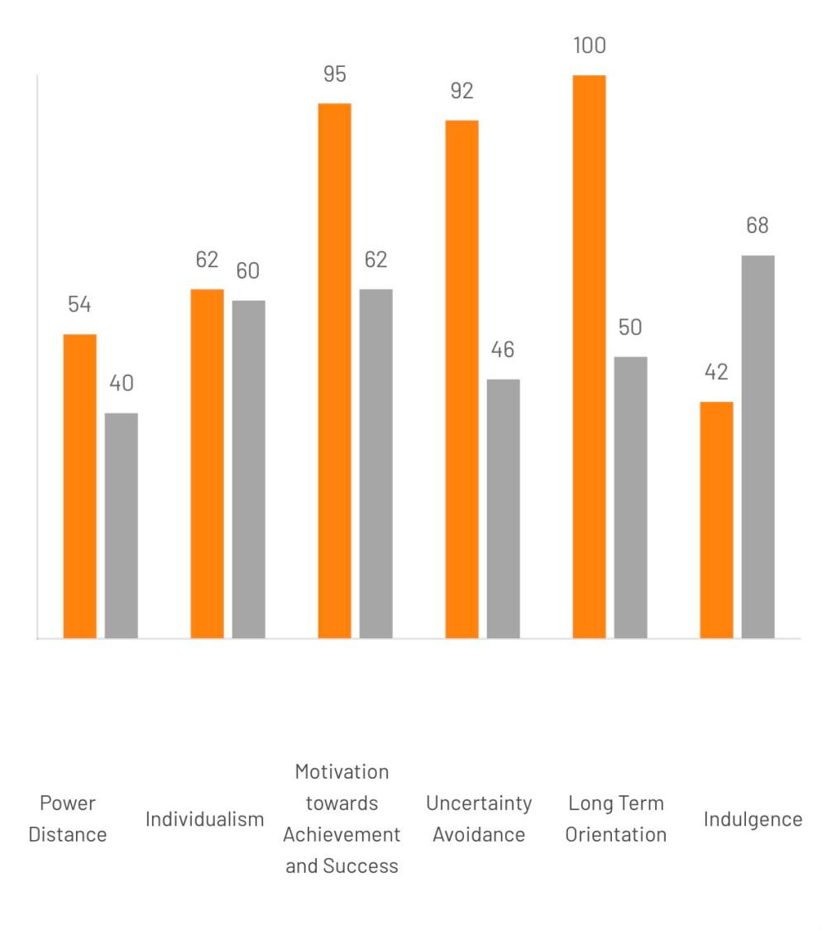
Country comparison (Source: Country comparison tool)

Advantages of Hofstede Dimensions
Hofstadter's model's main advantage lies in its ability to offer a concrete and systematic approach to the understanding of the cultural diversity between the countries, thus helping to make the complex cultural values comparable to each other (1980). The importance of the Hofstede Model for the field of International Business & Management cannot be overestimated, as it gives the opportunity to understand the differences in the leadership approach, communication style, and employee behavior in the framework of multicultural settings (Hofstede, Hofstede & Minkov, 2010). Furthermore, the model has been widely recognized and used in the academic communities as an efficient and convenient theoretical foundation for research in the sphere of cross-cultural problems (Beugelsdijk, Maseland & Van Hoorn, 2015). By showing traits of each of the cultural dimensions, the Hofstede model can help to avoid misunderstanding in cross-cultural communication and promote better decisions in global marketing and HR decisions (Tung & Verbeke, 2010).

Disadvantages of Hofstede model
Hofstede model has received a lot of criticism for its limitations with respect to its applicability and utility. One limitation is the charge of overgeneralize as far as national cultures are concerned. The point that all people of a certain country have something in common forgets about the existing differences among people of different areas of a country or ethnic groups (McSweeney 2002: 142-143). The other limitation stems from the fact that the data used to formulate the model was taken from only one transnational corporate entity (IBM), which is an argument against its applicability in practice (Hofstede 1980). One more disadvantage is that Hofstede model ignores many cultural shifts that happened over recent decades thanks to globalisation (Beugelsdijk, Maseland and Van Hoorn 2015). All these facts lead to the conclusion that Hofstede’s dimensions of culture can be employed to launch stereotypes and simplify multi-layered phenomena taking place in cultures (Tung and Verbeke 2010).

Technological Aspect
Technology is a crucial factor for Toyota’s competitive power in Japan and the US. Japan is significant in relation to Toyota because it has developed much strength in the field of robotics, automation, manufacturing engineering and hybrid technology. The Toyota Production System, which is based on efficiency, improvement and waste reduction, serves as a foundation of the company’s global production operation. The Japanese government is active in supporting advanced mobility technologies and innovations in the automotive industry * (METI, 2024)*. In the US, Toyota has advantages from a big technology ecosystem that includes software, artificial intelligence, battery technology and connected mobility. The company’s investments in battery manufacturing in North Carolina are aimed to develop its technological and production capabilities in the market. (Toyota Motor North America, 2025)

Favourable for Both Countries
Japan brings Toyota the experience in hybrid vehicles, robotics, automation, and engineering, whereas the United States provides access to software development, digital technology, battery innovation, and AI. As a result, combining capabilities can aid Toyota to create competitive next-generation mobility products.

Unfavourable for Both Countries
Fast-paced technological change obligates Toyota to significantly invest in electric vehicles, batteries, self-driving vehicles, software, and smart vehicles. The inability to keep up with rivals in the field of new technologies can negatively influence Toyota's competitive position. At the same time, the simultaneous creation of multiple powertrains may significantly raise R&D and production costs.

Environmental Aspects
Environmental issues are gaining in significance for Toyota since both consumers and governments need vehicles that produce less emissions and are produced in a more sustainable way. The Japanese government has set a goal of achieving 100% new electrified car sales by 2035, which puts less pressure on producers to step up their electrification efforts (METI, 2024). Such developments are beneficial for Toyota since the company has been using hybrid and other systems related to electrified vehicle for a long time. In the U.S., environmental legislation differs from state to state and has become even more complicated since there are both federal and local laws.

Favourable for Both Countries
The rise of environmental awareness creates conditions for Toyota to apply its experience in hybrids and electric vehicles as a source of competitive advantage. Government efforts to support the development of the infrastructure for charging stations and batteries may also help Toyota's advancing to lower emissions mobility (METI, 2024).

Unfavourable for Both Countries
Increased requirement in environmental performance will mean that Toyota will incur significant expenses in advancing battery technologies, electric vehicles, renewable energy, and low-carbon production. The shift from regular cars to electric ones will raise production and R&D costs. Moreover, disparities in environmental regulations in Japan and the USA will not allow Toyota to follow the same corporate strategy in both countries at the same time.

Legal Aspects
The legal environment in Japan, as well as in the United States, is complicated for Toyota. There are regulations on vehicle safety, emissions, labor relations, consumer protection, product liability, and corporate governance. In Japan, Toyota has the advantage of working within a familiar environment that makes compliance easier. However, the U.S. legal system, which at the same time combines federal and state requirements, imposes additional requirements on the company. The institutional differences may affect the threat level and costs of international businesses as firms have to adjust their strategies according to the regulatory environment of the country (North, 1990; Peng, Wang, Jiang, 2008). At the same time, legal premises concerning eco-efficiency and vehicle safety may push Toyota to make products of better quality with higher technological background.

Favourable for Both Countries
The legal systems in Japan and the US allow Toyota to have a much clearer path on how to conduct business in these nations as well as safely ensure the protection of intellectual property and safety regulations. Through following these laws, Toyota will also have a chance to strengthen its reputation.

Unfavourable for Both Countries
The increasing amount of laws might make Toyota’s compliance process costly and call for changing products. The US has even more complications as Toyota has to deal with various requirements across multiple federal and state jurisdictions. Moreover, international lawsuits and issues with product liability may harm both reputational and monetary performance.

1.2 Cross-Cultural Analysis (Hofstede’s Cultural Dimensions)
According to Hofstede’s six dimensions of culture, Japan and the USA reveal considerable cultural differences which may determine Toyota’s products and communication methods. To start with, Japan has a higher Power Distance index (54) than the USA (40), meaning that it is relatively more accepting of hierarchy, positions of authority and status. Furthermore, Japan has a much higher Masculinity rate (95) than the USA (62), indicating that in Japan, more emphasis is placed on competition, performance and quality. This can be seen in Toyota’s Japanese positioning, which stresses the excellence of engineering, performance and reliable models (for example, Crown and Century). The image of the company corresponds with Japanese cultural values emphasizing achievement and quality (Liker, 2004). However, the Power Distance index in the USA is lower and makes it possible for Toyota to employ very informal consumer-oriented approach. At the same time, the relatively high index of Masculinity allows Toyota to emphasize vehicle performance and accomplishment. In Toyota’s US marketing (for instance, such models as 4Runner), outdoor capability and adventure are highlighted (Toyota USA, 2025).Hofstede, Hofstede, and Minkov (2010) maintain that national culture has an impact on what is expected in terms of values and expectations, although these dimensions should be understood in terms of tendencies rather than as characteristics for all people.

The most important difference between Japan and the USA is in Individualism, Uncertainty Avoidance and Long-Term Orientation. Japan's score in Individualism is 46 versus the 91 scored by the USA, which indicates that the American society is much more individualistic and has much more importance attached to individualism, autonomy and self-expression. This means that Toyota can present the cars in the USA as products that foster individual lifestyles, freedom and adventures. In Japan, Toyota should focus more on family and relations with other people, and transport of people as a group via Alphard and Voxy. Japan's Uncertainty Avoidance score is quite high as well, with 92 points compared to the USA's score of 46. This means that Japan has a stronger desire for predictability, safety and reduced uncertainty. This implies that Toyota should convey the message of reliability, safety, quality, and engineering in Japan. Moreover, the Long-Term Orientation score of Japan is 88, while the USA has the score of just 26.The company Toyota has invested in technologies like hybrid technologies and hydrogen technologies for many years thereby adhering to this orientation (Toyota Motor Corporation, 2026). Since the US has shorter long-term orientation, communications focusing on the immediate gain of consumers, lifestyle experience, and current promotion may offer more opportunities. At the same time, the decision of the company to introduce its models produced in the US, including Camry, Highlander, and Tundra, into Japan seems to be an evidence of changing consumer needs in different cultural contexts (Toyota Motor Corporation, 2025).
The concept of indulgence versus restraint also showcases yet another pertinent distinction between Japan and the United States. Japan has an indulgence dimension of 42, while the United States registers a score of 68; this indicates the significance that leisure, happiness and self-indulgence have in American culture. As a result, Toyota can adopt a lifestyle-oriented marketing strategy in America and show its vehicles as allowing customers to enjoy recreation and adventure. Additionally, Toyota’s prior marketing campaigns in the U.S. indicate that the company is aware of the differences among various groups of American consumers, which is reflected in the Total Toyota marketing strategy (Toyota USA, 2013). In contrast, the lower score of Japan in indulgence indicates that practicality, efficiency and responsible consumption may be reflected in marketing communications; this does not, however, imply that Japanese consumers do not appreciate luxury and pleasure. In short, the comparison shows that Toyota is able to keep the same overall brand positioning while modifying its communication strategy according to local consumers’ needs. Although Hofstede’s concept is useful in identifying such differences, it is important not to use national culture-based scores for stereotypes, given that they may not reflect behavior of each individual
1.3 STP Analysis
Toyota’s localized Segmentation, Targeting, and Positioning (STP) strategy adapts perfectly to the infrastructural realities and the lifestyle demands of targete markets.
Market Segmentation
Japan (Home Market): Japan’s market necessitates micro-segmentation; It’s demographic segmentation consists of rapidly aging population and young families with rising disposible income. Geographically, rural migration shifts demand towards vehicles that can navigate dense infrastructure, tight urban parking and narrow streets.
USA (Host Market): Toyota segments the US market around lifestyle and vehicle size due to it’s demand for versatile utility. It ranges from budget-conscious commuters to large suburban families and corporate fleets. Brand also has B2B and highly successful environmentally aware customer base. Here, Toyota heavily capitalizes on the popularity of compact SUVs and trucks. For instance, the RAV4 is the most popular vehicle in 12 different US states (ConsumerAffairs, 2024).

Target Audience Analysis
Japan: Toyota offers highly efficient, compact cars specifically designed for urban maneuverability and efficiency-focused urban families; while micro-cars (Kei-cars) sustain massive domestic demand due to tax-advantages and insurance costs in rural prefectures.
USA: Toyota offers same models with distinct design categories to effectively capture these diverse behavioral segments within a single product line. Like the redesigned 2026 RAV4 in three distinct design categories: Core, Rugged, and Sport (Kelley Blue Book, 2026). A critical emerging target audience in the US is the environmentally aware consumer who still demands practical performance. Toyota specifically targets this hybrid-conscious demographic, a strategy that proved highly successful as electrified vehicle sales represented 50.5% of the brand's total volume in the first quarter of 2026 (Toyota Motor North America, 2026). Furthermore, regional targeting is employed; for example, the rugged Tacoma pickup truck is specifically targeted and heavily popular in states like Hawaii (ConsumerAffairs, 2024).

Brand Positioning and Value Proposition Alignment
Core Value Proposition: Globally, Toyota’s fundamental value proposition is built upon quality, durability, high fuel efficiency and strong resale value (IIDE, 2025; Spinny, 2026). The brand emotionally secures its position by building strong consumer trust through longevity, predictable ownership costs and high ownership satisfaction.
Japan Positioning: In its home market, Toyota's core brand is explicitly positioned as delivering "mobility for all". The value proposition relies heavily on a legacy of hybrid efficiency, globally proven platforms, and structural integrity tailored for long-term domestic use.
USA Positioning: In the host market, Toyota shifts its positioning to blend traditional reliability with modernized performance and lifestyle empowerment. For example, by making hybrid powertrains standard on the 2026 RAV4, Toyota positions the vehicle to offer "the best of two worlds: Stellar fuel economy and more power than a standard gasoline engine alone" (Kelley Blue Book, 2026), directly aligning its value proposition with the American consumer's desire for uncompromised performance and efficiency.

1.4 International Marketing Mix (7Ps) Comparative Analysis
Toyota continuously adapts its standardized business operations to penetrate diverse global markets and meet localized demands. This section critically evalates Toyota’s 7Ps Marketing Mix in Japan against the United States.
Product
Japan: Toyota's domestic product mix heavily Emphasizes compact hatchbacks, micro-cars (Kei-cars) and minivans like the Alphard or Voxy offering easy ingress and egress. Environmentally, the product line utilizes hydrogen platforms (Mirai) and standard or plug-in hybrids rather than pure battery electric vehicles.
USA: US product mix is dominated by mid-size sedans, massive SUVs (such as the Highlander and RAV4) and heavy-duty pickup trucks like the Tundra and Tacoma. Recognizing the American desire for uncompromised power, Toyota recently adjusted its US product mix by making hybrid powertrains standard on models like the 2026 RAV4 to offer both stellar fuel economy and increased horsepower.
Price
Globally, Toyota follows value-based pricing strategy; but economic and geopolitical factors decide market specifics.
Japan: Domestically, Toyota leverages extreme economies of scale to offer highly competitive pricing. Prices are kept relatively stable to maintain its dominant market share, appealing to a budget-conscious consumer base.
USA: Brand follows layered pricing strategy supported by leasing and auto-financing. Toyota offers entry-level pricing for certain models while charging premium for specialized models like the TRD Pro truck series. Toyota’s US pricing strategy is currently under severe economic pressure due to aggressive trade protectionism. In 2025 and 2026, U.S. imposed 15% tariffs on imported vehicles; Toyota has chosen to absorb much of the cost through aggressive internal cost-reduction activities as passing it directly onto the American consumer would destroy Toyota’s value proposition against domestic rivals like Ford.
Place
Japan: Toyota’s has high density of small showrooms, well embedded within local neighborhoods that act as a trusted community hub where consumers return to the same dealer for decades. This plays well with Japan’s high Uncertainty Avoidance culture and infrastructure reality.
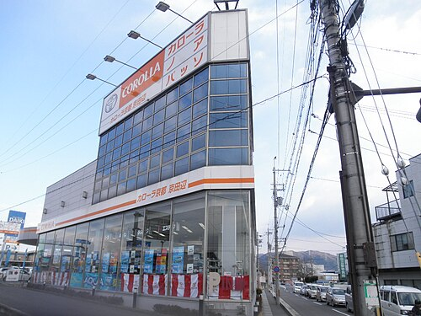
(Source: https://en.wikipedia.org/wiki/Toyota_dealerships_%28Japan%29 )
USA: American consumers exert short-term orientation and often expect to purchase and drive a vehicle on the exact same day. Toyota’s distribution strategy relies on expansive, mega-dealerships capable of holding massive inventory preferably near highways.
People:
Japan: Dealership staff follows the Japanese cultural philosophy of Omotenashi (deep, anticipatory hospitality); where sales professionals act as lifelong mobility consultants rather than mere transaction brokers. This builds deep-rooted consensus (Nemawashi) with families before a purchase is finalized.
USA: On the contrary, U.S. dealership environment is more transaction-driven and competitive; where sales personnel are thoroughly trained in product knowledge. However, Toyota still trains them to be respectful and solve customer problems.

Promotion:
Japan: Inorder to align with a collectivist and long-term oriented culture of Japan; Toyota’s domestic promotions emphasize heritage, reliability, and societal harmony. Marketing communications feature Toyota's commitment to the community, their investments in hydrogen infrastructure and environmental sustainability.
USA:
Toyota often uses aggressive and visually dynamic promotions that appeals to USA’s indulgent and masculine culture. Brand also utilizes seasonal sales (e.g., the annual "Toyotathon"), sports sponsorships and lifestyle marketing to position itself as the ultimate tool for individual freedom and outdoor adventure.
Process
Japan: Japanese consumers demand zero ambiguity and risk mitigation. Hence, the process of purchasing a vehicle is well structured, predictable and documented.
USA: American consumers demand for speed and convenience in their fast-paced lifestyle. Toyota’s U.S. purchasing process has been heavily digitized with digital retailing tools and streamlined through fast-tracked financing approvals and express maintenance lanes to satisfy it.
Physical Evidence:
Japan: Japanese culture demands restraint and perfection. Dealerships are clean, highly functional and space-efficient; vehicles are engineered with absolute precision and high-quality materials(even in base models) to satisfy this demand.
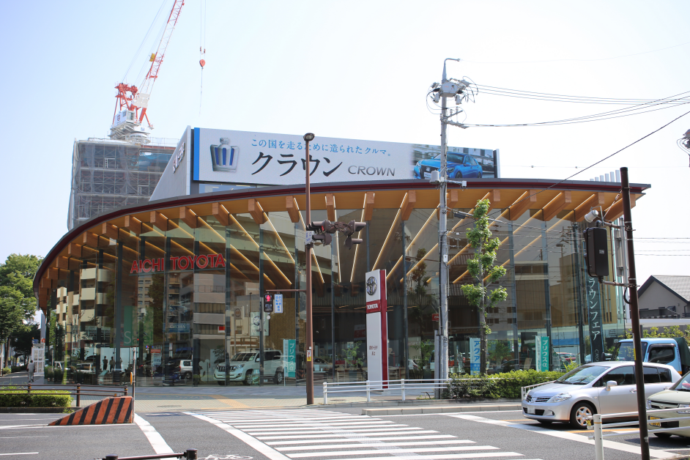
(Source: https://en.wikipedia.org/wiki/Toyota_dealerships_%28Japan%29 )
USA: Physical evidence in the US is designed to project scale, power and success. Dealerships feature giant signs, service bays and customer lounges with cafes. Vehicles often feature aggressive and stylized exterior and robust tactile interiors to visually communicate ruggedness and dominance on the road.
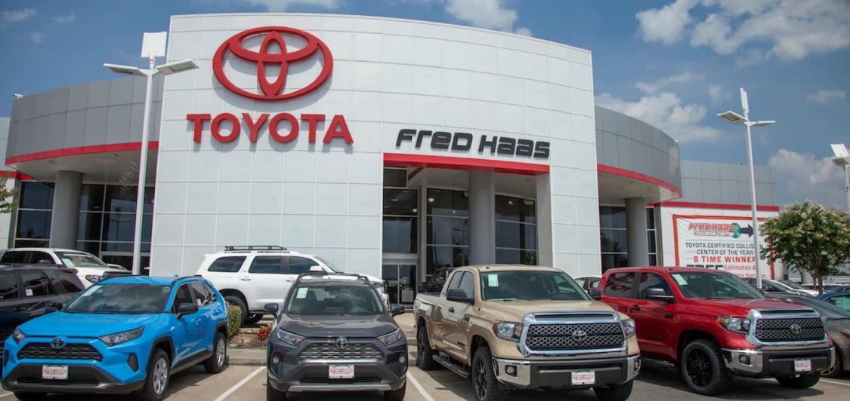
(Source: https://www.fredhaastoyota.com/about-us/ )
1.5 Market Entry Strategy Analysis: United States
Toyota's entry in USA is a classic case of staged, incremental internationalisation, where Toyota deepen its commitment gradually as market specific knowledge and confidence accumulated (Johansson and Vahlne, 1977). It started from exporting, then a shared-equity joint venture and finally a wholly owned foreign direct investment (FDI).
The Initial Export Failure (1957-1961): Toyota established its U.S. sales subsidiary in 1957 and exported Toyopet Crown to America in 1958. The vehicle had poor durability, it was underpowered and severely overheated on California freeways; resulting in a catastrophic failure with only 287 units sold in its first year. Toyota was forced to withdraw the model.
Export Re-Entry and Disruption (1965 - 1980): Toyota continued with export based strategy, gradually built a dealer network and adapted its cards to USA standards. Brand re-entered the market successfully in 1965 with the Corona and followed up in 1968 with the Corolla. The strategic brilliance of this entry was entering a completely neglected segment at the bottom of the market. As domestic USA companies were focused on heavy, high-horsepower vehicles and Toyota gained a first-mover advantage in the segment by offering small, highly reliable and affordable cars.
Demand for Toyota's fuel-efficient vehicles further skyrocketed as fuel prices quadrupled due to 1973 OPEC oil embargo and the 1979 Iranian Revolution. US auto industry blamed rising Japanese import for the losses and triggered a political backlash, which resulted in Voluntary Export Restraints by Congress in 1981 (Toyota Motor Corporation, 2012a). Toyota realized that relying purely on exports was politically unsustainable and shifted to localize production.
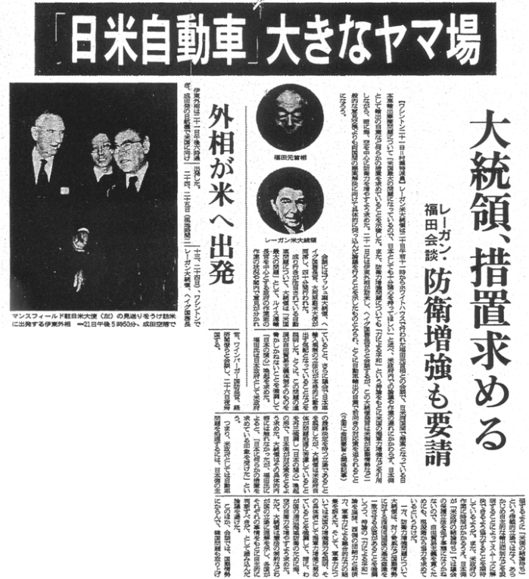
(Source: https://www.toyota-global.com/company/history_of_toyota/75years/text/leaping_forward_as_a_global_corporation/chapter1/section1/images/l03_01_01_01_img01.jpg )

Joint Venture Entry (1984): Toyota's initial response was not full FDI but a joint venture with it’s rival General Motors; as building a wholly owned manufacturing facility in the US was a massive cultural and financial risk. Toyota needed a partner to navigate complex American labor relations, adapt its corporate culture to unionized American workforce and effectively reduce the cost of learning before taking a risk of transferring it’s tacit process knowledge (TPS) to wholly owned US operation.
In February 1984, each partner contributed $100 million USD and New United Motor Manufacturing Inc. (NUMMI) was established in GM’s previously shuttered Fremont, California plant(Toyota Motor Corporation, 2012b). Toyota transformed this hostile culture Fremont plant into one based on teamwork and continuous improvement (Kaizen) through the Toyota Production System (TPS). Management abolished classist status symbols (like executive parking spaces and segregated cafeterias), fostering a team-oriented environment where blue-collar workers were treated as equals.
Wholly Owned FDI: Within a year of NUMMI's launch, Toyota announced its first wholly owned US assembly plant to be built in Scott County, Kentucky; then Georgetown facility (TMMK) opened in May 1988, producing the Camry (Toyota USA Newsroom, 2018).

1.6 Evaluation of Corporate Ethical Issues (Japan)
The Unintended Acceleration Concealment (USA): Toyota recalled 10 million+ US vehicles between 2009 and 2010 due to complaints of unintended acceleration linked to floor-mat entrapment and "sticky" accelerator pedals (U.S. Department of Justice, 2014). The mechanical defect itself was not an ethical breach but Toyota's promotional conduct once the problem was known. U.S. Department of Justice (2014) found that Toyota had publicly claimed to have addressed the root cause via a limited recall, while its own internal investigation had already identified a second, undisclosed defect ‘sticky-pedal fault’ as early as September 2009. Toyota was later required to admit that it had misled both consumers and its regulator, resulting in a $1.2 billion USD penalty and a deferred criminal prosecution agreement (U.S. Department of Justice, 2014).
Vehicle Safety Certification Scandal (Japan): In mid-2024, Toyota Motor Corporation admitted to extensive, systematic cheating on vehicle safety certification tests in Japan using airbag timer systems instead of genuine crash sensors during impact tests, fabricating pedestrian protection data and utilizing incorrect moving barrier weights (Mint, 2024). Toyota reported to the Ministry of Land, Infrastructure, Transport and Tourism (MLIT) that seven vehicle models (including 3 actively produced and 4 four discontinued) had been tested using fraudulent methods that deviated from official government standards. Consequently, Toyota was forced to suspend domestic production of the three active models for approximately three months. The scandal created an ethical crisis for Toyota that severely damaged its reputation for quality (Mint, 2024).
Greenwashing of the Hybrid Range: Since 2023, Toyota has run marketing campaigns named "Electrified" and "Beyond Zero" in the US, that refers to its mainly petrol-powered hybrid vehicle range using deceptive language associated with fully electric vehicles (Electrek, 2023). Independent monitoring by the watchdog group Ekō further alleged that Toyota's US and European marketing activities manipulated Google’s search algorithms and misdirected millions of consumers searching for EVs towards petrol hybrid cars instead. (Carbon Copy, 2024).
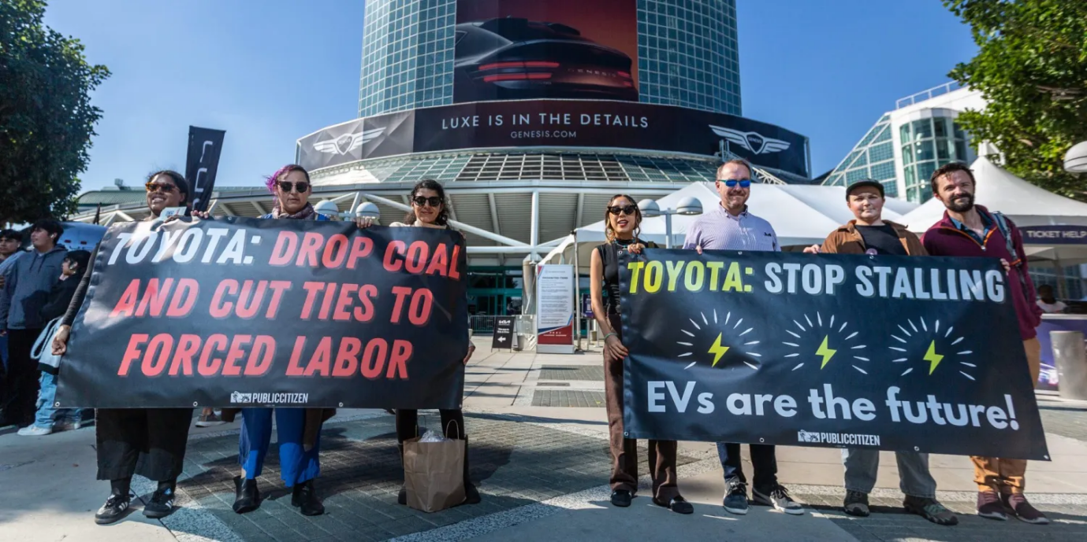
(Source: https://electrek.co/2023/11/24/toyota-is-still-greenwashing-after-change-in-leadership/ )

1.7 Strategic Recommendations
1. Extend the localisation strategy into battery-electric vehicles :
Toyota successfully converted a regulatory threat (the 1981 VER) into a durable competitive position in USA through local production via incremental, FDI-based entry. Now the similar policy pressure is rising around EV supply-chain content and the risk of tariffs on imported EVs and batteries. Toyota should prioritise localisation in this EV transition and prominently communicate it as an evidence of genuine electrification investment. Toyota has committed roughly 13.6 billion USD to battery and EV investment in North America between 2023 and 2030, including a North Carolina battery plant. Brand is scheduled to launch its first US-built battery-electric vehicle in the first half of 2026 (EnkiAI, 2026a; Electric Car Wiki, 2025).
2. Close the gap between ESG marketing claims and delivered electrification :
As evaluated in ethical issues seciton, regulators and watchdog group’s allegations about blurring the distinction between hybrid and electric vehicles. Battery-EV sales overtook plug-in hybrid sales in Toyota's global mix by May 2026 (EnkiAI, 2026a). Toyota should use this genuine progress as the basis for its promotional claims rather than ambiguous umbrella terms like "electrified" and explicitly align it’s promotional language with the FTC's Green Guides to reduce legal exposure. This would rebuild credibility with environmentally motivated consumers.
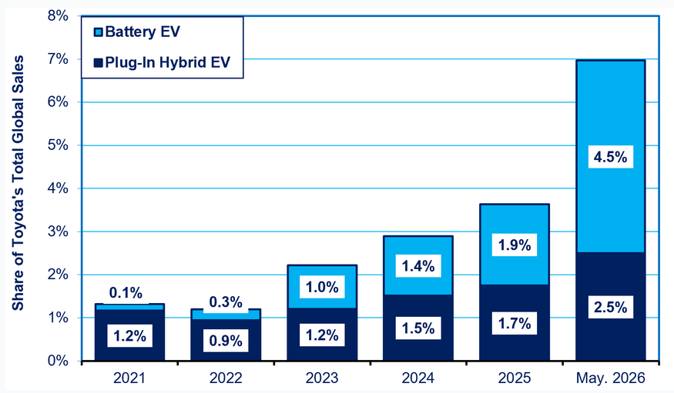
(Source: https://enkiai.com/ev/toyota-electric-vehicles-us-production/ )

Section 2 : Reflective Account
Gibb’s reflective cycle for reflection
1. Description
I had to compare both market environments, research and understand ethical concerns, lear about the market entry and then evaluate all the research from educational frameworks. The I had to make strategic recommendations.
2. Feelings
i was anxious and exhausted because of so much to reaserch and then difficulties in comparing that research with 7ps and finding differences.
It was interesting to know how big corporations think and make decision while entering a market and what they look for
3. Evaluation
later i understood purpose of each framework and how it was used for specific decision in auto industry and international branding.
4. Analysis
I got to know that marketin mix does not exist just like that, it has to adapt to PESTEL realities and brand needs.
5. Conclusion
going through the data and reports was waste of time in a way. I would try to search for specific arguments and data guided by the frameworks.
6. Action Plan
more practice for academic applications to real world scenarios and few more market enteries in different domains

References
1. Toyota once again becomes best-selling carmaker in 2025 (Anadolu Ajansı, 2026);https://www.aa.com.tr/en/economy/toyota-once-again-becomes-best-selling-carmaker-in-2025/3814196 (Accessed on : 29th June, 2026)
2. Toyota Motor North America Reports 2025 U.S. Sales Results, (Toyota USA Newsroom, 2026) https://pressroom.toyota.com/toyota-motor-north-america-reports-2025-u-s-sales-results/ (Accessed on : 1st July, 2026)
3. Toyota Motor Corp - Company Profile (IBISWorld, 2026) https://www.ibisworld.com/united-states/company/toyota-motor-corp/10379/ (Accessed on : 1st July, 2026)
4. Quantumrun (2026) Toyota Statistics 2026: Automotive Production Scale And Global Sales Performance. https://www.quantumrun.com/consulting/toyota-statistics/ (Accessed: 17 July 2026).
5. ConsumerAffairs (2024) Toyota Statistics. https://www.consumeraffairs.com/automotive/toyota-statistics.html (Accessed: 18 July 2026).
6. IIDE (2025) Toyota Business Model in 2026: Strategy, Revenue & Growth. https://iide.co/case-studies/business-model-of-toyota/ (Accessed: 18 July 2026).
7. Kelley Blue Book (2026) 2026 Toyota RAV4 Price, Reviews, Pictures & More. https://www.kbb.com/toyota/rav4/ (Accessed: 20 July 2026).
8. Spinny (2026) Upcoming Toyota Cars in India 2026. https://www.spinny.com/blog/upcoming-toyota-cars-in-india/ (Accessed: 21 July 2026).
9. Toyota Motor North America (2026) Toyota Motor North America Reports March, First Quarter 2026 U.S. Sales Results. https://pressroom.toyota.com/toyota-motor-north-america-reports-march-first-quarter-2026-u-s-sales-results/ (Accessed: 21 July 2026).
10. Toyota Motor Corporation (2012b) 75 years of Toyota: Section 3. Local production starts in North America, Item 2. Joint venture with GM. Available at: https://www.toyota-global.com/company/history_of_toyota/75years/text/leaping_forward_as_a_global_corporation/chapter1/section3/item2.html (Accessed: 26 July 2026).
11. Toyota USA Newsroom (2018) 30 years after groundbreaking, Toyota Kentucky proves age is only a number. https://pressroom.toyota.com/toyota-kentucky-30th-anniversary/ (Accessed: 27 July 2026).
12. Toyota Motor Corporation (2012a) 75 years of Toyota: Section 1. Voluntary restraints imposed on exports to U.S. Available at: https://www.toyota-global.com/company/history_of_toyota/75years/text/leaping_forward_as_a_global_corporation/chapter1/section1/item1.html (Accessed: 27 July 2026).
13. Johansson, J. and Vahlne, J.E. (1977) 'The internationalization process of the firm — a model of knowledge development and increasing foreign market commitments', Journal of International Business Studies, 8(1), pp. 23–32.
14. U.S. Department of Justice (2014) Justice Department announces criminal charge against Toyota Motor Corporation and deferred prosecution agreement with $1.2 billion financial penalty. https://www.justice.gov/archives/opa/pr/justice-department-announces-criminal-charge-against-toyota-motor-corporation-and-deferred (Accessed: 31 July 2026).
15. Carbon Copy (2024) Corporate watchdog accuses Toyota of misleading marketing, greenwashing. https://carboncopy.info/corporate-watchdog-accuses-toyota-of-misleading-marketing-greenwashing/ (Accessed: 2 August 2026).
16. Electrek (2023) Toyota is still greenwashing after change in leadership. https://electrek.co/2023/11/24/toyota-is-still-greenwashing-after-change-in-leadership/ (Accessed: 2 August 2026).
17. Electric Car Wiki (2025) Did Toyota stop making electric cars in 2026? What you need to know. https://electriccarwiki.com/did-toyota-stop-making-electric-cars/ (Accessed: 6 August 2026).
18. EnkiAI (2026a) Toyota electric vehicles 2026, $912M US production push. https://enkiai.com/ev/toyota-electric-vehicles-us-production/ (Accessed: 6 August 2026).
19.

