Networks and Cyber Security Essentials

Synthesise a solution to a potential REAL-LIFE scenario

Rhys Davies | Id: 2008896

Table of Contents
Pages
Abstract 1
1 Introduction 2
1.1 The Scenario 2
2 Che-Si’s Existing Network and Policies 2
2.1 The Existing Network and its Benefits 2
2.2 The Existing Network and its Drawbacks 2
2.3 Possible Attacks on the Existing Network 3
Sniffing 3
Internet Protocol (IP) Address Spoofing 3
Phishing 3
Malware (Malicious Software) 4
3 Proposed Solutions to Enhance the Che-Si’s Security 4
3.1 Digital Signatures and Encryption 4
3.2 Utilising a VPN 5
3.3 Mobile Device Management (MDM) 6
3.4 Virtual Machines (VM) 6
3.5 Passwords & Multi-factor Authentication (MFA) 6
3.6 Organisation Culture 6
4 Conclusion and Recommendations 7
5 References 9
Appendix A – Simulating a Sniffing Attack 10
Appendix B – Proposed Strategy for a More Secure Network at Che-Si 11

Figure 1: Types of breaches or attacks reported by UK businesses and Charities in 2019 (https://www.gov.uk/government/publications/cyber-security-breaches-survey-2020/cyber-security-breaches-survey-2020) 4
Figure 2: Diagram Illustrating the Digital Signature Process (https://www.docusign.com/how-it-works/electronic-signature/digital-signature/digital-signature-faq) 5
Figure 3: VPN Illustration (https://networkencyclopedia.com/virtual-private-network-vpn/) 5
Figure 4: Common ways that UK business and Charities identified breaches in security in 2019 7

Abstract
To be written at the end to explain what was done.
In this report I will assess Che-Si’s existing policies and infrastructure, demonstrating the vulnerabilities in their current system. After, I will design a new strategy for the company to recommend guidelines for their employees, vendors and clients on how to responsibly use their personal devices on the network.

Introduction

The Scenario
    - With the use of personal devices continuing to increase, so are the potential opportunities for cyber criminals to launch their attacks. A construction company by the name of Che-Si has offices all over the globe and like most other companies, they greatly depend on their network for effective operation of the firm.
    - To enable effective working, the existing policies allow their employees, vendors and clients to use video conferencing and access cloud storage from any device, anywhere in the world. This is useful and convenient for the people wanting to use the network however, Che-Si’s security is compromised, and the company is at risk of being targeted by cyber criminals who seek to gain access to their personal, business and client data.
    - The Chief of Information Technology (IT) Security at Che-Si has assigned me (an IT Security Consultant) to propose a solution to the current problem.

Che-Si’s Existing Network and Policies

The Existing Network and its Benefits
    - Che-Si’s existing network policies allow access from any device regardless of geographic location 24 hours a day. This set up is excellent for productivity and accessibility as its users have unlimited access and can use their own devices using the operating systems that they prefer such as Mac, Windows, IOS and Android.
    - In one respect this set up is beneficial to the company as there is less of a need for them to distribute laptops, tablets and smartphones which usually adds a large operational cost on the company.

The Existing Network and its Drawbacks
    - The current system makes them vulnerable to data theft and loss which puts them at risk of financial and reputational damages should at attacker exploit the vulnerabilities of the network.
    - For example, an attacker may leak Che-Si’s confidential client information. A breech such as this could result in their existing clients leaving and them, they would gain a poor reputation for security and deter potential clients from entering into business with the company in the future.
    - One common way that an attacker will try to gain access to an enterprise network is by targeting employees of the company. With the current system, the more personal devices that are used, the more weak spots there are in the in the network. The fact that the network can be accessed from any location at any time also increases the window of opportunity of an attacker gaining access.
    - It may also be the case that the personal devices used on the network are not be sufficiently protected by the user. Protections such as passwords, firewall, antivirus software may not be used. Lack of a password protection would make it easy for someone to gain access if the device is lost and stolen and a lack of firewall or antivirus software would make the device vulnerable to malware attacks.
    - There is no mention that the users are currently using a Virtual Private Network (VPN) to gain access to Che-Si’s network. Should the employees, clients and vendors use a public Wi-Fi to work on the network, this would also open an opportunity for a security breach.
    - There may be an overlap of corporate and personal space on the devices which risks company data is being stored on the device that is not properly protected.
    - Finally, there is the issue of a network user leaving the company and retaining important corporate data on the device.

Possible Attacks on the Existing Network
    - There are several techniques that an attack may use to gain access to Che-Si’s network in its existing set up. Some of the techniques are outlined below.

Sniffing
    - An attacker uses a tool to capture data packets that are being transferred on a network, especially public Wi-Fi. Valuable information can be collected by the attacker. Usernames and passwords may be disclosed or information that the attacker can use to launch a tailored phishing attack. Please refer to Appendix A for an illustration of this type of attack.

Internet Protocol (IP) Address Spoofing
    - An attacker uses a false IP Address to imitate an existing user on Che-Si’s network. The objective is to intercept incoming data packets being sent to the IP address that they are imitating. Important information can be obtained this way and may help the attacker gain further access onto the network.

Phishing
    - This may be a phone call, email or text message from an attacker posing as a trusted organisation. The aim is to get an individual to disclose personal information, banking and credit card details, and passwords which will help the attacker gain access to further access onto the network. [1]

Malware (Malicious Software)
    - This is a programme that is introduced to a device, typically disguised as a harmless looking file or an application. Different malware types carry out different functions but generally the intent is to cause disruption, monitor user activity and to gain valuable information. Ransomware (a form of Malware) could lock out one of Che-Si’s users with the attacker demanding payment in exchange for unlocking it. [2]
    - In 2019, The Department for Digital, Culture, Media & Sport reported that businesses and charities in the United Kingdom saw the highest number of cyber-attacks in the following areas. 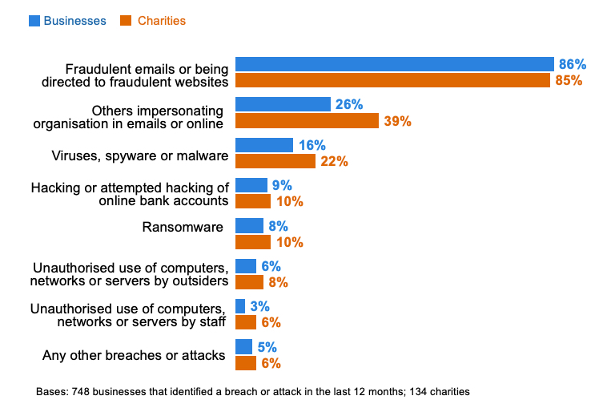
Figure 1: Types of breaches or attacks reported by UK businesses and Charities in 2019 (https://www.gov.uk/government/publications/cyber-security-breaches-survey-2020/cyber-security-breaches-survey-2020)

Proposed Solutions to Enhance the Che-Si’s Security

Digital Signatures and Encryption
    - Digital Signatures use Asymmetric Key Cryptography using public and private keys that are unique to everyone. Before a document is sent from one person to another it goes through a hash process using a Secure Hash Algorithm to create a digest. The sender encrypts the digest using their private key and it is then embedded into the document. The recipient of the document decrypts the digest using the sender’s public key. Finally, the recipient runs a hash which on the document and compares to the sender’s digest to check if the document has changed since it was sent.
    - The purpose of using Digital Signatures is to confirm whether a document has been modified since it was sent, and it also confirms who it has been sent by. An individual can apply for a Digital Certificate from the relative authority to reassure the recipient that the file has come from a legitimate source. [3]
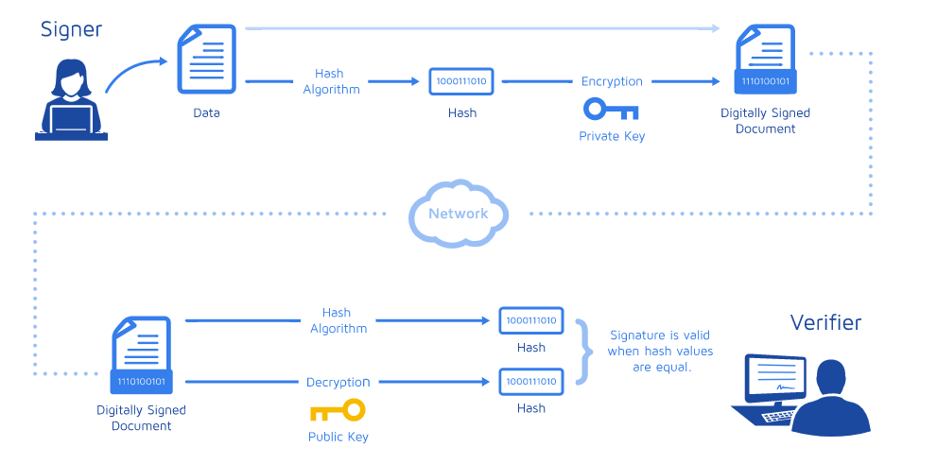
Figure 2: Diagram Illustrating the Digital Signature Process (https://www.docusign.com/how-it-works/electronic-signature/digital-signature/digital-signature-faq)

Utilising a VPN
    - Using a VPN would enhance the security of the network by ensuring that information is encrypted before it is sent between other devices on the network. This in an ideal solution for the company as it has multiple offices all over the world and access will be required from outside of the office. A VPN would support remote working from home or from a construction site office.
    - It’s worth noting that the protection of a VPN is limited to the communication between the devices on the network; it does not protect the device itself. If the user downloaded company data onto the device and it got lost or stolen, the data may be accessed by a potential attacker if it is not properly protected with passwords. [1]
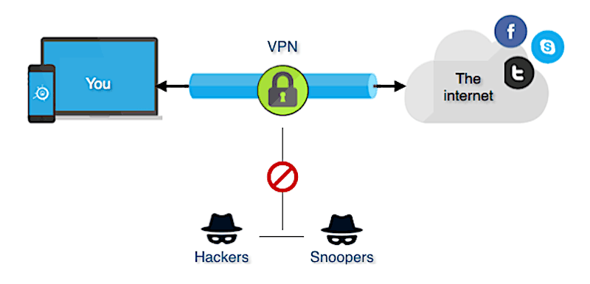
Figure 3: VPN Illustration (https://networkencyclopedia.com/virtual-private-network-vpn/)

Mobile Device Management (MDM)
    - This solution allows the IT administrator to manage and monitor devices on the network and enforce security policies. An important aspect of good security is ensuring that software is up to date; MDM allows administrators to control and monitor updates remotely.
    - A drawback of using MDMs is that it has trouble distinguishing between personal and corporate spaces on the device and therefore may be restrictive if the user wanted to use their device for many purposes or with other organisations with their own policies that may conflict. [1]

Virtual Machines (VM)
    - An VM is a virtual workspace within a device which would contain all the software and information needed for a user to carry out their jobs. Access onto the VM would be password protected and would provide a source of separation between the users personal and workspace on the mobile device. The benefit of this set up is that it would encourage the user to work on the machine and prevent the need for data to be downloaded onto the device.
    - In the case where the device gets lost or stolen, potential attackers would find it difficult to access confidential data is it would be stored within the VM with a password protecting it. This is also a beneficial method as if the user leaves the organisation, the VM may be removed and all the data within it.
    - A drawback to using MVM is that it can require a lot of processing power which may result in users with devices with low specifications finding this method restrictive. [1]

Passwords & Multi-factor Authentication (MFA)
    - Passwords serve as the ‘first line of defence’ against attackers therefore it is crucial that the password is unique and not easy to predict. It is generally recommended that it contain no personal information. It should be at least 8 characters long using both upper and lowercase letters; the use of numbers and at least one special character is encouraged to make it more difficult to figure out. [4]
    - In addition, MFA can be introduced to the sign in process to further enhance security. MFA requires an additional piece of information as a cross check to ensure that the correct person is signing-in. A common method is sending a text or an email with a one-time code. Only when the correct code has been entered will access be given. [5]

Organisation Culture
    - Technology will play an important role in reducing the threat of cyber-attacks on the company but to increase the resilience further it is vital to adopt the right culture within the company by raising awareness through training and the encouragement of new behaviours which become ‘second nature’ to help to safeguard the company. [6]
    - The graph below by The Department for Digital, Culture, Media & Sport demonstrates that Employees play a significant part in the prevention of cyber-attacks on an organisation.
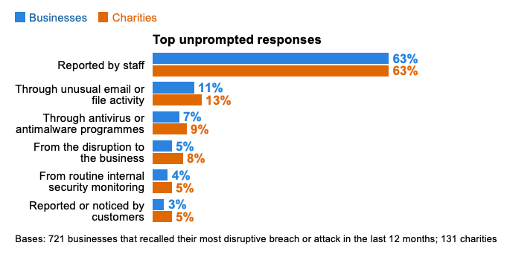
Figure 4: Common ways that UK business and Charities identified breaches in security in 2019

Conclusion and Recommendations
    - It has been recognised that Che-Si’s existing security policies are flawed. The way the current system works is leaving them open to threats from attackers. However, because of the nature of Che-Si being a global company operating 24/7, it is very important that the network is secured but in a way that doesn’t reduce its accessibility for its employees, vendors and clients.
    - Several possible cyber-attacks have been considered and discussed in this report. These include Sniffing, IP Spoofing, Phishing and Malware attacks. All of which could result in a cybercriminal gaining access to personal, company and client data.
    - After considering the options, it appears that there isn’t one single solution to solve all of the company security issues, it will be more of a combination of multiple approaches, both human and technological. The recommendations I (the IT Security Consultant) am proposing to Che-Si to improve the security of their network are outlined below:
- It is recommended that a VPN is used to allow people to safely gain access to the enterprise network when outside of an office. This is especially important when working on public Wi-Fi networks as data can be easily intercepted as demonstrated in Appendix A.
- An MDM may be used to manage software updates and enforce security policies of employees. However, this would be impractical to do with clients and vendors as they may have conflicting policies with their own companies.
- VMs can separate corporate and personal space on personal devices, it may also reduce the likelihood of users downloading data onto devices and would be easy to remove if an employee left the company. The drawback being the need for a great amount of processing power to run.
- Ensuring that everyone uses a password on their personal device, and it is changed regularly. It is also recommended that multi-factor authentication is used as an extra layer of security.
- It is strongly advised that Che-Si installs the right culture in its network users to make protecting the firm against cyber threats a part of their role. Raising awareness through training and short learning bursts could play a significant part in safeguarding the firm as proposed in the strategy in Appendix B .

References

[1] | Y. Wang, J. Wei and K. Vangury, “Bring Your Own Device Security Issues and,” IEEE, Las Vegas, NV, USA, 2014.
[2] | National Institute of Standards and Technology, “Guide to Malware Incident Prevention and Handling,” Department of Homeland Security, Gaithersburg, 2005.
[3] | C. Science, Director, Digital Signatures and Digital Certificates. [Film]. United Kingdom: Youtube, 2019.
[4] | UOttawa, “The Importance of passwords,” [Online]. Available: https://it.uottawa.ca/security/identity-authentication-theft#:~:text=Passwords%20provide%20the%20first%20line,all%20accounts%20on%20your%20computer.. [Accessed 04 Jan 2021].
[5] | National Institute of Standards and Technology , “Back to basics: Multi-factor authentication (MFA),” 28 June 2019. [Online]. Available: https://www.nist.gov/itl/applied-cybersecurity/tig/back-basics-multi-factor-authentication#:~:text=MFA%20helps%20protect%20you%20by,your%20password%20and%20your%20phone.. [Accessed 04 Jan 2021].
[6] | K. Huang and K. Pearlson, “For What Technology Can’t Fix: Building a Model of Organizational Cybersecurity Culture,” 52nd Hawaii International Conference on System Sciences, Hawaii, 2019.
[7] | Cisco, “How does a Virtual Private Network (VPN) work?,” 3 January 2021. [Online]. Available: https://www.cisco.com/c/en_uk/products/security/vpn-endpoint-security-clients/what-is-vpn.html .

Appendix A – Simulating a Sniffing Attack

Networks and Cyber Security Essentials

Synthesise a solution to a potential REAL-LIFE scenario

Rhys Davies | Id: 2008896

Table of Contents
Pages
Abstract 2
1 Introduction 2
1.2 Visual Representation of the Attack 2
2 How Cyber Criminals Carry Out the Attack 3
2.2 Wireshark ‘How to’ on capturing data 3
Setting up 3
Colour Coding and Filtering 4
Inspecting Packets 4
3 Example Attack 5
3.1 Hyper Text Transport Protocol (HTTP) Attack 5
4 Suggestion to Mitigate a Sniffing Attack 6
5 References 7

Figure 1: Illustration of a sniffing attack 12
Figure 2: Select interface 13
Figure 3: Monitoring packets in real time 13
Figure 4: Colour coding 14
Figure 5: Applying a filter 14
Figure 6: Inspecting Packets 15
Figure 7: BioAcoustica Website 15
Figure 8: Data captured by Wireshark 16

Abstract
This short note will demonstrate a sniffing attack. It will illustrate how the attack happens, the software that is used and offer suggestions on how to mitigate.

Introduction
    - A sniffing attack is where someone uses a program to capture packets of data that are being transferred on a network. The most likely place for this to happen is on a public Wi-Fi Hotspots. An attacker will connect to the hotspot to observe and capture the data of other connected users. The aim of the sniffer is to obtain usernames and passwords, emails, files and other personal and business information.

Visual Representation of the Attack
    - In Figure 1, we can see how people using a public Wi-Fi in a café may have their data captured by an attacker. All the victims in this scenario are unaware of what is happening.
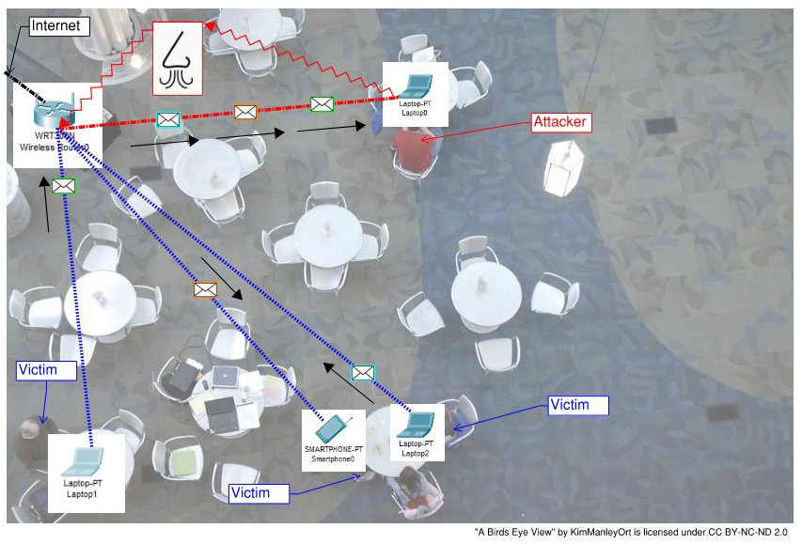
Figure 1: Illustration of a sniffing attack

How Cyber Criminals Carry Out the Attack
    - Packet sniffing software such as Wireshark, dSniff and Debookee may be used to carry out the attack. In this case we are going to look at Wireshark as an example.

Wireshark ‘How to’ on capturing data

Setting up Wireshark
    - The application is free to download here: https://www.wireshark.org/. First you need to choose what you would like to monitor on the interface menu (Figure 2). In this case of monitoring packets on a public WI-FI network you will need to select ‘WI-FI’. Once this is done, you will be able to see all of the data packets being transmitted through the network as shown in Figure 3.
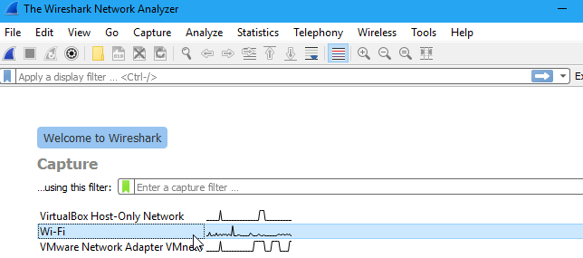
Figure 2: Select interface
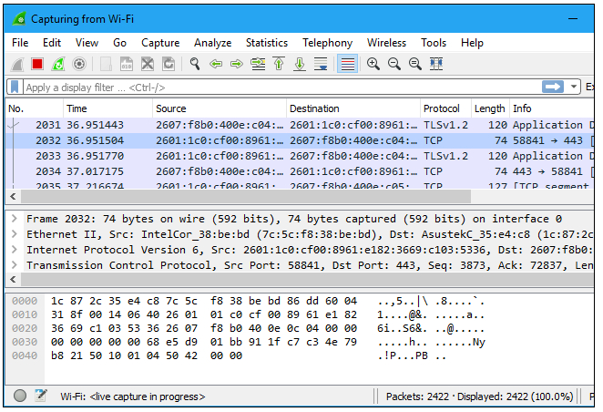
Figure 3: Monitoring packets in real time

Colour Coding and Filtering
    - Now, Wireshark is detecting thousands of packets so in order to narrow down the search we can colour code the different categories as seen in Figure 4 and apply a filter by typing in the green search area if you want to see specific packet types (Figure 5).
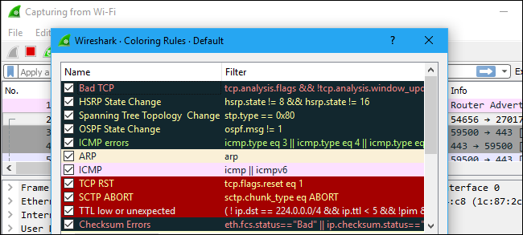
Figure 4: Colour coding
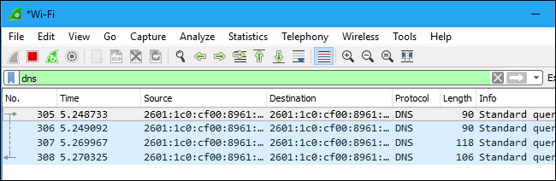
Figure 5: Applying a filter

Follow the Stream
    - If you see something that you’d like to keep track of, you can follow the ‘stream’ of packets, like viewing a conversation between two people.

Inspecting Packets
    - To view what is contained in the packet, you simply click on it to bring up the contents as shown in Figure 6: Inspecting Packets. [1]
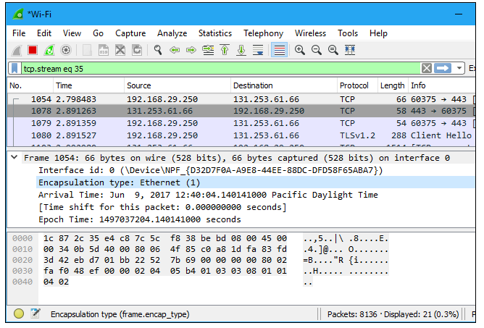
Figure 6: Inspecting Packets

Example Attack

Hyper Text Transport Protocol (HTTP) Attack
    - I have simulated a sniffing attack to capture HTTP data. Most websites now use HTTP-Secure (HTTPS) which encrypts the data, making it difficult for attacks to read the information in packets. I found a website by BioAcoustica which operates using HTTP.
    - I opened Wireshark, selected WI-FI interface and clicked on the ‘Capture’ button to start monitoring packets. I went back to the website and typed “HTTP CAN EASILY BE READ BY WIRESHARK” into the search box and hit enter as shown in Figure 7.
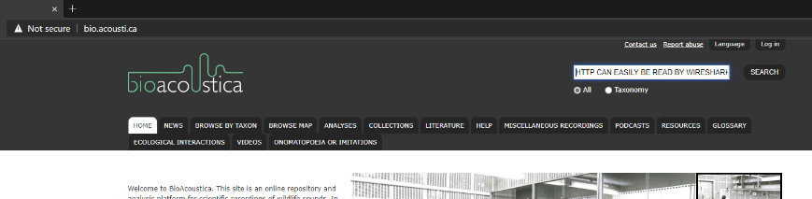
Figure 7: BioAcoustica Website
    - Figure 8 shows that Wireshark was able to capture the packet and I was able to see what was typed into the search box on the BioAcoustica website.
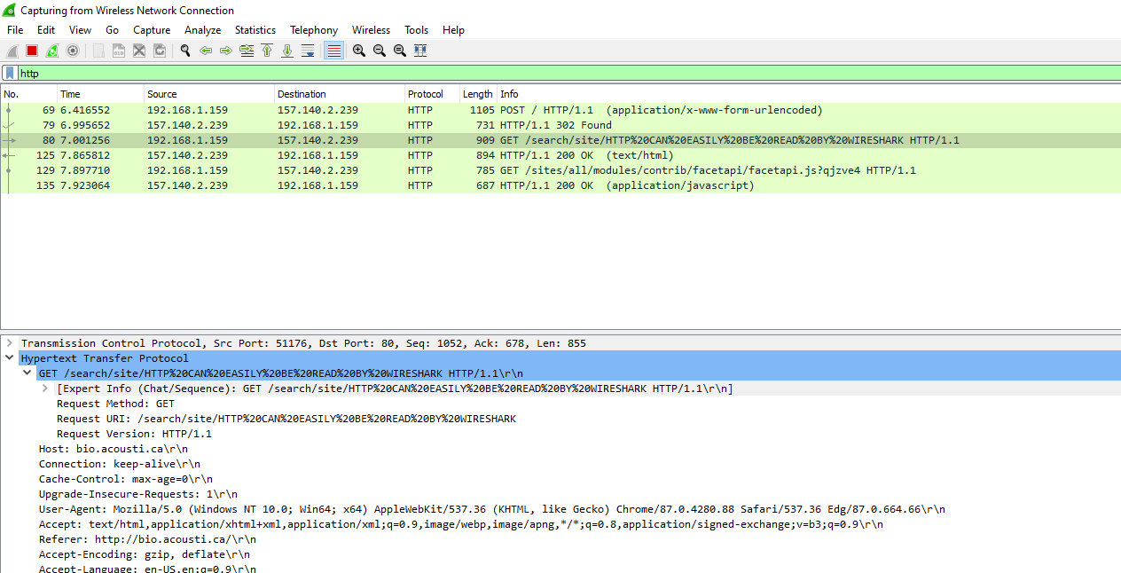
Figure 8: Data captured by Wireshark

Suggestion to Mitigate a Sniffing Attack
    - This note has demonstrated how easily cybercriminals can use sniffing tools to obtain information without the victim being aware. It is important to be mindful of such attacks whether you are using a public Wi-Fi for personal or business use. There are several ways that you can protect your data from this type of attack which are outlined below:
  - Public Wi-Fi is a prime location for sniffing attacks, only use trusted Wi-Fi networks.
  - If you do have to use a Public Wi-Fi network, it is recommended that you use a VPN, it acts as a tunnel for your data to pass through where it cannot be observed with a packet sniffing tool
  - Check to see if the websites you are using operate on HTTPS (not HTTP) this indicates your activity on that website is encrypted and your data is secure. [2]

References

[1] | GreyCampus, “What is a Sniffing attack and How can you defend it?,” 14 August 2018. [Online]. Available: https://www.greycampus.com/blog/information-security/what-is-a-sniffing-attack-and-how-can-you-defend-it. [Accessed 06 January 2021].
[2] | How-To-Geek, “How to Use Wireshark to Capture, Filter and Inspect Packets,” 14 June 2017. [Online]. Available: https://www.howtogeek.com/104278/how-to-use-wireshark-to-capture-filter-and-inspect-packets/. [Accessed 06 January 2021].

Appendix B – Proposed Strategy for a More Secure Network at Che-Si
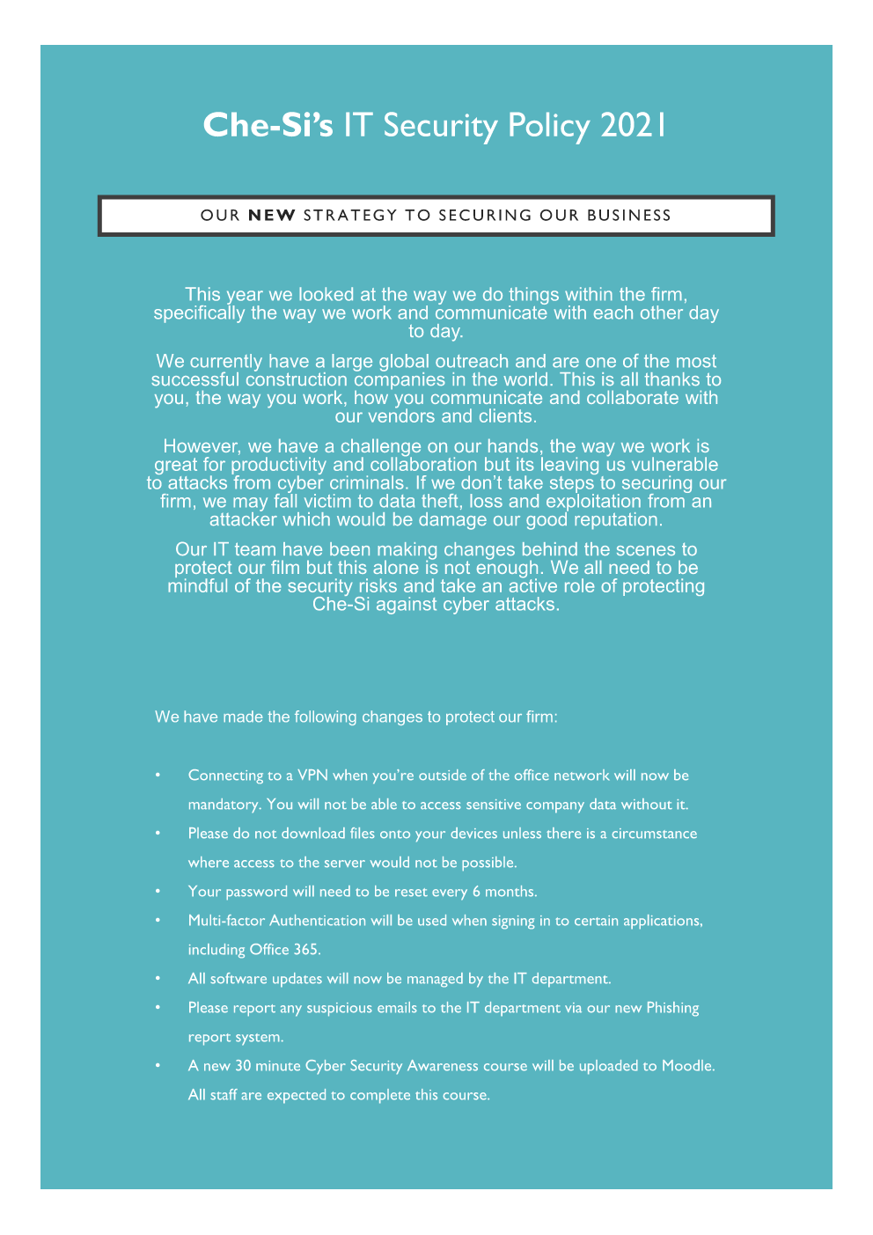

Asymmetric Key Cryptography – A technique of encrypting data with the use of a private key and corresponding public key.
Hash – A mathematical algorithm that converts data into unique code
Digest – The unique code that is the output of the hash process

