
Learning in the digital ERa
Assignment 1


Harrison Stone
1904085

Unit 1
There are many skills and attributes which are key to be successful within study and employment. Barbara Wels from LA Trobe university suggests that there are 8 different key skills for employment:
- Communication
- Teamwork
- Problem solving
- Self-Management
- Planning and organizing
- Technology
- Learning
- Initiative and enterprise
(WELS, 2013)
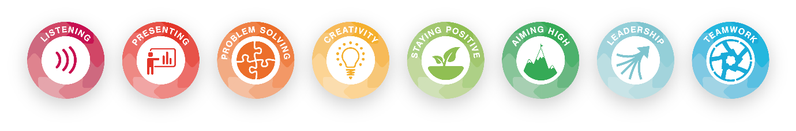
The key skills vary slightly depending on who wrote them however they all cover the same transferable skills. These skills can be broken down again into more skills, for example communication could be broken into more sub categories. Barbara Wels broke communication into:
- listen & understand
- speak clearly & directly
- write to the needs of the audience
- use numeracy effectively
- establish & use networks
- persuade effectively
- negotiate positively
- empathise
- be assertive
- share information
- read independently

“Unlike traditional employer programs that put new hires through rotation programs to improve their skills in various organizational contexts, program hiring strives to hire people who already possess desirable skill sets.” (Skip Smith, 2017)
This suggests that more modern employers are no longer looking to hire employees and to train employees up with programs within the organisation but rather hire people who already possess the transferable skills they desire for the set job role.
In conclusion essential skills otherwise known as soft skills are “” abilities and traits that pertain to personality, attitude, and behaviour rather than to formal or technical knowledge (Moss & Tilly, 2001, p. 44)”” (Aclan, 2016)

