

Course Title: MBA - International Business
Term 1

Module Name: Marketing Management
Module Code: LCMB7024

Student Name: Vivek Bharatbhai Odedara
Student ID: 2505516

Lecturer’s Name: Dr. Laila Maazouz

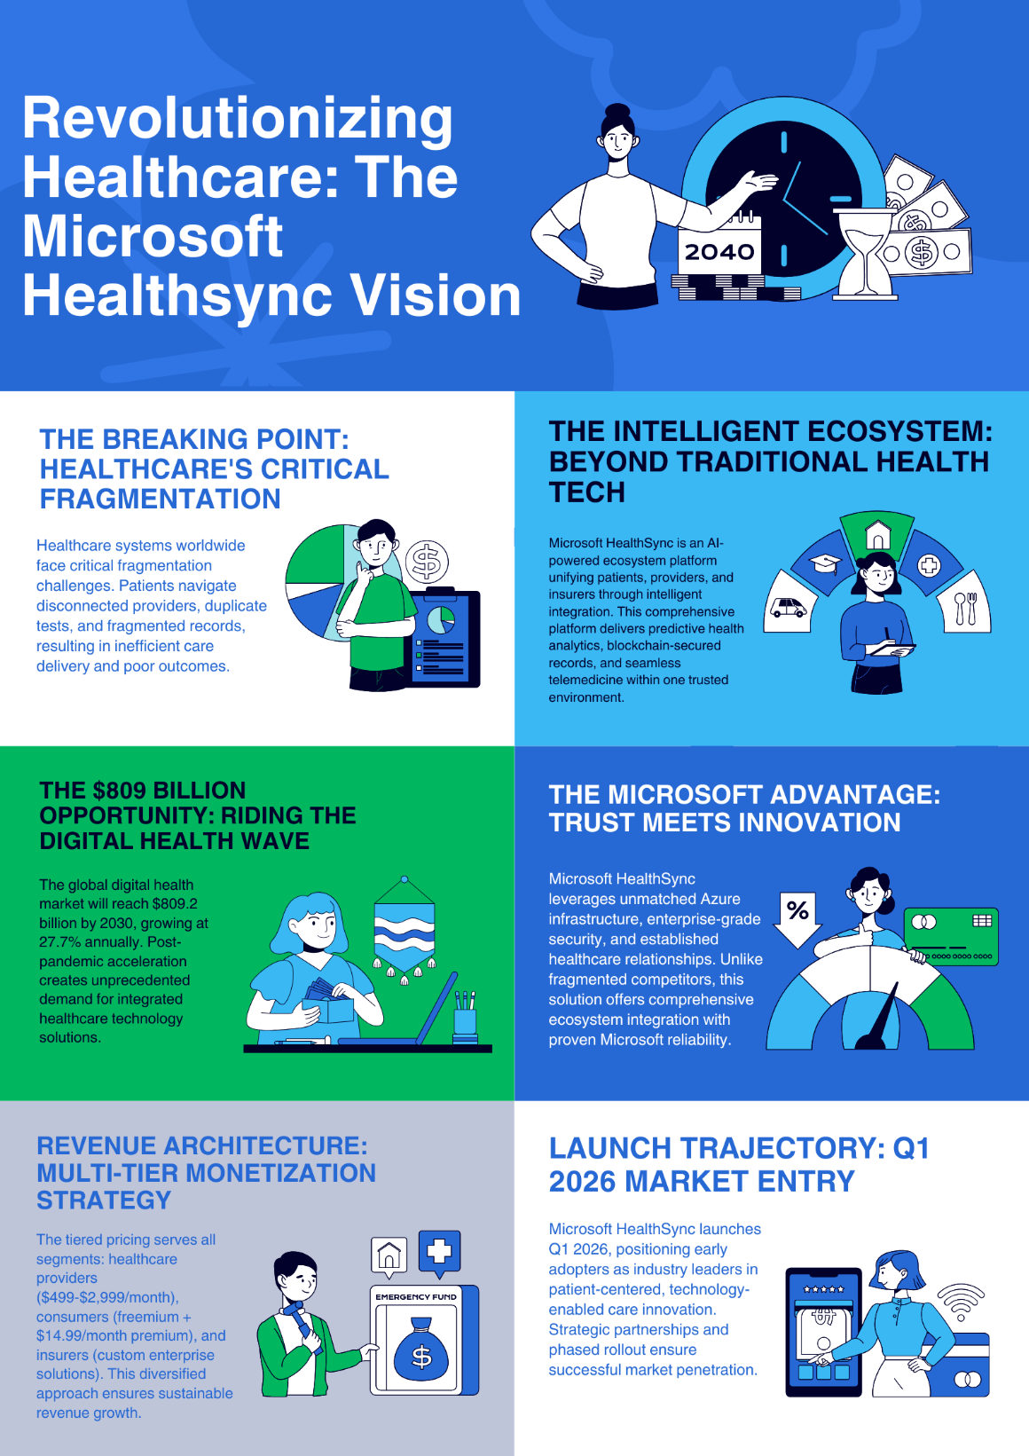

References
Blanchard, S.J. and Atalay, A.S. (2022). A new spatial classification methodology for simultaneous segmentation, targeting, and positioning (STP analysis) for marketing research. Review of Marketing Research, 5, pp.75–103. doi: https://doi.org/10.4324/9781351550901-4.
Clatworthy, S. (2022). Bridging the gap between brand strategy and customer experience. Managing Service Quality: An International Journal, [online] 22(2), pp.108–127. doi: https://doi.org/10.1108/09604521211218936.
Dominici, G. (2023). From Marketing Mix to E-Marketing Mix: a Literature Overview and Classification. [online] International Journal of Business and Management. doi: https://papers.ssrn.com/sol3/papers.cfm?abstract_id=1961974.
Goi, C.L. (2022). A review of marketing mix: 4Ps or more? International Journal of Marketing Studies, [online] 1(1), pp.1–4. doi: https://pdfs.semanticscholar.org/006a/f4780f1cff9f7075ab5b7073f4cebb32c3d5.pdf/1000.
Josko (2024). Development of the brand experience scale. [online] Academia.edu. doi: https://www.academia.edu/download/118452776/500272_101092_v3.pdf
Khan, I. and Rahman, Z. (2024). Retail brand experience: scale development and validation. Journal of Product & Brand Management, 25(5), pp.435–451. doi: https://doi.org/10.1108/jpbm-07-2015-0943.
Microsoft (2025). Microsoft - Official Home Page. [online] www.microsoft.com. doi: https://www.microsoft.com/en-in.
Mogaji, E. (2025). Market Segmentation, Targeting, and Positioning. Strategic Marketing Management, pp.103–133. doi: https://doi.org/10.1007/978-3-031-99367-1_5.
Nguyen, S. (2024). 4 Ps Of Marketing. [online] Mageplaza. doi: https://www.mageplaza.com/blog/4-ps-of-marketing.html.
Patel, S.R. (2024). UC Riverside Recent Work Title Microsoft’’s Paradigm Shift: Strategically Reinventing the Brand, Supporting Its Vision for Growth, and Strengthening Its Competitive Position. [online] doi: https://escholarship.org/content/qt6vk8d6nz/qt6vk8d6nz.pdf.
Remy, P., Soetam Rizky Wicaksono, Virania Agnes Setyowati and Ellenora Gracia Soejanto (2024). Exploring Vertical Brand Extensions: The Microsoft Case Study. Journal of Management and Informatics, [online] 2(3), pp.86–95. doi: https://jmi.stekom.ac.id/index.php/jmi/article/view/22.
Syaeful (2025). STP ANALYSIS (SEGMENTING, TARGETING, POSITIONING) AND SWOT ANALYSIS IN DIGITAL MARKETING STRATEGIES INFACING BUSINESS COMPETITION AT BT BATIK TRUSMI CIREBON. Journal on Islamic Economics, Finance & Banking [Z-CONOMICS], [online] 1(2). doi: https://az-zahra.or.id/jiefb/article/view/157.

