Name: Tahmina Sultana
Student number: 2431922
Module code: LCHS4009
Module Title: HEALTH AND
Social Care
Lectures NAME: DR, bernica ejiogu
Date: 27 MARCH 2026

Health and Social Care Portfolio

Chosen Job Vacancy
Job Title: Care Assistant
Employer: Avery Healthcare Group Ltd.
Location: Winson Green, Birmingham, UK
Closing Date: 02 May 2026

Job Advertisement Summary
The Care Assistant role at Avery Healthcare involves supporting elderly residents within a residential care home environment. The main responsibilities include: assisting residents with personal hygiene, supporting independence, monitoring clinical risk areas such as falls, infections and pressure sores, and working collaboratively with the care team to ensure continuity of care. Staff are expected to treat residents with dignity and respect while maintaining safe systems of work and effective communication with residents, colleagues, and visitors.
Avery Healthcare is one of the UK’s largest providers of residential elderly care homes, operating over one hundred homes across the country. The organization aims to create meaningful experiences for residents while providing a supportive working environment for staff and opportunities for professional development (Avery Healthcare, 2026).
This role aligns with my career goal of becoming a nurse, as it provides practical experience in delivering person‑centered care and supporting older adults within a professional healthcare setting.

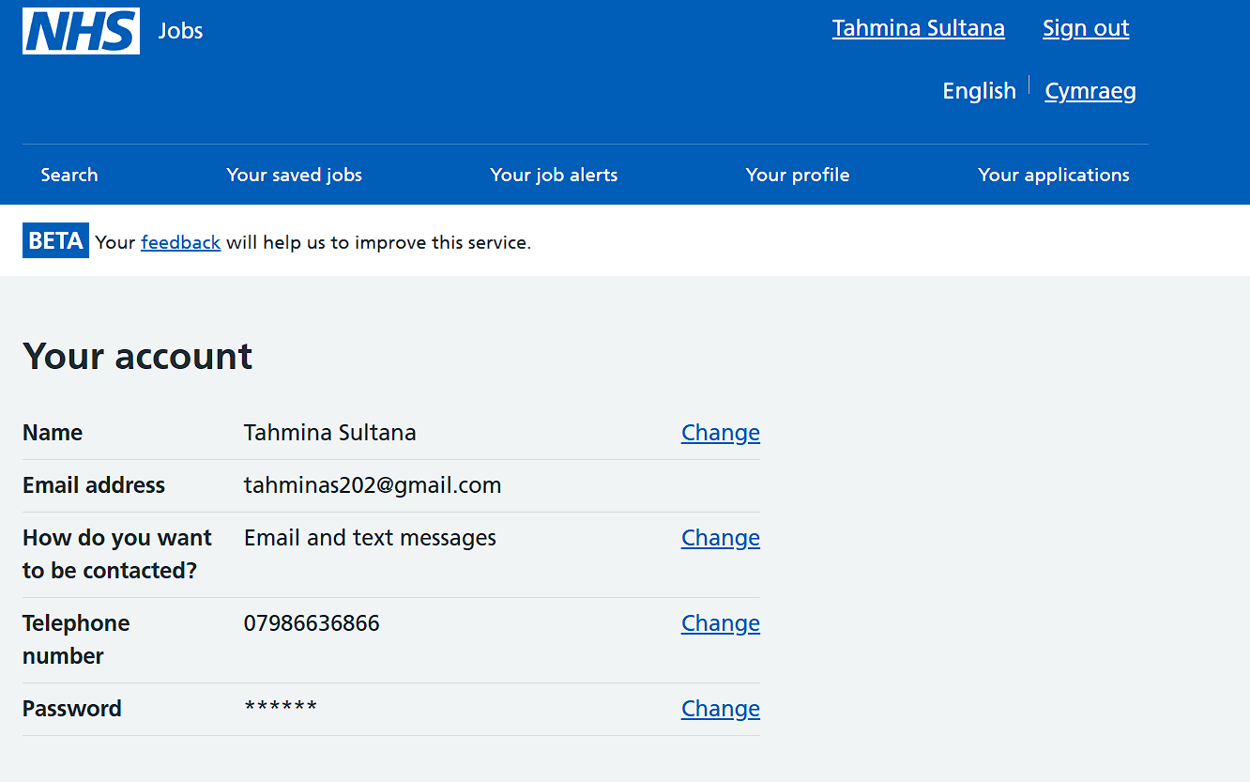

Avery Healthcare Group Ltd.

Care Assistant
The closing date is 02 May 2026
Apply for this job

Job summary
As a Care Assistant at Avery Healthcare, you'll be making a positive impact on residents' lives every day. Your compassion and dedication will truly make a difference, as you deliver high standards of personal care and contribute to the care team to ensure continuity of services to residents. Avery is committed to helping you grow in a caring, supportive environment, with opportunities to learn and develop throughout your career.

Main duties of the job
Your focus as a Care Assistant will be to deliver high standards of personal care, contributing fully to the care team to ensure continuity of services to residents. Other responsibilities will include assisting residents with personal hygiene, recognising and understanding clinical risk areas, acting courteously towards residents and their visitors, and practicing safe systems of work. You'll need the ability to communicate effectively, demonstrate initiative and be respectful, as well as being an efficient worker who can adapt and be flexible to cover a range of responsibilities.

About us
Avery Healthcare is one of the UK's largest providers of luxury elderly care homes. They are passionate about creating meaningful experiences for their residents and team members, offering exceptional care across their growing network of over 100 homes. Avery believes that the later years of life should be as enriching as any other, and they are committed to building a supportive and inspiring environment where employees feel valued and empowered every day.

Job description

Job responsibilities
Package Description:
Shift details: 08:00 - 20:00, 3 days a week
At Avery Healthcare, we are all about supporting the people who care for our residents. We know how hard our teams work and were here to celebrate and support you every step of the way. When you join us, youll be making a positive impact on residents lives every day your compassion and dedication truly make a difference. Were committed to helping you grow in a caring, supportive environment, with opportunities to learn and develop throughout your career. And as part of our close-knit team, youll experience a culture that values respect, compassion, and a shared commitment to exceptional care.Were now looking for a warm, enthusiastic, and dedicated individual to join our award-winning team as a Care Assistant. If this sounds like the place for you, wed love to hear from you!
ABOUT THE ROLE
Your focus as Care Assistant will be to deliver high standards of personal care, contributing fully to the care team to ensure continuity of services to residents.
Other responsibilities will include:
- Assisting residents in all their personal hygiene care ensuring optimum independence, dignity and respect of individuals at all times.
- Recognising and understanding clinical risk areas in residents such as weight loss, pressure sores, risk of falls, sign of infections and escalate any identified risks in a timely manner.
- Acting courteously towards residents and their visitors, respecting the dignity and individuality of each resident.
- Practicing safe systems of work across the range of task.
ABOUT YOU
To be successful in your application, you will live our values of caring, supportive, honest, respectful, and accountable in all that you do. Experience is not required as we are proud to offer a thorough induction and training programme to ensure confidence within your role.
Our ideal candidate must:
- Have the ability to communicate effectively both verbally and in writing.
- Demonstrate initiative and be respectful towards the residents and other people in the home.
- Be an efficient worker who can carry reasonable instructions from other team members.
- Be able to be adaptive and flexible to cover a range of responsibilities at short notice.
ABOUT AVERY
At Avery, were not just one of the UKs largest providers of luxury elderly care homes were a place where people love to work. We believe that the later years of life should be as enriching as any other, and were passionate about creating meaningful experiences for our residents and our team alike. With our vision of "creating meaningful lives together," we proudly offer exceptional care across our growing network of over 100 homes, building a supportive and inspiring environment where employees feel valued and empowered every day. Join us and see why Avery is the preferred choice for residents and team members alike.
Please note this role will require:
- A DBS Disclosure check, the cost of which will be met by Avery Healthcare.
- Proof of eligibility to work in the UK.
This advert may be withdrawn prior to the advertised deadline depending on the volume of applications received and business needs.

Person Specification

Qualifications

Essential
- Experience is not required as Avery offers a thorough induction and training programme to ensure confidence within the role.

Disclosure and Barring Service Check
This post is subject to the Rehabilitation of Offenders Act (Exceptions Order) 1975 and as such it will be necessary for a submission for Disclosure to be made to the Disclosure and Barring Service (formerly known as CRB) to check for any previous criminal convictions.

Employer details

Employer name
Avery Healthcare Group Ltd.

Address
Avery Healthcare
Winson Green
B18 4BJ

Employer's website
https://www.averyhealthcare.co.uk/ (Opens in a new tab)

Education
- BSc (Hons) Health and Social Care: University of Wales Trinity Saint Davide, Birmingham, UK (2025 – 2026)
- Level 4 in Health and Social Care: University of Wales Trinity Saint Davide, Birmingham, UK (2024 – 2025)
- Secondary Education: GCSE including English, Maths, and Science (Grades 5) Birmingham Metropolitan College in Birmingham, UK
- Maths (203 – 2024) Grade-5.
- English (2019-2021) Grade-4.
- Science (2017-2018) Grade-6.
Relevant Modules:
- Care of the Older Person,
- Safeguarding in Health and Social Care
- Communication in Professional Practice
- Health Promotion and Wellbeing
- Employability Skills in Health and Social Care

Key Skills
- Person‑centered care awareness
- Effective communication with vulnerable individuals
- Teamwork and collaboration
- Empathy and compassion
- Observation and reporting skills
- Time management and organization
- Basic digital and documentation skills

Work Experience
Customer Service Assistant (Part‑time)
[Company Name], UK | [Dates]
Responsibilities:
- Communicated effectively with customers from diverse backgrounds.
- Demonstrated patience, empathy, and professionalism in challenging situations.
- Managed multiple tasks efficiently within a busy working environment.
- Collaborated with colleagues to deliver high‑quality service.

Voluntary Experience
Community Volunteer
Manor House (Dates: 2010-2021)
Responsibilities:
- Assisted with community activities supporting individuals from diverse backgrounds.
- Demonstrated respect, empathy and understanding when interacting with others.
- Developed interpersonal and teamwork skills.

Achievements
- Successfully completed academic presentations on employability skills within health and social care
- Developed reflective practice skills using professional reflection models.

Interests and Hobbies
- Reading about health, wellbeing, and elderly care
- Community volunteering and supporting others.
- Fitness and maintaining a healthy lifestyle.

References
Available upon request

Task 2: Personal Statement (500 Words)
My career aim is to become an exemplary Registered Nurse within the luxury elderly care sector, providing clinical excellence that mirrors the high standards of Avery Healthcare. Having followed the growth of Avery Healthcare Group, I am particularly drawn to your vision of "creating meaningful lives together." I believe that the later years of life should be enriching, and as a nurse, I am dedicated to ensuring that clinical care supports, rather than hinders, the individuality and dignity of every resident.
My education in Adult Nursing has provided me with a rigorous scientific and practical foundation. I have developed a deep understanding of the complex needs of older adults, particularly in managing multi-morbidities and cognitive decline. During my clinical placements in Birmingham, I learned that effective nursing in a care home environment requires a balance of high-level clinical decision-making and empathetic personal care. I am proficient in recognising and escalating clinical risks such as pressure sores and signs of infection, which the Avery Healthcare (2026) job description identifies as a core responsibility. My ability to act on initiative while remaining a flexible team player ensures that I can contribute to the "close-knit team" culture that Avery prides itself on.
My personal strengths include resilience, accountability, and a natural capacity for empathy. In a residential setting, a nurse is often the primary advocate for a resident’s health and wellbeing. I take this responsibility seriously, ensuring that every interaction is respectful and that I am honest in my clinical assessments. These values align perfectly with Avery’s core values of being "caring, supportive, honest, respectful, and accountable." Furthermore, my professional skills in digital documentation and care planning mean I can efficiently manage the administrative requirements of the role, allowing more time for direct resident engagement.
I am eager to join the Winson Green team because of Avery's commitment to staff development. I am a lifelong learner, and I am excited by the prospect of participating in your award-winning training programmes. By joining Avery, I am not just seeking a job; I am seeking a platform to deliver the highest quality of life-affirming care to the residents of Birmingham. My combination of clinical competence, local knowledge, and a values-led approach makes me an ideal candidate to uphold Avery’s reputation as a preferred choice for residents and their families.

Task 3a: SWOT Analysis
Strengths
- Effective communication skills
- Empathy and compassion
- Good teamwork abilities
Weaknesses
- Limited professional experience
- Confidence in challenging situations
Opportunities
- Training and development programs
- Career progression within healthcare
Threats
- High competition for roles
- Emotional demands of the job

Task 3b: Personal Development Plan (PDP)
Goal 1: Improve communication skills.
- Action: Attend communication workshops and practice active listening
- Time limit: 6–12 months
- Monitoring: Feedback from tutors and peers
Goal 2: Gain practical experience.
- Action: Apply for part-time or voluntary roles in care settings
- Time: Within 1 year
- Monitoring: Reflect on experiences and supervisor feedback
Goal 3: Build confidence in challenging situations.
- Action: Participate in training scenarios and reflective practice
- Time: 1–2 years
- Monitoring: Self-reflection and mentor feedback

Task 4: Critical Reflection (600 Words)
Introduction: This reflection focuses on my LCHS4009 Component 1 presentation assessment, which explored the integration of clinical risk management in adult social care. I presented to a panel of lecturers and peers, focusing on how nurses identify early signs of infection in elderly residents—a key skill highlighted in the Avery Healthcare (2026) job description.
Feelings: Before the presentation, I felt a mixture of apprehension and excitement. I was confident in my knowledge but worried about the time constraints of a 15-minute slot. During the delivery, I felt a sense of relief as the audience engaged with my visual aids. Afterwards, I felt satisfied but aware that my responses during the Q&A could have been more concise.
Evaluation: The presentation's greatest strength was its evidence-based approach. My lecturer noted in verbal feedback that my "integration of current Department of Health guidelines was exemplary" (Lecturer Feedback, 2026). However, the delivery was slightly rushed towards the end. This hindered the clarity of my conclusion regarding multidisciplinary team (MDT) collaboration. According to the Royal College of Nursing (2025), clear communication is the cornerstone of patient safety; thus, rushing my delivery was a significant area for improvement.
Analysis: Analysing the experience through the cycle proposed by Adeana, the rush in delivery was caused by poor time management during the "Middle" section of the talk. I spent too long on pathophysiology and not enough on practical application in a care home setting. The lecturer provided feedback suggesting that I should "prioritize the 'so what' factor—how does this theory change a resident's daily life?" (Lecturer Feedback, 2026). This insight is vital for my future role at Avery Healthcare, where practical, life-enhancing care is prioritized over abstract theory. Furthermore, the Nursing and Midwifery Council (2024) emphasizes that nurses must communicate clearly and effectively, a standard I must strive to meet in every professional interaction.
Conclusion: I have learned that while academic depth is necessary, the ability to communicate complex clinical risks in a clear, accessible manner is more valuable in a multidisciplinary care team. As noted by Skills for Care (2025), the workforce must be adaptable and highly skilled in communication to meet the increasing complexity of resident needs. My performance was academically strong but required more focus on the audience’s practical needs.
Action Plan: To improve, I will engage with more frequent peer-review sessions to practice "elevator pitches" for complex clinical concepts to ensure brevity and clarity. For future assessments and professional handovers at Avery Healthcare, I will strictly apply the Gibbs Reflective Cycle (Adeana et al., 2020) to every clinical incident and assessment. This will ensure that I am "efficient and adaptive," as requested in the Avery Healthcare (2026) person specification, by allowing me to consistently evaluate my feelings, analyse my performance, and develop concrete steps for improvement. I will also monitor my progress through my Personal Development Plan, as outlined in Task 3b.

References
Adeani, I. S., Febriani, R. B. and Syafryadin, S. (2020). 'Using Gibbs’ Reflective Cycle in the Nursing Profession'. Journal of Nursing Education and Practice, 10(6), pp. 55-61. https://doi.org/10.5430/jnep.v10n6p55
Avery Healthcare (2026). Care Assistant - Winson Green (Job Advertisement). [Online] Available at: https://www.averyhealthcare.co.uk/ [Accessed 26 March 2026].
Department of Health and Social Care (2024). Standardising Clinical Risk Assessment in Social Care. [Online] Available at: https://www.gov.uk/government/organisations/department-of-health-and-social-care [Accessed 26 March 2026].
Nursing and Midwifery Council (2024). The Code: Professional standards of practice and behaviour for nurses, midwives and nursing associates. [Online] Available at: https://www.nmc.org.uk/standards/code/ [Accessed 26 March 2026].
Royal College of Nursing (2025). Elderly Care Nursing: Clinical Practice and Leadership. [Online] Available at: https://www.rcn.org.uk/clinical-topics/Older-people [Accessed 26 March 2026].
- Skills for Care (2025). The State of the Adult Social Care Sector and Workforce in England 2025. [Online] Available at: https://www.skillsforcare.org.uk/Adult-Social-Care-Workforce-Data/ [Accessed 26 March 2026].

