

Richard Hankey

ACCA5012

Application Development:

Review of Latest Game Development Trends
and
2D Game Implementation.

Contents
Introduction 3
Evaluation of the current trends in application development in 2019 4
Requirements 6
Player Controls 6
Aim or Objective 6
Design and Implementation. 7
Script classes 7
Screenshots 8
Evaluation 13
Test Cases 13
Known Bugs 18
Improvements 18
References 19

Introduction
Starting with a discussion of game development concepts, this report will list the latest trends in game development and include a brief description of usage and revenue of mobile gaming, continuing to detail some of the issues and resolutions to mobile game development.

Then the report will detail the requirements of the game application implemented, identifying the rules of the game and the controls, moving onto an outline of the design and development of the game application before concluding the report with an evaluation and bibliography.

Evaluation of the current trends in application development in 2019

Videos games and mobile apps are ubiquitous in modern society[1], [2]. The development of smartphones has made a huge impact on today’s applications and games [3]. With technology continually changing and updating, various topics are currently being discussed frequently within the gaming populace. The common trends amongst six randomly selected sources titled “game development trends in 2019”, or of similar context, are as following:
- Indie games
- Console Quality Mobile Gaming
- Cross-Platform Play
- Augmented Reality
- The abolition of microtransactions
[4]–[9]
With over 2.5 billion people playing games on various devices through several reports. One report by WePC.com, which combined data from various statistics, showed that in the U.S 72% of the population of mobile users play games on their mobile devices.[1] Also, mobile gaming had the highest revenue over the past 3 years[1], despite game developers being more interested or currently developing for PC[1], [10]. According to gamingscan.com the most popular type of App across smartphones in May 2019 were mobile games[11], setting a revenue record of $39 billion U.S Dollars in the first half of the year[12]. Due to the lucrative prospects of mobile gaming, developers are now targeting their resources into developing console-quality mobile gaming.
Console-quality mobile gaming has its limitations though; performance issues such as framerate, battery life or heat generation cause slow developmental adaptations due to the intensity of the GPU and CPU the games require to run[13]. In 2000, to combat the limitations of the hardware issue for the public, instead of constantly upgrading their hardware; cloud-based games were proposed.[14] Cloud-based gaming is the ability to play games on a device without installing any software or worrying about hardware requirements, as a dedicated system server, in a remote location, does all the processing for the user and provides an experience similar to that of a high-end console or PC[15]. This is currently being developed for the integration of mobile devices[16], although this remains limited due to the requirement of high bandwidth and delay of information, neither of which have yet to be resolved.[17], [18].
Cloud gaming development is still in its infancy with many reviews from users and journalists judging the current systems in place to be not quite complete, as the delay between user input and game interaction invokes substantial critique. Furthermore the systems’ current loading times and disconnection issues are yet to be explored and resolved [19]–[21].
Mobile gaming currently accounts for top usage and highest gross expectancy leading to development in many directions concerned with mobile gaming [1],[11]. A proportion of developers are leaning towards console-quality mobile gaming, with smartphones being the medium of choice for many users, which seems to be culminating with issues about compatibility, and devices are not quite ready to fit the requirements of console-quality games on mobile devices. With cloud-gaming being the resolution to the device requirements, it is starting to take root and gathering interest with many developers’ studios[22], cloud gaming on mobile devices might be the console replacement.

Requirements
To play the game user must have a working keyboard. And Unity (2019.2.14f1) to effectively run the application. The software application that has been implemented consists of very simple gameplay and due to bugs in the application, during runtime the game’s core functionality is:
- The player can move left, right and jump
- The player can fire a projectile
- Enemies are destroyed upon contact of the projectile
- Score and Time are on the HUD and carry over to the next scene and work accordingly.

Player Controls
The controls set for this game are as follows:
- Left or Right Arrow is to move left and right
- The Up Arrow is to jump
- The Spacebar is to fire a Fireball upwards
- The Escape button will pause the menu.

Aim or Objective
The aim of the game is to destroy the enemies, named BrainBugs, to proceed to the next level (currently set at 200 points with increments of 20 per enemy). The player will have to jump across the platforms and avoid falling down the gaps.
If the player falls down the gaps then the game will pause displaying a Game Over, with Restart Level, Restart Game and Quit button options.
If the player reaches an increment of 200 points the next level will load and once the 3rd level is completed the end game credit roll scene will load and then the game will quit.

Design and Implementation.

Script classes

Using the scripts in tutorial sessions as a skeleton program, the main class scripts that been developed are as follows:
- In the Character folder:
  - Enemy.cs - controls the enemies’ movement and raycasting to fire a projectile. [23]The enemy’s movement is dependant on the minimum and maximum range. If it moves over the minimum range it will turn back and go the opposite way. If it reaches the maximum it is removed from the game.
  - EnemyAttack.cs - this is an interface override, providing the attack for the enemy.
  - PlayerAttack.cs - the same as EnemyAttack.cs, but for the player character.
- In the Projectile folder:
  - FireBall.cs. - responsible for the forces of the projectile and collision with the “Floor” or “Ceiling”.
- In the Strategies folder:
  - The contents of the Attack Strategy folder are the interface prototypes.
  - In the Move Strategy folder:
    - FlyHorizontal.cs is responsible for the flight path and its direction
    - IjumpStrategy.cs. is an interface for player jump ability
- In the Trigger Strategies folder:
  - BaseBugTrigger.cs, (this script was developed but was never implemented).
  - EnemyFireTrigger.cs sets up a collider trigger with damage and a damage effect
  - FireBallTrigger.cs. sets up a collider trigger with points and a damage effect
- In the Utilities Folder:
  - In the Managers folder:
    - GameManager.cs and UIManager.cs (are both modified scripts developed in tutorial sessions). GameManager is now also responsible for loading the next scene by calculating the points interval.
  - CreditRoll.cs is a simple script which rolls credits via a UI component
  - I_ImpactSetter.cs injects object dependency for trigger collisions
- Other repurposed or modified scripts:
  - CameraFollow.cs. has not been modified but repurposed
  - Character > BaseCharacter.cs has additions, a jump and an attack interface
  - Character > Health.cs has not been modified and has not been used.
  - Character > Player.cs uses the extra interfaces and uses an ‘isGrounded’ boolean to only allow single jumps.
  - Strategies > Move Strategy > BaseMoveStrategy.cs has not been modified but repurposed
  - Strategies > Move Strategy > ImoveStrategy.cs has not been modified but repurposed
  - Strategies > Move Strategy > MovePlayer.cs uses the “Horizontal” axis to move the player and controls sprite rotation dependant on the direction.
  - Strategies > Move Strategy > TrackTarget.cs. has not been modified but repurposed
  - Trigger Strategies > BasePlayerTrigger.cs. has not been modified but repurposed
  - Trigger Strategies > TriggerColliderTypes.cs has the variables names modified and repurposed.
  - All of the Scene folder, developed in tutorial sessions, has not been modified but repurposed
  - Utilities > CustomUNityEvents.cs has not been modified but repurposed

Screenshots

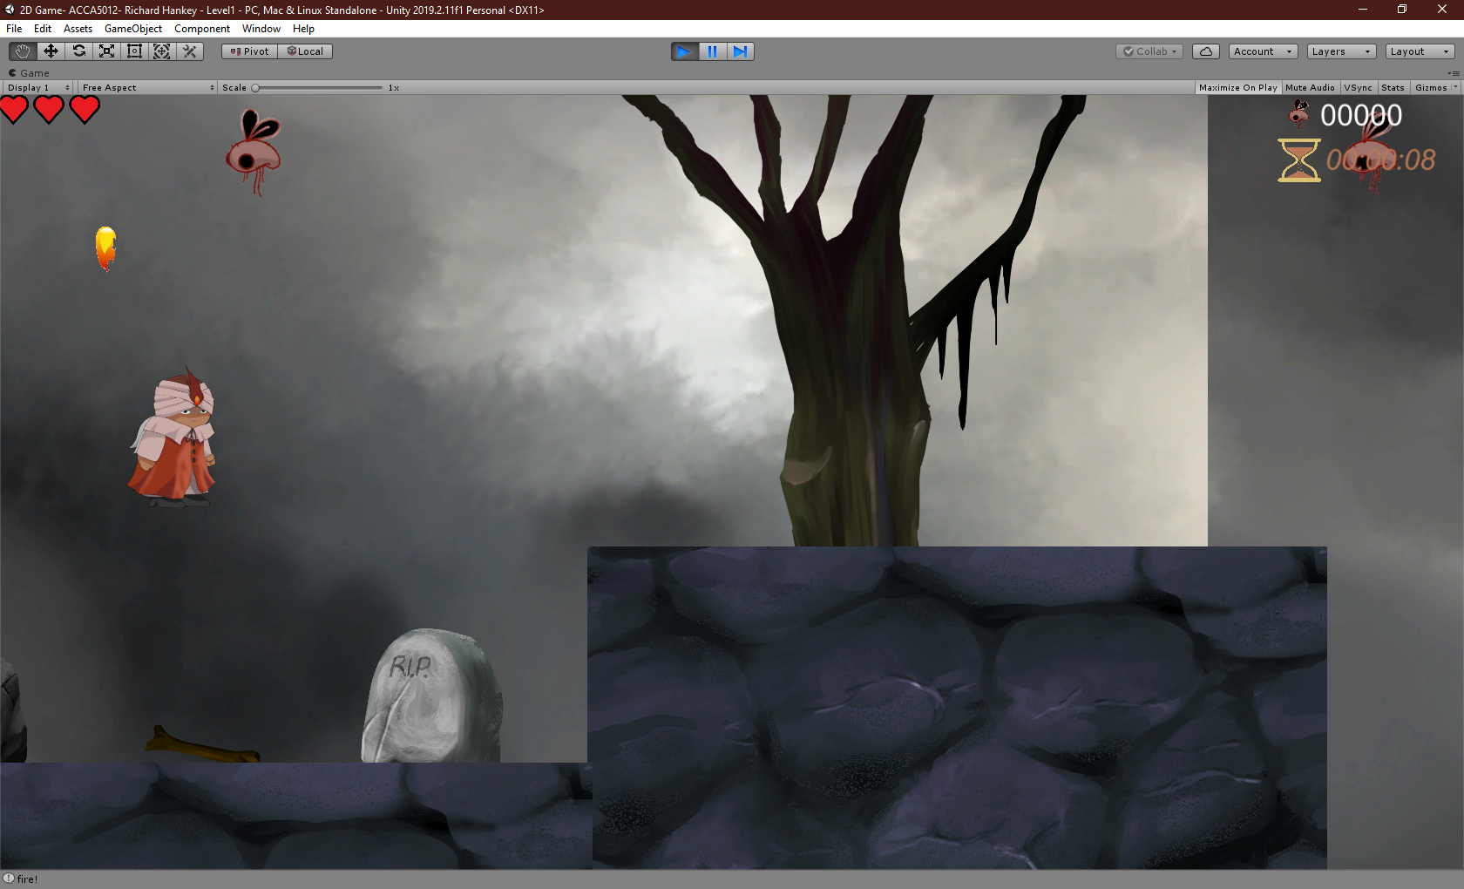
Screenshot of player character jumping and firing a projectile
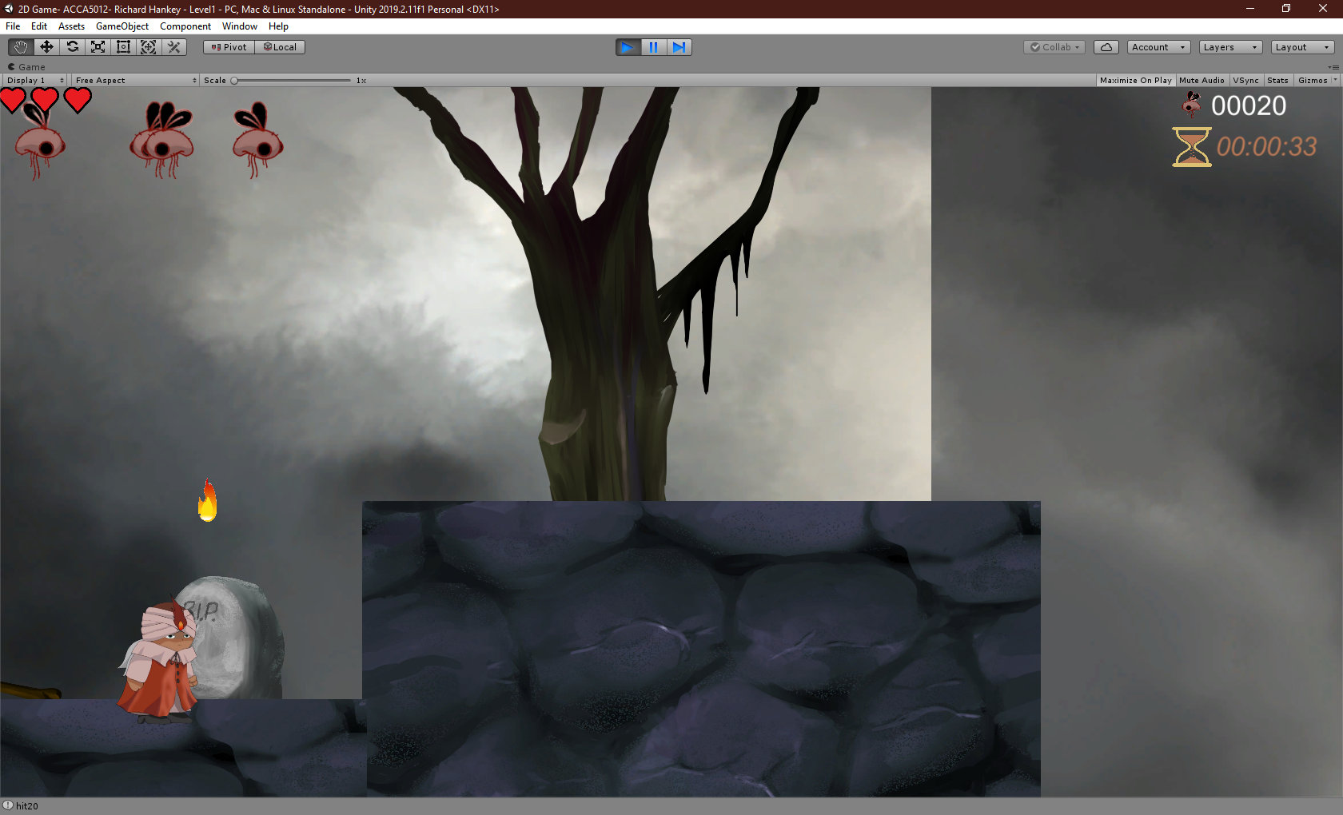
Screenshot of enemy Firing a projectile and enemies facing different directions
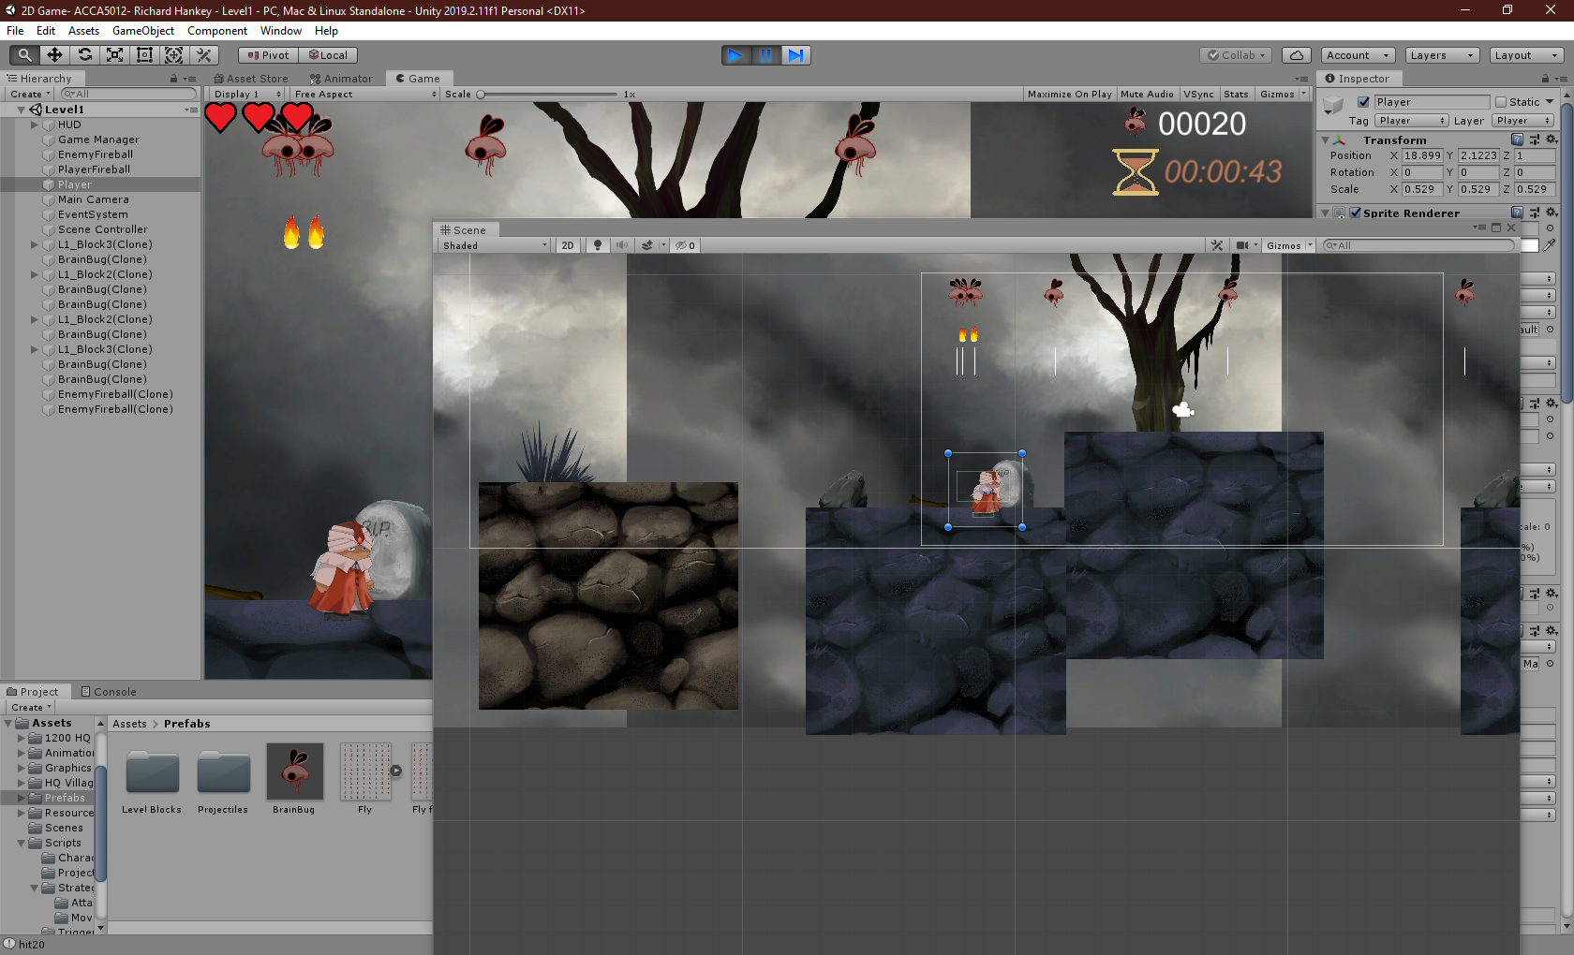
Screenshot showing two enemies firing with inset of scene view showing the raycast lines[23]
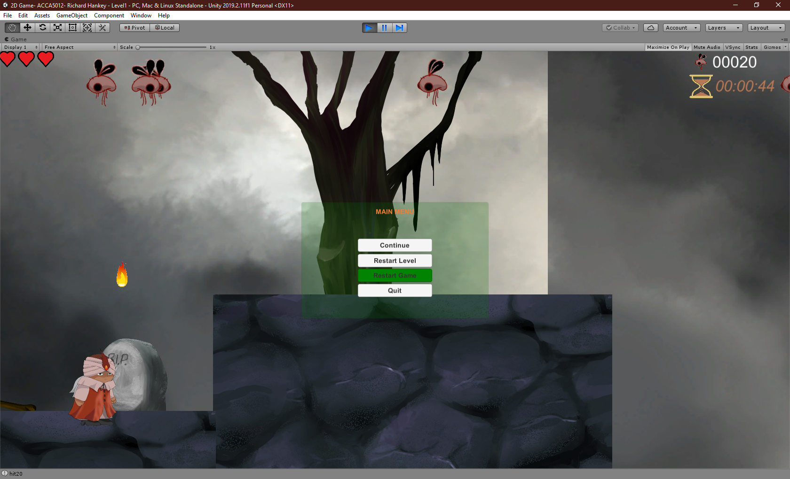
Above: Pause menu, Below: Pause menu with mouse pointing at different selections
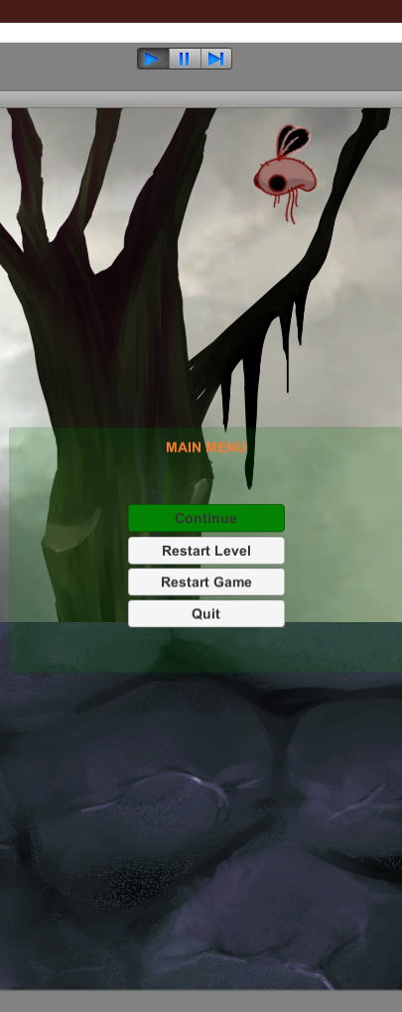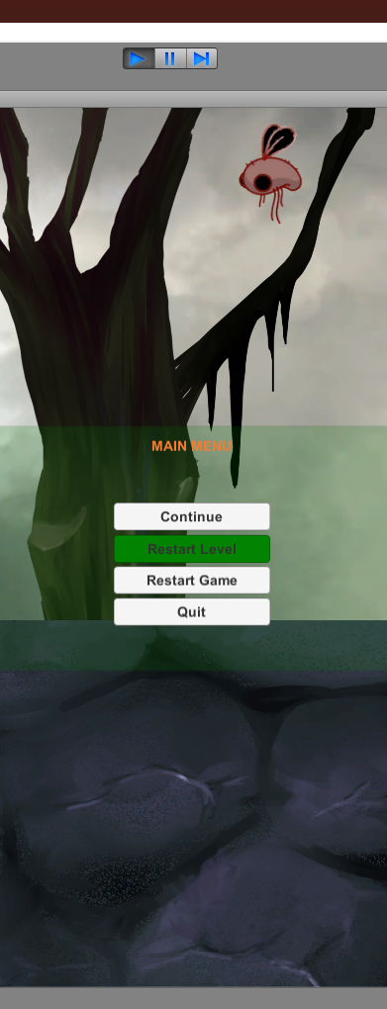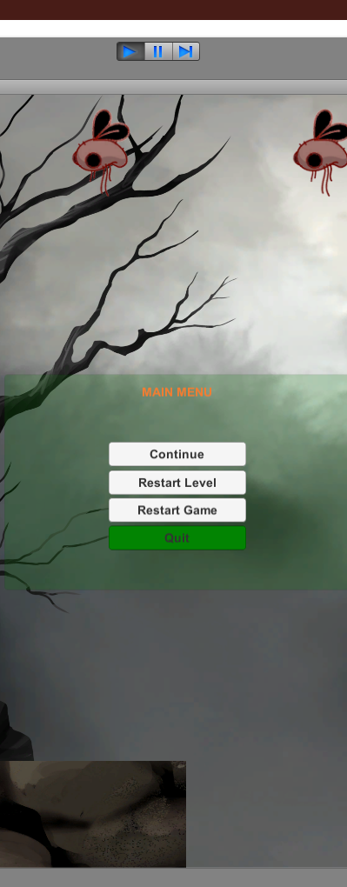
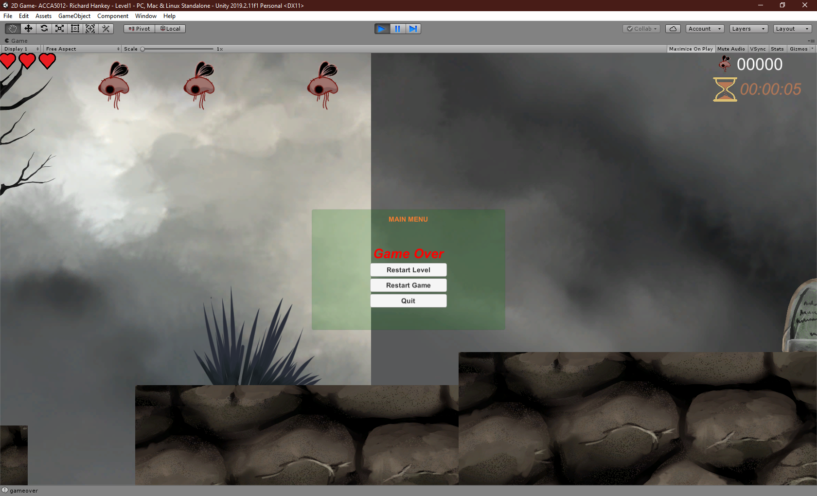
Game Over screen when player falls down the gaps
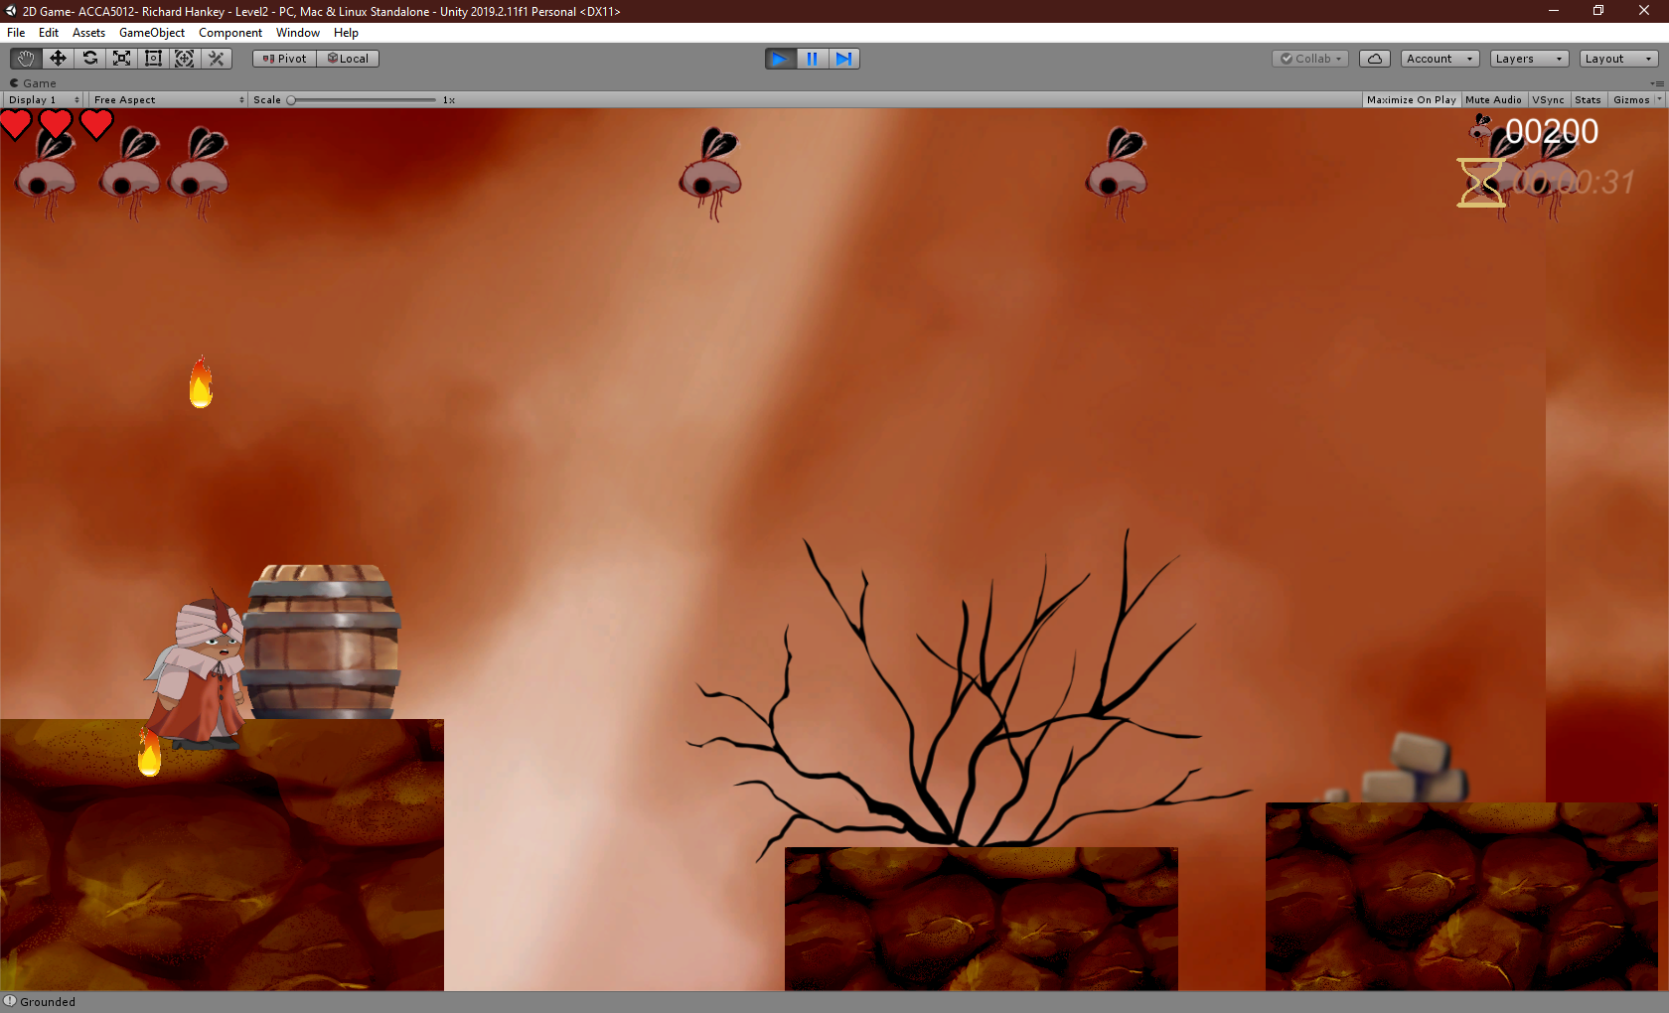
Next scene loaded on reaching 1st points interval
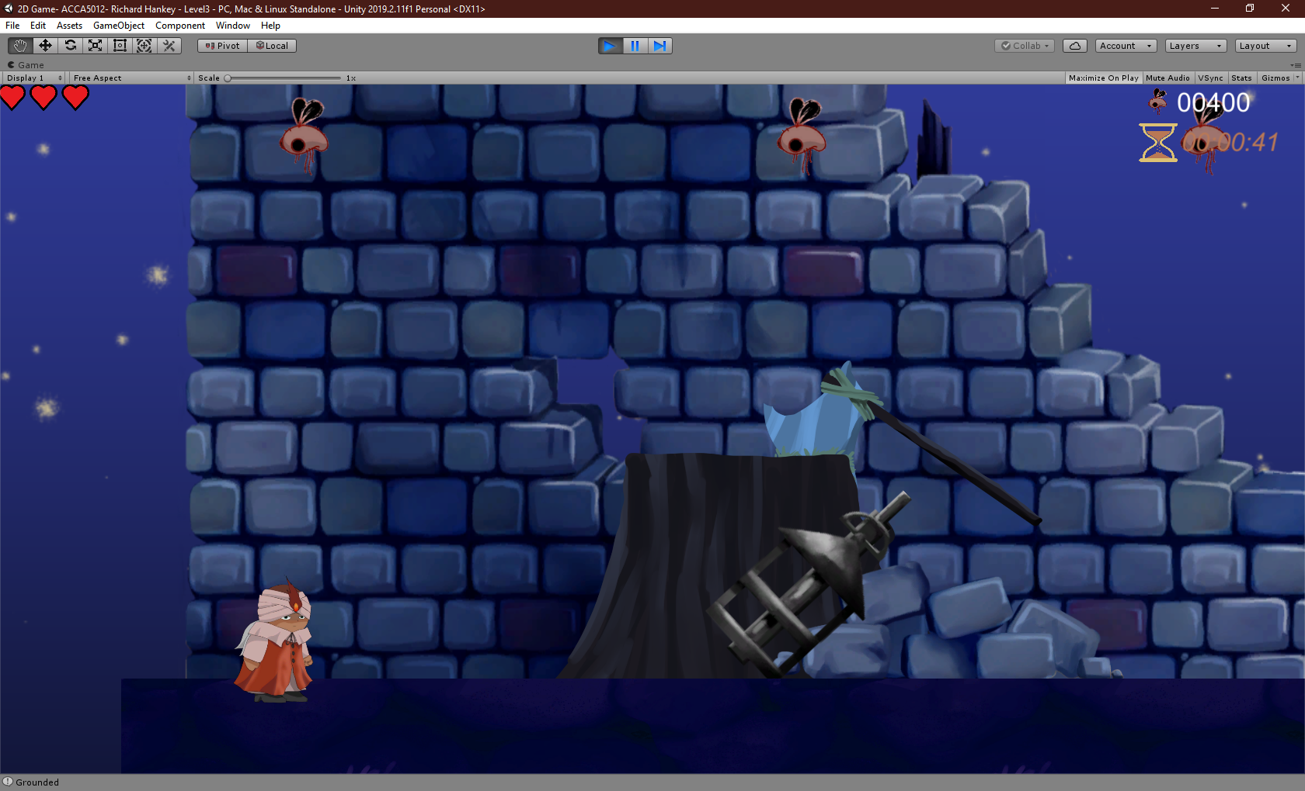
Next Scene loaded on reaching 2nd points interval
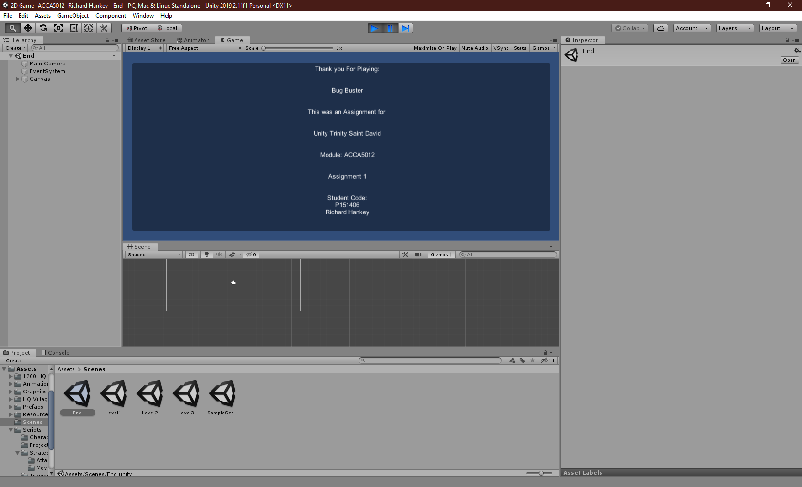
End credits screen upon hitting 3rd points interval, this is slightly bugged. See Known Bugs below.

Evaluation

Test Cases

Test ID | Test Scenario | Test Case | Pre-Requisite | Expected Result | Actual Result | Pass/Fail | Next Step
J_01 | Check if the player can jump | User presses ‘UpArrow’ | The application must be running and working | The Character will jump | The character jumps but can jump repeatedly in the air | Pass | Add method stop multiple jumps
J_02 | Check if the player can only jump once | User presses ‘UpArrow’ multiple times | The player character must jump at least once | The Character jumps once | The character jumps only once and will be able to jump again after landing on a platform | Pass | Nothing, Jumping tests complete
Atk_C_01 | Check if instantiated “FireBall” collides with the enemy character | User presses ‘SpaceBar’ to fire projectile upwards | The player character must be underneath enemy character and player character must be firing “fireball” game object | Fireball collides with enemy character and adds points to HUD | Fireball pass through enemy character | Fail | Check if trigger collider is attached to the enemy character and is listening to fireball
Atk_C_02 | Check if instantiated “FireBall” collides with the enemy character | User presses ‘SpaceBar’ to fire projectile upwards | The player character must be underneath enemy character and player character must be firing “fireball” game object | Fireball collides with enemy character and adds points to HUD | Fireball pass through enemy character | Fail | Check if the dependency injector method is using injecting the right object
Atk_C_03 | Check if instantiated “FireBall” collides with the enemy character | User presses ‘SpaceBar’ to fire projectile upwards | The player character must be underneath enemy character and player character must be firing “fireball” game object | Fireball collides with enemy character and adds points to HUD | Fireball hits the enemy character collider and adds points to the HUD. | Pass | Nothing, Player attack is working as intended
Dam_C_01 | Check if instantiated “FireBall” collides with the Player character | User walks into enemy fireball or allows enemy fireball to collide with player | The player character must be underneath enemy character and the fireball must be instantiated from enemyAttack Script | Fireball collides with Player character and logs the collision in a debug message | Fireball passes through player character | Fail | Check if trigger collider is attached to the enemy fireball and is listening to fireball
Dam_C_02 | Check if collider is listening | User walks into enemy fireball or allows enemy fireball to collide with player | The player character must be underneath enemy character and the fireball must be instantiated from enemyAttack Script | Debug logs a active game object that the listener is attached to | Debug logs listener as EnemyFire  game object | Pass | Attach collider to enemy Fire object in the script
Dam_C_03 | Check if attaching to enemyFire prefab works | The user walks into an enemy fireball or allows enemy fireball to collide with the player | The player character must be underneath enemy character and the fireball must be instantiated from enemyAttack Script | Fireball collides with Player character and logs the collision in a debug message | Fireball passes through the player character | Fail | Add method to test for any collision whatsoever
Dam_C_04 | If method finds any collision at all | The user walks into an enemy fireball or allows enemy fireball to collide with the player | The player character must be underneath enemy character and the fireball must be instantiated from enemyAttack Script | A debug notifies of a collision | Fireball passes through player character.  No debug message | Fail | Further investigation required

Dam_C## (Damage Collision) has had several dozens of attempts to fix or to assume the problem, it cannot be ascertained as to why this is not working. Further refactoring and debugging would be required.
Test ID | Test Scenario | Test Case | Pre-Requisite | Expected Result | Actual Result | Pass/Fail | Next Step
NxtSc_01 | Test if the next scene loads when interval has been reached | User must reach score interval in-game(currently set at 200) | Player character must not die and all attack scripts on the player must be fully functional | User scores 200 and next scene loads | Next scene loads at 200 but occasionally freezes | Fail | Check if the code script crashes.
NxtSc_02 | Test when the next scene loads if the code script crashes | User must reach score interval in-game(currently set at 200) | Player character must not die and all attack scripts on the player must be fully functional | User scores 200 and next scene loads | Next scene loads at 200 and code is still running and changing the position of the character player via the editor is allowed | Fail | Check is the time scale has changed
Time_01 | Test the timescale throughout the application | none | Points when destroying an enemy set to 200 so user must only destroy one enemy. | Time scale on the debug fluctuates | Timescale does not fluctuate but is occasionally set to 0 when the next level is loaded | N/A | Add logic gate/If statement to reset the timescale if its ‘0’ set upon loading the scene
Time_02 | Test the timescale throughout the application | User will play through as normal until a freeze happens | Player character must not die as this sets the timescale to 0 | The next scene does not freeze | Timescale hits zero and is reset to 1 upon loading the scene. | Pass | Test Next Scene again
NxtSc_03 | Test if the next scene loads properly. | User must reach score interval in-game(currently set at 200) | Player character must not die and all attack scripts on the player must be fully functional | User scores 200 and next scene loads | Next scene loads at 200 and doesn’t freeze | Pass | Nothing, Next Scene loading works
Pts_01 | Test if the points and time are carried over to the next scene | User will play through the game as normal | Player character must not die as this stops the game | User scores and times carry over. | Scores and time is reset to zero upon loading next scene | Fail | Look up/ research how the store the points and time to load them onto the next scene
Pts_02 | Check if using the PlayerPrefs saves the score and times[24], [25] | User will play through the game as normal | Player character must not die as this stops the game | User scores and times carry over. | User scores and times carry over. | Pass | Check if this works every time and throughout all scenes
Pts_03 | Check if using the PlayerPrefs saves the score and times every time and through all scenes | User will play through the game as normal | Player character must not die as this stops the game | User scores and times carry over. | User scores from previous iteration of the game were stored on scene 1 | Fail | Reset the score upon loading scene1
Pts_04 | Check if using the PlayerPrefs saves the score and times | User will play through the game as normal | Player character must not die as this stops the game | User scores and times carry over. | User scores and times carry over. | Pass | Nothing, this works as intended
G_Mgr_01 | Check if changing the score interval 500 in the inspector will result in working scene changes | User will play through the game as normal | Player character must not die as this stops the game | Scene load as the intervals are met | It loads the next scene when intervals are changed | Pass | Nothing. It is to be noted that changing the Interval has to be changed in every scene in the Game Manager’s inspector and be the same interval
UI_Btn_01 | Check if the buttons on the pause menu are being clicked | User will “esc” and click the buttons on the menu | Game pause menu must load | The buttons detect a click | The buttons detect a click | Pass | Add functionality to the buttons[26]
UI_Btn_02 | Check if the buttons on the pause menudo the intended purpose described on the button | User will “esc” and click the buttons on the menu | Game pause menu must load | Continue will unpause the game and remove the panel.  “Restart Level” and “Restart Game” will do as described. “Quit” will stop the application. | All buttons work as described on the buttons | Pass | Nothing. UI Buttons Work as intended
G_OVR_01 | Test if Game Over screen is loaded with functional buttons | User will jump or fall off a platform and fall past the camera view | The game must have control functionality | The game will freeze and the game over menu will appear on screen | The game over menu shows the pause menu with a game over on it | Partial Pass | Deactivate the main menu’s continue button upon game over
G_OVR_01 | Test if Game Over screen is loaded with functional buttons | User will jump or fall off a platform and fall past the camera view | The game must have control functionality | The game will freeze and the game over menu will appear on screen | The game over menu shows the pause menu without a continue button a game over on it. ADDITIONAL TEST: All buttons on this menu work according to TEST ID:  UI_Btn_02 | Pass | Nothing, Game Over Functionality is as intended

Known Bugs

Even though every effort has been made to ensure a fully functional application, there are however bugs and error within the application:
Major Bugs:
- The Script for the Collider on the Enemy’s projectile with the player character has proven fruitless, hence this application’s life system has not been implemented. This is the biggest bug in the application and is a detriment to achieving a functional game.
- The game seems to take a while to load on first run, it is unclear whether this is the Unity API’s fault or due to computational expensive algorithms within this application.
Minor Bugs
The minor bugs identified have a temporary fix:
- Occasionally the game will instantiate (spawn) multiple fireballs upon pressing the attack button. It is not known why this happens but to fix this; in the Editor, in the hierarchy, there will be a Game Object named “PlayerFireball”, delete this object then undo the deletion, this fixes the issue.
- The enemies will take several hits before they are destroyed from the game, this will allow for multiplicative points off one enemy. There is no fix on the build, but it would be recommended to play the game as it was intended: one fireball for one enemy to allow for the full experience of the intended play.
- The player will occasionally get stuck on or between the platforms, some friction elements have been added onto the character to reduce this as much as possible. But if this is to happen then jumping backwards or forwards (“Up arrow + left or right) will ‘wiggle’ the character free.
- The credit roll doesn’t work very well on Fullscreen mode, this is yet to be rectified. To see the credit roll as intended run the game and complete it not in full screen mode.
- The score interval must be set to the same value in every scene via Game Manager, otherwise the scene loading algorithm calculates the build index wrong and will initiate an endless game loop.

Improvements

Other than the bugs already mentioned there are some considerations for further expansion of the game:
- Adding game changing elements; like powerups or extra lives.
- Adding a boss battle
- Refining and refactoring the game’s core code to allow smoother scene changes and better collision detection
- Adding animations to the player character

References
[1] WePC.com, “2019 Video Game Industry Statistics, Trends; Data - The Ultimate List,” WePc. 2019.
[2] S. Sacirbey, “VIDEO GAMES and THEIR EFFECT on MODERN DAY SOCIETY | HuffPost.” [Online]. Available: https://www.huffpost.com/entry/video-games-and-their-eff_b_9873646?guccounter=1&guce_referrer=aHR0cHM6Ly93d3cuZ29vZ2xlLmNvbS8&guce_referrer_sig=AQAAAFdzWe9h_Ito96LG4_Z9bXOrUkjBVoACOGLD6CZmtlbV8PWqSIwgZNJmHIWlRx1PGe8lYL4mMDmgCLOytWd2XTNoImYMBu1IZ_Ps4EGYhYRF1TzRKntZNlt0mZNkTuvS4NBv0zuh94LOhyCuvS-rE8TFbXaW6fXxuAb9kYyGz2Jy. [Accessed: 24-Nov-2019].
[3] N. D. Bowman, S. Jöckel, and L. Dogruel, “‘The app market has been candy crushed’: Observed and rationalized processes for selecting smartphone games,” Entertain. Comput., vol. 8, pp. 1–9, May 2015.
[4] C. Ron, “Gaming Trends with the Most Potential for 2019 and Some That are Doomed to Fail - TechWalls.” [Online]. Available: https://www.techwalls.com/gaming-trends-with-the-most-potential-for-2019-and-some-that-are-doomed-to-fail/. [Accessed: 19-Nov-2019].
[5] D. Hawley, “Viral Nation | 12 Video Game Trends That Are Happening in 2019 - Viral Nation.” [Online]. Available: https://www.viralnation.com/blog/12-video-game-trends-that-are-happening-in-2019/. [Accessed: 19-Nov-2019].
[6] Plarium, “2019 Gaming Trends and Predictions Analysis - Plarium Blog.” [Online]. Available: https://plarium.com/en/blog/2019-gaming-trends/. [Accessed: 19-Nov-2019].
[7] GTRACING, “10 Gaming Industry Trends in 2019 [Experts Highly Recommended],” 2019. [Online]. Available: https://www.gtracing.jp/new/2019-04-24-182858.html. [Accessed: 19-Nov-2019].
[8] C. Stanway-Williams, “Five 2019 trends in gaming analytics | Articles | Big Data | Innovation Enterprise.” [Online]. Available: https://channels.theinnovationenterprise.com/articles/five-2019-trends-in-gaming-analytics. [Accessed: 19-Nov-2019].
[9] D. Samson, “5 Game development trends that will own 2019 - Web Design | Development | E-Commerce | Mobile Apps | SEO Marketing in Vadodara.” [Online]. Available: https://www.techiedavid.com/2018/12/27/5-game-development-trends-that-will-own-2019/. [Accessed: 16-Nov-2019].
[10] } Punyawee Anunpattana, M. Nor, A. Khalid, and H. Iida, “User-centered Entertainment Factors for Platform Transformation and Game Development,” 2019.
[11] “2020 Gaming Industry Statistics, Trends & Data (Large-Scale Study).” [Online]. Available: https://www.gamingscan.com/gaming-statistics/. [Accessed: 27-Nov-2019].
[12] R. Nelson, “Global App Revenue Reached $39 Billion in the First Half of 2019, Up 15% Year-Over-Year.” [Online]. Available: https://sensortower.com/blog/app-revenue-and-downloads-1h-2019. [Accessed: 27-Nov-2019].
[13] H. Dar, J. Kwan, Y. Liu, O. Pantazis, and R. Sharp, “The Game Performance Index for Mobile Phones.”
[14] W. Cai et al., “The future of cloud gaming,” Proceedings of the IEEE, vol. 104, no. 4. pp. 687–691, 2016.
[15] Z. Wu, “Gaming in the cloud: one of the future entertainment.”
[16] K. Lee et al., “Outatime: Using Speculation to Enable Low-Latency Continuous Interaction for Mobile Cloud Gaming.”
[17] X. Zhang et al., “Improving Cloud Gaming Experience through Mobile Edge Computing,” 2019.
[18] A. Franco, E. Fitzgerald, B. Landfeldt, and U. Körner, Reliability, timeliness and load reduction at the edge for cloud gaming. .
[19] J. Nelius, “Google Stadia verdict so far: Not ready for prime time | PC Gamer.” [Online]. Available: https://www.pcgamer.com/uk/google-stadia-verdict-so-far-not-ready-for-prime-time/. [Accessed: 01-Dec-2019].
[20] G. Park, “Google’s cloud gaming system has launched, but it isn’t ready,” 2019. [Online]. Available: https://www.smh.com.au/technology/video-games/google-s-cloud-gaming-system-has-launched-but-it-isn-t-ready-20191119-p53bua.html. [Accessed: 01-Dec-2019].
[21] F. Halliday, “The gaming world isn’t ready to go all-in on streaming, let alone Australia - PC World Australia.” [Online]. Available: https://www.pcworld.idg.com.au/article/659157/gaming-world-isn-t-ready-go-all-in-streaming-let-alone-australia/. [Accessed: 01-Dec-2019].
[22] M. Tauberg, “The Coming Cloud Gaming Wars - The Startup - Medium.” [Online]. Available: https://medium.com/swlh/the-coming-cloud-gaming-wars-c76bb1f0c3bd. [Accessed: 01-Dec-2019].
[23] “(124) Testing for Raycast Collisions | 2D Game Development in Unity 5.6 - YouTube.” [Online]. Available: https://www.youtube.com/watch?v=epZuI-YgXYo. [Accessed: 06-Apr-2020].
[24] “Unity - Scripting API: PlayerPrefs.” [Online]. Available: https://docs.unity3d.com/ScriptReference/PlayerPrefs.html. [Accessed: 05-Apr-2020].
[25] “c# - Keeping Scores in Unity and pass to next scene - Stack Overflow.” [Online]. Available: https://stackoverflow.com/questions/22862932/keeping-scores-in-unity-and-pass-to-next-scene. [Accessed: 05-Apr-2020].
[26] “Unity - Scripting API: UI.Button.onClick.” [Online]. Available: https://docs.unity3d.com/2019.1/Documentation/ScriptReference/UI.Button-onClick.html. [Accessed: 04-Apr-2020].

marking criteria and Student FEEDBACK

This section details the extent to which the assessment criteria are demonstrated by you, which in turn determines your mark. The marks available for each category of skill are shown. Lecturers will use the space provided to comment on the achievement of the task(s), including those areas in which you have performed well and areas that would benefit from development/improvement.

Common Assessment Criteria Applied (Assignment 1) | Marks available | Marks  awarded
1. Engagement with Literature Skills

A good discussion of current gaming trends, but you need to make it clearer what trend you chose to discuss in detail. The required background from a relevant peer-reviewed study is also somewhat limited, though you have applied a good selection of appropriate reference sources to aid your discussion. (Grade mark: 76.00%) | 25 | 19
2. Knowledge and Understanding Skills

3. Cognitive and Intellectual Skills

Overall, a good set of test cases has been documented but some of the test cases and their descriptions could be improved and one or two appear to be duplicated. A very good, reflective evaluation of the game has been provided, identifying the limitations of the game. (Grade mark: 80.00%) | 20 | 16
4. Practical Application Skills

A very good attempt featuring a simple game. Although, you have attempted to use a good variety of coding techniques, you have also made your code unnecessarily complex and in some cases duplicated code. The main area for improvement is understanding how to combine the advanced coding techniques effectively and applying code refactoring techniques to eliminate duplicate code and make your code more efficient and maintainable. Some other areas for improvement are avoid hard-coding values and learn how to use the event system. In terms of the gameplay, because you could not get the "enemy" working properly, this had an impact on the gameplay challenges for the player. (Grade mark: 75.00%) | 50 | 37.5
5. Transferable Skills for Life and Professional Practice

The report is of a good standard. See your report for some suggested improvements. (Grade mark: 70.00%) | 5 | 3.5

Assignment Mark (Assessment marks are subject to ratification at the Exam Board. These comments and marks are to give feedback on module work and are for guidance only until they are confirmed. ) | Late Submission Penalties (tick if appropriate) |  | 76%
 | Up to 1 week late (40% Max) |  | 76%
 | Over 1 week late (0%) |  | 76%

