
Acda5017 Group Project
B.Eng. (Hons) in Electrical and Electronic Engineering

Gareth John 2413461
Tom Morris 2413111
Joe Williams 2413881
Conner kinsey 2415170

May 26, 2026

Table of Contents
Table of Contents 1
1. Introduction - GJ 4
1.2 Aims & Objectives - GJ 5
2. Literature Review – History of the sewage pumping station – GJ 6
3. Research 7
3.1 Solar Panels – CK 7
3.2 Hydro Turbine 7
3.2.1 Turbine Selection and Operation - JW 7
3.3 Control Method & Pumps - TM 8
3.3.1 Direct On Line Control Method - TM 8
3.3.2 Variable Speed Drive - TM 8
3.3.3 Induction Motor - TM 9
3.3.4 Waste Pump - TM 9
4. Design 11
4.1 Solar Panels – CK 11
4.1.1 Proposed solar design - CK 11
4.1.2 Installation costs - CK 12
4.1.3 Energy generation analysis - CK 12
4.1.4 Financial analysis - CK 13
4.1.5 Environmental and ethical impact - CK 15
4.2 Hydro Turbine - JW 17
4.2.1 Power Generation Assessment - JW 18
4.2.2 Annual Turbine Energy Production – JW 21
4.2.3 Financial Assessment - JW 22
4.3 Control Method & Wastewater Pump – TM 23
4.3.1 Pump Motor Calculation - TM 23
4.3.2 Pump - TM 24
4.3.3 Energy Usage Analysis - TM 24
4.3.4 Waste Pump & Control Method Selection - TM 25
4.4 PLC Design – GJ 28
4.5 Overall System Design - GJ 29
5. Implementation & Simulation 30
5.1 PLC Software – GJ 30
5.1.1 PLC Hardware and Sensors 30
5.1.2 Duty Selection and Duty Sync 32
5.1.3 Starting a Pump and PID Flow Control 32
5.2 - Flow Target - Linear Scaling Between Start Level and FFTW (Full Flow to Works) 33
5.2.1 Alarms and the HMI in Operation 34
Flowchart - GJ 36
6. Evaluation - GJ 37
6.1 Maintenance of Site 38
6.1.1 Solar panel maintenance -CK 38
6.1.2 PLC, VSD & Pumps Maintenance -GJ 38
7. Environmental impacts - GJ 39
8. Conclusion & Reflections 40
8.1 CK 40
8.2 JW 40
8.3 TM 41
8.4 GJ 41
9. References 43
10. Appendices 47
10.1 PLC Hardwire termination - GJ 47
10.1.1 Digital Input 47
10.1.2 Digital Output 48
10.1.3 Analogue Input 49
10.1.4 Analogue Output 50
10.2 Solar Appendices - CK 51
10.2.1 Photovoltaic power potential survey. 51
10.2.2 Photovoltaic power potential (PVOUT) 52
10.3 Electrical Specifications for VSD & Pump - TM 53
10.4 Gantt Chart – TM 0
10.5 Meeting Minutes - TM 0
10.5.1 28/05/26 - TM 0
10.5.2 04/06/26 - TM 0
10.5.3 11/06/26 - TM 0
10.5.4 18/06/26 - TM 0
10.5.5 25/06/26 - TM 1
10.5.6 02/07/26 - TM 1
10.5.7 09/07/26 - TM 1
10.5.8 16/07/26 - TM 1

Introduction - GJ

The task decided as a group is a two-waste pumping station with energy efficiency to help with rising costs and utilise the energy source within the water industry. Tasks are broken up into sections where energy can be saved or made. Tasks are as follows
- PLC software
- VSD & Pumps
- Hydro Turbine
- Solar panels

For this project, PRINCE2 [1] Principles have been applied to support the planning, design, implementation, testing and evaluation stages, ensuring a structured and organised approach to project delivery.
The PRINCE2 methodology divides a project into manageable stages and focuses on clear objectives, defined roles and responsibilities, risk management and regular progress reviews. This allows project managers to monitor performance and make informed decisions throughout the project lifecycle.

Aims & Objectives - GJ

This project aims to upgrade an old two-pumping station that is costing lots of money and time to fix any issues. Issues include old equipment there are no longer being produced, and the cost to buy second-hand will increase over time. Upgrading the station will include energy saving or creating energy from the source within the water industry.
The objectives are as follows,
- Create an energy-saving PLC code that will incorporate the cost of energy to run the pumps via a VSD.
- Energy saving with solar panels
- Energy saving from the turbine with the flow of water that is available at the pumping station.
- Environmental factors around the pumping station.

Literature Review – History of the sewage pumping station – GJ

Pre 1800s – No Pumping Station
Before the Industrial Revolution, no towns or cities had any sewage systems. All the sewage went into the water stream. The River Thames in London was an open sewer [2, 3].
1858 – The Great Stink
In the summer of 1858, the smell coming from the River Thames was so bad that Parliament had to be abandoned. This was called the Great Stink, and the government was forced to act [2]. Engineer Joseph Bazalgette designed a new sewer network for London, completed in 1875 [3]. Steam-powered pumping stations were built across Britain [4].
1900s – Electric Pumps
Electric pumps are starting to replace the steam engines. By the 1960s, submersible pumps that go directly to the bottom of the wet well would make the pumping station simpler to design and build [5] Relay logic was widely used as a control method [6].
Today – PLC and VSD Control
Modern pumping stations use PLCs, VSDs and SCADA systems for automated control and remote monitoring. Using a PLC and VSD drives can reduce energy by 15-20% [7].

Research

Solar Panels – CK
Solar photovoltaic (PV) technology has developed into one of the world's fastest-growing renewable energy technologies. Continuous improvements in semiconductor materials, manufacturing processes and photovoltaic cell design have significantly increased module efficiencies while reducing installation costs.
Modern commercial photovoltaic modules typically achieve efficiencies exceeding 20%, making them suitable for residential, commercial and industrial applications. In 2024, solar PV accounted for the largest increase in global electricity generation of any energy source, highlighting its growing importance in supporting the transition to low-carbon energy systems [8], [9].

Hydro Turbine

Turbine Selection and Operation - JW

Several turbine technologies were considered for this application, with a hydrokinetic turbine selected due to its suitability for the low-head and low-flow conditions typically found in wastewater pumping stations. Unlike Pelton or Francis turbines, which require higher heads and cleaner water, hydrokinetic turbines can operate efficiently under variable flow conditions [10].
The turbine would be installed within the gravity-fed inlet pipe before the wastewater enters the wet well. As wastewater flows through the pipe, it rotates the turbine blades, transferring mechanical energy to a 1 kW permanent magnet synchronous generator (PMSG). This generator was selected for its high efficiency, low maintenance requirements and ability to generate electricity at relatively low rotational speeds. A suitable generator is estimated to cost £600–£1,000.
The generated electricity would pass through a 1 kW grid-tied inverter before being connected to the pumping station distribution board. This would allow the recovered energy to supply station equipment and operate alongside the proposed solar panel system, reducing reliance on grid electricity. A suitable inverter is estimated to cost £400–£800.
To improve reliability and simplify maintenance, the system would incorporate a bypass arrangement and isolation valves, allowing the turbine to be serviced without interrupting the normal operation of the pumping station.

Control Method & Pumps - TM
Pumping stations are used within multiple water supply and waste systems on commercial and industrial applications where the need for reliable and efficient fluid transport is a crucial aspect. When selecting a control method and pump for a dual pumping station, the performance and ability to minimise energy consumption is a priority to extend the equipment’s lifespan.

Direct On Line Control Method - TM
For a traditional pumping station, the control method is often a fixed speed method using on/off switching or manual adjustments, this control method is called Direct On Line (DOL). The DOL is made up of the following components according to [11] :
- Miniature Circuit Breaker – Activates when excessive current is flowing and doesn’t require any manual adjustment before or after it has been activated.
- Overload Protection Relay – Safeguards against burnout and guarantees the motor’s maximum life due to when the motor is overloaded it draws higher current values which cause overheating which will damage the motor.
- Step up & Step-down Transformer – Is used to regulate the voltage available and the voltage that is needed to be output.
- Contactor – Single pole relay switch used to switch the circuit on or off.
- 2-way Switch – Start push button (Normally Open) , Stop push button (Normally closed).
- Indicator – Indicates whether the circuit is on or off.
The DOL method is according to ICST [12] is a starting method in which the motor has a direct connection to the supply voltage which starts the whole system, the DOL then connects to the induction motor which then connects to the pump this means that the motor and pump receives the full voltage and current generated by the supply voltage. Using DOL comes with the highest starting current compared to other control method options available according to IMECS [13] and a risk of voltage drop which can cause damage to the induction motor and the pumps if they are frequently started and stopped.

Variable Speed Drive - TM
The most popular option in newer pumping stations is a Variable Speed Drive (VSD) and can also be called a Variable Frequency Drive (VFD). VSD is according to IRJET [14] an electronic device that can be used as a control method that allows it to change the power source to a variable frequency that is able to control the induction motor.
When using a VSD according to IOP [15] it converts the frequency of the supply voltage to another frequency value which in turn changes the speed of the induction motor depending on the new frequency value. The speed of the induction motor is also able to be changed by other methods according to such as [16] changing poles, voltage changing and connecting the resistance in the rotor circuit, but the changing of the frequency is viewed as the most efficient method.
The VSD is constructed using the following components according to IRJET [14] shown in Figure 1:
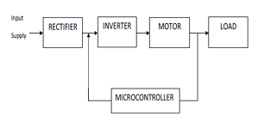
Figure 1 - Block Diagram of VSD
- Rectifier - Is used to convert AC into DC and given to the input of the inverter.
- Inverter – Can convert DC into AC current, the power is supplied by the DC source.
- Microcontroller – Is used to control the speed of the induction motor as shown above, it is used to regulate the frequency and output voltage.

Induction Motor - TM
An induction motor is a common type of AC electric motor; the water pump is driven by the induction motor. The induction motor used within this project will be a three-phase induction motor they are the most used induction motor as they are cheap and reliable according to ICST [12].
According to ICPEI [17] the larger the water pump is, the larger the induction motor is and when paired with a VSD drive it can save energy consumption by 15-20% and 10-15% of loss of water during the process as well.

Waste Pump - TM
According to Pumps&systems [18] there are multiple different types of waste water pumps, this is due to the differences in flow of waste, potential messy clogs and loss of pressure if the correct pump isn’t chosen leading to costly maintenance and shutdown periods.
There are multiple different types of wastewater pumps according to [18] examples of this are:
Non clog Sewage Pumps:
- Are used for large intact solids
- High flow rates and low head capability
- 2-inch discharge pipe minimum required
Grinder pumps are used for [18]:
- Low flow rate, very high head capability
- Small discharge pipes
- Solids exit in a slurry
According to [19] Submersible pumps are also used for wastewater:
- They operate underwater
- Able to efficiently handle solids
- Transports waste water over long distances
Centrifugal pumps are also used for [19] :
- Uses a rotating impeller to create a flow of fluid
- Handles low to medium viscosity liquids
- Used for sludge handling and aeration tanks
Lastly, air diaphragm pumps are also another option when it comes to wastewater pumps, they are used to [19]:
- Are air-operated pumps used for corrosive wastewater treatment
- Handles contaminated water
- Can handle chemical flows

Design

Solar Panels – CK

Proposed solar design - CK

The selected JA Solar module has dimensions of 1762 mm × 1134 mm, giving an area of approximately 2.0 m² per panel. Fourteen panels were chosen therefore requiring approximately 28 m² of installation space, leaving approximately 7 m² available for mounting hardware, panel spacing and maintenance access within the available 35 m² site area.
The proposed installation area of approximately 35 m², seen in Figure 17, will accommodate fourteen 450 W panels, providing a total installed capacity of 6.3 kW. This configuration maximises the use of the available space while maintaining sufficient clearance for panel spacing, mounting hardware and future maintenance access.
The selected module incorporates N-Type TOPCon technology, which provides improved conversion efficiency OF 22.5%, lower degradation rates and enhanced temperature performance compared with conventional photovoltaic panels [20].
The proposed system consists of:
- 14 × 450 W solar panels
- Total installed capacity of 6.3 kW
- Raised steel canopy structure
- Dual-input hybrid inverter
- Electrical protection and monitoring equipment
The design will also be elevated at 10ft, to ensure that maintenance and station operating can continue beneath the structure without affecting the pumping station operation.

Installation costs - CK

The installation cost estimate includes all major components required to construct a safe and operational solar photovoltaic system above the pumping station. Although the photovoltaic panels represent a significant part of the system, additional costs are associated with mounting hardware, electrical infrastructure and civil engineering works.
Table 1: The estimated overall installation cost of the proposed solar design.
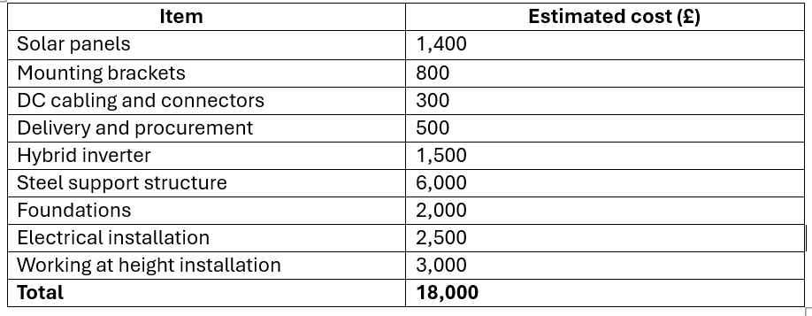

Energy generation analysis - CK

The feasibility of the proposed solar photovoltaic installation was assessed using data obtained from the Global Solar Atlas photovoltaic power potential study for the United Kingdom [21]. As shown in 10.2.1 South Wales is located within the yellow to light orange region of the map, indicating a photovoltaic power potential of approximately 950–1050 kWh/kWp/year. This demonstrates that the region receives sufficient solar irradiation to support renewable electricity generation throughout the year.
Further evidence is provided by the Global Solar Atlas country factsheet, which reports an average practical photovoltaic power output (PVOUT) of 2.613 kWh/kWp/day for the United Kingdom [21]. PVOUT represents the expected electrical energy generated by a photovoltaic system after accounting for environmental conditions, temperature effects and system losses.
The proposed installation consists of fourteen 450 W solar panels, providing a total installed capacity of 6.3 kW. Based on the solar resource data and PVOUT values presented in 10.2.1 and 10.2.2 , the system is expected to generate approximately 6,000 kWh of renewable electricity annually.

Table 2:The estimated annual generation and gross financial savings from the proposed solar photovoltaic installation.
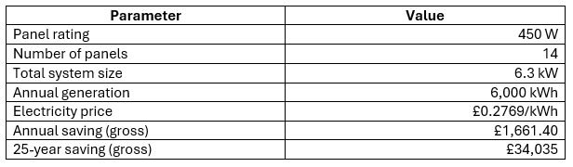

Financial analysis - CK
According to Direct Drainage (2026) [22], electricity is one of the main operating costs of sewage treatment and pumping systems. Using the workings out shown in Figure 2, an electricity price of 27.6 pence per kWh (£0.2769/kWh) [22], a solar photovoltaic (PV) system generating approximately 6,000 kWh per year could reduce electricity costs by around £1,661.40 annually.
After allowing approximately £300 per year for maintenance and future inverter replacement, the net annual saving would be approximately £1,361.40. Based on an estimated installation cost of £18,000, the payback period would be around 13.2 years.
Over a 25-year lifespan, the system could provide a net financial benefit of approximately £16,035, while also reducing reliance on grid electricity and lowering the pumping station's carbon emissions. These figures demonstrate that solar panels can provide a cost-effective and environmentally sustainable solution for reducing the long-term operating costs of the proposed dual water pumping station.

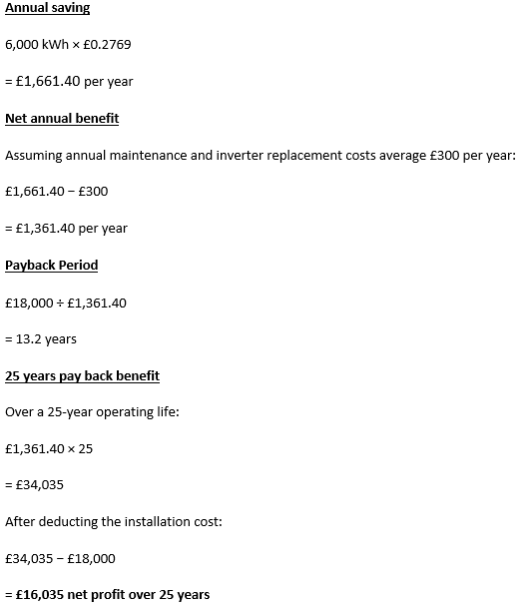
Figure 2: Financial analysis equations.

Figure 3: A pie chart showing the financial justification of the solar installation.

Environmental and ethical impact - CK

The environmental benefit of the proposed solar installation was assessed using the 2025 UK Government greenhouse gas conversion factor for grid electricity generation of 0.177 kg CO₂e/kWh [23].
Based on an annual electricity generation of approximately 6,000 kWh, the proposed photovoltaic system would reduce carbon dioxide equivalent emissions by:
6,000 × 0.177 = 1,062 kg CO₂e/year
This is equivalent to approximately 1.06 tonnes of CO₂e per year.
Over a 25-year operating life, the total carbon reduction is estimated to be:
1.06 × 25 = 26.6 tonnes CO₂e
This demonstrates that the installation would provide significant environmental benefits while supporting decarbonisation and sustainability objectives.
Table 3:Estimated carbon emission reduction from the proposed solar photovoltaic installation.
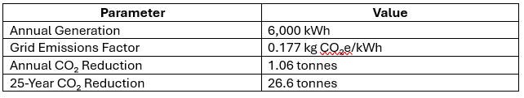

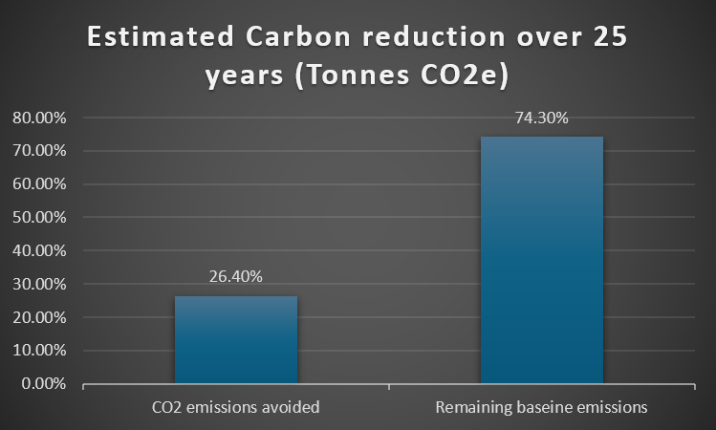
Figure 4: Comparison of carbon emission reduction from the proposed 6.3 kW solar photovoltaic installation.

Hydro Turbine - JW
As energy costs continue to rise and sustainability becomes an increasingly important consideration within engineering design, opportunities to recover energy that would otherwise be wasted should be explored wherever practical [24]. One potential solution is the implementation of a hydrokinetic turbine within the gravity-fed inlet pipe of a wastewater pumping station. By recovering a portion of the hydraulic energy contained within the incoming wastewater flow, the turbine can generate renewable electrical energy without requiring an additional energy source [25].
This section investigates the feasibility of integrating a hydrokinetic turbine into the proposed pumping station design. The selected turbine technology, method of operation, expected power generation, financial viability and environmental benefits are evaluated to determine whether energy recovery is a practical addition to the overall system. The electricity generated could help offset the pumping station's electrical demand, with any surplus exported to the grid where appropriate, improving both the efficiency and sustainability of the proposed design.

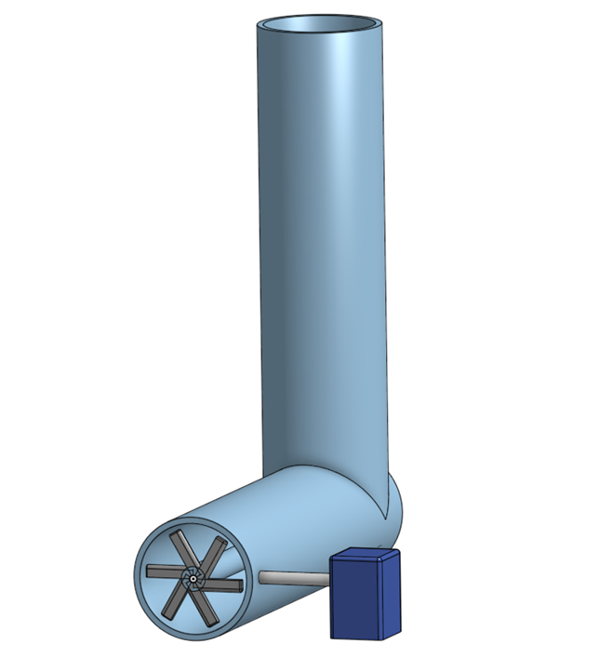
Figure 5. Illustrates the proposed turbine arrangement within the gravity-fed inlet pipe. Wastewater flowing through the pipe causes the turbine blades to rotate, driving a generator mounted externally to produce electrical energy.
Figure 5. Proposed hydrokinetic turbine installation within the gravity-fed inlet pipe of the wastewater pumping station.

Power Generation Assessment - JW
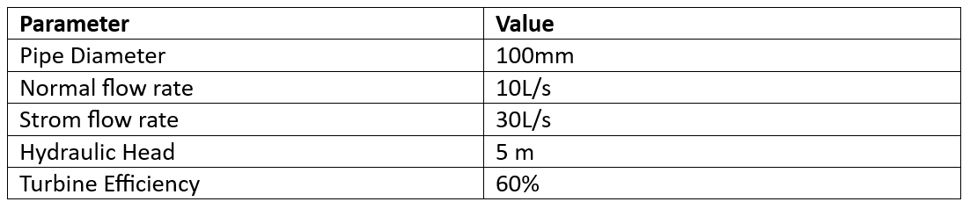
The proposed pumping station has an inlet pipe diameter of 100 mm and receives wastewater through a gravity-fed system. Design data provided for the project indicates a normal flow rate of 10 litres per second and a storm flow rate of 30 litres per second. An available hydraulic head of 5 metres has been assumed. For calculation purposes, an overall turbine and generator efficiency of 60% has been used.
Table 4. Assumed Hydraulic parameters used in turbine power calculations
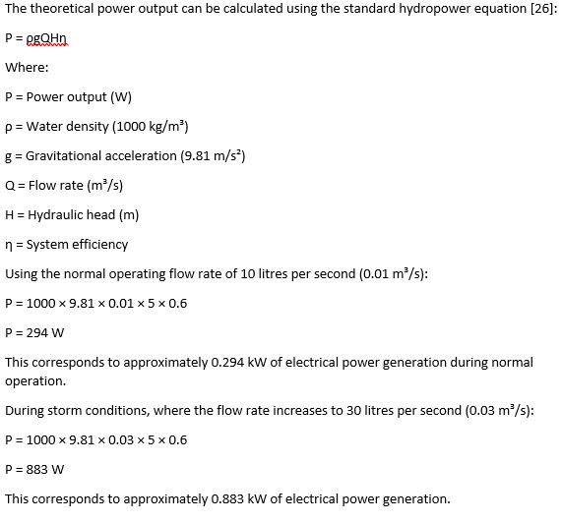
Figure 6: Theoretical power output equation.

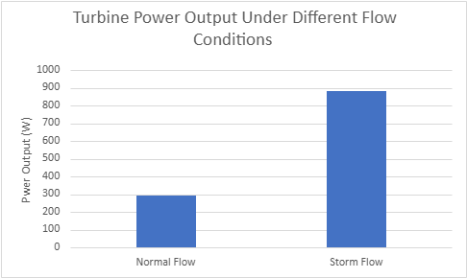
Figure 7: Estimated turbine power output under normal and storm flow conditions.
Figure 7 demonstrates the increase in electrical power generation during storm flow conditions due to the greater wastewater flow rate available to the turbine.

Although these outputs are relatively small compared to the power required by the pumps themselves, they represent energy that would otherwise be lost. The recovered electricity can therefore contribute towards reducing overall energy consumption and improving station efficiency.

Annual Turbine Energy Production – JW
To estimate annual energy generation, a sensitivity analysis was performed. As site-specific operational data was not available, it was assumed that storm flow conditions occur for approximately 5% of the year, with normal flow conditions occurring for the remaining 95%. These assumptions were used to estimate annual energy production for the proposed turbine system.
Normal operation:
0.294 kW × 8,322 hours = 2,447 kWh/year
Storm operation:
0.883 kW × 438 hours = 387 kWh/year
Total annual energy generation:
2,447 + 387 = 2,834 kWh/year
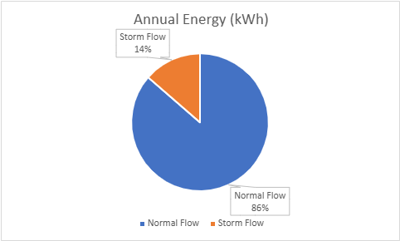
This level of generation is broadly equivalent to the annual electricity consumption of an average UK household. According to Ofgem's Typical Domestic Consumption Values, an average UK household uses approximately 2,500 kWh of electricity per year [26], meaning the proposed turbine could generate around 113% of this annual demand.
Figure 8. Contribution of normal and storm flow conditions to the total annual energy generation of the proposed turbine system.

Figure 8 shows that most of the annual energy generation is achieved during normal operating conditions, while storm flow events provide an additional contribution during periods of increased wastewater flow.

Financial Assessment - JW
Assuming an average electricity cost of £0.2769 per kWh [22], The annual value of the generated electricity can be estimated as:
2,834 × £0.2769 = £784.73 per year
Therefore, the turbine could provide annual electricity savings of approximately £785.
Assuming an installed system cost between £3,000 and £5,000 [27] [28], The simple payback period would be between 4 and 8 years. Given that wastewater infrastructure is typically designed for long operational lifespans, this payback period may be considered acceptable, particularly when combined with the environmental benefits provided by the system.

Figure 9 illustrates the relationship between installation cost and simple payback period, showing that higher installation costs result in longer investment recovery times.
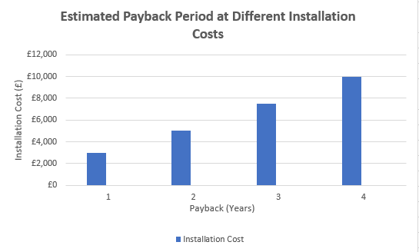

Figure 9. Estimated payback period for the proposed turbine system at various installation costs.

Control Method & Wastewater Pump – TM

Pump Motor Calculation - TM
The measurements used to calculate the size of the pump needed for the pumping station this was used in the following calculations in Figure 10:
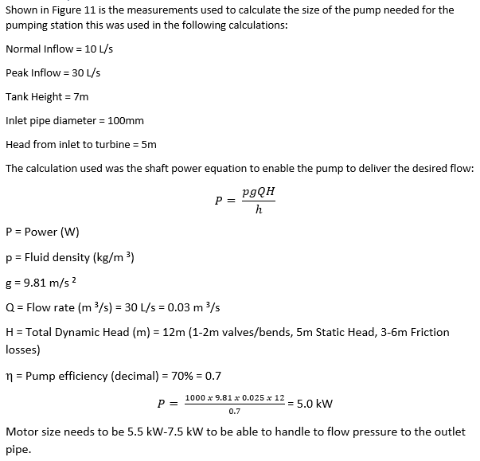
Figure 10 - Calculations for the Pump Size needed

Pump - TM
The dual pumps will only operate one pump and the other will be on standby for normal conditions (95% of the year) these pumps can be switched to ensure longevity of the pumping station.
During storm weather it will be in a duty/assist mode where the second pump will only assist if required.

Energy Usage Analysis - TM
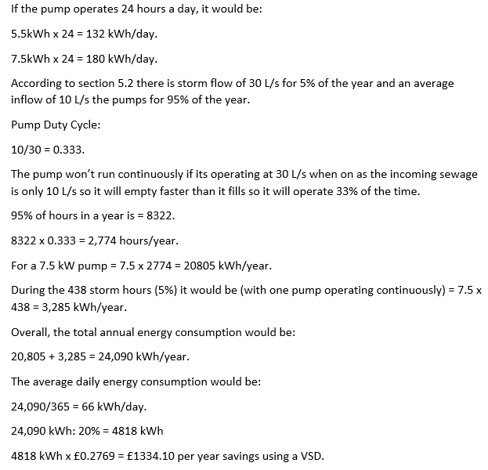
Figure 11 - Calculations for the Energy used by the Pump per Year
According to Literature Review – History of the sewage pumping station – GJ The difference in savings between a VSD and DOL would be 15-20%. The savings from this are shown above in Figure 11.

Waste Pump & Control Method Selection - TM
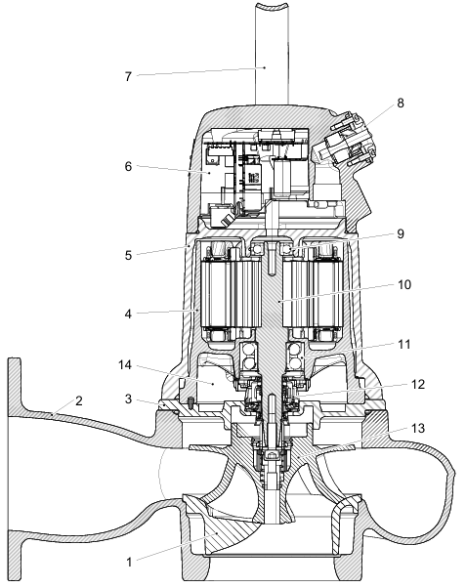
Figure 12 - Xylem Flygt Concertor N 6020 Waste Water Pump [29]
Shown in Figure 12 is the chosen pump for the station, it is a Xylem Flygt Concertor N 6020 7.3kW pump. The control method chosen was VSD due to them having multiple useful features, according to Xylem [30] it has an integrated VSD within the pump itself, this will reduce the need for external wiring for a separate drive and ensures that the pump will be able to be used effectively when controlling the speed of the pump. The pump also being a submersible pump means that the components won’t overheat due to the water cooling and eliminates the needs for fans.
It also has:
- Self-cleaning to ensure that it doesn’t have clogs due to the waste flowing through the pump.
- Easy to install due to not being able to wire the pump backwards
- Able to remotely adjust the speed of the pump and while on site
- It is compatible to be used with 3rd party controllers such as PLCs.
- Comes with a system warranty of 5 years
These features limit the need for constant maintenance and having two of these pumps will increase the longevity of the station and can enable one pump to clean itself while the other pump runs. They will operate in a duty/standby configuration.
The system is also according to [31] able to handle flow up to 540m³/h with heads to 54m and can power up to 13.5kW while being able to operate in wet pit or dry pit installations. It also uses an IE4 drive control.
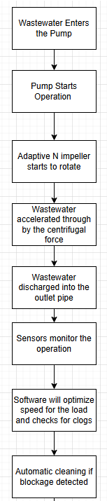
Figure 13 - Flowchart of Pump Operation
Figure 13 shows how the pump will operate within the pumping station.
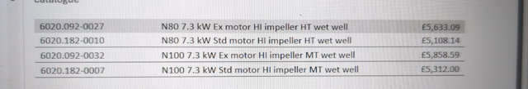
Figure 14 - Cost of the Pump for the Station
Using the bottom value shown in Figure 14 of £5312 the cost of the 7.3kWh std motor dual pumps will be £10624 there will be no additional cost due to the pumps being able to use the existing guide rail and base already located in the station.

PLC Design – GJ

Table 5 Below lists all the IO cards required for the upgrade. Figure 15 Shows the PLC in the order of Table 5. All the cards are mounted onto a rack. PSU (Power Supply Unit) must be 1st as this gives the power to the hardware cards. CPU (Central Processing Unit) must be next to the PSU [32]. For all the hardwired signals and analogue, see Appendix 12.1.
Labour and parts will be about £5000 on top. That a total of £11,080.64.
For relay logic installation, this would cost about £4000 with Parts and labour.
Worth mention that the Flow meter and level transducer will be used again as they are standard products.

Table 5 - Mitsubishi IQR equipment list and cost.

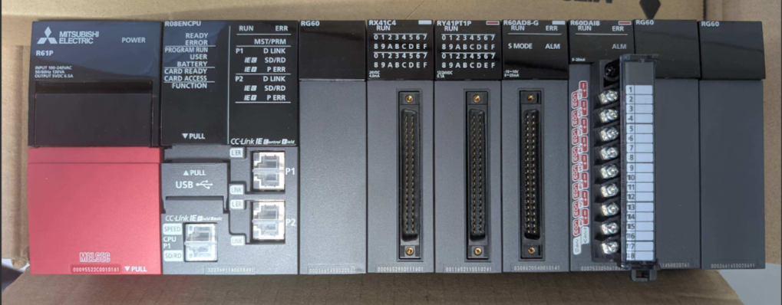
Figure 15 - Shows the Mitsubishi iQR PLC.

Overall System Design - GJ

Figure 16 Site Layout Diagram The layout drawing below shows all the important areas of the pumping station. Figure 17 Shows the location of the Solar panel. Figure 18 shows the layout drawing for the wet well. These layout drawings are vital to calculate how much energy this site can create.
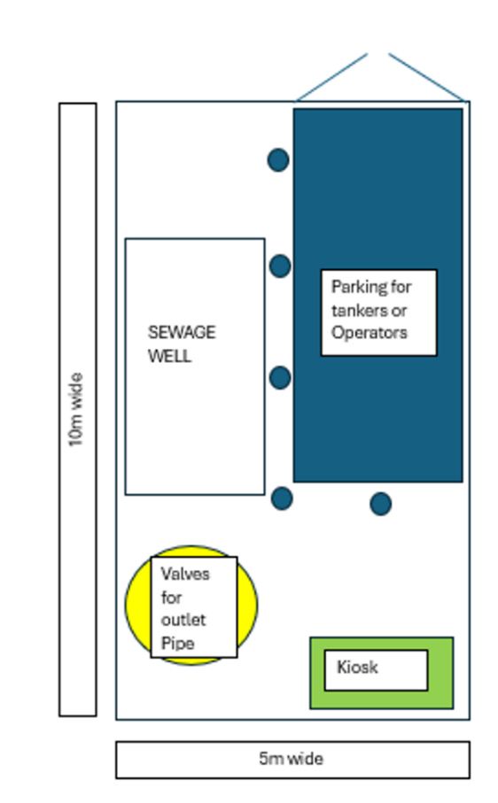  Figure 16 Site Layout Diagram | 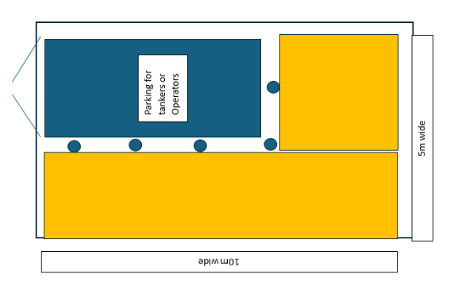  Figure 17 - Yellow area is where the Solar panels are located.
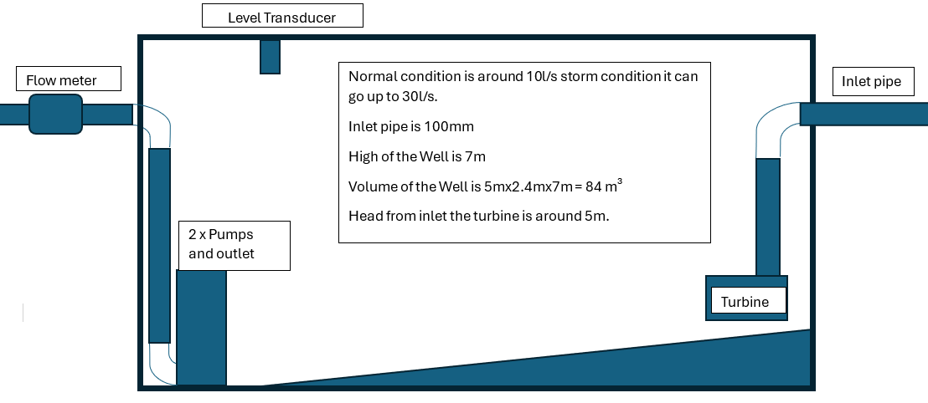
Figure 18 - Diagram of the wet well and the location of the equipment.

Implementation & Simulation

PLC Software – GJ

This section is to show how the PLC at the pumping station controls the foul pumping station, from the hardware up to the HMI. This program was designed for another pumping station but will be using the same control with different parameters.

Table 6 - Key tags are referenced throughout this report.
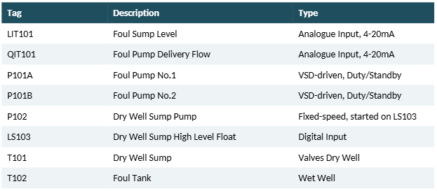

PLC Hardware and Sensors

As specified in Table 6 above, the rack includes a Power Supply, CPU, and Analogue and Digital I/O cards, with Analogue cards handling Level and Flow signals plus VSD speed demand, and Digital cards handling run/fault status and alarms [33].
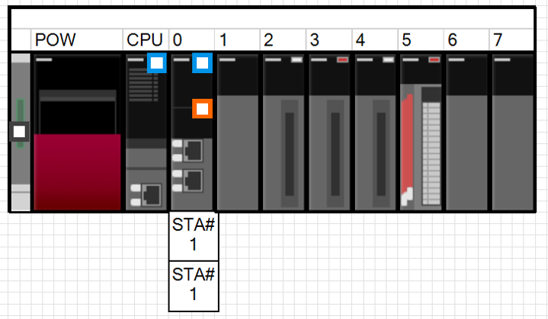
Figure 19- PLC rack, Power Supply, CPU and I/O cards across Slots 0 to 7.
The Sump Level (LIT101) and pump delivery Flow (QIT101) are read in as 4-20mA Analogue signals. A scaling Function Block (FB) converts the raw value (0 – 32000) into a proper engineering reading, metres for Level and litres/second for Flow, and flags if the instrument has failed, so the rest of the program only works with clean, scaled values shown below Figure 20. The set points are set within the HMI to give the engineering scales to the FB.

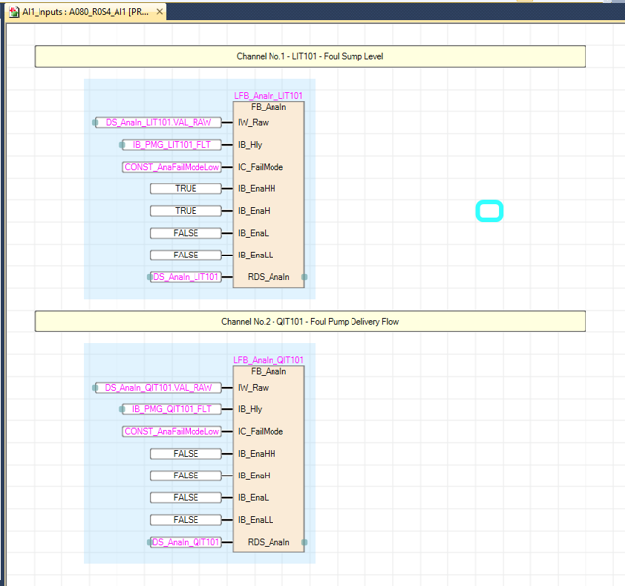
Figure 20 - Analogue scaling block

Duty Selection and Duty Sync

With 2 identical Foul Pumps, the PLC must decide which one leads (Duty) and which is the backup (Standby). If no Duty pump has ever been set, the logic forces a default selection. During normal running, an alternating pulse is made whenever both pumps are confirmed stopped at the same time, this is the On Event changeover used on this station.
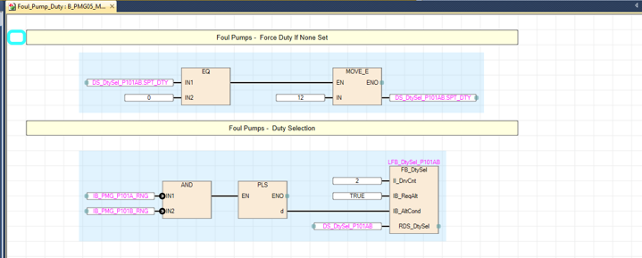
Figure 21 - Duty selection logic.
If the Duty pump fails and the Standby pump covers for it, the station shouldn't keep calling the failed pump Duty. The Duty Sync Function Block watches both pumps' running confirmation. If the backup has been running continuously for 10 seconds, it's automatically promoted and becomes the new Duty pump.

Starting a Pump and PID Flow Control

When a pump gets a run request when the level is at 1m, a timer starts, and the output speed is fixed at a configured starting speed of 48.0Hz, for 20 seconds shown in Figure 25, this is to blast any rags or baby wipes at a high speed [34]. Once the timer elapses, control is handed over to PID. If the flow meter has failed, the pump falls back to a fixed safe speed of 40.0Hz instead, because PID can't be trusted without working Flow feedback.
PID stands for Proportional, Integral, Derivative, it's a control loop that works out the error between the value that was given and where it should be, then adjusts the output to correct it [2]. Here, the PID drives the actual delivery Flow (QIT101) to match a target Flow (the Setpoint) by adjusting pump speed. On the live HMI faceplate, a flow of 77.67 l/s was tracking a Setpoint of 80.00 l/s, giving an Output of 46.65Hz, with Proportional gain 0.01, Integral time 0.1s and Output range 0-50Hz.

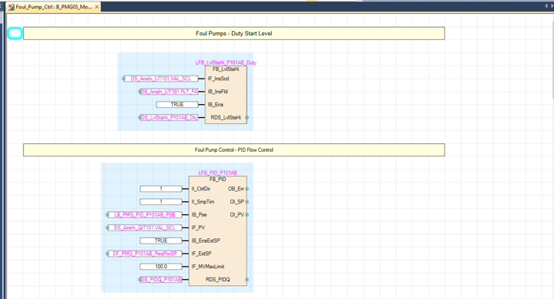
Figure 22- The PID Flow control block

- Flow Target - Linear Scaling Between Start Level and FFTW (Full Flow to Works)

Figure 23 - The relationship between Level and outlet Flow. Flow is capped at 80 l/s because the treatment works can't treat more than this.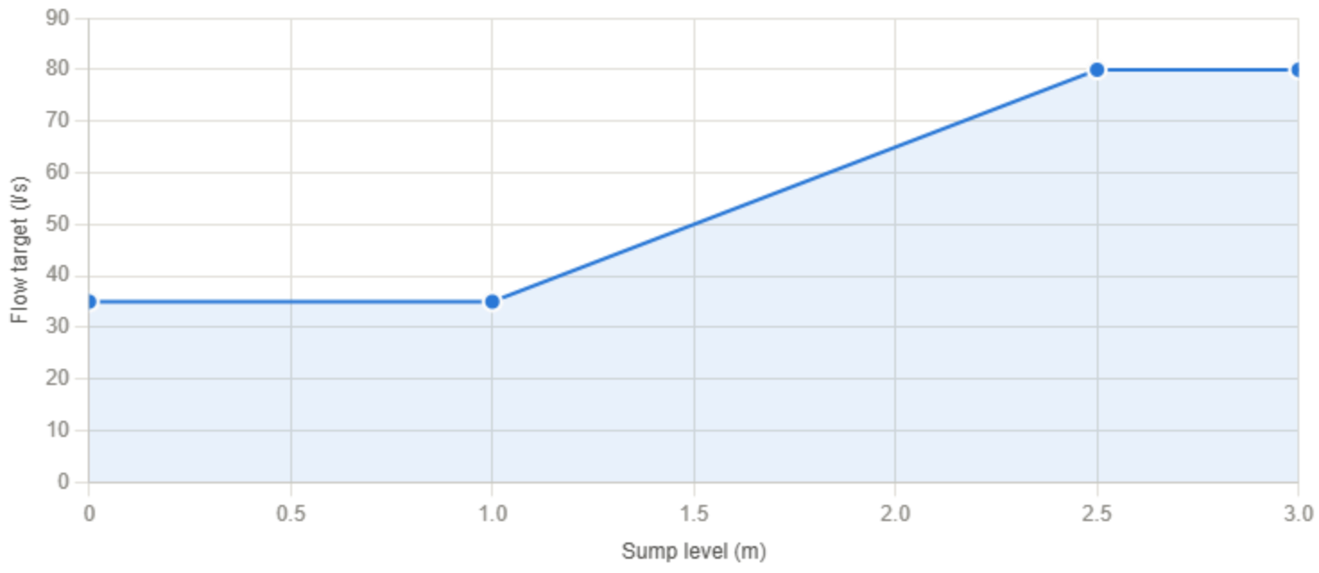
Figure 23 - Linear Scaling between Start Level and FFTW

The Flow target is worked out from the current Sump Level. Between Start Level (1.00m) and FFTW Level (2.50m), Flow target rises in a straight line from minimum Flow (35.0 l/s) to maximum Flow 80.0 l/s). Below Start Level, the flow target stays clamped at the minimum. Once the level drops to 0.50m, the pump stops.

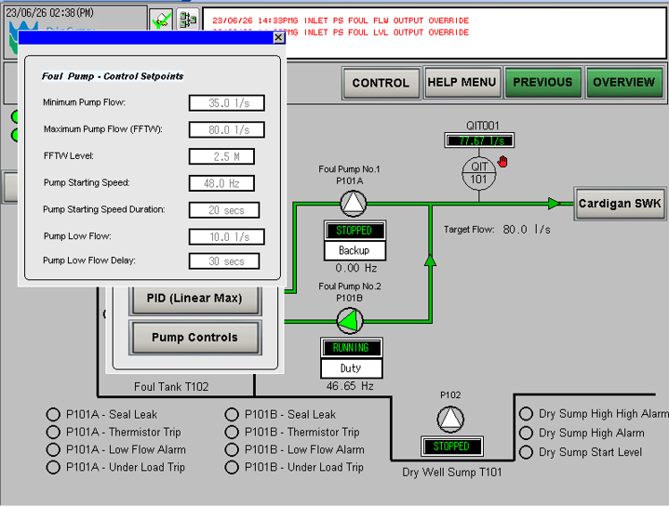
Figure 24 - HMI Control Setpoints screen.
Small changes in Flow would otherwise make the PID keep nudging pump speed up and down, wasting energy and adding wear. To stop this, the PLC applies a deadband of ±3 l/s around the Flow target. While measured Flow stays inside this band, the PID Loop is paused instead of making further corrections. The calculated speed is then converted to an Integer and scaled out through the Analogue Output card to the VSD.

Alarms and the HMI in Operation

The PLC constantly checks each pump for fault conditions, like Thermostat Trip, Seal Leak, Under Load and Low Flow, using a dedicated alarm Function Block per fault type. These are combined and sent out as hardwired Digital signals to the Telemetry outstation, keeping alarm reporting independent of any comms network.
The HMI Overview screen brings all of this together in 1 live mimic diagram. With the Sump empty, target Flow already shows the 35.0 l/s minimum. At 1.10m, just above the Start Level, Foul Pump No.1 is running at 48.00Hz, the fixed starting speed, with a target Flow of 38.0 l/s.

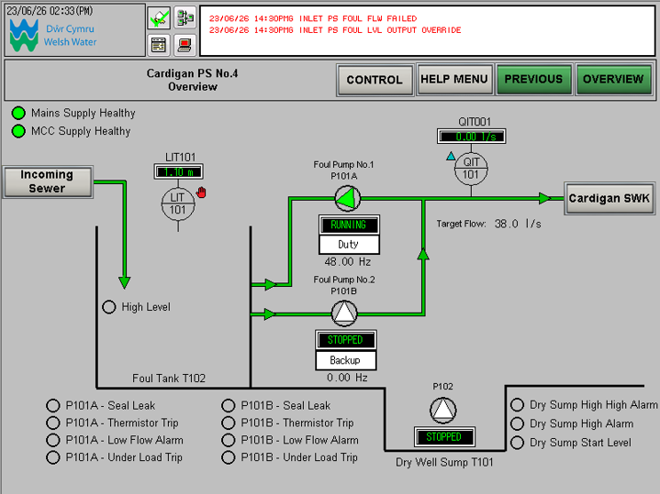
Figure 25 - Level 1.10m, Foul Pump No.1 running at 48.00Hz (starting speed), target Flow 38.0 l/s.
At 3.00m, above the FFTW (Full flow to treatment) Level, target Flow is clamped at the 80.0 l/s maximum, with the pump running at 46.65Hz to try and deliver close to that target. This shows the level-driven, linearly scaled PID Flow control strategy working in live conditions, the target Flow and pump speed follow the Sump Level automatically without an Operator needing to step in.
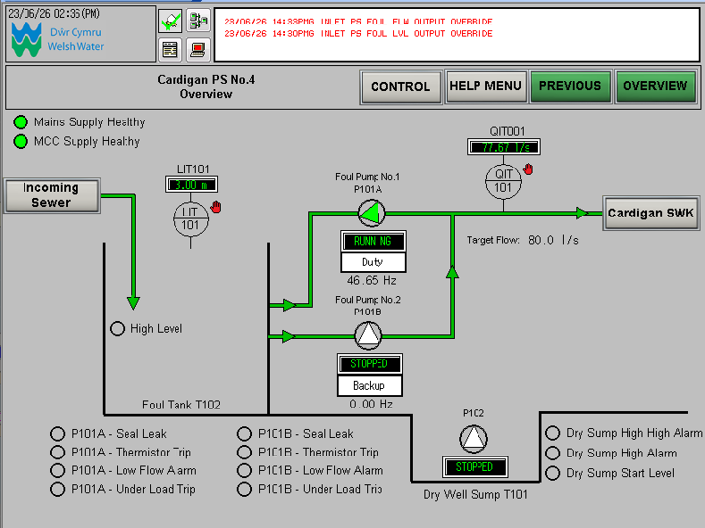
Figure 26 - Level 3.00m, above FFTW, target Flow clamped at 80.0 l/s, pump running at 46.65Hz.

Flowchart - GJ
Figure 27 shows the pump starting sequence. On a Run Request, the pump runs at a Fixed Starting Speed of 48.0Hz for 20 seconds, to blast any rags or wipes at high speed [15]. Once these elapses, the PLC checks if the Flow meter has failed. If it has, the pump falls back to a fixed 40.0Hz until the fault clears. If not, control passes to PID, which sets the Motor Speed. The PLC then checks Level. If the level hasn't dropped to the stop level (0.50m), the loop keeps monitoring and adjusting speed. Once Level reaches 0.50m, the pump stops and the sequence returns to Start, ready for the next Run Request.

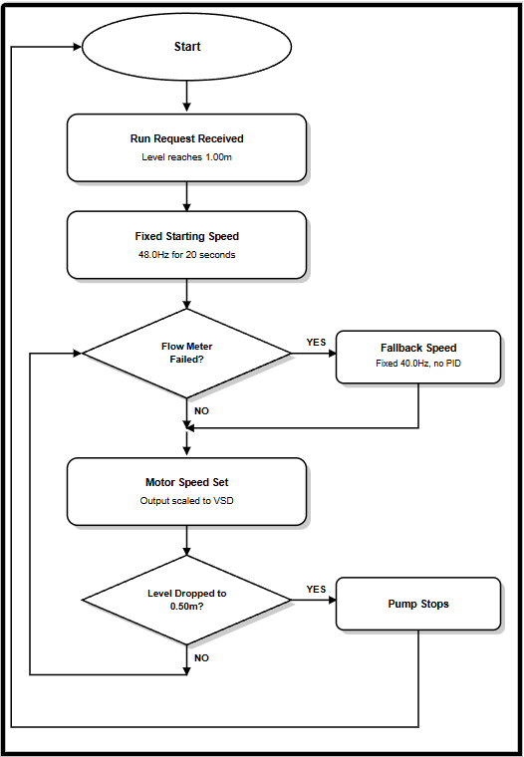
Figure 27 - Pump start sequence

Evaluation - GJ

In this evaluation, will show all the cost of the install together in Table 7 below. In a group meeting, this was discussed to evaluate the cost if it is viable to proceed with the installation. To determine if the cost is justifiable, a cost saving on the energy shown in Table 8 will need to be looked at to see if the project will be paid back in time Shown in Table 9.

Table 7 - Total cost of the project
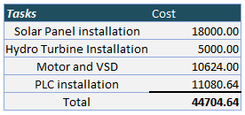

Table 8 - Total energy saving of the upgrade
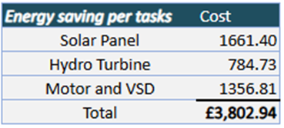

With the risks of blockages with the turbine, this will give operators more work to clear this. To save on the cost of the operator, the turbines will not be installed [35].

Table 9 – Number of years to pay back the project Cost.
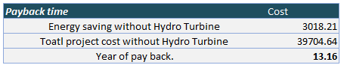

With a local grant from Swansea Council [36] providing a means to reduce the carbon footprint that can offset the capital cost will help reduce the payback time shown in Table 10.
Table 10 - Pay back with a grant over the years
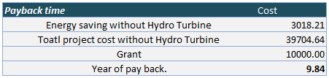

Maintenance of Site

6.1.1 Solar panel maintenance -CK
Solar PV systems generally require minimal maintenance. However, routine inspections are recommended to ensure maximum efficiency and safe operation.
Typical maintenance activities include:
- Cleaning of solar panels
- Visual inspection of electrical connections
- Structural inspections
- Corrosion protection
- Inverter servicing and replacement
Estimated maintenance costs are approximately £300 per year, with an inverter replacement allowance after 10–15 years.
Over a 25-year operating life, maintenance expenditure is estimated to be approximately £7,500, including routine inspections and inverter replacement allowance.

6.1.2 PLC, VSD & Pumps Maintenance -GJ

The cost of maintaining the function of the site will drop considerably with less fault-finding. The operator can check on the HMI where the fault is.

Environmental impacts - GJ

Overflow risk — pump/system failure can release untreated sewage into rivers, harming wildlife [37]
Odour— hydrogen sulphide and other gases from stagnant or poorly ventilated sewage can affect nearby residents and air quality [38]
Energy use — pumps consume significant energy, contributing to carbon emissions [38]
Noise Pollution – Pumps running at maximum power make loud noise in the surrounding area [38].
This design reduces — lower energy use (15-20% saving), enables faster fault detection and PID control to reduce the noise level most of the time.

Conclusion & Reflections

CK
Conclusions
- Successfully designed a reliable dual water pumping station.
- Developed a cost-effective design using readily available components.
- Proposed the use of solar panels to reduce energy costs and improve environmental sustainability.
- Produced a realistic project plan using a Gantt chart to manage tasks and milestones.
Reflections
- Improved understanding of pumping station design and operation.
- Gained experience in project planning and time management.
- Developed knowledge of PLC control systems and pump protection methods.
- Recognised the importance of considering cost, maintenance, and sustainability during the design process.
- Improved teamwork, communication, and technical presentation skills.

JW
Conclusions
- A hydrokinetic turbine is a practical way of generating renewable electricity from the gravity-fed inlet flow of a wastewater pumping station.
- The proposed system could generate approximately 2,834 kWh of electricity each year.
- The financial assessment showed that the system could provide annual electricity savings of approximately £785.
- Overall, the turbine would improve the sustainability and efficiency of the pumping station while working alongside the proposed solar panel system.

Reflections

- This project improved my understanding of hydroelectric power generation and renewable energy systems.
- I developed my engineering calculation and research skills by assessing the technical and financial feasibility of the turbine.
- Producing the CAD model helped me understand how the turbine and generator could be integrated into the pumping station.
- If this project were continued, I would use real flow data from an existing pumping station to produce more accurate power generation estimates.

TM
Conclusions
- Successfully was able to identify and select an appropriate control method, which was a VSD for the control of the flow of the wastewater and the reduction in energy consumption compared to a DOL.
- The dual pump system will enable an extended lifespan for the site and reduce the need for maintenance
- The selected pump was the Xylem Flygt Concertor N 6020 submersible wastewater pump due to the hydraulic requirements, integrated VSD, self-cleaning ability and the anti-clog function to reduce the need for maintenance and shut down time.
- The pumps were chosen to operate in a duty/standby operation in normal conditions and duty/assist operation in storm weather which will increase the lifespan of the site and the pumps as well by reducing wear.
- The pump was also chosen due to its ability to be used with 3rd party controllers such as a PLC.
- Overall, the pump and control method contribute significantly to the aim of reducing costs and increasing longevity of the system.
Reflections
- I gained an improved understanding of pumping stations as a whole.
- I understand more on how a specific pump and control method can impact how the system runs and being able to make a calculated design decision to accommodate for the conditions given.
- I also gained an understanding of proper planning and time management and how it is essential for any project to run efficiently and productively.
- Improvement in team communications skills and presentation skills have benefitted greatly from this project as they are a crucial aspect of any project that involves working with other people.
- If the project had to be developed further, I would look at the performance curves and site data of different sites to be able to validate my choices for the pump and control method.

GJ
Conclusions
- Successfully designed a PLC control system using a Level-driven, linearly scaled PID Flow control strategy to match pump speed to actual demand.
- The design meets the Aim of reducing energy use, using the 15-20% saving figure established in the Literature Review.
- The full signal chain was mapped and tested, from raw 4-20mA input through to VSD speed output, confirming the design works as intended.
- Duty/Standby and Duty Sync logic were included to spread pump wear evenly and improve reliability if a pump fails.
- A relay logic alternative was costed for comparison. Relay logic is cheaper but cannot provide PID-based VSD control, so it cannot deliver the same energy savings.

Reflections
- Improved understanding of PLC hardware, I/O card selection, and how the Power Supply, CPU, and I/O cards work together on the rack.
- Developed a much clearer understanding of PID control, particularly how Proportional and Integral work together and why Derivative wasn't needed here.
- Gained experience reading real ladder/FBD logic and tracing a signal from raw input through to final output, rather than just working from theory.
- Using an existing, real Welsh Water PLC/HMI setup as a working reference made the design far more grounded and realistic than working from a blank page.

References

[1] | “PRINCE2.com,” PRINCE2, [Online]. Available: https://www.prince2.com/uk/prince2-methodology. [Accessed 11 JUNE 2026].
[2] | “https://historicengland.org.uk/,” [Online]. Available: https://historicengland.org.uk/images-books/archive/collections/photographs/the-great-stink/. [Accessed 05 07 2026].
[3] | G. C. Cook, “Construction of London's Victorian sewers: the vital role of Joseph Bazalgette,” Postgraduate Medical Journal, vol. 77, no. 914, pp. 802 - 804, 2001.
[4] | J. Douget, “The Steam Pumping Stations of the London Main Drainage, 1858–75,” Industrial Archaeology, vol. 43, no. 2, pp. 135-146, 2021.
[5] | “Submersible Wastewater Pump Association,” [Online]. Available: https://www.swpa.org/submersible-wastewater-pump-story/. [Accessed 05 07 2026].
[6] | K. T. Erickson, “Programmable Logic Controllers,” The workhorse of factory automation keeps things on track , vol. 15, no. 1, pp. 14 - 17, 1996.
[7] | S. Yimchoy and U. Supatti, “Reduction of Energy and Water Loss in the Water Supply Pump Systems by Using PLC with Variable Speed Drives,” in International Conference on Power, Energy and Innovations (ICPEI), Nakhon Ratchasima, Thailand, 2021.
[8] | “International Energy Agency,” Global Energy Review 2025 – Electricity, 2025. [Online]. Available: https://www.iea.org/reports/global-energy-review-2025/electricity. [Accessed 10 July 2026].
[9] | International Energy Agency Photovoltaic Power Systems Programme (IEA PVPS), “Trends in Photovoltaic Applications 2025,” 2025. [Online]. Available: https://iea-pvps.org/trends_reports/trends-2025/. [Accessed 10 July 2026].
[10] | K. S. K. M. B. P. C. R. P. Ravi Kiran Karre, “A review on hydro power plants and turbines,” INTERNATIONAL CONFERENCE ON RESEARCH IN SCIENCES, ENGINEERING & TECHNOLOGY, vol. 2418, no. 1, 2021.
[11] | A. C. J. K. A. K. C. Ayushi Priya, “Exploration of Starting Methods of Induction Motor,” in Recent Developments in Control, Automation and Power Engineering, Conference Proceedings, 2025.
[12] | K. T. D. Raja Harahap, “Analysis Of Comparison Between Direct Starting Method (Direct On,” pp. 35-39, 2024.
[13] | M. L. a. B. K. H.H. Goh, “Comparison between Direct-On-Line, Star-Delta,” Proceedings of the International MultiConference of Engineers and Computer Scientists 2009 Vol II, vol. 2, pp. 1-2, 2009.
[14] | M. N. R. K. M. P. K. P. A. A. Y. Mr. Amit Kale, “A REVIEW PAPER ON VARIABLE FREQUENCY DRIVE,” International Research Journal of Engineering and Technology (IRJET), vol. 04, no. 01, pp. 1281-1284, 2017.
[15] | K. G. M. M. S. I. Khalid Hussien Khudier, “Design and Implementation of Constant Speed,” IOP Conference Series: Material Science and Engineering, pp. 1-8, 2020.
[16] | D. Kumar, “Performance Analysis of Three-Phase Induction Motor with AC,” Performance Analysis of Three-Phase Induction, pp. 1-2, 2017.
[17] | U. S. Suttapong Yinchoy, “Reduction of Energy and Water Loss in the Water,” 2021 International Conference on Power, Energy and Innovations, pp. 9-10, 2021.
[18] | C. Wurtsmith, “Pumps&Systems,” 17 April 2026. [Online]. Available: https://www.pumpsandsystems.com/article/differences-between-wastewater-pump-types/. [Accessed 12 July 2026].
[19] | “Waterandwastewater.com,” 8 January 2026. [Online]. Available: https://www.waterandwastewater.com/a-comprehensive-guide-to-wastewater-treatment-pumps/. [Accessed 12 July 2026].
[20] | JA Solar Technology Co., Ltd., “JAM54D41 LB Series Datasheet (Deep Blue 4.0 Pro),” 2024.
[21] | Solargis; The World Bank Group, “Global Solar Atlas – United Kingdom,” 2026. [Online]. Available: https://globalsolaratlas.info/download/united-kingdom. [Accessed 15 June 2026].
[22] | Direct Drainage, “Sewage Treatment System Running Costs in the UK (2026 Guide),” Direct Drainage, 2026. [Online]. Available: https://direct-drainage.co.uk/blogs/sewage-treatment-systems-faqs/how-much-does-a-sewage-treatment-system-cost-to-run-in-2026?srsltid=AfmBOorxZhoS7y-dU9nOp-lkAyZoseR02w4JBnQE8HJPdemVWYJFIiUF. [Accessed 13 07 2026].
[23] | Department for Energy Security and Net Zero, “Greenhouse Gas Reporting: Conversion Factors 2025,” 2025. [Online]. Available: https://www.gov.uk/government/publications/greenhouse-gas-reporting-conversion-factors-2025. [Accessed 20 June 2026].
[24] | A. M. Omer, Energy, environment and sustainable development, Nottingham: Science Direct, 2007.
[25] | F. P. L. C. L.i. Lago, “Advances and trends in hydrokinetic turbine systems,” Energy for Sustainable Development, vol. 14, no. 4, pp. 287-296, 2010.
[26] | OVO Energy, “Average electricity usage in the UK: how many kWh does your home use?,” OVO, 1 07 2026. [Online]. Available: https://www.ovoenergy.com/guides/energy-guides/how-much-electricity-does-a-home-use. [Accessed 09 07 2026].
[27] | Centre for Alternative Technology, “Micro-Hydro Power,” Centre for Alternative Technology Charity, [Online]. Available: https://cat.org.uk/info-resources/free-information-service/energy/micro-hydro/?utm_source=chatgpt.com. [Accessed 07 07 2026].
[28] | P. c. A. M. Christine Power, Microhydropower Energy Recovery at Wastewater-Treatment Plants: Turbine Selection and Optimization, Journal of Energy Engineering, 2016.
[29] | “The Global Manuals Library,” [Online]. Available: https://www.manualslib.com/manual/1600313/Xylem-Flygt-Concertor-6020.html. [Accessed 12 July 2026].
[30] | Xylem, “Flygt,” 2018. [Online]. Available: https://www.xylem.com/siteassets/brand/flygt/resources/flygt-resources/flygt-concertor-brochure-us-and-canada-revised.pdf. [Accessed 12 July 2026].
[31] | “My Pump Solutions,” [Online]. Available: https://www.mypumpsolutions.co.uk/flygt/#get-in-touch. [Accessed 12 July 2026].
[32] | “Mitsubishi,” [Online]. Available: https://dl.mitsubishielectric.com/dl/fa/document/manual/plc/sh081262eng/sh081262engas.pdf. [Accessed 06 July 2026].
[33] | J. J> R. Hackworth and F. D. Hackworth, “Programmable Logic Controllers: Programming Methods and Applications.,” Upper Saddle River, New Jersey, Pearson Prentice Hall, 2004.
[34] | “worldpumps.com,” Mark Allen Group, 21 07 2009. [Online]. Available: https://www.worldpumps.com/content/features/sewage-blockages-cut-by-pump-control. [Accessed 08 07 2026].
[35] | WaterUK, “New proof that flushing wipes is a major cause of sewer blockages,” WaterUK, 12 12 2017. [Online]. Available: https://www.water.org.uk/news-views-publications/news/new-proof-flushing-wipes-major-cause-sewer-blockages. [Accessed 14 07 2026].
[36] | “Swansea Council,” [Online]. Available: https://www.swansea.gov.uk/businessfunding?lang=en. [Accessed 14 07 2026].
[37] | “Event Duration Monitoring,” [Online]. Available: https://corporate.dwrcymru.com/en/community/environment/event-duration-monitoring. [Accessed 15 07 2026].
[38] | “Are there environmental concerns associated with pump stations, and how are they addressed?,” Shopify, [Online]. Available: https://direct-drainage.co.uk/blogs/news/are-there-environmental-concerns-associated-with-pump-stations-and-how-are-they-addressed. [Accessed 15 07 2026].
[39] | International Energy Agency, “Global Energy Review 2025 – Electricity,” 2025. [Online]. Available: https://www.iea.org/reports/global-energy-review-2025/electricity. [Accessed 10 July 2026].
[40] | International Energy Agency, “Global Energy Review 2025 – Electricity,” 2025. [Online]. Available: https://www.iea.org/reports/global-energy-review-2025/electricity. [Accessed 10 July 2026].
[41] | GOV.UK, “Gas and Electricity Prices in the Non-domestic Sector,” 2026. [Online]. Available: https://www.gov.uk/government/statistical-data-sets/gas-and-electricity-prices-in-the-non-domestic-sector. [Accessed 23 June 2026].
[42] | Sustainability Directory, “How Is the Theoretical Power Output of a Hydropower Plant Calculated?,” Sustainability Directory, 05 01 2026. [Online]. Available: https://energy.sustainability-directory.com/learn/how-is-the-theoretical-power-output-of-a-hydropower-plant-calculated/. [Accessed 14 07 2026].

Appendices

PLC Hardwire termination - GJ

Digital Input
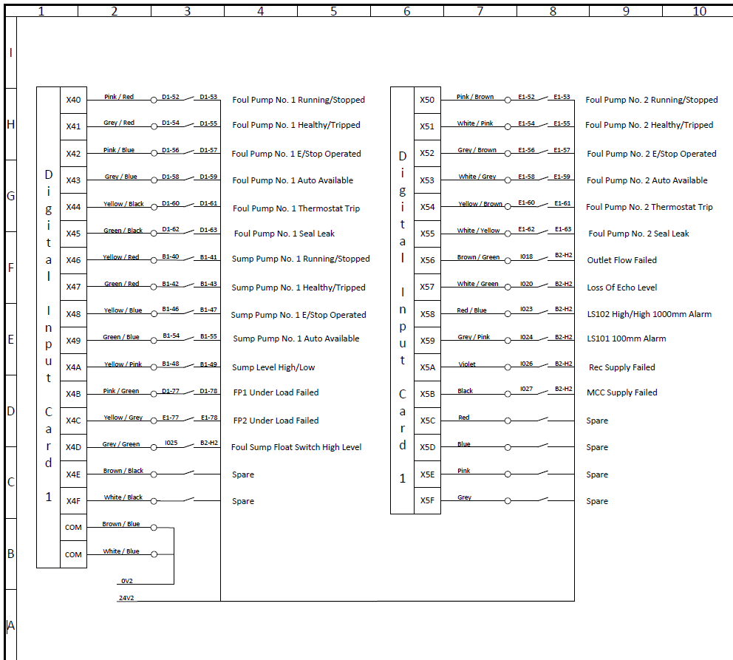

Digital Output

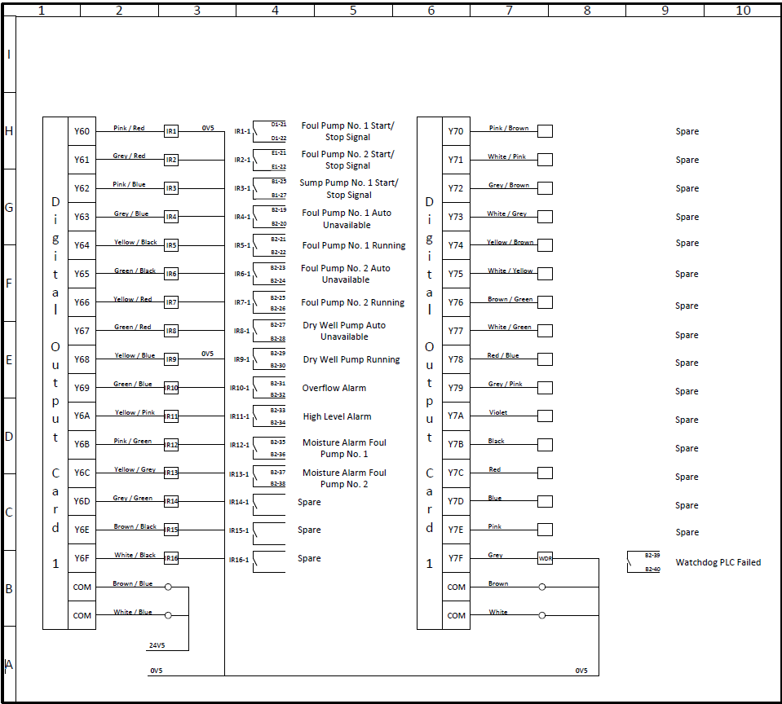

Analogue Input

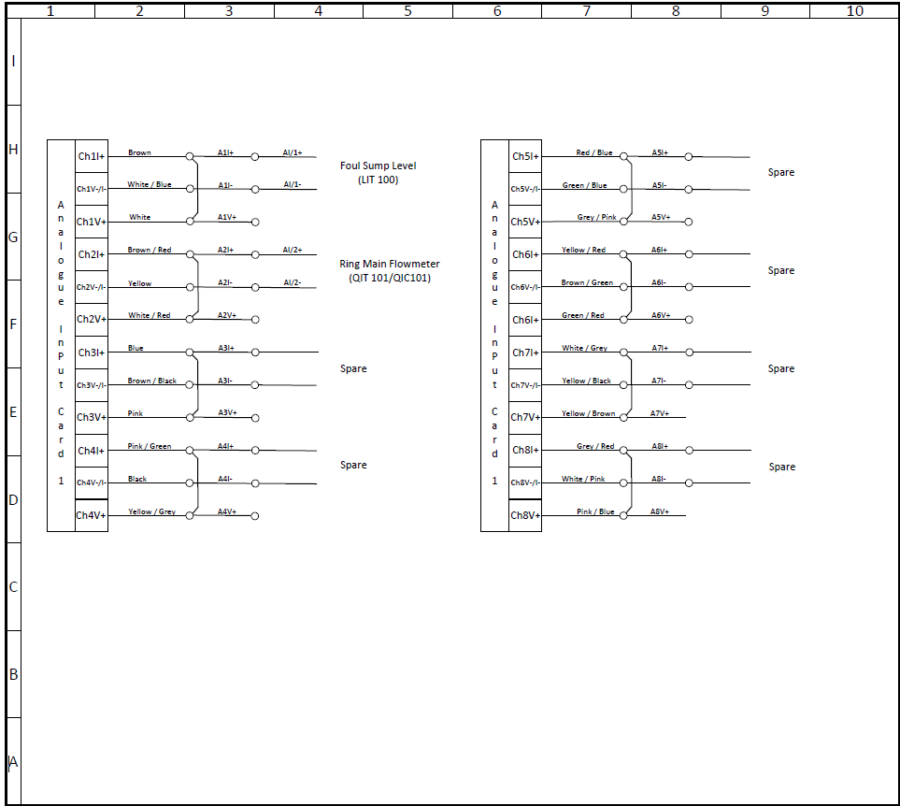

Analogue Output

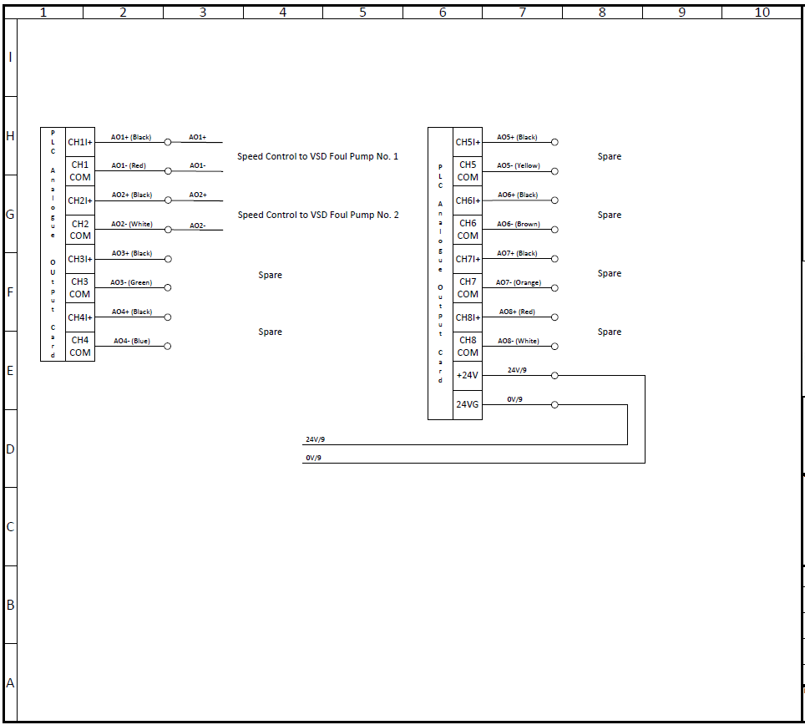

Solar Appendices - CK

Photovoltaic power potential survey.

Figure 28: Photovoltaic statistics for the UK from 2019 [21]

Photovoltaic power potential (PVOUT)
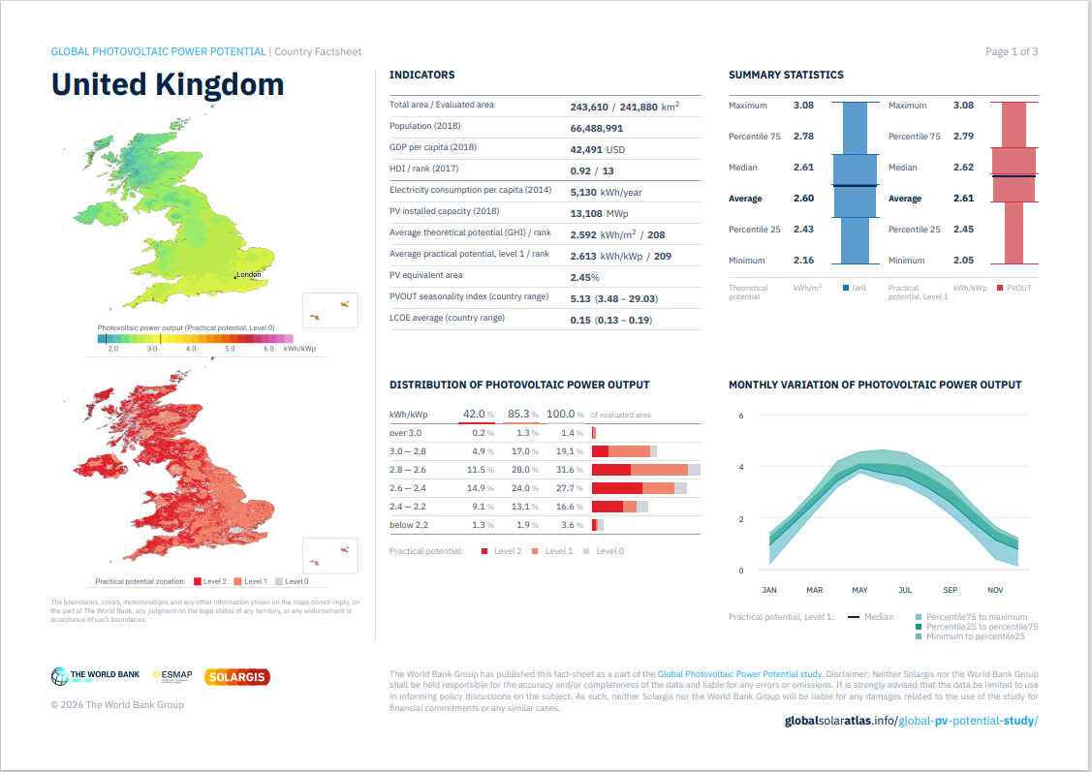
Figure 29:Photovoltaic power potential (PVOUT) for the UK from 2019 [21]

Electrical Specifications for VSD & Pump - TM



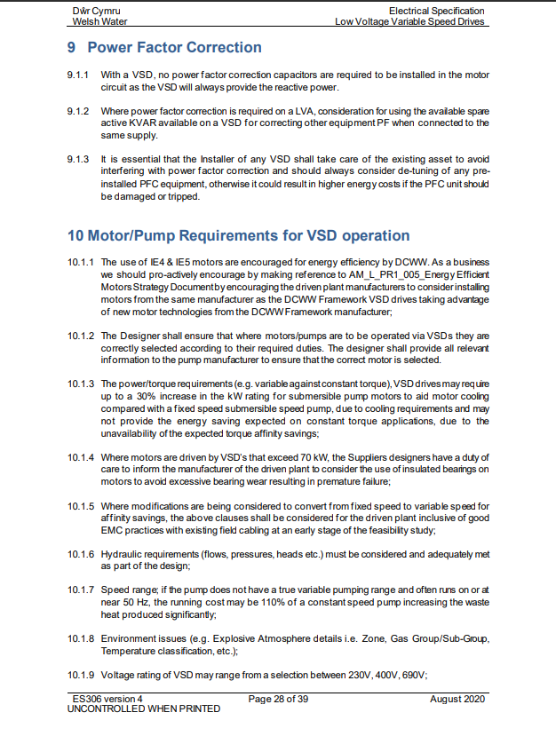

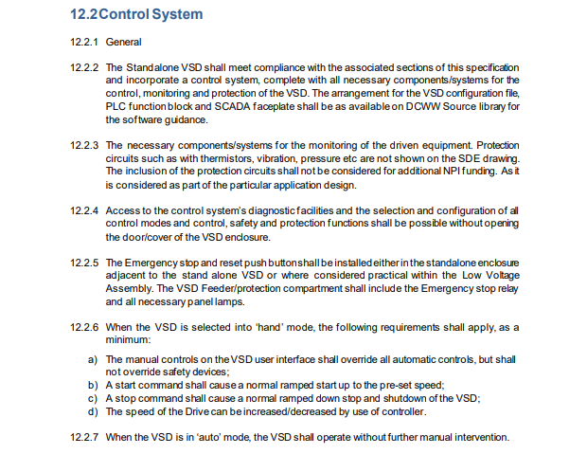
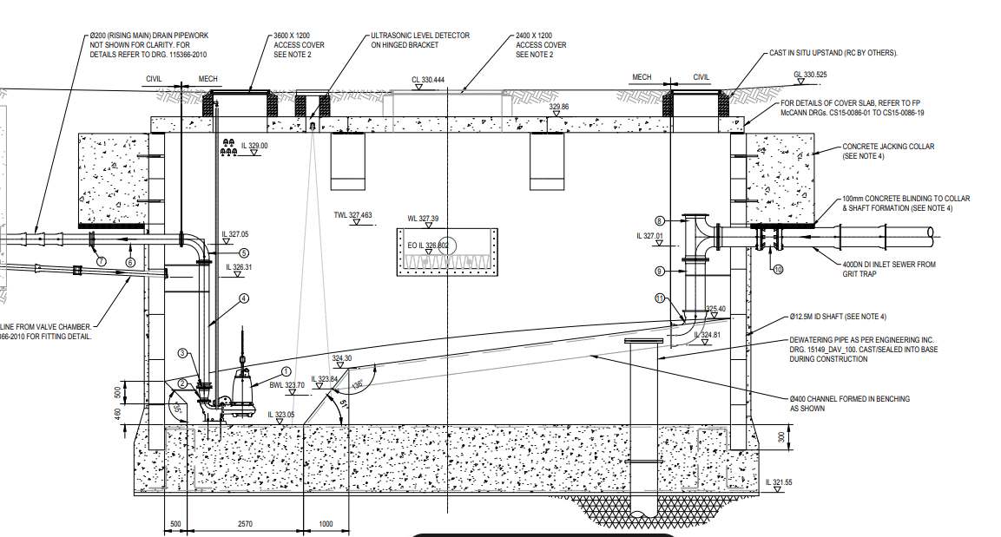

Gantt Chart – TM

Figure 30 - First half of Gantt Chart

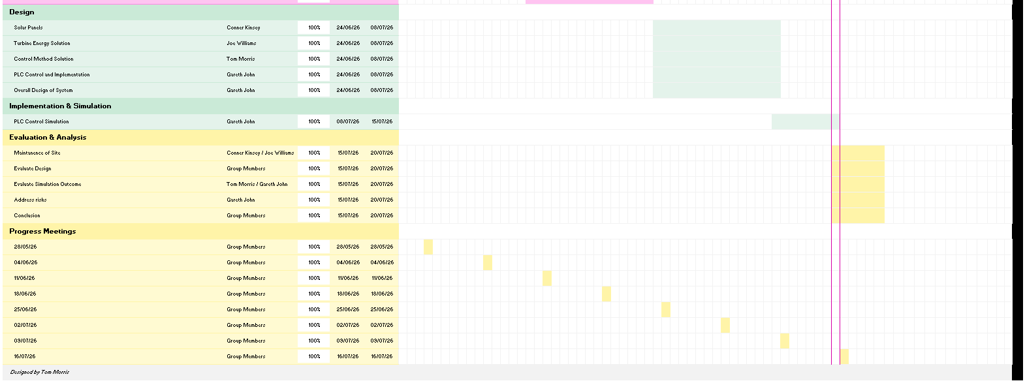
Figure 31 - Second half of Gantt Chart

Meeting Minutes - TM
This section shows detailed minutes from scheduled meetings to evidence progression and group work throughout the project and to monitor the project's planned timeline.

28/05/26 - TM
Attendees: Gareth John, Tom Morris, Conner Kinsey, Joe Williams
Key Points Discussed
- Discussed 5 different ideas for the project
- Discussed Pros & Cons of each project idea
- Decided on the project idea
- Identified risks with project idea
- Start presentation for project idea

04/06/26 - TM
Attendees: Gareth John, Tom Morris, Conner Kinsey, Joe Williams
Key Points Discussed
- Discussed presentation and improvements
- Discussed Plan for project
- Assigned roles for different areas in the project
- Conner assigned to Solar Panels
- Joe assigned to Hydro Turbines
- Tom assigned to Control method & pump selection
- Gareth assigned to PLCs

11/06/26 - TM
Attendees: Gareth John, Tom Morris
Key Points Discussed
- Joe and Conner are unable to attend due to work commitments.
- Gareth discussed the PRINCE2 project phase approach and showed how it aligns with the current project.
- Project specifications and code requirements for the PLC were discussed.
- Discussed simulation timeline, screenshots and how the PLC simulation would be documented.
- Discussed where the group is on their tasks, everyone seems to be on track and aligned.
- Both agree that the main priority is meeting the deadlines set and where possible complete tasks earlier so that they have more time to prepare for the end presentation.

18/06/26 - TM
Attendees: Gareth John, Tom Morris, Joe Williams, Conner Kinsey
Key Points Discussed
- Discussed where the group is on their respective tasks
- Research is close to being completed
- Concerns raised about word count limitation
- Group is on track according to the Gantt chart

25/06/26 - TM
Attendees: Tom Morris, Joe Williams, Conner Kinsey
Key Points Discussed
- Discussed progress on coursework
- Gareth unable to attend due to work commitments
- Design stage and how to structure the work discussed
- Still on track with the plan

02/07/26 - TM
Attendees: Gareth John, Tom Morris, Conner Kinsey
Key Points Discussed
- Joe unable to attend due to being away on PTO
- Highlighted concerns with progression
- Discussed how the design section should be outlined
- Spoke about trying to finish the coursework earlier to have more time to prepare for the presentation
- Deadline set for the 14^{th of} July, if possible, to have all sections written up

09/07/26 - TM
Attendees: Gareth John, Joe Williams, Tom Morris, Conner Kinsey
Key Points Discussed
- Spoke about Energy Savings
- Spoke about the cost of different aspects within the project
- Spoke about risks related to any components on the pumping station
- Decided that the risk of using the Turbine was too great to have it in the final design
- Coursework document the main priority to complete, 200 words left to add.
- Gantt Chart needs to be added to the document appendices

16/07/26 - TM
Attendees: Gareth John, Joe Williams, Tom Morris, Conner Kinsey
Key Points Discussed
- Discussed word count for the final coursework submission
- Covered the document as a group to ensure everything was correct for the submission
- Spoke about the presentation and the information to be within the presentation and how it will be structured
- Spoke about how long the presentation will be and potential questions that may be asked.

