Student Name: Nidia Rios Ahmed
Student Number: 2511212
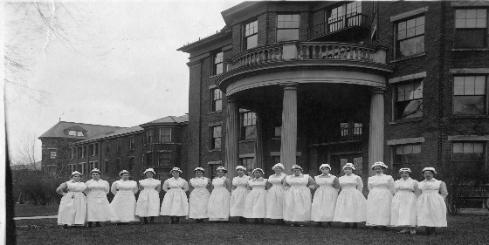
Module: Introduction to Health and Social Care
Module code: LCHS4003
Lecturer: Mumtaz Goolam
Title: Residential care home

Q: what is a residential care home?  A: According to Legislation.gov.uk a care home is any place that can provide suitable accommodation without discrimination of disability, capacity or addiction including some mental health to anyone requiring help, from nursing to assisting with personal care. Allocation to people residing in care homes must be in accordance with the 1984 Act.  Q: How long have care homes been around?  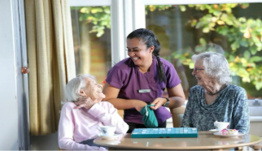  A: In all honesty, the revelations upon research were shocking and extraordinarily long but most definitely extremely interesting. It will be presented factual but briefly as the aim is to also show its continuity and developments over time. | Research from Lambournalmshouse.org shows that for example St Oswald’s Hospital in Worcester was founded in 990. A refuge was created by the bishop “to help the sick, bury the dead, assist the poor and provide shelter to travellers”. This is the oldest and still standing institution established to provide food and shelter to the poor.  Previously called hospitals or “bed-houses” are the Alms houses charitable housing institutions, over a millennium year of changes and adaptations alongside the monarchy, the church and state to continuously keep providing, helping, and assisting to those in need and the vulnerable.  With two objectives and focus that has lasted over a millennium which is to provide “hospitality and shelter” and by “always preserving their dignity.”
“Regulation 12: Safe care and treatment - Care Quality Commission CQC Regulation 12 requires care providers to ensure that all care and treatment is delivered safely, including managing risks, maintaining staff competence, safe premises and equipment, proper medicines management, infection control, and coordinated care planning.”  There are laws and regulations in place to ensure that residents in care homes are protected and that staff are fully compliant. Healthcare has been revolutionised in the las Millenium, and it will keep doing so. The priority has in the past been focusing on the person requiring the care, but laws have changed and not only protect the service user but also the staff. The Equality act 2010 this law protects everyone from discrimination and states that all individuals must be respected and treated fairly. | Following the Code of conduct in health and social ensures that healthcare workers know beforehand what is expected from them, understanding this permits the health care worker to carry out their work correctly, taking pride in maintaining the service user’s, safety, respect, and dignity as of paramount importance. By doing this they are also keeping themselves protected, registering and completing all logs, adhering to manual handling training. Reporting any issues correctly and promptly.  Laws are in place to protect everyone, to keep everyone safe. If unsure always ask for further, help, training, information.
According to a report written by The Health Foundation www.health.org.uk  “The NHS constitutional standard that at least 92% of patients should wait no more than 18 weeks from referral to starting treatment has not been met nationally since 2016.⁴⁷ In cancer care, the 62-day waiting time target – that at least 85% of patients should start treatment within 62 days of an urgent GP referral – was last met in 2015.”  www.necsu.nhs.uk/digital-applications/capacity-tracker/ from the 19 August to 19 September CQC ran a voluntary survey via Capacity Tracker.  From Domiciliary agencies, care homes and hospitals that participated the survey it gave the government a better idea of what issues to tackle and in which order. This came after a big surge of work visas in the healthcare sector were being applied after Brexit. This survey covers several issues that happen daily and constant in the health and sector. | 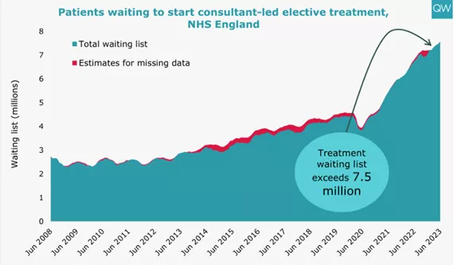
To summarise, there are many issues in the healthcare sector that we are aware of, many that we are not so much aware, this research only demonstrates that with each challenge there are also many solutions and many more possibilities of a more positive outcome.  The trouble is that it is much easier to focus on the problem without realising that it is more productive to be positive and support change, campaign for awareness, encourage fundraising, education, training. There are plenty of independent non-profit organisations other than the most common ones that we are familiar with that provide such services.  www.carecampaignforthevulnerable.com | With optimism in mind, we should want to educate ourselves to support ourselves and others.  It can be time consuming but on the long run it will be worth it if enables a job to be done correctly and efficiently, not to mention rewarding.  There is no price on education or peace of mind. Communication is key.
Reference Care Campaign for the Vulnerable (2026) Care Campaign for the Vulnerable. Available at: http://www.carecampaignforthevulnerable.com (Accessed: 15 February 2026).  Care Learning (2025) Health and social care blog. Updated 25 April 2025. Available at: http://www.carelearning.org.uk (Accessed: 16 February 2026).  Care Quality Commission (2025) Guidance and regulations: Regulations for service providers and managers. Last updated 16 May 2025. Available at: http://www.cqc.org.uk (Accessed: 21 February 2026).  Health Foundation (2023) Nine major challenges facing healthcare and care in England. November. Available at: http://www.health.org.uk (Accessed: 19 February 2026). | Legislation.gov.uk (2026) Legislation.gov.uk. Available at: http://www.legislation.gov.uk (Accessed: February 2026).  Lambourn Alms houses (2026) Lambourn Alms houses. Available at: http://www.lambournalmshouses.org (Accessed: 20 February 2026).  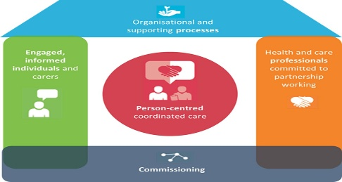  NHS North of England Commissioning Support Unit (2026) Capacity Tracker. Available at: http://www.necsu.nhs.uk/digital-applications/capacity-tracker (Accessed: 16 February 2026).

