
Digital Skills and Research Methods

Submitted by: Samuel Edayi
Student Number: 1706729

Abstract:

Students sometimes feel lack of energies and study stress after engaging few hour mental work and different study related tasks. It is natural to feel work lag while doing similar kind of activities and metal work for a long time. Coffee and drinking coffee can be a solution to this temporary problem. In this report it will be discussed about the influence of coffee on the level of mental energy of students. For assessing the influence it is used and measured some techniques and specific questionnaires to find the impact on their mental behaviour and relaxation on their mental relief against stress. Both the primary and secondary sources are used for collecting necessary information. Primary data collection is done through written questionnaires and surveys along with personal interview. Some of the students were provided with free coffee after finishing two classes one after another and some other are just before starting the class. It is found that the students are feeling relaxed and become refreshed after drinking coffee while they were exhausted after back to back class and few hour of study. So it can be communicated that students may drink coffee to regain their mental energy and feel more concentrated after drinking a cup of coffee.

Table of Contents
Abstract: 2
Title of the research: 4
Introduction: 4
Background of the study: 4
Research questions: 5
Research aim 5
Research objectives: 5
Methodology of the research: 5
Research findings and analysis: 6
Qualitative research and discussion: 12
Conclusion and future research: 12
Conclusion: 12
Future research: 12
Recommendations: 13
References: 14

Title of the research:

Influence of coffee on level of mental vitality of students.

Introduction:

Coffee is a popular drink around the globe. Along with some physical benefit it can provide some mental benefit too. Regular coffee drinkers will get the benefit of fortification against diabetes, Parkinson’s disease healthy heart and so on. But the mental benefit associated with it sometimes greater than the physical benefits. Peoples usually tend to feel tried after working few hours, but the students feel more mental stress and become overwhelmed by the information and study they are engaged with. Drinking a mug of coffee gives them the scope of mental relaxation and revives to study with more concentration. In this report it will be researched about the influence of coffee and its benefits on mental energy of students with structured and analytical means.

Background of the study:

Students of UK are facing a great problem of lack of energy for finishing the study related tasks and the activities they are assigned. More students are engaged in doing part time jobs as they have to pay the tuition fees of them by their own along with paying the payment of their daily living. But studying and acquiring knowledge is still their top priority. But the students sometimes feel dizzy and faced lacking in their energy level after conducting in study for a longer time period just after finishing a long hour of work. It is natural and the students may take some initiatives to restore the mental energy level of them so that they can conduct with another long hour of study. Coffee and drinking coffee can boost their level of energy and help them to restore the enthusiasm of proper study and restore the level of their mental energy as well.

Research questions:

- Is drinking coffee influencing the mental energy of students?
- How coffee is influencing to increase the mental energy of students.
- Why coffee is an effective drink to refresh and relax students.

Research aim

The aim of the research is to find the influences and effects of drinking coffee and its impacts on the mental energy level of students.

Research objectives:

- To find an effective way to relax and increase the mental vitality of the students.
- Notice the influences of coffee as a mental stimulant.
- Discovers the impacts and benefits of drinking coffee on students those are feeling stressed.
- Communicating recommendation for further research.

Methodology of the research:

Strategy of the research:
For collecting data of the research it is used various techniques and after that data are converted into information. According to Prof. Russell Ackoff, “Data is raw. It simply exists and has no significance beyond its existence (in and of itself). It can exist in any form, usable or not. It does not have meaning of itself. In computer parlance, a spread sheet generally starts out by holding data” Ackoff (1989). It is used both qualitative and quantitative data, words and numeric values both are used for collecting data. Qualitative data are used to find the root of the rationale underneath. While quantitative data are used to conduct the research to deliver and communicate the output of the research by numeric value which can quantified and communicated through visual representation.
- Population: The students of UK are considered as the population of the research and among them sample of the data will be chosen.
- Sampling: 100 students were selected for conducting this research from the campus of “University of Wales” as the sample of the data. Random sampling is done for collecting data.
- Method of the data collection: Data collection for the research can be done by conducting both primary and secondary data collection method. For this research it is used mainly the primary data collection method. But secondary method of data collection is also done in a small arena. Primary data collection ensured the authenticity of the research and secondary method provides the reliability of the research.
- Ethical issues: The research is conducted by following the standards of the research methods. All related information of the participants of the research is protected and ensured the privacy concern of the participants as well. It is followed appropriately the guideline of “Research Integrity and Ethics Code of Practice” of “University of Wales” and research ethics committee of the university. This is done “to enhance the quality and integrity of research as well as to protect the rights and welfare of participants and minimise the risk of physical and mental discomfort, harm and danger from research procedures” (Maund, 2017).

Research findings and analysis:

For the purpose of data collection it is used and analysed some specific questionnaire asked to the participants of the research. The research questionnaires were designed and structured for extracting the information and analysing the data collected (Matthews, 2013). In the following section of the paper it is provided the questionnaires asked to the participants of the research.
Topic of the research: Influence of coffee on level of mental vitality of students.

Questionnaire of the research:
Q1. Does drinking coffee mentally refresh you?
Q2. Do you feel more enthusiastic about continuing your studies after drinking coffee?
Q3. Do you think that you tend to grab your study materials more quickly if you start studying after drinking coffee?
Q4. Do you believe that your analytical ability boosted if you drink coffee?
Likert Scale is used to analyse the find the answers of the specific questions. The Likert items used for answering the questions were- Strongly Disagree, Disagree, Neutral, Agree, and Strongly Agree (Rose, 2014).
The data analysis of the research and findings of the research is shown below-
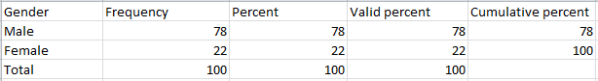
Table 1: Number of participants in the research based on gender
The research was conducted and the participants of the research were both male and female students. Among them 78% were male research participants and 22% were female students as the participants of the research.
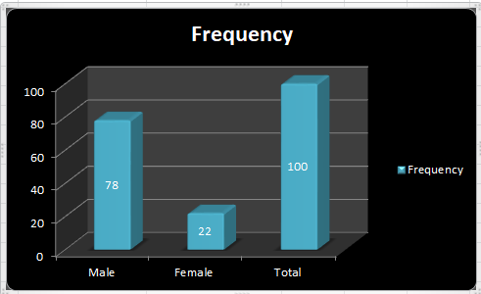
Figure 1: Number of participants in the research based on gender
Question 1: Does drinking coffee mentally refresh you?
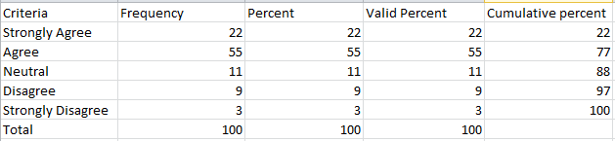
Table 2: Drinking coffee mentally refreshing the students
By the research done above, it is clearly found that, 22% participants of the research strongly agreed that drinking coffee mentally refreshing them, 55% students are agreed with the question and only a 9% disagreed with the condition. In this question 11% participants were neural about the question while only 3% respondents were strongly disagreed that drinking coffee mentally refreshing them.

Figure 2: Drinking coffee mentally refreshing the students

Question 2: Do you feel more enthusiastic about continuing your studies after drinking coffee?
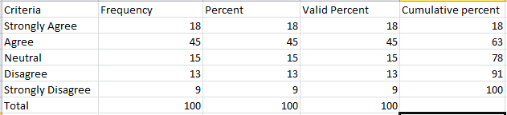
Table 3: Students are feeling more enthusiastic to study after drinking coffee.
According to the research done for the above question, 18% participants strongly agreed that they feel more enthusiastic about continuing their studies after drinking coffee. 45% participants were agreed with the question where 15% participants remained neutral about their opinion. Only a 13% disagreed with the question and 9% strongly disagreed with the condition.

Figure 3: Students are feeling more enthusiastic to study after drinking coffee.

Question 3: Do you think that you tend to grab your study materials more quickly if you start studying after drinking coffee?
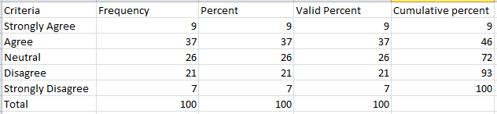
Table 4: Study materials are grabbed more quickly after drinking coffee.
This was the third question of the research. Research data become more scatted in this question. Here 9% participants strongly agreed that they tend to grab study material more quickly just after drinking coffee. 37% students or participants agreed with the question. But the number of neutral participants was higher here and the number was 26%. But 21% participants disagreed that they are grabbing their study material more quickly if they start their study after drinking coffee and only 7% disagreed with the question.

Figure 4: Study materials are grabbed more quickly after drinking coffee.

Question 4: Do you believe that your analytical ability boosted if you drink coffee?
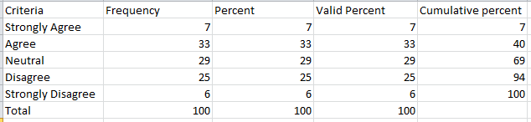
Table 5: It is believed by the students that their analytical ability is boosted by drinking coffee.
According to the data presented above, 7% participants strongly agreed and believe that their analytical ability is boosted by drinking coffee and 33% participants agreed with the question. In this research question 29% respondent remain neutral. 25% respondent disagreed that, drinking coffee is boosting their analytical ability and only a 6% participants strongly disagreed with the condition.

Figure 5: It is believed by the students that their analytical ability is boosted by drinking coffee.

Qualitative research and discussion:

Qualitative research is done while conducting personal interview with the participants. The interview was done through focused interviews. The findings of the research cannot be quantified numerically and visualized in graph or tables (Wengraf, 2011). Most of the respondents agreed that drinking coffee is increasing their level of mental energy. They states that it helps them to conduct with more study hour and they feel relaxed after drinking coffee. It helps them to restore the mental vitality of them.
The rationale behind increasing energy and relaxation is that caffeine in coffee stimulates the brain activity and relaxed the muscles and nerve of the drinker. Another reason behind this is the students get satisfaction while drinking coffee and the concentration of them is diversified in another task rather than studying. Socializing with friends and gossiping with the mates or unknowns while drinking coffee is another reason of increasing the mental relaxation and restoring the mental vitality of students.

Conclusion and future research:

Conclusion:

Students of various institutions tend to fell dizzy after studying for long times. They have to alter their mood and get relaxed for another study hour. After conducting the research, it is found that drinking coffee is a primary solution for the problem of mental energy of the students. It not only helps them to restore their energy level but also increase their concentration and analytical ability.

Future research:
Research is an on-going process and there is scope available for future research on this specific topic as students will be more benefited if more findings can be evolved by future research.

Recommendations:

- Students may take a short break while studying for a long time and feel overwhelmed to drink a cup of coffee in order to restore their mental vitality.
- Opinions of the instructors and faculties have to be collected about drinking coffee and their positivity.
- Coffee and drinking coffee has to be promoted as a healthy and beneficial drink.

References:

Maund, A. Schriek, M. and Tinkler, P. (2017). Certificate in Higher Education: Skills for the Workplace Student Yearbook. Sage Publications.
R.L. Ackoff (1989) "From data to wisdom". In: Journal of applied systems analysis. Vol 16. pp.3-9
Morgan, P. (2016). The Business Student’s Guide to Study and Employability. Sage Publications
Matthews, B. and Ross, L. (2013). Research methods. New York, NY: Pearson Longman.
Wengraf, T. (2011). Qualitative research interviewing. Thousand Oaks, Calif.: Sage.
Rose, K. (2014). UK Social Media Statistics for 2014. [online] Rosemcgrory.co.uk. Available at: http://www.rosemcgrory.co.uk/2014/01/06/uk-social-media-statistics-for-2014/ [Accessed 9 Jan. 2015].
Quinn Patton, M. and Cochran, M. (2012). A Guide to Using Qualitative Research Methodology. [online] fieldresearch.msf.org.

