University of Wales Trinity Saint David (UWTSD)
ACBA4023 – Health, Safety and Welfare
Assignment: Health, Safety & Welfare
Student Name: _Charlie Tee___________________
Student ID: _2517370_________________________
Module Code: ACBA4023
Title: Health, Safety and Welfare


Contents
Contents 2
1. Introduction 3
2. Will the Building Safety Act and Building Safety (Wales) Bill be relevant and how will they impact this project? 4
2.1 What is the building safety act 2022? 4
2.2 How the building Safety act applies to the Croft street Scheme 4
2.3 How the Building safety Bill (Wales) impacts Croft Street refurbishment. 5
3. Explain which Health and Safety legislation which you think is most applicable for this type of construction work and how to comply with it from a managerial perspective including procedures and training (40%) 6
3.1 Health and safety Legislations 6
3.2 What legislation is most important for Croft Street refurbishment 6
3.3 Why was CDM (2015) Introduced? 7
3.4 Managerial compliance 7
4. The director also wants to be sure that you understand the CDM regulations. How would they be complied with on this specific project to reduce risks and make the project safer 9
6. Conclusions 9
7. Glossary 10
8. References 11

1. Introduction
This is a report on a proposed project in Swansea (Croft Street) covering the relevant Health and safety that would be involved with the works and what legislations will directly influence this, We will also be covering the CDM Regulations for the given project and how we can use these to reduce risk and increase the safety of the site.
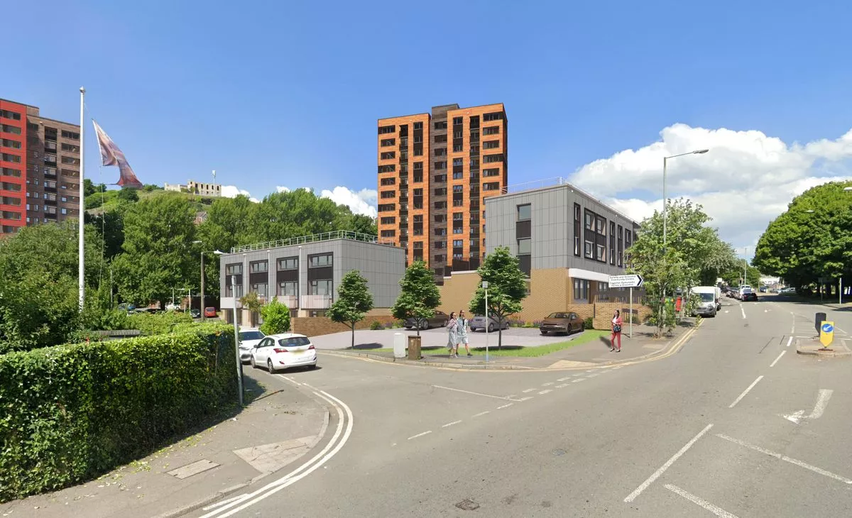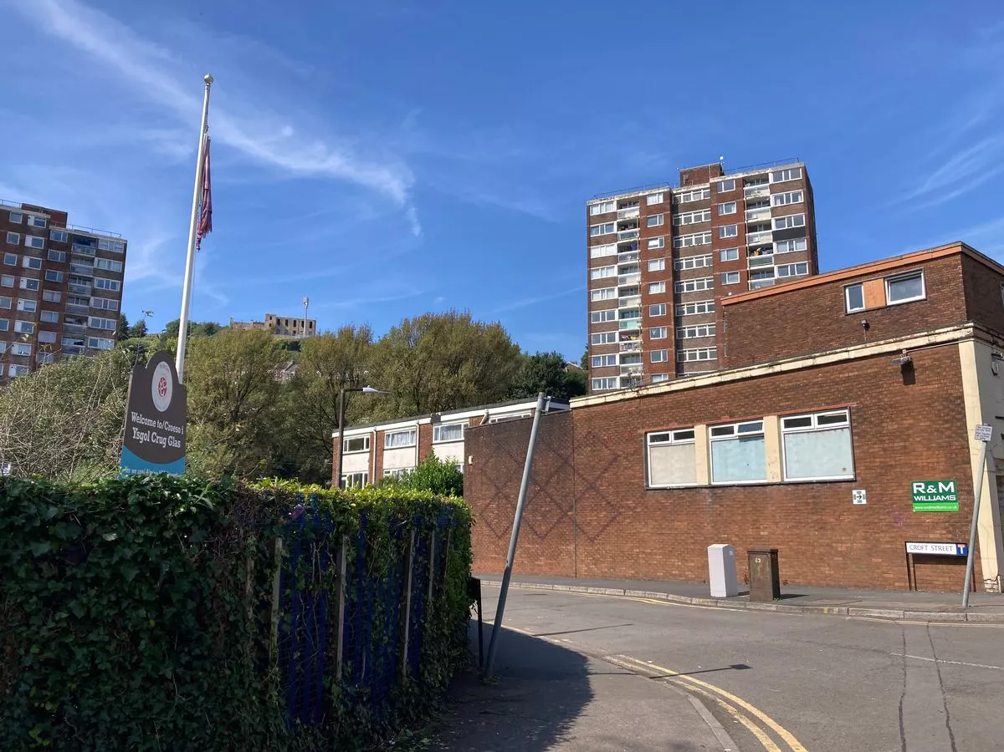
Proposed Existing
Overview
The croft Street Scheme involves two fourteen story high rise blocks and low-rise flats. The refurbishment of croft street is to include new kitchens and bathrooms, Fire Sprinklers, Safety systems, Security upgrades, and External cladding.

2. Will the Building Safety Act and Building Safety (Wales) Bill be relevant and how will they impact this project?


2.1 What is the building safety act 2022?
The building safety act 2022 is a UK legislation introduced after the tragic fire at Grenfell tower in 2017. The legislation was brought in to improve the safety in residential buildings. It created a stricter process for the design, construction, and ongoing maintenance/ management of these buildings. The legislation particularly protects what is classed as ‘Higher risk buildings’ (Over 18m or 7 storeys) as they present more of a risk if something is to go wrong.

2.2 How the building Safety act applies to the Croft street Scheme
Direct impacts
As previously stated, the Croft Street block has two fourteen storey high rise blocks, which means that it falls into the ‘Higher risk building’ category. To start the approvals of work must go through a strict approval system called ‘Gateway’ which means the project must be approved at key stages to ensure the works are compliant, This means for the cladding and fire system upgrades there must be a detailed fire strategy, and designs must be approved by a regulator. This could lead to programme delays if there are delayed approvals and contractors working on site will have reduced flexibility during the construction of the project.
Responsibility and liability
The act creates duty holders on a project (Clients, Designers, and contractors) Who become legally responsible so if there are criminal offences there is an authority to be blamed. Swansea council must appoint a responsible person for the high-risk building on their end

but they must also ensure that their contractors are competent. To mitigate this risk best the appointed contractors should provide Individual Competence: Individuals conducting building or design work must possess the necessary skills, knowledge, experience, and behaviours to ensure work complies with all relevant requirements. The contractor must also Vigilantly check the Skills, Knowledge, Experience, and behaviours of the subcontractors prior to instruction, this must be completed by checking qualifications of their operatives and supervisors, previous experience i.e. portfolios or case studies of similar types of work of their capabilities to conduct the task.
Fire regulations/Safety
Due to the refurbishment being inclusive of fire safety upgrades, both the materials for the cladding and the sprinklers must be evaluated in line with the fire safety standards. The key fire safety standards for the Croft street scheme are:
Approved document B – this is the main fire safety guidance under the building regulations it covers the fire spread over external walls and the use of materials in high-risk buildings. In the Croft street building as, it is over 18m it must have non-combustible materials for the cladding.
Performance and standards - This cladding will then need to pass the BS8414 test for cladding systems and meet the BR135 both put in place to ensure the safety due to multiple causes of fires in high-risk buildings being associated with the cladding. It would also be noted that all relevant firestopping will need to be complete alongside the sprinklers to make sure it is compliant.
Both standards and approved document b ensures that the correct materials are being used, and systems are evaluated properly and pass in the case of an actual fire.

2.3 How the Building safety Bill (Wales) impacts Croft Street refurbishment.
The building safety bill for Wales has a significant impact on the Croft street refurbishment. although the building safety act is used in Wales the Welsh bill is not the same. The bill focuses on the responsible/accountable person as discussed before to continuously manage the fire risks of the building. This includes things as regular risk assessments of Croft Street, inspections to see if upgrades are needed in line with compliance. Overall, it would impact the design and construction phase and gives roles and responsibilities to all involved.

3. Explain which Health and Safety legislation which you think is most applicable for this type of construction work and how to comply with it from a managerial perspective including procedures and training

This Photo by Unknown Author is licensed under CC BY-SA

3.1 Health and safety Legislations
Health and safety legislations are key to the industry as not only do they keep the residents and public safe, but they also ensure whoever is conducting the work is safe. It is also essential because without it the industry standards would drop and increase significant risk.

3.2 What legislation is most important for Croft Street refurbishment
For this project, the most important and primary legislation for most construction projects is the Construction (Design and Management) Regulations 2015 (CDM). These regulations are the standard health and safety law for construction projects in the UK. The aim of the regulations is to improve the health, safety, and welfare on construction sites, clearly define the roles and responsibilities on sites and ensure that from start to finish risks are planned, managed, and controlled.

3.3 Why was CDM (2015) Introduced?
The CDM Regulations were introduced due to the previous poor industry safety record with consistent hazards and accidents happening on sites in the UK. There was also a common theme of only considering the safety at the construction phase. This is now mitigated by using what is called ‘Designing out of risk’ in summary preparing for this risk before starting works on site. This is particularly important for Croft Street to ensure all site safety is considered using preconstruction using site walks with the contractors and other relevant authorities.

3.4 Managerial compliance

Roles and responsibilities
In the CDM Regulations there are multiple sections that different authorities will follow, for Croft Street these are the authorities involved and their roles and responsibilities
Swansea Council – Swansea Council are the Client for the works at Croft Street they must make sure that the project has been planned properly and issue a principal contractor. They must also make sure they provide all relevant preconstruction information whilst giving the principal contractor time to mobilise works to ensure the safety over anything. Budget should be considered with a contingency sum for risk, and they must make sure the contractor is competent to conduct the works.
Principal Designer – The key role for the designer Is to provide the information to the contractor to follow the specifications for the works. But in this process, they must make sure that they thoroughly manage the health and safety design for the Fire sprinklers and external cladding as this is more of a risk than the Kitchen installation.
Principal Contractor – the principal contractor will have the main responsibility of providing The Construction phase plan to the client and have it on site as it is a requirement of CDM. It is constructed by the Contracts manager/project manager for the contractor to ensure they are compliant with the delivery of any Project or job no matter how big or small. The CPP will coincide with the client’s pre-construction information. The CPP shows how they will safely deliver a Project and how they will mitigate risk to all. The CPP must be signed by the competent person and be approved by the CDMC prior to being released on site. For Croft Street this will include the protection of residents during kitchen installation and public areas with the external cladding and most importantly the fire plan which must be displayed on notice boards and a copy onsite in the health and safety file.
Risk assessments and method statements (RAMS)
The law will require the appointment of the contractor on Croft Street to identify the risks on site and present how they will be controlled. This is done by completing a risk assessment on the site and a method statement to back it up.
This form is to be produced, and the Contractors contract/project manager must highlight what tasks and associated risks are present at Croft Street. This is a general tick box exercise in which following completion will lead the CM onto printing the Generic Risk Assessment associated with that task. All operatives must ensure that they sign this form to state they have read the Risk Assessment. Some key risks to highlight on the Croft street are:
- Working at height
- Falling Materials
- Fire risks
- Working in occupied buildings
- Exposure to hazardous materials (COSHH assessment)
- Structural risks
- Manual handling
- Access
These risks must be managed using appropriate procedures to keep in line with the CDM Regulations to keep the workers and residents safe.
The Risk Assessment must then be backed up and supported by a method statement which is used to explain how the task will be carried out safely, Method Statements are not generic, they must be site specific and catered for the environment in which the contractor is working. Failure to present method statements on Croft Street with such an elevated risk at Croft Street could result in severe injury. In the Croft street method statements, it would be expected that for the cladding and the risk of working at height it includes:
- Step‑by‑step installation process
- Use of scaffolding
- PPE requirements
- Lifting procedures
- How falling materials are prevented

With these steps Swansea Council can be confident that the contractor is competent and can manage the site safely leading to a smooth delivery of the project

4. The director also wants to be sure that you understand the CDM regulations. How would they be complied with on this specific project to reduce risks and make the project safer

The CDM regulations would be complied with on the Croft Street refurbishment project by using different control measures to reduce the risks and ensure the safety. Given the scope of works in the project and the fact is a high risk building the CDM Regulations must be applied.
Firstly, the Working at height controls are a key requirement on this due to the ‘Higher risk building.’ To make sure CDM is complied with the principal contractor must ensure that the correct scaffolding systems are in place in line with the specifications and installed by a competent subcontractor if external, this then needs to be inspected weekly especially following extreme weather conditions. Within these works there should be constant supervision on site so that overall, this risk can be reduced.
Risk assessments and method statements must also be put together for high‑risk activities such as cladding installation and internal refurbishments. Managers must ensure these are clearly communicated through inductions and toolbox talks and followed on site. This ensures that risks such as falling materials and fire hazards are properly controlled.
Furthermore, site and traffic management procedures must be managed. Although the project is a refurbishment, materials and equipment will still need to be delivered safely within a residential area. Site managers/Forepersons must ensure designated delivery zones, safe pedestrian routes, and clear signage are in place. This reduces the risk of vehicle collisions and protects residents and members of the public who may be present on or near the proposed site
Fire safety procedures are also critical, particularly due to the high‑rise nature of the buildings and the refurbishment works being conducted. Managers must implement permit‑to‑work systems for hot works such as cutting or drilling, ensure fire extinguishers are available, and always maintain clear escape routes. Workers must also be trained in fire safety procedures and emergency evacuation plans. This is particularly important on Croft Street, as fire can spread quickly in high‑rise buildings and pose significant risk to both occupants and workers if not properly controlled.

6. Conclusions
In conclusion, the Croft Street project is influenced by key legislations including the Building Safety Act, the Building Safety (Wales) Bill, and CDM 2015. These ensure risks such as working at height, fire safety, and working in occupied buildings are properly controlled. This requires effective planning, supervision, and enforcement of procedures. Although this can increase time and cost, it is essential for reducing risk and protecting both workers and residents, ensuring the project is delivered safely and in compliance with legislation.

7. Glossary
- Accountable Person (AP) – Person responsible for managing building safety risks.
- Approved Document B (ADB) – Fire safety guidance within Building Regulations.
- BS 8414 – Fire performance test for cladding systems.
- BR 135 – Pass/fail criteria for cladding fire tests.
- Building Safety Act (BSA) 2022 – Law improving safety in high-risk buildings.
- Building Safety (Wales) Bill – Welsh law for managing safety in residential buildings.
- CDM 2015 – Main regulations for managing construction health and safety.
- Construction Phase Plan (CPP) – Plan for managing site safety during construction.
- Duty Holders – People legally responsible for safety on a project.
- Gateway Process – Approval stages for high-risk building projects.
- Higher-Risk Building (HRB) – Building over 18m or 7 storeys.
- Hot Works – Activities involving heat or sparks with fire risk.
- Method Statement – Step-by-step plan for carrying out work safely.
- Permit to Work – System controlling high-risk activities.
- PPE – Equipment worn to protect workers.
- Principal Contractor (PC) – Responsible for site safety during construction.
- Principal Designer (PD) – Responsible for safety during design stage.
- Risk Assessment – Identifies hazards and control measures.
- RAMS – Risk assessments and method statements combined.
- Scaffolding Inspection – Regular checks to ensure scaffold safety.
- Site Induction – Initial safety briefing for workers.
- Working at Height – Work with risk of falling.

8. References
British Safety Council (2024). What Is COSHH? Everything You Need to Know | British Safety Council. [online] British Safety Council. Available at: https://www.britsafe.org/training-and-learning/informational-resources/what-is-coshh. Accessed 07/05/2026
Bsigroup.com. (2020). BS 8414-1:2020 - TC | 30 Apr 2020 | BSI Knowledge. [online] Available at: https://knowledge.bsigroup.com/products/fire-performance-of-external-cladding-systems-test-method-for-non-loadbearing-external-cladding-systems-fixed-to-and-supported-by-a-masonry-substrate. Accessed 07/05/2026
BBC News (2019). Grenfell Tower: What happened. BBC News. [online] 29 Oct. Available at: https://www.bbc.co.uk/news/uk-40301289. Accessed 07/05/2026
HM Government (2010). Fire safety: Approved Document B. [online] GOV.UK. Available at: https://www.gov.uk/government/publications/fire-safety-approved-document-b. Accessed 07/05/2026
Hanaan Parkinson-Ramsbottom (2026). Risk assessment in construction. [online] BrightHR. Available at: https://www.brighthr.com/articles/health-and-safety/construction-site-safety/risk-assessment-construction/.07/05/2026
HSE (2023). Introduction to fire safety - HSE. [online] www.hse.gov.uk. Available at: https://www.hse.gov.uk/fireandexplosion/fire-safety.htm. Accessed 07/05/2026
HSE (2015). Construction - Construction Design and Management Regulations 2015. [online] Hse.gov.uk. Available at: https://www.hse.gov.uk/construction/cdm/2015/index.htm. Accessed 07/05/2026
Minett, A. (2020). A Complete Guide to CDM Regulations. [online] CHAS. Available at: https://www.chas.co.uk/blog/cdm-regulations-complete-guide/. Accessed 07/05/2026
Making Buildings Safer. (2025). Gateway Three: The final safety gate before occupation - Making Buildings Safer. [online] Available at: https://buildingsafety.campaign.gov.uk/building-safety-regulator-making-buildings-safer/the-building-control-authority/gateway-three-the-final-safety-gate-before-occupation/. Accessed 07/05/2026
Senedd.wales. (2025). Building Safety (Wales) Bill | Senedd. [online] Available at: https://business.senedd.wales/mgIssueHistoryHome.aspx?IId=46141. Accessed 07/05/2026
The Hub | High Speed Training. (2019). What is a Method Statement? | Free Downloadable Template. [online] Available at: https://www.highspeedtraining.co.uk/hub/what-is-a-method-statement/ Accessed 07/05/2026
www.designingbuildings.co.uk. (n.d.). Site layout plan for construction. [online] Available at: https://www.designingbuildings.co.uk/w/Site_layout_plan_for_construction. Accessed 07/05/2026

‌

.

‌

‌
‌

‌

