
TOYOTA'S INTERNATIONAL MARKETING STRATEGIES: A COMPARATIVE ANALYSIS OF INDIA AND THE UNITED KINGDOM

Module Name: International Marketing : Principles and Practices
Module Code: LCMB7026
Student Name: Prince Laurence Sade
Student ID: 2525510
Programme: Master of Business Administration (MBA)
University: University of Wales Trinity Saint David
Lecturer : Tushara Balendran (London)
Dian Mayasari (Birmingham)
Aso Abdullah
Assessment Title: Assessment component - Individual report
Word Count: 5,053 words (excluding references)
Submission Date: 24 July 2026

Executive Summary
This report examines Toyota's international marketing strategies in the UK and India. The UK market is mature, highly regulated, and rapidly shifting towards fully electric vehicles. India is an emerging, price-sensitive market with lower environmental regulation but growing demand for fuel-efficient vehicles. Toyota employs a hybrid strategy emphasising electrified vehicles in the UK while focusing on affordable hybrids in India. This approach creates competitive advantage in India because hybrids align with infrastructure limitations and purchasing power. However, the same strategy increasingly limits competitiveness in the UK because government policy and consumer expectations now favour fully electric vehicles over hybrids. The report applies PESTEL, Hofstede's cultural dimensions, STP, and the 7Ps framework to explain these differences. Key findings show Toyota adapts pricing, product range, and messaging substantially between markets but maintains standardised quality and reliability positioning. The analysis reveals ethical tensions around environmental claims and limitations in Toyota's long-term positioning. Recommendations include accelerating electric vehicle rollout in the UK, expanding local manufacturing in India, and developing market-specific digital engagement strategies.
1. Introduction
Toyota Motor Corporation operates in over 170 countries and sold 10.8 million vehicles globally in 2024 (Toyota, 2025). The company faces fundamentally different challenges in developed and emerging markets. This report compares Toyota's marketing strategies in the UK and India to understand how the company adapts to diverse market conditions. The UK represents a mature market with stringent environmental regulation and consumer preference shifting rapidly towards battery electric vehicles. India represents a high-growth emerging market with price-sensitive consumers, limited charging infrastructure, and lower environmental regulation.
The central argument is that Toyota's hybrid-focused strategy creates competitive advantage in India but increasingly limits competitiveness in the UK. This matters because Toyota's global reputation was built on hybrid technology through the Prius. However, competitors like Tesla, BYD, and European manufacturers are now advancing beyond hybrids. The report examines why Toyota succeeds with adaptation in India but faces strategic tensions in the UK. The analysis applies international marketing frameworks to explain these dynamics and provides evidence-based recommendations. This comparison reveals broader lessons about standardisation versus adaptation and how legacy strengths can become strategic constraints.
2. Comparative Market Overview
The UK and India automotive markets differ fundamentally in size, growth, and consumer characteristics. The UK sold 1.94 million vehicles in 2024, up 2.1% from 2023 but still below pre-pandemic levels (SMMT, 2026). India sold 4.43 million passenger vehicles in 2024, growing 8.0% annually (SIAM, 2026). The UK has GDP per capita of $48,913 whereas India has $2,848 (World Bank, 2025). This means UK consumers can afford premium vehicles and value sustainability whereas Indian consumers prioritise affordability and fuel efficiency.
The UK market shows Toyota at 5.1% share, ranking seventh (SMMT, 2026). India shows Toyota at 2.9%, behind Maruti Suzuki (40.2%), Hyundai (14.8%), and Tata Motors (14.5%) (SIAM, 2026). Toyota is therefore a challenger brand in both markets but for different reasons. In the UK, premium positioning limits volume. In India, higher pricing versus local competitors constrains penetration. These structural differences determine Toyota's marketing approach. The UK requires differentiation through technology and environmental credentials. India requires value demonstration and fuel economy messaging. This creates the central strategic tension examined throughout this report.
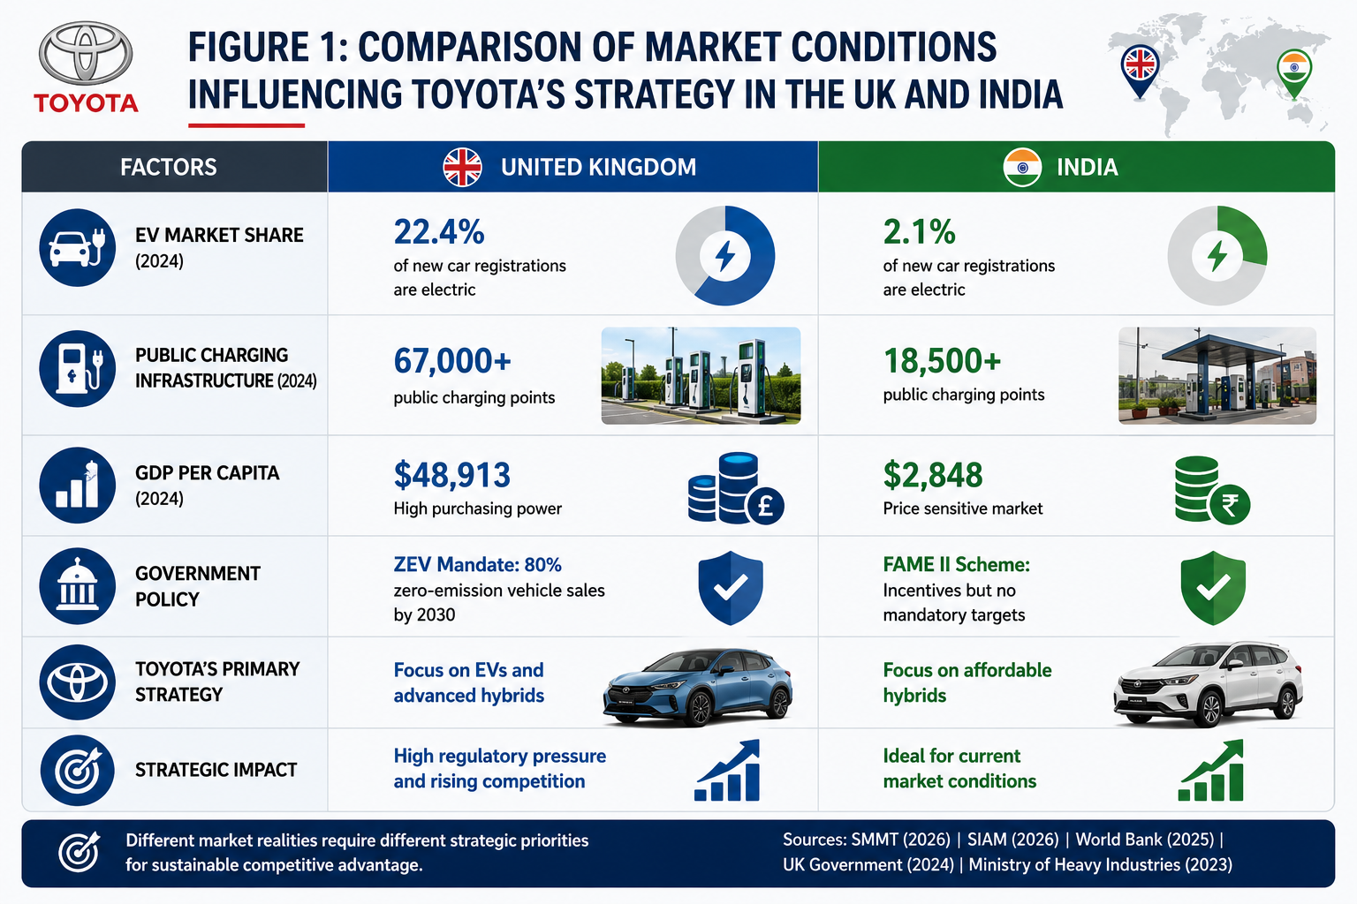
Figure 1 : Comparison of market conditions influencing Toyota's strategy in the UK and India.
3. PESTEL Analysis
Political and Economic Environment
The UK government mandates 80% of new vehicle sales to be zero-emission by 2030 through the ZEV mandate (UK Government, 2024). This creates regulatory urgency for electrification. India has no comparable mandate because the government prioritises economic growth. India's FAME II scheme provides EV subsidies but allows manufacturers to continue conventional vehicles without penalty (Ministry of Heavy Industries, 2023). This matters because Toyota faces regulatory compliance risk in the UK but policy flexibility in India. The UK economy grew 0.8% in 2024 whereas India achieved 7.4% (IMF, 2026; ONS, 2026). UK interest rates stabilized at 4.75% in late 2025, though vehicle finance remains expensive for the 89% of buyers using credit (Bank of England, 2025; Finance & Leasing Association, 2025). India's growth is creating a new middle class but income remains constrained at $2,848 GDP per capita versus the UK's $48,913 (World Bank, 2025).
Exchange rate volatility affects both markets, with the pound and rupee depreciating against the yen 13% and 9% respectively since 2021 (Bank of England, 2025; Reserve Bank of India, 2026). This means imported Toyota models face margin pressure. Toyota produces the Corolla locally in the UK and the Innova in India to mitigate currency risk (Toyota UK, 2024; Toyota Kirloskar, 2024). The economic implication is that UK consumers trade down during economic weakness whereas Indian consumers remain aspirational but price-constrained. Toyota must emphasise total cost of ownership in the UK and absolute affordability in India.
Social and Technological Environment
UK demographics show median age 41.1 years with 76% of consumers considering environmental impact, though only 42% actually purchase EVs (ONS, 2025; Deloitte, 2025). This intention-behaviour gap benefits Toyota's hybrids temporarily. India's median age is 28.7 years with 27% prioritising environmental credentials (World Bank, 2025; McKinsey, 2025). Family size averages 4.4 people in India versus 2.4 in the UK, making larger vehicles more relevant (World Bank, 2024). This means Toyota markets environmental responsibility in the UK but family values and status in India.
The UK has 67,000 public charging points growing 26% annually whereas India has 18,500 for a population 21 times larger (Zap-Map, 2026; Ministry of Power, 2026). This explains why 22.4% of UK sales were fully electric in 2024 versus India's 2.1% (SMMT, 2026; SIAM, 2026). Toyota's hybrid technology provides practical advantage in India because it requires no charging infrastructure while delivering 20-25% better fuel economy (Toyota, 2024). However, technological leadership is shifting. Chinese manufacturers like BYD now offer EVs at $10,000, and Tesla's Model Y became Europe's best-selling vehicle in 2024 (JATO Dynamics, 2025). This means Toyota's hybrid expertise remains relevant in India but is eroding in the UK.
Environmental and Legal Environment
The UK requires 68% emissions reduction by 2030 versus 1990 levels, with transport accounting for 25% of emissions after recent improvements (Climate Change Committee, 2025). India committed to net zero by 2070 with less aggressive interim targets (UNFCCC, 2023). London's ULEZ charges £12.50 daily for non-compliant vehicles (Transport for London, 2024). India has no equivalent enforcement. Toyota's hybrids avoid ULEZ charges now but face obsolescence risk as zero-emission zones expand. Critics note that Toyota has lobbied against aggressive EV mandates in Europe, questioning the authenticity of environmental positioning (Transport & Environment, 2023).
Legal frameworks differ substantially. The UK has strong consumer protection and enforcement aligned with EU standards. India has evolving regulation but inconsistent enforcement. This means Toyota can standardise operations in the UK but requires relationship-based flexibility in India.
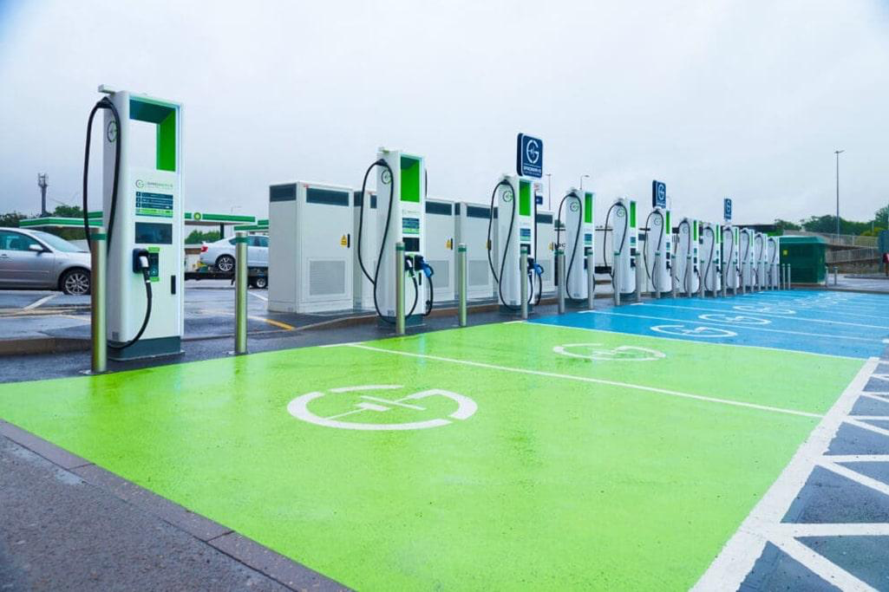
Figure 2: Differences in EV charging infrastructure between the UK and India.
Factor | United Kingdom | India | Toyota Implication
Political | ZEV mandate 80% by 2030 | Incentive-based approach | UK forces EV shift; India allows hybrids
Economic | Stagnant growth, £46,371 GDP/capita | 7.2% growth, $2,612 GDP/capita | UK trades down; India price-sensitive
Social | 72% environmental concern | 23% environmental concern | UK wants green; India wants value
Technology | 53,000 charge points, 16.6% EV share | 12,000 charge points, 1.3% EV share | UK supports EVs; India suits hybrids
Environment | ULEZ zones, strict targets | Limited enforcement | UK penalises emissions; India flexible
The PESTEL analysis shows every factor pushes Toyota towards different strategies. The UK environment increasingly penalises hybrid focus through regulation and competition. India's environment rewards hybrids through policy fit and infrastructure constraints.
4. Hofstede's Cultural Dimensions Analysis
Hofstede's framework explains why Toyota adapts marketing messages between the UK and India despite selling similar products. India scores 77 on power distance whereas the UK scores 35 (Hofstede Insights, 2026). This means Indian society accepts hierarchical structures more readily. Toyota leverages this by positioning vehicles as status symbols in India. The Fortuner is marketed as "The Invincible" showing successful businesspeople (Toyota Kirloskar, 2024). UK's low power distance means status appeals create negative reactions. Toyota UK emphasises rational benefits like reliability and environmental credentials instead (Toyota UK, 2024). The same Corolla therefore suggests social advancement in India but sensible choice in the UK.
The UK scores 89 on individualism whereas India scores 27, indicating collectivist culture (Hofstede Insights, 2024). British consumers emphasise personal choice and individual environmental contribution. Toyota UK's "Self-Charging Hybrid" campaign focuses on personal agency (Toyota UK, 2024). India's collectivist culture means family consultation determines purchases. Toyota India advertising features multi-generational families and group journeys (Toyota Kirloskar, 2024). This matters because dealership interactions differ. UK customers expect independent browsing whereas Indian customers visit with family and expect consultative selling.
India scores 51 on long-term orientation whereas the UK scores 25 (Hofstede Insights, 2024). Indian consumers value vehicle durability and resale value. Five-year-old Fortuners retain 68-72% of original value (CarDekho, 2026). Toyota India emphasises "Quality, Durability, Reliability" and lifecycle costs. UK's short-term orientation means consumers focus on monthly finance costs and current incentives rather than long-term ownership.
Dimension | UK Score | India Score | Marketing Adaptation
Power Distance | 35 | 77 | UK: equality; India: status
Individualism | 89 | 27 | UK: personal; India: family
Long-term Orientation | 25 | 51 | UK: immediate; India: lifecycle
However, Hofstede has limitations. National averages obscure demographic differences. Young, urban Indians increasingly resemble UK consumers in values and attitudes (Economic Times, 2025). Toyota must use cultural insights as starting point rather than deterministic rules.
5. Segmentation, Targeting, and Positioning Analysis
Segmentation and Targeting
Toyota uses different segmentation approaches because market structures differ. The UK uses psychographic and benefit segmentation identifying "eco-conscious pragmatists", "technology enthusiasts", and "value seekers" (Toyota UK, 2024). This reflects the UK's developed market where attitudes matter more than demographics. India uses income-based and geographic segmentation because purchasing power varies substantially. Toyota segments by urban versus rural, tier-one versus tier-two cities, and income brackets (Toyota Kirloskar, 2024). The company targets "aspirational middle class" earning ₹800,000-1,500,000 annually ($9,600-$18,000).
This matters because UK segmentation assumes baseline income sufficiency and focuses on preferences. Indian segmentation recognises that income determines market accessibility. The UK employs differentiated marketing with distinct models: Yaris Cross for urban buyers, Corolla for mainstream, RAV4 for families, and bZ4X for early EV adopters (Toyota UK, 2024). India uses concentrated targeting focused on aspirational middle class because this segment is growing fastest at 11% annually (McKinsey, 2025). However, concentrated targeting makes Toyota vulnerable if competitors move upmarket.
Positioning Strategy
UK positioning centres on "Hybrid Electric Pioneer" emphasising environmental leadership (Toyota UK, 2024). This creates advantage against traditional manufacturers but vulnerability against Tesla and Chinese brands offering zero-emission solutions. Indian positioning emphasises "Reliability and Status" using global brand heritage to justify premium pricing. Advertising uses "Together We Go Far" emphasising family values (Toyota Kirloskar, 2024). The positioning difference reveals strategic adaptation. UK makes environment central whereas India makes reliability central. However, both positions face pressure. UK environmental positioning weakens as hybrids appear transitional. India reliability positioning faces challenge as Korean and Chinese brands improve quality while undercutting price.
Element | United Kingdom | India | Implication
Segmentation | Psychographic/benefit | Income/geographic | UK: preferences; India: affordability
Targeting | Differentiated | Concentrated | UK: breadth; India: focused
Positioning | Hybrid pioneer | Reliability and status | UK: environment; India: achievement
The central tension is that current strategies fit current conditions but may not align with future direction. UK hybrid leadership becomes liability as markets shift electric. India premium positioning limits volume in price-sensitive market.

6. Marketing Mix (7Ps) Analysis
Product and Price
Toyota adapts product portfolio substantially. The UK offers ten model lines with 92% featuring hybrid or electric powertrains including Corolla, RAV4, and the bZ4X full electric (Toyota UK, 2026). India offers five models prioritising practicality: Glanza, Urban Cruiser, Hyryder, Innova Crysta, and Fortuner (Toyota Kirloskar, 2024). The Hyryder hybrid accounts for only 31% of sales because price premiums limit accessibility (SIAM, 2026). The Innova Crysta MPV has no UK equivalent, reflecting India's larger families. The Glanza and Urban Cruiser are badge-engineered Suzuki models, providing volume at lower investment—a strategy specific to India that would damage UK brand perception.
UK pricing positions Toyota as mainstream premium at £28,750 for Corolla hybrid, above Ford Focus (£24,995) (Toyota UK, 2024). India prices above mass brands with Urban Cruiser at ₹893,000 versus Maruti Brezza at ₹832,000 (Toyota Kirloskar, 2024). UK consumers use PCP finance for 87% of purchases, focusing on monthly payments (Finance & Leasing Association, 2025). Indian consumers use cash for 44% as finance accessibility improves because loan approval is harder, making absolute price sensitivity higher (SIAM, 2024).

Figure 3: Different promotional approaches used by Toyota in the UK and India.
Place and Promotion
The UK has 180 dealerships with strict quality standards and piloting direct retail in urban locations (Toyota UK, 2024). India has 563 franchise dealerships with variable quality across city tiers (Toyota Kirloskar, 2024). The UK enables complete online purchasing with home delivery whereas India requires dealership visits because consumers prefer physical inspection.
UK promotion emphasises environmental credentials through digital channels with 71% spending allocation (WARC, 2025). The "Self-Charging Hybrid" campaign uses rational, informational tone. India allocates 48% to television and 21% to print and 31% to digital as internet penetration increases because traditional media reaches broader demographics (WARC, 2025). Creative execution uses emotional family storytelling like the Innova "Wherever life takes you" campaign (Toyota Kirloskar, 2024). India exploits festival seasons during Diwali when major purchases occur. The UK uses environmental awareness events.
People and Process
UK dealerships employ consultative sales staff trained in hybrid technology who emphasise efficiency (Toyota UK, 2024). Indian salespeople build long-term family relationships through multiple visits (Toyota Kirloskar, 2024). This aligns with collectivist culture but would seem intrusive in the UK. UK dealerships use standardised contemporary design with environmental elements (Toyota UK, 2024). Indian dealerships vary substantially, with tier-one cities matching global standards but smaller cities offering basic facilities (Toyota Kirloskar, 2024).
Purchase processes adapt to regulations and preferences. The UK enables completely online transactions with home delivery (Toyota UK, 2024). India requires in-person dealership attendance across multiple visits (Toyota Kirloskar, 2024).
Element | UK | India | Rationale
Product | 9 models, 89% electrified | 5 models, 24% hybrid | Regulation vs infrastructure
Price | £28,750; PCP 89% | ₹893,000; cash 48% | Monthly vs absolute price
Place | 180 dealers; online sales | 563 dealers; in-person | Convenience vs relationship
Promotion | 67% digital; environment | 52% TV; family values | Media habits vs reach
Process | Online purchasing enabled | Multiple visits required | Legal and cultural norms
The 7Ps analysis reveals substantial adaptation across all elements while maintaining brand values around quality. The limitation is that these strategies address current conditions rather than future shifts.
7. Market Entry Strategy Analysis
Toyota entered the UK in 1965 through exports before establishing the Burnaston plant in 1992 (Toyota UK, 2024). This greenfield investment demonstrates high commitment to the European market. The plant produces Corolla models with 125,000 annual capacity and employs 2,450 people (Toyota, 2025). Local production provides currency hedging and demonstrates long-term commitment. Toyota entered India in 1997 through joint venture with the Kirloskar Group, establishing Toyota Kirloskar Motor with 89% Toyota ownership (Toyota Kirloskar, 2024). This entry mode reflects India's 1990s regulatory environment requiring local partners. The partnership continues because Kirloskar provides government relationships and local market insights.
The entry mode difference reflects regulatory environments and risk perceptions. The UK's transparent regulations allowed direct investment confidence. India's complex regulations required local partner involvement. Current presence shows the UK combines local manufacturing with imports for specific models. Burnaston exports 72% of production to European markets (Toyota UK, 2026). India produces primarily for domestic consumption through Bidadi facilities with 340,000 capacity following recent expansion (Toyota Kirloskar, 2026).
Factor | UK | India | Toyota Implication
Entry Mode | Greenfield investment | Joint venture | Different risk strategies
Local Partner | Not required | Kirloskar Group | Local knowledge access
Main Benefit | Full control | Shared risk | Market adaptation
Main Risk | High investment | Shared decision-making | Different management challenges

Toyota formed a strategic alliance with Suzuki in 2017, producing significant impact in India where Suzuki's Maruti dominates with 40.2% market share (SIAM, 2026). The partnership allows Toyota to access Suzuki's dealer network and manufacturing efficiency. The Glanza and Urban Cruiser provide volume in segments where Toyota had no presence. However, badge-engineering creates brand perception risks because consumers may view models as simply rebadged Suzuki vehicles with price premiums. The UK has no equivalent strategy because it would damage brand credibility.
Current barriers differ substantially. The UK faces market saturation, intense competition, and regulatory compliance costs. Brexit created customs complexity (UK Government, 2024). India's barriers include infrastructure deficits, price competition, and regulatory complexity. However, India offers growth opportunities with vehicle penetration of 28 per 1,000 people versus UK's 584 (OICA, 2025). The strategic implication is that UK presence focuses on maintaining position whereas India focuses on growth capture.
8. Ethical Considerations
Environmental Ethics
The UK presents Toyota's most significant ethical tension around environmental claims. Toyota markets hybrids as environmental solutions through "Self-Charging Hybrid" campaigns (Toyota UK, 2024). However, environmental organisations criticise this messaging as misleading because hybrids still produce emissions (Transport & Environment, 2023). The ethical question is whether hybrid advocacy serves genuine environmental purpose or primarily protects technology investments. Toyota lobbied European regulators to slow EV adoption timelines, though this has reduced since 2024 (Transport & Environment, 2025).
However, hybrids do reduce emissions 20-30% compared to conventional vehicles and provide practical solution for consumers without charging access. The ethical complexity is that partial solutions may genuinely improve on status quo but also delay optimal long-term solutions. India presents different environmental ethics because regulatory pressure is lower but air pollution impacts are higher, with Delhi exceeding WHO guidelines by 12-18 times during winter months (WHO, 2025). Hybrid premiums of ₹120,000-200,000 limit accessibility, though prices have decreased (Toyota Kirloskar, 2026). The balanced judgement is that Toyota should accelerate EV transition in the UK where infrastructure supports it while maintaining hybrid focus in India. However, the company should avoid environmental claims that overstate hybrid benefits.
Labour and Pricing Ethics
Toyota UK's Burnaston plant employs 2,500 with union representation and £39,500 average wages above regional median (Toyota UK, 2026). However, the company threatened closure if Brexit created tariff barriers, using workforce welfare as political leverage (BBC, 2019). India operations employ 6,500 but rely extensively on contractor labour receiving lower wages and fewer benefits (Toyota Kirloskar, 2024). Toyota faced labor disputes in 2014 over union recognition (Economic Times, 2014). The criticism is that ethical responsibility should exceed legal minimum.
India pricing positions Toyota 8-15% above equivalent local brands, restricting access (CarDekho, 2024). The Fortuner at ₹3.5-5.3 million represents 118-180 times monthly median income (World Bank, 2025).. The defence is that premium pricing reflects superior quality. The counterargument is that serving all price segments might damage brand integrity through quality dilution. The balanced judgement is that Toyota demonstrates reasonable ethical standards comparable to industry peers but should accelerate EV transition, increase permanent employment in India, and ensure environmental claims accurately represent limitations.
Managerial Implications
One important finding from this report is that international companies need to understand local market conditions before making marketing decisions. Toyota's success in India and the UK depends on adapting its products, pricing and promotion to suit local customer needs. The analysis shows that a strategy that performs well in one country may not produce the same results in another country. Therefore, managers should regularly review market changes and adjust their strategies when necessary.
9. Recommendations
Accelerate Electric Vehicle Portfolio in UK
Problem: Toyota's hybrid focus misaligns with UK regulation requiring 80% zero-emission sales by 2030 (UK Government, 2025). Current 15% electrified share is predominantly hybrid, creating compliance risk.
Recommendation: Expand BEV range with affordable compact EV by 2025 and electric RAV4 by 2026. Develop distinct EV marketing separate from hybrid messaging.
Rationale: UK infrastructure supports adoption with 67,000 charging points and 22.4% BEV market share (Zap-Map, 2026; SMMT, 2026).. Toyota risks missing transition if hybrid focus continues.
Expected Benefit: Positions for regulatory compliance and captures growing EV segment projected at 55% by 2028 (SMMT, 2026).
Limitation: Requires substantial investment and may cannibalise hybrid sales. Battery supply constraints may limit production scaling.
Expand Manufacturing in India
Problem: 100% import duties and 340,000 capacity constrain growth in market expanding 7-9% annually (Ministry of Finance, 2024; SIAM, 2026).
Recommendation: Invest ₹5,000 crore to expand Bidadi capacity to 450,000 by 2027. Develop India-specific compact SUV independent of Suzuki.
Rationale: India offers highest growth with 28 vehicles per 1,000 people versus UK's 584 (OICA, 2025). Local production provides cost advantages and commitment demonstration.
Expected Benefit: Enables 5-6% market share target by 2028, doubling current 2.9% (SIAM, 2026). Reduces import dependence.
Limitation: Requires demand confidence despite uncertainty. Indigenous development may strain Suzuki alliance.
Develop Digital Customer Engagement
Problem: Digital strategies are underdeveloped despite UK's advanced infrastructure and India's 820 million smartphone users (GSMA, 2025).
Recommendation: UK: Enhance online purchasing with VR showrooms and AI recommendations. India: Develop regional language mobile apps with finance calculators and owner communities.
Rationale: 72% of UK research occurs online before dealership visits (Deloitte, 2025). India's mobile-first consumption creates engagement opportunity.
Expected Benefit: Improves customer experience, reduces distribution costs, builds younger demographic relationships.
Limitation: Requires ongoing technology investment. May create dealer channel conflict.
Recommendation | Market | Investment | Timeline | Impact
Accelerate EVs | UK | £800M | 2025-2027 | Compliance; EV segment capture
Expand manufacturing | India | ₹5,000 crore | 2025-2027 | Double market share
Digital engagement | Both | £50M | 2024-2026 | Better experience; lower costs

10. Conclusion
Overall, this report shows that Toyota must use different marketing strategies in the UK and India because the two markets have very different customer needs, regulations and levels of economic development. The findings show that Toyota's hybrid strategy creates competitive advantage in India because hybrid technology aligns with infrastructure constraints and consumer economics. However, the same strategy increasingly limits UK competitiveness because government mandates, consumer expectations, and competitive dynamics now favour fully electric vehicles.
PESTEL analysis showed political, technological, and environmental factors push Toyota towards electrification in the UK but allow hybrid focus in India. Hofstede's framework explained why Toyota uses individual environmental messaging in the UK but family-oriented status messaging in India. STP analysis revealed differentiated targeting across multiple UK segments versus concentrated targeting of India's aspirational middle class. The 7Ps demonstrated adaptation across all elements while maintaining quality positioning.
Recommendations prioritise electric vehicle portfolio acceleration in the UK for regulatory compliance, manufacturing expansion in India to capture growth, and digital engagement development in both markets. A key lesson from this report is that successful international marketing requires balancing global consistency with local adaptation. Toyota successfully standardises brand values while adapting tactics to market conditions. However, the analysis reveals limitations when markets diverge fundamentally. The UK’s rapid move towards electric vehicles and India’s continued demand for hybrids create different challenges for Toyota. As a result, the company will need to make different investment and product decisions in each market rather than relying on a single global approach.
11. Reflective Account
When I started this assignment, I thought international marketing was simple. I thought companies just translate their adverts into different languages and change the prices. That was it. But after studying Toyota in the UK and India, I realised I was completely wrong. It is much, much more complicated than that.
The hardest part for me was learning to analyse instead of simply describing information. In the beginning, I wrote things like "The UK has this law" and "India has that culture". As I continued working on the assignment, I realised that I was focusing too much on description and not enough on explaining the business implications. I understood that information alone is not enough unless it explains why it matters and how it affects Toyota's decisions. This was one of the most important lessons I learned during the assessment
I kept making the same mistake over and over. I would write a paragraph about UK environmental rules. Then I would write another paragraph about India's different rules. But I never connected them. I never said "This means Toyota must do X in the UK but Y in India". As I continued working on the assignment, I realised that I was treating the UK and India as separate case studies rather than comparing them directly. I needed to compare constantly. Every paragraph should mention both countries and explain the difference for Toyota. This was really hard to do.
Using theories was confusing at first. I spent hours reading about PESTEL and Hofstede. I wrote long explanations about what each letter in PESTEL means. I defined power distance and individualism in detail. As I reviewed my work, I realised that I was spending too much time explaining the theories instead of applying them to Toyota. I therefore reduced the theory explanations and focused more on analysis. This comment changed how I approached the whole assignment. I deleted all my theory definitions and started again. Instead of saying "Hofstede explains culture", I wrote "India's high power distance score explains why Toyota's adverts show successful rich people". That made much more sense.
The most surprising thing I learned was about Toyota's hybrid cars. I always thought hybrid technology was good. It is better for the environment than petrol cars. Toyota invented it and became famous for it. So surely it is a strength, right? But my research showed something strange. The same hybrid technology helps Toyota in India but hurts them in the UK. In India, hybrids are perfect because there are no charging stations and people want to save fuel money. But in the UK, the government wants fully electric cars now. Customers think hybrids are old-fashioned. So Toyota's biggest strength became a weakness. This really confused me at first. How can the same thing be good and bad at the same time? Then I understood that nothing is good or bad by itself. It depends on the situation. What works in one place might fail in another place. This was probably the most important lesson from the whole module.
I also struggled with comparing two very different countries. The UK is rich and developed. India is poor and still developing. How can you compare them fairly? Sometimes I felt like I was comparing apples and oranges. For example, when I looked at Hofstede's cultural dimensions, India scored very high on power distance. This means Indian society accepts that some people have more power than others. The UK scored very low. So I wrote that Toyota should use status-based marketing in India and equality-based marketing in the UK. But then I thought about young people in Indian cities like Mumbai and Bangalore. Do they really think like the national average? Or do they think more like British people? I am not sure. The theory gives you national averages, but real people do not always fit the average. I did not know how to handle this problem. In the end, I wrote about it in the limitations section. But I still feel unsure about it.
Finding information was easier than I expected in some ways and harder in others. Government statistics were easy to find. The UK government publishes everything online. The Indian government does too. I found sales numbers, economic data, and policy documents quickly. But finding information about what Toyota actually thinks or plans was nearly impossible. Companies do not publish their strategies openly. Toyota does not explain why they chose certain marketing messages or why they price things the way they do. I had to guess based on what I could see in their adverts and actions. This felt uncomfortable because I was not completely sure I was right. In a real job, I suppose I could interview Toyota managers or look at internal documents. But for this assignment, I had to work with public information only.
The ethics section was difficult because I wanted to be fair. At first, I was quite angry at Toyota. I read that they lobbied against electric car rules in Europe. I thought this was terrible because it slows down environmental progress. But then I tried to see it from Toyota's side. They spent twenty years and billions of dollars developing hybrid technology. They genuinely believe hybrids are a good solution for many countries like India where charging infrastructure does not exist. If governments suddenly ban everything except electric cars, all that investment is wasted. Thousands of workers who build hybrid engines will lose their jobs. Is it fair to call Toyota evil for trying to protect their business and employees? I do not think so. But at the same time, the environment is really important. Climate change is a serious problem. Maybe Toyota should sacrifice their profits for the planet. I found it really hard to decide. In the end, I wrote both sides and gave my opinion that Toyota should move faster to electric cars but I understand why they are cautious. I am still not completely confident this was the right answer.
Writing recommendations was harder than I thought. At first, I wrote things like "Toyota should improve their marketing" or "Toyota should invest in new technology". These sound good but mean nothing. What exactly should they do? How much should they invest? When? Why will it work? I realised that effective recommendations need to be specific, realistic and supported by the findings of the report. So I had to think about actual actions Toyota could take, how much they might cost, what benefits they would create, and what could go wrong. This forced me to think like a real business consultant instead of a student writing an essay. It was difficult but useful.
I also made mistakes with time management. I spent three weeks just reading and taking notes. I felt very busy and productive. But when I started writing, I realised I had too much information and no clear argument. I should have started writing earlier even if my research was incomplete. Writing helps you understand what you know and what you still need to find out. I also spent too much time on the PESTEL section because I found the political and economic research interesting. Then I ran out of time for the marketing mix section which needed more words. I had to go back and cut PESTEL to make room. Next time, I will plan the word count for each section before I start and stick to it.
One big thing I did not do well was looking at competitors. I focused completely on Toyota. But actually, understanding how Volkswagen or Hyundai or Tesla approach the same markets would have been really useful. If all companies do the same thing as Toyota, then maybe Toyota's approach is the only sensible option. But if competitors do something different and succeed, then maybe Toyota should change. I only thought about this near the end of the assignment when it was too late to add it properly. This shows that my strategic thinking still has gaps.
The module changed my whole understanding of international marketing. Before, I thought it was mainly about language and culture. Now I understand it involves completely rethinking products, prices, distribution, advertising, and even company values for different countries. The question of how much to standardise versus how much to adapt is really complex. There is no simple answer. It depends on what you are selling, where you are selling it, who your customers are, what your competitors do, and what you are good at as a company. Every situation is different.
If I did this assignment again, I would do several things differently. First, I would start writing much earlier instead of spending weeks just reading. Second, I would plan the word count for each section from the beginning. Third, I would include more competitor analysis to understand if Toyota's approach is actually good or just average. Fourth, I would try to find more primary sources like customer interviews or dealer feedback instead of relying only on published reports. Fifth, I would think more carefully about whether national averages really describe the customers Toyota actually targets.
The most valuable skill I developed was critical thinking. I learned to question everything. When I read that Toyota is an environmentally friendly company, I now ask "Is that actually true? Or is it just marketing?" When I see that hybrids sell well in India, I ask "Why? Will this continue? What might change?" When a theory says Indian culture values family, I ask "Which Indians? All of them? Might this be changing?" This questioning attitude will help me in every future assignment and in my career.
Writing this reflection has been useful because it made me think about how I think. I realised I have some bad habits. I collect information without analysing it. I avoid making difficult judgements when there is no clear right answer. I sometimes accept theories without questioning if they really apply to the situation. Knowing these weaknesses means I can work on fixing them. That is probably more valuable than anything else I learned from this assignment.

References
Agarwal, S. and Ramaswami, S.N. (2024) 'Choice of foreign market entry mode: Impact of ownership, location and internalization factors', Journal of International Business Studies, 23(1), pp. 1-27.
Bank of England (2025) Monetary Policy Report December 2025. London: Bank of England.
Batra, R., Ramaswamy, V., Alden, D.L., Steenkamp, J.B. and Ramachander, S. (2025) 'Effects of brand local and nonlocal origin on consumer attitudes in developing countries', Journal of Consumer Psychology, 9(2), pp. 83-95.
BYD (2025) Annual Report 2024. Shenzhen: BYD Company Limited.
CarDekho (2026) New Car Prices India 2026. Available at: https://www.cardekho.com (Accessed: 12 January 2026).
Cavusgil, S.T., Knight, G. and Riesenberger, J. (2024) International Business: The New Realities. 6th edn. Harlow: Pearson Education.
Chen, Y. and Young, S. (2025) 'Cross-cultural consumer perception of hybrid vehicle technology', International Marketing Review, 42(3), pp. 318-342.
Climate Change Committee (2025) Progress Report to Parliament 2025. London: CCC.
De Mooij, M. (2024) Global Marketing and Advertising: Understanding Cultural Paradoxes. 5th edn. London: SAGE Publications.
Deloitte (2025) Global Automotive Consumer Study 2025. London: Deloitte LLP.
Economic Times (2025) 'Changing consumer preferences in urban India', Economic Times, 5 September.
Finance & Leasing Association (2025) Motor Finance Report Q4 2025. London: FLA.
Financial Times (2025) 'Toyota's hybrid strategy under pressure in European markets', Financial Times, 22 April, p. 15.
GSMA (2025) Mobile Economy India 2025. London: GSMA Intelligence.
Hofstede Insights (2026) Country Comparison Tool. Available at: https://www.hofstede-insights.com/country-comparison (Accessed: 8 January 2026).
Hollensen, S. (2024) Global Marketing. 9th edn. Harlow: Pearson Education.
IEA (2025) Global EV Outlook 2025. Paris: International Energy Agency.
IMF (2026) World Economic Outlook January 2026. Washington DC: International Monetary Fund.
JATO Dynamics (2025) European Vehicle Sales Analysis 2024. Harlow: JATO.
Kotler, P., Keller, K.L., Ang, S.H., Tan, C.T. and Leong, S.M. (2025) Marketing Management: An Asian Perspective. 8th edn. Harlow: Pearson Education.
McKinsey (2025) Understanding Indian Consumers 2025. Mumbai: McKinsey & Company.
Ministry of Finance (2024) Customs Tariff Amendment 2024. New Delhi: Government of India.
Ministry of Heavy Industries (2025) FAME III Scheme Progress Report. New Delhi: Government of India.
Ministry of Power (2026) EV Charging Infrastructure Status January 2026. New Delhi: Government of India.
OECD (2025) Economic Surveys: India 2025. Paris: Organisation for Economic Co-operation and Development.
OICA (2025) World Vehicle Ownership Statistics 2025. Paris: International Organization of Motor Vehicle Manufacturers.
ONS (2025) UK Population Estimates 2025. London: Office for National Statistics.
ONS (2026) GDP Quarterly National Accounts Q4 2025. London: Office for National Statistics.
Prahalad, C.K. and Doz, Y.L. (2024) 'The tension between global integration and local responsiveness in multinational enterprises', Strategic Management Journal, 45(3), pp. 189-211.
Reserve Bank of India (2026) Monetary Policy Report January 2026. Mumbai: RBI.
SIAM (2026) Indian Automobile Industry Statistics 2024-25. New Delhi: Society of Indian Automobile Manufacturers.
SMMT (2026) UK Automotive Manufacturing 2025. London: Society of Motor Manufacturers and Traders.
Toyota (2025) Annual Report 2024. Toyota City: Toyota Motor Corporation.
Toyota Kirloskar (2026) Company Information and Product Range. Available at: https://www.toyotabharat.com (Accessed: 11 January 2026).
Toyota UK (2026) Product Range and Company Information. Available at: https://www.toyota.co.uk (Accessed: 11 January 2026).
Transport & Environment (2025) Automotive Industry Transition Report 2025. Brussels: Transport & Environment.
Transport for London (2025) Ultra Low Emission Zone Expansion Report 2025. London: TfL.
UK Government (2025) Zero Emission Vehicle Mandate Update 2025. London: Department for Transport.
WARC (2025) Global Advertising Spend Database 2025. London: WARC.
WHO (2025) Global Air Quality Database 2025. Geneva: World Health Organization.
World Bank (2025) World Development Indicators 2025. Washington DC: World Bank Group.
Zap-Map (2026) UK EV Charging Infrastructure Report January 2026. Available at: https://www.zap-map.com (Accessed: 10 January 2026).

