ECGE4002P
1909965
Academic study skILLS FOR STUDENTS

Table of Contents
Portfolio Task One 3
Resources Available 3
Skills Audit 4
What Success Looks Like for Me 5
Portfolio task 2: Developing Critical Thinking 5
Portfolio Task 3: Developing Critical Writing 6
What I Think About Education in Wales 6
References 8

Portfolio Task One

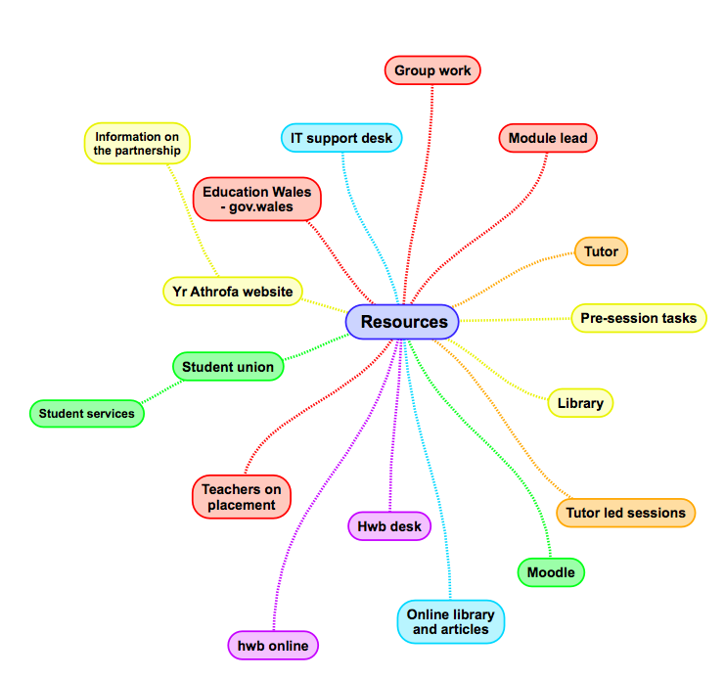
Resources Available

Skills Audit

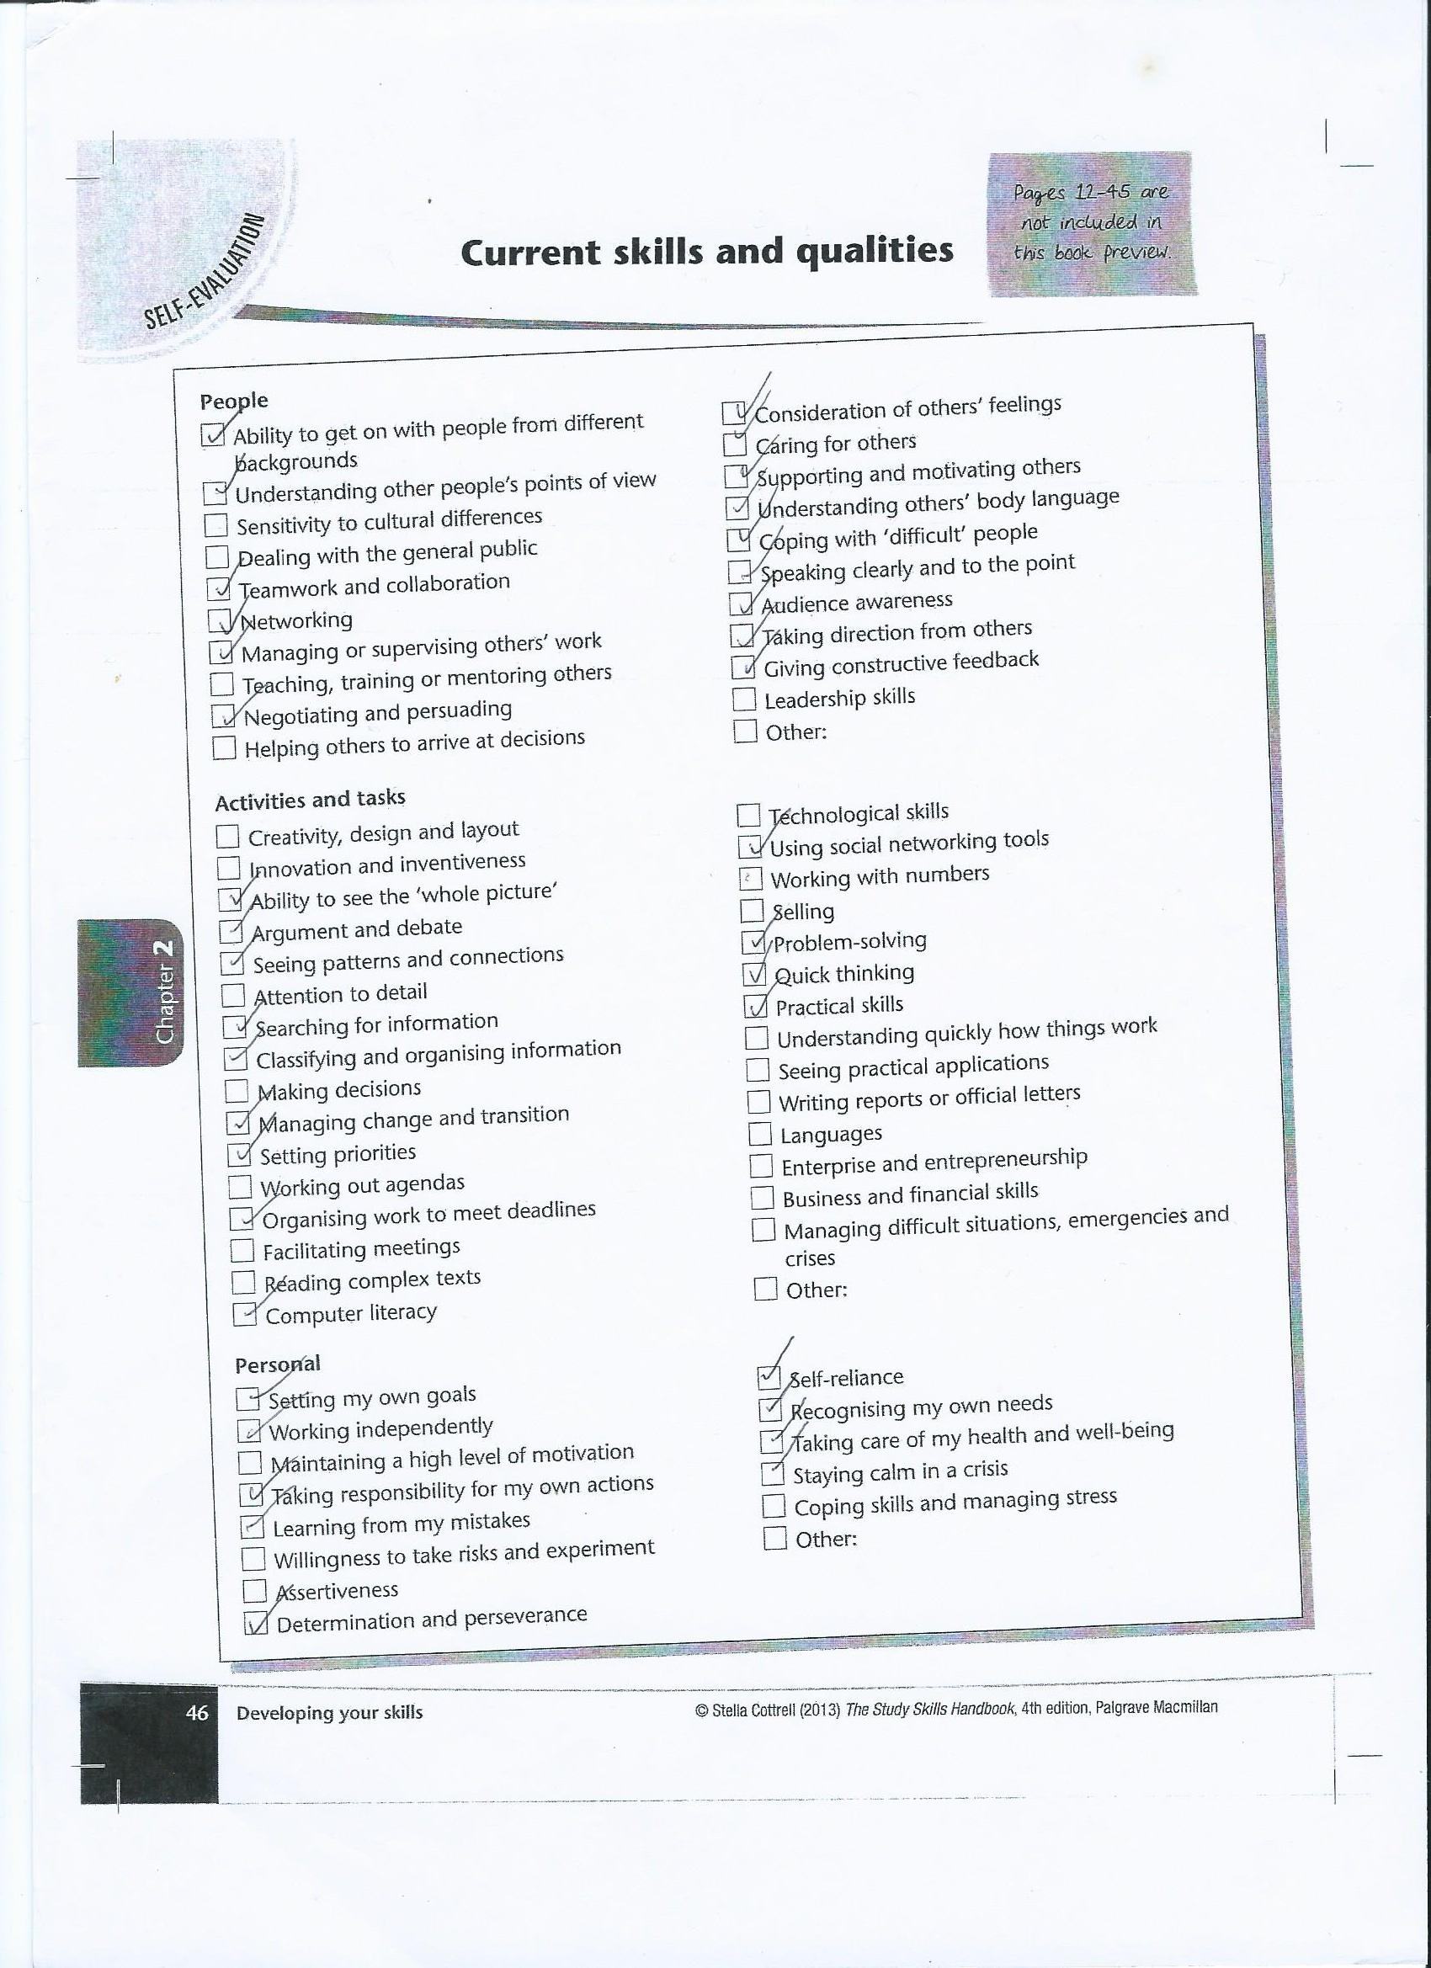

What Success Looks Like for Me

To achieve my idea of ‘success’, there are many skills and qualities I need to obtain, whether this be through opportunities to implement skills that I don’t use in my everyday life, or improving the skills I have potential to use but need advice in doing so.
A quality I left unmarked in the ‘people’ category, and believe is critical to teaching, is sensitivity to cultural differences. Hale, Snow-Gerono, and Morales, 2008, p.1424, stated, “Educators must embrace new ways of challenging themselves to think differently about the world they live in and how the world affects the educational experiences of their students.” I am enthusiastic to further my knowledge of cultural differences to empower children to be proud of their roots. Additionally, from the ‘Activities and Tasks’ section, I need to improve my skills in writing reports and letters so I can notify parents of important information. Improving my writing in all aspects will help my advanced study as my academic writing will be of a higher standard. Lastly, a ‘personal’ skill I need to improve is my management of stress. If I present myself as relaxed and controlled, the class climate will be more positive for the students which is said to increase their interest to learn (Kyriacou, 2007). Thus, I can be adaptable so neither the class’s or my success are affected. Manging stress will also help during my higher education study.
These are not the only skills and qualities I need to work on to feel successful but are the ones I feel are critical to achieving success and will help to build on other skills and qualities.

Portfolio task 2: Developing Critical Thinking

Cottrell (2005) explains that a good critical analysis looks for both positive and negative features and considers why they are good or bad. She claims critical thinking is formed by a developed range of skills, explaining that it is a cognitive process of identifying and evaluating: arguments, assumptions, and evidence. She lists the mental processes needed for this, which include: attention, categorisation, selection and judgement. Cottrell (2005) exclaims “critical thinking rarely takes place in a vacuum”. Thus, expanding on the idea that selection and judgement is an important skill for critical thinking; selection is needed to identify relevant information but judgement is needed simultaneously to consider any bias or inaccuracy. Ennis (1987, cited Cottrell 2005) explains that the ability to reflect sceptically is important as it allows you to analyse information with an open-mind as you understand that you may be lacking information. He details that this allows you to judge whether something is likely to be accurate. Therefore, Ennis implies that judgement is a skill needed to think critically, showing a similarity in ideas of Ennis and Cottrell. Their idea can be supported by Cottrell’s inclusion of three lecturers critical thinking process as all three’s approach is evaluative and selective.
Reasoning is another skill Cottrell has noted as effective during thinking critically as it means the person has evidence to their beliefs and actions but can also consider other peoples, allowing for a supported conclusion. Emotional self-management seemingly corresponds with this as Cottrell details how personal and emotional reasons can create barriers to thinking critically. She expands on this thought by saying that some evidence may create feelings of anger if it goes against the person’s beliefs and actions. Thus, the ability to manage emotions results in your reasons being clearly presented (Cottrell, 2005). Likewise, Cottrell points out that the ability to deliver information to people who may have differing beliefs is a skill of critical thinking in your own work. She explains that considering the evidence that challenges your beliefs allows you make an informed opinion and identify any weaknesses in your argument.
Cottrell highlights how reluctance to question the accuracy of an expert can create a barrier for critical analysis. She defines this reluctance as being conceived through a feeling of rudeness and nonsensicality as the student has less experience of the subject than the expert. However, when putting this skill to use with the ones previously mentioned, it will entail a thoroughly accurate conclusion.
Cottrell states that students tend to rely on research with small sample sizes and/or unreliable authors and dates. Hence why learning to think critically is a task set by many lecturers to enable students to judge whether the information in other people’s work and their own is factual and has considered alternative explanations. However, she explains that many students dismiss this, preferring to be handed facts over learning how to develop their ‘mental muscle’ and identify the information accurately themselves (Cottrell, 2005).
Cottrell demonstrates critical thinking’s benefits to advanced study, stating that lecturers have expressed how people lose marks for a lack of evidence of critical thinking. Although it may appear a long process, Cottrell argues that it saves time due to acquiring the ability to identify relevant, accurate information and underlying messages.

Portfolio Task 3: Developing Critical Writing

What I Think About Education in Wales

Donaldson’s methodology used for the review of Wales’ curriculum involved engagement of many individuals and organisations in wales. This was followed by a period of national consideration, labelled the ‘Great Debate’ by Huw Lewis, Minister of Education (Donaldson, 2017). In the feedback analysis that followed, the second most important thing students wanted from education was ‘skills for work’ (Welsh Government, 2019). In Donaldson’s (2015) review, it states that digital competency (DC) is an increasing feature of the modern workplace. In 2001, Cullingford and Oliver stated that digital technology is far more advanced than it was when the Education Reform Act was formed in 1988 due to its rapid development. Therefore, I conclude the DC framework in the 2022 curriculum is beneficial to Welsh education when considering that a principle of curricular is to ensure young people meet the skill requirements for employment (Donaldson, 2015). Donaldson’s inclusion of DC as part of a cross-curriculum with the relevant areas of learning and experience (AoLE) allows for unification, another principle of curricula, to be made between DC, literacy and numeracy.
Donaldson (2015) has proposed an engaging curriculum to improve achievement levels because schools have strived to impress examining bodies rather than delivering interesting teaching, consequently, detaching from the initial aims of the 1988 curriculum. This detachment resulted in low achievement levels, evidenced by Estyn evaluations of performance and qualifications in wales (Donaldson, 2015). Donaldson (2015) has created ten principles that the 2022 curriculum should follow; Evidence-based, unified and manageable were some of the principles which I believe will strengthen the new curriculum. I think an evidence-based curriculum is beneficial as it will be a researched curriculum based on the practice of wales and other countries (Donaldson, 2015) that have been advantageous to young people, thus, delivering the best quality education. I believe a unified curriculum allows for connections to be made between subjects and enable young people to build on knowledge. I hope a manageable curriculum will allow for engaging education as it will allow teachers from losing the focus of the curriculum. However, whether these principles will be successful is questionable due to previous weaknesses that have occurred with curricula, such as: detachment from delivering engaging lessons, attention diversions towards complicated planning tools in attempt to help manage changes and finally, unproductive concentration on performance measured aspects (Donaldson, 2015).
Donaldson has steered away from creating discrete AoLE, instead, opting for six AoLE (Donaldson, 2017). I believe this will be the most impactful part of the curriculum on education in wales as it will allow for unification of skills and knowledge.
Furlong stated, teachers who “are able to take a sharper focus on the needs of individual learners” are needed to achieve the system Donaldson developed (Furlong, 2015, p. 6). I agree that this will benefit welsh education as it should result in inclusive lessons delivered by teachers who can identify students excelling and those who are behind. Additionally, teachers will be able to identify the learner’s specific needs rather than placing them into a category allowing for Donaldson’s (2015) instruction to use progression steps as reference points for the development of each child’s education, rather than universal expectations of children’s performance at specific times to be implemented.

References

Cottrell, s. (2005) Critical thinking Skills: Developing effective analysis and argument. Basingstoke: Palgrave Macmillan.

Cullingford, C., Oliver, P. (2001) The National Curriculum and its Effects. Hampshire: Ashgate Publishing Limited.

Donaldson, G. (2015) Successful Futures. Available at: https://gov.wales/sites/default/files/publications/2018-03/successful-futures.pdf (Accessed: 29 October 2019).

Donaldson, G. (2017) ‘A Systematic Approach to Curriculum Reform in Wales’, Wales Journal of Education, 19(1), pp. 7-20.

Furlong, J. (2015) Teaching Tomorrows Teachers: Options for the future of initial teacher education in Wales. Available at: https://gov.wales/sites/default/files/publications/2018-03/teaching-tomorrow’s-teachers.pdf (Accessed: 27 October 2019).

Hale, A., Snow-Gerono, J., and Morales, F. (2008) ‘Teacher and Teacher Education’, Transformative Education for Culturally Diverse Learners Through Narrative and Ethnograph, 24(6), pp. 1424.

Kyriacou, C. (2007) Essential Teaching Skills 3rd Ed. Cheltenham: Nelson Thornes Ltd.
Welsh Government (2019) Feedback analysis: children and young people’s report. Available at: https://gov.wales/sites/default/files/consultations/2019-10/curriculum-for-wales-2022-feedback-analysis-children-young-peoples-report.pdf (Accessed: 29 October 2019).

