
CAREER DEVELOPMENT
REPORT
TRACEY WILLIAMS 1905282



November 2nd 2019

Contents.
Introduction ………………………………………………………… 2
7 Habits …………………………………………………………… 3
Smart …………………………………………………………… 4
SWOT ……………………………………………………….. 5 - 6
Go mad ……………………………………………………….. 6 - 7
Tows ……………………………………………………………… 7
Maslow ……………………………………………………………. 8
Honey and Mumford ………………………………………………. 9
Vark ………………………………………………………………. 9
Kolb ………………………………………………………………. 10
Personal Development Plan ……………………………………... 10
Conclusions ……………………………………………………….11
Appendices. ………………………………………………… 12 - 15
References ……………………………………………………...16

Introduction.

Professional Career Development is the proactive planning and implementation of action steps towards your career goals.(Careers-online).It is important to me as I would like to personally develop my knowledge within a different career, therefore doing this course will enhance my learning and knowledge background to broaden my recognition of other career avenues. I have been in my current job for twenty- six years, so for me to go further I need to look at all different aspects of career development. I am confident in the job I do because I have many years of experience in the role, venturing into something new is going to be challenging and quite daunting. Embarking on this Career Development course will help me with my confidence issues and presenting myself professionally.

This report will show how my learning journey progresses, and I will be talking about Coveys Seven Habits, Smart, Swot analysis and Go mad. Also looking into different learning cycles and strategies like Maslow, Honey and Mumford and Kolb. It will also show my reflective writing and the results of the questionnaires, and whether they are accurate or not.

Findings.

A good example of this is Steven Coveys the Seven Habits. (Covey, 1989). this will help me to recognise my Accomplishments, Connections and Growth. BE PROACTIVE by taking control and making something happen rather than just adapting to a situation. What I want to achieve in life and what I believe in to get the job I desire. KEEP THE END IN MIND to be driven by my principles and values and understanding that I value most and not by the agendas surrounding me. What it is i am setting out to achieve. FIRST THINGS FIRST in order to manage myself effectively. I must have the discipline to prioritize my day today actions based on what is most important, not what is most urgent. THINK WIN WIN expressing my feelings and ideas with courage and consideration for others. Sticking to my values and commitments and believing that agreements are beneficial to getting a solution. SEEK FIRST TO UNDERSTAND to listen before I speak so I don’t regret saying something I don’t mean and losing my credibility. SYNERGISE having new possibilities through openness and creativity, ending up with a transformation. Both sides get what they want and build their relationship in the process. SHARPEN THE SAW be aware of each other’s strengths and weaknesses. Be able to work together as a team to reach my goal. (Covey, 2002, p.7).

In order to start developing myself professionally I began by finding out my Strengths, Weaknesses, Opportunities and Threats, and using the Tows Analysis/Swot Matrix for this is good to achieve my goal. One of the best Personal Development Plan objectives is SMART.

Specific -- What exactly do I want to have completed.
Measurable—How will I know whether I have completed it or not.
Achievable—Am I likely to be able to achieve this goal.
Realistic—In the timescale I have allocated. Resourced—Do I have enough resources available to me.
Time-bound—By when I want to have completed this. The shorter the timescale the more precise I should be. (Morgan 2017).

My SMART goal is
Specific—My objective is I plan to achieve the best possible marks for my Professional Career Development Module, by attending all my classes.
Measurable—I will study as much as I can to reach my goal. I will ensure to use all resources including the internet and library, referencing and making notes for the module.
Achievable— These are the Strengths, Weaknesses, Opportunities and Threats I need to work on to be able to achieve my goal.
Realistic/Relevant—I am willing to commit to achieving my marks to pass the course and attending all my classes.
Time-bound—Making sure I give myself enough time to reach my deadline and complete the course within one year.

SWOT Analysis is an acronym for Strengths, Weaknesses, Opportunities and Threats. It is a framework for identifying and analysing the internal and external factors that can have an impact on people. Albert Humphreys came up with the idea in the 1960’s to 1970’s. (Sarsby, 2016, p.11)

This is my SWOT analysis

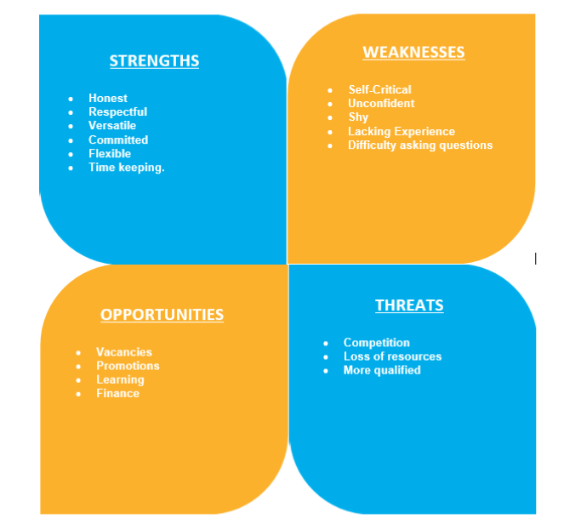

Strengths—I am honest and respectful of others. I am always committed to my tasks to get the job done. I have good communication skills and always willing to give and receive constructive feedback. I am well trained in having many years’ experience in customer service in retail. I am flexible as my children are grown up and I have no family issues. Also good at time keeping, hate being late.
Weaknesses—I am quite self- critical and unconfident in myself. I am quite shy in standing in front of a class and presenting myself. I have difficulty in asking questions sometimes because I don’t want to appear that I have not understood something. I lack experience in technology skills.
Opportunities—The learning opportunity I have now by doing this course, which will help getting me a promotion. Vacancies from other companies could be beneficial in increasing my wages and finance. Learning new technology skills.
Threats—There is a lot of competition out there with some people being more qualified in certain roles. Loss of resources especially funds and materials needed to do the job.

Albert Humphreys Tows Analysis is another way to help convert Strengths into Weaknesses and Threats into Opportunities.
My Weakness into Strength will be to get more experience in Career Development and Employability Skills. To do more presentations in class to build up my confidence.
My Threats into Opportunities will be by completing this course I will become more qualified for jobs and hopefully then will have less competition. (Tim Friesner (2017) described the Tows Analysis).

Andy Gilberts the Art of Making a Difference (Go M.A.D.) is another way to improve people’s lives in the workplace by the use of solution focused thinking. To improve your world through better thinking by enabling behaviour change. Giving people choices on how they think with practical tools that guarantee better actions and results. Developing forward thinking who are passionate about enabling change to happen more effectively and sustainably. Discover why some people succeed and others don’t (go mad thinking 2018).

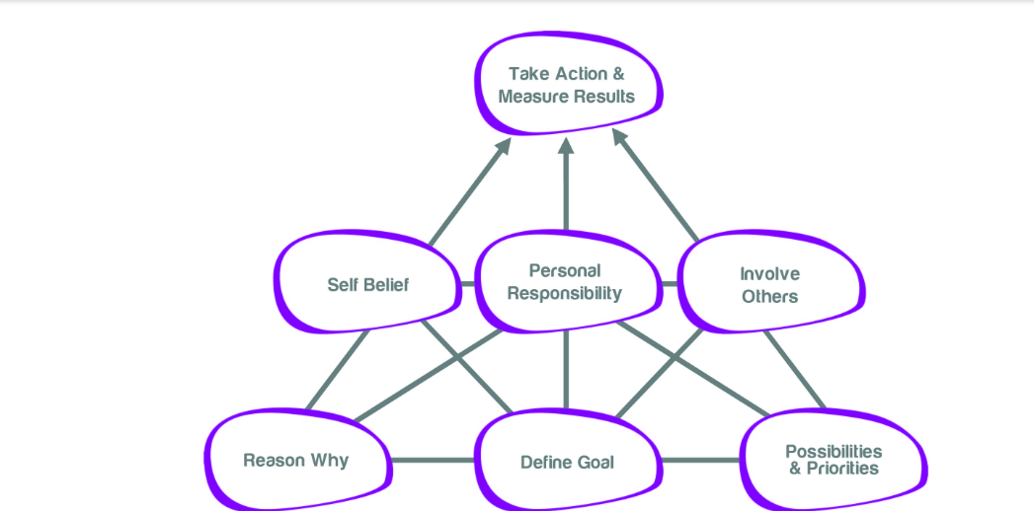

My Reason Why - is I want to go further in my career and by learning and developing new skills should get me there. I can be better off financially which will make life a lot easier. Spend more quality time with my family by going away on holidays. Most importantly being healthy to enjoy life as much as I can.
Define Goal - my reason why is my motivation to achieve my goal. I want to end up with a new career and succeeding in this course is my ultimate goal.
Self-belief - this Career Development course will give me the confidence I need to have the ability to make a difference towards my goals.
Possibilities and Priorities - I am prioritising my Career Development to reach my goal by motivating myself with the possibility of achieving all my Reasons Why.
Personal Responsibility – I am aware that these choices are mine and I have responsibility for my actions. If I don’t finish the course, it will be my fault and nobody else’s.
Involve others – I will ask for help from my tutors if I am unsure of anything and greatly accept any feedback to help me pass the course.
Take action and Measure Results - These principles give me a strong foundation for success. Now I need to follow these actions otherwise it is all wasted if nothing happens.

Maslow’s hierarchy of needs is a motivational theory in psychology comprising a five-tier model of human needs, often depicted as hierarchical levels within a pyramid. Needs lower down in the hierarchy must be satisfied before individuals can attend to needs higher up. From the bottom of the hierarchy upwards the needs are, Physiological, Safety, Love and Belonging, Esteem and Self-Actualization. Mcleod (2018) was a useful source of information.

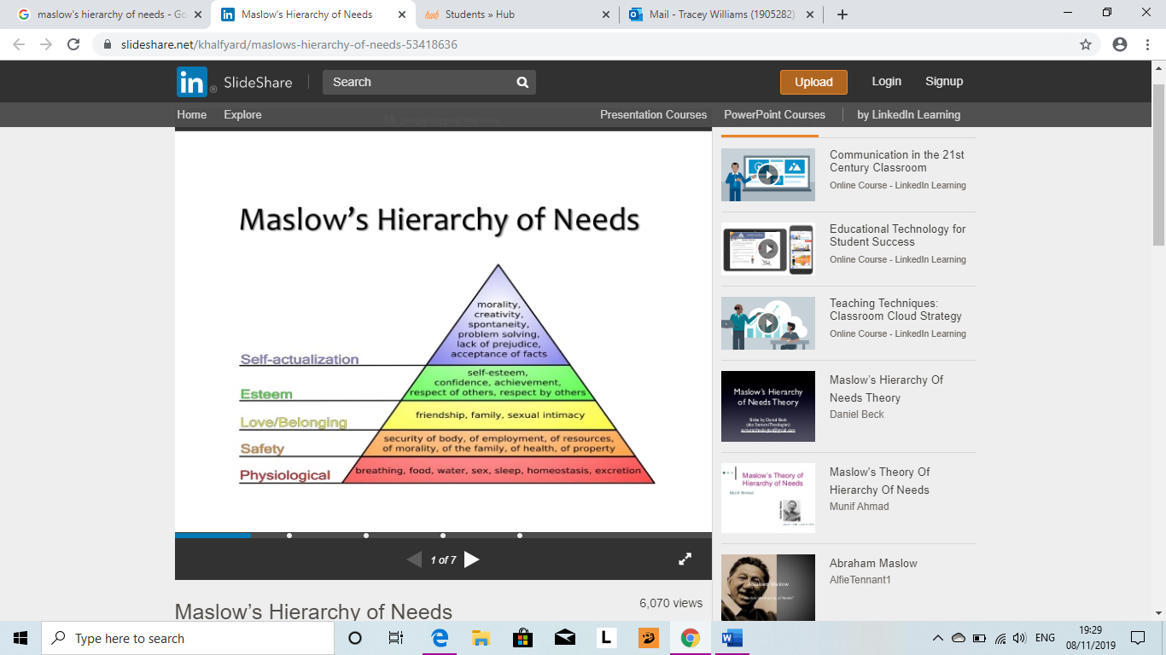
The first level relates to physiological needs which Maslow thought was basic, because without these needs there is no motivation to move onto the next level. Level 2 refers to safety, feeling secure in our homes our family and employment. Level 3 is to feel loved in relationships and family, and a sense of belonging to friendships. Level 4 is having the confidence to achieve and have respect of others, which will build up self- esteem. Once all four levels are met the realisation of achieving full potential and self -fulfilment and seeking personal growth.

Learning Styles

Honey and Mumford (1992) identified that different people have innate learning preferences, and their model of learning styles relates closely to each of the four stages. Research conducted by Honey and Mumford suggests that some people are better at learning from experience (Activists),others better from learning by reflection (Reflectors), others by developing their own ideas about how the world works and preferring theoretical input (Theorists), and finally some individuals prefer to take information, plan for the future and ask ‘what if?’ (Pragmatists). (Morgan, 2017, p.96)

After completing the questionnaire, I was surprised how accurate my result was. My result was a Reflector, I do like to stand back and observe first rather than be in the front for discussions. I like to have time to think over things by collecting information first before reaching a conclusion, and I am quite cautious. (See Appendices)

Another learning style is VARK (Fleming 1987) which focuses on how learners prefer to use their senses (hearing, seeing, writing, reading or experiencing) to learn. The acronym VARK stands for Visual Aural Read/Write and Kinesthetic. Visual learners prefer to learn information through charts, graphs and other visual means. Aural learners prefer to hear information. Read/Write learners prefer to learn information as words and Kinesthetic learners prefer to learn through experience and practice whether simulated or real. (Gardener, Jewler, Barefoot, 2008, p.43).

Again, my results of the questionnaire were accurate (see appendices). I am a Read/Write learner, I like to look for information from books and journals, I understand it better.

David Kolb’s experimental model of learning (Kolb,1984) is very similar, but he suggests that learning is a process, and that there are no fixed timescales for each phase, but they flow into each other in a cyclical way. The model is quite useful in attempting an explanation of the role of reflection in learning. (Burns and Sinfield,2012, p.416).
There are four stages to the Kolb cycle:

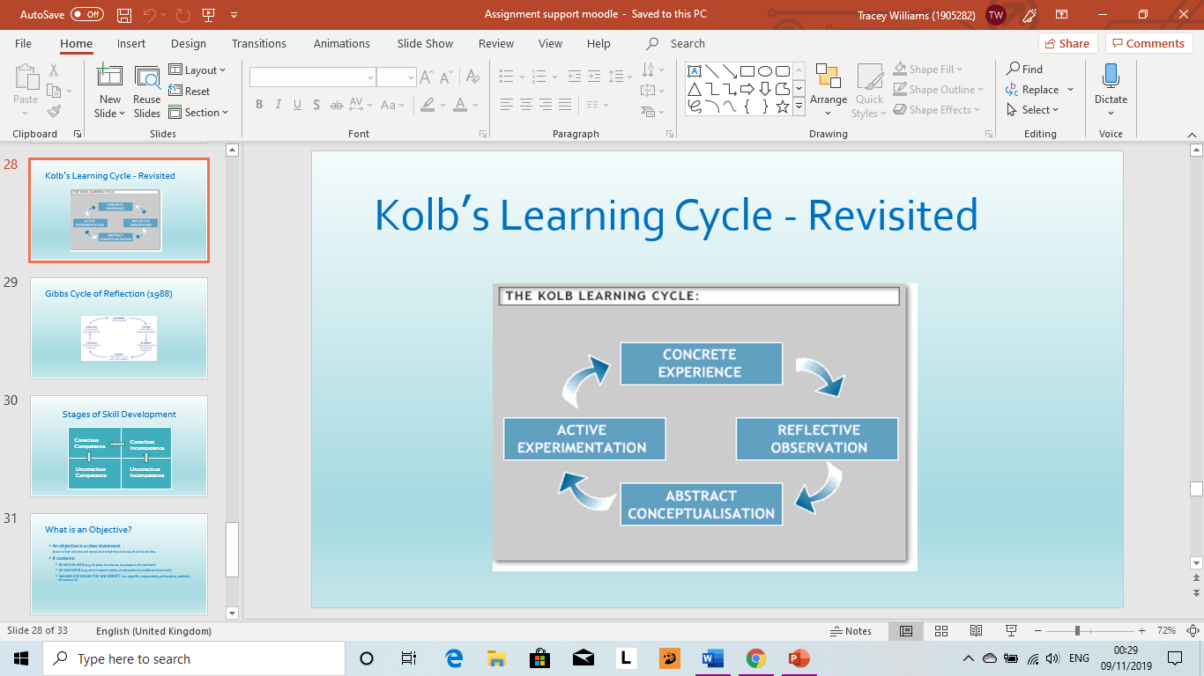

Personal Development Plan refers to much more than career planning, although that is one important aspect of the initiative. It is about creating structured opportunities for students to develop and wider range of skills and personal qualities that will benefit them in life, work and study. (Cottrell, 2010, p.8)
My Personal Development Plan is for my Personal Career Development I want to achieve the best possible marks and attend all my classes. By doing this I will be more qualified and hopefully have less competition. I will use all my resources available to me and achieve this in a years’ time.
For my Presentation skills I need to interact more with people and teams. By presenting more in front of the class and family and friends will help me lose some of my shyness. I will know I have achieved this by completing a presentation confidently. (see appendices for graph).
Conclusions.

To achieve my Professional Career Development, it is important for me to enhance my learning and knowledge, and to broaden my recognition of better career avenues. I have learned so many different types of learning strategies that will help me to achieve my goal at the end of my module. One of the main Personal Development Plan objectives is SMART. I will use this to help me reach my goal and work on my weaknesses and turn them into strengths, and my threats and turn them in to opportunities. I will better myself academically by attending all my classes and completing the tasks I am given to the best of my ability.

My goal is to have a new career either in team leadership or management, and by developing new career skills I should achieve this. By working with people as a part of a team will help with my confidence and presenting myself professionally. Having support from family and tutors and being committed to complete my tasks and give myself enough time to reach my deadlines, I will try to get the best possible marks to pass the course, and in a years’ time hopefully will be the start of my new career.

Appendices.

Development  Objective | Specific  Actions | Blockers and how they will be removed | Support  required | How I will know when I have achieved the objective
Personal Career Development | To achieve the best possible marks and attend all my classes. | Competition.  By completing this course, I will be more qualified, so less competition. | To use all resources available to me for my module. | When I receive my marks at the end of the course in a years’ time.
Presentation  Skills | To interact with people and work with teams. | Shy of standing in front of people. Practice presenting more in class. | Family, friends and classmates. | When I have completed a presentation with confidence.

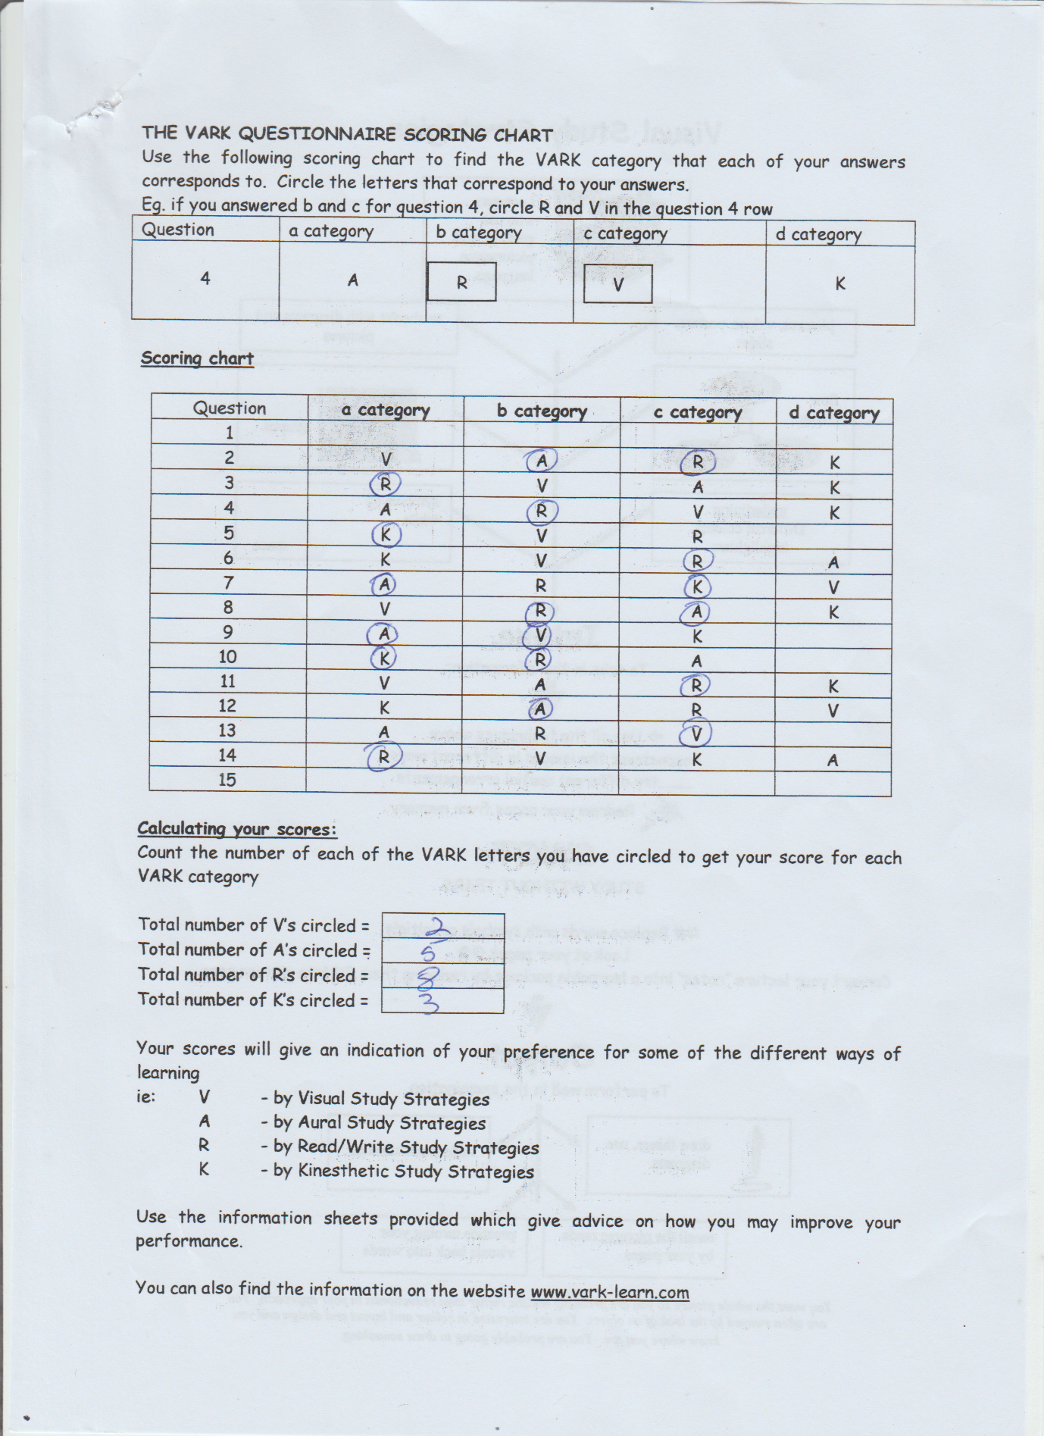

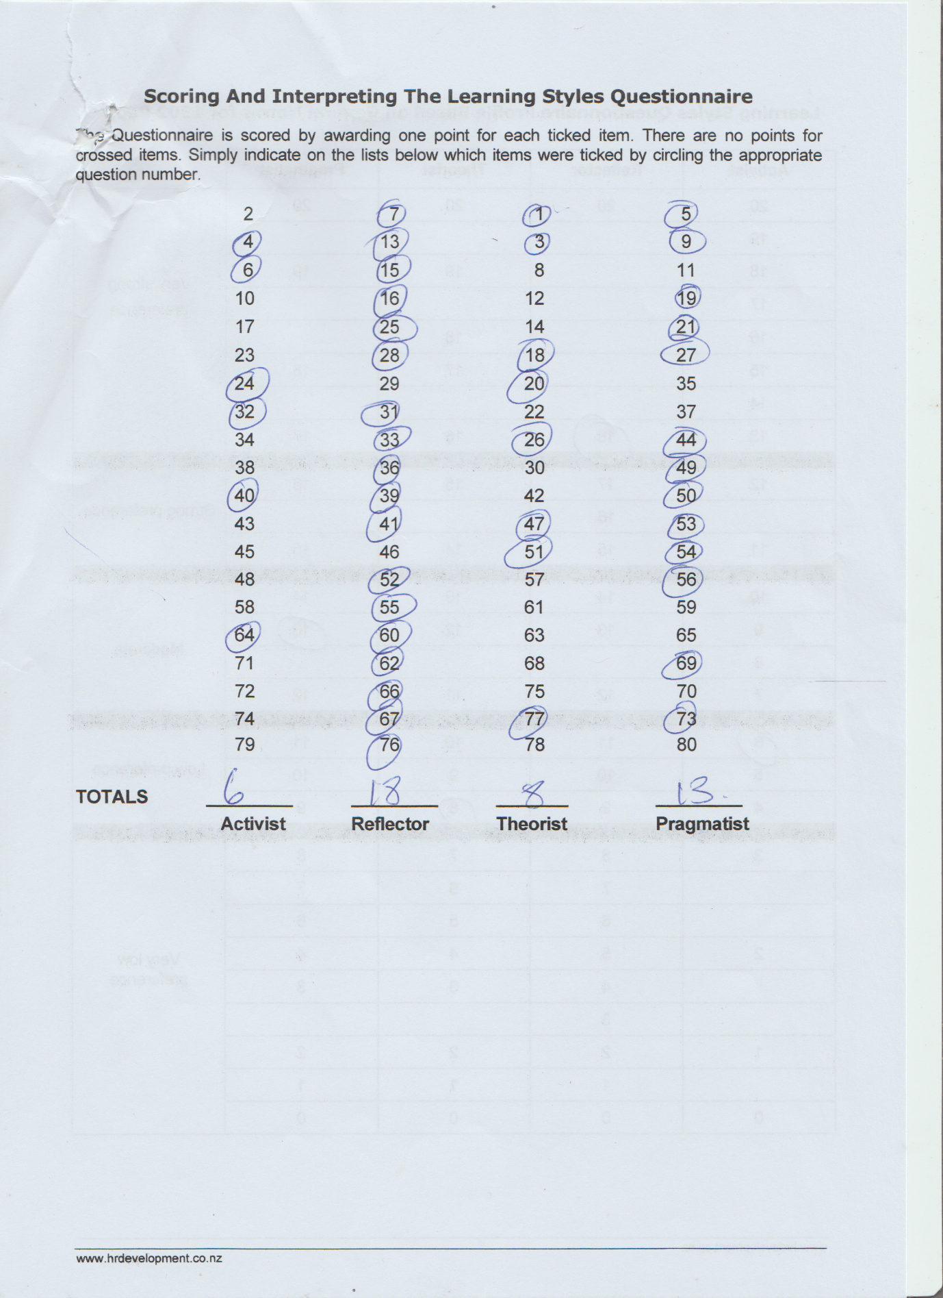

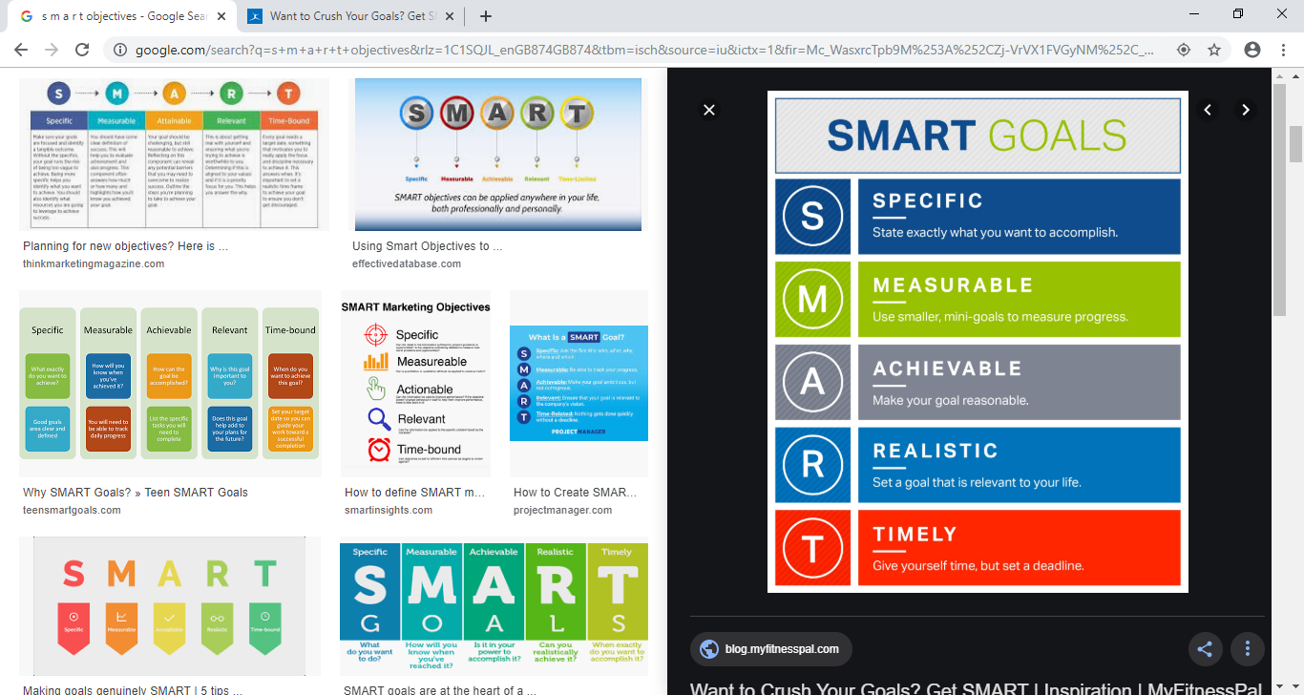

Reference.
Burns,T and Sinfield, S. (2012) Essential Study Skills.3rd edn. London: Sage.
Careers advice online (2017) What is career development. Available at : http://www.careers-advice-online.com/what-is-career-developmenthtml (Accessed 5th November 2019).
Cottrell, S. (2010) Skills for Success: Personal Development and Employability. 2nd Ed. Hampshire: Plagrave Macmillan.
Covey, S. (2002) The 7 Habits Journal. New York: Simon and Schuster.
Friesner, T. (2017) ‘Tows Analysis’, Tim Friesner today [blog]. 27 April 2017. Available at: marketingteacher.com/tows-analysishtml (Accessed 5th November 2019).
Gardener, J.N, Jerome Jewler,A and Barefoot, B.O.(2008)Your College Experience Strategies for success. Boston: Cengage Learning.
Gomad Thinking (2018) Explore the framework for success. Available at: http://www.gomadthinking.com (Accessed 5th November 2019).
Mcleod, S. (2018). Maslow’s Hierarchy of Needs.Available at: http://www.simplypsycology.org/maslowhtml (Accessed 6th November 2019).
Morgan, P. (2017) The Business Students Guide to Study and Employability. London: Sage Publications Ltd.
Sarsby, A (2016) SWOT Analysis. England: Lulu.com.

