The Taste of Home
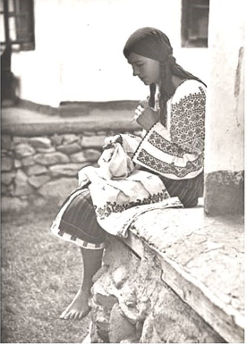  BUSINESS MODEL CANVAS WITH ENTREPRENEURIAL REFLECTION  BMIH5001, ENTREPRENEURSHIP CHRIS WILKIN | Denis Buzdugan, 2130036  Word Count: 2094

In a world where eating is about more than just the food—it's about the whole experience the debut of a Romanian restaurant in the hospitality sector is both innovative and appropriate. By providing a genuine Romanian gastronomic and cultural experience, this business carves out a position in a market crowded with varied cuisines (Mitrica et al., 2020). With traditional tastes and cultural richness that set it apart from the many dining options available, this restaurant aims to transport its customers to the heart of Romania and set a new standard for immersion in culture in the business (Kastenholz and Gronau, 202). It strives to satisfy the growing demand for authentic and immersive dining.

The Key Partners segment is crucial since it forms the very framework that ensures the validity and effectiveness of the business model's operations.
Strategic partnerships with regional Romanian groups, such as the "Romanian Cultural Institute," are essential to authenticity and go beyond simple logistics. According to the study by Bolborici et al. (2022), these communities act as cultural ambassadors, making sure that the project embodies the authentic Romanian spirit that is essential to the value offered. Working together with neighbourhood farms in Rochester as well as the neighbouring areas, like "Rochester Farms," makes it possible to obtain fresh produce, which is essential to Romanian cooking and upholds the dedication to quality and freshness.
According to a study by Duggan et al. (2021), collaboration with well-known food delivery platforms like Deliveroo, Uber Eats, and Just Eat is crucial in today's industry. In the quick-paced food service sector, these solutions are not only avenues for reaching a wider audience but also essential for preserving operational effectiveness. They guarantee that the restaurant's offers are affordable for a larger group of people, fostering convenience without sacrificing the quality of the eating experience.
We carefully chose the partners to create an environment that is both efficient and uniquely Romanian. Its unique combination of contemporary financial acumen and cultural integrity endeavours stand out in the gastronomy scene.
Taste of Home's core activities are essential to both the company's mission and its overall performance. According to the Jahna (2023) report model, the restaurant takes pleasure in a foundation of carefully selected activities that represent authenticity and satisfy patron expectations. One of the tasks assigned to chefs such as those of the prestigious "Bucharest Culinary Institute," who are experts in Romanian cuisine, is to cook fresh and traditional Romanian dishes. Their knowledge guarantees that every dish is a true reflection of the nation's illustrious culinary past.
Additionally, the restaurant actively promotes Romanian culture through events and music, in addition to food. Working with regional cultural groups like the "Transylvania Folk Ensemble" gives customers a comprehensive Romanian experience (Yang and Luo, 2021).
These activities are perfectly aligned with the general value proposition, which guarantees authentic cultural immersion. The meticulous preparation of traditional dishes, as well as the vibrant cultural events, create a one-of-a-kind dining experience that distinguishes the restaurant from competitors like "The Vincent Rooms Brasserie, Bar & Escoffier Restaurant," that provides a broader European cuisine without such a focus on cultural specificity. This alignment guarantees that the venture does more than just serve food; it also delivers a rich cultural narrative that connects with the target customer base, meeting and exceeding their expectations.
The restaurant's success is dependent on skilled Romanian chefs, cultural understanding, and financial resources, which work together to forge a competitive edge while maintaining the authenticity of culture (Yun et al., 2020).
The chefs, who come from culinary institutions such as the "Bucharest Gastronomy School," bring traditional dishes and techniques to the table, making sure the food is both authentic and of the highest quality. Their expertise is the foundation of the restaurant's menu, distinguishing it from competitors such as "Global Eats," which serves a broader European cuisine (Traynor, 2022).
Cultural knowledge, provided through connections with organisations such as the "Romanian Heritage Foundation," improves the culinary experience by transforming it into a learning experience through Romanian heritage and customs (Ogunmokun et al., 2020).
Finally, a strong financial strategy is critical to the venture's growth and sustainability. According to Holovnia et al.'s (2022) research, strategic investments and sound financial planning allow the restaurant to effectively navigate the competitive hospitality landscape, ensuring the continued delivery of an authentic Romanian experience. This extensive resource base not only differentiates the restaurant from the competition, but also assures its continued existence and relevance.
This unique venture's value proposition is based on authentic Romanian cuisine and deep immersion into culture. The restaurant's offerings are in stark contrast to the typical fare available at local Chinese, Italian, and Indian restaurants such as "Royal China Group," "Daphne's," and "Bundobust." These establishments cater to their respective cultural cuisines, but they may lack the depth of cultural immersion that this Romanian restaurant seeks to provide.
The Romanian culinary experience is distinguished by the emphasis on traditional recipes passed down through generations, prepared with locally sourced ingredients that represent the richness of Romanian soil (Voinea et al., 2020). Unlike the quick stir-fries of a Chinese restaurant, the complex blending of flavours in a Romanian sarmale necessitates time-honed skills, which chefs at "Carpathian Culinary Arts" have (Marele and Ghergheles 2020). While Italian and Indian restaurants, such as "Daphne's" and "Bundobust," have their appeal (Mariani and Okumus, 2022), they do not capture the full cultural experience that dining at a Romanian table provides.
From the hearty soups that rival any Italian minestrone is to the delicate pastries that compete with any Indian sweet, the restaurant ensures that each dish tells a story about Romanian history and tradition. It's a culinary story that not only pleases the palate but also teaches and enthrals the diner, making it a unique destination in the local European gastronomic scene (Casangiu, 2020).
Customer relationships are critical at Taste of Home restaurants, with a strategy that combines personalised service and engagement with consumers (Pei et al., 2020). Staff from programmes such as "Hospitality Excellence" provide a familial atmosphere, encouraging loyalty and returning customers. Tailored loyalty programmes encourage repeat business, integrating the restaurant's essence in diners' routines (Basu et al., 2022).
Engagement extends to social media, where platforms such as Instagram facilitate discussion and community building (Dhanesh et al., 2022). Feedback tools like TripAdvisor act as beacons of improvement and customer satisfaction (Cobanoglu et al., 2021). Unlike larger chains, this establishment places an emphasis on personalisation and cultural connection, guaranteeing that each guest's experience is more than just a meal but an unforgettable journey through Romanian tradition. These deliberate relationship-building efforts aim to cultivate a loyal customer base and differentiate themselves in the challenging hospitality environment (Park and Widyanta, 2022).
The Taste of Home's Channels are carefully selected to reach a diverse audience, leveraging Similarweb's insights. Social media engagement is critical, as evidenced by Bundobust's achievement, whose audience frequently uses social media networks, indicating a strong online presence that appeals to a gender-diverse audience (54.83% female and 45.17% male), particularly those aged 25-34. This demographic insight informs the restaurant's social media strategies, ensuring that content is pertinent and appealing to this core age group.
Local events capitalise on the community focus evident in Royal China Group's consumer base, where social as well as community subjects are of interest. By replicating such successful engagement, the Romanian restaurant hopes to attract the 44.21% male and 55.79% female demographic, which is primarily 25-34 years old, while also instilling a sense of belonging and cultural appreciation.
Food delivery platforms such as Deliveroo and Uber Eats are used, similar to the efficiency of operation seen at Daphne's Italian restaurant. These platforms cater to the ease of use sought by younger demographics, which is consistent with the restaurant's goal of serving health-conscious individuals and culture enthusiasts who value authenticity and accessibility (SimilarWeb, 2024).
Customer Segments for the Romanian restaurant are discerningly chosen. Romanian expats provide a ready-made clientele seeking the taste of home, mirrored in the cultural familiarity that Royal China Group offers to its visitors. Cultural enthusiasts are drawn to a unique dining experience, a segment that Bundobust captures with its top category interest in social media networks, suggesting a tech-savvy customer base keen on cultural exchange. Health-conscious individuals are targeted through menu offerings tailored to fresh, local ingredients, much like the clientele of Daphne’s, who are likely to value quality and dietary options (SimilarWeb, 2024).
The business model caters to these segments' diverse preferences by creating an authentic Romanian atmosphere that is reminiscent of expats' home country, a cultural hub for enthusiasts, and a refuge for health-conscious diners looking for nutritious, locally sourced food (Azlie et al., 2023). This tailored approach to Customer Segments and Channels, based on real-world data from Similarweb, positions the Romanian restaurant as an outstanding experience in the global culinary scene.
The Romanian restaurant's cost structure has been carefully planned for financial sustainability, managing fixed costs that include rent for the High Street location, utilities, and employee wages with variable costs such as locally sourced products and seasonal menu changes. The business model wisely manages costs by collaborating with local farms for produce, lowering logistics costs and profiting from fresher ingredients (Jia et al., 2023).
In terms of revenue streams, the restaurant benefits from a variety of channels, including dine-in sales of traditional dishes, takeaway and delivery orders made possible by partnerships with platforms such as Deliveroo and Uber Eats (Duggan et al., 2021), event hosting for cultural nights, and selling of Romanian cultural artefacts (Yang and Luo, 2021). To increase repeat business, a loyalty programme is implemented, encouraging clients to return and thus increasing customer lifetime value and consistent revenue flow. This varied strategy ensures a diverse income stream that supports the company's growth and market resilience (Basu et al., 2022).
In conclusion, the Romanian restaurant's business model, which is supported by a strong BMC, provides a unique value proposition by combining authentic cuisine with an authentic cultural experience. It meets the diverse needs of its customers through strategic partnerships, meticulously planned activities, and targeted channels. The financial framework, which includes a cautious cost structure and diverse revenue streams, reinforces the venture's viability. Reflecting on these aspects, the restaurant is poised for success, ready to leave a lasting impression on the hospitality landscape and connect deeply with customers seeking the welcoming atmosphere of Romanian tradition.

Reflection on Entrepreneurial Characteristics and Motivations
My GET2 test results, while reflecting my current entrepreneurial and management technique, also show areas for improvement. With a 'Need for Achievement' of 75%, I am motivated to succeed, but my 'Need for Autonomy' of 50% indicates a dependence that could be linked to my parents' continued financial support. Their cautious and protective nature, while well-intentioned, may stifle my ability to make independent decisions and assess risks.
The Gibbs Reflective Cycle helps me develop strategies to improve these areas. For 'Autonomy', it will be necessary to put me in situations where I must rely on my own judgement. This could entail leading a new project or making decisions without seeking parental approval, which would boost my self-efficacy, as suggested by Bandura's theory. In terms of 'Calculated Risk-taking', I intend to carefully evaluate and take risks that contribute to business growth, therefore moving away from the safety net provided by my parents.
The 'Locus of Control' indicates a person's belief in their capacity to control events that affect them. My 83% score here indicates a strong sense of personal independence, which can be used to advance my entrepreneurial goals. However, breaking free from the comforts of parental supervision is essential for this. Taking on greater difficulties and responsibilities in stages can help me reshape my professional persona, moving from dependence to autonomy.
Critically evaluating my reasons and characteristics using academic models shows that, while parental support has advantages, it also presents challenges for creating a fully autonomous entrepreneurial identity. Accepting opportunities for self-reliance will help me refine my business acumen and improve my ability to manage and grow my business ideas effectively. This process is about more than just withdrawing from parental assistance; it is about actively shaping an environment in which my own decisions and risks are the main indicators of success.

To summarise, the journey to strengthen my 'Need for Autonomy' and 'Calculated Risk-taking' is both essential and appropriate. As I progress down this path, I anticipate a shift in my entrepreneurial endeavours in which the ability to act independently and take risks becomes second nature. This evolution will help not only my personal development but also the long-term strategy and creative potential of my business initiatives.

References
- Azlie, W.E., Zahari, M.S.M., Majid, H.N.A. and Hanafiah, M.H., 2023. To what extent does consumers’ perceived health consciousness regarding organic food influence their dining choices at organic restaurants? An empirical investigation. International Journal of Gastronomy and Food Science, 34, p.100843. https://doi.org/10.1016/j.ijgfs.2023.100843
- Basu, S., Pereira, V., Sinha, P., Malik, A. and Moovendhan, V., 2022. Esoteric governance mechanism and collective brand equity creation in confederated organizations: Evidence from an emerging economy. Journal of Business Research, 149, pp.217-230. https://doi.org/10.1016/j.jbusres.2022.05.007
- Bolborici, A.M., Lupu, M.I., Sorea, D. and Atudorei, I.A., 2022. Gastronomic heritage of Făgăraș Land: A worthwhile sustainable resource. Sustainability, 14(3), p.1199. https://www.mdpi.com/2071-1050/14/3/1199
- Casangiu, L., 2020. CULINARY HABITS, BETWEEN TRADITION AND CHANGE. CASE STUDY: ROMANIANS IN PARMA, ITALY. New Trends in Sustainable Business and Consumption, p.25. https://www.researchgate.net/profile/Bassel-Diab/publication/342124082_BASIQ_2020_Conference_proceedings/links/5ee37056458515814a583fe1/BASIQ-2020-Conference-proceedings.pdf#page=25
- Cobanoglu, C., Dogan, S., Berezina, K. and Collins, G., 2021. Hospitality and tourism information technology. University of South Florida M3 Center Publishing, 17(9781732127593), p.2. https://www.researchgate.net/profile/Betsy-Stringam-2/publication/344753638_Hotel_and_Guestroom_Technology/links/614a1314a3df59440ba1339b/Hotel-and-Guestroom-Technology.pdf
- Dhanesh, G., Duthler, G. and Li, K., 2022. Social media engagement with organization-generated content: Role of visuals in enhancing public engagement with organizations on Facebook and Instagram. Public Relations Review, 48(2), p.102174. https://doi.org/10.1016/j.pubrev.2022.102174
- Duggan, J., McDonnell, A., Sherman, U. and Carbery, R., 2021. Work in the gig economy: A research overview
- Hernandez-Rojas, R.D., Folgado-Fernandez, J.A. and Palos-Sanchez, P.R., 2021. Influence of the restaurant brand and gastronomy on tourist loyalty. A study in Córdoba (Spain). International Journal of Gastronomy and Food Science, 23, p.100305. https://doi.org/10.1016/j.ijgfs.2021.100305
- Holovnia О, Z.T., Lopatiuk, R., Melnyk, S., Prylutskyi, A., Stavska, U. and Tabenska, O., 2022. Problems and prospects of development of hotel and restaurant and tourist industry in the conditions of integration processes. International Science Group. https://isg-konf.com/wp-content/uploads/2022/09/Monograph/979-8-88831-930-7/979-8-88831-930-7.pdf
- Jahan, M.S., 2023. INTERNSHIP AFFILIATION REPORT ON Activities at the Analyst Department of TEKARSH. http://dspace.uiu.ac.bd/bitstream/handle/52243/2720/INTERNSHIP%20AFFILIATION%20REPORT%20Finalized.pdf?sequence=1&isAllowed=y
- Jia, F., Shahzadi, G., Bourlakis, M. and John, A., 2023. Promoting resilient and sustainable food systems: A systematic literature review on short food supply chains. Journal of Cleaner Production, p.140364. https://doi.org/10.1016/j.jclepro.2023.140364
- Kastenholz, E. and Gronau, W., 2022. Enhancing competences for co-creating appealing and meaningful cultural heritage experiences in tourism. Journal of Hospitality & Tourism Research, 46(8), pp.1519-1544. https://doi.org/10.1177/1096348020951637
- Marele, D.C. and GHERGHELEŞ, C.G., 2020. Study on Bihor county traditional gastronomy. Agricultural Management/Lucrari Stiintifice Seria I, Management Agricol, 22(2). https://www.cabidigitallibrary.org/doi/pdf/10.5555/20203573053
- Mariani, M. and Okumus, B., 2022. Features, drivers, and outcomes of food tourism. British Food Journal, 124(2), pp.401-405. https://doi.org/10.1108/BFJ-02-2022-022
- Mitrică, B., Mocanu, I., Grigorescu, I. and Dumitrașcu, M., 2020, October. Cultural Tourism in Romania—A General Outline of the Conceptual Framework. In Proceedings of the GEOLINKS Conference Vision for New Horizons. International Conference on Environmental Sciences, Plovdiv, Bulgaria (pp. 5-7). https://www.researchgate.net/profile/Bianca-Mitrica/publication/344670412_CULTURAL_TOURISM_IN_ROMANIA_-A_GENERAL_OUTLINE_OF_THE_CONCEPTUAL_FRAMEWORK/links/5f88433692851c14bcc92b66/CULTURAL-TOURISM-IN-ROMANIA-A-GENERAL-OUTLINE-OF-THE-CONCEPTUAL-FRAMEWORK.pdf
- Ogunmokun, O.A., Eluwole, K.K., Avci, T., Lasisi, T.T. and Ikhide, J.E., 2020. Propensity to trust and knowledge sharing behavior: An evaluation of importance-performance analysis among Nigerian restaurant employees. Tourism management perspectives, 33, p.100590. https://doi.org/10.1016/j.tmp.2019.100590
- Park, E. and Widyanta, A., 2022. Food tourism experience and changing destination foodscape: An exploratory study of an emerging food destination. Tourism Management Perspectives, 42, p.100964. https://doi.org/10.1016/j.tmp.2022.100964
- Pei, X.L., Guo, J.N., Wu, T.J., Zhou, W.X. and Yeh, S.P., 2020. Does the effect of customer experience on customer satisfaction create a sustainable competitive advantage? A comparative study of different shopping situations. Sustainability, 12(18), p.7436. https://doi.org/10.3390/su12187436
- SimilarWeb. Analyze Your Competitive Landscape. Available at: www.Similarweb.com (Accessed: 02 February 2024)
- Traynor, M., Cain, L. and Moreo, A., 2022. Shooting for the stars: the case of an elite chef. Journal of Foodservice Business Research, 25(1), pp.107-125. https://doi.org/10.1080/15378020.2021.1924416
- Türker, N. and Süzer, Ö., 2022. Tourists' food and beverage consumption trends in the context of culinary movements: The case of Safranbolu. International Journal of Gastronomy and Food Science, 27, p.100463. https://doi.org/10.1016/j.ijgfs.2021.100463
- Voinea, L., Popescu, D.V., Bucur, M., Negrea, T.M., Dina, R. and Enache, C., 2020. Reshaping the traditional pattern of food consumption in romania through the integration of sustainable diet principles. A qualitative study. Sustainability, 12(14), p.5826. https://doi.org/10.3390/su12145826
- Yang, M. and Luo, S., 2021. Effects of rural restaurants’ outdoor dining environment dimensions on customers’ satisfaction: A consumer perspective. Foods, 10(9), p.2172. https://www.mdpi.com/2304-8158/10/9/2172/pdf
- Yun, J.J., Park, K., Gaudio, G.D. and Corte, V.D., 2020. Open innovation ecosystems of restaurants: Geographical economics of successful restaurants from three cities. European Planning Studies, 28(12), pp.2348-2367. https://doi.org/10.1080/09654313.2020.1721438

Appendix A
Mindmap:
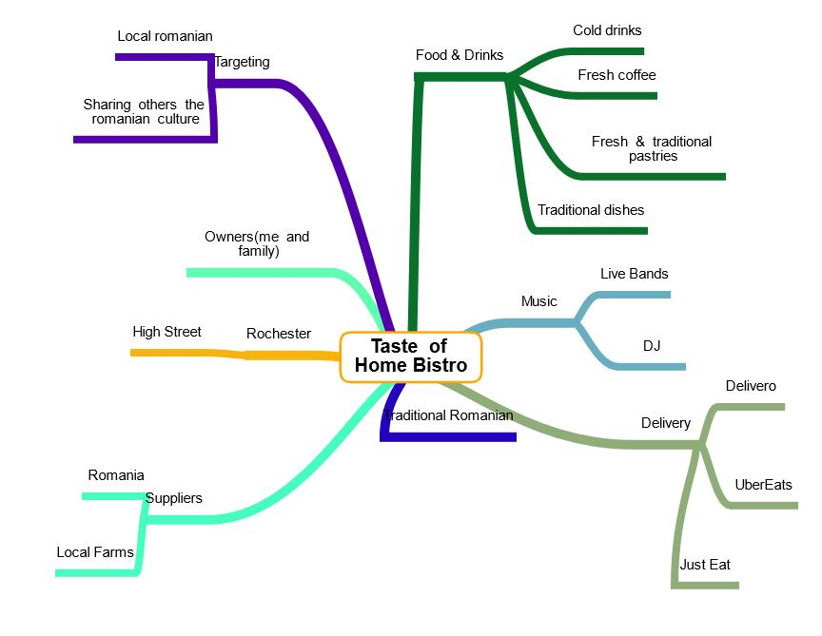
Business Canvas
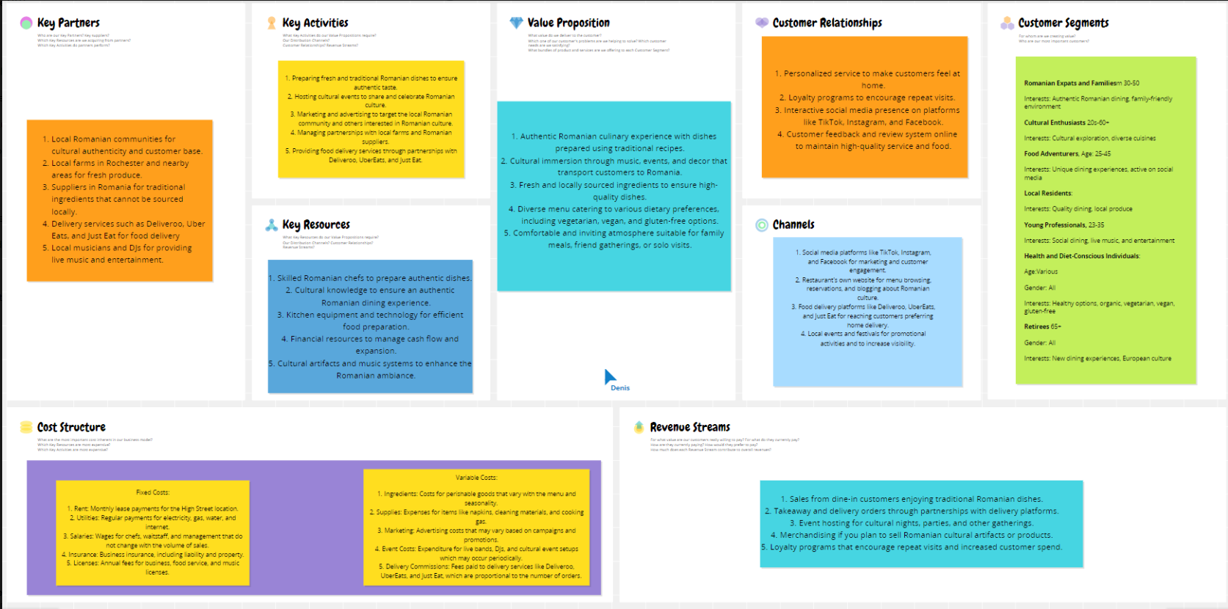

Appendix B
GET2 test results:
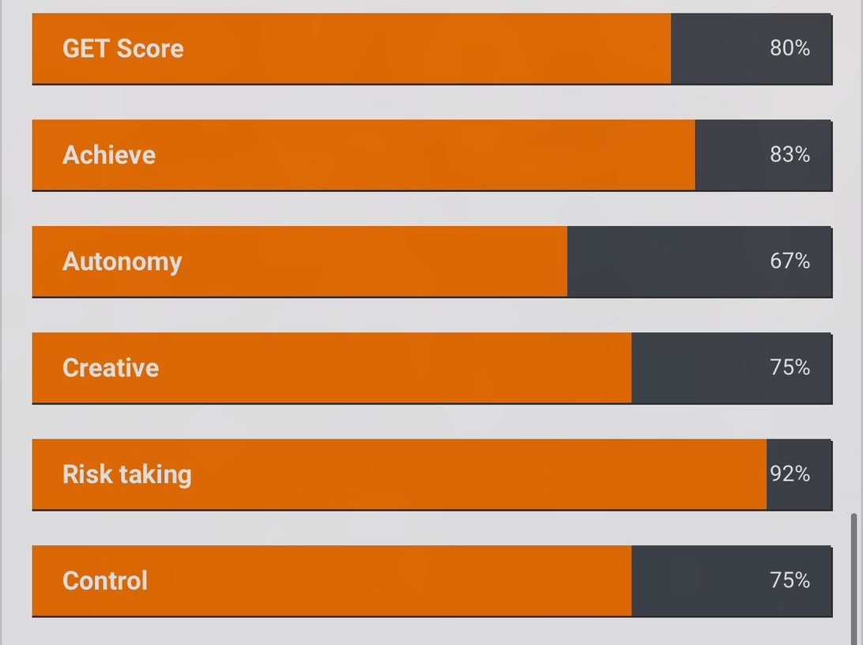

What kind of entrepreneur are you? test results:


