Student Name: IULIA PETRONELA FERENT  Student ID: 2225255  Module Title: Foreign Languages & Cultural Awareness  Module code: BMIH5003  Lecturer: HEIDI PROSSER  Date: 06/02/2024 | 
ASSIGNMENT 1: PORTFOLIO
(4 Components)

Component 1: Professional Reflection (500 words +/- 10%)

Weighting: 25%
Cultural awareness is becoming the core element in industries that interact with foreign clients, guests, or customers. Therefore, the hospitality industry which is among the widely spread industries and mainly has tourists as its consumer market requires to be aware of the cultural differences (YURTSEVER and ÖZEL, 2021). This signifies that foreign language learners are being taught about cultural differences however, the rapid globalization demands the spread of cultural awareness on the wider spectrum. The lack of cultural awareness can cause misunderstanding in several ways and the individual belonging to dissimilar cultures often do not understand the cause of the misinterpretation. The lack of cultural awareness often builds a negative stigma for the public or people who belong to that particular culture (Rayan and Fawaz, 2017). This negligence of cultural awareness was experienced by me when I was assigned to the event at The Grand Brighton hotel. The evening that day started well but unfortunately, the incident which took place spoiled the ambiance of the party. It was the poolside party arranged by the hotel for the foreign guests and the arrangements were cross-checked by the manager to ensure that everything happens smoothly. The dinner tables were sectioned for the convenience of the guests who had different preferences of food choices. However, the problem arose when the guest was misguided and because of this, the person ate an Italian dish that contained pork meat. As soon as the guest realized that he had eaten pork meat, he felt offended that the staff member misguided him. I was serving the drinks when I heard the chaos so I rushed towards them. Where my colleague was trying to make the person understand that he asked him to have food from the second section but he took it from the third section. The misunderstanding that happened was not a small thing for the guest as his culture does not allow him to eat pork meat. He was furious because he felt offended and his cultural norms were indignant. However, for another guest, this was not something that should be given importance so they were feeling infuriated. They were feeling that way because according to them their event was being spoiled due to some minor issue or misunderstanding. However, for the guest who was involved in that issue seems it was a matter of cultural offence. This event communicated to me that cultural misconceptions can result in being offensive to the individual which we might not feel or realize. Therefore, the requirement to have cultural awareness is becoming a vital element for the institutes and for the hotel industry specifically to reduce the possibility of events that can hurt the individual's cultural norms. However, the study suggests that learning or working in a collaborative environment that has culturally dissimilar individuals can aid the learners in enhancing their cultural awareness (de Hei et al., 2019). Therefore, I believe that hotel management should include staff who belong to different cultures in regard to avoid cultural misunderstanding.
References:
de Hei, M., Tabacaru, C., Sjoer, E., Rippe, R. and Walenkamp, J. (2019). Developing Intercultural Competence Through Collaborative Learning in International Higher Education. Journal of Studies in International Education, 24(2), pp.190–211. doi:https://doi.org/10.1177/1028315319826226.
Rayan, A. and Fawaz, M. (2017). Cultural misconceptions and public stigma against mental illness among Lebanese university students. Perspectives in Psychiatric Care, 54(2), pp.258–265. doi:https://doi.org/10.1111/ppc.12232.
YURTSEVER, A. and ÖZEL, D. (2021). The Role of Cultural Awareness in the EFL Classroom. Turkish Online Journal of Qualitative Inquiry, 12(1). doi:https://doi.org/10.17569/tojqi.776499.
Component 2: Training Plan (500 words +/- 10%)

Weighting: 25%

Identified cultural misunderstanding ( in a few words):
The F&B department of The Grand Brighton has arranged a cultural diversity program in which the hotel arranged a culture program where diverse cultural guests came and the program was different from the guest. This cultural diversity program was effective badly on the hotel but it caused a negative impact because the staff had fewer skills for welcoming their different cultural guest. Therefore, the hotel will arrange a training program for their staff so the staff will understand and be trained in cultural sensitivity.

Training plan (Why/What/Who/Where/When)
The hotel arranging the “Cultural Sensitivity Training” program. In this training, the hotel trained their staff about a different culture of guests, these are the crucial aspects because without understanding cultural differences, the staff cannot show gratitude and gestures for their guests. In the training program, it should be aware to the staff that different cultures have some different expectations people have some personal space they do not want that to interfere in their personal space and also some people are reserved and only want formal interactions with other people. Ro understands this staff should know about guests’ body language, their eye contact, and also know about their appropriate physical touch. These are the things that staff should know about their guest and will not discomfort their guest (Tsiopanis, 2021). The hotel provides training to its staff that staff should be aware of which types of guests are invited to their hotels because some guests like it when their last name and title will used for attention and communication. These are things that help to be aware of the cultural differences and build trust and respect with the guest. Therefore guests will be happy and attracted. Furthermore, the staff will trained about the different religions and beliefs. In some cultures, there are some dietary restrictions like halal or haram, these are important things to understand and provide their guest with different types of food so they can easily select their desired food without disappointment from the hotel services (Čelić et al, 2021). These are the things that hotel staff should know about their guest so that it will help to give them a better experience with hotel services.
Additionally, the hotel should provide their staff with customized service for their guest so that the staff will fulfill the guest’s cultural needs and can improve their guest’s experience. Guests should know about their staff’s religion and culture, if the guests are from the Muslim religion the hotel should provide halal food, provide them with prayer mats, and also understand their qibla directions. This customized service to the guest helps to build respect and trust from the guest to the hotel. The other customized service is that the hotel should provide the staff with different languages so that the guest can easily communicate with the hotel staff and can also the staff explain to the guest about hotel services (Davronov et al, 2019). These are the significant training that the hotel will provide to the staff so that it greatly affects the hotel and makes a positive image in front of guests.
References:
Čelić, I., Milićević, S. and Đorđević, N., 2021. Staff training and development: A comparative analysis of national hotels in Serbia and international hotel chains. Megatrend revija.
Davronov, I.O. and Khalimova, N.J., 2019. Professional development of hotel staff as a key to improve the quality of services in bukhara hotels. Мировая наука, (4 (25)), pp.27-29.
Tsiopanis, A., 2021. The effectiveness of staff training practices in the hotel industry.

Component 3: Student Self-Reflection (500 words +/- 10%)

Weighting: 25%
The Kolb’s reflective model is the significant approach to evaluate the experience in regard to enhance the learning process. The four core stages of the Kolb’s reflective cycle includes concrete experiences, reflective objectives, abstract conceptualization, and active experimentation. Through these stages the person can explore its experience in terms of reflective approach. Experiencing is the part of effective learning as it facilitates the person’s feeling and analysis (Vince, 2022). The fundamental principle of the active learning is to experience the situation and through the reflective analysis of that particular experience one can improve the cognitive ability. The core purpose to implement the Kolb’s reflective model is to evaluate my experience related to the lack of cultural awareness within the hospitality industry. The language and cultural interconnection builds the stance for the hospitality industry to integrate the training sessions or workshops in regard to develop the cultural awareness of the employees. It is necessary for the industry because the sector is approached by the tourists mainly thus, the dissimilarity of cultural background can cause difficulty for the staff and guest to communicate. According to Kolb and Kolb (2018), the active experience which is delivered through the means of training sessions can aid the person to enhance the work and personal proceedings. Therefore, I believe the training and workshops based on the cultural awareness and language will aid me to perform better on professional and personal grounds. Theoretical learning along with the experimental learning provides the learner wider vision to explore the context of the teachings (Yang et al., 2021). Hence, the incorporation of language learning along with cultural awareness will be beneficiary for me if the training sessions will include the theoretical knowledge along with the experimental circumstances. Being the hotel staff I will be able to serve the foreign guests with excellence as I can comprehend their language and cultural requirements. It will aid me personally as well because the language training of foreign languages will enhance my skills and cognitive abilities. Moreover, the cultural awareness will be beneficiary for me to interact with the individual’s belonging to dissimilar cultural background which will eventually aid me to groom. Apart from this perspective the reflection make me realize the rapid globalization demands for the cultural awareness within the hotel industry to perform prolifically and prosper towards the desired aims. Through this reflective analysis I concluded that the cultural dissimilarity is the matter of concern in this era and the hotel industry is required to fill this gap by conducting seminars, workshops or training programs which spread cultural awareness. I believe through the progressive approach towards integrated cultural and language training programs the hotel industry can flourish in the desired domain. As the cultural awareness will indirectly improve the customer satisfaction for the hotel and this will further result in progressive approach to maintain the loyalty of the customer with the hotel. Being the part of hotel industry I have experienced that language barrier and lack of cultural awareness can cause challenges for the hotel or its staff to tackle with the foreign guests.
References:
Kolb, A. and Kolb, D., 2018. Eight important things to know about the experiential learning cycle. Australian educational leader, 40(3), pp.8-14.
Vince, R. (2022). Reflections on ‘Behind and Beyond Kolb’s Learning Cycle’. Journal of Management Education, 46(6), pp.983–989. doi:https://doi.org/10.1177/10525629221114040.
Yang, C.Y., Xie, D. and Wong, J.W.C. (2021). CHALLENGES AND BENEFITS OF EXPERIENTIAL LEARNING: THE CASE OF OVERSEAS EXCHANGE PROGRAMS. Advanced Education, (19), pp.79–88. doi:https://doi.org/10.20535/2410-8286.239232.

Component 4: Training Presentation (6 Slides)

Weighting: 25%
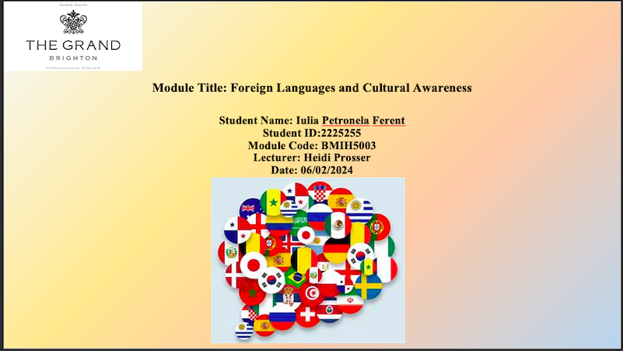

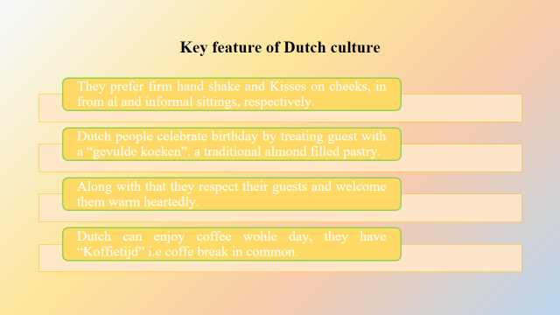
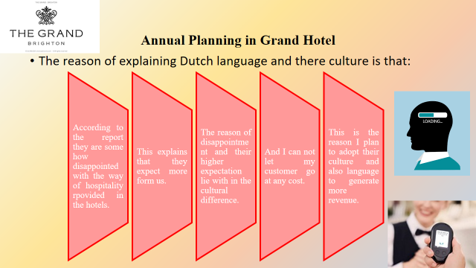
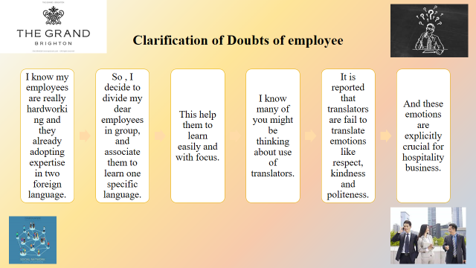
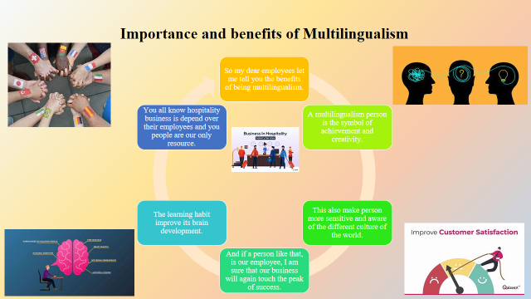
References (no screenshots):
- Fernandes Sampaio, C.A., Hernández Mogollón, J.M. and de Ascensão Gouveia Rodrigues, R.J. (2019). The relationship between market orientation, customer loyalty and business performance: A sample from the Western Europe hotel industry. Tourism and Hospitality Research, 20(2), pp.131–143. doi:https://doi.org/10.1177/1467358419829179.
- Hahn, T., 2023. The Restaurant as a Medium (Connect/Disconnect) On Culinary Temples and Porous Spaces. Food-Media-Senses: Interdisciplinary Approaches, 100, p.55.
- Mariani, M.M., Borghi, M. and Okumus, F., 2020. Unravelling the effects of cultural differences in the online appraisal of hospitality and tourism services. International Journal of Hospitality Management, 90, p.102606.
- Perpetua Ishika and Dawson Kyungai (2019). Role of English LanguMultilingual and Multicultural Development, 40(2), pp.133–147. doi:https://doi.org/10.1080/01434632.2018.1493114.
- Rita, P., Borges-Tiago, M.T. and Caetano, J., 2023. The theory-practice research gains from big data: evidence from hospitality loyalty programs. International Journal of Contemporary Hospitality Management.
- Williams, S.M., 2019, October. Modern Central European Hotels and Spas in Cultural Criticism: Grand Hotel Nostalgia: An Introduction. In Forum for Modern Language Studies (Vol. 55, No. 4, pp. 415-425). Oxford University Press.

