2.P Foundation Substantiation
Using information gathered from the desk study and borehole reports it has been decided that the riverside building being constructed will be using concrete pile foundations.
The piles will be precast piles that will be transported and driven into the ground in several locations disclosed on the foundation drawings (figure 1).
The health centre being constructed will use precast piles as they are able to reach the deeper, more compact gravel below to ensure the shear strength and bearing capacity of the structure is optimal.
These piles are also the most suitable option to the load provided by the unevenly shaped building.
An advantage of using precast piles is that the installation period is lower than most other foundations although the cost upfront for the client is higher.
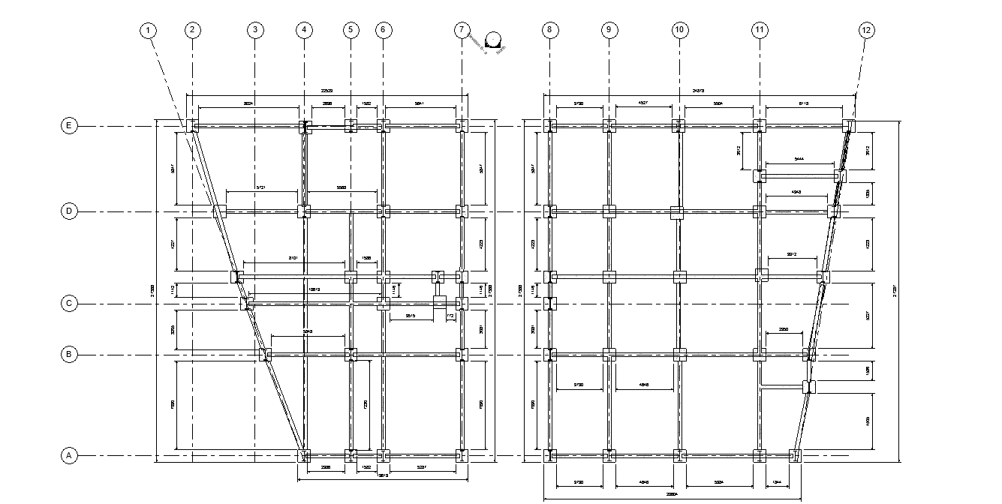

The casting of the piles and the installation will be sub-contracted to Roger Bullivant Engineering, based in Port Talbot, awarded ground engineering specialist of the year 2023.
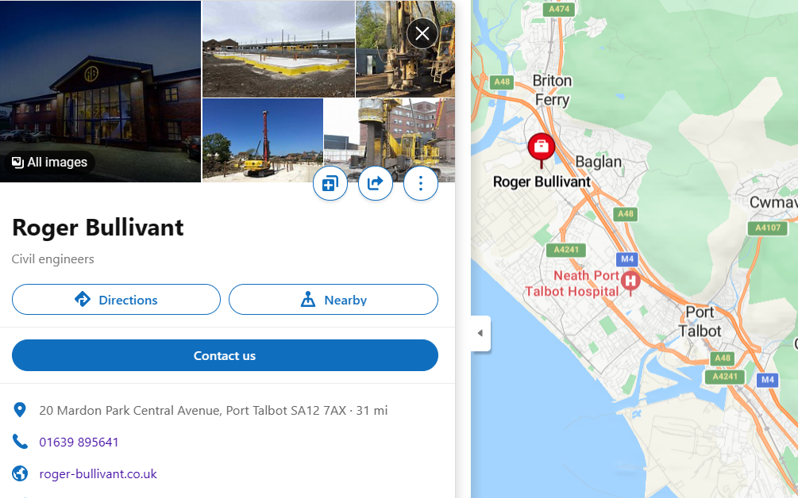
(Figure 2- Location of sub-contractors’ firm)
The installation will be assisted by a top-driven hydraulic hammer as this will assist in displacing the gravel below and will result in higher shear strength (Roger Bullivant, n.d.). The pile will be driven to 15 metres in depth to ensure the compact gravel is reached and once the 1st pile is installed there will be a control point where the quality of the pile installation is ensured before installation of further piles continues.
Once the control measures confirm that the pile installed is of high quality and has been installed correctly then installation of other piles can then begin.
The sub-contractor will also provide precast pile caps to be installed after the installation of the piles. The precast pile caps are designed with flared heads to ensure maximum support for internal concrete slabs used in commercial buildings similar to the Riverside project (Roger Bullivant, n.d.).
If the engineer responsible for the quality assurance checks decides that, for any reason, the piles installed are not up to BS EN 12794 standards then the suppliers will be contacted, and the contract possibly terminated.
While we understand the needs of the client and the very limited time from project start to completion, Apex Construction will not be responsible for poor quality or installation of foundations.

Roger Bullivant. (n.d.). Driven Precast Concrete Piles. [online] Available at: https://www.roger-bullivant.co.uk/products/piling/driven-precast-concrete-piles/. [Accessed 22 Apr 2024]
Roger Bullivant. (n.d.). Precast Ground Beam System for Efficient and Sustainable Foundations. [online] Available at: https://www.roger-bullivant.co.uk/products/foundation-packages/precast-caps/ [Accessed 22 Apr. 2024].

‌
‌

