

Name : Petrica Dana
Student ID -2215984
Module code -LCBB4006
Module name – Academic Skills
Lecturer-Lizeta Demetriou
ACADEMIC SKILL INDIVIDUAL REPORT
Cottrell, S. (2019) The Study Skills Handbook, 5th Ed. London: Red Globe Press.

Table of Contents
INTRODUCTION 3
MAIN BODY 3
Study skills. 3
CONCLUSION 5
REFERENCES 1

INTRODUCTION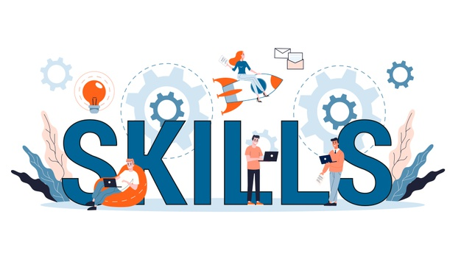
Study skills are important in order to study and gain good marks. The report will be covering study skill handbook, 5th Edition London: red Globe press and specifically focusing on the part of self-efficacy which is related which managing success in the life of student.

MAIN BODY

Study skills.
Study skill is one such skill that helps student to study effectively in whatever subject one is interested in. this can be defined as the process which helps students to recognize and develop interest in studies and enhances their productivity while they are studding (Cottrell. (2019). Study skills basically requires some habits like the habit of listening, reading and active learning. The most important thing is that the study skill is associated with self-efficacy. Self-efficacy simple means personal belief and the capabilities of individuals which forces to them to learn. It is very important that student start believing in themselves and for that students needs practice. Critical thinking, taking charge, using different opportunities, making better choices are some things that can help student in effective learning (Hailikari. Katajavuori. and Asikainen., 2021). Practising on the points above is not only a way to develop study skills instead a student should know why study is important and what it brings into their life ahead and this can be easily seen from the students that do best in universities as they are well motivated, and they know the real value of education.
The overall article aims at promoting the levels of understanding for the students regarding the ways through which the good marks as well as with the outcomes that are successful, this is possible for any student in particular. Next is to clarify the overall expectations of the students in particular regarding the conventions and the study tasks and the ways through which critical thinking can be used in the manner that is most effective as well as most suitable in particular. Also, this supports the students by identification of their weaknesses as well as strengths and the things that can be achieved by them in particular. This is also providing guidance to the students in a precise and step- by- step manner and also offers insights as well as resources in particular.
It is a major necessity and a goal or the objective of a student in particular to achieve the success that they have specifically aimed for in the higher education. This is not focused on the betterment of one particular skill. A set of skills is required to attain this particular goal. But improvement in the levels of the studying skills is one major skill that is considered to be essential or relevant in particular. This part of the article in particular starts with giving description regarding the transformational experiences in the lives of the students while studying higher education. These experiences can be life changing and help the individuals to learn different aspects of life personally as well as professionally. This can be done through first of all implementing the value of self- efficacy within the students in particular. Which means it is essential for an individual to understand his or her capabilities and then further believe in them in particular. This is a very necessary aspect to be considered. Then only the individual will take the first step in having transformational experiences of his or her life.
For this first of all the individual is required to take charge of the planning and the best ways through which the goals or the objectives of the student can be achieved in particular. This can be done through effective and efficient planning, which can be done by thinking in a manner that is precise and detailed both at the same time. The decisions taken should be well- informed and taken in accordance to proper research and investigation. The right or the correct mindset for the purpose of studying should particularly be developed too. Then the time management should be proper and time should be more as well and the choices made should be wise and should be according to the requirements of the individual in particular. One major aspect is to take decision regarding what is actually required by the individual and then the opportunities that are present in the environment need to grasped or to be grabbed by the individual specifically. Also, the understanding regarding the higher levels of the study is also essential and the ways it differs from that of the other studies is also considered to be essential or important.
Mainly the article focuses on the fact that the vision of student towards achievement or attainment of the success is very necessary. Time, money and resources are something that can be invested in a huge amount but still there might be results that might not be achieved. Which basically means that these things are only not the ones that are necessary rather there are things like imagination, vision and belief that also play a major and a very vital role. Also, this part of the article states that there are many things that are expected from the student in particular, which differentiates the school education and the higher level of studies. These include the skills like, independence, capability for setting aims or goals mainly for the purpose of improving the quality of their work, then self- motivation, time- management skills, an open mind towards the perspectives of others too, ability to make critical decisions, learn the best that is taught and on their own too.
It also states that the higher level of the studies is different in many ways and the teacher plays a major role, not only in the educational life but also on the personal lives of the students in particular. The things that can be expected in the higher education like lectures, tutorials, workshops, seminars, etc. are also mentioned in the article.
Through this article in particular I have personally learnt a bunch of things that will help me in enhancing one of the majorly required and necessary academic skills of mine that is the study skills in particular. I have mainly learnt the meaning and the importance that study skills particularly hold in the life of an individual who is studying higher level of education in particular. Also, I learnt that as I usually study independently, the benefits, the risks ans the challenges that independent study has. Through this I understood that what are the aspects that I need to focus on to reduce the risks of independent learning in particular.
Also, this will help me improving my overall performance in the field of business management which I am studying in and this will also help or support me in the future when I am working with a company as my research skills, planning skills and decision making skills will also improve in particular.

CONCLUSION
This report gives description regarding the article that the overall information of the report is inclined towards and also the report gives a reflection regarding the ways through which the study skills will help an individual and the learning outcomes from the article are also presented above in the report in particular.

Books and journals
Cottrell, S. (2019) The Study Skills Handbook, 5th Ed. London: Red Globe Press.
Hailikari, T., Katajavuori, N. and Asikainen, H., 2021. Understanding procrastination: A case of a study skills course. Social Psychology of Education, 24(2), pp.589-606.
https://sites.duke.edu/

