

Candidate name: Chuanmo Yang
Course name: Organisation consultancy
Unit code: M6X01422
Title name: The analysis of recruitment system in Virgin

Summary
The aim of this report is to evaluate the main issues of recruitment system in Virgin Company and provide recommendations for dealing with them. The main findings include the following points.

- The company did not have balanced recruitment standards, which overemphasized applicants’ previous performance.
- Some companies have faked Virgin's name and posted some false advertisements and recruitment information online, which has damaged Virgin's reputation. Some candidates provide some fake information in qualifications.
- There exists a number of problems in the process of interview.

Based on the analysis for the existing problems, some recommendations are provided for improvement. In order to solve the problem of unbalanced hiring standards in Virgin, Virgin needs to establish comprehensive standards. For example, it can pay more attention on the applicants’ practical application abilities and psychological quality. In order to reduce the fake recruitment news and fake resumes, Virgin needs to standardize online recruitment platform, and severely punish false recruitment. Recruiters need to recognize false information of resume accurately. To reduce the problems in interview process, it is important for the interview examiner to make enough preparations before interview and try to set some flexible answers.

contents
Summary 2
1.0 Introduction 4
1.1 Introduction of the organisation 4
1.2 Project justification 4
1.3 Aims and objectives of the project 5
2.0 PEST analysis in recruitment process 6
2.1 The definition of PEST analysis and its advantages and disadvantages 6
2.2 Political factors influence on recruitment 6
2.3 Economic factors influence on recruitment 7
2.4 Social factors influence on recruitment 7
2.5 Technological factors influence on recruitment 8
3.0 Research methodology 8
3.1 Definition of primary research and its pros and cons 8
3.2 Secondary research definition and its benefits and drawbacks 9
3.3 Secondary literature of recruitment in Virgin Company 10
4.0 Literature review 10
5.0 Findings and analysis 11
5.1 Main problems of recruitment system in Virgin 11
5.1.1 The problems of based on merits and its effects 11
5.1.2 The problems of fake recruitment and its effects 12
5.1.3 The issues of interview procedure in Virgin Company 14
6. Conclusion 16
7. Recommendations 17
8. References 18

1.0 Introduction

1.1 Introduction of the organisation
The purpose of this report is to further develop a detailed study of Virgin's recruitment system based on previous proposals.

Virgin Group Ltd. is a British global venture capital business set up by businesspersons of Sir Richard Branson and Nik Powell. Virgin Group's date of merger is listed as 1989 by Companies House, who list it as a holding company; however, Virgin's business and trading activities date back to the 1970s. The net worth of Virgin Group was assessed at £5–6 billion as of November 2014 (Richard, 1998). Virgin Group is a diversified grouping of more than 200 privately held companies. Virgin is one of the world’s most popular brands and has extended into several sectors from travel to telecommunications, health to banking and music to relaxation (Hannah, 2015). The slogan of the Virgin airline is “embrace the human spirit and let it fly”. The Virgin Atlantic team is doing a good job of finding candidates. The team are looking for candidates who are dedicated to work, take security very carefully but who know how to have fun (Hannah, 2015).

1.2 Project justification
There are a series of reasons for choosing the project topic of recruiting system in Virgin Company. First of all, with the increasing pressure of current social competition, recruiting has become an important part in human resource management. Recruiting has a number of benefits on filling up the vacancies with the right candidate. An effective recruitment and selection strategy can ensure that the whole recruitment process can be directed in a fair and justified manner and the results are consistent (Schroeder, 2015). Moreover, an efficient recruitment process can lower costs, enhance a business’s reputation both from a market and candidate viewpoint (Ridding, 2019). In Virgin Company, HR has been making some progress in recruitment recent years. However, there still exists a number of problems of recruiting and retaining employees. For recruiting, the standards adopted by HR has some limitation. For example, sometimes HR only stresses on the previous performance of the employees and ignores their transferable abilities (Talent Tech labs, 2014). In addition, sometimes the job advertising information of recruitment can be fraudulent to staff to some extent. In 2014, Virgin company lost approximately 7,000 clients owe to terrible candidate experience (Talent Tech labs, 2014).

1.3 Aims and objectives of the project
The aim of the project is to evaluate the problems and challenges of recruitment system in Virgin Company and provide a number of recommendations. The first objective is to find the main problems related to the limited standards such as only based on merits when hiring people in Virgin Group. The second objective is to investigate the main issues of fraudulent recruitment in Virgin company and candidates’ personal CVs. The third objective is to analyze the main issues of designing the interview questions or interview procedure in Virgin Company. The last objective is to provide useful recommendations for improving the recruitment system in Virgin.

2.0 PEST analysis in recruitment process

2.1 The definition of PEST analysis and its advantages and disadvantages
PEST analysis is a widely used tool that helps people analyze the political, economic, social-culture and technological changes in business environment (Richardson, 2019).

There are a number of benefits of using this model. Fundamentally, a PEST analysis can help people determine how these factors would impact the performance and activities of business in the long-term. Secondly, PEST analysis can raise awareness of potential threats. Thirdly, with PEST analysis, people can have the capability to examine changes thoroughly and develop a plan to diminish all profit rise or damage. The business may suffer some unexpected threats without it (Frue, 2018).

However, there exits some disadvantages of using it. The factors in this model could change rapidly, even in only a few hours. For instance, a political party can be forced out and the technology can be out dated. Any shift can change the result of the PESTLE analysis. What’s worse, it makes it hard to predict the future of businesses. In addition, most data may not be very easily found and there may be risks of mishandling information. For the PEST analysis, on one hand, people need plenty of information; On the other hand, people may become confused when they handle with a lot of information (Galea, 2015).

2.2 Political factors influence on recruitment
Before recruiting the staff, a number of political factors should be considered. For example, there is the Employment Act 2008 that protects employees in the workplace. In the same way, people have the Employment Exchange Act, 1959, which commands that managers (business institutions retaining 20 employees each) should inform the unfilled positions to the workforce exchanges. More importantly, people have the formation which bans bias in the situation of workforce and also provides protected prejudice to the less-privileged sections of the society (Kukreja, 2019). This regulation prohibiting employment bias ensures that Virgin employees can have equal employment opportunities as much as possible. For tax policy, the Virgin Group claimed tax reliefs and incentives which are available under UK tax (Virgin Group, 2019). By using tax relief policy, the cost of hiring people could be reduced, as a result, it is beneficial for recruitment in Virgin Company.

2.3 Economic factors influence on recruitment
Financial situations in a company have an important impact on the recruitment (Bassiouni, 2013). Virgin Atlantic increased overall revenue by £150m, a 5.8% year on year growth. This company returned to a strong financial position and improved its profitability in 2018 (Virgin Atlantic, 2019). As a result, the good profitability in Virgin could put a positive impact on the number of recruited employees and the quality of recruiting.

2.4 Social factors influence on recruitment
The workers’ faiths and social cultures have an important effect on their morals and attitudes towards their work. Understanding the incentive and drives of people in a society in the process of designing the recruitment is very important. Interviewers need to take considerations into the alterations to the cultural and social of people they plan to recruit due to the development of the economy (Kilhefner, 2019).

Virgin is a multinational cooperation, and the recruitment involves in a lot of countries. Since there exist different social backgrounds, culture and religions in different countries, the conditions of hiring will be different. For example, Virgin in India has to consider more the social customs and religious features in seeking for suitable employees. In UK, it is not right for candidates in Virgin to put some personal photos in their personal CVs as this country respects for privacy culture (Smith, 2017).

2.5 Technological factors influence on recruitment
Technology plays an important role in increasing the efficiency of making choices and plans. Job advertising is one of the methods that technology can have an influence on recruitment. Companies can now simplify their online recruiting rules to attract the job candidates more rapidly and cheaper. An increasing number of recruiters is currently transforming from the traditional job advertising to online recruitment as the traditional one is highly cost (Job Net, 2019).

With the development of technology, Virgin Company has been trying to use video interviews. Rather than a human recruiter judging people’s performance, computer analytics could analysis performance and make a decision whether people should be shortlisted, which can save much energy and time (Salmons, 2017). However, with the development of online job advertising, Virgin have to face the false recruitment problem. For example, the members of the public sometimes receive fraudulent employment chances of the emails and also fake internet investigations (Virgin Australia, 2018). Furthermore, the fake recruiting information online will mislead the job applicants in Virgin Company.

3.0 Research methodology

Research methodology is the specific processes or techniques used to identify, select, process, and evaluate information about a topic. In a research paper, the methodology section allows the reader to evaluate a study's overall effectiveness and reliability critically (Goundar, 2014). Research methodology mainly include primary and secondary research.

3.1 Definition of primary research and its pros and cons
Primary research refers to a methodology used by researchers to collect data in a direct way, instead of depending on data collected from previous research. It has a number of advantages of up to date, relevant and specific to people’s research objectives. However, it is time-consuming and also complex if the research respondents are not supportive. Besides, there may be some misleading information if the sample is small, as a result, the researchers need to choose a good research sample (Rahman, 2016).

Why the primary research is not adopted in this report is that it is very difficult to collect enough participants who work in Virgin Company and know very well about the recruitment system in Virgin Company.

3.2 Secondary research definition and its benefits and drawbacks
Secondary research is a research approach that collects the existing data and analyzes them, gathers, categorizes, and organizes the literature, and finds a logical understanding of the facts through the research of the literature. These literatures can be collected in public libraries, internet, books, data obtained from completed survey. Some government and non-government institutions also store statistics, which can be used for research aims and can be searched from them (Bhat, 2017).

Secondary research makes a full use of accessible statistics, and thus is more cost-effective and time-saving than primary research that is generally time-consuming and may have difficulties in gathering enough participants due to some uncertain situations. The second advantage of secondary research is the extensiveness of statistics that is openly available currently. In addition, people can find the limitations in the research and improve it through the research of the predecessors (Management study guide, 2017).

The main limitation of secondary research is that the secondary data set may not reply to the investigator’s direct research questions to the extent that the research would have expected. The second limitation is that whatever a researcher checks a secondary database, they are always unable to know how the information was collected accurately, and how the process was implemented. The third drawback is that that the researcher may have difficulties in gaining information specific to his or her needs (Foley, 2017).

3.3 Secondary literature of recruitment in Virgin Company
Some official academic papers mainly cover the basic theory of recruitment and selection, such as the PESTL and SWOT analysis on the recruitment in an organization. These articles are well structured. There are a number of diagrams, which can help to better understand the basic framework of recruitment process, the important factors influencing the recruitment process and the appropriate methods of reaching the targeted employees. Some journals and BBC news provide important information including the success of recruitment system in Virgin Company, the problems of recruiting and retaining employees in Virgin Company, which can help to analyze the reasons about the failure of recruiting staff and offer related recommendation for Virgin Company for improvement.

4.0 Literature review
4.1 The theory of standards for hiring employees
There are a number of criteria for recruiting employees. According to Monney (2019), the candidates who have self-confidence is an important standard to recruit as a confident attitude can have a first good impression on recruiters. According to Seidel (2019), a good work experience and a strong work background represent a good work ethic, and thus are essential criteria for employing staff. The specific abilities and professional knowledge of potential staff are also a vital recruitment factor. According to Markowitz (2014), the value the individual brings to the organization is an important factor to consider. In addition, the candidates who have good communication skills, a good pressure resistance, emotional management ability and good moral character can be also regarded as important factors. By summarizing the opinions of these researchers, hiring a good employee not only depends on his personal ability and professional level, but also his moral character, psychological quality and first impression are important.

4.2 The perspectives on fake recruitment
According to Broughton (2016), recruitment fraud is a type of fraud providing fabricated job opportunities. It is normally done through online services such as false websites, or through unknown e-mails or other communications requesting to be from the company. According to Foley (2016), these communications come in many methods, for instance, counterfeit job postings and requests to fill out applications or engage in interviews - and attempt to trick job applicants into offering individual information or payments, purportedly to get employed for jobs that basically do not exist.

4.3 The theory of designing an effective interview procedure
According to Samuel (2013), five key advantages to interview planning are: efficiency, clarity, relevance, consistency and a good candidate experience. In order to save on hiring costs, people need an efficient process. This means both a streamlined hiring process and a process that leads to the right employee for the job. According to Cappelli (2014), the lack of sufficient preparation for an interview is the largest fault in the interviewing procedure. For process of raising questions, Samuel (2013) held the point of view that it is not recommended for interviewers to rely too much on a programmed questioning method as it may cause the fixed answers and is always disconcerting to the interviewee. By summarizing the views of the researchers, an enough preparation before interview and flexible interview questions are both important.

5.0 Findings and analysis

5.1 Main problems of recruitment system in Virgin

5.1.1 The problems of standards limitation and its effects
In Virgin, there exists a problem of limited standards of hiring candidates. The pie chart (Diagram 1) illustrates the different proportions of recruiting standards in Virgin Company.

This graph shows that the biggest percentages of hiring standard in Virgin is individual performance in previous company, which accounts for 30%. The second is the actual ability, which accounts for 20%. The proportions of team working abilities and communication skills take account of 30% totally, which are less than the percentages of personal work performance. The percentages of emotional management skills and stress resistance are 20% totally.

Diagram 1: Different proportions of hiring standards in Virgin

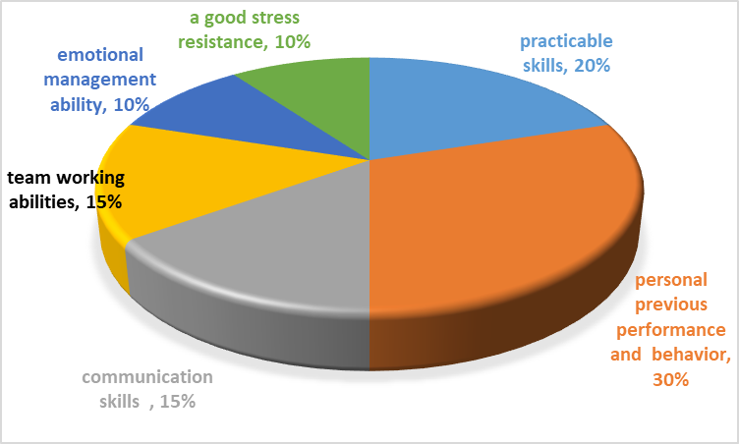

Sources from: (Olenski, 2015)

According to the data, it indicates that the company overstress on the job seekers’ previous outcomes. The company's second focus is on practical application capabilities. Virgin pays less attention to some soft skills including teamworking skills and good communication skills. In addition, Virgin pays less attention to the aspects of candidates’ psychological quality consisting of emotional management skills and stress management abilities. The ignorance of paying attention to the applicants’ soft skills and mental quality in Virgin is not conducive to the overall development of the job seekers. It could cause the fact that the job applicants focus too much on their previous results, and they may lose confidence in other personal aspects.

5.1.2 The problems of fake recruitment and its effects
Fraudulent recruitment is a very serious problem for different organizations. Original misstatements or misinterpreted information posted on a CV is always regarded as ‘a white lie’, however, it can and does cause bigger financial and reputational costs down the line (Shepherd, 2018).

Virgin Australia has received reports of fraudulent internet investigations declaring to be from the airline sent through email. These fake surveys commit free flights on the Virgin Australia network once a recipient offers personal information such as date of birth, mobile phone number and address. These surveys do not originate from Virgin Australia and are incorrect. The spelling and syntax are always wrong in the fake employment and money may be requested sometimes (Virgin Australia, 2018).

Diagram 2 illustrates the different types of false resume information for Virgin candidates in a sample of 5000 CVs.

Diagram 2: Different types of false information for Virgin candidates
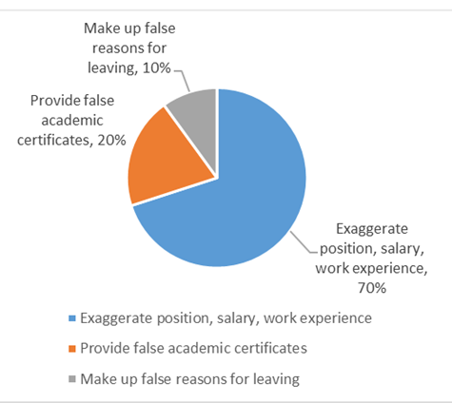
Sources from: (Rosen, 2017)

This diagram shows that the job applicants who exaggerate job positions and wages take the biggest proportion of 70%. The total proportions of making up fake reasons for leave and offering fake academic certificates occupy 30%.

Fake recruitment could bring a number of challenges to the recruitment system in Virgin Company. Above all, the reputation of the business in the eyes of suppliers, customers, competitors, staff and other business partners will be damaged. Secondly, businesses might become excessively internally focused in reply to a scam (Blackbourn, 2019). For individuals that monitored the swindler, the fraud may affect their reputation, thus their career. For the untrue information of candidates resumes, it will bring great difficulties to the recruitment of human resources (Button, 2019).

5.1.3 The issues of interview procedure in Virgin Company
There are a series of problems of interview process in Virgin Company. The following two diagrams illustrate it.

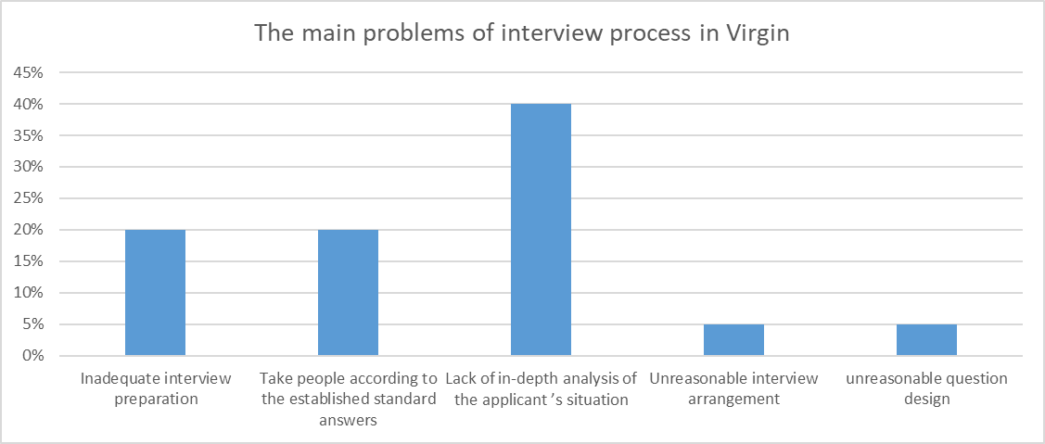
Diagram 3 The main issues of interview procedure in Virgin
Sources from: (Varvakis, 2016)

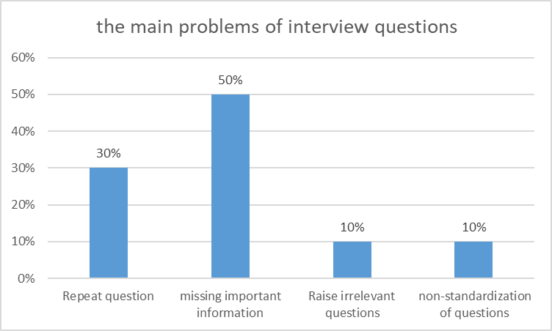

Diagram 4 The main problems of questions during interview process
Sources from: (Varvakis, 2016)

The diagram 3 illustrates that the lack of in-depth analysis of the candidates’ situations take the largest proportion of 40%. The proportions of inadequate interview preparation and judging the applicants by the standard answers are 40%. The proportions of unreasonable question design take 10%. The second bar chart (Diagram 4) illustrates the problem of missing essential information takes the largest proportion of 50%. The irrelevant and non-standardization questions take account of 20%. The diagram 3 indicates that the lack of in-depth analysis of the actual situation of job applicants is the most serious problem in the interview process. This is related to false information of job applicants for Virgin to an extent. Sometimes, the exaggerated information of job seekers may mislead the recruiters in Virgin Company and they may not identify the misleading information very well. As a result, the problem of the lack of deep investigation of the actual situation of candidates occurs.

6. Conclusion
This report provided evaluations of recruitment in Virgin Company. First of all, Virgin Company has the problem of limited recruitment standards. Virgin pays less attention to soft skills and emotional control than the original work performance of job seekers. Secondly, there exist fake online job recruitment and false resume information of candidates in Virgin, which may have an adverse impact on the company’s reputation and the recruitment system. Thirdly, there exists main problems including irrational interview arrangement, irrational questions, lack of in-depth understanding about the job seekers’ real needs and situations.

7. Recommendations
In order to improve the recruitment system in Virgin Company, a number of recommendations are provided as follows.

- Establish a balanced and comprehensive standard for recruitment system. Expand more recruitment standards into the applicants’ practical application abilities and psychological quality. The company cannot overemphasize on the applicants’ previous performance.

- Standardize online recruitment platform, severely punish false recruitment. Accurately identify false information of applicants’ resume.

- Do sufficient preparations before interview and do in-deep analysis for the applicants’ situation. The interviewer should be flexible according to the actual situation, not blindly judge by pro-prepared answers.

8. References
Bassinouni, D. (2013) “What is financial factors”, [online] Available at< https://www.igi-global.com/dictionary/fuzzy-mcdm-approach-for-make-or-buy-decision-problem/39752> Access [2nd May, 2020]

Bhat, D. (2017) “The effectiveness of secondary data”, Journal of secondary research, 33(1) pp23

Button, D. (2019) “The real cost of recruitment fraud”, Computer Fraud & Security, 16(3) pp8

Blackbourn, D. (2019) “The real cost of recruitment fraud”, Computer Fraud & Security, 16(3) pp13

Broughton, A. (2016) “The use of social media in the recruitment process”, London: CIPD

Cappelli, G. (2014) “Designing and conducting an effective interview”, [online] Available at< https://www.citeman.com/9006-designing-and-conducting-an-effective-interview.html> Access [6th May, 2020]

Foley, B. (2017) “Research Methods: How and When to Use Primary and Secondary Research”, [online] Available at< https://www.surveygizmo.com/resources/blog/research-methods-how-and-when-to-use-primary-and-secondary-research/> Access [3rd May, 2020]

Foley, C. (2016) “What is Recruitment Fraud? Is Your Company at Risk?” [online] Available at< https://hrdailyadvisor.blr.com/2015/01/19/what-is-recruitment-fraud-is-your-company-at-risk/> Access [5th May, 2020]

Frue, J. (2019) “Pestle and Swot Analysis of Virgin Atlantic 2016-2017” [online] Available at< https://www.123writing.com/free-sample/pestle-and-swot-analysis-of-virgin-atlantic-2016-2017> Access [20nd February, 2020]

Galea, D. (2015) “Potential Limitations of the PEST Analysis and How to Address Them”, London: CIPD

Goundar, D. (2014) “Fundamentals of research methodology and data collection”, Research Methods Handbook, 15(5) pp25

Hannah, S. (2015). "Virgin Cruises to base first 2,800-passenger ship in Miami” London: Virgin Books.

Job Net (2019) “5 Ways Technology Has Impacted on Recruitment Process”, [online] Available at< https://www.onrec.com/news/news-archive/5-ways-technology-has-impacted-recruitment-process> Access [4th May, 2020]

Kilhefner, J. (2019) “Social Factors Affecting Employment”, Journal of PEST analysis, 16(4) pp23

Kukreja, D. (2019) “PESTLE Analysis for a Recruitment Agency”, Journal of PEST analysis, 15(4) p34

Management study guide (2017) “Secondary data”, [online] Available at< https://www.managementstudyguide.com/secondary_data.htm> Access [2nd May, 2020]

Markowitz, D. (2014) “Organizational Hiring Standards”, Harvard Business Review, 25(2) pp36

Monney, C. (2019) “6 Tips for Hiring the Right Employee”, Theory of hiring employees, 23(4) pp35

Olenski, S. (2015) “Hiring on merits in Virgin”, [online] Available at< https://www.virgin.com/entrepreneur/problem-hiring-people-merit> Access [3rd May, 2020]

Rahman, B. (2016) “The limitations of primary research”, Journal of primary research, 17(6) pp34

Richard, B. (1998). “Losing My Virginity: The Autobiography.” London: Virgin Books.

Richardson, J. (2019) “A Brief Intellectual History of the STEPE Model or Framework”, Human Resource Management Review, 14(4) pp16

Ridding, C. (2019) “Benefits of an effective Recruitment and Selection policy”, [online] Available at< https://www.brewsterpartners.co.uk/news/benefits-of-a-recruitment-and-selection-policy> Access [4th May, 2020]

Rosen, M. (2017) “Why lying on a CV could leave you searching for a job”, [online] Available at< https://www.manchestereveningnews.co.uk/business/business-news/why-lying-on-a-cv-could-leave-you-690035> Access[7th May, 2020]

Samuel, F. (2013) “10 steps for conducting effective job interviews”, [online] Available at<https://wellsfargoworks.com/management/article/10-steps-for-conducting-effective-job-interviews> Access [5th May, 2020]

Schroeder, G. (2015) "The importance of recruitment and selection process for sustainability of total quality management", International Journal of Quality & Reliability Management, 19(5) pp. 540-550.

Seidel, L. (2019) “Recruitment and Selection: Hiring the Right Person”, Society for HRM, 26(3) pp37

Shepherd, N. (2018) “Recruitment Fraud Statement”, Theory of fraudulent recruitment, 34(5) pp34

Talent Tech labs (2014) “How Ph. Creative Transformed Virgin Media’s Candidate Experience” [online] Available at<https://talenttechlabs.com/blog/candidate-experience-case-study-virgin-media/> Access [20nd February, 2020]

Varvakis, D. (2016) “Main issues in interview process”, [online] Available at< https://www.coburgbanks.co.uk/blog/assessing-applicants/8-potential-problems-with-your-interview-process/> Access[8th May, 2020]

Virgin Atlantic (2019) “Virgin Atlantic Ltd 2018 Financial Results”, [online] Available at<https://corporate.virginatlantic.com/gb/en/media/press-releases/2018-financial-results.html> Access [2nd May, 2020]

Virgin Australia (2018) “Our recruitment process” [online] Available at< https://www.virginaustralia.com/au/en/about-us/careers/our-recruitment-process/> Access [20nd February, 2020]

Virgin Group (2019) “Tax Strategy Statement”, London: CIPD

