
APPENDIX GA36c

LEVEL 6 ASSESSMENT SPECIFICATION

Student name: | Connor Clack | Student ID number: | 264503
Programme: | BSc (Hons) Applied Computing
Module: | Usability Engineering
Module code: | ACCB6017 | Contribution to Overall Module Assessment (%): | 50%
Lecturer: | Pauline Greenaway | Internal Verifier | Gaynor Thomas
Assignment Title: | Cluedo Part 2 | Word count (or equivalent): | 3000
Submission deadline: | 14/05/2023 | Return date of provisional marks & written feedback: | TBA
Submission method: | All written assessments, where practical and possible, must be submitted via Turnitin unless otherwise instructed by the Lecturer. (Please DO NOT put this assessment specification into Turnitin or it will match many similarities with other students’ submissions.)  Alternative submission method (if applicable):  Late submission of the assessment will result in a late penalty mark. Penalties for late submission: Up to one week late, maximum mark of 40%. Over one week late, 0%. Only the Extenuating Circumstances Panel may approve a change to submission dates.
Academic honesty / referencing: | Academic honesty is required. In the main body of your submission you must give credit to authors on whose research and ideas your work is based. Append to your submission a reference list that indicates the books, articles, etc. that you have used, cited or quoted in order to complete this assessment.

Module Learning Outcomes
(from module syllabus)
Upon the successful completion of this module, the student should be able to:
- Research and evaluate cognitive and social information processing
- Select, apply and analyse critically techniques of interface evaluation
- Synthesize a solution to a complex design problem from the concepts and principles of usability engineering and software development
- Critically analyse, individually and as part of a team exercise, input and output hardware appropriate for specialised applications, for example for use by disabled people, and for three-dimensional modelling applications

TASK DESCRIPTION

Task
The boardgame CLUEDO is familiar to many as one that requires players to move their pieces around a board that represents a country mansion, finding clues that will help them solve the murder of Dr Black.
You are to design a UWTSD version of this as a computer game.

“Oh no! The Vice-Chancellor has been murdered! Who did it?”

You may set the game on any or all of the university campuses, and may include up to 8 players who should represent different parts of the university.

You should submit a report containing the following:
- A complete set of full-colour storyboards with appropriate example content together with a short discussion of the changes made due to the feedback collected on the wireframe storyboards, together with evidence of usability testing of these changes.
- A description of the process used to collect feedback on your final storyboard prototypes and a summary of the positive and negative feedback elicited
- A discussion of what data would be gathered if a working version were to be build and released, and how that data could be used to influence the next version of the app.
- A reflective summary of the overall design process and how it has been informed by both usability theory and by the inclusion of the potential users in the design process
The report should include appropriate illustrations and references to research literature (at least two thirds of these should be books/journal papers).

Your submission should be presented in the form of a report that includes the following sections:
- (30%) Full colour design storyboards (not hand-drawn and scanned). They should show all of the major functionality of the app at a size appropriate for a mobile phone, and should take all of the usual aspects of interaction design theory into account in the design. Where the design differs from that of the wireframe model the reasons for this should be documented and justified. The complete set of storyboards should be presented in an appendix but significant elements such as the main screen designs should be discussed in the main body of the report. These can be created using any suitable software; Adobe XD is a good choice for this, but other packages are fine provided that you remember to show not only the screens but how the user moves between the screens.
- (20%) How did you collect feedback on your prototypes? How did you ensure that your test subjects covered the range of personas you defined earlier? What feedback did you get, both in terms of usability and of emotional response? Were these what you expected and, if not, why not?
- (20%) What information are you going to collect from you users in the working version? Why do you need it and how will you collect it? Can data be collected automatically or will you need to continue to interact directly with your users to get the data you need? Are there differences between collecting usage data and emotional response data?
- (20%) How would your storyboards have differed if you had approached the app purely from a usability viewpoint? Were there any conflicts between usability and user experience that you had to resolve? Use examples from your design process to explain these.

The final 10% will be awarded for document presentation and appropriate references to the research literature. The report should be submitted through Turnitin. Do not submit the assignment brief document with this.

GUIDANCE FOR Students IN THE COMPLETION OF TASKS

NOTE: The guidance offered below is linked to the five generic assessment criteria overleaf.

- Engagement with Literature Skills
Your work must be informed and supported by scholarly material that is relevant to and focused on the task(s) set; you should make use of scholarly reviews and primary sources, where appropriate (for example, refereed research articles and/or original materials appropriate to the discipline). You should provide evidence that you have accessed a wide range of sources, which may be academic, governmental and industrial; these sources may include academic journal articles, textbooks, current news articles, organisational documents, and websites. You should consider the credibility of your sources; academic journals are normally highly credible sources while websites require careful consideration/selection and should be used sparingly. Any sources you use should be current and up-to-date, mostly published within the last five years or so, though seminal/important works in the field may be older. You must provide evidence of your research/own reading throughout your work, using a suitable referencing system, including in-text citations in the main body of your work and a reference list at the end of your work.

Guidance specific to this assessment: You need to justify your decisions related to good design and poor design by suitable reference to the literature.

- Knowledge and Understanding Skills
At level 6, you should be able to demonstrate coherent and detailed knowledge and a systematic understanding of the subject area, at least some of which is informed by the latest research and/or advanced scholarship within the discipline. You should be aware of the uncertainty, ambiguity and limits of knowledge. Your work must demonstrate the growing extent of your knowledge and systematic understanding of concepts and underlying principles associated with the subject area. Knowledge relates to the facts, information and skills you have acquired through your learning. You demonstrate your understanding by interpreting the meaning of the facts and information (knowledge). This means that you need to select and include in your work the concepts, techniques, models, theories, etc. appropriate to the task(s) set. You should be able to explain the theories, concepts, etc. meaningfully to show your understanding. Your mark/grade will also depend upon the extent to which you demonstrate your knowledge and understanding; ideally each should be complete and detailed, with comprehensive coverage.

Guidance specific to this assessment: Consider how you could collect data in a real-world situation. This will involve identifying and selecting potential commercial data collection services as well as bespoke data collection options..

- Cognitive and Intellectual Skills
You should be able to: critically evaluate evidence, arguments, assumptions, abstract concepts and data some of which are at the forefront of a discipline (and that may be incomplete) to devise and sustain arguments, to make judgements and/or solve problems; describe and comment upon particular aspects of current research, or equivalent advanced scholarship, in the discipline Your work must contain evidence of logical, analytical thinking, evaluation and synthesis. For example, to examine and break information down into parts, make inferences, compile, compare and contrast information. This means not just describing what! But also justifying: Why? How? When? Who? Where? At what cost? At all times, you must provide justification for your arguments and judgements. Evidence that you have reflected upon the ideas of others within the subject area is crucial to you providing a reasoned and informed debate within your work. Furthermore, you should provide evidence that you are able to make sound judgements and convincing arguments using data and concepts. Sound, valid conclusions are necessary and must be derived from the content of your work. Where relevant, alternative solutions and recommendations may be proposed.

Guidance specific to this assessment: What changes did you make to the design as a result of the test carried out in the previous assignment? How will these solve your problems?

- Practical Skills
At level 6, you should be able to apply the methods and techniques that you have learned to review, consolidate, extend and apply your knowledge and understanding, and to initiate and carry out projects. You will deploy accurately established techniques of analysis and enquiry relevant to the discipline, and apply them in complex and unpredictable contexts, to devise and sustain arguments and/or to solve problems. You should be able to frame appropriate questions to achieve a solution - or identify a range of solutions. You should be able to demonstrate how the subject-related concepts and ideas relate to real world situations and/or a particular context. How do they work in practice? You will deploy models, methods, techniques, and/or theories, in that context or circumstances, to assess current situations, perhaps to formulate plans or solutions to solve problems, or to create artefacts, some of which may be innovative and creative. This is likely to involve, for instance, the use of real world artefacts, examples and cases, the application of a model within an organisation and/or benchmarking one theory or organisation against others based on stated criteria. You should show awareness of the limitations of concepts and theories when applied in particular contexts.

Guidance specific to this assessment: You should produce a full updated interface for this prototype design, using an appropriate workplace tool. This should be tested with real users rather than simply relying upon designer tests.

- Transferable Skills for Life and Professional Practice
Your work must provide evidence of the qualities and transferable skills necessary for graduate-level employment requiring the exercise of initiative and personal responsibility and decision-making in complex and unpredictable circumstances. This includes demonstrating: the learning ability for professional development to advance existing skills and acquire new competences of a professional nature that will enable you to assume significant responsibility within organisations; that you can initiate and complete tasks and procedures, whether individually and/or collaboratively; that you can use appropriate media to effectively communicate information, arguments and analysis in a variety of forms to specialist and non-specialist audiences; fluency of expression; clarity and effectiveness in presentation and organisation. Work should be coherent and well-structured in presentation and organisation.

Guidance specific to this assessment: This is a report, not a paper, so no abstract is needed. Ensure that your report looks professional. Document presentation is important. Remember to use technical English, to stick to the numerical referencing method, and to caption all of your illustrations.

Student FEEDBACK FORM

This section details the extent to which the assessment criteria are demonstrated by you, which in turn determines your mark. The marks available for each category of skill are shown. Lecturers will use the space provided to comment on the achievement of the task(s), including those areas in which you have performed well and areas that would benefit from development/improvement.

Generic Assessment Criteria | Marks available | Marks  awarded
1. Engagement with Literature Skills
.
Although references have been included to support discussion relating to heuristic evaluation and external data collection tools, there is no evidence of supporting references in relation to the application of interaction design theory. |  | 14
 | 30 | 14
2. Knowledge and Understanding Skills

Data collection methods appropriate for the full version have been discussed although more detail could have been provided, |  | 18
 | 30 | 18
3. Cognitive and Intellectual Skills

Good quality full colour storyboard has been produced and feedback received as part of the previous assignment has been actioned with justification of changes completed. Further feedback obtained on the final using Nielsen’s Heuristic Evaluation with focus groups conducted to obtain qualitative feedback. No specific information to confirm this, although additional comments included as part of the heuristic evaluation provide this.  Reflective summary on the results of the evaluation process following the adjustments made in the production of the full colour storyboard. |  | 20
 | 30 | 20
4. Practical Application Skills

 | 0
5. Transferable Skills for Life and Professional Practice

No report format applied. You should avoid using task questions as a framework for your submission. | 10 | 6

Assessment Mark (Assessment marks are subject to ratification at the Exam Board. These comments and marks are to give feedback on module work and are for guidance only until they are confirmed. ) | Late Submission Penalties (tick if appropriate) |  | 58%
 | Up to 1 week late (40% Max) |  | 58%
 | Over 1 week late (0%) |  | 58%

GENERIC ASSESSMENT CRITERIA

Level 6
In accordance with the Framework for Higher Education Qualifications, at the end of Level 6 students should have coherent and detailed knowledge and a systematic understanding of their subject area, at least some of which is informed by the latest research and/or advanced scholarship within the discipline. They will be able to accurately deploy established techniques of analysis and enquiry within a discipline, using their conceptual understanding to devise and sustain arguments and/or to solve problems. They should be aware of the uncertainty, ambiguity and limits of knowledge. They should be able to critically evaluate evidence, arguments, assumptions, abstract concepts and data (that may be incomplete), to make judgements, and to frame appropriate questions to achieve a solution - or identify a range of solutions. They will apply the methods and techniques that they have learned to review, consolidate, extend and apply their knowledge and understanding, and to initiate and carry out projects. They will have the ability to manage their own learning, and to make use of scholarly reviews and primary sources (for example, refereed research articles and/or original materials appropriate to the discipline). They will demonstrate the qualities and transferable skills necessary for employment requiring: the exercise of initiative and personal responsibility; decision-making in complex and unpredictable contexts; the learning ability needed to undertake appropriate further training of a professional or equivalent nature.

Level 6 | FAIL | MARGINAL FAIL | SATISFACTORY  (3rd / Pass) | GOOD  (2.2 / Pass) | VERY GOOD  (2.1 / Merit) | EXCELLENT  (1st / Distinction) | EXCEPTIONAL  (1st / Distinction)
Category | 0-29% | 30-39% | 40-49% | 50-59% | 60-69% | 70-84% | 85-100%
Engagement with literature (including reading, referencing,  academic conventions and  academic honesty) | Little or no evidence of reading and/or reliance on inappropriate sources.  Views and findings mostly unsupported and non-authoritative.  Referencing conventions used incoherently or largely absent. | Poor engagement with essential reading. No evidence of wider reading. Reliance on inappropriate sources, and/or indiscriminate use of sources. Heavily reliant on information gained through class contact. Inconsistent and weak use of referencing. | Engagement with a limited range of mostly relevant and credible sources. Some omissions and minor errors.  Referencing conventions evident though not always applied accurately or consistently. | Engagement with an appropriate range of research-informed literature, including sources retrieved independently. Some over-reliance on texts. Referencing may show minor inaccuracies or inconsistencies. | Engagement with a wide range of research-informed literature, including sources retrieved independently.  Selection of relevant and credible sources. Very good use of referencing, with no/very few inaccuracies or inconsistencies. | Engagement with an extensive range of relevant and credible literature, informed by the latest research. Consistently accurate application of referencing. | Exceptional engagement with an extensive range of relevant and credible literature, informed by the latest research. High-level referencing skills consistently and professionally applied.
Knowledge and understanding (Coherent and detailed knowledge and systematic understanding of the subject area, at least some of which is informed by the latest research and/or advanced scholarship within the discipline.) | Major gaps in knowledge and systematic understanding of the subject matter. Substantial inaccuracies. No awareness of knowledge of the latest research and/or advanced scholarship within the discipline. | Gaps in knowledge, with only superficial systematic understanding. Some significant inaccuracies and/or irrelevant material. No awareness of knowledge of the latest research and/or advanced scholarship within the discipline. | Limited knowledge and systematic understanding of the relevant concepts and principles within the subject area which to some limited extent, is informed by current research and scholarship. | Knowledge is reasonably detailed, accurate with a good systematic understanding of the field of study and to some extent, current research and scholarship. | Knowledge is reasonably extensive coherent and detailed. Exhibits very good understanding of the breadth and depth of established views, and the work is, at least in part, well-informed by current research and scholarship. | Excellent coherent and detailed knowledge and systematic understanding of the principles and theories of current research and scholarship. Clear awareness of challenges to established views and the limitations of the knowledge base. | Exceptionally coherent and detailed knowledge and systematic understanding of the principles and theories of the subject, well-informed by current research and scholarship. A critical, sophisticated and nuanced awareness of the ambiguities and limitations of knowledge.
Cognitive and intellectual skills  (Conceptual and critical thinking, analysis, synthesis and evaluation of research, assumptions, abstract concepts and data (that may be incomplete); logic, argument and judgement.) | Wholly or almost wholly descriptive work. Little or no analysis, synthesis or evaluation.  Failure to develop arguments, leading to illogical or invalid judgements. Unsubstantiated generalisations, made without use of any credible evidence. | Largely descriptive work, with superficial use of critical evaluation. Weak development of arguments and judgements. Information accepted uncritically, uses generalised statements made with scant evidence and unsubstantiated opinions. Ideas sometimes illogical and contradictory. | Limited attempt at critical thinking, analysis, synthesis and evaluation, tending towards description.  Some evidence to support emerging arguments and judgements but these may be underdeveloped or with a little inconsistency / mis-interpretation.  Asserts rather than argues a case. | Some critical thinking, analysis, synthesis and evaluation. Can analyse new and/or abstract concepts and data without guidance.  An emerging awareness of different stances and ability to use evidence (that may be incomplete) to support the argument.  Mostly valid arguments and logical judgements. Some tendency to assert/state opinion rather than argue on the basis of reason and evidence. | Sound critical thinking, analysis, synthesis and evaluation demonstrating critical thinking. Ability to devise and sustain persuasive arguments, and to review the reliability, validity and significance of evidence (that may be incomplete) to make mostly appropriate and valid judgements. | Excellent critical thinking, analysis, synthesis and evaluation. Ability to investigate contradictory or incomplete information and make strong, persuasive, arguments and sophisticated judgements. Some evidence of independent thought and ability to ‘see beyond the question’, suggesting a grasp of the broader field and wider concepts. | Exceptional critical thinking, analysis, synthesis and evaluation based on judiciously selected evidence.  Ability to investigate contradictory or incomplete information and make strong, persuasive, arguments and sophisticated, nuanced, judgements. Evidence of independent thought and ability to ‘see beyond the question’, suggesting an outstanding grasp of the broader field and wider concepts.
Practical skills  (Apply/deploy accurately established tools and techniques; initiate and carry out projects; formulate solutions to solve problems in complex and unpredictable contexts.) | Limited or no use of methods, materials, tools and/or techniques.  Little or no appreciation of the context of the application.  Limited understanding of the application of theory to practice or making appropriate links between the two.  Very weak problem-solving skills in complex and unpredictable contexts. | Rudimentary application of methods, materials, tools and/or techniques but without consideration and competence. Flawed appreciation of the context of the application.  Weak understanding of the application of theory to practice, with only occasional evidence of making appropriate links between the two. Weak problem-solving skills in complex and unpredictable contexts. | An adequate awareness and mostly appropriate application of well-established methods, materials, tools and/or techniques.  Basic appreciation of the context of the application. Theoretical knowledge and understanding applied in practice, but not always making logical links between the two.  Can identify problems and propose basic solutions in complex and unpredictable contexts without fully appreciating the complexity. | A good and appropriate application of standard methods, materials, tools and/or techniques.  Clear appreciation of the context of the application. Mainly consistent, accurate and logical application of theory to practice, making appropriate links between the two  Can identify problems and propose mostly appropriate solutions in complex and unpredictable contexts. | A very good application of a range of methods, materials, tools and/or techniques.  Very good consideration of the context of the application, with perceptive insights. Can identify problems and propose appropriate solutions in complex and unpredictable contexts.  Evidence of some innovation and creativity. | An advanced application of a range of methods, materials, tools and/or techniques.  The context of the application is well considered, and insightful.  Application and deployment extend beyond established conventions. Can identify complex problems and propose excellent solutions. Innovation and creativity evident. | Exceptional levels of application and deployment skills in unpredictable, practical contexts, drawing skilfully on the latest research within the discipline. Can identify complex problems and propose sophisticated solutions. Assimilation and development of cutting edge processes and techniques.
Transferable skills for life and professional practice  (Exercise of initiative and personal responsibility; professional development; initiate and complete tasks and procedures: individually and/or collaboratively; use appropriate media to communicate effectively; fluency of expression; clarity and effectiveness in presentation and organisation.) | Communication medium is inappropriate or misapplied.  Work is poorly structured, disorganised and/or confusingly expressed. Very weak use of language and/or very inappropriate style. Little or no evidence of autonomy (or collaboration, where relevant) in the completion of tasks. Little or no evidence of the skills required in graduate employment. | Communication medium is poorly designed and/or not suitable for the audience.  Work is poorly presented in a disjointed manner. It is loosely, and at times incoherently, structured, with information and ideas often poorly expressed. Weak use of language and/or inappropriate style. Weak independent initiative (or collaboration, if relevant). Limited evidence of the skills required in graduate employment. | Can communicate in a suitable medium but with some room for improvement.  Mostly ordered presentation and structure in which relevant ideas / concepts are reasonably expressed. Work may lack coherence in places. Can work as part of a team, but with limited involvement in group activities.  Demonstrates the basic skills required in graduate employment, with some areas of minor weakness. | Can communicate effectively in a suitable format, but may have minor errors.  Mostly coherent, organised work, in a suitable structure and is for the most part clearly expressed. Can work effectively independently and/or as part of a team, with clear contribution to group activities.  Demonstrates the skills required in graduate employment, with some areas of strength and some of minor weakness. | Can communicate well, confidently and consistently in a suitable format.  Work is coherent, fluent, well-structured and organised. Can work very well autonomously and/or as part of a team, with very good contribution to group activities.  Demonstrates very good graduate employment skills, with just occasional minor weakness. | Can communicate professionally confidently and consistently in a suitable format.  Work is coherent, very fluent and is presented professionally. Can work autonomously with initiative. Where relevant can work professionally within a team, showing leadership skills as appropriate, managing conflict and meeting obligations. Demonstrates excellent graduate employment skills and an appetite for further development. | Can communicate with an exceptionally high level of professionalism.  Work is exceptionally coherent, very fluent and is presented professionally. Can work exceptionally well and professionally within a team, showing advanced leadership skills. Demonstrates exceptional graduate employment skills and an appetite for further development.

THIS DOCUMENT IS ALSO AVAILABLE IN WELSH
Task 1
Full-colour storyboards with appropriate example content together with a short discussion of the changes made due to the feedback collected on the wireframe storyboards, together with evidence of usability testing of these changes.
After developing a full-colour version of the prototype it was important to identify the key changes that have been made. The changes that were made to the full-colour version have been applied from the various user-feedback that was gathered during the review of the grey-scale version.

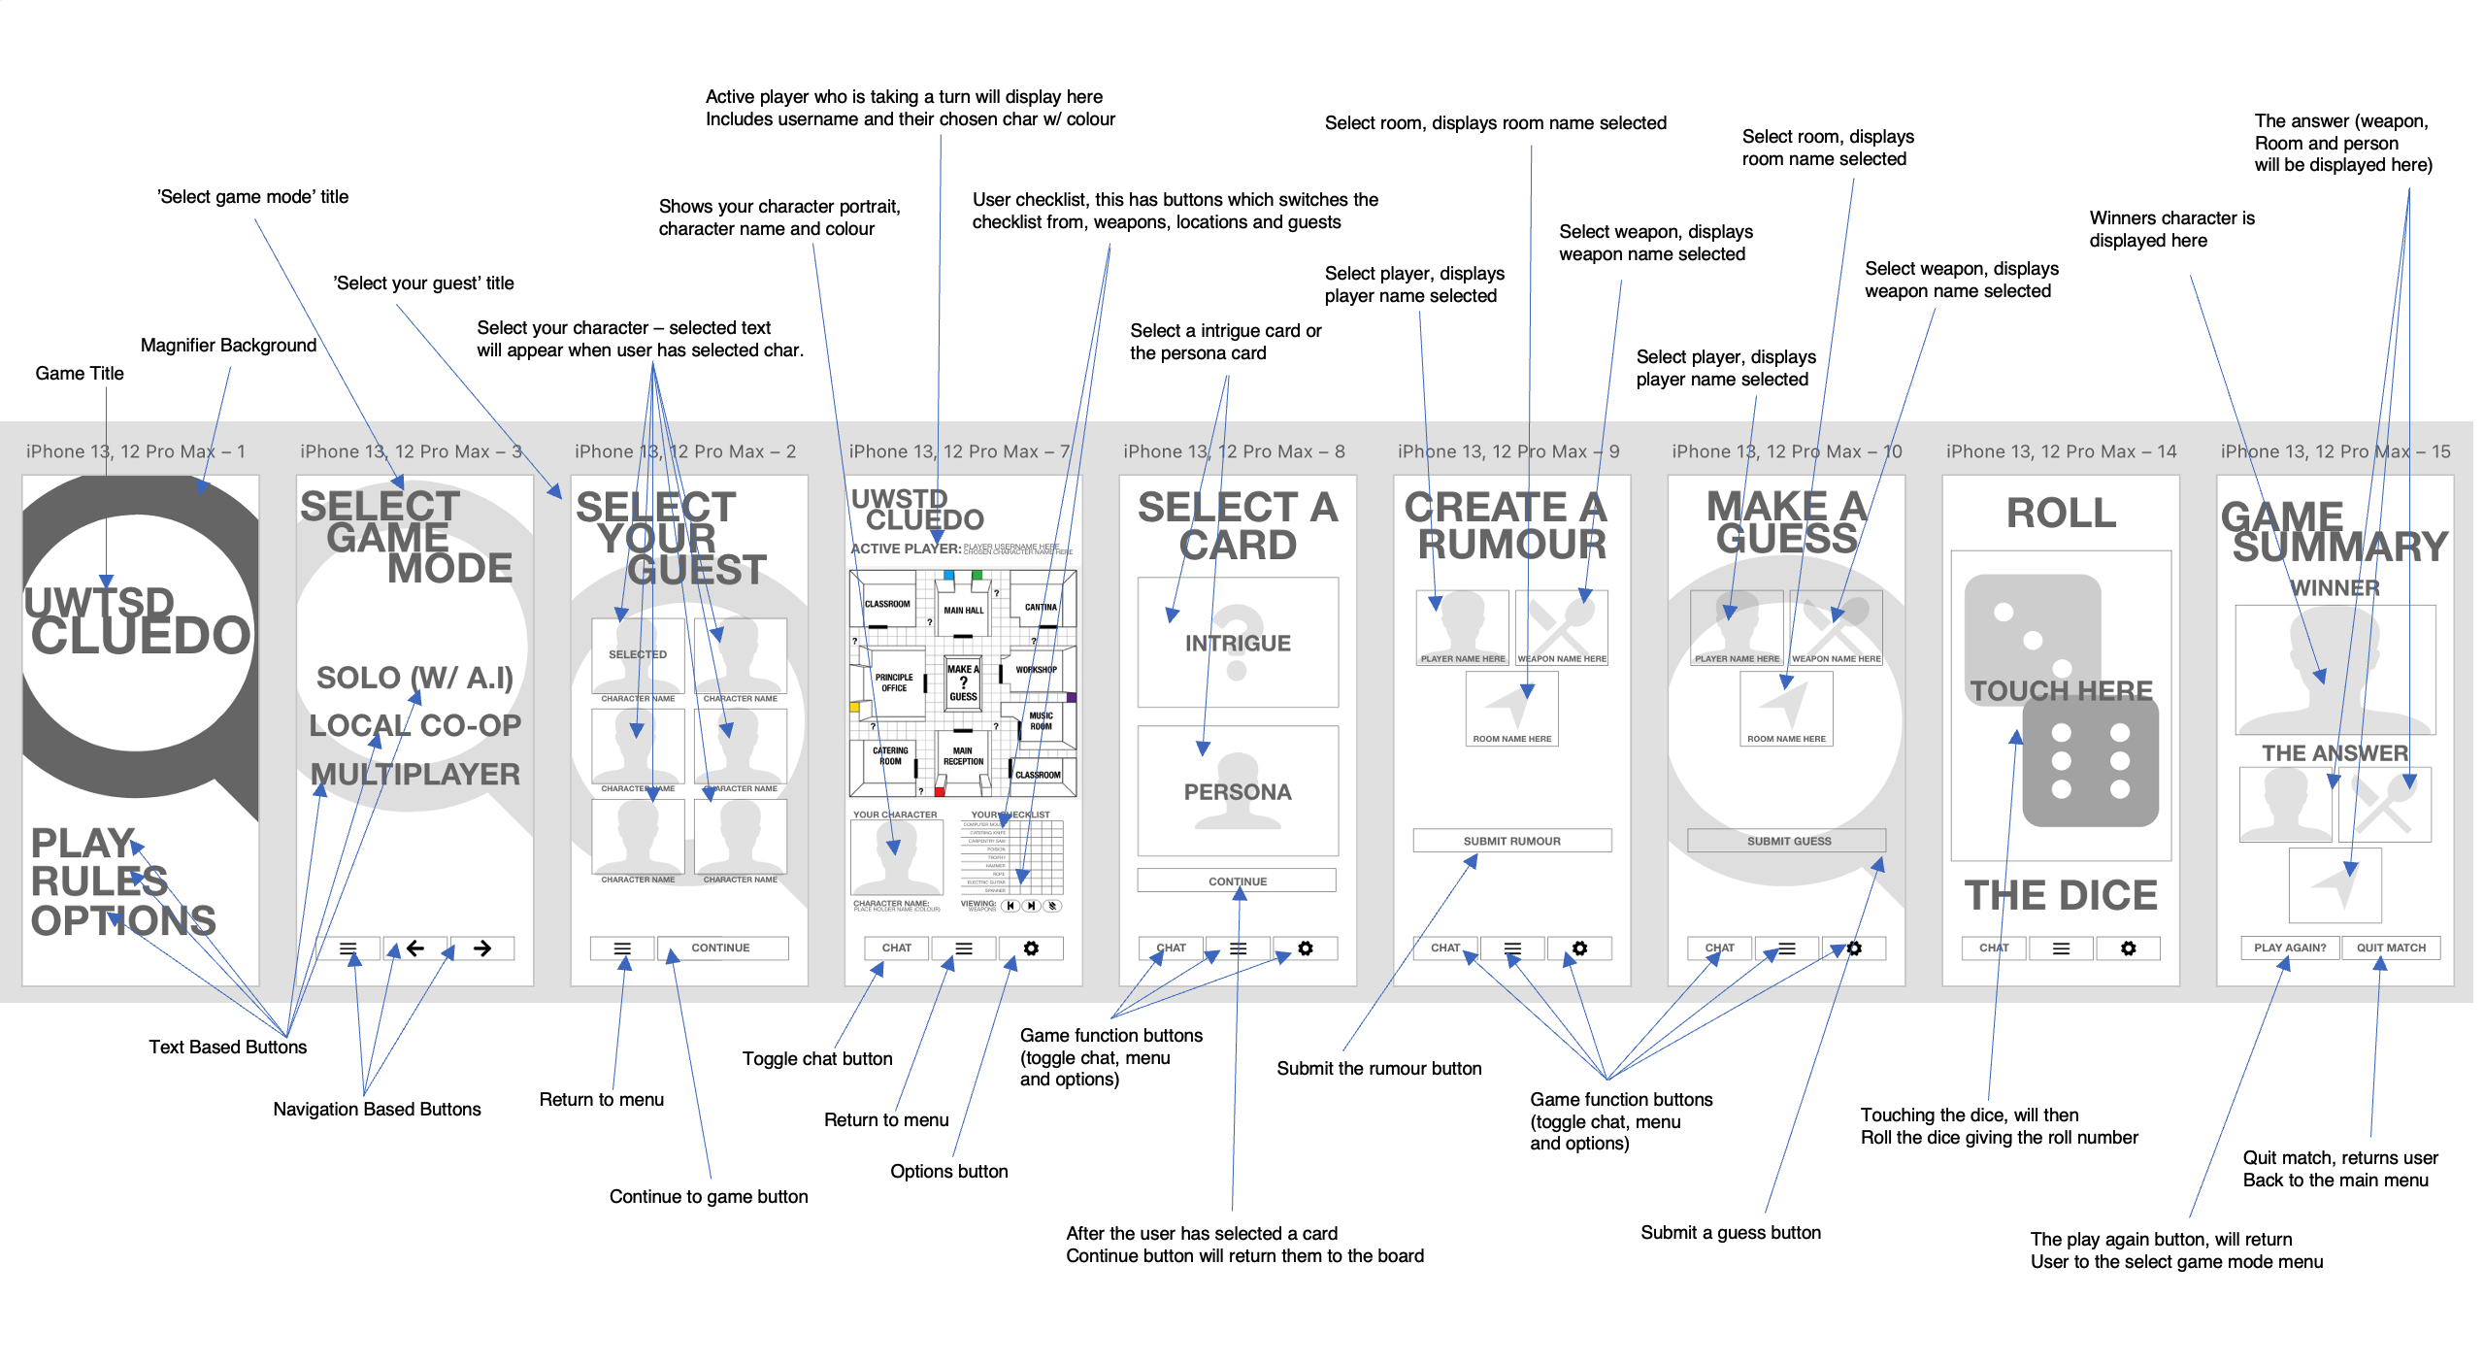

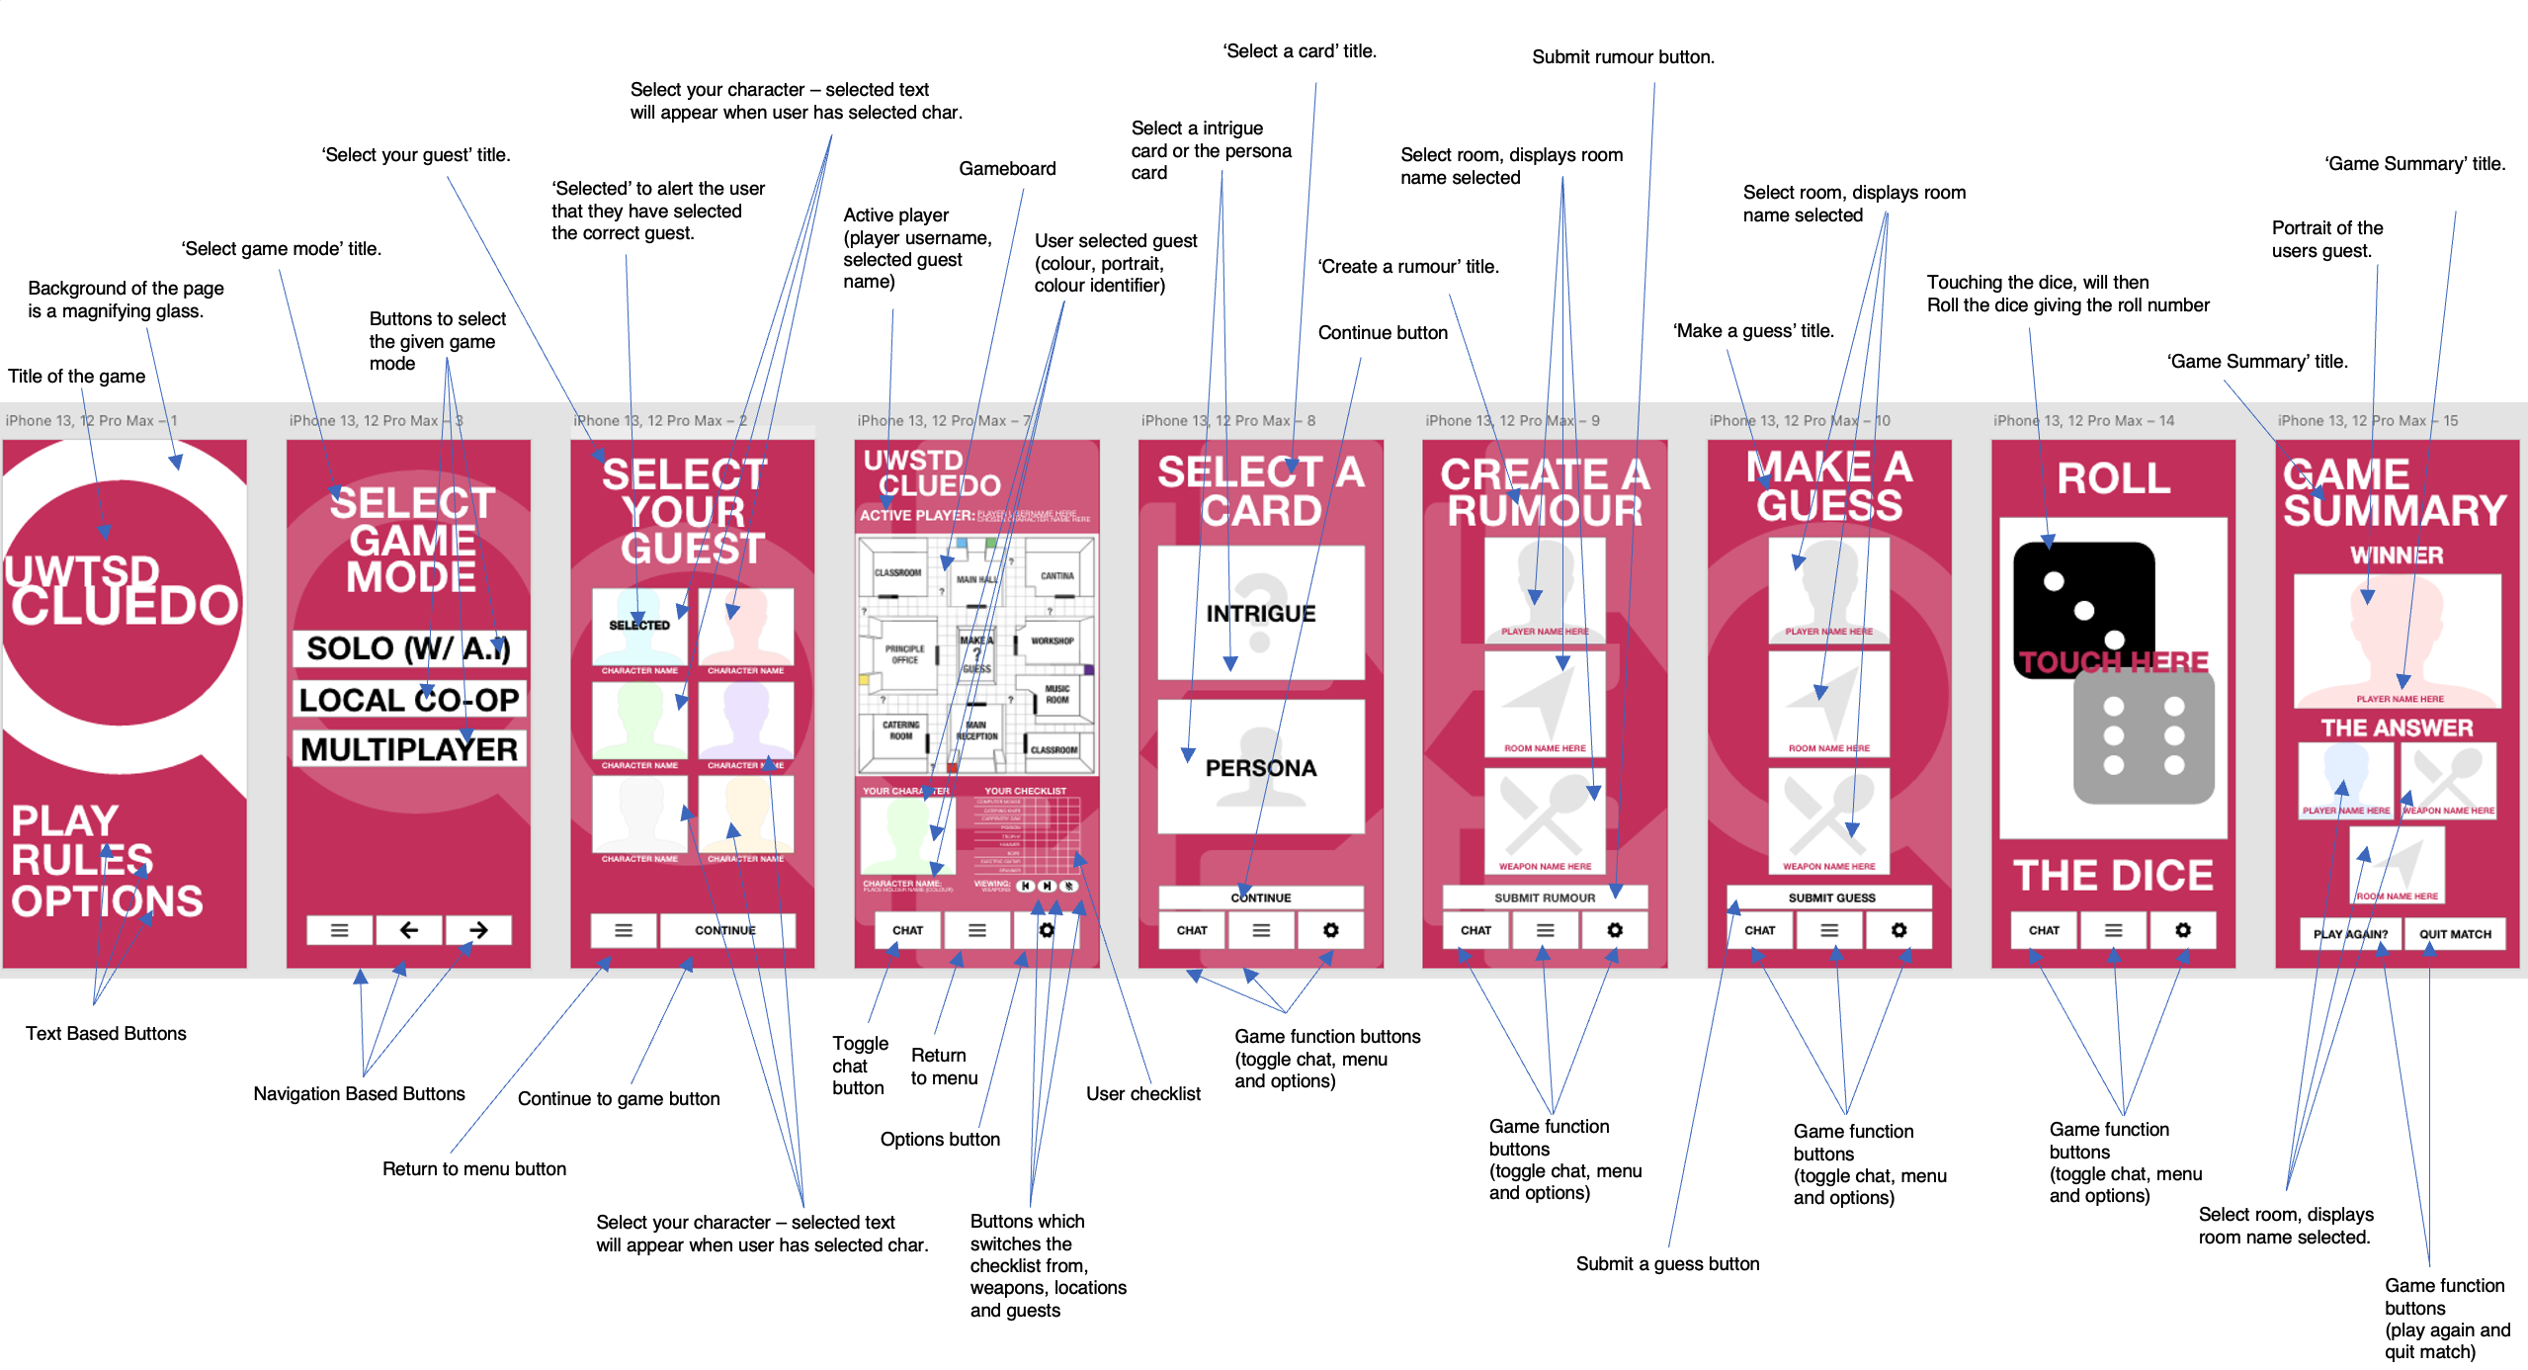

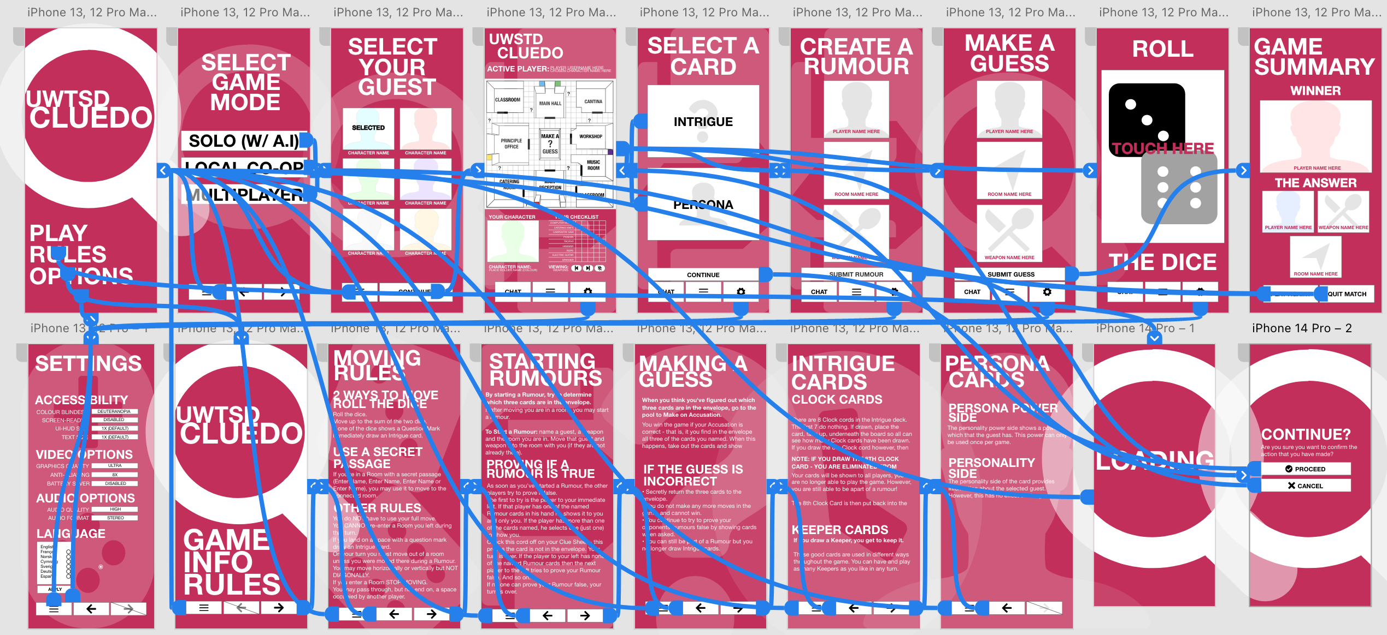

The first change that was made to the full-colour version of the prototype was the addition of a confirmation page. The reason for this is due to the fact that the previous prototype did not contain any user control/feedback options. This prevented users from going back and preventing a mistake that they had made. This consist of a proceed and cancel button, so that the user can confirm the action that they have made within the application. This also allows for the user to review the action that they have done and can revert if necessary. In addition, a loading page was also implemented to alert users that the application was loading specific aspects of the game. This provides additional recognition so that the user is aware of something taking place.

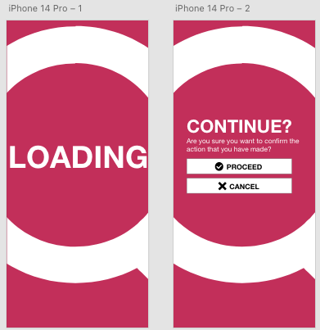

The second change that was made to the full-colour version of the prototype was the size of the navigation buttons. During the previous feedback it was clear that there were some less severe usability issues that were linked to the various navigation buttons on the application. The changes to the button size will allow for users to have a much easier experience. As feedback suggested, due to the limitations of phone screen sizes it was causing issues for users to click on the buttons. By increasing the size of the buttons, this prevents that issue from occurring and providing ease-of-use to the user.

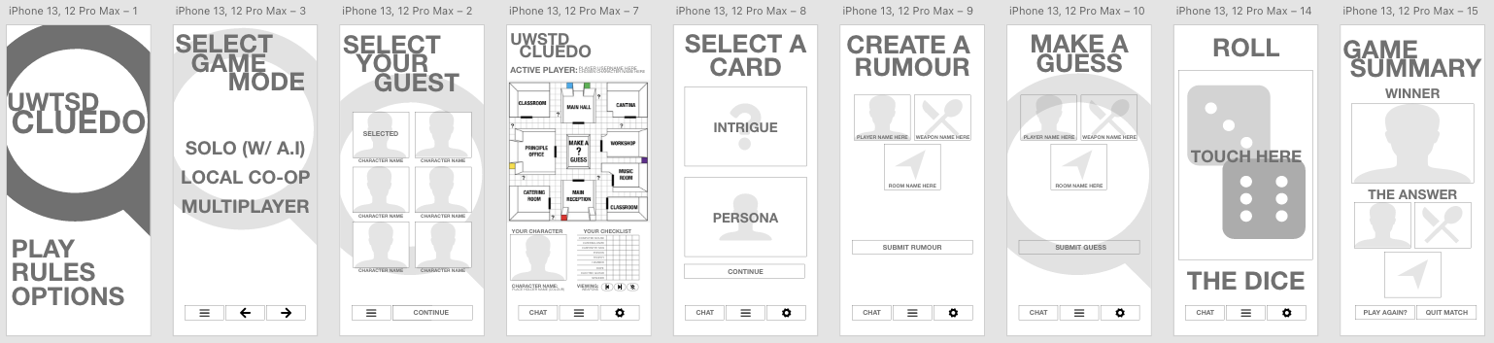
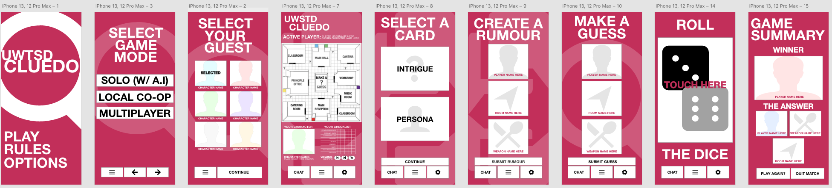

The third change that was made to the full-colour version of the application was the various layout changes to specific pages of the application. The reason that these pages were changed was due to the large amounts of wasted space within the application. This can mainly be applied to the ‘Create a Rumour’ and ‘Make a Guess’ pages. In order to reduce the wasted space, the sizes of the boxes where users can select a guest, location and weapon has been increased.

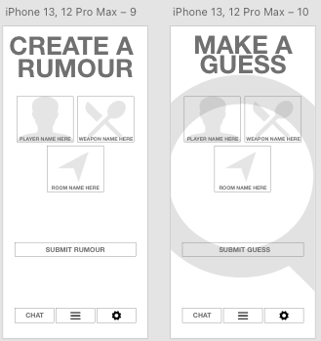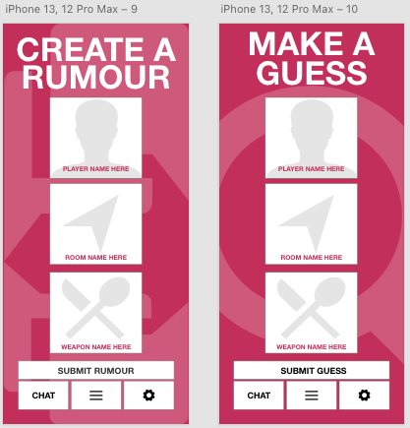

The fourth change that was made to the full-colour version of the application was the increase in text size. The reason for this change was due to the fact that users highlighted that text on various pages were too small and provided readability issues when reading. In order to fix this issue the text on the various pages has been increased from 16px to 20px. Additionally, in the settings page, a text-size setting has been implemented which allows for users to customize the font size to their own liking.

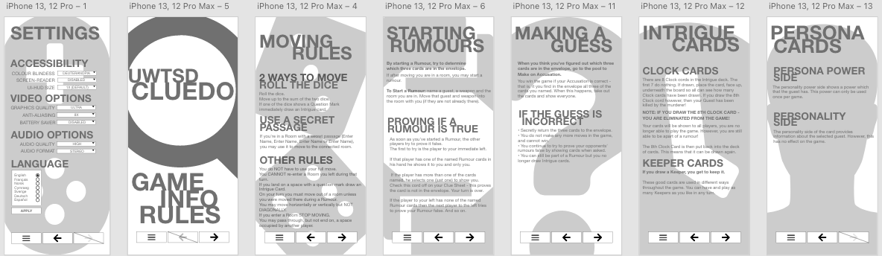
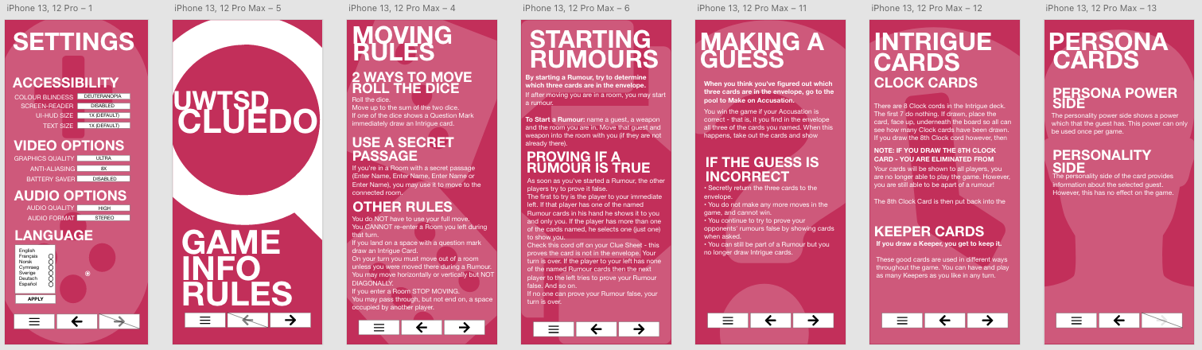
In order to identify whether or not these changes have been beneficial, it was important to conduct usability heuristic evaluations again. This was done by using the four personas that were used previously. This covered the ten heuristics that were created by Jakob Nielsen. This ensures that the application’s user interface is being designed in a way that can provide positive user experience to those who are using the application. Although usability heuristic testing was conducted, focus groups were also conducted to allow for user feedback to be made, this allows for both qualitative data and quantitative data to be gathered.

Feedback Questionnaire Results #1: Keith
Jakob Nielsen’s Usability Heuristics | Rating (0 no usability problems – 5 severe usability problems) | Additional Comments
The Visibility of System Status. | 0 | Loading screens were present, the prototype was very responsive.
Match between system and the real-world. | 0 | The rules and the game itself are the same as the boardgame.
User control and freedom | 2 | Nice to see an additional page to show a confirmation of whether I wanted to make that action or not. Would be nice if it was a pop-up instead.
Consistency and Standards | 1 | Colour scheme is consistent throughout, the white text and white parts of the background provided some issue with reading.
Error Prevention | 4 | Encountered an error when using the application, sadly there was no warnings or popups to tell me that I had encountered it or to tell me what the problem was.
Recognition rather than recall | 0 | Buttons were in a consistent location, the increase in button size was a nice addition.
Flexibility | 0 | Accessibility menu with various settings were nice to see. Beneficial for visual impairment users.
Aesthetic and Minimalist Design | 0 | Design was minimalist and didn’t have any unnecessary objects.
Recognition, Diagnose and Error Recovery | 0 | The addition of error warnings would be beneficial. Confirmation box allowed me to prevent some mistakes made during the test.
Documentation | 1 | Documentation was present in the form of rules and various game function information. A how to play guide would be useful.

Feedback Questionnaire Results #2: Fiona
Jakob Nielsen’s Usability Heuristics | Rating (0 no usability problems – 5 severe usability problems) | Additional Comments
The Visibility of System Status. | 0 | No problems to report. Nice to have the addition of a loading screen/icon.
Match between system and the real-world. | 0 | The rules of the game are the same as the boardgame so no problems with that.
User control and freedom | 0 | No issues present with control from the prototype.
Consistency and Standards | 1 | Colour scheme was consistent, would be nice if we had some customisability options.
Error Prevention | 0 | No issues experienced when using the prototype.
Recognition rather than recall | 2 | Buttons were in a nice location, button sizes for the checklist and submit guess and rumour were slightly too small compared to the others.
Flexibility | 0 | No issues to report.
Aesthetic and Minimalist Design | 0 | White space was used well, design was simple.
Recognition, Diagnose and Error Recovery | 0 | No issues experienced when using the prototype.
Documentation | 0 | Documentation was present within the application.

Feedback Questionnaire Results #3: Barry
Jakob Nielsen’s Usability Heuristics | Rating (0 no usability problems – 5 severe usability problems) | Additional Comments
The Visibility of System Status. | 2 | No significant problems, loading screen was a nice addition. Would be nice if it was an icon on the screen instead of a dedicated page.
Match between system and the real-world. | 0 | Haven’t played much of Cluedo so can’t really comment. Worked well though.
User control and freedom | 0 | Seemed like it worked well and had no issues. Would be nice if the confirmation of an action was a pop-up.
Consistency and Standards | 0 | Nice colour scheme, layout was consistent throughout.
Error Prevention | 0 | No issues to report.
Recognition rather than recall | 0 | Buttons were in a consistent location which allowed me to understand where they would be throughout the application.
Flexibility | 0 | Nice to see various setting that can help the user.
Aesthetic and Minimalist Design | 3 | Design was minimalistic, some text was overlapping which was hard to read and wasn’t very consistent.
Recognition, Diagnose and Error Recovery | 0 | No issues experienced when using the prototype.
Documentation | 0 | Documentation was present, this was in the form of game rules and various aspects of how to play.

Feedback Questionnaire Results #4: Kristina
Jakob Nielsen’s Usability Heuristics | Rating (0 no usability problems – 5 severe usability problems) | Additional Comments
The Visibility of System Status. | 0 | No issues to report.
Match between system and the real-world. | 0 | Played Cluedo briefly before and it seems like the same as the board-game.
User control and freedom | 0 | Was able to conduct all of the functions, the increased size on the buttons allowed for easy navigation.
Consistency and Standards | 1 | Colour scheme was consistent throughout, checklist text size was slightly too small.
Error Prevention | 0 | No issues were present when the prototype was being used.
Recognition rather than recall | 3 | Button sizes for the checklist were too small, it was hard to navigate through the checklist.
Flexibility | 0 | Accessibility options were present, no issues to report.
Aesthetic and Minimalist Design | 0 | Aesthetic was clean and was some-what minimalistic.
Recognition, Diagnose and Error Recovery | 4 | Error pop-ups would be a beneficial addition to the application.
Documentation | 2 | Documentation was in the application, a how to play guide and more information would be beneficial.

After conducting the usability heuristic testing with the ten heuristics provided by Jakob Nielsen. It was clear that colour version of the application has made significant usability-based improvements with the addition of various new pages that are useful to the user. Although there were additional issues identified, these issues can be dealt with and solved within future iterations of the application.
A description of the process used to collect feedback on your final storyboard prototypes and a summary of the positive and negative feedback elicited.
Feedback was collected in the form of usability heuristic testing from the four user-personas that had previously conducted testing on the grey-scale versions of the application. By using the same users, this allowed for them to check if the issues that they ran into last time had been fixed and resolved. By using the ten heuristics provided by Jakob Nielsen. This allowed for a wide range of testing to be conducted, so that as many usability issues could be identified as possible.

When it came to the positive feedback that was elicited from the user personas. It was clear that the issues from previously, which were fixed in the colour-version, were the main aspects of the positive feedback that was received. The first positive feedback that was elicited was the addition of a confirmation page, this allowed users to confirm whether they were happy to proceed with the actions that they have made. This prevents any mistakes during the game that was made from the user. The second positive feedback was the increased size of the buttons, this was an issue on the previous prototype and caused navigation problems for users. With this iteration they were increased and did not cause any navigational problems in this iteration. The third positive feedback that was elected was the reduction of empty space and white space. This was done by increasing the size of various aspects of the application, such as the sizes of the selecting a guest, weapon and location on the make a guess and create a rumour pages of the application. The final positive feedback was the increased size of the text. This allowed for easier reading of various documentation and text on various pages of the application and provided better ease-of-use. Additionally the implementation of a text size setting was added which allows users to customise the size of the font to their likening. Although there was positive feedback elicited from the usability heuristic testing, there were some negative feedback that was collected. The first negative feedback that was highlighted was the size of the checklist buttons on the gameboard page and the size of the submit a rumour and submit a guess. It was highlighted by various users that these buttons were too small and caused issues when using the application. The second negative feedback was the lack of pop-ups for a user confirming their action. There currently is a page that the user is taken to, to verify if the actions they have made are intended. However, users would like to see a pop-up instead of a dedicated page. Another negative feedback that was identified was the lack of error pop-ups. If a user experiences an issue with the application, there is no pop-ups to inform them that they have encounter an issue or error. This means that the user is unaware of an issue that might be present in the application and may affect their experience when using it. The final negative aspect that was identified was the overlapping of text on various pages of the application. The intention of this was a design aspect. However, it is clear that users are reporting that this is causing issues when they are reading various documentation pages.

A discussion of what data would be gathered if a working version were to be build and released, and how that data could be used to influence the next version of the app.
If the prototype was a working version which had been built and released to the market. Data could be used and collected which could be used to influence and allow for future iterations of the application to be made. The reason for having this type of data is to allow for any issues to be identified and future changes which can benefit the user to be considered and implemented. This would also allow for a much more positive user experience when using the application. In order to collect this type of data, various commercial external and bespoke internal methods can be used.

When it comes to commercial external methods these could include Smartlook or Mixpanel. Smartlook (1) is a quantitative and qualitative analytics service which can be used to analyse user behaviour on mobile applications. This method allows for the recording of user sessions which can be used to playback users experience and identify any issues that may have or may arise during their time on the application. Smartlook also allows for filters to be applied to view various specific behaviours that need to be viewed. Additionally, this method allows for an overview of user’s behaviours by using heatmaps. This can identify specific areas of the application which are more popular or are used the most. Another commercial external method is Mixpanel (2). This method focuses heavily on quantitative data collection, which can be used to analyse conversations, app usage and retention rate from users who are using the application. By measuring app usage it can provide key details of how long users are spending using the application, this can identify if the user is having a positive experience or not, by seeing if they are spending marginal or little time on the application. Additionally this method can be used to identify user retention rate. This can be used to see whether or not users are consistently using the application or if there is a reduction of use over time. When it comes to bespoke internal methods these could include focus-groups or review systems. Focus-groups can be used to gather feedback, opinions and insights regarding the application. Whether this is usability related, feature related or general feedback. This allows for the gathering of qualitative data that can be used to make changes and further improvements to the application. Members of a focus-group would be avid users of the application, so that there is an extensive coverage of information due to the fact they have first-hand experience of using and playing the game. Another bespoke internal method is reviewing systems. This allows for users of the application to rate the app based on a rating system. 1 being not good to 5 being great. Something that is beneficial with reviewing systems is that it allows for the user to comment and provide details about why they gave the specific rating that they chose. This again, can help with making improvements and influencing change in future iterations of the application.

Another important aspect to consider is how can the data be collected. Whether that is by collecting the data automatically or communicating with the users to get the various data that is required. This can be done depending on what method is chosen. Data can be collected automatically if commercial external methods are used. While direct contact can be used, if focus-groups are utilised. Commercial external methods automatically collect data from users by using various techniques such as screen recordings, tracking and screen monitoring, this is beneficial as the data is gathered will contain little anomalies. While focus-groups requires someone to capture the data manually which can result in anomalies which can be done by mishearing someone’s opinion or forgetting key important topics. When collecting data it is important to identify the differences between usage data and emotional response data. Usage data focuses on user experience quantitative based data that is gathered from external methods such as Smartlook and Mixpanel. This includes data that focuses on heat maps, app usage from users, review statistics, user retention rate and app download statistics. While emotional response data focuses on user feedback, opinions and their emotions towards the application. Emotional response data focuses on qualitative data which can be gathered from reviews, focus-group conversations and understanding user opinions.

A reflective summary of the overall design process and how it has been informed by both usability theory and by the inclusion of the potential users in the design process
The overall design process provided a clear understanding of the various heuristics that Jakob Nielsen and Ben Schneiderman have defined and outlined. This has allowed for the application prototype to be designed with considerations from these heuristics to provide the best positive user interaction. In order to improve the prototype to include the other various issues that were highlighted, follow-up questionnaires, focus groups and heuristic testing can be used. This will allow for new revisions to implement various changes to solve the issues that were identified.

When testing the prototype, various methods were considered. These methods included questionnaires, focus groups and usability testing. In order to gather data, focus-groups and usability testing heuristics were used. This allowed for both qualitative and quantitative feedback to be collected that can help aid in identifying usability problems within the prototype which can be improved in future iterations. Usability testing was the best method in identifying problems since it focuses on the various heuristic rules that the user interface should adhere to. Focus groups was another good method to use as opinions from the user-personas allowed for deeper interaction with the application and more unique and in-depth feedback. Although questionnaires were a method that wasn’t used, this could be used in future iterations of the prototype to gather more in-depth information.

Heuristic testing allows for each of the various application pages to be reviewed, covering an extensive number of heuristics. By trying to tailor and develop an application user interface to meet all of the various heuristics, will allows for a positive user experience. Heuristics that were used to develop this application prototype was based mostly off of Jakob Nielsen’s ten usability heuristics. In the end product that was developed seven out of the ten heuristics were covered and implemented successfully. While three were still a work-in-progress. This was highlighted by the various user-personas that conducted testing, which were able to provide valuable feedback on what needs to be improved and what does not. Visibility of system status was the first heuristic that was covered within the protype. This heuristic focuses on “the design keeping users informed about what is going on through appropriate feedback” (3). This was where loading screens were used to tell the user that there is something taking place within the background of the application. The second heuristic that was covered within the prototype was the match between system and real-world. This is where “design should speak the user’s language, it should use words, phrases and concepts that are familiar” (3). Since this application is based off the game Cluedo, all of the language that is used has been depicted from the real board-game, allowing for users to already be familiar with the mobile app game version. The third heuristic that was successfully covered within the prototype was user control and freedom. This is where “clearly marked ‘emergency exits’ to leave unwanted actions without having to through an extended process” (3). This heuristic was mainly covered within the navigation system within the prototype, which allows the user to go back and forwards through the various pages of the application. Additionally with the confirmation page, this allowed users to make sure that they are ready to proceed after making specific decisions within the game. The fourth heuristic that was successfully covered within the application was consistency and standards. This is where “users shouldn’t have to wonder whether different words, or actions mean the same thing” (3). This consisted of the various buttons and functions within the application. All the functions were highlighted clearly to allow the user to understand what they did, and the various functions and buttons did not do different things providing a consistency when using the application. The fifth successful heuristic that was implemented into the prototype was error prevention. This is where the “design carefully prevents problems from occurring [...] done by eliminating error-prone conditions or check for them by present users with confirmation options before committing to actions” (3). The prototype application did not have any conditions would result in errors occurring. Confirmation options were used if the user was committing to an action within the prototype. The sixth successfully implemented heuristic was flexibility. “Create a design that can cater to both inexperienced users and experienced users. Allow for users to tailor to frequent actions” (3). Within the prototype application there are various user customisable settings which allows for the application to be tailored towards users with various impairments. The design allows for both experienced and inexperienced users to understand how the application functions. The final heuristic that was implemented successfully into the application was aesthetic and minimalistic design. This is where “interfaces should not contain irrelevant information that isn’t needed” (3). All of the information that is within the application provides the user with important information and the designs do not contain any information that is deemed irrelevant.

Although seven of the ten heuristics were successfully implemented into the prototype, three of these heuristics need to be re-iterated and implemented. The first heuristic that needs improvements to be made is recognition rather than recall. This is where “the user should not have to remember information from one part of the interface to another” (3). The reason for this is that some buttons and text fields were not included correctly into the prototype such as the buttons that control the user checklist on the gameboard screen. The second heuristic that needs to be implemented is documentation. This is where “necessary documentation is used to help users understand how to complete their tasks” (3). Although there is already some documentation included in the prototype. Additional documentations are required to inform the users on how various functions of the application works and a how-to-play guide, that can be used to assist the user. The final heuristic that needs to be implemented/improved is recognition, diagnose and error recovery. This is where “error messages should be expressed in a plain language, that precisely indicated the problem” (3). Currently the prototype is unable to provide users with error messages when they encounter an error, this means that this will need to be created and implemented into the next iteration.

References
[1] Havlon T. Smartlook. 7 Best UX Analytics tools for user research in 2023. Smartlook. Feb 2023. Accessed: 04/05/2023. At: https://www.smartlook.com/blog/ux-analytics-tools/
[2] Havlon T. Smartlook. 7 Best UX Analytics tools for user research in 2023. Mixpanel. Feb 2023. Accessed: 04/05/2023. At: https://www.smartlook.com/blog/ux-analytics-tools/
[3] Nielsen J. 10 Usability Heuristics for User Interface Design. Apr 1994. Nov 2020. Accessed: 04/05/2023. At: https://www.nngroup.com/articles/ten-usability-heuristics/

Appendix



