Introduction
This assignment is made up of three parts. Part one is a review of relevant research and literature, which has informed my professional practice, alongside focusing upon the opportunities and challenges when developing pedagogical approaches. Part two is a detailed strategic plan based on an initial SWOT analysis. Part three is a construction of a poster and rationale to engage colleagues in the dialogue of Successful Futures, along with a critical evaluation.

Successful Futures (2015) allows us as professionals to shape and tailor the curriculum to the needs of individual pupils within the local area. It aims to bring learning to life. However, this provides many opportunities, as well as challenges for teachers. Donaldson (2015:63) highlights that “decisions about teaching and learning are very context and purpose specific, and are best taken by teachers themselves”. This has allowed the development of the Curriculum for Wales document to be flexible on identifying what pedagogy in Wales will look like. Many professionals and pioneer schools often talk about their ‘pedagogical approach’ to teaching. This terminology has been quite significant in recent years, especially within the education system.
What is Pedagogy and what does it mean?
Times Educational Supplement (TES) (2018) editorial describes pedagogy as being, the method and practice of teaching. It will encompass teaching styles, theory, feedback and assessment. In our trustee group we felt pedagogy is the way teachers deliver the curriculum. Classroom practitioners will adapt and assess according to the needs of the individual learner. Teachers will need to access research or learn from other schools adapting their pedagogical approaches to inform decisions to change their teaching method and style. It will allow for the provision to change as long as there is quality professional development and learning within the workplace.
Siraj-Blatchford, Sylva, Muttock, Gilden & Bell, (2002:10) refers to pedagogy as “the instructional techniques and strategies that allow learning to take place”. They refer to the interactive process between the teacher and learner and how it is applied to the learning environment. Whilst Education Scotland, (2005:9) refers to the influence of pedagogy by the “cultural, social and political values we have for children”. Pedagogy involves us to be reflective and committed to change. Every teacher will develop their own pedagogical approach depending upon the age, ability and the experience of the teacher. However, this will depend on the leadership in the school and what is driving the school forward. There may be class pedagogy approaches within phase groups and whole school pedagogy approaches. This will be for consistent approaches.
What are the characteristics of an effective pedagogical teacher?
School effectiveness research has changed over recent years with a focus on the ‘how and why’ rather than the ‘what’. Effectiveness can be a controversial term in itself “the degree to which something is successful in producing a desired result; success.” Judging effectiveness can be difficult and challenging. Hattie (2012) explains if students don’t know what success looks like then how are they going to achieve. We as teachers need to show learners what the outcome will or could look like at the end, whilst giving them the tools to succeed. Hattie (2012) believes teaching visible to the pupils or learners will allow them to learn to become their own teachers. He argues that this is a core attribute to lifelong learning which Donaldson (2015) indicates as one of the four purposes.
- Ambitious, capable learners who are ready to learn throughout their lives.
- Enterprising, creative contributors who are ready to play a full part in life and work.
- Ethical, informed citizens who are ready to be citizens of Wales and the world.
- Healthy, confident individuals who are ready to lead fulfilling lives as valued members of society.
In our trustee groups discussions were held around what an effective pedagogical teacher needed to be. We considered them to be adaptive, flexible, be brave to take risks, allow for pupils voice, develop that positive relationship with pupils, engagement of tasks and most of all to be supportive. In a recent large scale study conducted by Siraj and Taggart (2014) with the Effective Pre-school and Primary Education (EPPE) it was highlighted there were eleven effective pedagogical strategies. Our trust group felt there were lots of similarities. Some of these included being well organised, shared goals, clear learning environments, behaviour management, collaborative learning, personalised learning, making explicit links and assessment for learning. All of which are incorporated into the professional teaching and leadership standards. These are very similar to the pedagogy principles which Donaldson (2015) highlighted in Successful Futures for Wales.
Smith (1994) argues that a focus on teaching as a specialist role is best understood in other ways. He feels pedagogy needs to look at the care and well-being of the child or learner and we should be taking practical steps to help them and therefore be joining with others to bring meaning to life. This will allow the child/learner to flourish. Smith (1994:63) believes pedagogy has three main principles. He believes it “is an orientation, a set of processes and a way of thinking. Effective pedagogy will allow us to animate, care and educate”.

The National College for school leadership (1988) sets out nine claims of which makes great pedagogic practices. However, the review suggests that outstanding pedagogy is far from straightforward. Husbands and Pearce (2012) state that successful pedagogies develop when practitioners have a clear understanding of research and knowledge to support high quality and planning. Whilst building upon those active positive relationships. The nine claims were based on pupil voice, behaviour, clear thinking and goals, prior learning and experience, pupil learning, range of techniques, assessment for learning and inclusivity. Our trust group discussions felt that the nine claims were not concise and very broad. They could be interwoven into each other. Pupils learning will encompass behaviour, thinking goals and pupil voice. Whilst assessment would encompass techniques, inclusivity and prior learning and experience, further discussions allowed us to consider putting the nine claims under one umbrella called ‘assessment for learning’.
In order to understand the nature of pedagogy, it is necessary prerequisite to understanding what role technology will have in supporting education in the future. Trust group discussions felt our curriculum needed to allow and be designed to be flexible and adaptive with the ever changing technology. Alongside, professionals will need to be trained and kept up to date to enhance pupils learning. This needs to be funded to access this information.
Pedagogy Principles in Successful Futures
As a result of Donaldson’s review (2015), schools across Wales applied to be ‘pioneer’ schools. The selected schools were heavily involved in offering detailed prescriptions on teaching models whilst putting into place their pedagogical practises.
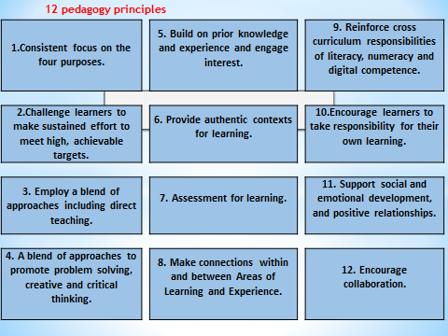
Table 1a- Twelve pedagogy principles

Fullan & Hargreaves (2016:1) state that “the quality of teaching is the most important in-school factor that affects student learning and achievement.” Therefore it is crucial that pioneer schools share their best pedagogical practices. Fullan & Hargreaves (2016) highlight the fact that not all ‘old’ pedagogy is ‘bad’ and that not all ‘new’ pedagogy’ is good. For example, a good but old pedagogy is teachers and pupils developing positive relationships with each other. Wiliam (2013) agrees with this in stating that “How and what is taught is just as important. Pedagogy trumps curriculum every time”.
Donaldson (2015:64) indicates that “all our children and young people will form positive relationships based upon trust and mutual respect.” Donaldson (2015) makes no indication of specific teaching methods, which allows and provides teachers to develop their own autonomy, and puts trust back into the professionalism. Successful Futures (2015) chapter five clearly lays out the pedagogical principles but clearly indicates that they all do not relate to the four purposes. The four purposes are driving the Curriculum for Wales which I recommend being linked to the principles. This is making the pedagogy principles a stand-alone area where they should be entwined with the purposes. Our trust group discussions felt leaders and teachers see this as an add on to the curriculum. The idea indicated within chapter five is that it allows teachers to realise their creativity and to have a broad and balance teaching learning approaches. It allows children to explore, problem solve and make connections. It emphasis how children need to learn from their mistakes which Hattie (2012) states in that learners need to understand that making mistakes will help them to improve on their learning. Learning needs to be at the forefront, whilst teaching is primarily on the learners achievement and success. Bruce (1996) agrees with Hattie (2012:15) in that he stated “the best way to prepare children for their adult life is to give them what they need as children.” Show them what success looks like, so they can achieve in adulthood.
Donaldson (2015) explains that not one pedagogy should be favoured but we should be choosing between modern and more traditional methods, this implies for a broad range of teaching and learning experiences. It clearly states that we should not be throwing away all traditional teaching techniques and methods, as we need to adapt to the learners. However, other research indicates pupil voice is a significant key to pedagogy, I felt this was missing within the twelve principles in chapter five. Within this chapter there was no clear indication that leaders should be driving the curriculum forward. Our trust group discussions felt schools have really battled with the twelve pedagogy principles. There is no indication if Donaldson had deliberately numbered the principles according to their importance and number one, good teaching and learning and overall purpose of the curriculum has a higher priority that the other eleven principles. However, this seems to be the case in other research principles highlighted above, for example, the nine claims, in that they are numbered. With this in mind, pedagogy principle seven has been given a separate chapter of its own within Successful Futures (2015). This is clearly indicating that assessment has more of a priority. Other principles have not been explored more in depth. In our trustee group we felt many of the principles could be interwoven to reduce the number of them and that some were already part of the teaching and leadership standards.
In our trust group we felt pedagogy principle eleven; Good teaching and learning supports social and emotional development and positive relationships was of high importance. If this was not established then how can you pursue the curriculum purposes. This will also support learners and allow them to understand the impact they will have on others and have on themselves. The trust group felt pedagogical principles two; eight and nine would not have such a high priority as other principles would need to be in place to support the learner.

Assessment in Successful Futures
Chapter six of Successful Futures Donaldson (2015) concentrates on assessment which is pedagogy principle seven. Wiliam (2011) describes assessment as the bridge between teaching and learning. This I agree with but surely Assessment for learning is the main body of curriculum design and a main focus within the professional teaching and leadership standards. Assessment gives a holistic picture of both the learner and schools strengths and weakness. Priestley (2017:7) states
“If we develop a holistic curriculum then pedagogy will be encompassed within this as it is an integral part of the curriculum. It will include content, provision, pedagogy and assessment”.
Therefore we do not need pedagogical principles as an additional chapter within Successful Futures.
In our trust groups we looked at the characteristics of an assessment literate teacher. We made clear links to the twelve pedagogical principles and it was felt that Donaldson (2015) could have grouped them. Which would allow us to have four main pedagogical principles that being; 1. Assessment for learning, 2. Consistent focus on four purposes, 3. Making connections and 4. Encouraging collaboration. This we felt was similar to Teaching Educational Supplement (TES) editorial which highlights four approaches that being;
1. Behaviourism,
2. Constructivism,
3. Social Constructivism
4. Liberationist.
Comparing International and Welsh pedagogical approaches
I am going to focus on Finland, New Zealand and Scotland and understand how these countries approach pedagogy.
Finland Pedagogy approach
Finnish Education has a high regard to pedagogy. This is at the forefront of initial teacher training, whereby in Wales this word ‘Pedagogy’ has only recently come into place with it not having a high priority. The term is becoming at the forefront of education since the recommendations of Graham Donaldson (2015) and the change of the professional and teaching standards. For the purpose of this assignment Teachers in Finland enjoy pedagogical autonomy in the classroom and are considered pedagogical experts. They are entrusted with considerable independence in the classroom and have decision-making authority as concerns school policy and management. Education in Finland is deeply involved in drafting the local curricula and in development work and they have responsibility for the choice of textbooks and teaching methods. They regard the learning environment as a significant learning tool in steering the learning, teaching and the organisation of control. Pupils' learning and well-being of the individual is supported and is highly regarded as the most important basis for pupils learning to take place. Both schools and the learning outcomes and assessment of pupils are in the nature of encouragement and support. The aim is to provide information that will help both schools and pupils to develop. Finland has no formal testing and schools are not ranked.
Scotland
Pedagogical approach in Scotland has changed since Donaldson (2011) did a review on the Scottish of Excellence curriculum. Teachers are now involved in the Critical Collaborative, Professional Enquiry (CCPE) approach of which Priestley and Drew (2016) have used to develop teacher enquiry research projects. The concept is based on teacher’s enquiry into the teaching–learning relationship. Teachers and learners adapt their planning and activities accordingly.
New Zealand
New Zealand effective pedagogies are very similar to which Donaldson (2015) highlighted i.e. prior learning experiences, shared learning, making connections, inquire teaching and learning. New Zealand believes students will succeed if there is a strong pupil and teacher relationships. The New Zealand curriculum (2007:35) states “teaching strategy works differently in different contexts for different students; effective pedagogy requires that teachers inquire into the impact of their teaching on their students”. The New Zealand inquiry is similar to the CCPE approach of Scotland. New Zealand curriculum (2007:35) states it’s “moment by moment (as teaching takes place), day by day, and over the longer term”.
Opportunities and challenges in developing a pedagogical approach.
The Curriculum for Wales presents very exciting opportunities for both teachers and pupils. It allows them to be creative and develop a curriculum which is localised. It will allow pupils to be ‘Healthy, Confident individuals, ready to lead fulfilling lives as valued members of society’ which is one of the main focuses within Finland. This is being addressed through the new Area of Learning Experience (AOLE) Health and Well-being. This outlines how we can equip and support our young learners for life. It is, on essence allowing us to prepare pupils to learn. It will give them the understanding of how to deal with different experiences and develop new skills. However, with this being a focus in the new curriculum it will face many challenges to ensure that Successful Futures is implemented successfully. For example, many schools are introducing the ‘Thrive approach’ and ‘Mindfulness’ to address some aspects of the AOLE. Thrive is an approach whereby we look at the needs of an individual child signalling their behaviour. It provide us with targets and strategies to support the child on a daily basis. However, this will have significant impact on the amount of funding provided to each school, resources, commitment from staff, accessing of training, confidence in delivering, transition and assessment of children. There needs to be clear indications on how will this be monitored and measured.
We need to reflect on the Scottish government to ensure funding is substantial and that teachers are not disengaged or demotivated and no actual change will take place. Priestley and Minty (2016:5) states that the Scottish government did “not address the structural and cultural issues that might constrain or enable teacher agency.” This resulted in teachers current planning and teaching ‘fitted’ into the new curriculum. In terms of reflecting on my professional practise I believe as teachers we need to be ‘take risks’ and adapt planning and activities. We need to consider and adopt the CCPE (Scottish) and New Zealand inquiry concept.
Another challenge facing Wales is allowing schools to be creative but at the forefront is the completion of reading and numeracy tests at the age of six. Teachers are expected to achieve good results with a focus on year two and year six. In Finland Halinen (2016:21) indicates that there are “no inspections or national examinations.” Formal testing takes place at the age of sixteen. The new curriculum needs to be flexible and the process of assessment needs to change. Also the ‘structural’ approach of primary and secondary schools need to be working much more closely through a cluster approach to ensure transition of skills, assessment and opportunities in consistent throughout.
In this section, I will aim to analyse the challenges and opportunities facing our pioneer schools on developing a pedagogical approach. I was able to visit several pioneer schools which have informed my professional practice. During the learning visits I observed lessons and learnt about their journey’s in both a primary and secondary setting.
School A
School A has four hundred and fifty pupils of which 26% are free school meals and 20% additional learning needs (ALN). The school has been on a significant and rapid journey within the last year due to the new head teacher. The pedagogical change has been more of a focus on pupil voice and the development and change of the classrooms. The classrooms felt much more relaxed due to the new style which consisted of limited furniture, wooden furniture, soft textiles, soft furnishings, limited displays on walls, natural lighting and backing displays and each class consisted of either a cooking or art area which they shared. Children were given the opportunities to cook recipes linked to their topic which they were heavily involved in through pupil led learning; the cooking took place in a control but relaxed area.
The school focused upon developing positive relationships with their pupils and building up the trust. They felt it benefitted the teacher and pupil to move through the school with ease and pupils understood the routines and the free flowing of activities between rooms. Children and staff felt much more at ease. However, both the school and myself felt this would be very difficult to manage in a secondary setting and in my professional judgement I feel children should experience different teachers through a primary school in order to develop self-confidence with change and to experience and develop relationships with other members of staff, otherwise they would become quite attached and over reliant on the same member of staff. This could cause issues if the teacher was absent and could cause distress with pupils. However, this kind of pedagogy of free flowing and adult type learning setting is very similar to the Finnish curricula.
School B
School B has one hundred and forty eight pupils, 26% Free school meals (FSM) and an additional support worker is placed in each class. The school has adopted the pedagogical approach of ‘Mantle of the Expert’. It has the same approach which Donaldson has intended in Successful Futures (2015). This approach allows pupils to take on responsibilities for their learning through an imaginary context to develop and generate purposeful learning activities. Allowing the pupil’s a voice. The head-teacher and staff feels ‘Mantle of the Expert’ encompasses the twelve pedagogical principles as mapped out by Donaldson. The need to change the pedagogy of the school was due to staff’s well-being, poor and low standard of pedagogy and poor behaviour and engagement across the school. With this different pedagogical approach through the implementation of ‘Mantle of the Expert’ and staff engaging in action research as a whole team, it was felt that pupils oracy, perseverance and resilience had improved significantly, with staff well-being improving as they were being given the autonomy to trial and test out these strategies and techniques.
The school works very similar to the school A in that the learning environment looked less like a traditional classroom. It contained adult furniture, not every child had a chair, some child who had difficulty keeping still had work benches where they could stand to complete tasks. It believed classrooms needed to support not just the learning but the emotional and physical learning of a child. It was clear throughout that well-being was highly regarded within the school and was at the heart of the school for both pupils and staff. It was evident through various forms i.e. changing of the routine of the day to support the staff and pupils who were late and missed vital information in maths and language lessons. Morning sessions focused upon feelings, physical development, socialising through snack time, relaxation time. Through the rest of the day there was no allocated time or length of which lessons had to be done. The pupil was leading the learning and if it was felt the lesson should carry on, then it would, for example, learners spend days/weeks on quality prototypes than one that has been created in 1 session and not been given the time to review and reflect. This is the same concept as Donaldson (2015).
The head teacher believes Beard (2018) should have been employed to review the curriculum in Wales due to his vast experiences of pedagogies through travelling around the world. Beard (2018) believes we are what we learn but learning has lost touch with human progress. We are being educated in world where information and knowledge is important. Beard (2018:4) states “Our education predicts how much we’ll earn, how content we will be, even how long we’ll live”. The education system is very narrow and we are not allowing our pupils to develop independence and skills. He states we need to develop the roots of creativity and classrooms should be inclusive for all and flexible. He believes we should be transforming the learning in the twenty first century to access our better future selves.
School C
This secondary school is a pioneer school, which has one thousand pupils .15% are FSM and 13% have ALN.
The secondary school setting was very different to the experiences and learning environments which were displayed in both primary settings. The classrooms were very formal whereby the tables/desks were positioned in rows and the teacher was at the front directing the teaching. This type of pedagogy was evident throughout, mainly because they were under exam pressure. Teachers needed to ensure pupils were given the knowledge and information to access the exam. This was having a significant influence on the style/approach of pedagogy being delivered. In my professional opinion the learning environment was very bland and not inviting. Work which was displayed supported pupils for exams. However, whilst listening to learners it was evident they could clearly explain the process, what they were doing and why, but focused on formal tasks which did not stretch the learner of whom gave an excellent explanation. Pupils feedback from teachers in books were wordy and at length, however, time was given to review the feedback and allow them to act upon it. There was a big emphasis on ensuring pupils reached their full potential by ensuring they were able to get full marks in a test or piece of course work. Lots of pressure was placed on pupils emotional Well-being when being asked to find out why they dropped one mark in a test. This is not in line with the Donaldson report (2015) which puts a significant emphasis on pupils well-being. This has been clearly evident in the Welsh curriculum draft of the individualised area of learning experience health and wellbeing.
School D
This secondary school has six hundred and forty eight pupils, 28%FSM and 26% are ALN. The pedagogy was clearly different in this school compared to School C. It was more about the learner and engaging them in their learning. They focused more on encouraging the pupils to think creatively, evaluate and analyse their performances and applying it through their learning experiences. However, the learning environment was much more relaxed and calm but I felt staff did not form those relationships with their pupils unlike primary school settings as everything was governed by timetables constraints. Classrooms were tools to develop and enhance discussion to deepen their thinking and understanding. The pedagogies was enlightening and felt rewarding as they were striving to support and provide a wide range of opportunities for their pupils in developing a range of skills alongside trialling elements of the draft curriculum for Wales.
Janis (2016:13) indicates that the “most important challenge a teacher must confront is keeping an open mind.’” This is imperative for all teachers to embrace because as Successful Futures is implemented there will be significant changes and challenges. Donaldson (2015) clearly indicates that the curriculum is paramount to successful and meaningful assessment. However, our trust group believes sufficient time has not been given for practitioners and schools to fully understand and engage with seventeen descriptors in pedagogy in the professional teaching standards, twelve pedagogical principles along with the new curriculum for Wales documentation. Schools and leaders need to fully understand how all of this is incorporated together. With this in mind, why have we in Wales just accepted the sixty eight recommendations and has there been any significant evidence within Scotland’s education that the recommendations Professor Donaldson outlined in the Excellence for Scotland has had any impact on pupils learning and well-being. If the new curriculum is meant to be shaped and tailored to your school this should allow schools to select the recommendations which they feel will have as a positive impact.
In this section a strategic plan will be developed from the SWOT (Strengths, Weaknesses, Opportunities and Threats) analysis. The purpose of a strategic plan in education is to help define what the school is intending to achieve with the pupils. It clearly sets out the objectives and success criteria.
SWOT analysis
When implementing Successful Futures (2015) one challenge and new opportunity is the inclusion of the Area of learning of Experience (AOLE) Health and Wellbeing. There are important reasons why this is one area which will prove to be demanding and challenging for our school and the SWOT analysis indicates this. The SWOT analysis was undertaken by the whole staff.

Strengths  - Healthy schools NQA award  - Health and Well-being is valued highly in school.  - Health and Well-being lead.  - Staff training available with local authority.  - Keeping up to date with current issues.  - All staff understanding and recognising the need to change.  - Supportive SLT to deliver change.  - Staff share their experiences of techniques and strategies.  - Established routines/team..  - PASS survey used and acted upon to support learners. | Weaknesses  - Finance – school budgets are being reduced yet are expected to deliver programmes to support individuals-ACE, THRIVE, mindfulness.  - Lack of resources – support learning  - Outdated resources – Technology moves so fast  - Lack of Wi Fi – the internet connection is poor in some locations to access training and resources.  - Staff training – staff starting at different positions and some more aware of programmes than others.  - Draft curriculum too prescriptive  - Lack of time to understand and read document.  - Wellbeing of staff and pupils of implementation of new curriculum.  - Time scales.
Opportunities  - Prepares children for the world of work- skills, coping strategies/techniques  - All schools starting at the same time  - School to school sharing of best practice. Cluster approach best suited for transition.  - Training-development of new skills.  - Staff meetings/collaboration.  - Update or new resources/technology.  - Utilise staff /resources current skills- Learning from each other.  A Detailed Strategic Plan linked to AOLE Health and Wellbeing.  In order for the implementation of pedagogy to deliver the Curriculum for Wales in our school, school leaders need to drive the change forward, in order for it to be successful. In my professional opinion we need to assess if we have the people in the right places to drive the change. As a school we need to empower itself and its teachers to develop pedagogy.  Current Principle Focus: Healthy, Confident Individual Pupils who are ready to lead fulfilling lives as valued members of society. | Threats  - Significant change in curriculum  - Time and funding to implement changes.  - Workload  - Staff unwilling to change- old fit into new curriculum  - Demands of current curriculum i.e. personalised assessments.  - No SLT driving the change.  - Learning Environment-suitability.
Priority | Actions | Success criteria | Potential Barrier | How we evaluate
1 | Staff to improve their understanding and knowledge of the Health and Well-being AOLE in the draft curriculum for Wales. This will be linked to their performance management via ETLF. | Staff are involved in providing critical and reflective feedback to Welsh government about the AOLE.  Health and wellbeing cross curricular links made in planning.  Clear understanding of the What matter statements and mapping out what we are currently doing and how and what we can do to move forward. | If SLT are not driving this understanding, the need to change and not providing the time and professional discussions across the school to be reflective. | - Discussions in performance management and staff meetings.  - AOLE mapping book and planning  - Curriculum for wales reflective online document.
2 | Governors and school leaders reflect on the results of the SLO diagnostic tool (focus on wellbeing) and how it can be used to improve the school. | Governors/SLT will have clear concepts of what we need to improve as a school.  SLO results will be shared in the cluster and cluster targets developed and how it can be supported. | Governors not fully participating in the change.  Not full agreements on specific targets i.e. mindfulness as a cluster.  Cluster decision with PL and HT on budgeting/funding for specific training and resources. | - SLO targets evidence in PM/SDP. Impact termly.  - Regular meetings/minutes on the progress of specific targets identified as a cluster.  - PDG/EIG funding indicating and evaluating of termly progress of new initiatives.
3 | Cluster approach carry out action research/CCPE linked to AOLE health and well-being and one pedagogy principle. | Schools share their approaches in implementing and accessing research alongside reviewing and reflecting on research.  Decisions on the approach decided within cluster triads.  Report given to governors/SLT within schools on progress and changes termly.  Presentations of triads of findings. | - If Allocation of meetings are not set out prior to commencing the research i.e. at least twice a term to reflect and review.  - Funding:-Purchasing IRIS connect to share reflections.  - Accessing Permission off parents to use video footage outside of their own school parameters.  - Inconsistent approach of reviewing and reflecting and the use of research methods amongst groups.  - Not full commitment from team.  - Staff may feel uneasy use IRIS connect. | - IRIS connect video clips.  - Self, peer reflections journals.  - Research materials accessed used.  - Timeline of actions.  - Use of proxy indicators to support change.  - Compare baseline and final reflections.  - Cluster triad presentation.
4 | All teaching and non-teaching staff to access and carry out ‘Mindfulness’ training. | Completion of 5 1 hour sessions of mindfulness to enrich and enhance teaching and student learning.  Discuss completion of modules in phase meetings.  Children have daily access to mindfulness sessions.  Staff carry out their own mindfulness sessions. | - If mindfulness is not carried out by staff themselves then they will find it difficult to teach.  - Progress is not always quick in mindfulness and may lead to giving up.  - Time allocated for training to be completed.  - Not successful if not carried out regularly. | - Record of completion of sessions linked to HT.  - Completion of personal diary of mindfulness.  - Planning indicates mindfulness sessions.  - Health and Well-being co-ordinator observes/drop in sessions of mindfulness activities.  - Less frequent use of quiet zone (Cwtch)  - Less number of children receiving social and emotional interventions.
5 | Review and audit the Health and Wellbeing initiatives and programmes. | Well-being co-ordinator and SLT review the impact and success of wellbeing programmes through the year. i.e. action research groups, mindfulness sessions, THRIVE.  Work alongside Pupil voice group.  Decisions made on what we need to sustain, adapt, start and stop.  Share information with cluster and decide as a cluster approach of initiatives to move forward. | - Not getting the information you want or expected to receive.  - Inconsistencies of delivery of approaches with different members of staff.  - No progress has been made within specific year groups due to a lack of method delivery and no planning.  - Pupil voice are not being actively involved regularly and promoting well-being i.e UNCRC. | - Develop a survey for staff to give feedback on new initiatives.  - Planning, training records, observations, discussions with all staff.  - PM review evidence.

Priority 1- Staff need to be encouraged to engage with the new AOLE to ensure they have a full understanding of what is expected from them as a professional and from their pupils. It is important we create and develop professional discussions and dialogues about the changes and the impact it will have on us. In order for this to be effective, SLT need to consider staff’s well-being and provide them with the time to understand and engage with the document. This will have real impact on moving the school forward and will allow all staff to share their opinions and feel valued in the changes. As Hattie (2012:15) states “it is not about the teacher, it is about the teachers”.
Priority 2- Using the results from the Schools as Learning Organisations (SLO) model survey which was set out as a five point scale, this will indicate what we could do more to improve on our development and the realisation of a shared vision of learning with pupils being at the centre. It will allow us to share our vision with all stakeholders and provide the much needed extended collaboration with external partners, cluster and wider cluster schools. The OECD Schools as learning organisations report (2017) indicates that School leaders play a vital role in generating the conditions needed for effective learning organisation.
Priority 3- It is vitally important that we share our approaches and vision as a cluster to ensure there is a smooth transition into secondary schools. The same approaches and training is vitally important for all children, but mostly those with a specific need. We as educators need to develop the skill of engaging with action research. Action research can implement changes which will have an effect on social development and improvement. Kemmis and McTaggart (1988) view action-research as a collaborative process carried out by those with a shared concern. It is a form of collective reflection. It is important that we learn the process of action research to trial new pedagogies in line with the new curriculum.
The professional teaching and leadership standards are the biggest driver towards the realisation of the Curriculum for Wales. It has set high expectations for teachers and leaders whilst allowing them to continue to develop professionally, through a range of pedagogic approaches. Another barrier which we need to overcome is the use of IRIS connect. Staff will potentially feel uneasy being filmed but we need to ensure and promote it as an evaluative tool where we reflect on teaching techniques and behaviours.
Priority 4- As a society, we are much more open and aware of children and adolescence mental health. The modern world has brought about new pressures for children. More and more interventions are being put in place to support children’s social, emotional and cognitive development. Mindfulness has been proven to alleviate pressures and stresses of everyday lives in children. Therefore it is important staff combat their own fears of carrying out mindfulness on a daily basis on themselves to ensure this is transferred into the classroom effectively and regularly. This will then reduce the number of children accessing attention and listening interventions.
Priority 5- Audit review can support staff and identify areas where more training needs to be put in place. This can be shared with the cluster to see if there are similar areas of strengths and weaknesses. Resources and training can be gathered together to improve on Wellbeing techniques and develop pupil voice groups.

Poster-Diagram 2a

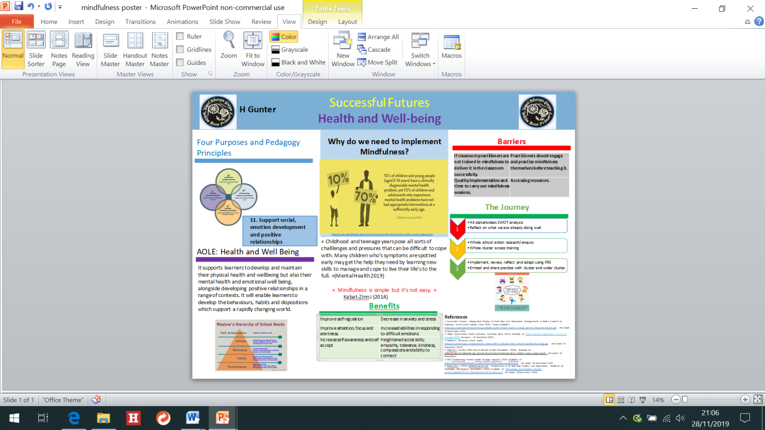

Rationale and Justification
The poster has been explicitly designed for non-pioneer schools. It has been created to support all stakeholders (staff, non-teaching staff and governors) of the journey within my own school. The focus has been linked to one of the four purposes i.e. Healthy, confident individuals and the AOLE Health and Wellbeing. This is a new area in the Welsh curriculum and I believe in previous years it has been underdeveloped. It has been in schools, but not necessarily been at the forefront of education. I believe it is fundamental to support both staff and pupils wellbeing, as it enables them to successfully overcome difficulties and achieve what they want out of life. Educators can provide children and young people the knowledge, understanding, strategies, techniques and skills they need to make their own decisions and manage their lives, now and in the future. The reason for this poster is I feel more young people are not equipped to deal with their emotions, so schools need to be responsible for teaching, modelling, build behaviour practises to implement the AOLE health and wellbeing successfully.
The layout of the poster was designed to ensure it was visually appealing and easy to follow. When designing the poster I wanted it be organised with clear headings and sub headings. Through research of academic posters it became clear that I needed to attract the reader in the first three seconds in order for them to carry on reading. The design of the poster provided a discernible reading order with a clear sequence of information through a series of columns. I felt there needed to be a balance between images, text and for it not to be cluttered.
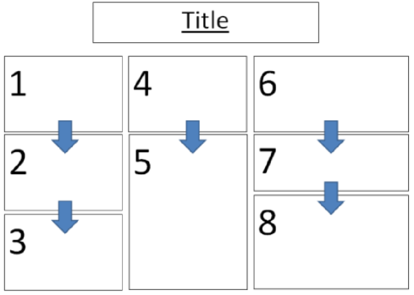
Manchester University research team (2015) stated that the best academic posters are clearly organised, written in columns and read from top to bottom and left to right. I used this template for my own design.
Diagram 3a

The colour scheme was chosen purposefully as I did not want it to overpower, detract, obscure the information or images that I wanted to provide. The main body for the poster is blue, this represented our school. The Health and Well-being linked with the draft Curriculum for Wales colour scheme. I decided that the barriers and benefits would be in red and green to show the positive and negative aspects. The journey flow chart visually appeals to the next steps or processes to achieve the end goal.
The poster starts with the link of one of the four purposes, ‘Heathy, Confident Individuals’ with successful futures pedagogical principle eleven which supports social, emotional development and positive relationships. This makes a clear link into the AOLE Health and Wellbeing. The AOLE clearly supports the development and the maintaining of physical, mental and emotional well-being, alongside developing positive relationships. This supports Maslow’s hierarchy of needs (1943). He suggests that people are motivated to fulfil basic needs before moving on to other, more advanced needs. Maslow (1943) suggested we should not focus on the “problematic behaviourism” but look closely at what makes learners happy and the things they can do in order to achieve this. Maslow focused on five needs;
1. Physiological,
2. Safety
3. Belonging
4. Esteem
5. Self-Actualisation
Maslow’s psychology was focused on developing ‘Healthy, Confident Individuals’. I believe if these five basic needs are not addressed throughout the school years, we cannot expect pupils to learn and achieve. I agree with Maslow in that pupils will experience different needs throughout their lives; this is why educators need to provide them with the tools to deal with these difficulties to cope in the future.
There is significant research from the children’s society (2008) which suggests that children as young as five years old have clinically mental health problems, yet 70% of children and adolescents have not had the appropriate interventions to support them at an early age. At present, these statistics do not seem to be improving. Primary schools should be working towards being much more than centres of learning. I feel if schools are to succeed in helping their students, our priorities as a nation must be realigned, and the education system must rebalance academic learning and emotional wellbeing. This is what our children and young people deserve. Donaldson (2015) addresses this in successful futures, along with the draft Curriculum for Wales focusing upon mental and emotional well-being as a high priority for learning. Learners should be prepared both academically and emotionally for the challenges they face inside the classroom and developing positive life outcomes. Young Minds Wise Up campaign (2017:1) states that “mental health and wellbeing programmes in schools, can lead to significant improvements in children's mental health, and social and emotional skills. Wellbeing provision in schools can also lead to reductions in classroom misbehaviour and bullying.”
Incorporating Mindfulness as a well-being programme in the classroom has many benefits, that being;
- Improves pupils attention, focus and alertness.
- Improves self-regulation
- Decreases anxiety and stress
- Increased abilities in responding to difficult emotions.
- Pupils feel more empowered to learn
- Improve behaviour and sleep patterns.
Mindfulness sessions, slow down the pace but speeds up the success later on in learning. However, there can be barriers in implementing mindfulness but we need to address these and look to focus on how we can overcome them in order for it to be successful. Staff must be trained and time given to implement the strategies and techniques, to allow it to be effective. Engagement from staff should be a priority before classroom practise. Staff should be practising mindfulness on themselves before introducing it into the classroom, this will help them understand their own emotions and set up a positive learning environment. We should be given the opportunity to access resources and understand how they are used to support mindfulness sessions, otherwise we are setting up our pupils to fail before they begin. Some pupils maybe disruptive to begin the sessions but we must be mindful of this and overcome it with short sessions, allowing sessions to take place on a 1.1 and then integrate them back into the class session and talk to the child about their emotions.
Another barrier would be the fear of change amongst staff. It can be quite daunting and increase anxiety levels as they are unsure how to implement it and when. Staff will experience the Kubler Ross (1969) see concept known as the ‘grief curve’. It clearly displays the emotions people experience through change.

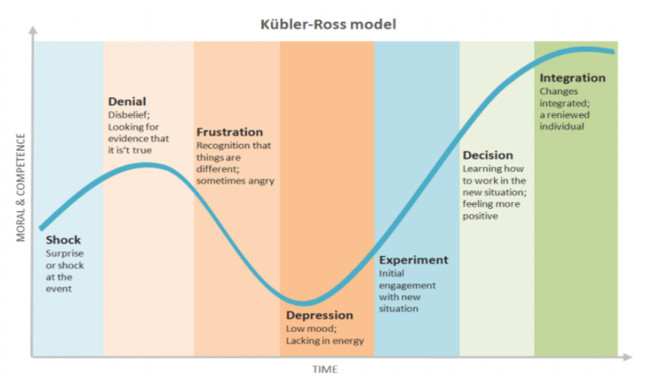
Diagram 4a

It is important that schools support teachers in the process of making transitions and change. The easier it is for teachers to move along the process the more beneficial the rewards and successes there will be in the well-being and learning of pupils and staff.
There needs to be a clear pathway for mindfulness to be successful. As a school, all stakeholders need to address and reflect on how we support our learners in health and wellbeing by carrying out a SWOT analysis. From here we can create an action plan to support the learners and staff’s wellbeing. This is an opportunity for us all to access research and find the best methods through reviewing and reflecting regularly. This process would be supported by the cluster to ensure there is a similar approach to care for the emotional well-being, to aid transition into secondary schools.

Critical Evaluation of Poster
The academic Health and Wellbeing poster has been given to the Senior Leadership Team (SLT) and teaching staff within my own school to critically evaluate. They felt overall it displayed a clear journey we are going through. However, several points were considered for adaptation.
- The information was far too detailed and it was difficult to read both text and images at some distance. The font needed to be larger with it being placed in bullet points. Also, the text needed to be placed in text boxes to show more of a clear concept.
- The image including mindfulness % was challenging to read and needed to be replaced with a graph or data chart which shows the increase of mental health problems over the years. At a glance, this would be easier to read.
- They felt it was important to include contact details or QR codes which includes further information to access websites on mindfulness and allows the reader to delve into the poster more at their own leisure.
- The images used need to be of high quality as they appear to be a little distorted and small which is problematic to read.
- When considering the colour used in the poster, senior leadership team felt that I needed to address people who were colour blind as they would not be able to differentiate between the colours. To eradicate this I would place the poster on different coloured backgrounds which they find easier to read on i.e. light blue or orange.
- The first sub heading is misleading as it has been described as ‘pedagogy principles’ but only one principle has been highlighted. The heading either needs to be changed or additional principles need to be included.
- It was felt that the ‘barriers’ section, needed to address or indicate solutions for those problems.

