
Learning In The Digital Era Module Code: ACCA4025
Assignment 1: E-Portfolio

Name: Tyler Williamson
Student No. 2237644
Course Title: Data and Information Systems

Table of Contents

1 E-Portfolio 2
1.1 Link to online E-Portfolio: Home | E Portfolio (tjay2014.wixsite.com) 2
1.2 Screenshot of Homepage 2
2 Task 1 - Written summary 3
2.1 Screenshot of Task answers 3
3 Task 2 - Academic Poster 5
3.1 Link to the Academic Poster online: Learning in the digital era - Task 2 (Academic Poster).pptx 5
3.2 Screenshots of the Task Answers 5
4 Task 3 - Automatic Referencing Tool 6
4.1 Screenshots of the Task Answers 6
5 Task 4 - E-Portfolio creation and review 10
5.1 Screenshot of the Task Answer 10
5.2 Screenshots of all pages of the online E-Portfolio 11

E-Portfolio

Link to online E-Portfolio: Home | E Portfolio (tjay2014.wixsite.com)

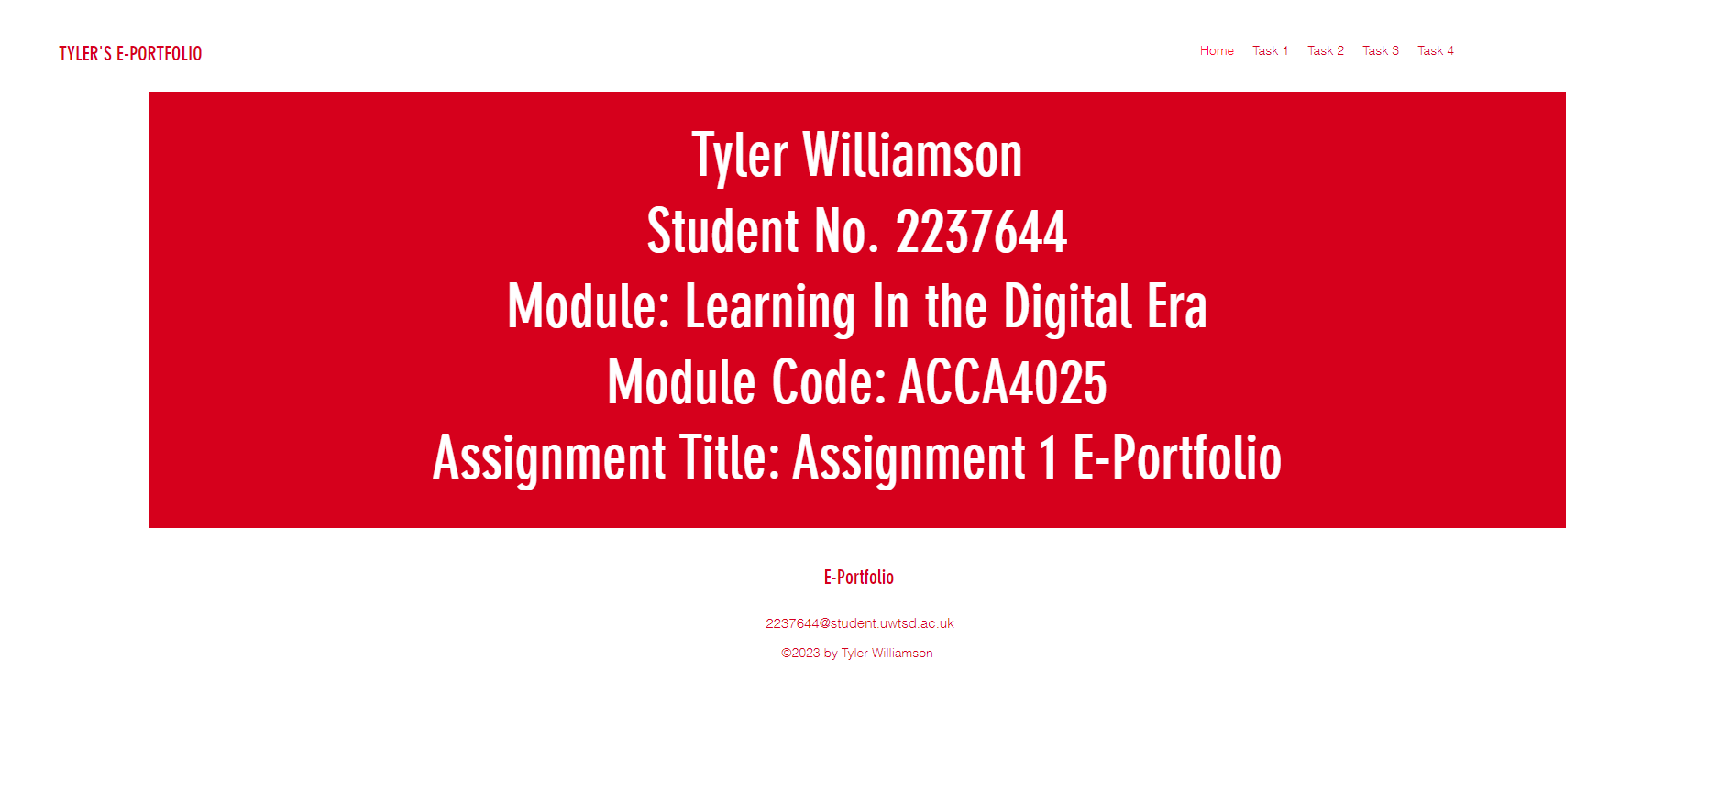
Screenshot of Homepage

Task 1 - Written summary

Screenshot of Task answers
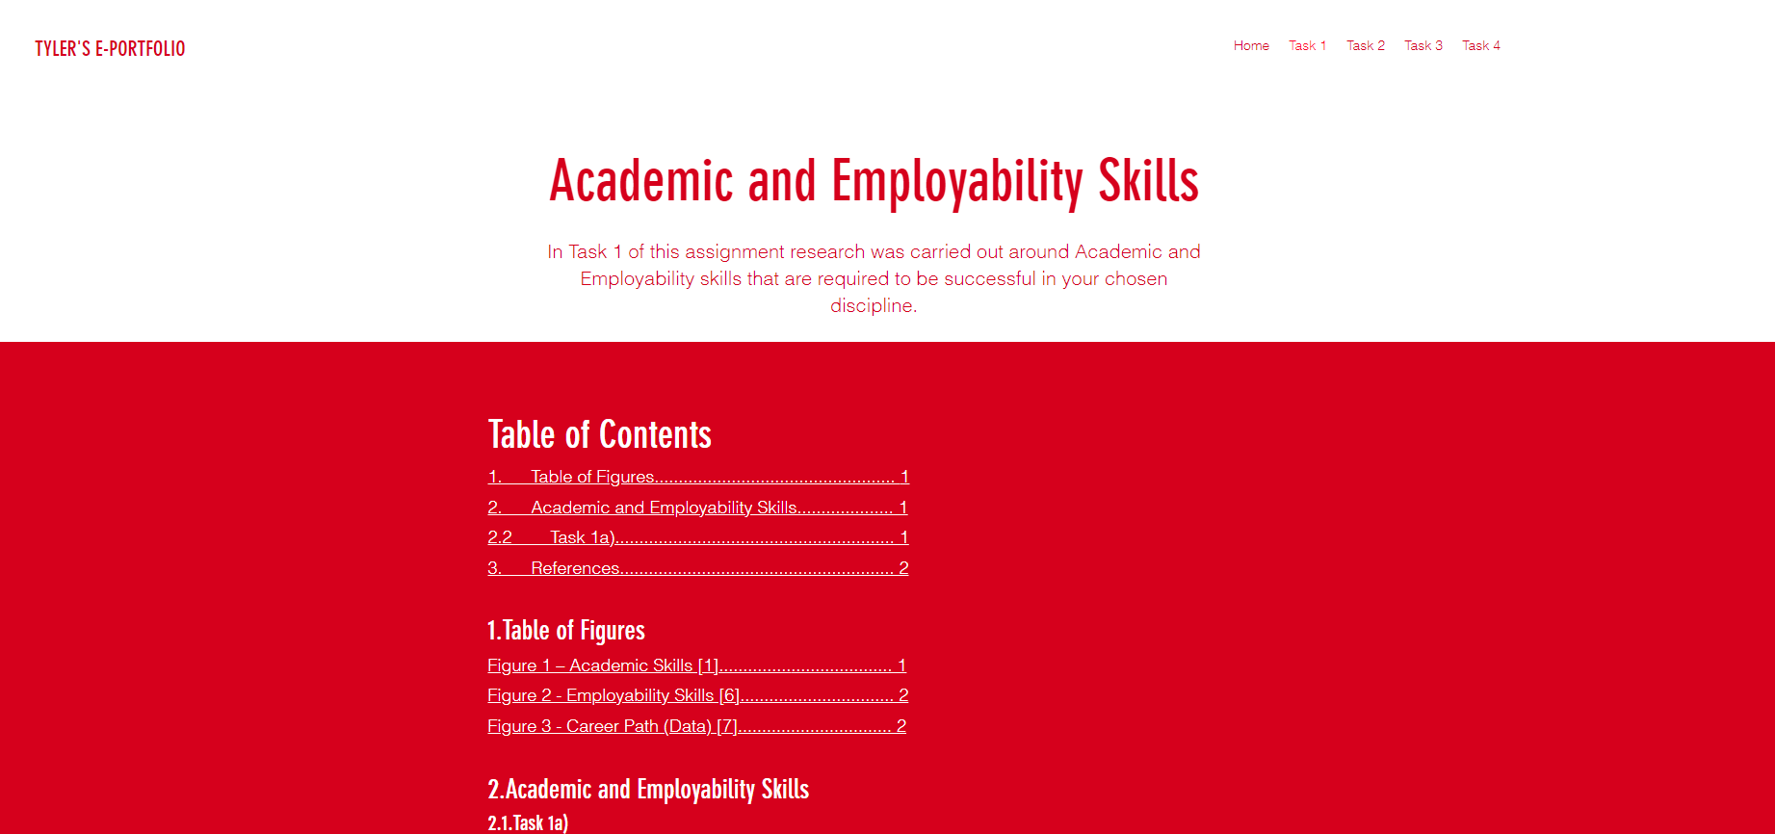
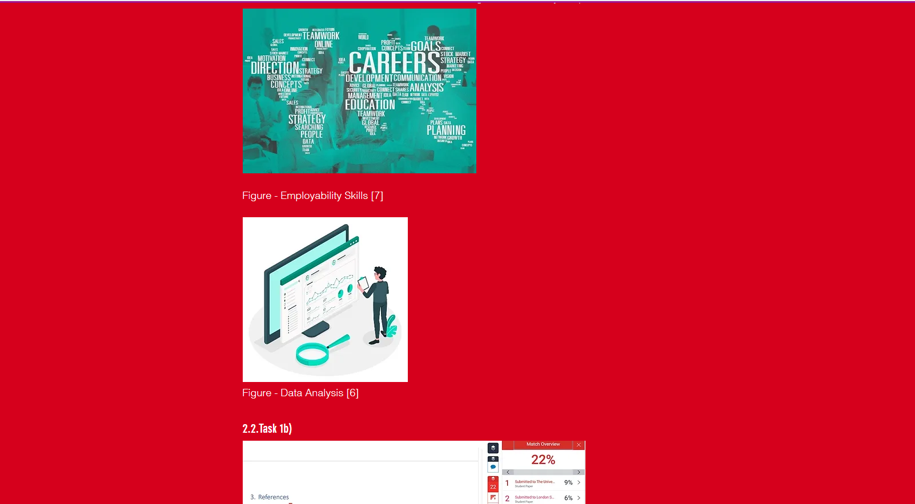
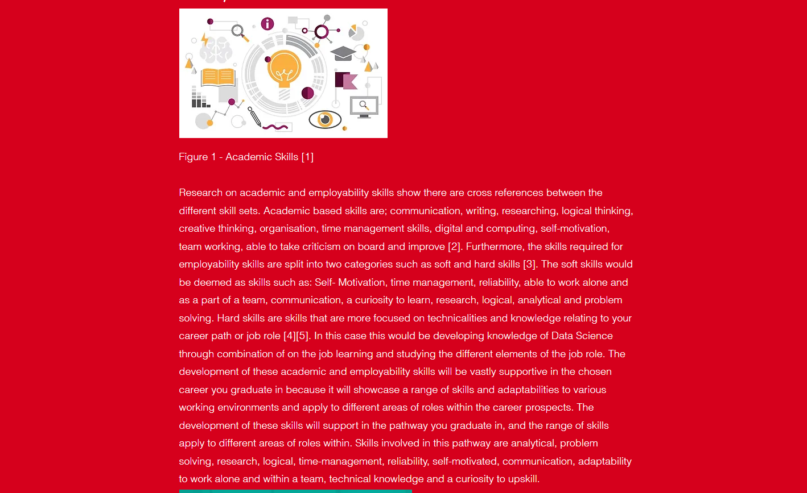

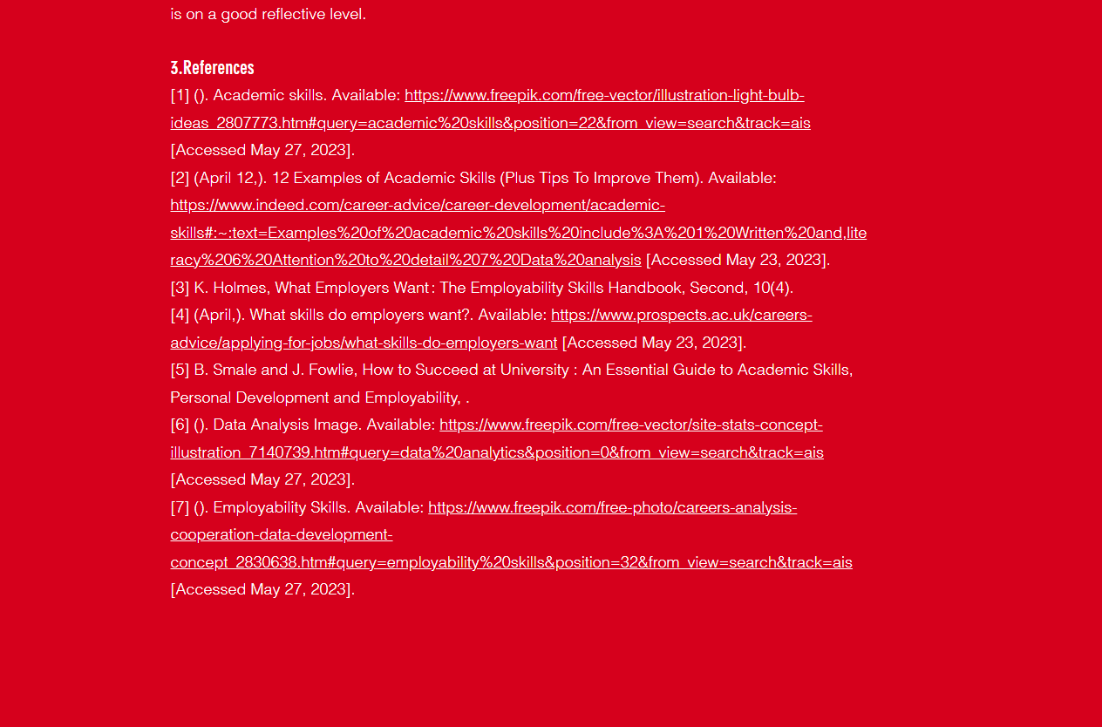
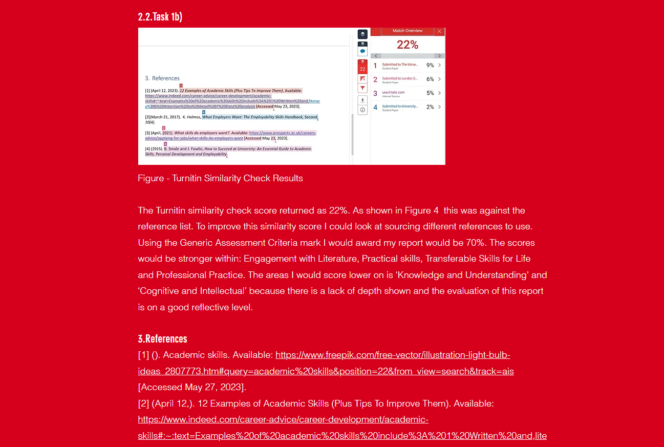

Task 2 - Academic Poster

Link to the Academic Poster online
Learning in the digital era - Task 2 (Academic Poster).pptx

Link to the Teamwork Mind Map
https://mm.tt/map/2788176652?t=QlezpHk3nB

Screenshots of the Task Answers
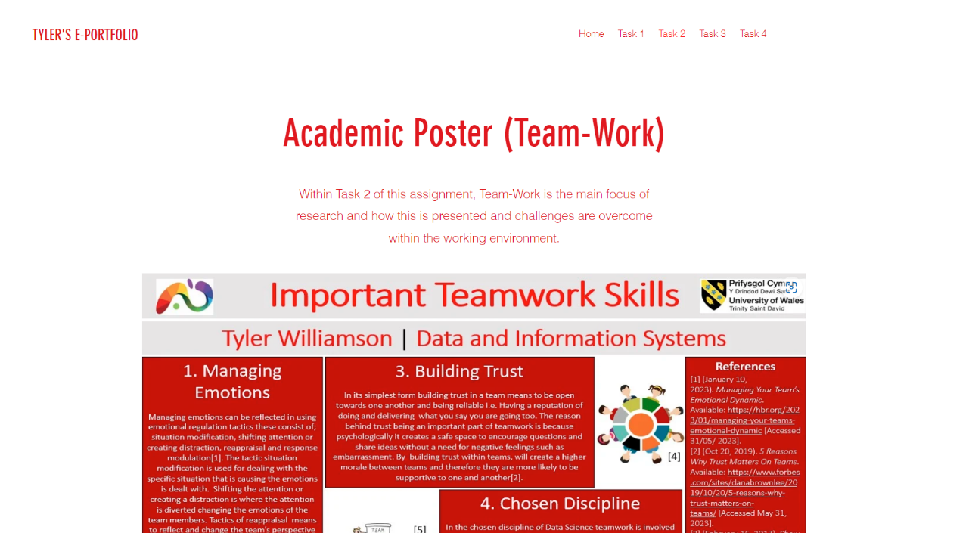

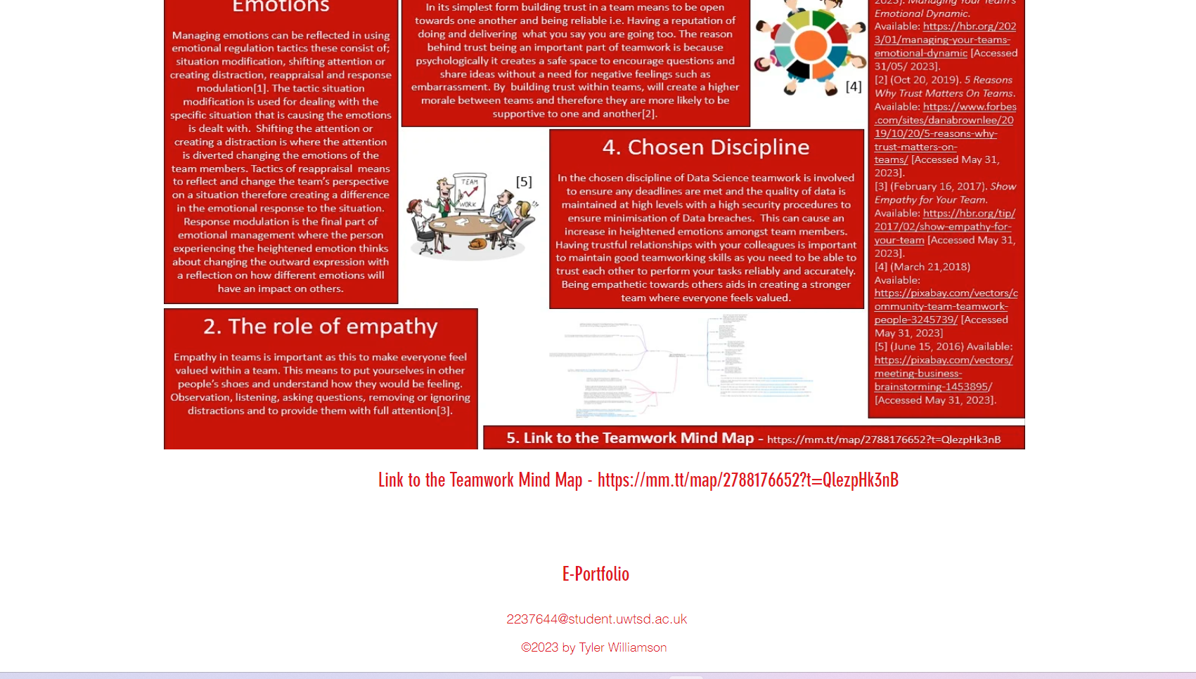

Task 3 - Automatic Referencing Tool

Screenshots of the Task Answers
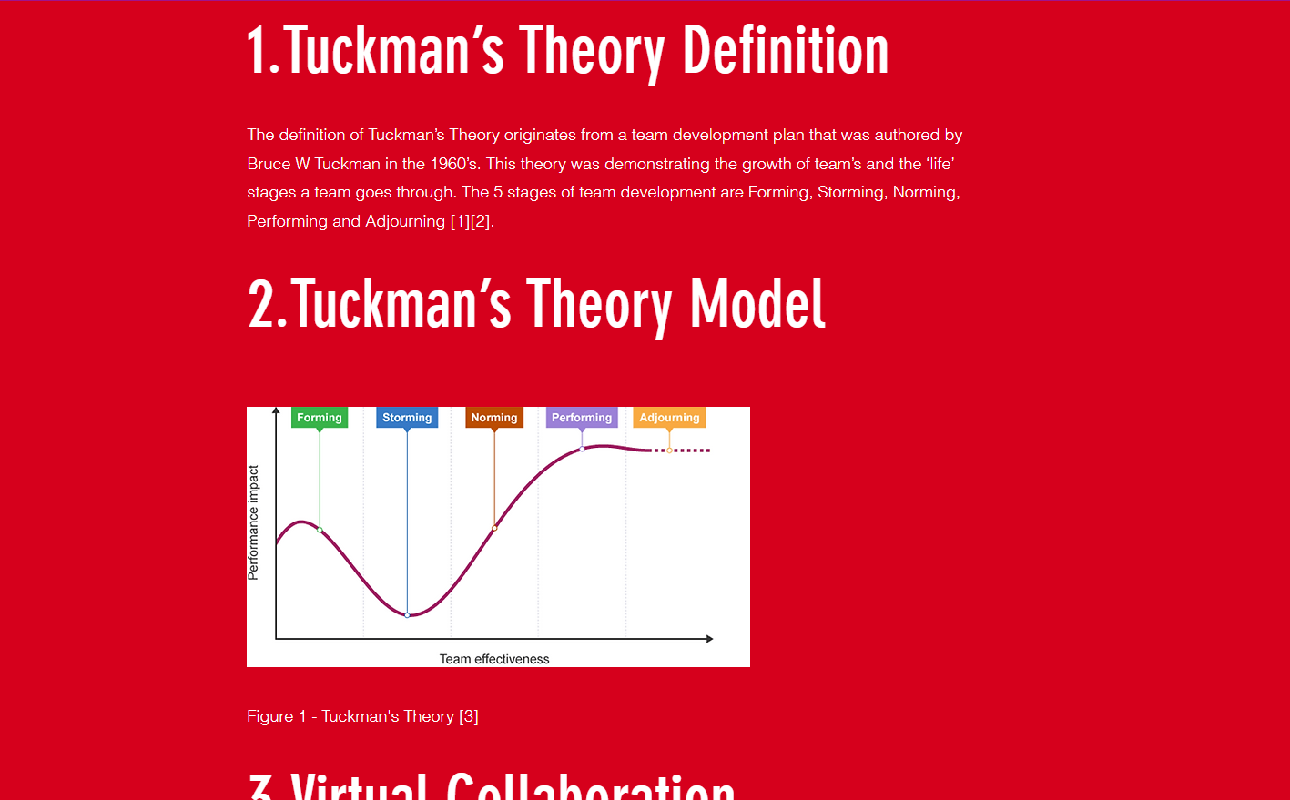
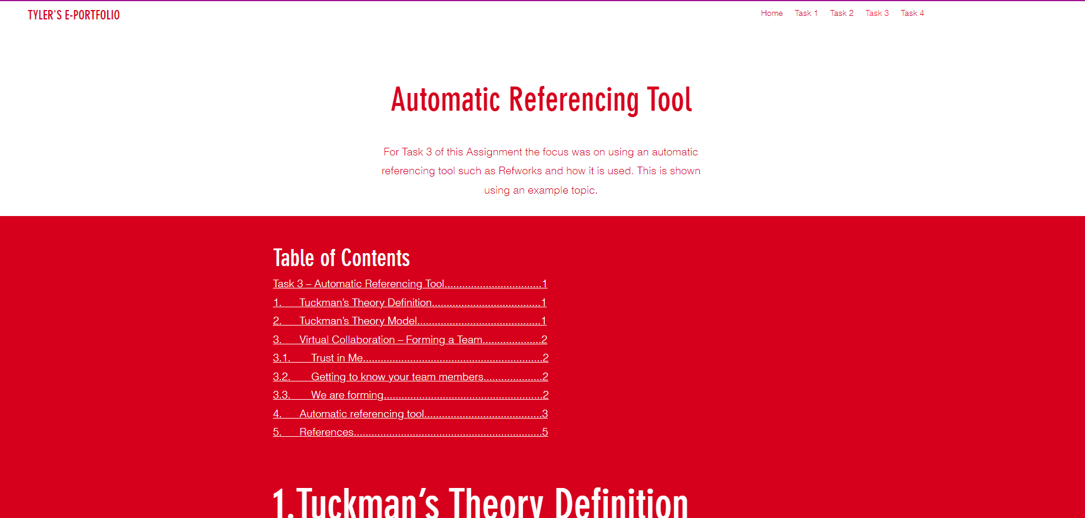

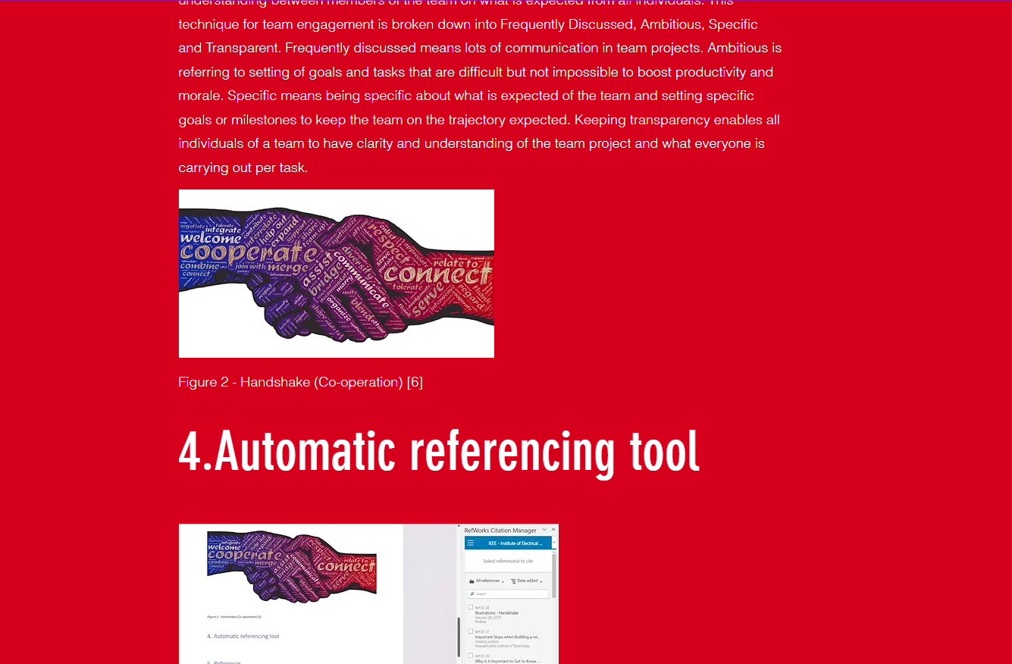
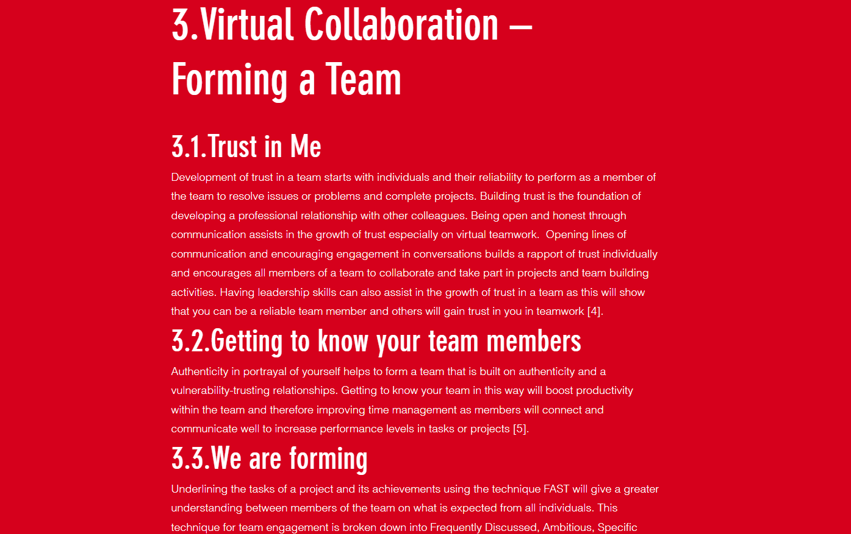

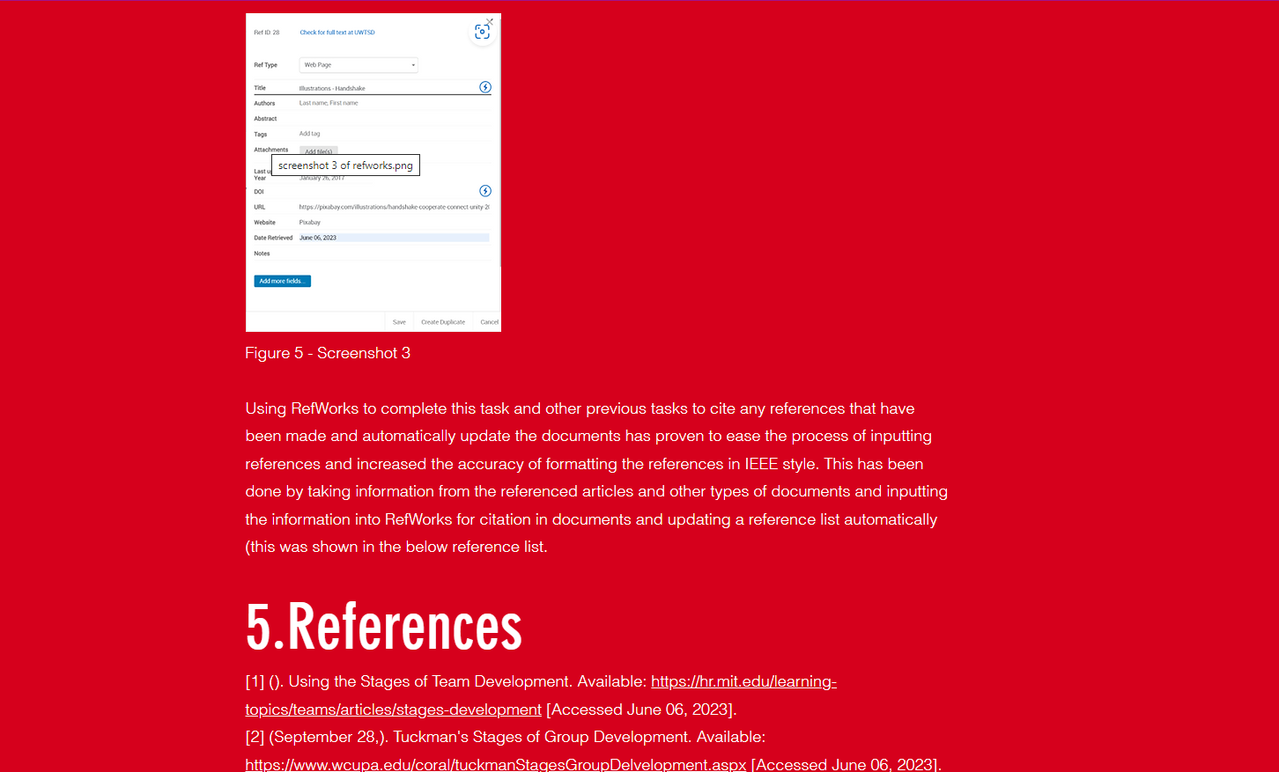
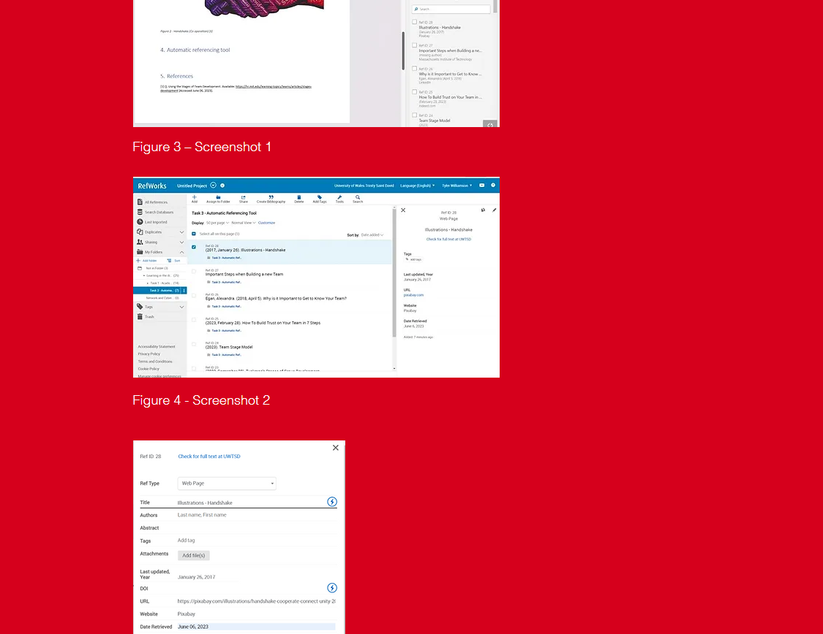
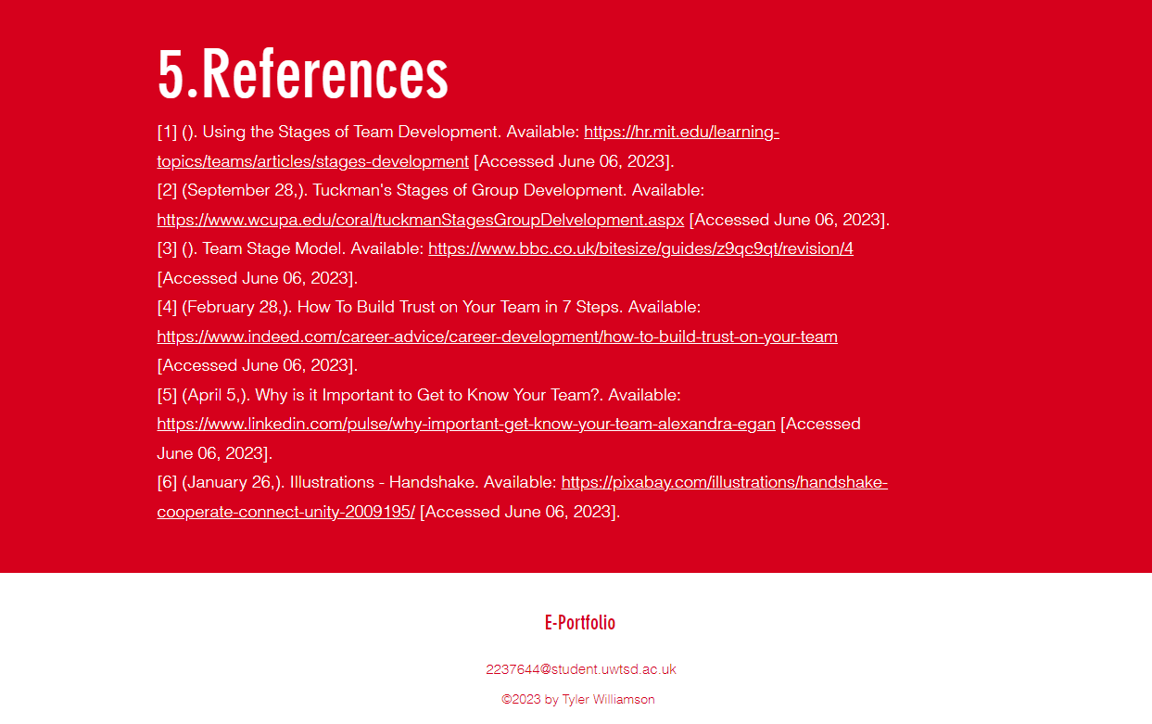

Task 4 - E-Portfolio creation and review

Screenshot of the Task Answer
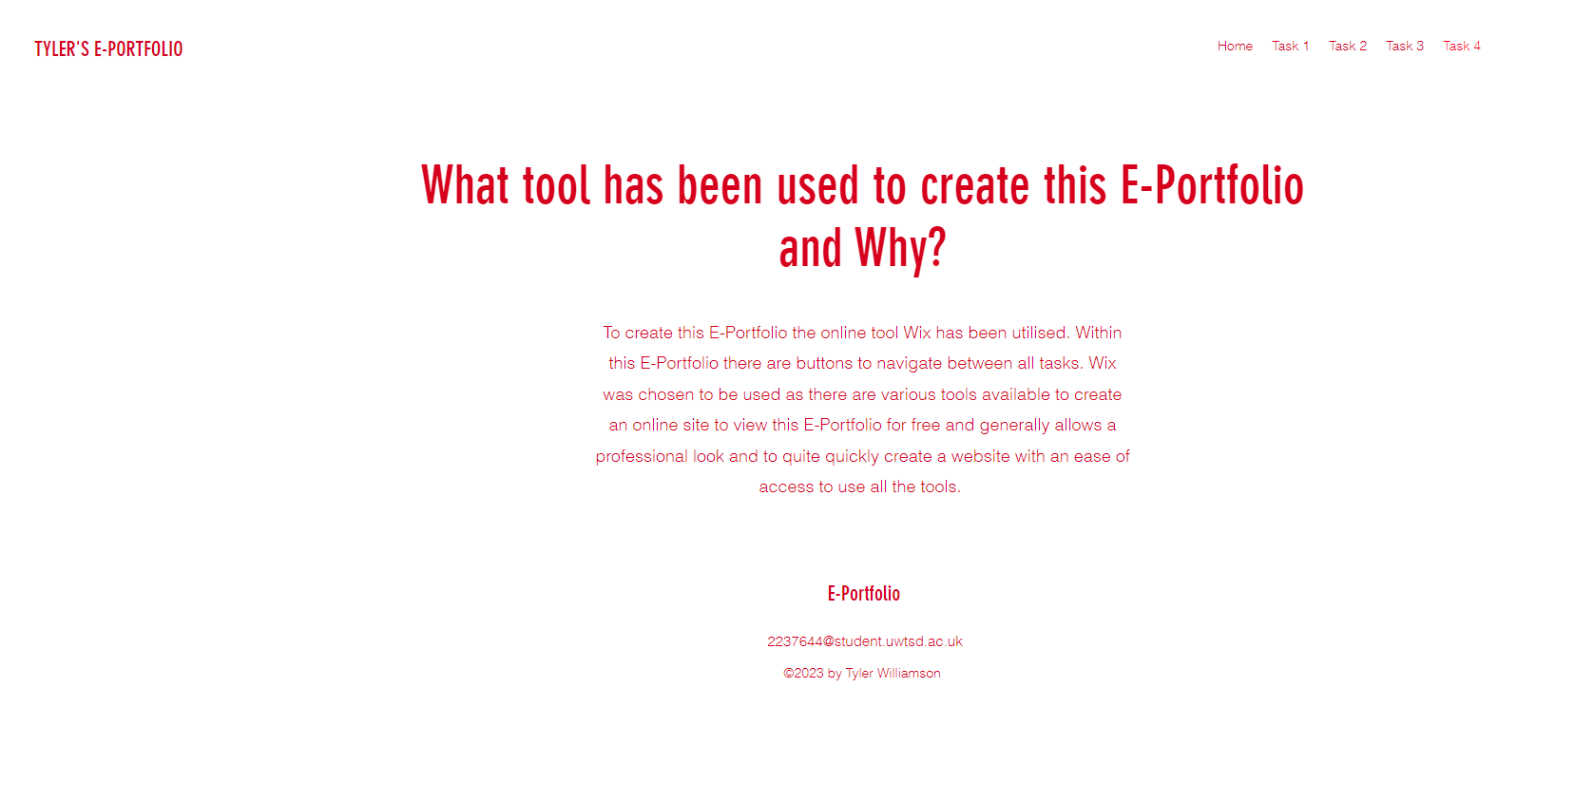

Screenshots of all pages of the online E-Portfolio



