Engineering Science Tensile Strength Report
- Introduction
The tensile strength test is a useful tool to find the yield point of a material when it is being pulled at apart at an equal force across an axis. The specific materials that will be used in the experiment are called Duralumin, Aluminium, PVC and Mild Steel. All of the materials used will have a centre area reduced in size so that particular area will experience the highest level of stress.
(Duralumin is a high specification aluminium alloy.)
The aim of this experiment is to test the tensile strength of the material which allows us to calculate the stress, the strain and the young’s modulus of the material being tested. These calculations allow people to create stress and strains graphs on the sample piece. Based on the characteristics of the material over the duration of the test, we can physically see a change in length, displayed upon a DTI Gauge (Dial Test Indicator) and the point at which the material yields and therefore shears.
The tensile test measures the ability of a material to support a stress (force per unit area). The response of a tensile sample to the application of an increasing stress can be described in terms of elastic and plastic behaviour. Initially the sample undergoes elastic elongation as it is pulled. As increasing stress is applied, the sample undergoes permanent deformation; that is plastic strain.
Ramesh Singh, in Applied Welding Engineering, 2012
- Experimental Procedure
When entering the test lab, you will see the tensile test rig setup and ready for tensile testing. The main piece of kit consists of many different items including:
- 1.A Top Plate
- 2.A Top Chuck
- 3.A Bottom Chuck
- 4.A Dial Indicator (DTI)
- 5.A Vertical Scale
- 6.Springs
- 7.A Load Nut
- 8.And A Load Nut Scale

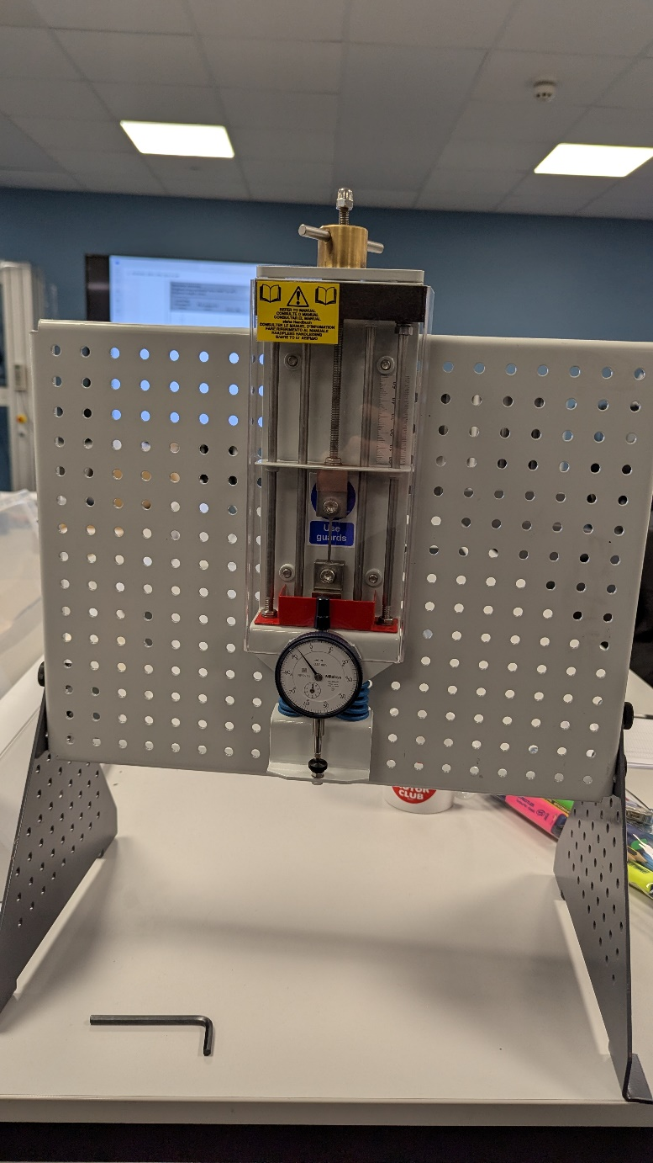
Figure 1 ( Picture Showing The Tensile Test Rig)
The Tensile Tester is a very simple piece of equipment to use, two chucks hold the sample piece of material in place, as you begin to wind the load nut out it starts to pull the material apart at a slow rate of speed, the elongation of the sample piece will be displayed on the Dial Indicator, the dial indicator will give off a very precise reading to allow for the most accurate results in the test, although you must read out the elongation after each turn on the load nut quickly as the material will try to bounce back to it’s original from. (TecQuiptment Ltd, 2012, Engineering Science Guidance Notes)
To load the sample into the chucks you will have to remove the plastic safety guard and use an Allen key to undo the bolts, place the sample into place and re-tighten the bolts, and place the safety guard back into position. When fitting a new sample make sure you spin the load nut to a point where the dial indicator shows a slight amount of force being applied and use the outer circle to set it to 0. Samples will be produced in the from of a specimen (See Picture Below Figure – Below.)
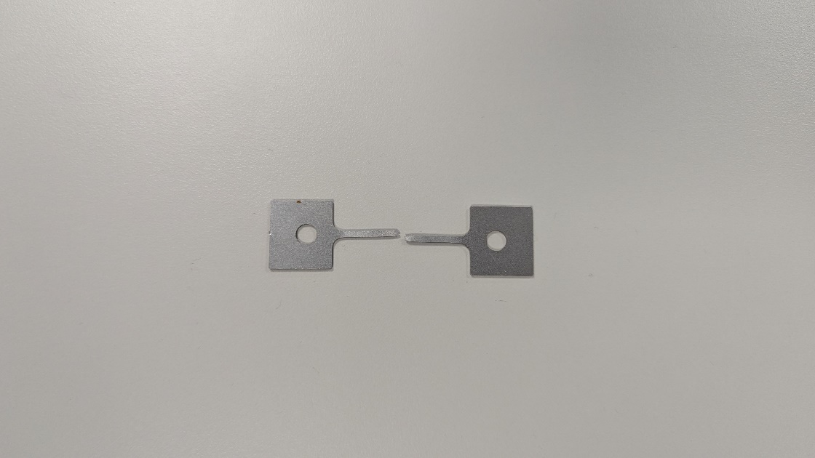
Figure 2 (Broken Specimen)
Once the sample is in place and the dial indicator is set to 0 you can start applying a force on the load nut and taking a reading after every 2 lines on the load nut scale up to 5mm, then take a reading every 1 full turn up to 10mm, then you can start doing 10 full turns although the sample will most likely break before reaching anywhere near a value of 20mm. ( TecQuiptment Ltd, 2012, Engineering Science Guidance Notes)
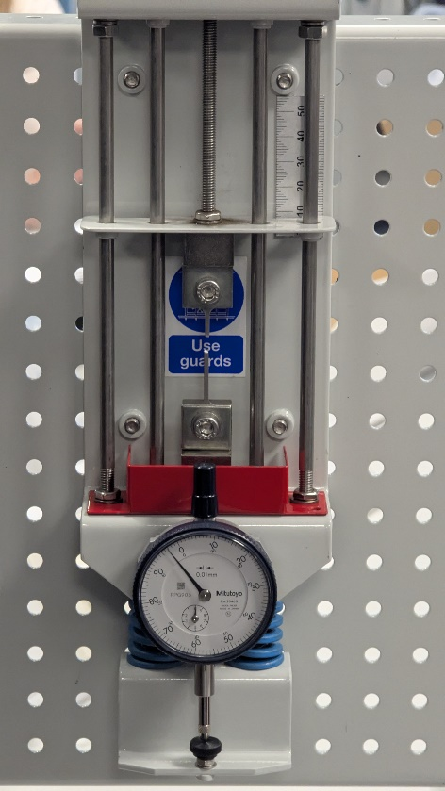
Figure 3 ( Tensile Tester In Use)
- Results
Figure 4 Table Results For Steel
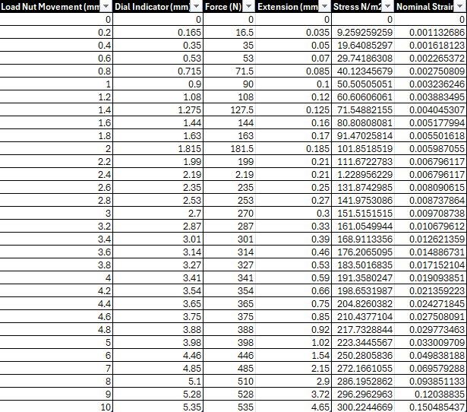

Figure 5 Table Results For Duralumin
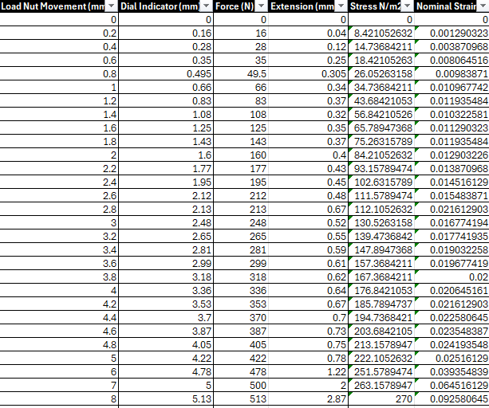
Figure 6 Table Results For Aluminium
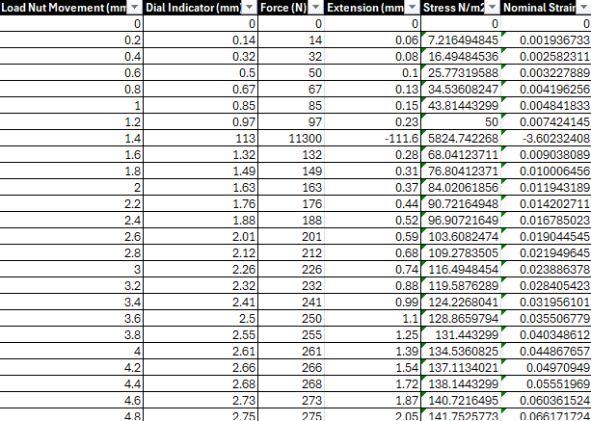

Figure 7 Table Results For PVC
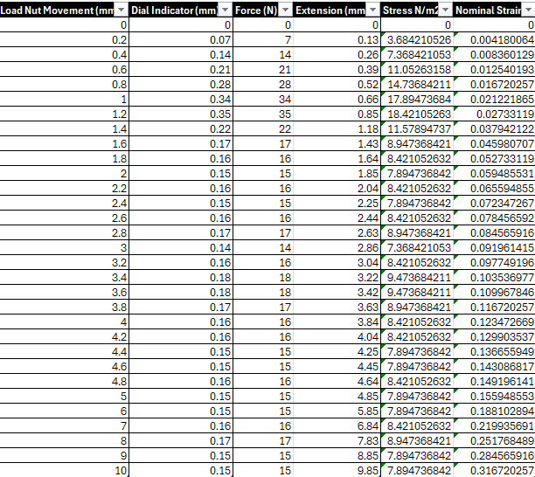

Analysis
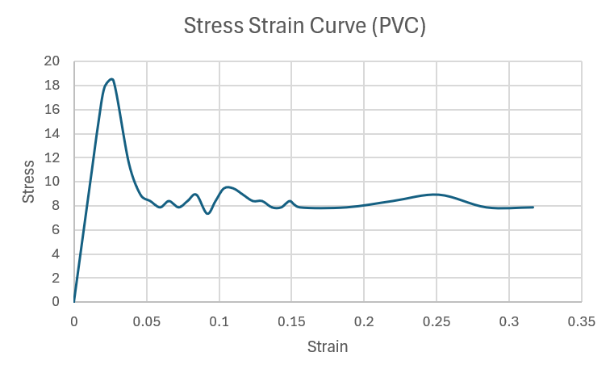
Figure 8 PVC Stress Strain Curve
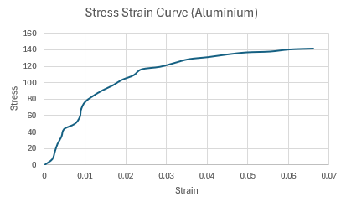
Figure 9 Stress Strain Curve Aluminium

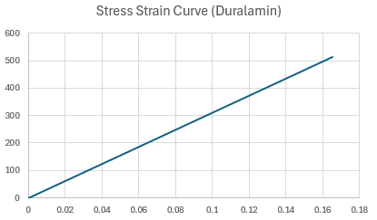
Figure 10 Stress Strain Curve Duralumin

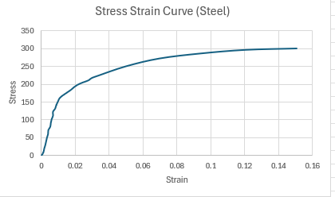
Figure 11 Stress Strain Curve Steel

Conclusion
Results For PVC:
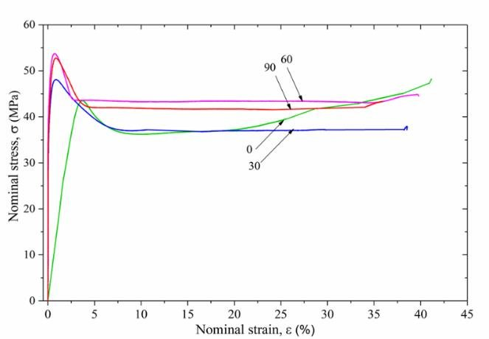
Figure 12 (Hadj Amar, 2018, Research Gate)
As we can see by the results presented by Hadj Amar in 2018 in the yield point comes in at around the mark of 43 for the PVC plastic, although their test does vary a little in comparison to the one on figure 8. The test conducted by Hadj Amar it all to do with the life span of the PVC and how it reacts to the tensile tester after a certain amount of aging, so it is possible that the plastics used in figure 8 hadn’t aged as much as the plastics used in Figure 12. Another factor that could’ve come into play is the temperature of both rooms used, as this can vary the results of the yield point quite dramatically especially when it comes to PVC plastics.

Results For Aluminium and Steel:
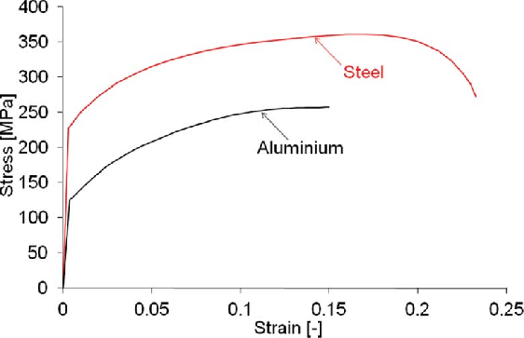
Figure 13 Stress Strain Curves for Aluminium and Steel
Shown In the image above is the Stress and strain curves produced for Steel and Aluminium by Bin Liu, when you consider all the variables involved its quite incredible how the results line up so well in comparison to figure 9 and 11. The X and Y axis follow each other almost perfectly and the yield points are very similar also. Obviously figure 13 has a much smoother graph but this could be to do with the fact that figures 9 and 11 were done by a dial indicator and the human eye so there may be some slight variables in the results. (Bin Lui, 2013, Research Gate)

Results For Duralumin:
Duralumin, strong, hard, lightweight alloy of aluminium, widely used in aircraft construction. The original composition has been varied for particular applications; it may contain about 4 percent copper, 0.5–1 percent manganese, 0.5–1.5 percent magnesium, and, in some formulations, some silicon. After heat treatment and aging, these alloys are comparable to soft steel in strength. (Erik Gregersen, No Date Specified, Brittania).
Figure 10 seems to have some sort of anomaly going on where no yield point is being displayed, although we can say that duralumin follows Hookes law because the TecQuiptment Guide notes say that most materials with a moderate stress, show an increase in stress and a gives a corresponding increase in strain which could be why we are seeing the straight diagonal line throughout figure 10. ( TecQuiptment Ltd, 2012, Engineering Science Guidance Notes)
Evaluation
To eliminate errors as far as possible in the test you can run the tests multiple times to make sure that the results come out somewhat the same each time, this allows people to change any errors made in the first couple of attempts made during the test. Another measurement that should be taken into place is the temperature of the room, if you have a varying temperature in the lab while testing each specimen then the results will fluctuate majorly.
Further Work
To improve the experiment further you could make sure that each material has aged the exact same amount of time, and you could make sure that the test is done in a room will control heating. This would allow for each material to be tested in a controlled environment and help towards a more accurate result as each material would’ve been tested in the same temperatures and would have the same life span as each other.
References
Ramesh Singh, in Applied Welding Engineering, 2012
https://www.sciencedirect.com/topics/engineering/tensile-testing#:~:text=Tensile%20testing%20is%20a%20destructive,elongates%20to%20that%20breaking%20point.

(Hadj Amar, 2018, Research Gate)
https://www.researchgate.net/figure/Stress-strain-curves-of-u-PVC-after-0-30-60-and-90-days-of-aging_fig6_334515890

(Bin Lui, 2013, Research Gate)
https://www.researchgate.net/figure/Engineering-stress-strain-curves-of-aluminium-and-steel-material_fig1_259177104

(Erik Gregersen, No Date Specified, Brittania).
https://www.britannica.com/technology/duralumin

