DS 1 Template

My Screenshots/Photos
- Please add 4–6 screenshots or photos of your digital life.
- You can use your phone or laptop.
- For each screenshot, write one or two sentences explaining what it shows.

Screenshot/Photo 1
[Insert Photo/Screenshot below]
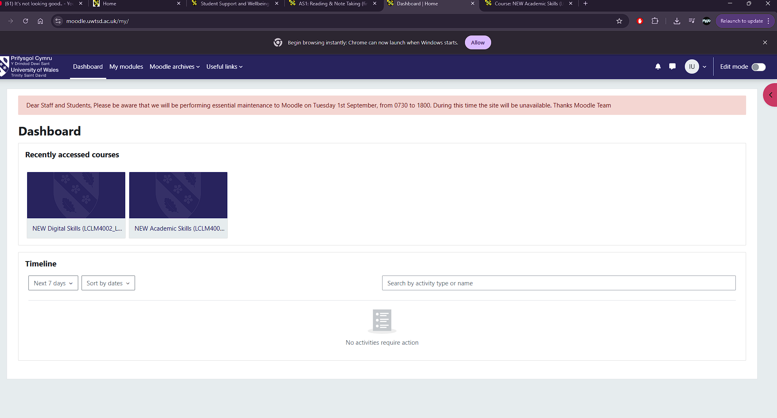
I navigate through my University Dashboard to check my modules

Screenshot/Photo 2
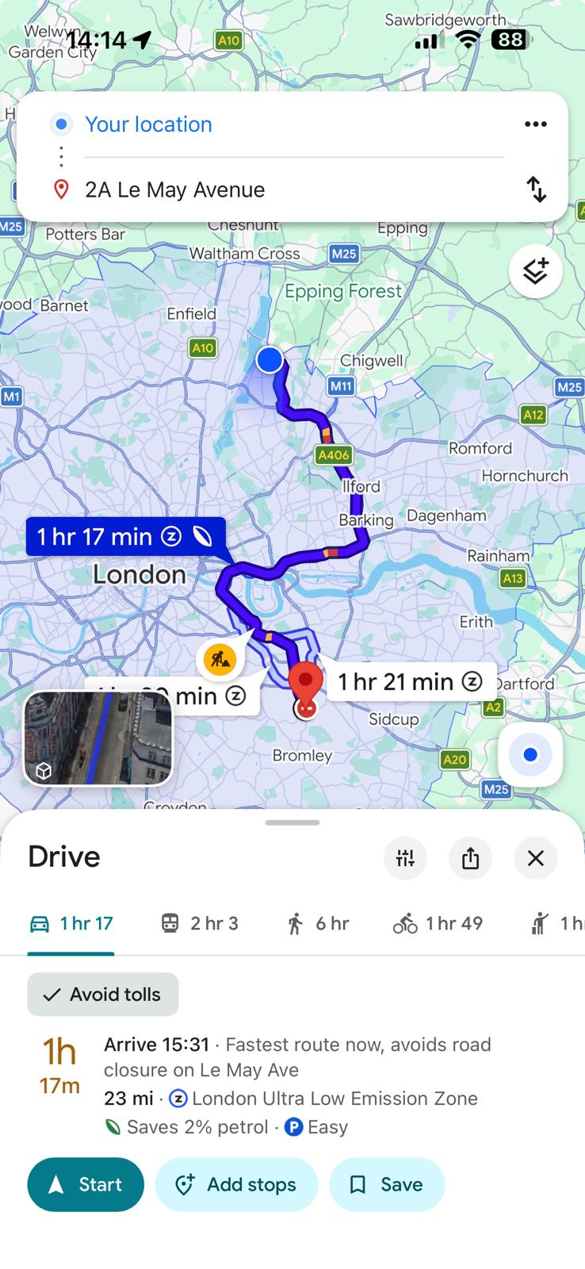
Using Google Maps to reach my destination every time

Screenshot/Photo 3
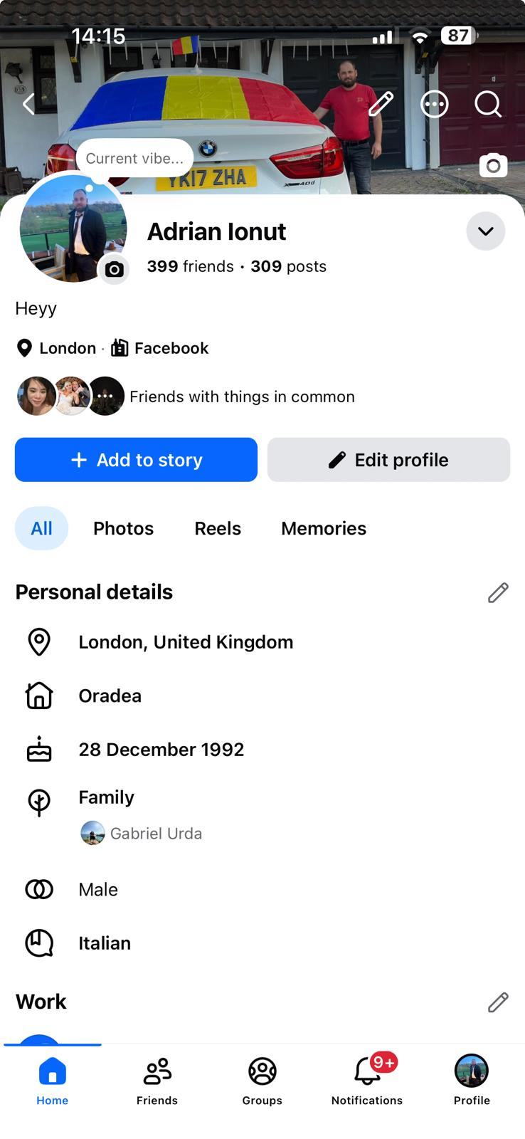
Using Social Media to connect with other people

Screenshot/Photo 4
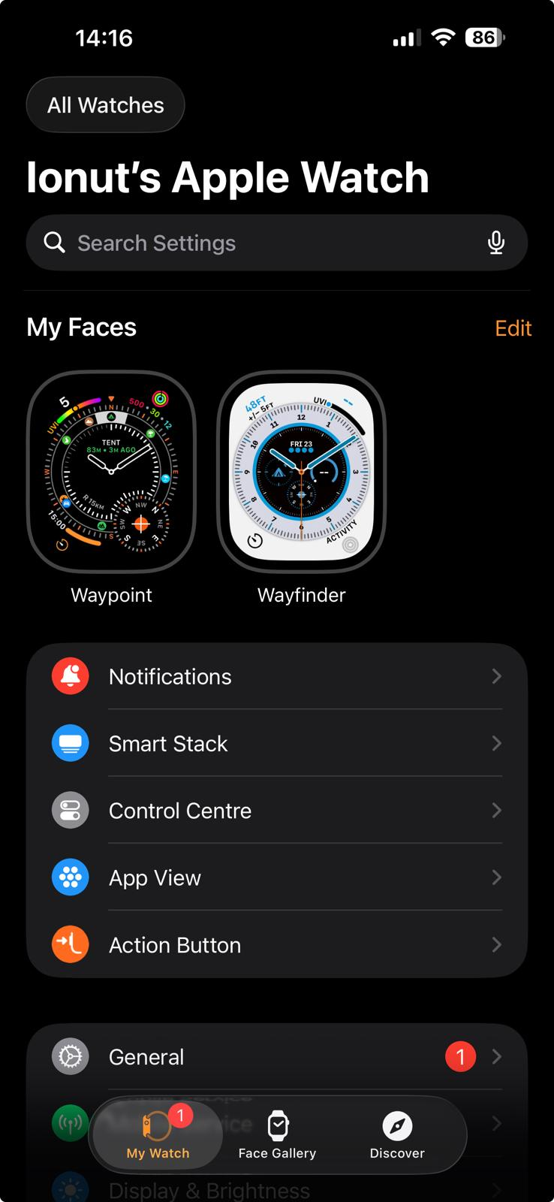
Using Smart Watch to keep track of daily steps and health

Screenshot/Photo 5
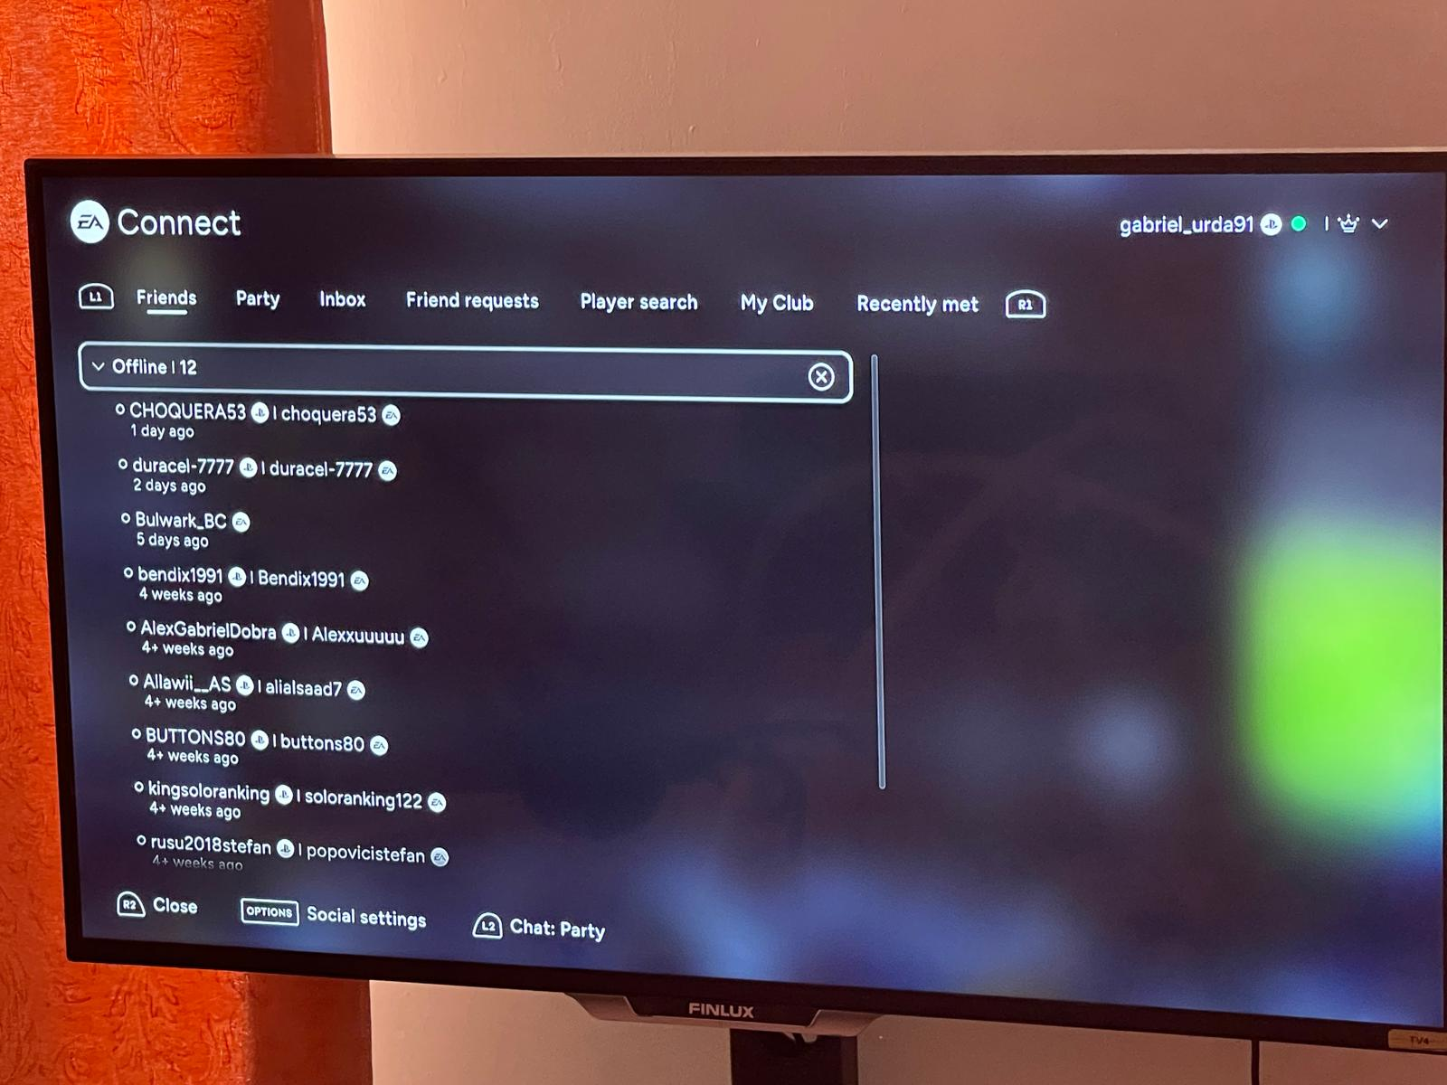
Watching TV for entertainment

Screenshot/Photo 6
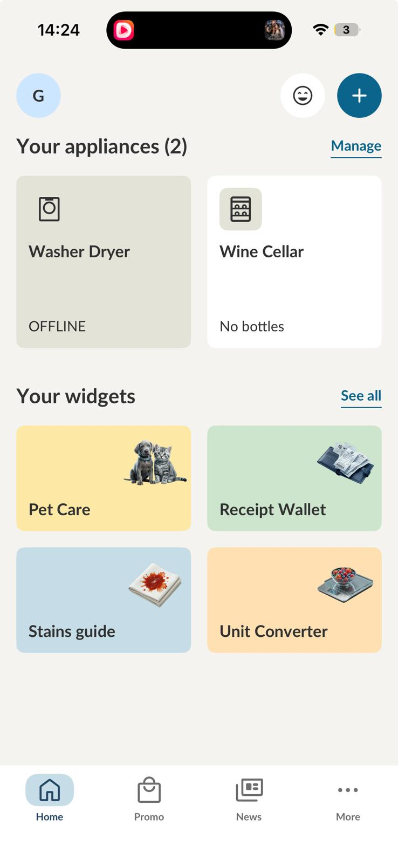
Using phone app to connect to the washing machine, smart fridge or the wine cellar

My Short Reflection
- Write 5–8 simple sentences about your digital life.
- You can use the sentence starters below if helpful.
- I use digital tools to study, communicate, and find my way using Google Maps.
- I feel confident when I use my university dashboard and social media.
- I often use these tools: Google Maps, Facebook, my Apple Watch, and smart home apps.
- I want to improve my digital skills, especially for learning and using new technology.
- I sometimes feel nervous about online privacy and keeping my personal information safe.
- I hope this module will help me become more confident with digital technology.
- Digital skills are important for me because they make everyday life, study, and communication easier.

Sentence starters
- I use digital tools to …
- I feel confident when I …
- I want to improve …
- I often use these tools: …
- I sometimes feel nervous about …
- I hope this module will help me …
- Digital skills are important for me because …
You can write more if you want.

Submission Checklist
Before you submit, please check:
​​​ ☐ I added 4–6 screenshots
☐ I wrote short sentences for each screenshot
☐ I wrote my short reflection
☐ My work is my own
☐ My file opens correctly
​​☐ My file opens correctly

