

The prediction and analysis of crowd default based on data mining technology
by
Youqian Chen
2216701

Supervisor: Dr Divya Chidambaram

Project submitted as part of the requirements for the award of MSc Data and Artificial Intelligence

September 2023

DECLARATION

I, Youqian Chen declare that I am the sole author of this Project; that all references cited have been consulted; that I have conducted all work of which this is a record, and that the finished work lies within the prescribed word limits.

This work has not previously been accepted as part of any other degree submission.

Signed : Youqian Chen

Date : 09/09/2023

FORM OF CONSENT

I, Youqian Chen hereby consent that my Project, submitted in candidature for the M.Sc. Data and Artificial Intelligence degree, if successful, may be made available for inter-library loan or photocopying (subject to the law of copyright), and that the title and abstract may be made available to outside organisations.

Signed :Youqian Chen

Date : 09/09/2023

Abstract
With the development of economy and society, the lending behavior has become very active, but in the lending behavior, the phenomenon of overdue and default has become more and more serious. Although the society hopes to help more people solve the difficulties in capital turnover through lending, so as to help them overcome the temporary difficulties, there are many "bad customers" who do not repay on time or even default on their trust. This has caused very serious losses to the society and relevant lending enterprises. Therefore, if a quantitative forecasting model can be obtained based on today's big data technology to accurately predict whether people will default, it is undoubtedly of practical significance off-site. The aim of this study is to compare the accuracy of data mining methods such as logistic regression, Xgboost, DNN, and LSTM in predicting the probability of customer default, and to assess the value of their results from a risk management perspective. Accurate prediction of default probability is essential for risk management.

There are some unbalanced phenomena in the modeling samples, default group: non-default group = 2.3:7.7. This analysis first conducts data processing and feature analysis on the default data set, and visually analyzes the relationship between the basic information, behavioral information and default of the crowd. Then, Spearman single factor analysis and non-parametric test methods were used for factor screening. Finally, a relevant classifier model was established and it was found that Xgboost performed better in predicting default probability, with an accuracy of more than 77%, a high robustness of the model and a recall rate of more than 60%.This shows that using the Xgboost model can more accurately assess a customer's risk level and provide a more reliable basis for risk management decisions.

Key words: default probability prediction, risk management, Xgboost, non-parametric test
Content
Abstract
1.Introduction 1
1.1 Research background and significance 1
1.2 Review of relevant literature 3
1.3 Research content 4
1.4 Article structure 5
2.Relevant theoretical knowledge and technology 7
2.1 Process of prediction model 7
2.2 Data Preprocessing 8
2.2.1 Data Cleaning 9
2.2.2 Feature selection 10
2.3 Data mining algorithm 12
2.3.1 Logistic regression model 12
2.3.2 Xgboost Model 12
2.3.3 Deep neural network model 15
2.3.4 Long and short memory neural network model 17
2.4 Evaluation criteria 19
2.5 Summary of this chapter 20
3.The characteristics of breach of contract 21
3.1 Description of data attributes 21
3.2 Data visualization analysis 22
3.2.1 Basic Data Analysis 22
3.2.2 Behavior data analysis 25
3.3 Data outlier processing 28
3.3.1 Isolated forest algorithm removes outliers 28
3.3.2 Single factor logic removes outliers 31
3.4 Feature and target variable analysis 33
3.4.1 Relationship between basic information and target variables 33
3.4.2 Relationship between amount level and target variable 35
3.4 Summary of this chapter 37
4.Predictive analysis based on machine learning model 38
4.1 Feature selection 38
4.1.1 Divide the data set 38
4.1.2 Feature selection 38
4.2 Model Prediction 43
4.2.1 LR modeling results 43
4.2.2 XGB modeling results 46
4.2.3 DNN modeling results 49
4.2.4 LSTM modeling results 51
4.2.5 Comparison of modeling results 53
4.3 Model optimization 54
4.3.1 Optimization results 54
4.3.2 Importance of features 58
4.4 Summary of this chapter 59
5.Conclusion 61
5.1 Summary 61
5.2 Outlook 62
Reference 63

List of figures
Figure 1 Schematic diagram of the prediction process 8
Figure 2 Topology of DNN 15
Figure 3 RNN network diagram 17
Figure 4 LSTM core theory diagram 18
Figure 5 LIMIT_BAL, AGE violin diagram 22
Figure 6 Default payment next month Pie 23
Figure 7 SEX Pie 23
Figure 8 Distribution of EDUCATION in the bar chart 24
Figure 9 MARITAL STATUS histogram distribution 25
Figure 10 Bar chart of history of past payments 26
Figure 11 Distribution density of the amount of bill statement 27
Figure 12 Distribution density of amount of previous PAY_AMT 27
Figure 13 Outlier test results of isolated forest 29
Figure 14 Continuous data distribution after isolated forest outlier processing 30
Figure 15 Continuous data distribution after single-factor outlier processing 32
Figure 16 Distribution of target labels after outliers are processed 32
Figure 17 Relationship between SEX, EDUCATION, MARITAL STATUS and target variables 33
Figure 18 Relationship between LIMIT_BAL, AGE, and target variables 34
Figure 19 Relationship between PAY and target variable 35
Figure 20 Relationship between bill and target variables 36
Figure 21 Relationship between PAY_AMT and target variables 37
Figure 22 Heat map of PAY variable correlation 39
Figure 23 BILL_AMT variable correlation heat map 40
Figure 24 Heat map of PAY_AMT variable correlation 41
Figure 25 Heat map of residual correlation of behavior variables 41
Figure 26 LR 10 random cross-verification results 45
Figure 27 XGB cross-verification results for 10 times 48
Figure 28 DNN cross-verification results for 10 times 51
Figure 29 LSTM cross-verification results for 10 times 52
Figure 30 Comparison of AUC curves between training set and test set after optimization of each model 57
Figure 31 Feature importance score chart 59
List of tables
Table 1 Confusion matrix 19
Table 2 Field description 21
Table 3 Level of Spielmann correlation coefficient 39
Table 4 KW test results of continuous variables 43
Table 5 Average performance of technical indicators of each model 53
Table 6 Average performance of technical indicators of each model after optimization 58

1.Introduction

1.1 Research background and significance
Risk management is a crucial task in the financial and related industries. Accurately assessing customers' credit risk and default probability is of great significance for financial institutions and other related enterprises. Loan overdue refers to the situation where the borrower fails to repay the loan principal and interest on time. For financial institutions and creditors, overdue loans are an important risk factor that may lead to financial losses and credit risks. Therefore, establishing an effective risk control mechanism for overdue loans is crucial for protecting the interests of financial institutions and stabilizing the financial market.

The risk of loan overdue is caused by various factors, including the borrower's personal credit status, repayment ability, economic environment, industry prospects, etc. In the past few decades, academia and financial institutions have been committed to researching and developing various loan overdue risk assessment and risk control models to help predict and manage loan overdue risk. The traditional loan overdue risk control model is mainly based on statistical methods and empirical rules, using the borrower's personal information (such as age, income, occupation, etc.) and loan characteristics (such as loan amount, interest rate, repayment term, etc.) to assess risk. These models are typically modeled using algorithms such as logistic regression, decision tree, and random forest, and trained and validated using historical data.

However, with the development of machine learning and big data technology, more and more financial institutions are exploring loan overdue risk control models based on machine learning. Machine learning models can utilize richer data features and more complex algorithms to improve prediction accuracy. For example, non-traditional data such as borrower's social media data, consumer behavior data, and mobile communication records can be used to enhance the predictive ability of the model.

Past studies have demonstrated the effectiveness of data mining methods in predicting customer default probability. However, most studies only focus on the classification results (trusted or untrusted customers) and ignore the accuracy of default probabilities. From a risk management perspective, accurately predicting the probability of default is more valuable than simply classifying the results. Accurate default probability prediction can help financial institutions better assess the risk level of customers and take corresponding risk control measures to reduce potential risks.

Therefore, this study aims to compare the accuracy of data mining methods such as logistic regression, Xgboost, DNN, and LSTM in predicting customer defaults, and to assess the value of their results from a risk management perspective. By comparing the performance of different methods, we can determine which method is more accurate and reliable in predicting the probability of default. This will provide a valuable decision-making basis for risk management departments in financial institutions and other related industries to help them develop more effective risk management strategies.

The results of this study have important practical implications for financial institutions and other related industries. Accurately predicting the probability of customer default can help institutions better assess the credit risk of customers, so as to take appropriate measures to reduce the potential risk. This helps to improve the overall risk management capabilities of the institution, protect the interests of the institution and ensure the sustainable development of the business. In addition, the methods and results of this study also provide a useful reference for future related research, and promote the further development and innovation in the field of risk management.
To sum up, the research background and significance of this study is that by comparing the accuracy of different data mining methods in predicting customer default probability, it provides valuable information and decision support, brings practical application benefits to risk management departments of financial institutions and other related industries, and provides a useful reference for future research.

1.2 Review of relevant literature
The application of quantitative machine learning methods to financial risk control has developed very rapidly in recent years. Literature [1,2] This review provides an overview of risk management in financial institutions. It describes the different types of risks faced by financial institutions (such as credit risk, market risk, and operational risk), as well as common risk management methods (such as risk assessment, risk monitoring, and risk control).Literature [3,4] introduces the extensive application of data mining in financial applications. It introduces the basic concepts and techniques of data mining and discusses different application scenarios in the financial sector, such as credit scoring, fraud detection, market forecasting, and portfolio optimization. The article also summarizes the advantages and limitations of different data mining methods, and provides prospects for future research directions. As for the application of theoretical model, a credit scoring method based on Gradient Boosting Machines (GBM) was introduced in literature [5] as early as 2001.The results show that GBM model has excellent performance in predicting customer default probability, and has higher accuracy and robustness than traditional logistic regression model. Literature [6] This review reviews the development and application of credit scoring techniques. It introduces the application of traditional statistical methods (such as logistic regression and decision trees) as well as more advanced data mining techniques (such as neural networks and support vector machines) to credit scoring. The review also discusses the advantages and disadvantages of different approaches and provides a vision for future research directions. In recent years, relevant literature [7] has compared the application of logistic regression, decision tree and neural network algorithms in credit scoring. The results show that neural network model has better performance than logistic regression and decision tree model in predicting customer default probability. In addition, for the study of Neural Networks, literature [8] discussed the application of Deep Neural Networks (DNN) in credit card fraud detection. The results show that DNN model has better performance than traditional logistic regression model in predicting customer default probability, and can identify potential default risk more accurately. With the development of neural networks in literature [9], the application of Long Short-Term Memory (LSTM) in credit card fraud detection was discussed. The results show that LSTM model has better performance than the traditional logistic regression model in predicting the probability of customer default, and can better capture the time dependence.

1.3 Research content
This paper mainly studies using data mining technology to predict loan default data. The data in this paper comes from UCI public data set, and the relevant research contents of this paper are as follows:

- Data processing and analysis. Process the original default data set, analyze the distribution of characteristic attributes in the data set and the absence of data, check the distribution of data, find outliers according to the knowledge principle of the data, then remove the existing problems and meaningless data, and process the data accordingly according to the actual situation, so as to obtain the effective data set for final use.

- Feature selection. Feature redundancy is very undesirable for modeling, which not only increases the complexity of the model, but also has a negative impact on the generalization ability of the model. This paper will use correlation theory and non-parametric tests to screen features.

(3) The classification model is used to predict the crowd default. Choose linear model such as logistic regression (LR), nonlinear model such as Xgboost(XGB), deep neural network (DNN) and long and short memory neural network (LSTM), each model has different characteristics, and comprehensively analyze which model is more conducive to the prediction of default crowd.

1.4 Article structure
The thesis is divided into five chapters. The introduction of each chapter is as follows:

Chapter One: Introduction. This paper gives a brief description of the background, significance and relevant research status of the topic, and expounds the content of this paper and the organizational structure of the paper.

Chapter Two: Introduction of relevant knowledge and technology. It mainly introduces the theories and methods involved, and details the working method of data preprocessing used in processing the original data. Then, it summarizes the basic principle of the classification algorithm applied in this paper, and expounds the meaning of the model evaluation criteria after the model is established.

Chapter Three: data characteristics analysis. Preprocess the original data set, check whether the data has abnormal data, check the descriptive statistics of the data, remove the invalid data and do the relevant single-factor visual analysis.

Chapter four: Predictive analysis based on data mining model. The feature selection of the obtained effective data set is carried out, and then the LR, XGB, DNN and LSTM algorithms are used to establish models and compare different evaluation indicators. SMOTE was treated on the training set label according to the label distribution to further enhance the model effect.

Chapter Five: Summary and prospect. This paper briefly summarizes the work of this paper, summarizes the research results, and then points out the problems and shortcomings in the research process, and provides a clear idea and content for the next stage of research.

2.Relevant theoretical knowledge and technology

2.1 Process of prediction model
The prediction process based on data mining is divided into the following processes:

Step 1: Identify the research question and determine the type of prediction model. The prediction of whether a crowd defaults is generally a classical binary classification problem, so we need to obtain valuable features related to the goal according to business knowledge. Only when the features are meaningful, the model prediction is meaningful and more explanatory.

Step 2: Get the data and process it. There are many ways to collect data, such as: obtaining data from other systems through API interfaces, writing website crawlers and then crawling data with targets, sensor collection. There are many ways to extract data, generally in order to save time and effort, we can choose open source data sources. Generally, the data set obtained will be relatively large, so the original data set must be processed. It can be processed by null value and outlier value processing, unbalanced sample correction, feature selection and so on.

Step 3: Choose an algorithm and build a model for the data. In disease prediction, choosing the appropriate machine learning algorithm is particularly important, and different algorithms are suitable for different scenarios, depending on the type of task. Tasks are generally divided into supervised learning and unsupervised learning, and disease prediction is generally supervised learning, and commonly used algorithms are K nearest neighbor algorithm, support vector machine algorithm, decision tree algorithm and so on.

Step 4: Model evaluation. After the model is constructed, it needs to be evaluated. Usually, we will use some specific evaluation indicators to evaluate the accuracy of the model used, and can also be used to compare the performance of various models. Commonly used evaluation indicators include accuracy, confusion matrix and root-mean-square error.

Step 5: Model optimization. After the evaluation of the model, if the evaluation index of the model is not good enough, the model needs to be optimized, which can be optimized through parameter adjustment. If the effect is not satisfactory, it needs to go back to the third step, re-select the algorithm, then build the model, and then make the prediction.

The flow chart of prediction based on data mining is shown in Figure 1.
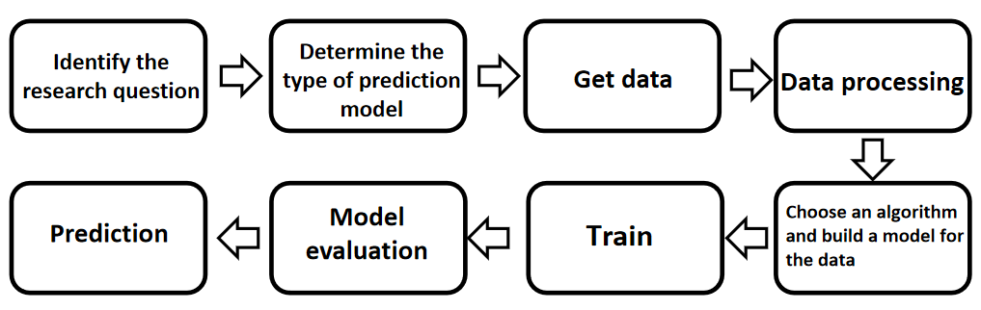
Figure 1 Schematic diagram of the prediction process

2.2 Data Preprocessing
In general, the original data in the database is relatively large, and most of the original data has not been processed, they may have some incomplete, containing noise and other problems, the database may exist problems include outdated or redundant fields, missing values, outlier values, and values inconsistent with the policy or common sense. Therefore, in order to carry out data mining effectively, data needs to be preprocessed.

2.2.1 Data Cleaning
In the process of training the model, we should remove useless data as much as possible, which is conducive to improving the accuracy. Data cleaning is to filter out those data that do not meet the requirements. The process of re-checking and verifying data is data cleaning, which needs to clear the duplicate and redundant information, correct the wrong information and ensure the consistency of the data, so that we will have a better quality of the data. Data that needs to be cleaned is generally unnecessary, incorrect, missing, and abnormal data.

- Check the consistency of data

Consistency check is based on the reasonable value interval for each variable, and the correlation between variables to test the consistency of the data. In this process, we need to find data that is outside the normal range, data that is unrealistic in real life, and data that contradicts other variables. For example, height is a negative number, and variables measured using a 1-8 scale have a value of 0, which are considered to be outside the threshold of the normal range.

- Deal with invalid values and outliers of the data

In the data, there will be invalid values and outliers, possibly because of survey, coding, and input errors during the collection of the data, at which point the data needs to be properly processed. Abnormal data is generally divided into error value and outlier value, we should pay attention to these data, and combined with the analysis of the cause of the exception to deal with these data. Outliers can be identified by statistical analysis. The simplest way to deal with outliers is to delete them directly, or to retain them for the time being and then conduct comprehensive analysis in combination with the overall model.

2.2.2 Feature selection
In the actual modeling process, the data characteristics in the learning task will determine the upper limit of the model in most cases. When there are too many sample numbers, data analysis will easily lead to dimensional disasters, making the data trained in the analysis process take too long, or redundant fields will affect the accuracy of the model, resulting in errors. There are three methods for feature selection, namely filter type, package type and embedded type.

In this paper, the Spearman Rank correlation coefficient and non-parametric test method in the filter are mainly used for feature selection.

- Spearman Rank correlation coefficient

Spearman Rank correlation coefficient is a statistical index that reflects the close relationship between two variables. Spearman Rank and Pearson differ in their requirements on data conditions. Spearman Rank has lower requirements on correlation coefficient, which does not require linear relationship between variables or normal distribution of variables as a whole. Spearman correlation coefficient is calculated and solved according to the position order of the original data.

Spearman Rank correlation coefficient is defined as:
$$\begin{aligned}ρ_{s}=1−\frac{6\sum{d_{i}^{2}}}{m\left(m^{2}−1\right)}\#（1）\end{aligned}$$
Where, $m$ is the number of data and represents the rank difference of variables.$d_{i}$Its calculation process: the two variables X and Y are sorted, the sorted position information value is called the rank, the difference of the rank is $d_{i}$, the number of values is denoted as $m$, and finally the above formula is substituted for calculation.

- Non-parametric test

In actual production, the differences between the mean values (or distributions) of multiple groups of independent data are often compared, but the actual data is difficult to conform to normality and is basically biased, so it is difficult to use parameter test for analysis. As a Kruskal-Wallis test that does not have much requirement on sample distribution, it is a test that generalisates two independent samples Wilcoxon(Mann-Whitney) to three or more groups.

The null hypothesis for the test of whether the distribution is the same can be set as $H_{0}:F_{1}(x)=F_{2}(x)=...=F_{k}(x)$, where$k$ is the number of independent samples, $F$ is the meaning of the distribution function, then $H_{1}$at least two of the alternative hypotheses are not equal, and the same $H_{0}:F_{1}(x)=F_{2}(x)=...=F_{k}(x)$ is true for the null hypothesis of the positional parameters (mean, median, etc.). Then we will construct relevant statistics, specifically refer to reference [10], and finally make decisions. For large samples and small samples, the distribution of statistics is different by looking up the table. For large samples, $H$approximate obedience ${}^{2}\left(k−1\right)$can be obtained, while for small samples, the table can be directly looked up, and the decision value or $p$ value is used to determine whether to reject or accept the null hypothesis.

There are also many other methods, such as embedding method: embedding method allows the algorithm to select the desired features on its own. That is, after the algorithm is trained, each feature will receive a weight value, which can be printed out, set a threshold, and select features with weights greater or less than the threshold. The larger the weight, the greater the impact of this feature on the model. These weight coefficients usually indicate that features have a certain contribution or significance in the model, but this method is not used in this article and can be used as an understanding.

2.3 Data mining algorithm
This modeling will use LR, XGB, DNN and LSTM related algorithms for correlation. In order to have a deeper understanding of the underlying model, we will introduce relevant theories on the underlying algorithm below.

2.3.1 Logistic regression model
The LR model is a classic linear regression model, in which the probability of the dependent variable taking a value of 1 is $p=P(y=1|X)$, and the probability of taking a value of 0 is$1−p$. We establish a logistic regression transformation:
$$Logit\left(p\right)=ln\left(\frac{p}{1−p}\right)=z (1)$$

Regression is established for formula (1) under independent variables:$px_{1},x_{2}…x_{p}$
$$Logit\left(p\right)=ln\left(\frac{p}{1−p}\right)=β_{0}+β_{1}x_{1}+…+ β_{p}x_{p}+ε (2)$$

(2) $ε$is the interference term, because the value range of $ln\left(\frac{p}{1−p}\right)$ is $\left(−∞,+∞\right)$ ,the $x_{p}$ value is arbitrary. We put the actual values and calculated values into (2), and by establishing a system of equations combined with least squares or gradient descent algorithms, it can be estimated that $β_{p}$ and $ε$ value.

2.3.2 Xgboost Model
XGB is suitable for large-scale sparse data and has the advantages of fast computing speed and high accuracy. XGB is suitable for large-scale sparse data and has the advantages of fast computing speed and high accuracy. It supports the selection of a variety of weak learner models, and also adds L1 and L2 regularization terms, which can prevent overfitting and have stronger generalization ability [11].

The objective function of XGB consists of loss function and XGB is a forward iterative model for training multiple trees. For the first tree, the first sample, the model predicts:
$$\begin{aligned}{{\hat{y}}_{i}}^{\left(t\right)}=\sum_{k=1}^{t}{f_{k}\left(x_{i}\right)}={\hat{y}}_{i}^{\left(t−1\right)}+f_{t}\left(x_{i}\right)\#\left(1\right)\end{aligned}$$
Where${{\hat{y}}_{i}}^{\left(t\right)}$ is the prediction result of the sample after the first iteration, the model prediction result of the $f_{t}\left(x_{i}\right)$T-th tree, and ${\hat{y}}_{i}^{\left(t−1\right)}$is the prediction result of the $t−1$tree. Further, we can get our original objective function as follows:
$$\begin{aligned}Obj=\sum_{i=1}^{n}{l\left(y_{i},{\hat{y}}_{i}\right)+\sum_{j=1}^{t}{{Ω(f}_{j})}}\#\left(2\right)\end{aligned}$$
Where $l\left(y_{i},{\hat{y}}_{i}\right)$is the loss function of the model, ${\hat{y}}_{i}$is the predicted value of the entire model for the $i$ th sample, ${\hat{y}}_{i}$is the true value of the first sample, $\sum_{j=1}^{t}{{Ω(f}_{j})}$is the sum of the $t$complexity of all trees, as the regularization term in the function.
After splitting the regular term, it is as follows:
$${Obj}^{(t)}=\sum_{i=1}^{n}{l\left(y_{i},{\hat{y}}_{i}^{\left(t\right)}\right)+\sum_{j=1}^{t}{Ω\left(f_{j}\right)}}$$
$$=\sum_{i=1}^{n}{l\left(y_{i},{\hat{y}}_{i}^{\left(t−1\right)}+f_{t}(x_{i})\right)+\sum_{j=1}^{t}{Ω\left(f_{j}\right)}}$$
$$\begin{aligned}=\sum_{i=1}^{n}{l\left(y_{i},{\hat{y}}_{i}^{\left(t−1\right)}+f_{t}\left(x_{i}\right)\right)+Ω\left(f_{j}\right)+constant}\#\left(3\right)\end{aligned}$$

To make a simplification without changing the accuracy of the objective function, next, we need to use Taylor series to approximate the expansion of the objective function, the goal is to extract the constant term. Taylor's formula is used to expand the original formula in the second order, and the result is:

$$\begin{aligned}l\left(y_{i},{\hat{y}}_{i}^{\left(t−1\right)}+f_{t}\left(x_{i}\right)\right)=l\left(y_{i},{\hat{y}}_{i}^{\left(t−1\right)}\right)+g_{i}f_{t}\left(x_{i}\right)+\frac{1}{2}h_{i}f_{t}^{2}\left(x_{i}\right)\#\left(4\right)\end{aligned}$$
Where, $g_{i}$the corresponding is the first derivative of the loss function, which $h_{i}$is the second derivative. Furthermore, the expansion formula of the objective function can be obtained as follows:
$$\begin{aligned}{Obj}^{\left(t\right)}≈\sum_{i=1}^{n}{\left[l\left(y_{i},{\hat{y}}_{i}^{\left(t−1\right)}\right)+g_{i}f_{t}\left(x_{i}\right)+\frac{1}{2}h_{i}f_{t}^{2}\left(x_{i}\right)\right]+Ω\left(f_{t}\right)+constant}\#\left(5\right)\end{aligned}$$

The optimization of the model is actually to find the parameters, so the next step must be to parameterize the tree model.

The complexity of the tree includes the weight of the leaf nodes, and the RE is to sparse the weight and make the model simpler. The complexity of the tree is as follows:
$$\begin{aligned}Ω\left(f_{t}\right)=γT+\frac{1}{2}λ\sum_{j=1}^{T}{ω_{j}^{2}}\#\left(6\right)\end{aligned}$$
Where λ and ω are hyperparameters, $T$ are the number of leaf nodes of the current tree, and $ω_{j}^{2}$are the$L_{2}$ norm of leaf node values. Parameterize the tree and bring it into the objective function:
$${Obj}^{\left(t\right)}≈\sum_{i=1}^{n}{\left[f_{t}\left(x_{i}\right)+\frac{1}{2}h_{i}f_{t}^{2}\left(x_{i}\right)\right]+Ω\left(f_{t}\right)}$$
$$=\sum_{i=1}^{n}{\left[g_{i}ω_{q}\left(x_{i}\right)+\frac{1}{2}h_{i}ω_{q}^{2}\left(x_{i}\right)\right]+γT+\frac{1}{2}λ\sum_{j=1}^{T}{ω_{j}^{2}}}$$
$$=\sum_{j=1}^{T}{[(\sum_{i∈I_{j}}{g_{i}})ω_{j}}+\frac{1}{2}(\sum_{i∈I_{j}}{h_{i}}+λ)ω_{j}^{2}]+γT (7)$$

Where, is the sum of the first derivative of the samples contained in leaf node j, and is the sum of the second derivative of the samples contained in leaf node J.$G_{j}=\sum_{i∈I_{j}}{g_{i}}H_{j}=\sum_{i∈I_{j}}{h_{i}}j$For this objective function, we only need to take the $ω_{j}$derivative and use greedy algorithm to achieve feature splitting.

2.3.3 Deep neural network model
DNN is an algorithm that uses error back propagation of measurement data. A DNN network consists of an input layer, one or more hidden layers and an output layer. This method is a supervised learning algorithm. The specific method of this algorithm is to minimize the sum of squared errors of the output layer by adjusting the weight and threshold of the network, that is, to make the predicted data approximate the expected value as correctly as possible [12,13].The topology diagram is as follows:
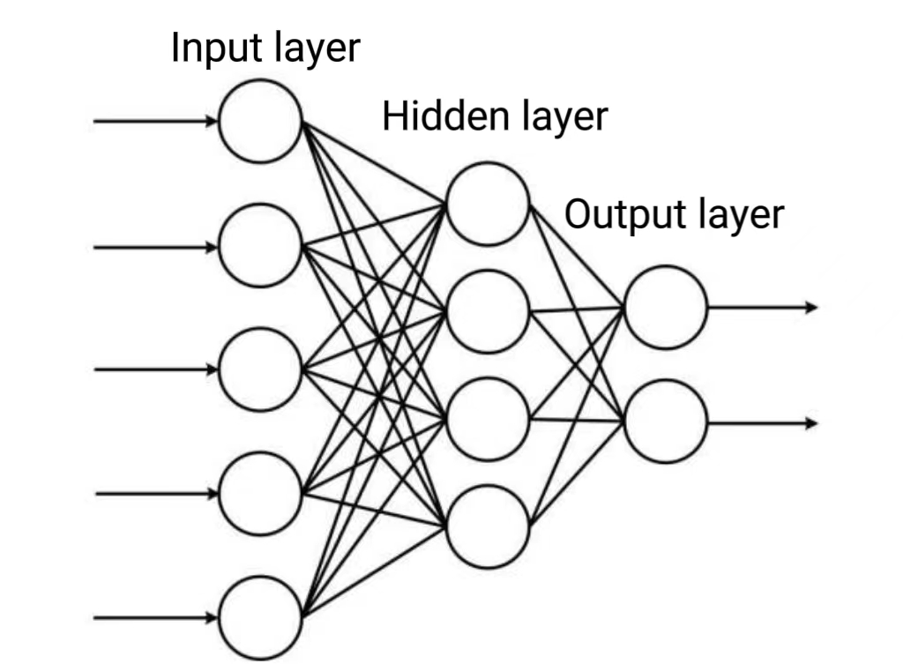
Figure 2 Topology of DNN

The specific steps of the algorithm model are as follows: when defined $n$as the number of neurons in the input layer, $p$ the number of neurons in the hidden layer, and $q$ the number of neurons in the output layer, there are eight steps as follows:

Step P1: Initialize the network. Each connection weight is given a standard normal distribution random number,$e$error function is set, calculation precision value and $M$ maximum learning times are given.
Step2: Randomly select the first$k$ input sample $x\left(k\right)=\left(x_{1}\left(k\right),x_{2}\left(k\right),…,x_{n}\left(k\right)\right)$and the corresponding real output is $d_{o}\left(k\right)=\left(d_{1}\left(k\right),d_{2}\left(k\right),…,d_{q}\left(k\right)\right)$;

Step3: Calculate the input $h_{i_{h}}\left(k\right)=\sum_{i=1}^{n}{w_{ih}x_{i}\left(k\right)−b_{h}(h=1,2,…,p)}$and output $h_{o_{h}}\left(k\right)=f\left(h_{i_{h}}\left(k\right)\right)$of each neuron in the hidden layer and the input$y_{i_{o}}\left(k\right)=\sum_{h=1}^{p}{w_{ho}ho_{h}\left(k\right)−b_{o}\left(o=1,2,…,q\right)}$and output $y_{o_{o}}\left(k\right)=f\left(y_{i_{h}}\left(k\right)\right)f\left(∙\right)$of each neuron in the output layer, where is a nonlinear activation function;

Step4: Use network output and actual output to calculate the partial derivative of the error function to each neuron in the output layer. The partial derivative of the error function to each neuron of the hidden layer is calculated by using the connection weight from the hidden layer to the output layer and the output of the output layer and the hidden layer.

Step5: Use the output of neurons in the output layer and the output of neurons in the hidden layer to correct the connection weight. Use the input of neurons in the hidden layer and neurons in the input layer to correct the connection weight;

Step6: Calculate the global error in $m$ sample
$$E=\frac{1}{m}\sum_{k=1}^{m}{\sum_{o=1}^{q}{{\left(d_{o}\left(k\right)−y_{o}\left(k\right)\right)}^{2}} (8)}$$

Step7: Determine whether the network error meets the requirements. When the error reaches the preset precision or the number of learning times is greater than the set maximum number, the algorithm ends. Otherwise, select the next learning sample and corresponding real output, return to Step3, and enter the next round of learning. So far all the theoretical layers and derivations of the model have been reviewed.

2.3.4 Long and short memory neural network model
After introducing the general DNN model, the understanding of LSTM will be clearer. LSTM is very similar to DNN in many aspects, but the difference is that LSTM is a special type of recurrent neural network (RNN) with memory unit and gating mechanism. The core idea of LSTM is to control the flow of information through a gated unit to solve the problem of gradient disappearance and gradient explosion in traditional RNN [14,15,16]. The following is the network structure diagram of traditional RNN:
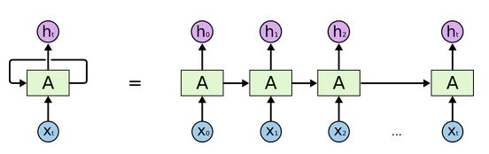
Figure 3 RNN network diagram

From Figure 3, assuming $X_{t}∈R^{n∗x}$that it is the first $t$batch input in the sequence (here $n$is the number of samples, $x$ is the sample feature dimension), corresponding to the hidden layer state $h_{t}∈R^{n∗h}$ ($h$is the hidden layer length), and the final output $Y_{t}∈R^{n∗y}$ ($y$is the output vector dimension, that is, how many elements the output vector contains!) . Then at the $t$ time of calculation $h$, there is the formula:
$$h_{t}=φ\left(X_{t}W_{xh}+h_{t−1}W_{nh}+b_{h}\right) (1)$$
Here $φ$ is a specific activation function, $W_{.,.}$is the weight to be learned, $b_{.}$ is the deviation value to be learned, then the output result is:
$$o_{t}=φ\left(h_{t}W_{yh}+b_{y}\right) (2)$$

Then the optimization of parameters is also realized based on the derivation of chain rule and gradient descent algorithm. Then for the LSTM model based on gate theory, the specific internal structure is shown as follows:
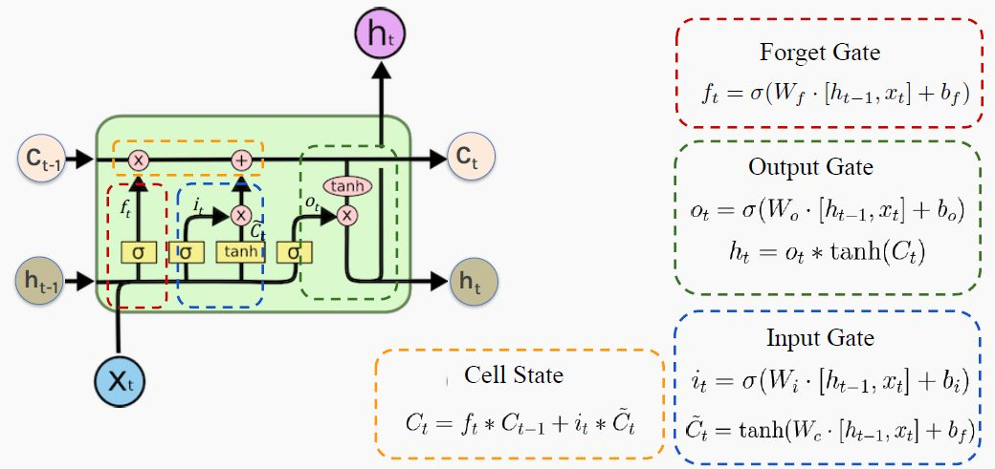
Figure 4 LSTM core theory diagram

The so-called "gate" structure is the ability to remove or add information to the cell state. Here the cell state is the core, it belongs to the hidden layer, similar to the conveyor belt, running throughout the chain, the information circulating on the above will remain unchanged will become easy, through the "three-gate structure" can finally complete the update of the cell value $C_{t}$, so as to obtain the next hidden layer value. When the activation function $φ$ selects a function whose sigmoid belongs to 0~1, the forgetting gate is approximately equal to 1, and the input gate is approximately equal to 0, which $C_{t}$is not updated, then the past cell information has been retained until now, solving the problem of gradient dissipation. Similarly, the output gate can be approximately equal to 1, or it can be approximately equal to 0, then the cell information will be passed to the hidden layer when it is approximately equal to 1; At approximately zero, cell information is kept to itself. At this point all the parameters are updated and continue down, so that the bottom of the LSTM model is complete.

2.4 Evaluation criteria
The problem studied in this paper is binary classification, so the binary classification is taken as an example here. The prediction results in binary classification problems may occur in the following cases: a point belongs to the positive class, and if it is predicted to the positive class, it is called true positive (TP); If a point belongs to the negative class, but it is predicted into the positive class, it is called false positive (FP);A point belonging to a negative class is called true negative (TN) if it is predicted to be in a negative class; If a point belongs to a positive class, but it is predicted into a negative class, it is called a false negative class (FN).The results are shown in Table 1 as the confusion matrix.

Table 1 Confusion matrix
True value | Predicted value
 | 1 | - 1
1 | True Class (TP) | Pseudonegative class (FN)
- 1 | False positive class (FP) | True negative class (TN)

(1) Accuracy represents the total percentage of predictions that are correct:

$$\begin{aligned}Accuracy=\frac{TP+TN}{TP+FP+FN+TN}\#（1）\end{aligned}$$

(2) Recall represents the proportion that is predicted correctly in the actual positive class;
$$\begin{aligned}Recall=\frac{TP}{TP+FN}\#（2）\end{aligned}$$

(3) Precision refers to the proportion of predictions that are correct in the positive category:
$$\begin{aligned}Precision=\frac{TP}{TP+FP}\#（3）\end{aligned}$$

(4) F1 score (F1-score) is calculated by accuracy and recall, which is equivalent to a comprehensive evaluation of the two results.

$$\begin{aligned}F1=\frac{2}{\frac{1}{Prcision}+\frac{1}{Recall1}}\#（4）\end{aligned}$$

(5) The value of AUC is the area under the receiver operating characteristic curve (ROC), and the horizontal coordinate of the ROC curve is False Positive Rate (FPR).True Positive Rate, TPR: True positive rate, TPR:

$$\begin{aligned}TPR=\frac{TP}{TP+FN}\#（5）\end{aligned}$$
$$\begin{aligned}FPR=\frac{FP}{FP+TN}\#（6）\end{aligned}$$

The ROC curve is obtained by continuously adjusting the threshold of binary classification and connecting the coordinates (TPR, FPR) under different thresholds. The area under the ROC curve is the value of AUC.

2.5 Summary of this chapter
This chapter mainly introduces the process of prediction model, the method of data preprocessing, the algorithm summary and theory of LR, XGB, DNN and LSTM, and the principle and meaning of model evaluation index. It includes data preprocessing methods for data cleaning and feature selection, principles and meanings of indexes such as confusion matrix, accuracy rate and precision rate.

3.The characteristics of breach of contract

3.1 Description of data attributes
The research data for this article comes from the customer default dataset published on the UCI website, which has a total of 24 fields, including ID, gender, age, education, marital status, past repayment status, past repayment amount, etc. Where the target variable is whether there is a default on the next repayment date. The modeling data set involves a total of 30,000 data, the specific fields are listed in the following table 2:
Field name | Field type | Field description
id | int | ID
LIMIT_BAL | int | Line of Credit (NT $)
gender | int | Gender, 1: female;2: Male
EDUCATION | int | Level of education, 1= Graduate school;2= university; 3= high school; 4= other
MARITAL STATUS | int | Marital status, 1= married;2= single; 3= other
AGE | int | age
history of past payment | int | History of past payments, many months, -1= on-time payments;1= one month delay in payment; 2= two months delay in payment; 8= eight months delay in payment; 9= Payment delay of 9 months or more
amount of bill statement (NT dollar) | int | Bill amount (NT $), many months
amount of previous payment (NT dollar) | int | Last payment amount (NT $), many months
default payment next month | int | Default on next month's repayment, 0= no default;1= default
Table 2 Field description
The id is the encoding of the data record. The data is meaningless and invalid. Therefore, delete the id field first.

3.2 Data visualization analysis
Visual analysis is a necessary process of data analysis, and when data visual analysis is performed, a variety of tools and techniques can be used to transform the data into charts, graphs, or other visual forms in order to better understand and interpret the data.

3.2.1 Basic Data Analysis
The basic data here mainly include LIMIT_BAL, SEX, EDUCATION, MARITAL STATUS, AGE, default payment next month, etc. Since LIMIT_BAL and AGE are continuous data, So fiddle them and observe the distribution:
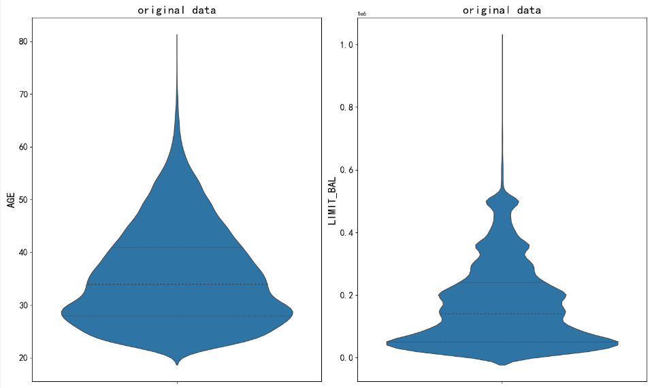
Figure 5 LIMIT_BAL, AGE violin diagram
Through distribution observation, it is found that most of the AGE distribution is between 25 and 45, that is, there are many young people, under 18 years old can not participate in loan service, but above 65 years old is also difficult to participate in loan service, fortunately, these samples account for a small proportion. Therefore, from the practical point of view of distribution, there may be some older data that do not meet the reality. The LIMIT_BAL distribution is mainly between 5e4 and 5e5. However, due to its obvious trailing phenomenon, the LIMIT_BAL distribution is abnormally large. The follow-up of outliers needs to be further processed, otherwise it will have a great negative impact on the model.

Then, observe the distribution of discrete basic data. The first is the pie chart distribution of default payment next month, as shown in Figure 6 below:
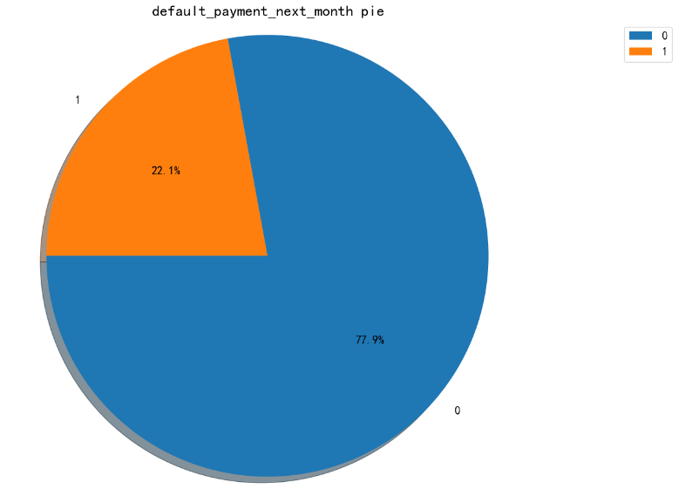
Figure 6 Default payment next month Pie
From the perspective of default rate, we find that the expected number of people accounts for about 20%, which is a normal proportion, after all, in reality, the normal number of trustworthy people still occupy the majority.

From the gender composition of this group, the number of women is greater than the number of men, about 6:4 ratio, as shown in Figure 7 below:
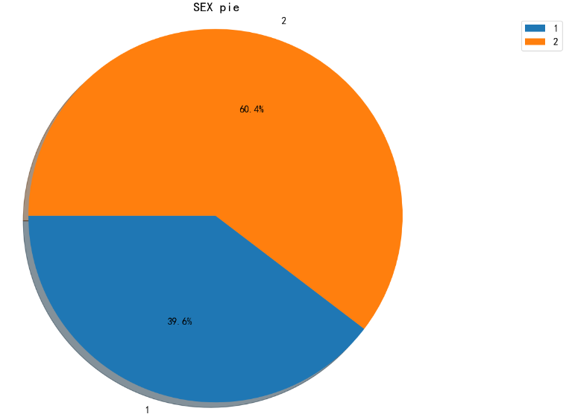
Figure 7 SEX Pie
For the distribution of the number of people in the education level, we draw the following histogram:
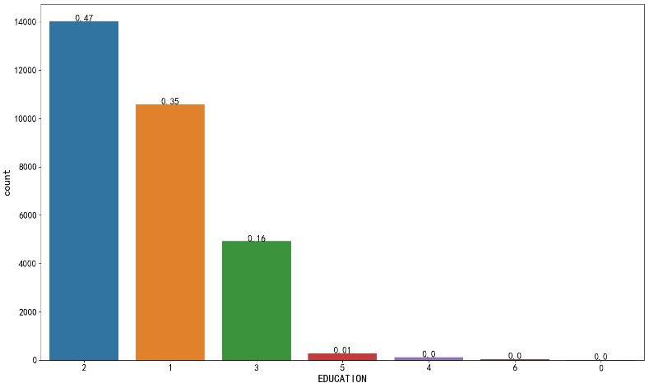
Figure 8 Distribution of EDUCATION in the bar chart
From the perspective of the education level of this group of people, most of them have undergraduate and postgraduate education, up to more than 80%, that is, the overall education level of the population is quite high, but through the bar chart, it is found that there are very few people with education levels 0 and 6. In order to prevent the occurrence of anomalies to interfere with the modeling, it is recommended to delete the groups with levels 0 and 6.

Finally, we observe the distribution of MARITAL STATUS:
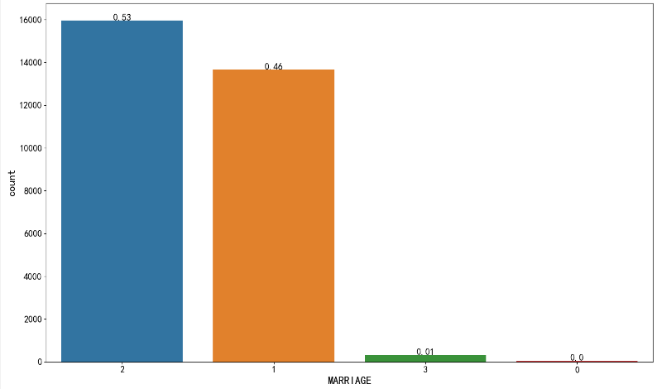
Figure 9 MARITAL STATUS histogram distribution

From Figure 9, it is found that the MARITAL STATUS of this group is single, which accounts for more than 50%, but the number of married people is also quite a lot, up to 45%. Therefore, most of the MARITAL STATUS of this group is normal, but there are also other marital status, which accounts for a very small proportion. There are a very few states of 0, we are also regarded as abnormal people, directly delete.

3.2.2 Behavior data analysis
Through the above basic data analysis, we have a comprehensive understanding of the outline information of this group of people, which is of great help to business understanding and modeling understanding. Then we visually analyze behavioral data such as history of past payment, amount of bill statement, amount of previous payment, etc. The first is a diagram showing the distribution of past payments:
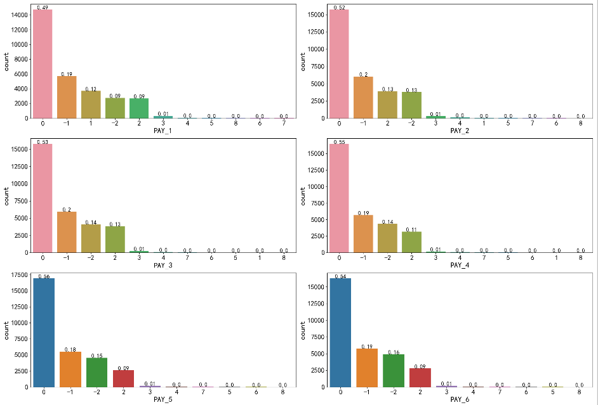
Figure 10 Bar chart of history of past payments

From the distribution of the bar chart 10, we find that in the past 6 months of tracking (the larger the number, the longer the tracking month), in general, the proportion of people who repay on time still accounts for the vast majority. Some people may default once in nearly one month of tracking, twice in nearly two months of tracking, and so on, so the longer the tracking time, The proportion of possible defaults more than once will increase.

Then, the amount of bill statement is shown in the distribution density diagram, and the following results are obtained:
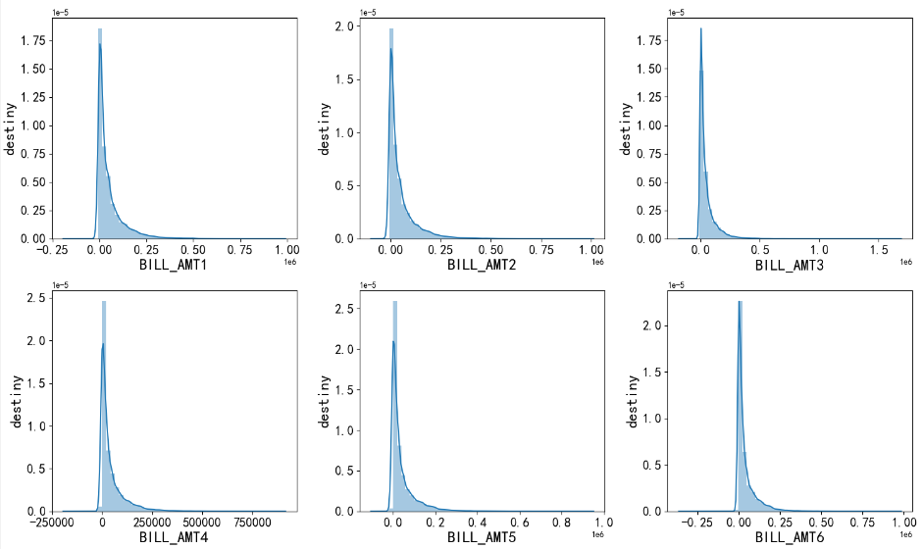
Figure 11 Distribution density of the amount of bill statement

It can be found from Figure 11 that there are a lot of long-tail phenomena in this index, that is, there are a small number of outliers in each variable. Similarly, the distribution density of amount of previous payment can be observed as follows:
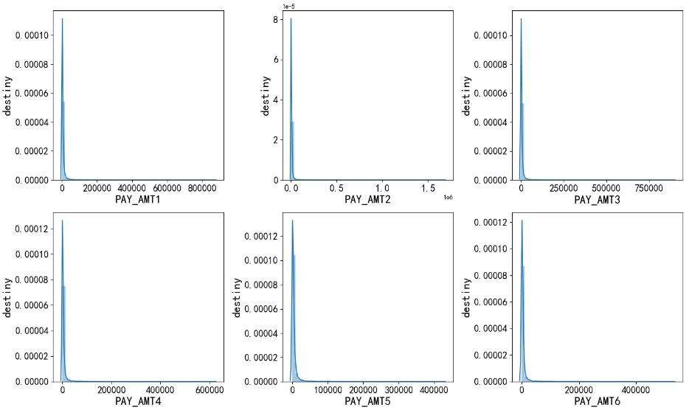
Figure 12 Distribution density of amount of previous PAY_AMT

It can be found from Figure 12 that the long-tail distribution of such data is more serious than the amount of bill statement. In summary, we need to process the outliers of the modeling samples based on a series of kernel density display results, otherwise these severely trailing data will be put into the modeling data, resulting in negative overfitting of the model.

3.3 Data outlier processing

3.3.1 Isolated forest algorithm removes outliers
Isolation Forest is a machine learning algorithm for detecting and removing outliers. The general steps of isolated forest model modeling are as follows [17,18] :

1: Import necessary libraries, such as Isolation Forest classes and other data processing libraries in scikit-learn. Load the data set and perform necessary data preprocessing, such as missing value processing, data conversion, etc.

2: Anomaly detection, create an Isolation Forest object, and set relevant parameters, such as n_estimators (the number of trees in the forest) and contamination (estimation of the proportion of outliers).fit the Isolation Forest model to the data set using the fit() method. Use the predict() method to predict the outlier value score for each sample (-1 for abnormal, 1 for normal), and sort or select thresholds according to the score to determine which samples are considered outliers;

3: Outlier processing. According to the result in Step 2, you can choose to delete the outlier from the data set. Deleting the outlier may affect the performance and results of the model, so it needs to be handled with caution.

4: Build models, use data sets processed by outliers to build machine learning models, select appropriate model types and algorithms, such as regression, classification or clustering, according to specific problem requirements.
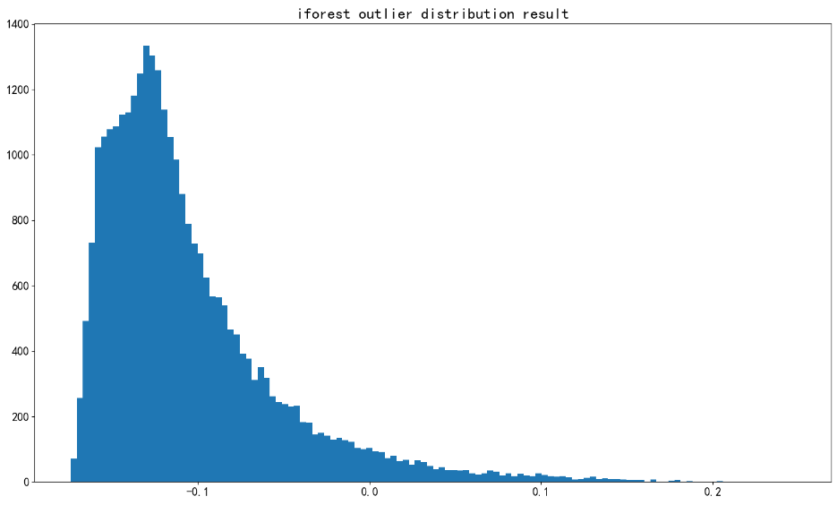
Figure 13 Outlier test results of isolated forest
For this outlier test, we set the proportion of outliers to 5%, based on data with few discrete labels removed. The final threshold distribution is shown in Figure 13, and it is found that threshold values greater than 0 are outliers, with a total of 1498 and 28,387 normal samples. Then, for the outlier processing results, we observe the distribution density diagram of continuous variables:
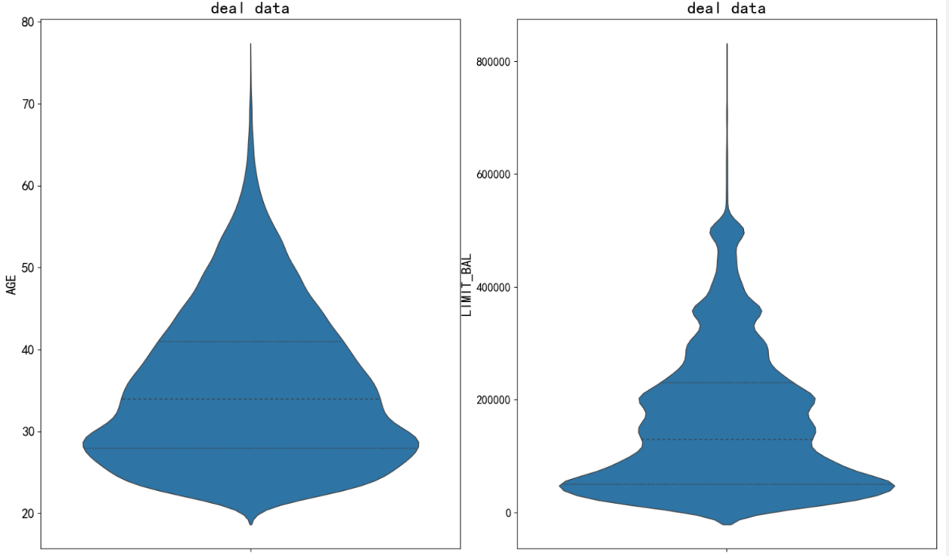
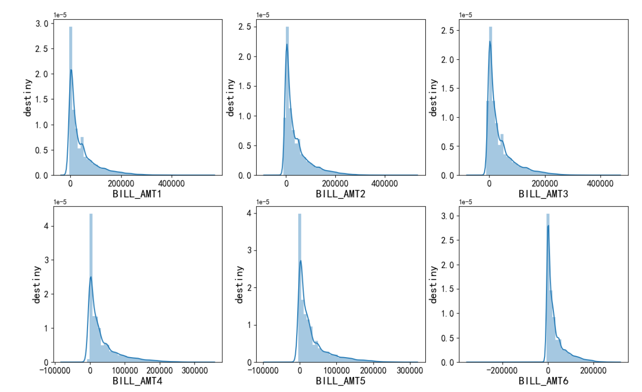
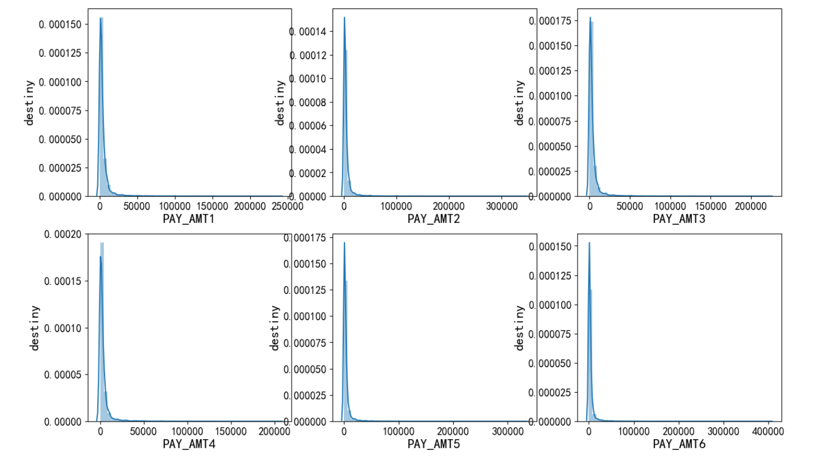
Figure 14 Continuous data distribution after isolated forest outlier processing
From the group of figures 14, we found that after outlier screening, the extreme value processing of continuous data is still relatively obvious, such as PAY_AMT5, which has a trailing value of 400000 before processing, and a trailing value of 300000 after processing, and those older than 80 years old are also excluded. After all, isolated forest is a global idea to remove anomalies. It may not be completely accurate to a single factor, so for a single factor that still has an exception, further processing is needed.

3.3.2 Single factor logic removes outliers
According to the rule of thumb, it is impossible for the normal repayment amount to be negative, so it is necessary to further calculate the amount of bill statement and the amount of previous payment to keep their values within a reasonable range. The setup logic here is:

1: All amount values must be $≥0$, if there are less than 0 then set to 0;

2: The upper limit of all monetary values$≤mean\left(s\right)+n∗sig(s)$, where$s$ is the self-vector-value. Since we have eliminated extreme anomalies in isolated forests, it is reasonable to use the Laida criterion for single factors again. Finally, we draw the distribution density diagram of processing results:
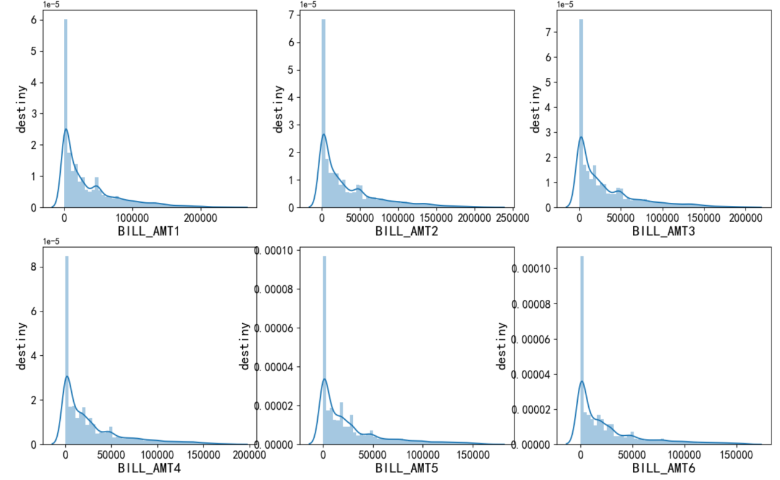
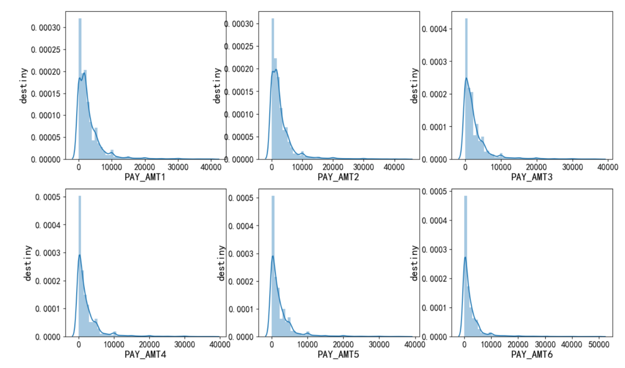
Figure 15 Continuous data distribution after single-factor outlier processing

Figure 15 shows the continuous variable distribution results after isolated forest and then single-factor outlier processing. From the results, we find that the data distribution has been greatly improved, and the long tailing phenomenon almost does not exist, which provides a good data basis for the following modeling.

After processing outliers, we want to keep the sample label from changing too much, otherwise it is overprocessing, so we give the pie chart:
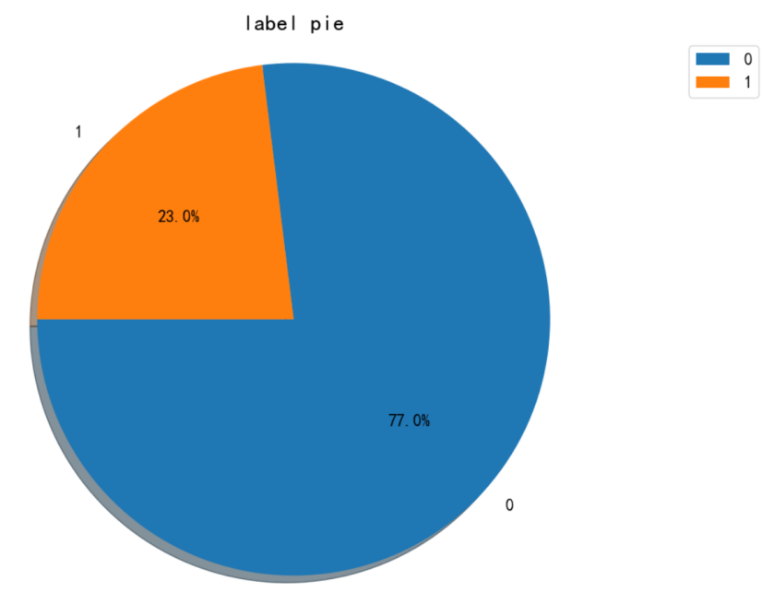
Figure 16 Distribution of target labels after outliers are processed

As can be seen from the figure above, the proportion of different labels in the population is basically consistent with the original value (22.1% : 77.9% in the original value), and the treatment of outliers has not significantly changed the distribution of labels in the population, and the treatment is still reasonable.

3.4 Feature and target variable analysis

3.4.1 Relationship between basic information and target variables
The basic information involved in this paper is LIMIT_BAL, SEX, EDUCATION, MARITAL STATUS and AGE. The basic information of the population also has some influence on the performance of the default rate. Firstly, observe the performance of gender, EDUCATION and MARITAL STATUS on the target variables:
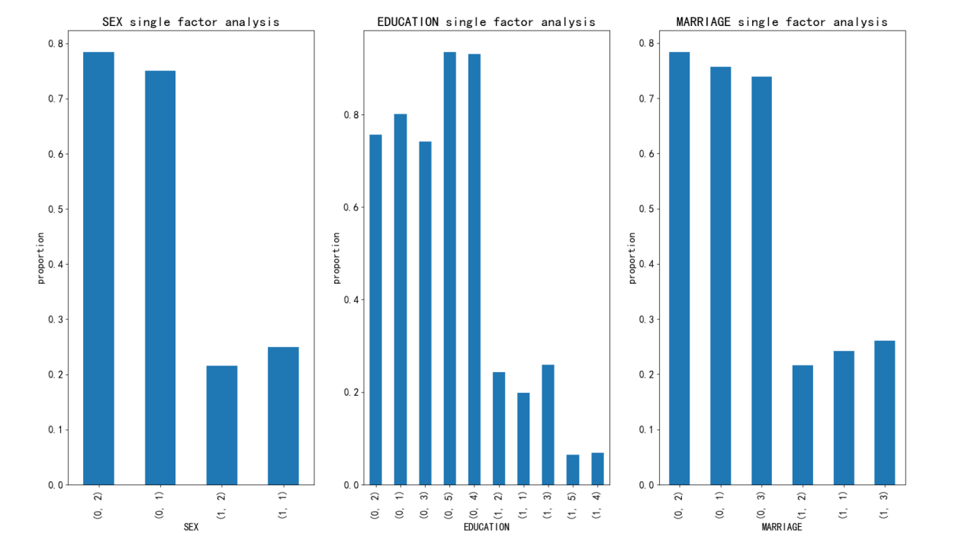
Figure 17 Relationship between SEX, EDUCATION, MARITAL STATUS and target variables

From the figure above, we find that both women and men account for more than 20% in their own population. According to the internal statistics of gender, the level of default of women is slightly higher than that of men, which may be because women's economic ability is slightly lower than that of men in general. Therefore, gender difference still has a certain impact on the impact of target variables. Similarly, by observing the impact of education level on target variables, we find that the default level of high school students is higher than that of universities and graduate students, and the default level of universities is also higher than that of graduate students, indicating that with the improvement of education level, the default rate of the population has a downward trend. Finally, we observe the influence of marital status on the target variables, and we find that the default rate of single people is the lowest, followed by married people, and the highest among people with other conditions. This indicates that the simpler the marital status of a group, the higher the default rate, which may be related to family economic pressure.

Next, observe the horizontal performance of LIMIT_BAL and AGE on the target. Here, we mainly solve the performance of their mean value on the target. Since we have removed abnormal data, it is reasonable to solve the mean value, as shown in the figure below:
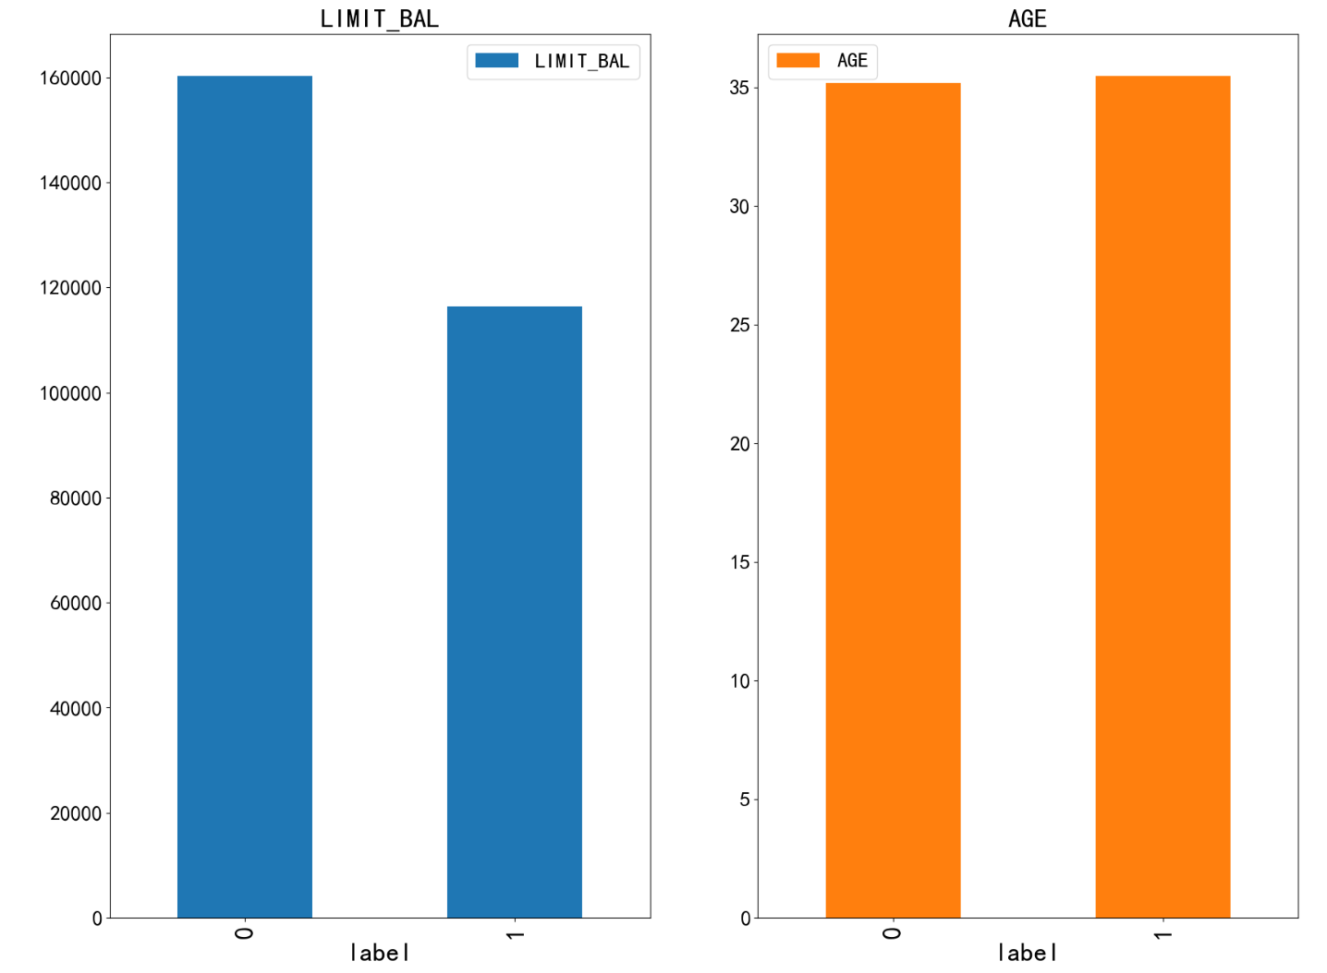
Figure 18 Relationship between LIMIT_BAL, AGE, and target variables

From the bar chart above, we can find that the LIMIT_BAL average performance is obviously differentiated in different categories. For defaulters, the LIMIT_BAL average level is significantly lower than that of non-defaulters. It seems that once a default occurs, the credit limit will be damaged. If we look at the average age of different groups, we find that there is almost no difference, which means that default does not have much to do with age, and default can occur at any age.

3.4.2 Relationship between amount level and target variable
For the PAY, BILL_AMT, and PAY_AMT metrics, we also plot a bar chart of the mean across different populations, as shown below. The first is PAY, as shown in Figure 19 below:
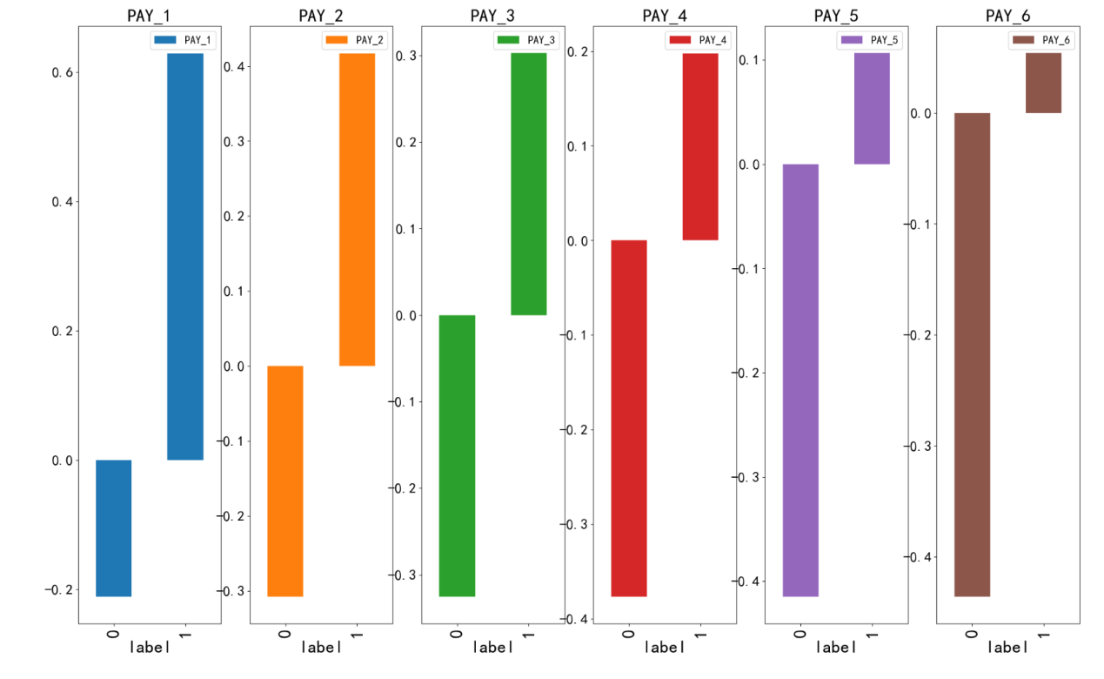
Figure 19 Relationship between PAY and target variable

It is obvious from the above set of figures that the average PAY level of each month is very differentiated among different groups of people. For defaulters, the average level of each PAY is greater than 0, while for non-defaulters, the average level of each PAY is less than 0. It seems that the historical default situation has a great influence on the future default situation.
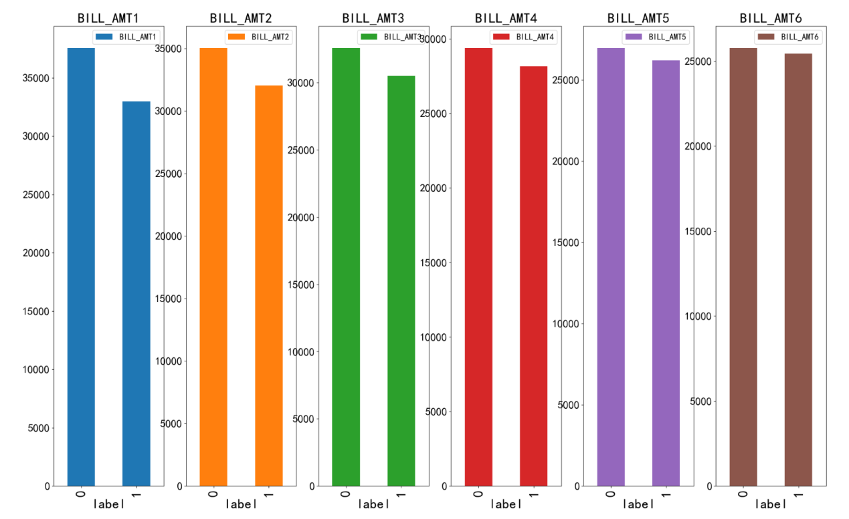
Figure 20 Relationship between bill and target variables

Similarly, we observe the performance of bill level in different groups in each month, and we find that the longer the traceability time, the level of repayment bill in different groups is similar. The closer the repayment is, the higher the bill level of the non-defaulting group is than that of the defaulting group, which is likely to be due to the increase in risk exposure of the defaulting group over time. So the amount will be limited, and naturally the bill level will go down.
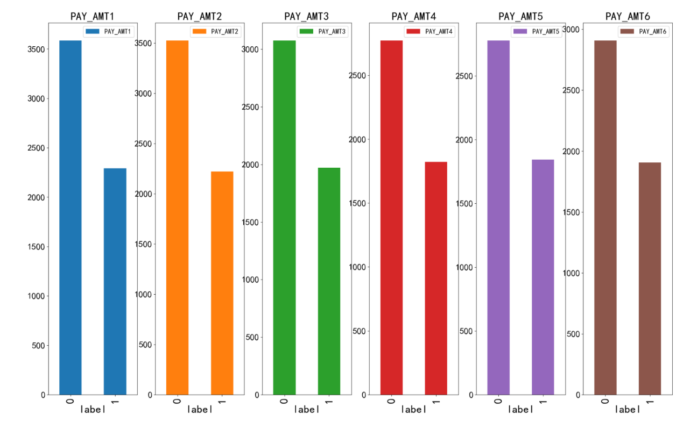
Figure 21 Relationship between PAY_AMT and target variables

Finally, we observe the performance of repayment ability in different months on different groups, and we find that no matter in the past month, the repayment ability of non-defaulters is greater than that of defaulters, so the repayment ability is an important reference factor for risk control and interception of defaulters.

3.4 Summary of this chapter
This chapter mainly preprocesses the default data set, and then makes an exploratory analysis of the processed data. Combine statistical information and visualization of features to remove outliers. Univariate analysis, exploratory analysis between features and labels, and multivariate analysis

4.Predictive analysis based on machine learning model

4.1 Feature selection
After data processing, algorithms should be selected for model construction. The model construction needs to divide and process the data set first. Features can be selected based on correlation between analysis factors, etc.

4.1.1 Divide the data set
After the data preprocessing is completed, there are 25,473 sample data remaining. The data set is divided into the training set and the test set according to 8:2, but random cross-validation will be used to better evaluate the generalization ability of the model. The data set is divided into multiple folds (such as K-folds), one part of which is used each time as the validation set, and the rest as the training set, which is trained and evaluated several times to evaluate the model with more objective results.

4.1.2 Feature selection
In the process of model building, the features we choose sometimes determine the upper limit of the model in most cases. The selection of features can reduce the probability of dimensional disasters, eliminate irrelevant features, retain key elements, reduce the difficulty of learning tasks, and better mine the rules contained in the data itself. There are many methods, we choose the feature selection method using Spielmann rank and random forest-based model.

(1) Spielmann rank correlation analysis. It can check the correlation between features, if the collinearity is too large, it may cause instability of the model, resulting in poor robustness of the model. The correlation threshold is usually set at 0.8, that is, if the absolute value of the correlation between the other two variables is greater than 0.8, one of them is deleted. The correlation levels between the two variables are shown in Table 3.
Table 3 Level of Spielmann correlation coefficient
Absolute value of the correlation coefficient | 0.0-0.2 | 0.2-0.4 | 0.4-0.6 | 0.6-0.8 | 0.8-1.0
Correlation rank | Very weak correlation or no correlation | Weak correlation | Moderate correlation | Strong correlation | Strong correlation

Spearman correlation coefficient was used to calculate the correlation between variables, check the collinearity of feature sizes, and visualize the correlation coefficients between variables in the form of heat maps. Then, the correlation heat map analysis between behavioral data was shown, first of all, the heat map of PAY-related data, as shown in Figure 22:
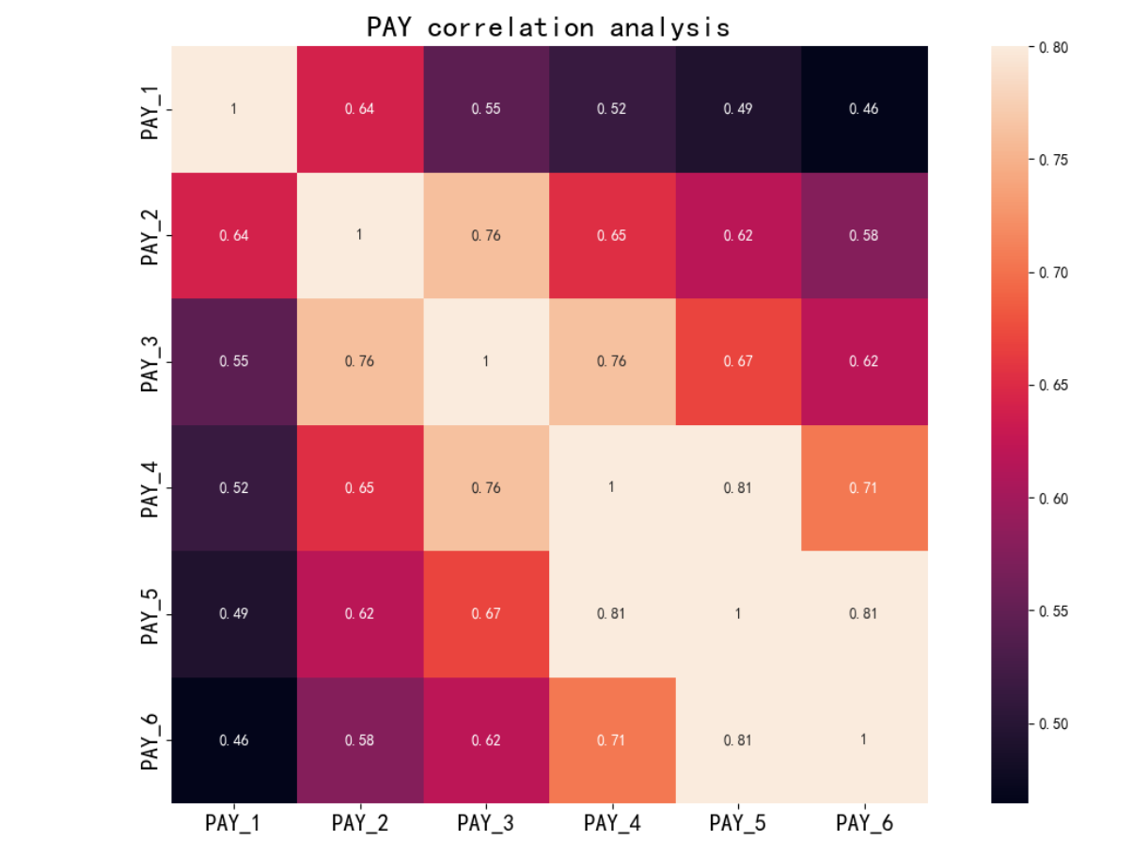
Figure 22 Heat map of PAY variable correlation
It can be seen from the thermal map that the correlation between some variables is relatively strong, but not many. For example, the correlation between PAY_4 and PAY_5, PAY_5 and PAY_6 is higher than 0.81, but the correlation between PAY_4 and PAY_6 is also high, but it has not reached the zero limit. This shows that the longer the traceability time and the two months with similar traceability time, the performance of on-time repayment is similar, so from the collinearity principle, we can only keep PAY_4 and PAY_6 variables. Then observe the correlation between BILL_AMT variables as shown in the following heat map:
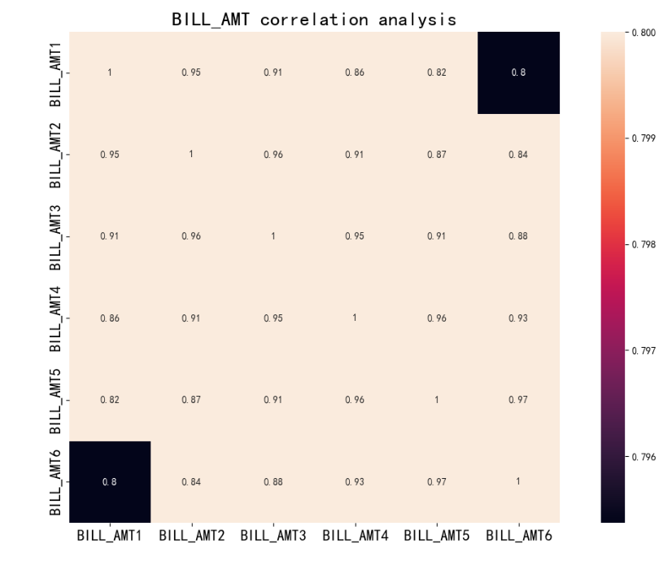
Figure 23 BILL_AMT variable correlation heat map

We found that the correlation between these variables is extremely strong. According to the correlation theory, only BILL_AMT1 and BILL_AMT6 need to be retained. The reason for such strong correlation is that the repayment amount of people may remain basically unchanged every month. Then observe the correlation of the PAY_AMT variable as follows:
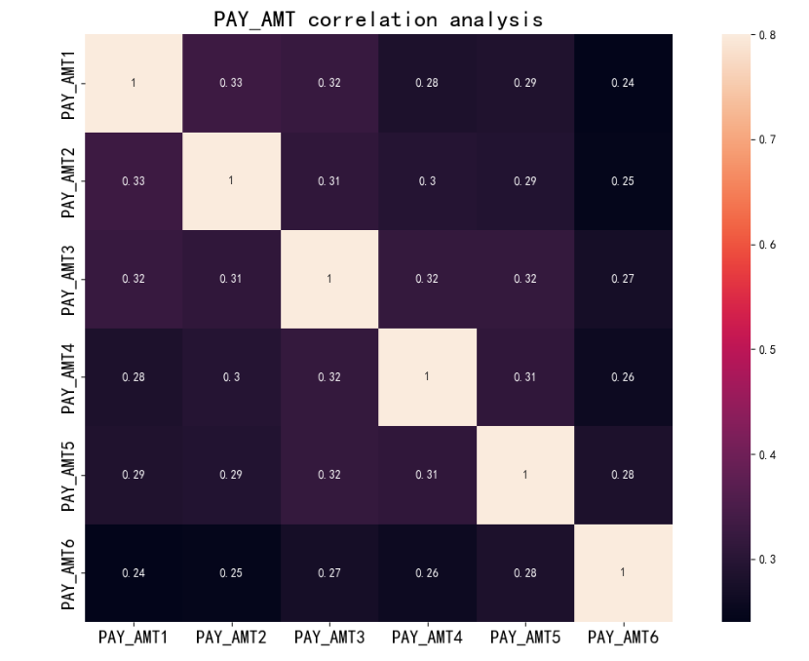
Figure 24 Heat map of PAY_AMT variable correlation

Contrary to BILL_AMT, there is no strong correlation between PAY_AMT data almost every month, so it seems that the repayment performance is different from month to month
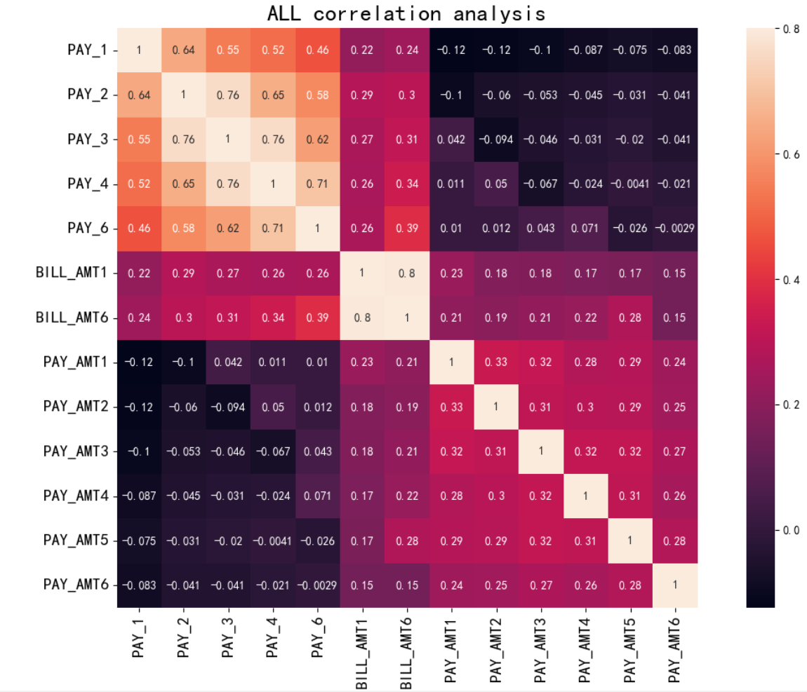
Figure 25 Heat map of residual correlation of behavior variables

From Figure 25, we find that all the remaining behavioral variables no longer have any strong correlation variables, so all can be retained, so we have completed the correlation analysis.

(2) Non-parametric test was used to analyze the significance of variables. Based on the single factor analysis in the previous chapter, we found that some continuous variables actually did not have a substantial effect on the variables. Next, we analyzed from a statistical point of view and theoretically proved which continuous variables really did not have a significant impact on the target variables, and then deleted the non-significant variables for the second dimension reduction. From the visual analysis in the previous chapter, we also found that the distribution shape of these continuous variables does not conform to the normal or common distribution, so it is more reasonable to use non-parametric test. As a Kruskal-Wallis test that does not require much on sample distribution, it is a test that extends two independent samples Wilcoxon(Mann-Whitney) to three or more groups, and can test the difference between the mean (or distribution) of multiple groups of independent data. Next, the correlation test results of the remaining continuous variables are given:
Num | Variable | KW_statistic | P_value
0 | LIMIT_BAL | 728.948929 | 1.516174 e-160
1 | AGE | 0.559803 | 4.543395 e-01
2 | PAY_1 | 2121.779143 | 0.000000 e+00
3 | PAY_2 | 1125.399662 | 9.964831 e-247
4 | PAY_3 | 881.071494 | 1.278495 e-193
5 | PAY_4 | 725.989345 | 6.672608 e-160
6 | PAY_6 | 485.396940 | 1.430194 e-107
7 | BILL_AMT1 | 23.651205 | 1.154736 e-06
8 | BILL_AMT6 | 2.604782 | 1.065418 e-01
9 | PAY_AMT1 | 620.299352 | 6.436493 e-137
10 | PAY_AMT2 | 504.302636 | 1.101061 e-111
11 | PAY_AMT3 | 463.928666 | 6.713569 e-103
12 | PAY_AMT4 | 392.367636 | 2.526062 e-87
13 | PAY_AMT5 | 315.754480 | 1.218110 e-70
14 | PAY_AMT6 | 332.986874 | 2.149071 e-74
Table 4 KW test results of continuous variables

The above table is the display table of the KW test results. From the significance level, the variables AGE and BILL_AMT6 obviously do not meet the test, so it is recommended to delete these two variables again. Through the analysis of the above two steps, we have completed the feature engineering and then started the formal modeling task.$α=0.01$

4.2 Model Prediction
After selecting variables, 15 features are retained. LIMIT_BAL, SEX, EDUCATION, MARRIAGE, PAY_1 PAY_2, PAY_3, PAY_4, 'BILL_AMT1 PAY_AMT1, PAY_AMT2, PAY_AMT3, PAY_AMT4, PAY_AMT5, PAY_AMT6 selection model after using these Features to build models. Based on the research question and the understanding of the data set, we can make it clear that this is a classification problem and the classification model needs to be used. In this experiment, four models were selected, including two machine learning models and two deep learning models. The machine learning model was linear logistic regression model (LR) and nonlinear Xgboost model (XGB), and the deep learning model was DNN (Deep neural network) and LSTM (short and long memory neural network), respectively, to compare the effect analysis of different types of models on modeling.

4.2.1 LR modeling results
We first output the LR modeling results. The LR model is a relatively simple type of model with few parameters involved, mainly as follows:

1. regularization parameter: A logistic regression model can use regularization to control the complexity of the model and prevent overfitting. The regularization parameter can be L1 regularization or L2 regularization, which is used to balance the goodness of fit and complexity of the model.

2. penalty type: The regularization parameter can be L1 or L2 regularization.L1 regularization tends to produce sparse parameter vectors, i.e. some parameters are zero, while L2 regularization tends to make the values in the parameter vectors all small.

3. class weights: Logistic regression can handle unbalanced class distribution. Category weights can be used to adjust the importance of different categories to better handle samples from a small number of categories.

4. intercept: Logistic regression models can include intercept (also known as a bias term), which is used to adjust the position of the decision boundary.

After understanding the parameters and many experiments, we finally determined the appropriate parameters and output the AUC results of random cross-validation (10 random cross-validations) of the training set and test set to observe whether the model has overfitting phenomenon:
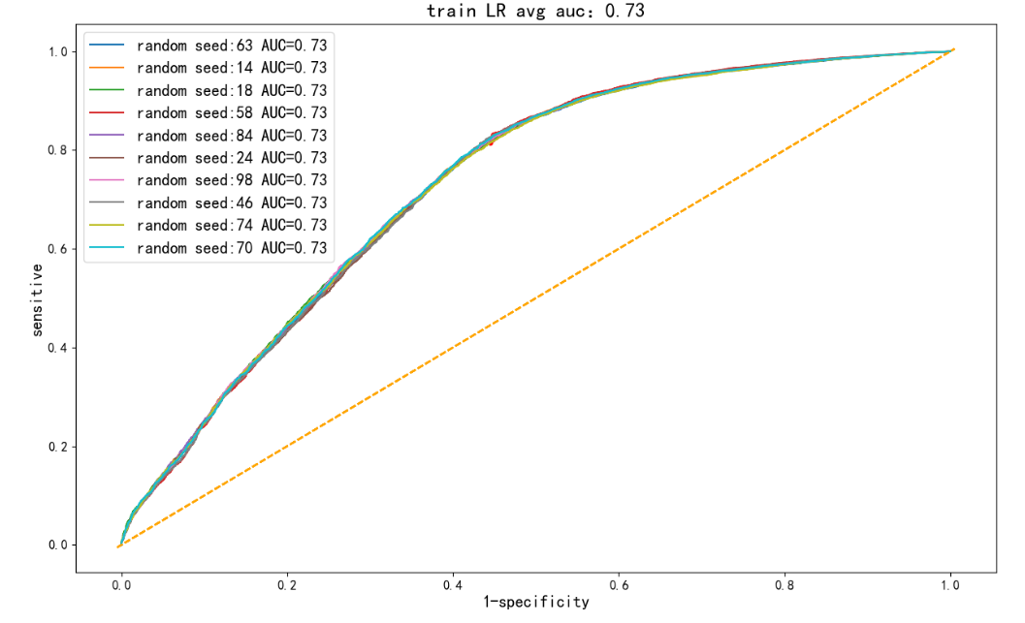
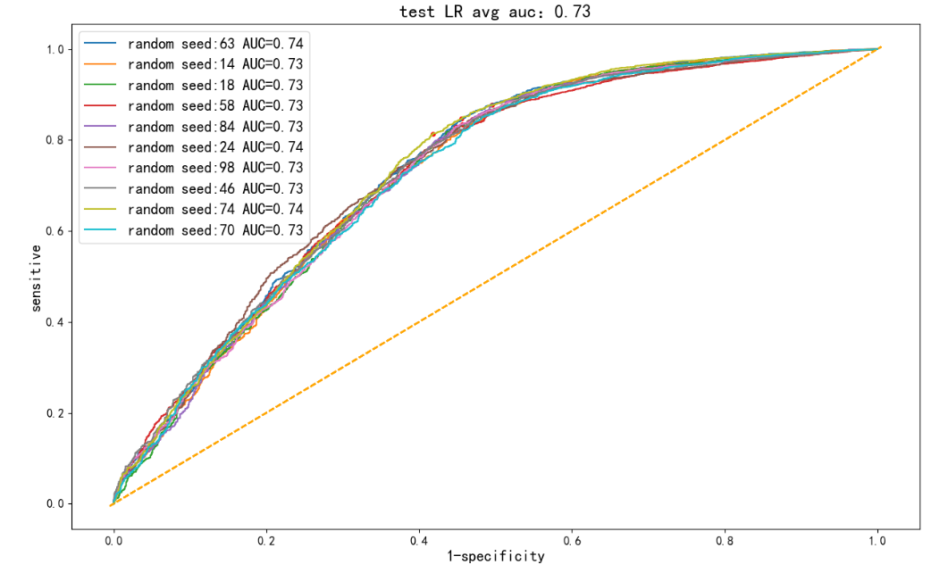
Figure 26 LR 10 random cross-verification results

It is found in Figure 26 that after 10 random cross-validation, the overall AUC level of the training set is around 0.72, and the test is also around 0.72, so there is no overfitting phenomenon in the LR model.

4.2.2 XGB modeling results
Compared with the LR model, XGB is still more complex and involves more parameters. The specific main parameters are explained as follows:

1. learning_rate: The learning rate, also known as step size control, determines the weight coefficient of each weak learner and determines the speed of learning parameter updates. The default value is 0.3, setting this parameter can prevent overfitting.

2. n_estimators: The number of iterations, also known as the number of trees. In the actual parameter adjustment process, we usually combine learning_ Adjust the rate together. The higher the value, the stronger the learning ability of the model.

3. max_depth: Set the maximum depth of the tree to avoid overfitting. The larger the value, the more specific the model learns. The default value is 6.

4. min_child_weight: The sum of the weight of the smallest sample on the leaf. Overfitting can be avoided. When the value is large, the model can avoid learning local samples, but if the value is too high, it will lead to underfitting.

5. gamma: The minimum value of loss reduction that must be set in order to further partition the leaf node of the tree. The larger the value, the more conservative the algorithm.

6. reg_lambda:L2 regularization weight term, which controls the regularization part of Xgboost, increasing this value will make the model more conservative. The default is 1.

7.scale_pos_weight: Set this parameter to a positive value when different samples are very unbalanced, which can make the algorithm converge faster. It is usually set as the ratio of negative to positive sample size.

8. eval_metric: Customize loss function and evaluation function in model training to make the model more accurate training.

9. early_stopping_rounds: Specifies the number of early stop rounds, that is, we will stop iteration if the validation set indicator does not improve within n rounds. The reduction of n can effectively reduce overfitting.

To optimize the parameters of Xgboost model, the first step is to determine learning_rate and n_estimators parameters. First, set learning_rate to 0.1 to reduce the iteration time and adjust n_estimators parameters. The second step is to keep the n_estimator and learning rate unchanged, adjust max_depth and min_child_weight which have the greatest influence, and then gamma; Step 3 Adjust L2 regularization reg_lambda; Step 4 Adjust scale_pos_weight. During adjustment, we should first make coarse adjustment and then fine adjustment, and then reduce the learning rate and increase the n_estimator at last. Then, according to the above adjustment logic, our output modeling result is as follows:
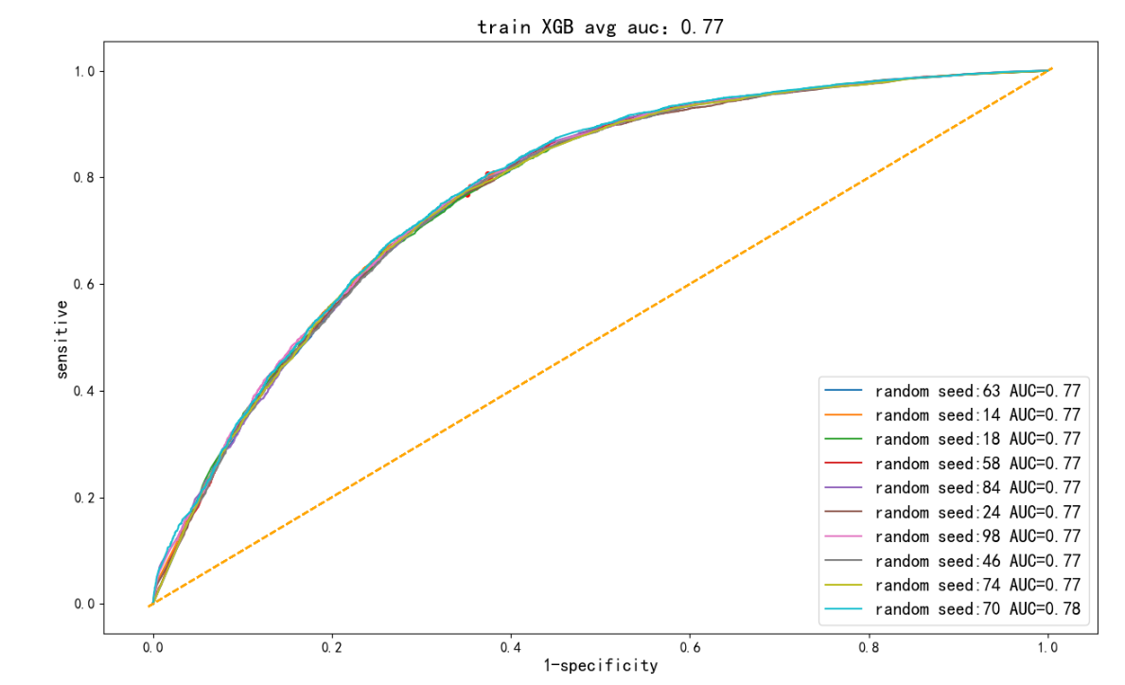
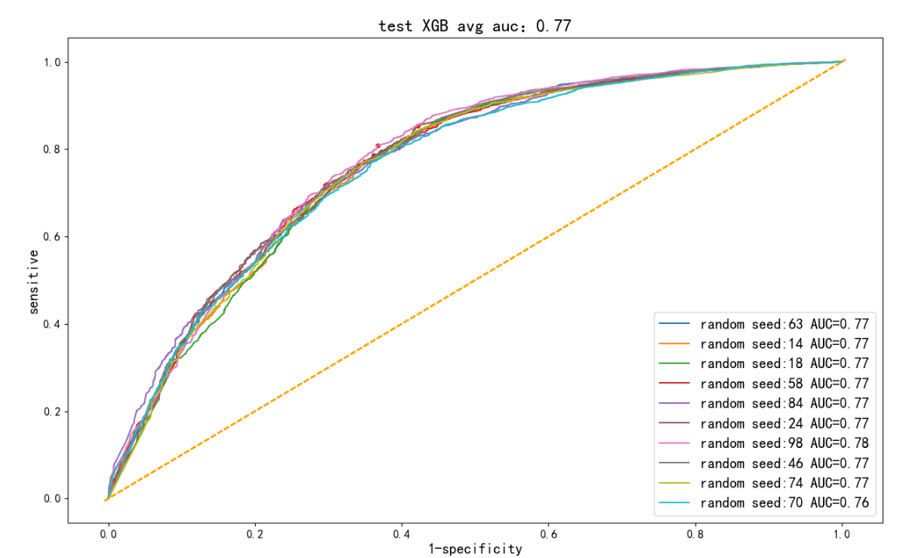
Figure 27 XGB cross-verification results for 10 times
From the perspective of XGB modeling effect, the AUC values of the training set and the test set are generally very consistent, which indicates that XGB does not have any overfitting phenomenon, and the model effect is improved compared with LR.

4.2.3 DNN modeling results
DNN is a classical nonlinear neural network model, which involves a lot of parameters. Next, the main parameters are explained:

1. network architecture: The network structure of DNN includes the number and size of input layer, hidden layer and output layer. The number of nodes and layers in each hidden layer can be adjusted according to the complexity of the problem and the characteristics of the data set.

2. activation function: The activation function is used to introduce nonlinear transformation and increase the expression ability of the network. Common activation functions include ReLU, Sigmoid, and Tanh, which map linear combinations of inputs to nonlinear outputs.

3. weights and biases: Each neuron in the DNN has weights and biases associated with it that adjust the weight and bias of the input. The weight controls how important each neuron is to the input, while the bias is used to adjust the neuron's activation threshold.

4. optimization algorithm: The training process of DNN involves an optimization algorithm to adjust the parameters of the network to minimize the loss function. Common optimization algorithms include Gradient Descent and its variants, such as Stochastic Gradient Descent and Adam.

5. learning rate: The learning rate determines the step length of each parameter update. A smaller learning rate can cause the model to converge more slowly but stably, while a larger learning rate can cause the model to be unstable or fail to converge.

6. batch size: Small-batch samples are usually used for parameter updating during DNN training. The batch size determines the number of samples used for each parameter update, and larger batch sizes can speed up training, but may also increase memory requirements.

7. regularization parameter: Regularization is used to control the complexity of DNN models and prevent overfitting. The regularization parameter can be L1 regularization or L2 regularization, which is used to balance the goodness of fit and complexity of the model, and increasing L1 and L2 also makes the model more conservative.

Similarly, after adjusting the relevant parameters through several experiments, the following modeling results are obtained:
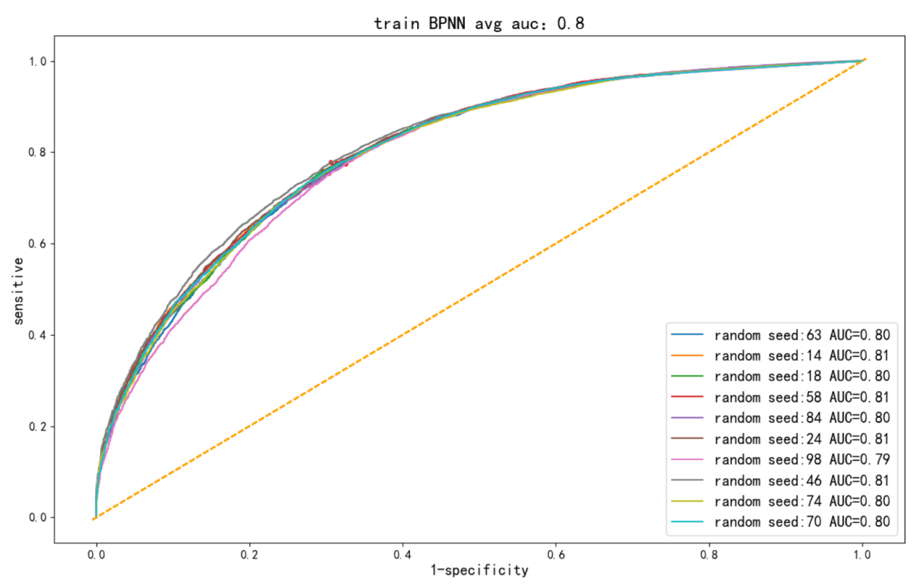
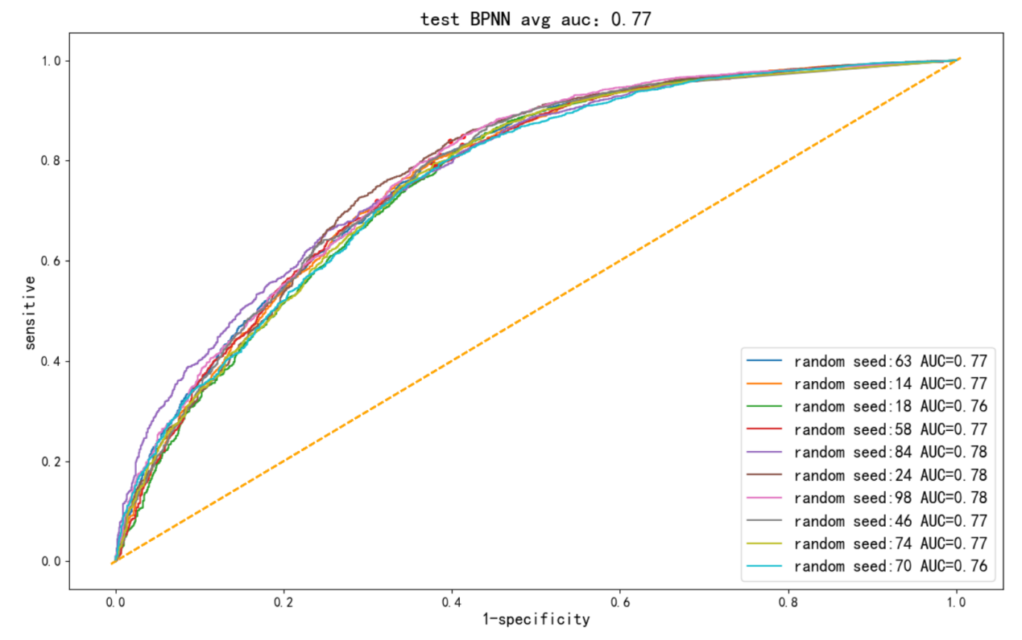
Figure 28 DNN cross-verification results for 10 times

According to the above results, from the perspective of overfitting, DNN model still does not have any overfitting phenomenon, but its model effect is similar to that of XGB. Finally, we can observe the modeling effect of LSTM.

4.2.4 LSTM modeling results
LSTM is a kind of recurrent neural network. Unlike DNN, its modeling takes into account the predicted values of previous periods, so there is a continuous type of time. If more results of past periods are considered, the model will become more complex and time-consuming.

1.input_shape: Shape of the input data. For LSTM networks, the input shape is usually a three-dimensional tensor that includes the number of samples, the time step, and the number of features.

2. recurrent_dropout: Similar to dropout, but it applies to loop connections. It helps reduce dependencies between time steps.

Since there is no strict timing situation in our scenario (that is, the prediction between everyone is independent), the step size can be directly selected 1, otherwise it will inevitably cause overfitting, and then adjust the learning rate, optimization function and other parameters, and finally get the following results:
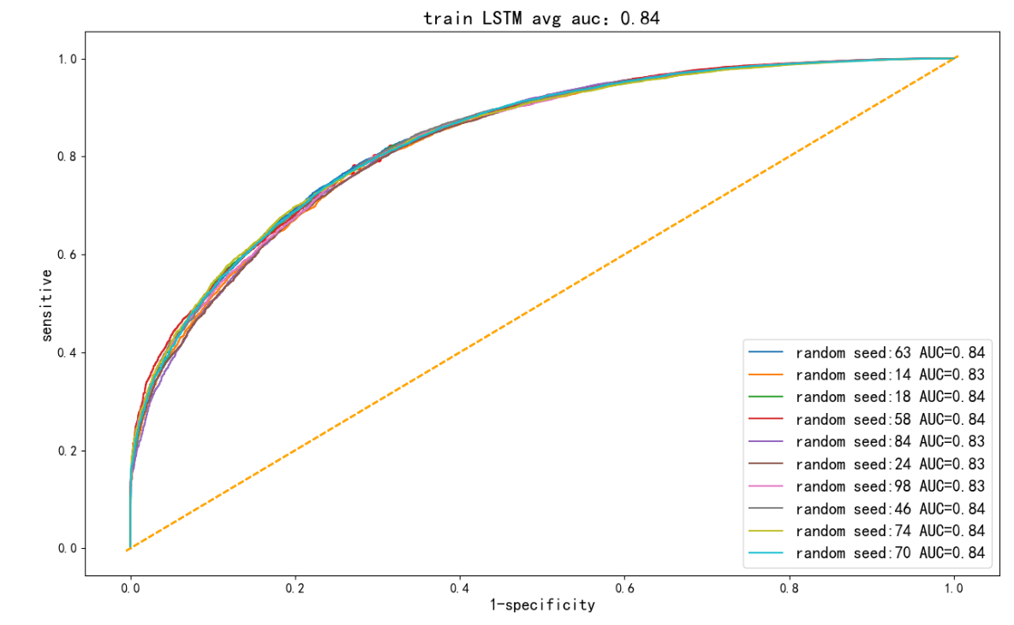
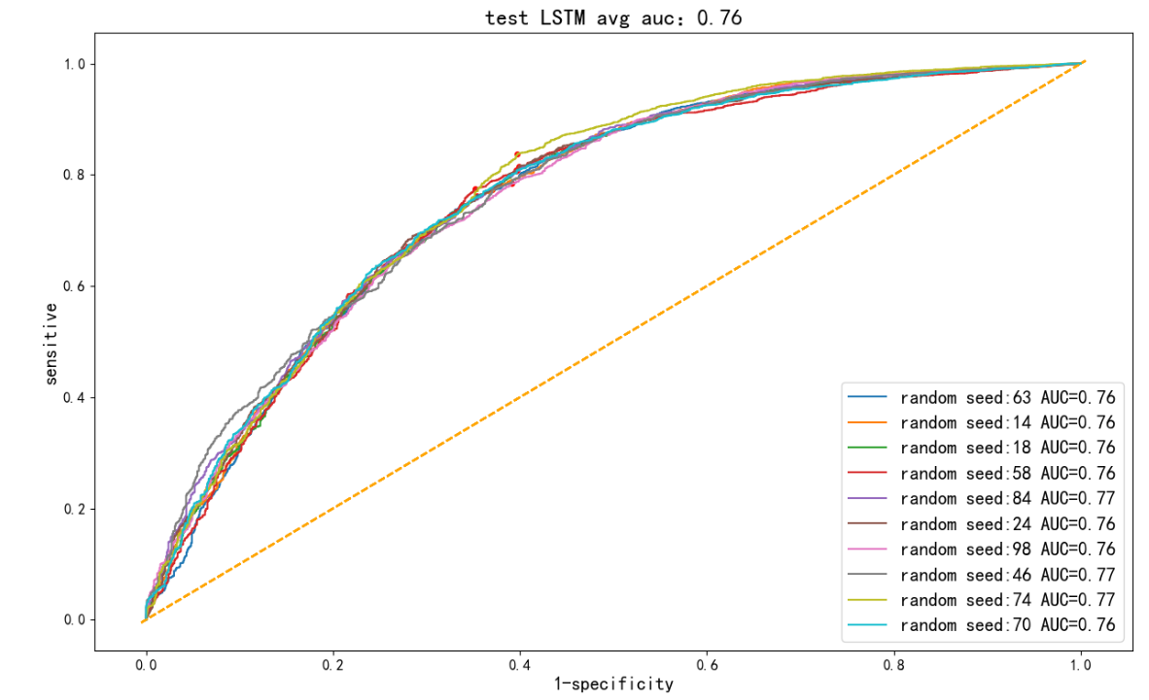
Figure 29 LSTM cross-verification results for 10 times

From the figure above, we find that LSTM's performance is slightly overfitting, because the AUC level of the test set is about 8% different from that of the training set, which also warns us that this data modeling is not the more complex the model, the better, and LSTM is not the preferred model for data sets that obviously do not have time series.

4.2.5 Comparison of modeling results
Finally, we draw the relevant technical indicators of the four models on the test set in the following table:
Test set | LR | XGB | DNN | LSTM
Accuracy | 0.80 | 0.80 | 0.81 | 0.81
F1 value | 0.38 | 0.53 | 0.46 | 0.45
Recall | 0.26 | 0.49 | 0.35 | 0.34
AUC | 0.73 | 0.77 | 0.77 | 0.76
Total time spent | 0.75 s | 4.35 s | 98s | 475s
Table 5 Average performance of technical indicators of each model

It can be seen from Table 5 above that the accuracy performance of all models in the test set is similar. This is because our label defaulters are much smaller than non-defaulters, so the models tend to predict the direction of non-defaulters, resulting in similar accuracy of the models, but the F1 value performance of each model is different, and XGB is the best. That is, model robustness XGB is the best; From the perspective of default sample recall rate, the best performance is still XGB, but despite this, the recall rate is only about 50%, that is, only half of the defaulters are accurately identified; In terms of the AUC recognition rate of the model, the performance of XGB, DNN and LSTM is similar, that is, under different probability thresholds, the accuracy of the model is about 0.77.However, in terms of the time spent on the model, it is obvious that the neural network model is much larger than the machine learning model, because the neural network will be more complex and diverse in nonlinear operations. In summary, we believe that XGB performance is the best model.

4.3 Model optimization

4.3.1 Optimization results
According to the previous analysis, we realize that there are differences in the number of default samples and non-default samples, so although the accuracy of each model reaches 80%, the recall rate is not very high (the highest is 50%). In this case, the first thing is to change the probability threshold level (normally 0.5 is the positive and negative sample threshold value, but for the prediction of default or not, the recall rate is not very high. The other option is to change the sample distribution of the training set to maintain the normal probability threshold, but the test set still has to maintain the actual distribution. If the change of the sample distribution of the training set can improve the recall rate on the test set, it will undoubtedly play a substantial optimization of the model.

In view of the above analysis ideas, we use the SMOTE method to balance the sample labels, let the number of default samples and non-default samples reach the theoretical 1:1, and then output the AUC performance of each model on the training set and the test set (the relevant parameters of the model need to be consistent with before optimization) :
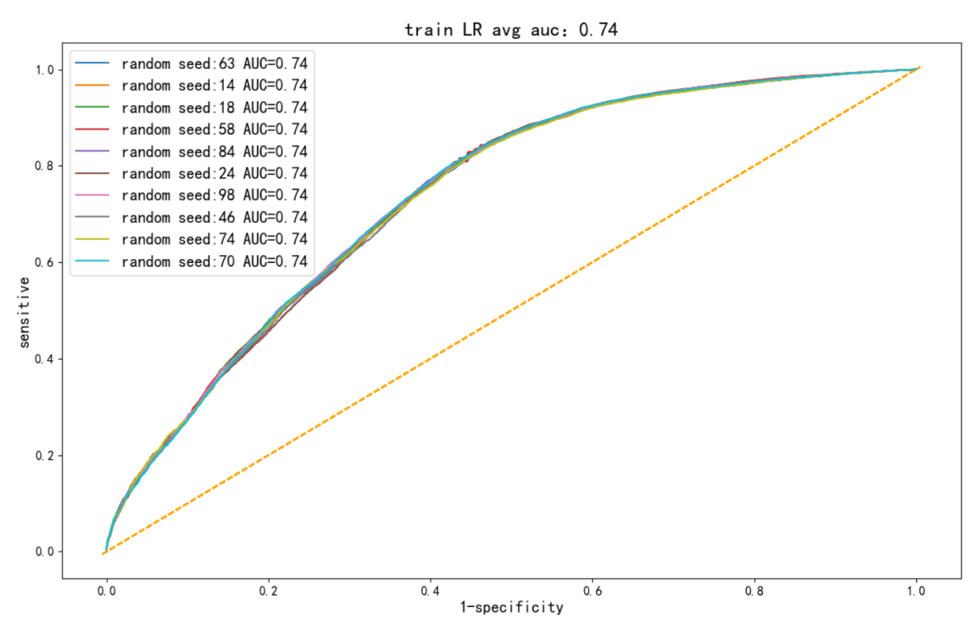
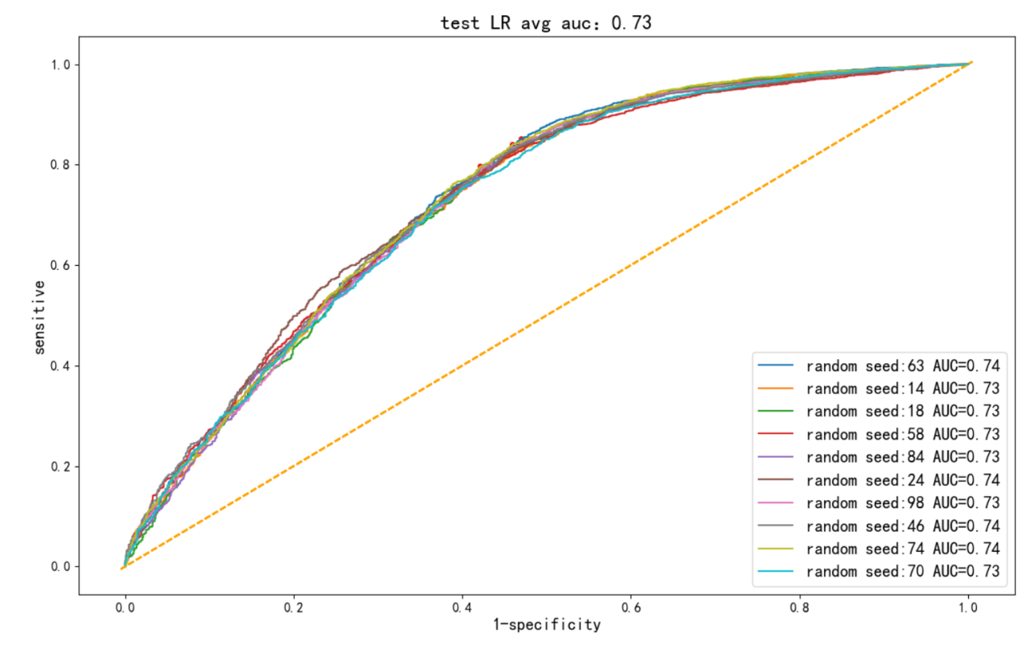
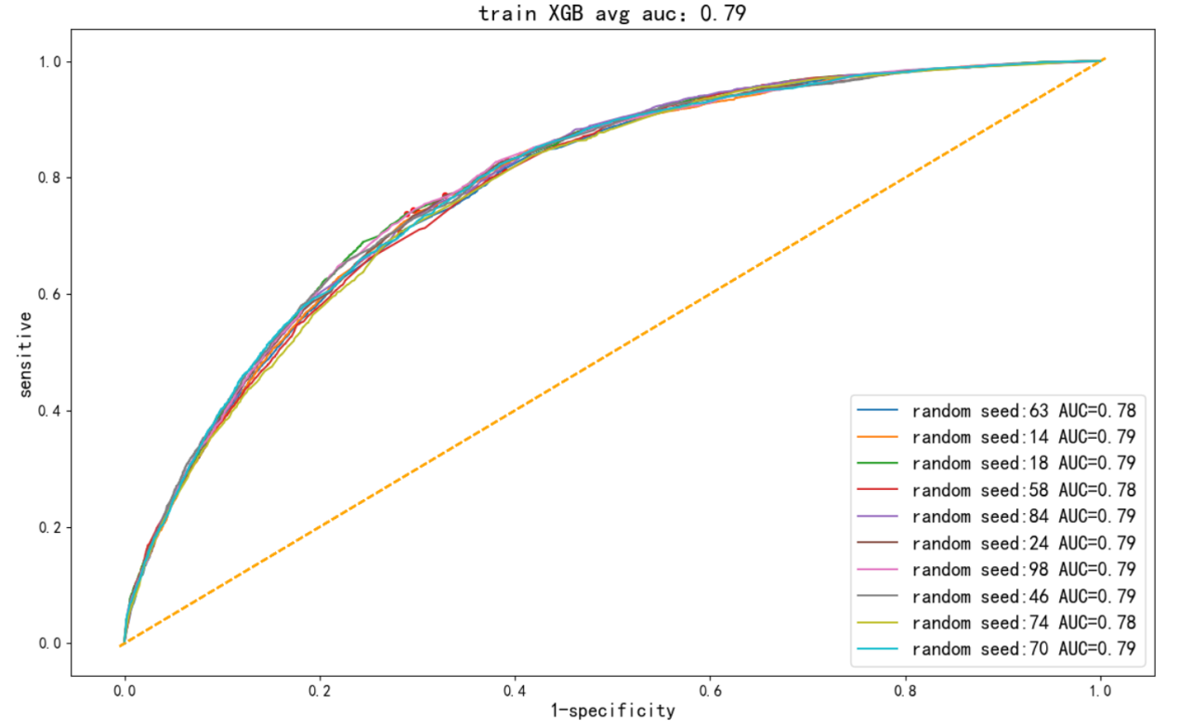
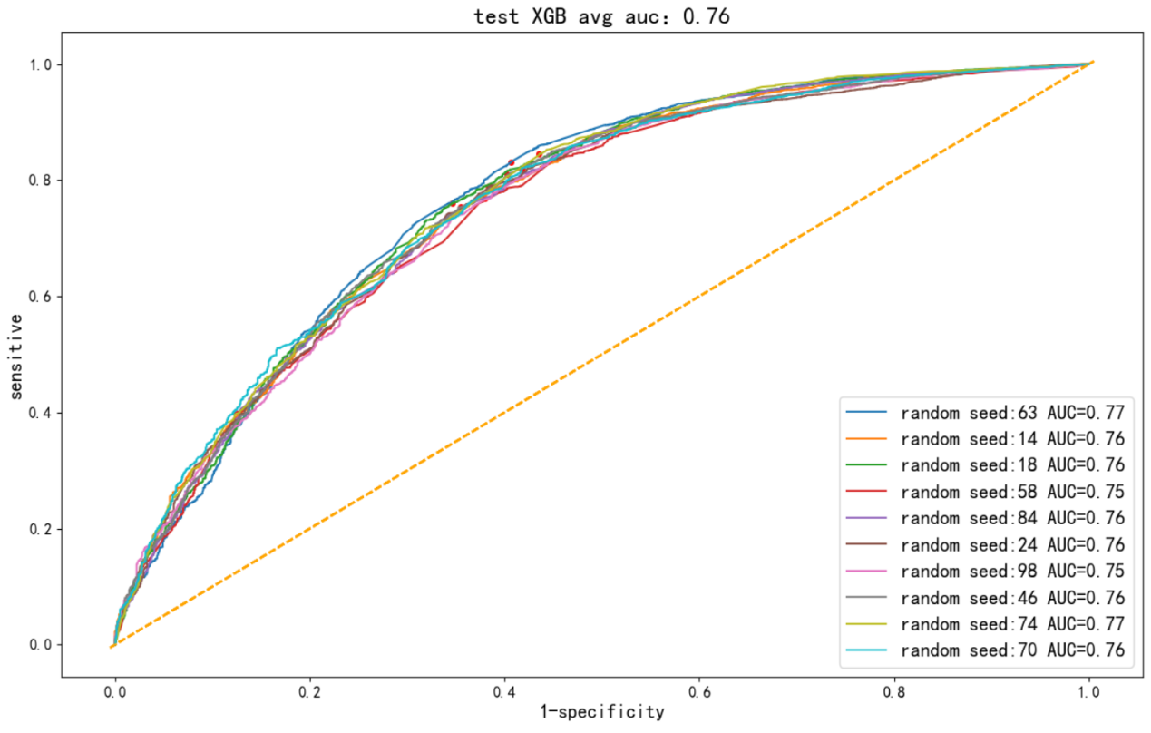
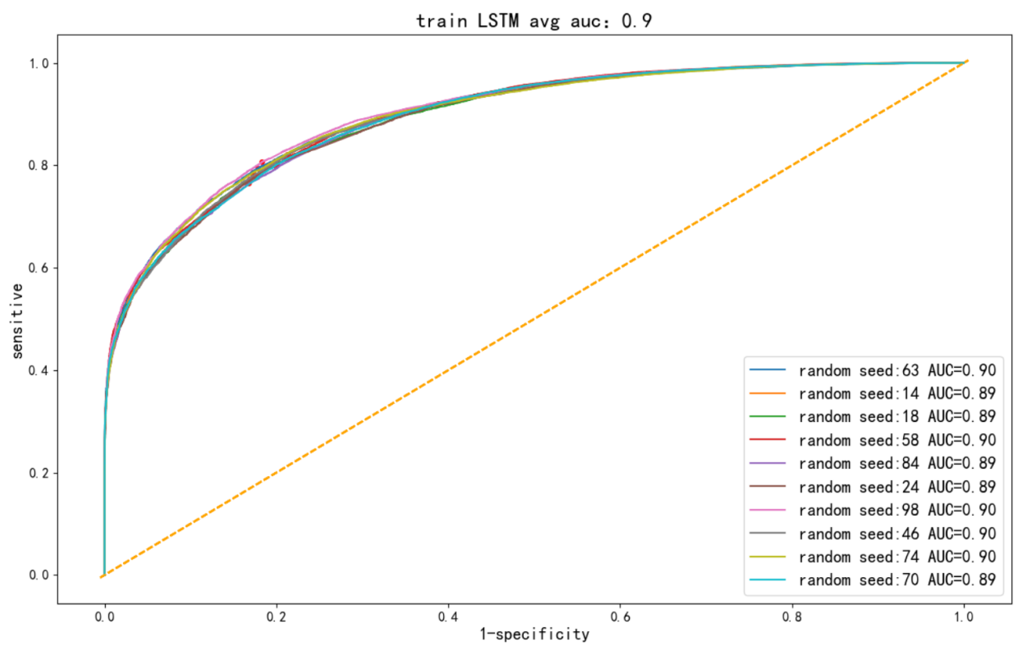
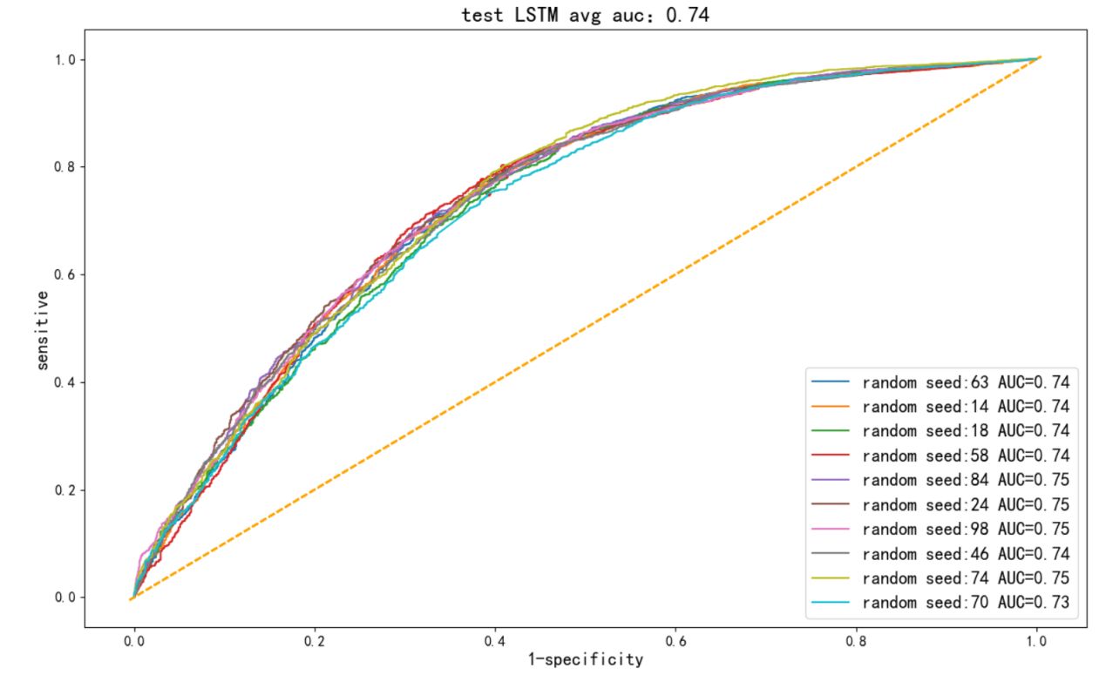
Figure 30 Comparison of AUC curves between training set and test set after optimization of each model

From the above group of diagrams, it is found that only LR and XGB still maintain the characteristics of non-overfitting of the model, and DNN and LSTM models aggravate the overfitting of the model. Then, the technical indicators of each model are output for analysis.

Test set | LR | XGB | DNN | LSTM
accuracy | 0.67 | 0.77 | 0.73 | 0.72
F1 | 0.48 | 0.54 | 0.52 | 0.51
recall | 0.66 | 0.60 | 0.65 | 0.62
AUC | 0.73 | 0.77 | 0.76 | 0.74
Total time spent | 1.03 s | 5.45 s | 122s | 552s
Table 6 Average performance of technical indicators of each model after optimization

It can be seen from Table 6 above that the recall rate of all models in the test set has been greatly improved. The LR model has the highest recall rate of 0.66, which is fully qualified. However, the AUC and accuracy rate of the LR model are lower than those of other models, that is, many non-defaulters are also predicted as defaulters, and the accuracy is not very high. For XGB model, the accuracy and AUC remain at the same level, and the recall rate also reaches 0.6 level, and the model is completely acceptable in terms of time. As for DNN and LSTM, there is no advantage compared with XGB, and there is a certain degree of overfitting. In summary, we still believe that XGB is the best model.

4.3.2 Importance of features
Xgboost model has good performance, and the feature importance analysis of Xgboost model is shown in Figure 31 as follows:
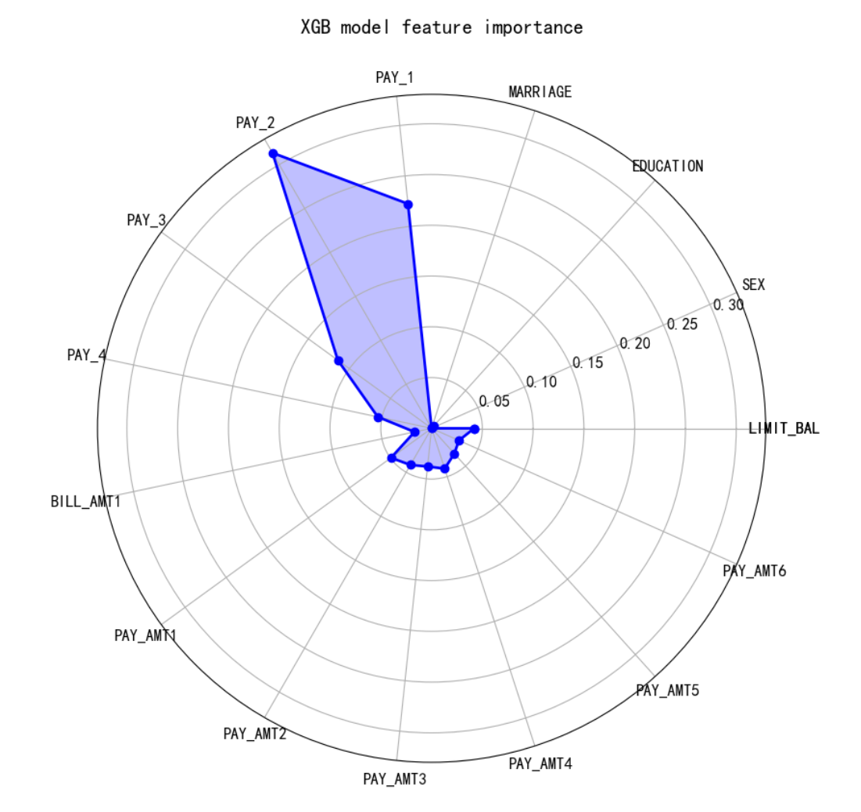
Figure 31 Feature importance score chart

It can be seen that PAY_1, PAY_2, PAY_3 and other features are very important features, that is to say, it is very important to affect the future default and the past default performance of this person, so in reality, we must pay attention to the past default situation of this person, observe his credit information and other information, once we get such information, Then, through the machine learning model we have established, we can accurately give the default situation of this person in the next month, so that relevant coping strategies such as pre-loan, mid-loan and post-loan can be developed in advance to reduce the default rate and achieve more profits.

4.4 Summary of this chapter
This chapter involves a lot of content, which is also the core content of this design. After feature processing, overfitting analysis of each model and in-depth optimization of modeling samples are carried out to obtain an XGB model with good timeliness, accuracy, recall rate and robustness. In addition, we have learned the most important factors affecting default through the importance of features, which plays a very important guiding significance for our future application.

5.Conclusion

5.1 Summary
Aiming at the problem of population default rate analysis, relevant data are obtained on the open data platform UCI. After getting the data, the data is preprocessed first and the outlier is processed. After that, exploratory analysis of the data set is carried out. Then, Spielman single factor analysis and non-parametric test method were used to screen the significant features. Then the modeling analysis is based on two kinds of machine learning and two kinds of deep learning respectively. Finally, we put SMOTE balance on the modeling sample and get the comprehensive label of the best model XGB model. The final accuracy is about 77%, the recall rate is about 60%, and the F1 value is about 54%. This result can provide effective reference for the relevant risk control strategy personnel to intercept the defaulting crowd.

Through the research and analysis, we can draw the following conclusions:
(1) The customer's basic attributes such as gender, education level and marital status have a difference in the performance of breach of contract
Similarly, for example, the default rate of people with low education level is relatively higher, so education can still improve a person's credit quality to a certain extent. We also found that age had little effect on default.

(2) A person's historical default behavior and repayment behavior have a great impact on whether he will default in the future. People with good historical performance tend to have significantly lower future default situations, so we should pay attention to a person's history-related behavior.

(3) In practice, on the one hand, it is necessary to suppress the defaulting group, and on the other hand, it is necessary to develop non-defaulting customers, so as to achieve the maximum profit. For the people with good credit, we can increase the credit limit.

(4) XGB model can have good application in default risk control, which can make good prediction of whether the crowd is predicted or not, and can also identify important factors affecting default.

5.2 Outlook
This modeling is relatively complete and scientific in both the data analysis stage and the modeling analysis stage, but there are still the following points worth looking forward to:

(1) For the data set of this study, some characteristics are that the information is not strict and clear enough, and there is no certain degree range, such as LIMIT_BAL. It is not clear what the degree of this indicator is, which may cause some interference to business analysis. In addition, for some amount data, there are too many negative values, which cannot exist in normal times, but there is no clear explanation here, so we set them to 0 roughly.

(2) Although the model selection in this paper is scientific and comprehensive enough, the selection of model parameters is more correct based on the understanding of the underlying parameters of the model and the determination of many experiments, but there is no strict automatic parameter adjustment. In the future modeling, some scientific parameter adjustment methods such as random grid and genetic algorithm can be selected.

(3) In future modeling, we can try to make the features more interpretable, such as conducting discrete processing of the features, calculating feature IV and WOE coding, so that excessive outliers can be retained instead of directly deleted, which is the goal of the future outlook.

Reference
- Thomas et al. A Review of Credit Scoring Techniques[J]. Scientific Reports.2017
- Gupta et al. An Overview of Risk management in Financial Institutions[J]. FinTech.2018
- Wu Yifei;Dorfman Jeffrey H. Reducing residential mortgage default: Should policy act before or after home purchases[J]. PubMed.2018
- Håvard Kvamme;Nikolai Sellereite;Kjersti Aas;Steffen Sjursen. Predicting mortgage default using convolutional neural networks[J]. Elsevier. 2018
- Kumar et al. Data Mining for Financial Applications: A Survey[J]. FinTech.2014
- Friedman et al. Credit Scoring with Gradient Boosting Machines[J]. statistical view.2001
- Thomas et al. A Comparative Study of Credit Scoring Algorithms: Logistic Regression, Decision Tree, and Neural Network[J]. Scientific Reports.2017
- Li et al. Deep Neural Networks for Credit Card Fraud Detection[J]. Scientific Reports.2017
- Sakar et al. Long Short-Term Memory Neural Networks for Credit Card Fraud Detection [J]. Scientific Reports.2018
- Johnson Roger W. Alternate Forms of the One-Way ANOVA F and Kruskal–Wallis Test Statistics[J]. Taylor & Francis.2022
- Hajek Petr;Abedin Mohammad Zoynul;Sivarajah Uthayasankar. Fraud Detection in Mobile Payment Systems using an Xgboost-based Framework[J]. PubMed. 2022
- Zhenqing Liu,Yiwen Cao,Yize Wang,Wei Wang. Computer vision-based concrete crack detection using U-net fully convolutional networks[J]. Automation in Construction.2019
- Zhongbin Zhang,Ye Liu,Lihua Cao,Heyong Si.Journal of Energy Resources Technology A Forecasting Method of District Heat Load Based on Improved Wavelet Neural Network[J].2020
- Kumar K. Sharath;Bai M. Rama. LSTM based texture classification and defect detection in a fabric[J]. Elsevier.2023
- Choubisa Manish;Dubey Manish. Financial models for indian stock prices prediction using LSTM and bi-directional LSTM model[J]. India journal.2023
- Zhang Yun;Liang Guangshun;Cao Cong;Zhang Yun;Li Yan. Short communication: Part contour error prediction based on LSTM neural network[J]. Copernicus.2023
- Xiong Zhangming;Zhu Daofei. Anomaly Detection of Metallurgical Energy Data Based on iForest-AE[J]. MDPI. 2022
- Wang Haotong;Li Yanjun. Research on anomaly detection and positioning of marine nuclear power steam turbine unit based on isolated forest[J]. Elsevier. 2023

